**Name ___________________________________________**

Class ___________________________________________

1. Which events occur during a four-stroke reciprocating engine cycle? Select all that apply.
2. A fuel and air mixture is converted into oxygen.
3. A fuel and air mixture is sucked into the cylinder through the intake valve.
4. A fuel and air mixture is ignited.
5. A fuel and air mixture is ejected through the exhaust valve.
6. A fuel and air mixture is compressed.
7. What first step should be taken during an electrical fire during flight?
8. Turn off all interior lights.
9. Land immediately.
10. Turn off the master switches.
11. Extinguish the fire, if possible.
12. Which of the following is NOT true of a cruise propeller?
13. They have a higher pitch.
14. They produce lower RPM.
15. They are more effective at higher power.
16. They are more efficient for long-range cruising.
17. Which of the following would decrease the propeller pitch?
18. The pilot increases propeller RPM.
19. The pilot makes a 1 G turn.
20. The pilot uses the elevator to change the pitch.
21. The pilot goes from a climb to cruising altitude.
22. Which of the following are sources of information for the pilot about weather conditions.
23. Flight Service (1-800-WX-BRIEF)
24. Aviationweather.gov
25. National Oceanic and Atmospheric Administration (NOAA)
26. All of the above
27. A carburetor mixes fuel and air before sending it to the intake manifold while a fuel injection system delivers fuel and air __________.
28. directly to the intake valve
29. directly to the cylinder
30. directly to the fuel pump
31. directly to the carburetor
32. For UAS, fuel may take the form of __________. Select all that apply.
33. compressed air
34. batteries
35. liquid fuel
36. fuel cells
37. hot air
38. __________ occurs when the correct fuel is used for the engine type and when the spark plugs are precisely timed.
39. Normal combustion
40. Detonation
41. Pre-ignition
42. All of the above
43. Where can the aircraft serial number be found?
44. Under the pilot’s seat
45. On the right landing gear
46. The title page of the POH/AFM
47. In the repair manual
48. In which in-flight emergency would a pilot immediately need to reduce the airplane’s altitude?
49. Uneven fuel tank balance
50. Hazardous storm conditions
51. Electrical fire
52. Explosive decompression
53. A supercharger _________.
54. adds no additional load on the engine
55. is more efficient than a turbocharger
56. has a lower throttle response than a turbocharger
57. is less efficient than a turbocharger
58. Which of the following lists the 5 stages of a jet engine in the correct order?
59. intake, turbine, combustor, exhaust, compressor
60. turbine, intake, combustor, compressor, exhaust
61. intake, compressor, combustor, turbine, exhaust
62. intake, turbine, combustor, compressor, exhaust
63. __________ is a formal, paid work-based learning experience that may last up to two years.
64. Job shadowing
65. An internship
66. Work-study
67. An apprenticeship
68. If a pilot flies with the altimeter set at 28.50 when the correct setting would be 29.00, the pilot is flying __________ than intended.
69. 500 feet higher
70. 50 feet lower
71. 500 feet lower
72. 50 feet higher
73. Which of the following is true about lithium-based batteries used in UAS? Select all that apply.
74. They can stay in the air longer than nickel-based batteries.
75. They don’t need to be charged as frequently as nickel-based batteries.
76. They are more likely to catch fire than nickel-based batteries.
77. They have a longer lifespan than nickel-based batteries.
78. They have a higher power to rate ratio than nickel-based batteries.
79. When the engine is running, the __________ of the electrical current the spark plugs need to ignite the fuel-air mixture.
80. batteries provide all
81. magnetos provide all
82. ground power unit provides all
83. magnetos provide some
84. True or False. UAS never use internal combustion engines.
85. What is the difference between jet fuel and avgas?
86. Avgas is colorless, while jet fuel isn’t.
87. Jet fuel has a higher flashpoint than avgas.
88. Jet fuel is kerosene-based and avgas is gasoline-based.
89. Jet fuel is red-colored, while avgas is blue-colored.
90. How can water enter the fuel supply? Select all that apply.
91. Low humidity
92. Faulty filler caps
93. Overheating
94. Higher altitudes
95. Condensation in partially filled fuel tanks
96. A turbocharger uses the engine’s __________ to drive a turbine that compresses incoming air.
97. fuel-air mixture
98. intercooler
99. compressor
100. exhaust gases
101. Hydraulics is the use of fluids to __________.
102. lubricate engine parts
103. stabilize temperature
104. transmit power
105. all of the above
106. The _________ is the source of ignition in most reciprocating engines.
107. intake port
108. spark plug
109. cylinder head
110. piston
111. When hydraulic fluid pressure exceeds a set pressure, the __________ opens to reduce pressure and routes fluid back to the reservoir.
112. actuator
113. fluid reservoir
114. selector valve
115. relief valve
116. True or False. If the alternator of an engine fails, the electrical system will drain the battery.
117. Replenishing hydraulic fluid, replacing position and landing lights, and installing or repairing new tires are examples of _________.
118. an FAA inspection
119. free maintenance provided under every warranty
120. preventive maintenance
121. all of the above
122. __________ is the pressure of the air against an aircraft caused by the movement of the aircraft.
123. Static pressure
124. Dynamic pressure
125. Total pressure
126. Air pressure
127. Why is it recommended that pilots avoid using flaps, gears, and spoilers during icing conditions?
128. More fuel is required using these devices during icing environments.
129. They increase surface area and ice accumulation.
130. Drag devices are likely to get stuck.
131. Maneuvers would be minimized during icing environments.
132. True or False. A pilot who performs preventive maintenance must make an entry in the aircraft logbooks.
133. A pilot’s VSI shows the following. What is the vertical speed and direction of the aircraft?

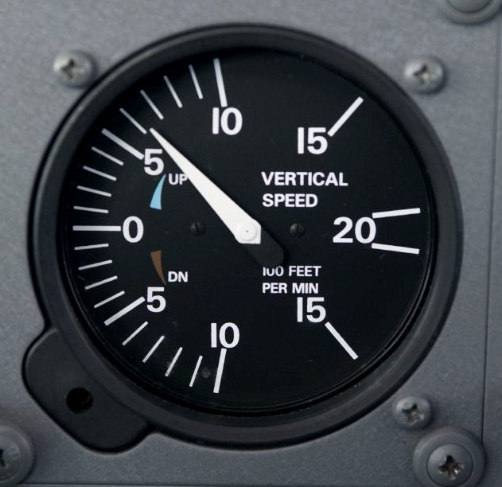

Editorial credit: AOPA

1. 60 ft/min climb
2. 600 ft/min climb
3. 60 ft/min descent
4. 600 ft/min descent
5. What happens during the combustion stage of a jet engine?
6. Air enters the engine through suction.
7. Air moving rearward propels the engine.
8. Hot gasses from the combustor power the compression shaft.
9. Compressed air enters the combustor, creating a contained explosion.
10. An airspeed indicator is a scale that shows the difference between __________ and total pressure.
11. air pressure
12. pressure altitude
13. static pressure
14. density pressure
15. Which indicated airspeed (mph) and load factor is in the caution zone of the Vg Diagram?

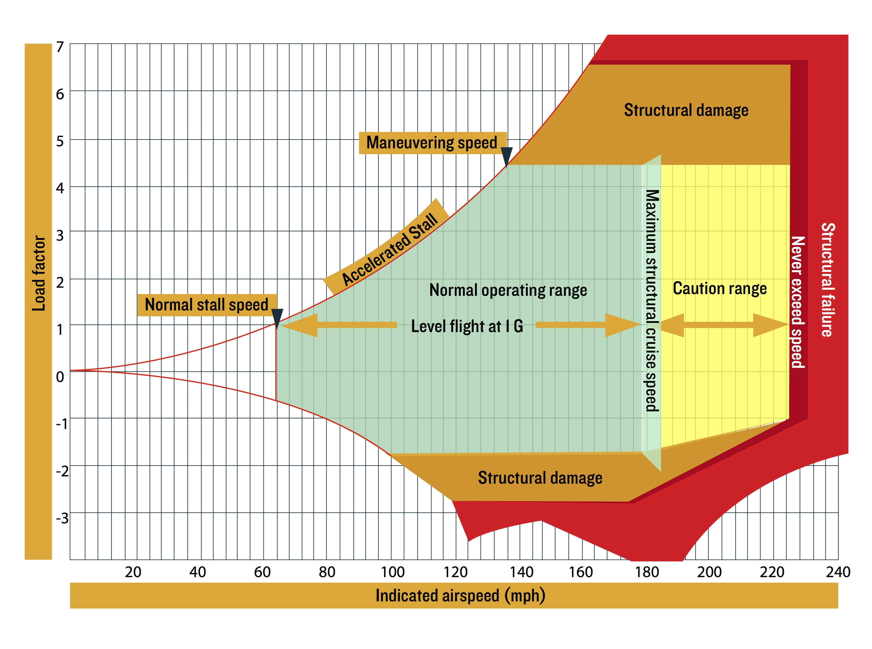

1. Airspeed 210 mph, load factor 0
2. Airspeed 100 mph, load factor 4
3. Airspeed 140 mph, load factor –1
4. Airspeed 170 mph, load factor –2
5. True or False. When the static port becomes blocked and the aircraft descends below the altitude where the static port became blocked, the airspeed indicator will indicate lower-than-actual airspeed.
6. Which of the following does an Attitude and Heading Reference System control? Select all that apply.
7. Airspeed indicator
8. Heading indicator
9. Turn rate indicator
10. Slip and skid indicator
11. Attitude indicator
12. When there is a suspected failure of the pitot-static systems due to icing, the pilot should __________.
13. turn off the engine cooling system
14. decrease airspeed
15. turn on pitot heat
16. all of the above
17. Pilots use “ARROW” to remind them of __________.
18. safety procedures in the event of an electrical fire
19. when to perform a preflight inspection
20. the aircraft’s registration date and requirements
21. the required documents that must be in an aircraft during flight
22. When the static port becomes blocked, the altimeter will __________.
23. fluctuate between higher-than-actual and lower-than-actual readings
24. begin decreasing down to its lowest possible reading
25. show a higher-than-actual reading
26. freeze at the last pressure indication and will not change
27. True or False. Airplane Flight Manuals must be approved by the FAA.
28. What could be the source of a low oil pressure gauge reading?
29. Not enough oil in the sump
30. Oil pump failure
31. Leaking oil line
32. All of the above
33. The tail number of an aircraft is N580AT. Which part of this tail number shows that the aircraft is registered in the United States?
34. AT
35. N5
36. A
37. N
38. Which of the following are UAS registration requirements? Select all that apply.
39. Registered operator must be at least 13 years old.
40. Registration number must be visible on the outside of the aircraft.
41. UAS with at least two rotors must be registered.
42. UAS weighing more than .55 pounds must be registered.
43. UAS that can hover must be registered.
44. A cabin pressure regulator prevents the __________ from exceeding its limitations.
45. oxygen level
46. cabin temperature
47. engine temperature
48. differential pressure
49. True or False. Safety is the primary reason the FAA mandates regular aircraft inspections.
50. Which of the following is recommended when checking the airplane’s engine oil?
51. Check around the engine, on the fuselage, and on the ground for signs of oil leaks.
52. After checking, be sure the oil filler cap is secure.
53. Use the dipstick accessed through the cowling to check the oil.
54. All of the above.
55. Which of the following is true about an EFD? Select all that apply.
56. It is also called a “glass cockpit.”
57. It reduces pilot workload in comparison to analog gauges.
58. It is only used in commercial airliners.
59. It improves situational awareness.
60. EFD stands for “engine flight diagram.”
61. A(n) __________ is issued by the FAA to address a safety problem related to an aircraft or its equipment.
62. Airworthiness Certificate
63. Airworthiness Directive
64. Airworthiness Bulletin
65. Temporary Airworthiness Certificate
66. True or False. Aircraft icing in flight is most likely to occur when it is snowing.
67. The FAA gives the __________ full authority in an emergency because of the ability to make immediate and careful decisions that result in the least amount of harm to everyone involved.
68. Pilot in Command (PIC)
69. National Transportation Safety Board (NTSB)
70. Control tower
71. All of the above
72. In which situation would a pilot set the fuel-air mixture to a “full rich” position?
73. At high altitudes where the air density is high.
74. At high altitudes where the air density is low.
75. At low altitudes where the air density is low.
76. At low altitudes where the air density is high.
77. Many accidents that appear to have a single cause actually have numerous contributing factors which occur in a sequence called __________.
78. an accident log
79. an error chain
80. a ripple effect
81. an emergency list