1. The airspeed indicator is showing 0 airspeed even though the plane is in motion. All the other instruments on the aircraft appear to be functioning normally. The pilot suspects a pitot-static malfunction. What might be the problem? (9.A.3)
2. Ram air port blockage
3. Drain hole blockage
4. Static port blockage
5. Both ram port and drain hole blockage
6. A pilot’s VSI shows the following. What is the vertical speed of the aircraft? (9.A.1)

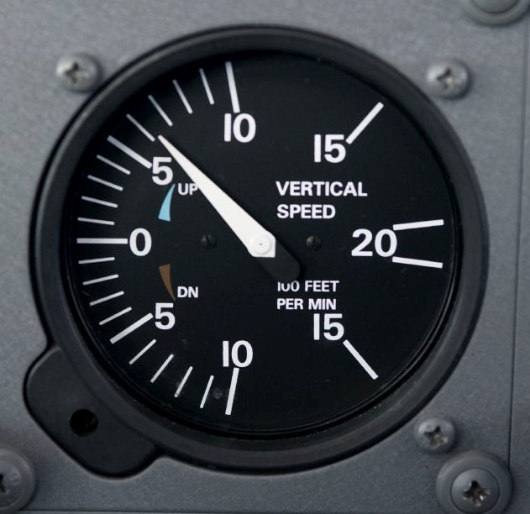

Editorial credit: AOPA

1. 0.6 ft/min climb
2. 600 ft/min climb
3. 0.6 ft/min descent
4. 600 ft/min descent
5. How does a gyroscope respond to a deflective force when it is powered? (9.B.1)
6. It moves in the direction of deflection and the deflection occurs 90 degrees in the direction of rotation from the point at which the force is applied.
7. It moves in the direction of deflection and the deflection occurs 90 degrees opposite the direction of rotation from the point at which the force is applied.
8. It moves opposite the direction of deflection and the deflection occurs 90 degrees in the direction of rotation from the point at which the force is applied.
9. It moves opposite the direction of deflection and the deflection occurs 90 degrees opposite the direction of rotation from the point at which the force is applied.
10. What does the white arc on the airspeed indicator indicate? (9.A.2)
11. The safe operating range for the flaps
12. The maximum speed with flaps extended
13. The normal operating range of the aircraft
14. The power-off stall speed at maximum takeoff weight
15. **What information is processed by the air data computer (ADC)? (9.C.1)**
16. Information from gyroscopic instruments
17. Information about direction and heading
18. Information about static and ram pressure
19. None; it is used to store information collected during flight.
20. **How is the groundspeed of an aircraft calculated? (9.A.2)**
21. Headwinds are added and tailwinds are subtracted from the true air speed
22. Tailwinds are added and headwinds are subtracted from the true air speed
23. Headwinds are added and tailwinds are subtracted from the calibrated air speed
24. Tailwinds are added and headwinds are subtracted from the calibrated air speed
25. **What information is provided on a compass correction card? (9.B.2)**
26. The amount of adjustment required to correct for northerly turning error
27. The amount of adjustment required to correct for magnetic deviation
28. The amount of adjustment required to correct for magnetic variation
29. The amount of adjustment required to correct for acceleration error
30. **How should a pilot adjust their altimeter before takeoff if operating at an airport where no altimeter setting is provided? (9.A.1)**
31. The altimeter should be adjusted until it displays 0.
32. The altimeter should be adjusted until it displays the airport’s elevation.
33. The altimeter should be adjusted until it displays the elevation at sea level.
34. The altimeter should be adjusted until it displays the lowest possible elevation.
35. An aircraft’s static port is blocked but the ram air port and the drain hole remain unobstructed. What instruments would become unreliable? Select all that apply. (9.A.3)
36. Airspeed indicator
37. Altimeter
38. Attitude indicator
39. Heading indicator
40. Turn coordinator
41. Vertical speed indicator
42. **A pilot is turning the plane north. Which of these guidelines should they follow? (9.B.2)**
43. The pilot should stop the turn after the desired heading because the compass leads the turn
44. The pilot should stop the turn before the desired heading because the compass leads the turn
45. The pilot should stop the turn after the desired heading because the compass lags the turn
46. The pilot should stop the turn before the desired heading because the compass lags the turn
47. **What do the white horizontal lines on the attitude indicator indicate? (9.B.1)**

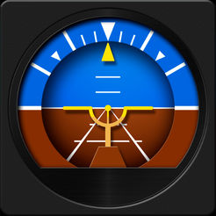

Editorial credit: Leland Roys

1. The degrees of bank
2. The degrees of pitch
3. The height above the ground
4. The rate of turn
5. What is denoted by VLE? (9.A.2)
6. The speed at which an aircraft will gain the greatest amount of altitude over a given distance
7. The speed at which a pilot can safely fully deflect one control surface in smooth air
8. The maximum speed for flying with landing gear extended
9. The never exceed speed
10. **The pilot needs to regularly reset the compass card of the heading indicator to match the magnetic compass. Which of these will cause the compass card to drift so that it needs to be reset? (9.B.1)**
11. A change in aircraft altitude
12. A change in aircraft location
13. The rotation of the Earth
14. The magnetic field of the Earth
15. **How should a pilot adjust the reading from their magnetic compass to calculate true north near Richmond, Virginia? (9.B.2)**

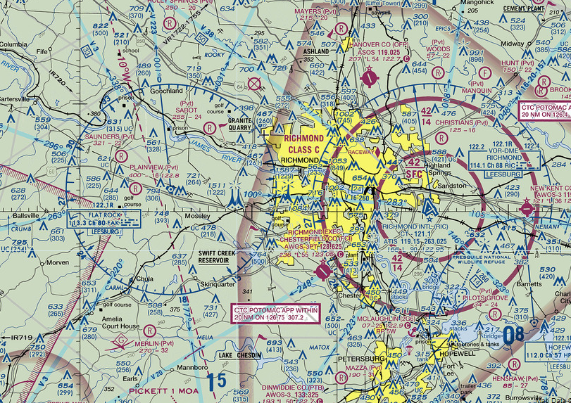

Editorial credit: SkyVector

1. Add 10°
2. Subtract 10°
3. 018°
4. 001°
5. What type of speed is read directly from the airspeed indicator? (9.A.2)
6. Calibrated airspeed
7. Groundspeed
8. Indicated airspeed
9. True airspeed
10. Acceleration in which of these situations would cause the magnetic compass to deflect toward the north? (9.B.2)
11. Accelerating when flying eastward in the Northern Hemisphere
12. Decelerating when flying westward in the Northern Hemisphere
13. Accelerating when flying northward in the Northern Hemisphere
14. Decelerating when flying southward in the Northern Hemisphere
15. What is the definition of density altitude? (9.A.1)
16. The indicated altitude when the pressure is set to 29.92 inHg
17. The altitude above mean sea level
18. The pressure altitude corrected for non-standard temperature
19. The altitude above the ground
20. What instruments are controlled by the attitude heading and reference system (AHRS) in aircraft with an electronic flight display (EFD)? Select all that apply. (9.C.1)
21. Airspeed indicator
22. Attitude indicator
23. Heading indicator
24. Slip/Skid indicator
25. Turn indicator
26. Vertical speed indicator
27. Which of these instruments do not rely on a gyroscope? Select all that apply. (9.B.1)
28. Altimeter
29. Attitude indicator
30. Heading indicator
31. Inclinometer
32. Turn and slip indicator
33. How are predicted future speed, altitude, and heading displayed on EFDs? (9.C.1)
34. As green arrows
35. As green lines
36. As magenta arrows
37. As magenta lines
38. What is one indication that there is a gyroscopic instrument failure on an aircraft? How should the pilot respond if this happens when flying in instrument conditions (i.e., without outside visual references)? (9.B.1)

Pilots may suspect a failure of a gyroscopic instrument if it is displaying conflicting information from other instruments, if the gyroscope appears to have tumbled or is moving erratically, if there are lights, alarms, or warning flags on the instruments, or if there is low or zero vacuum pressure. In response, a pilot should cover the failed instruments to remove them from the scan and rely on remaining instruments. If possible, the pilot should enable secondary backup systems such as standby vacuum or GPS. The pilot should declare an emergency and request assistance navigating to the nearest airport for landing.

1. What are two benefits of EFDs over analog gauges? Explain how each benefit contributes to flight safety. (9.C.1)

EFDs use lasers and solid-state gyros to determine attitude and heading information. This means that these instruments are less likely to fail. EFDs also provide more accurate navigation data, keeping the pilot on course. EFDs are also able to provide more types of data, such as traffic and weather, and trend data, which increases situational awareness. EFDs put more data in one place, simplifying the scan. Finally, EFDs have a more intuitive display, making it easier for pilots to interpret and respond appropriately.

1. Explain how static, dynamic, and total pressure are related. (9.A.1)

Static pressure is the pressure of still atmospheric air pressing down on an aircraft. Dynamic pressure is the pressure of the air against an aircraft caused by the movement of the aircraft. Total pressure is the sum of the static and dynamic pressures.

1. Explain why turning errors are greatest near the poles and least near the equator. (9.B.2)

Magnetic field lines run parallel to the surface of the Earth, for the most part, but converge at the poles. This means that the magnetic compass dips toward the surface when flying near the poles, contributing to turning error. This dip is largest near the poles and least near the equator.

1. During flight, a pilot notices that adding power and raising the aircraft’s nose does not result in changes in the altimeter. Describe two actions the pilot should take to react to this situation. (9.A.3)

When there is a suspected failure of the pitot-static systems, the pilot should rely on other methods of airspeed and altitude control, including:

* Fly at known pitch and power settings
* Use groundspeed and altitude indicated on GPS units
* Activate alternate static source if the aircraft has a backup system
* Turn on pitot heat if pitot tube icing is suspected