**1. What type of aircraft can a person legally fly at age 14? Select all that apply. (1.A.1)**

1. Glider
2. Balloon
3. Turboprop
4. Helicopter
5. Private jet

**2. The ______ pilot certificate requires the fewest number of flight hours. (1.A.1)**

1. sport
2. recreational
3. private
4. instrument

**3. What type of certificate must a pilot obtain in order to fly for a commercial airline? (1.A.1)**

1. Sport Pilot Certificate
2. Private Pilot Certificate
3. Instrument Rating
4. Airline Transport Pilot Certificate

**4. Which of these tasks could be aided by a drone pilot license? Select all that apply. (1.A.1)**

1. Transporting airline passengers
2. Real estate surveying
3. Police surveillance
4. Flying long-haul cargo
5. Filmmaking

**5. With respect to the certification of aircraft, which are categories of aircraft? (1.B.1)**

1. Normal, utility, acrobatic
2. Airplane, rotorcraft, glider
3. Landplane, seaplane
4. Single-engine, twin-engine, multi-engine

**6. For FAA aircraft certification purposes, how are aircraft categorized? (1.B.1)**

1. Based on the function
2. Based on the capacity
3. Based on the landing gear
4. Based on the number of engines

**7. Which of these best describes an airplane? (1.B.1)**

1. A heavier-than air aircraft that is drive by engines and has fixed wings
2. A heavier-than-air aircraft that relies on lift generated by one or more rotors
3. A heavier-than-air aircraft whose flight does not depend on an engine
4. A lighter-than-air aircraft that uses gas buoyancy or an airborne heater

8. Which of these best describes the airplane below? (1.B.1)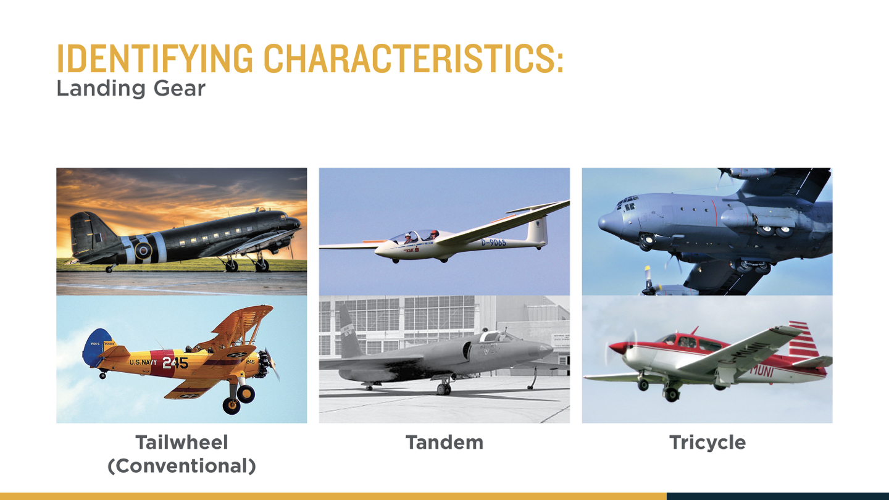

1. Tailwheel biplane
2. Tailwheel mid wing
3. Tricycle biplane
4. Tricycle triplane

**9. A UAS contains which of the following? Select all that apply. (1.B.2)**

1. Sensors
2. Human operator
3. Unmanned aircraft
4. Controller

**10. By what characteristic does the FAA classify UAS? (1.B.2)**

1. By weight
2. By operator
3. By type of engine
4. By type of landing gear

**11. A _________ is a type of UAS that most closely resembles a helicopter. (1.B.2)**

1. sUAS
2. Quadcopter
3. Multirotor UAS
4. Single-rotor UAS

**12. A multi-rotor UAS with 8 rotors is called a _____. (1.B.2)**

1. Tricopter
2. Quadcopter
3. Hexacopter
4. Octocopter

**13. Which of these are advantages of fixed-wing UAS over rotor-equipped UAS? Select all that apply. (1.B.2)**

1. Can takeoff and land on shorter runways
2. Can carry larger payloads
3. Has a longer range
4. Can fly faster
5. Can fly higher

**14. What is meant by a partially autonomous UAS? (1.B.2)**

1. A pre-programmed system that can learn, react, and conduct missions without additional input
2. A system that can fly a pre-programmed flight path
3. A system that can be remotely controlled by a pilot
4. A system that can fly without a pilot

**15. What type of designs can engineers use to make a stealth fighter more difficult to detect? Select all that apply. (1.C.1)**

1. Add sensitive thermal imaging equipment
2. Use sharp angles in the design of the fuselage
3. Keep bombs inside the aircraft
4. Mix cold air with hot exhaust
5. Use laser range finders

**16. What types of missions does the Boeing 747 fly? Select all that apply. (1.C.1)**

1. Passenger transport
2. Cargo transport
3. Stealth fighting
4. Firefighting
5. Air combat

**17. With respect to the certification of aircraft, which are classes of aircraft? (1.B.1)**

1. Normal, utility, acrobatic
2. Airplane, rotorcraft, glider
3. Landplane, seaplane
4. Single-engine, twin-engine, multi-engine

**18. The MQ-9 Reaper is a drone aircraft designed to perform strike and reconnaissance missions. Which of these features is not needed in this aircraft? (1.C.1)**

1. Attachment points for weapons
2. Communication systems
3. Seats and parachutes
4. Infrared sensors

**19. What type of missions can the Twin Otter accomplish? Select all that apply. (1.C.1)**

1. Transporting armored vehicles
2. Taking off from the ground
3. Landing on water
4. Landing on snow
5. Flying to space

**20. What type of aircraft is restricted to altitudes less than 400 ft? (1.B.2)**

1. Glider
2. Balloon
3. Small UAS
4. Twin-engine airplane

**21. In several sentences, describe what a tenth grade student can do now to begin a career in aviation. (1.A.1)**

Find a local flight school or certified flight instructor to start flying lessons; join the aviation community through groups like Aviation Explorers, EAA’s Young Eagles program, the Civil Air Patrol, and the Academy of Model Aeronautics; use a flight simulator for the computer; purchase a drone or remote-controlled aircraft; attend an aviation seminar; and take online training.

**22. In several sentences, explain why the FAA divides aircraft into categories and classes. (1.B.1)**

The FAA divides aircraft into categories and classes so that it knows which set of certification rules to apply. Aircraft with very different characteristics, such as airplanes and helicopters, must be evaluated using rules and standards appropriate to the category and class of aircraft to which they belong.

**23. In several sentences, explain the importance of knowing common aircraft characteristics. (1.B.1)**

Aircraft characteristics provide the common vocabulary for how pilots communicate about aircraft (high wing vs. low wing; twin vs. single). It is also helpful for pilots to know the manufacturer and model name of common aircraft. In addition, the ability to identify an aircraft by model or characteristics helps to understand an aircraft’s performance, such as speed and climb rate.

**24. In several sentences, explain how multiple aircraft may work together to accomplish the same mission. Provide an example. (1.C.1)**

A single mission may have varied tasks that must be carried out by a multitude of aircraft in order for it to successful. For example, to fight a wildfire, tankers may be used to spread water or fire retardant in front of a fire to stop its progression, while the aerial surveying for fires might be completed by small general aviation airplane or even a UAS. Further, a helicopter may be need to evacuate injured firefighters from the scene of the fire.

**25. In several sentences, explain the difference between tailwheel, tandem, and tricycle landing gear. (1.B.2)**

A tailwheel airplane has the main gear located near the front of the airplane, while a third wheel supports the tail   
 of the airplane. This is also known as conventional landing gear due to the fact that early aircraft used this   
 configuration.

An airplane with tandem gear has the front and rear gear are aligned along the longitudinal axis of the aircraft. It is used in some military aircraft and gliders.

A tricycle gear airplane is the most common of the three types of landing gear configurations. In this configuration there is a single nosewheel in the front of the aircraft and two main wheels farther back on the aircraft.