**Name ___________________________________________**

Class ___________________________________________

**1. _______ decreases at 1’’Hg per 1,000 foot increase in altitude.**

a. Barometric pressure

b. Density pressure

c. True altitude

d. Measured pressure altitude

**2. Viscosity is a fluid’s resistance to _______.**

a. friction

b. light

c. flow

d. heat

**3. What are the standard temperature and pressure values for sea level?**

a. 15 degrees C and 29.92” Hg.

b. 59 degrees C and 1013.2 millibars

c. 59 degrees C and 29.92” Hg.

d. 0 degrees C and 1013.2 millibars

**4. Knowing the pressure altitude is important to aircraft performance because it can be used as a tool to arrive at _______.**

a. humidity

b. air temperature

c. density altitude

d. buoyancy

**5. Pressure altitude corrects for the difference between _______ and standard pressure.**

a. humidity

b. density altitude

c. barometric pressure

d. standard temperature

**6. Which factor would tend to increase the density altitude at a given airport?**

a. decrease in ambient temperature

b. increase in barometric pressure

c. decrease in relative humidity

d. increase in ambient temperature

**7. Pressure altitude is calculated from (29.92 – 28.92) ✕ 1,000 + 3,500. What information do these numbers give?**

a. The barometric pressure is 29.92 ”Hg and the elevation is 1,000 feet.

b. The barometric pressure is 28.92 ”Hg and the elevation is 1,000 feet.

c. The barometric pressure is 29.92 ”Hg and the elevation is 3,500 feet.

d. The barometric pressure is 28.92 ”Hg and the elevation is 3,500 feet.

**8. Which of the following are units of measure for atmospheric pressure? Select all that apply.**

a. feet per second (ft/s)

b. square centimeters (cm2)

c. millibars (mb)

d. pounds per square inch (psi)

e. inches of mercury (Hg)

**9. Which combination of atmospheric conditions will reduce takeoff and climb performance?**

a. Low temperature, low relative humidity, and low density altitude

b. High temperature, low relative humidity, and low density altitude

c. Low temperature, high relative humidity, and high density altitude

d. High temperature, high relative humidity, and high density altitude

**10. Which statement is true about an object moving through a fluid?**

a. Viscosity changes according to the size of the object.

b. The object moves faster if the fluid is more viscous.

c. Fluid friction increases as the object’s velocity increases.

d. Less viscosity means more fluid friction.

**11. Which formula is used for calculating density altitude?**

a. mass ÷ volume

b. PA + [120 (OAT ‒ ISA) ]

c. (29.92 – Barometric Pressure) 1,000 + Elevation

d. 15 – (2 ÷ 1,000 x PA)

**12. Atmospheric pressure is _______ to air density.**

a. equal to

b. directly proportional

c. inversely proportional

e. unrelated

**13. The “standard day” serves as a universal baseline for measuring _______.**

a. atmospheric pressure

b. barometric temperature

c. density altitude

d. ground roll

**14. The Magnus Effect occurs because a spinning object drags the air around it. The air being dragged by the object interacts with the surrounding air to create regions of _______.**

a. high friction

b. warm and cool air

c. high and low pressure

d. high and low viscosity

**15. An airport has an elevation of 1,700 feet. A density altitude of 2,200 feet means that an aircraft will perform as if it is ________ above sea level.**

a. 3,900 feet

b. 500 feet

c. 1,700 feet

d. 2,200 feet

**16. Which of these factors has the smallest effect on air density? (3.A.2)**

a. Pressure

b. Humidity

c. Temperature

d. Altitude

**17. The Coanda Effect is the tendency for a jet of fluid to _______.**

a. force objects to move faster

b. lift objects upward

c. attach to a convex or bulging surface

d. become more dense

**18. True or False. The primary reason for computing density altitude is to determine airplane performance.**

**19. Objects with the same _______ but different masses have different densities.**

a. temperature

b. volume

c. area

d. viscosity

**20. In what way is the Coanda Effect similar to the Magnus Effect?**

a. They both create air movement that influence the direction of an airborne object.

b. They both impact the direction of an object that has a convex or bulging surface.

c. They both involve spinning objects that create regions of low pressure.

d. They both describe the movement of air molecules creating regions of high and low pressure.

**21. Explain how the chart would be used to determine the distance needed for an aircraft to take off. Explain why this is important.**

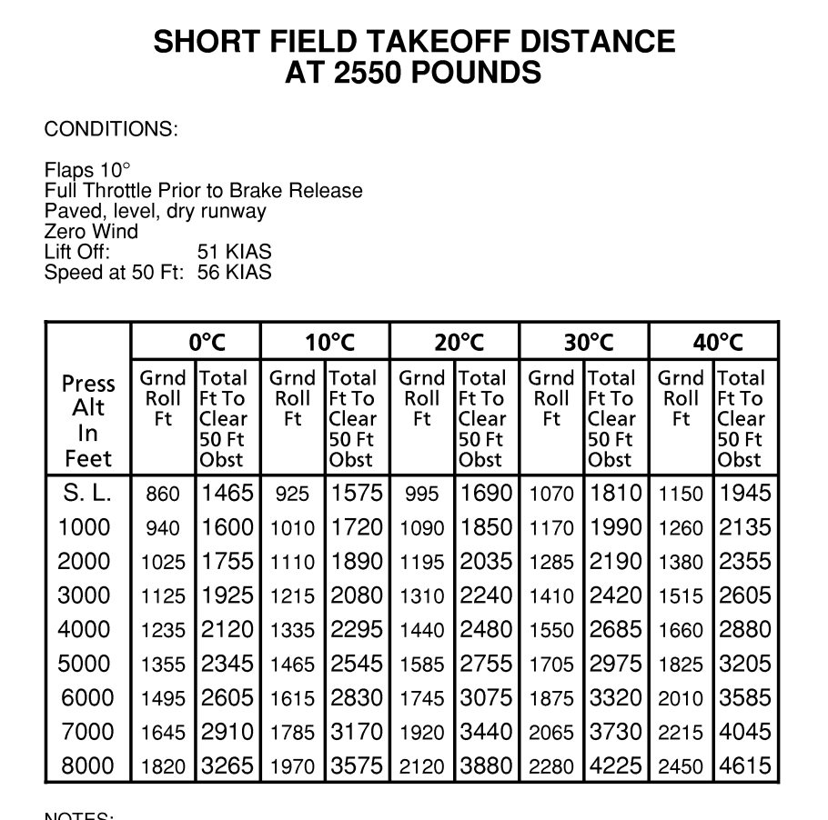

**22. Explain how the Magnus Effect works and give a real-world example.**

**23. Explain what limits an aircraft’s ability to perform and fly at extremely high altitudes.**

**24. Explain why an aircraft will have diminished performance on a hot day at a high-altitude airport.**

**25. What is the equation DA = PA + [120 (OAT ‒ ISA)] used for? Explain what DA, PA, OAT, and ISA represent in the equation.**