**1. _______ decreases at 1’’Hg per 1,000 foot increase in altitude. (3.B.1)**

a. Barometric pressure

b. Density pressure

c. True altitude

d. Measured pressure altitude

**2. Viscosity is a fluid’s resistance to _______. (3.A.1)**

a. friction

b. light

c. flow

d. heat

**3. What are the standard temperature and pressure values for sea level? (3.B.1)**

a. 15 degrees C and 29.92” Hg.

b. 59 degrees C and 1013.2 millibars

c. 59 degrees C and 29.92” Hg.

d. 0 degrees C and 1013.2 millibars

**4. Knowing the pressure altitude is important to aircraft performance because it can be used as a tool to arrive at _______. (3.A.2)**

a. humidity

b. air temperature

c. density altitude

d. buoyancy

**5. Pressure altitude corrects for the difference between _______ and standard pressure. (3.B.1)**

a. humidity

b. density altitude

c. barometric pressure

d. standard temperature

**6. Which factor would tend to increase the density altitude at a given airport? (3.B.1 and 3.A.1)**

a. decrease in ambient temperature

b. increase in barometric pressure

c. decrease in relative humidity

d. increase in ambient temperature

**7. Pressure altitude is calculated from (29.92 – 28.92) ✕ 1,000 + 3,500. What information do these numbers give? (3.B.1)**

a. The barometric pressure is 29.92 ”Hg and the elevation is 1,000 feet.

b. The barometric pressure is 28.92 ”Hg and the elevation is 1,000 feet.

c. The barometric pressure is 29.92 ”Hg and the elevation is 3,500 feet.

d. The barometric pressure is 28.92 ”Hg and the elevation is 3,500 feet.

**8. Which of the following are units of measure for atmospheric pressure? Select all that apply. (3.A.2)**

a. feet per second (ft/s)

b. square centimeters (cm2)

c. millibars (mb)

d. pounds per square inch (psi)

e. inches of mercury (Hg)

**9. Which combination of atmospheric conditions will reduce takeoff and climb performance? (3.B.1 and 3.A.2)**

a. Low temperature, low relative humidity, and low density altitude

b. High temperature, low relative humidity, and low density altitude

c. Low temperature, high relative humidity, and high density altitude

d. High temperature, high relative humidity, and high density altitude

**10. Which statement is true about an object moving through a fluid? (3.A.1)**

a. Viscosity changes according to the size of the object.

b. The object moves faster if the fluid is more viscous.

c. Fluid friction increases as the object’s velocity increases.

d. Less viscosity means more fluid friction.

**11. Which formula is used for calculating density altitude? (3.B.1)**

a. mass ÷ volume

b. PA + [120 (OAT ‒ ISA) ]

c. (29.92 – Barometric Pressure) 1,000 + Elevation

d. 15 – (2 ÷ 1,000 x PA)

**12. Atmospheric pressure is _______ to air density. (3.A.2)**

a. equal to

b. directly proportional

c. inversely proportional

e. unrelated

**13. The “standard day” serves as a universal baseline for measuring _______. (3.B.1)**

a. atmospheric pressure

b. barometric temperature

c. density altitude

d. ground roll

**14. The Magnus Effect occurs because a spinning object drags the air around it. The air being dragged by the object interacts with the surrounding air to create regions of _______. (3.A.1)**

a. high friction

b. warm and cool air

c. high and low pressure

d. high and low viscosity

**15. An airport has an elevation of 1,700 feet. A density altitude of 2,200 feet means that an aircraft will perform as if it is ________ above sea level. (3.B.1)**

a. 3,900 feet

b. 500 feet

c. 1,700 feet

d. 2,200 feet

**16.** **Which of these factors has the smallest effect on air density? (3.A.2)**

a. Pressure

b. Humidity

c. Temperature

d. Altitude

**17. The Coanda Effect is the tendency for a jet of fluid to _______. (3.A.1)**

a. force objects to move faster

b. lift objects upward

c. attach to a convex or bulging surface

d. become more dense

**18. True or False. The primary reason for computing density altitude is to determine airplane performance. (3.B.1.)**

**19. Objects with the same _______ but different masses have different densities. (3.A.2)**

a. temperature

b. volume

c. area

d. viscosity

**20. In what way is the Coanda Effect similar to the Magnus Effect? (3.A.1)**

a. They both create air movement that influence the direction of an airborne object.

b. They both impact the direction of an object that has a convex or bulging surface.

c. They both involve spinning objects that create regions of low pressure.

d. They both describe the movement of air molecules creating regions of high and low pressure.

**21. Explain how the chart would be used to determine the distance needed for an aircraft to take off. Explain why this is important. (3.B.1)**

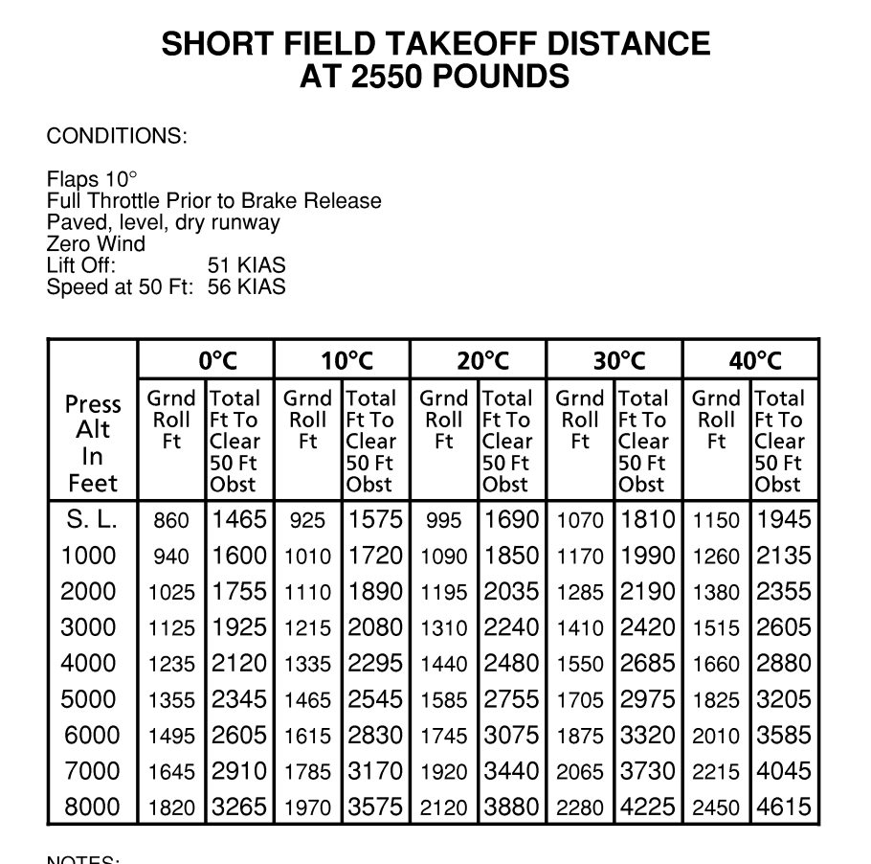

Pilots use charts like these to determine the effect of density altitude on aircraft performance. As

density altitude increases, air density decreases, causing the aircraft to perform as if it is flying at

a higher altitude than it actually is. Understanding and accounting for density altitude is important

for flight safety. In these charts, the temperature and pressure columns combine to account for

density.

**22. Explain how the Magnus Effect works and give a real-world example. (3.A.1)**

The Magnus Effect occurs because a spinning object drags the air around it. The air being dragged by the object interacts with the surrounding air to create regions of high and low pressure. If the region of low pressure is imbalanced, the object is pulled toward the region of lowest pressure. This allows baseball pitchers or soccer players to curve the path of their balls by varying the amount of spin they put on the balls.

**23. Explain what limits an aircraft’s ability to perform and fly at extremely high altitudes. (3.A.2)**

Air density decreases as altitude increases. This is why every airplane has a flight ceiling, an altitude  
above which it cannot fly. As an airplane ascends, it reaches a point where there isn't  
enough air to generate the lift required to overcome the airplane's weight, enough air for the engine to burn the fuel, or enough air for the propeller to convert engine power into thrust.

**24. Explain why an aircraft will have diminished performance on a hot day at a high-altitude airport. (3.B.1)**

Air density decreases as altitude increases. This means that the air is less dense at airports situated at higher elevations. However, other factors—such as temperature and air pressure—can also affect air density, causing it to increase or decrease even as altitude remains constant. Airports in areas with higher temperatures and at higher elevations have higher density altitudes. This means the air is less dense, and so there is less air for the engine to use to create power, to lift the wings, and to push through the propellers to generate thrust. This leads to longer takeoff and landing distances and a general decrease in aircraft performance.

**25. What is the equation DA = PA + [120 (OAT ‒ ISA)] used for? Explain what DA, PA, OAT, and ISA represent in the equation. (3.B.1)**

DA represents density altitude, PA represents pressure altitude, OAT represents outside air temperature, and ISA represents International Standard Atmosphere. The equation is used to calculate density altitude when PA, OAT, and ISA are known.