**Name ___________________________________________**

Class ___________________________________________

**­­­**

1. **Positive stability in an aircraft is its tendency to return to its original __________ when displaced.**
2. amplitude
3. attitude
4. direction
5. acceleration
6. **What happens to the rotor system in a helicopter when the pilot raises or lowers the collective control?**
7. The engine goes to max power or idle
8. The thrust of the tail rotor increases or decreases
9. The pitch angle of the rotor blades increase or decrease as a whole unit
10. The swash plate tilts right or left to alter the pitch of individual rotor blades
11. **True or False. Pitch stability refers to the movement of an aircraft’s nose up and down around its lateral axis.**
12. **The __________ yaws the airplane left or right.**
13. elevator
14. rudder
15. control columns
16. yoke
17. **Which of the following are the three axes of flight? Select the three answers that apply.**
18. Tail axis
19. Longitudinal axis
20. Forward axis
21. Lateral axis
22. Vertical axis
23. **Which of the following are ways that a control input can be transmitted to a control surface? Select all that apply.**
24. Hydraulic pressure
25. Wind tunnels
26. Electronic signals
27. Anti-torque pedals
28. Cable and pulley
29. **How are flaps used during flight? Select all that apply.**
30. They increase lift
31. They are retracted at cruising altitude
32. They reduce drag during takeoff
33. They are retracted during descent
34. They are extended during landing
35. **Trim systems are designed to _____________.**
36. relieve the pilot of the need to maintain constant pressure on the flight controls.
37. be used during approach and landing to increase wing lift.
38. move in the opposite direction from one another to control roll.
39. increase drag for rapid descents and to reduce lift after landing.
40. **When a leading edge device is lowered, it increases the wing’s __________.**
41. center of gravity.
42. camber.
43. dihedral.
44. all of the above
45. **Which of the following is not a primary flight control surface?**
46. Ailerons
47. Flaps
48. Elevator
49. Rudder
50. **Variable speed rotors controlled by onboard _______ provide stability and maneuverability for a multi-rotor UAS.**
51. ailerons
52. cameras
53. computers
54. radios
55. **How do quadcopters counteract the torque forces created by each of the four rotors?**

1. Rotors that sit on opposite sides from one another spin in opposing directions
2. All four rotors spin counter-clockwise
3. The main body absorbs all torque forces
4. A computer is used to limit the amount of torque from each rotor

1. **True or False.  An aircraft become progressively more difficult to control as the center of gravity moves aft.**
2. **An airplane has a tendency to descend in a turn because ____________.**
3. Thrust is not equal to drag.
4. The vertical component of lift decreases.
5. The airplane is in a skid.
6. The horizontal component of lift decreases.
7. **A skidding turn can be avoided by _____________.**
8. adding more power.
9. using a greater angle of bank.
10. proper rudder use.
11. all of the above.
12. **An airplane’s rate of turn is _________.**
13. equal to its airspeed.
14. inversely proportional to its airspeed.
15. exactly twice the airspeed.
16. always greater than its airspeed.
17. **A person weighing 180 pounds and experiencing 4 Gs of force would feel as though they weighed __________.**
18. 45 pounds.
19. 360 pounds.
20. 540 pounds.
21. 720 pounds.
22. **How should a pilot operate an airplane in a way that minimizes dangers from turbulence? Select all that apply.**
23. Fly at maneuvering speed or slower
24. Accelerate to move quickly through turbulence
25. Reach a higher cruising altitude
26. Avoid areas of rough conditions
27. Avoid turning the airplane in any direction
28. **During an approach to a stall, an increased load factor will cause the aircraft to _________.**
29. stall at a higher airspeed.
30. stall at a lower airspeed.
31. have a tendency to spin.
32. be more difficult to control.
33. **The amount of load that can be safely imposed on an airplane depends upon the _______.**
34. weight of the airplane.
35. abruptness with which the load is applied.
36. position of the center of gravity.
37. speed of the airplane.

1. **Use the Vg diagram to explain what could happen to an airplane and its occupants when it is maneuvering with an indicated airspeed of 160 mph and a load factor of –2.5 Gs.**

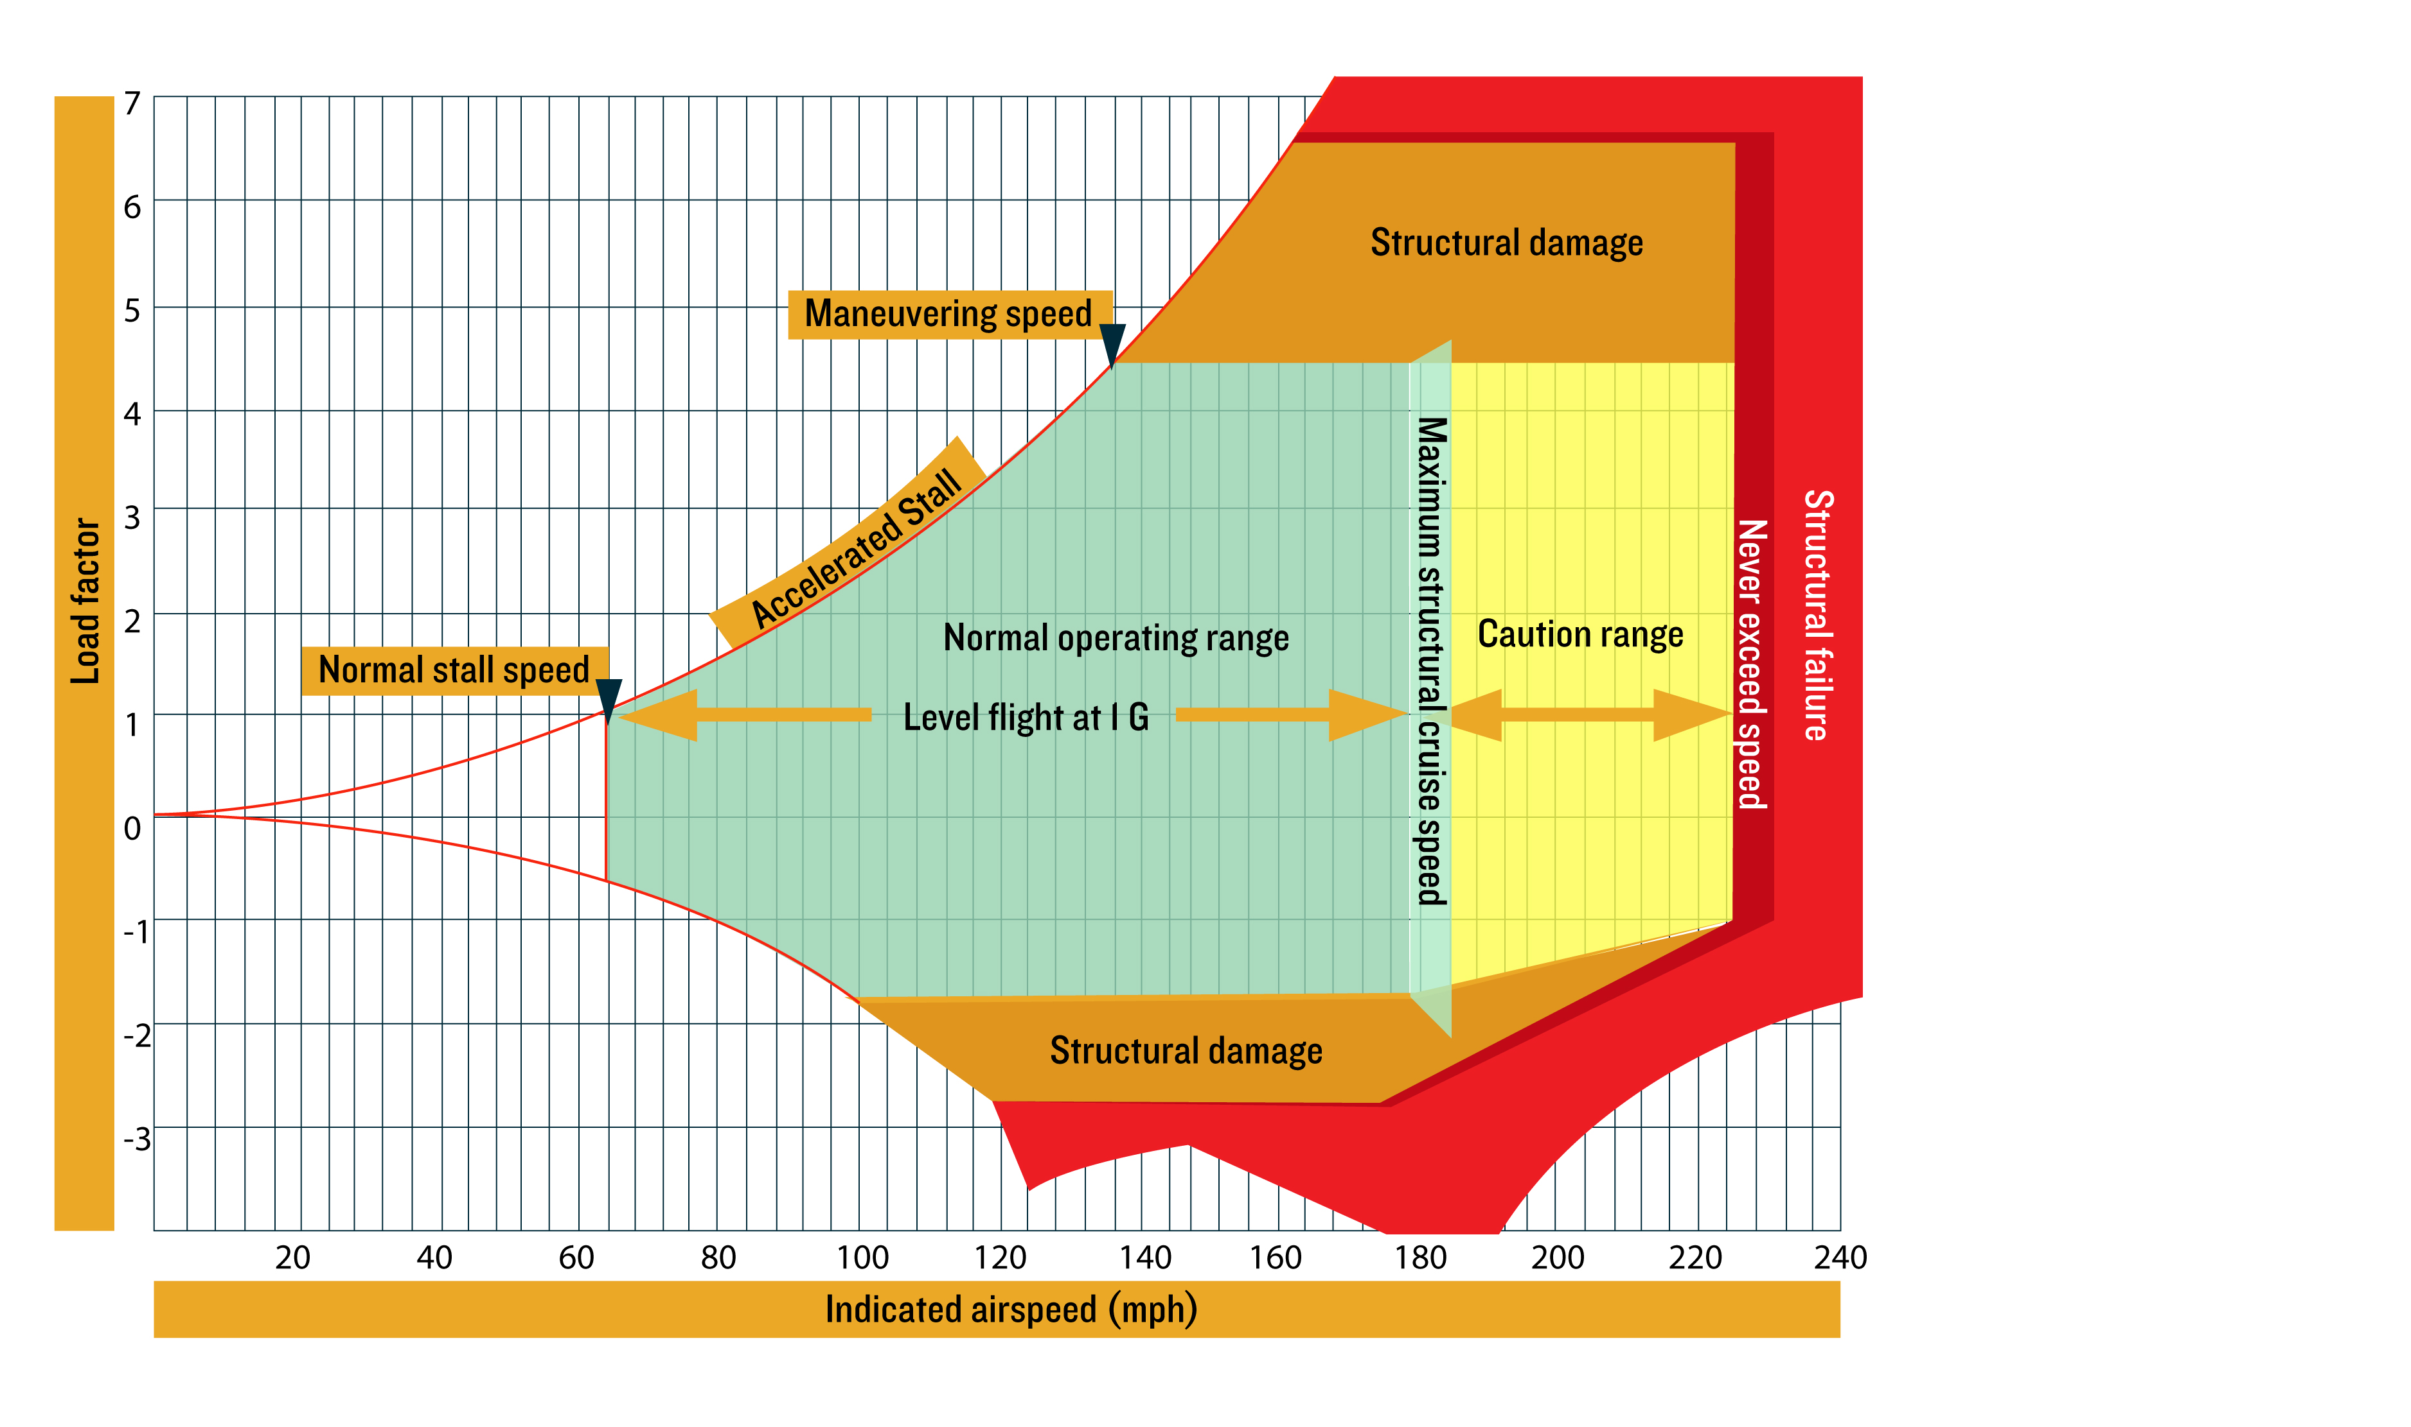

1. **Describe the location of the lateral axis of an airplane. Explain how the airplane maneuvers about its lateral axis and the flight control surface involved.**

1. **Describe how lift changes in a turn.**

1. **In several sentences, explain how a pilot should operate an aircraft to avoid overstressing its structure.**

1. **Describe what causes adverse yaw.**