Strategic Fundamentals and Environment Plan for Business Upstart

Jeffery Morse

Brandman University

Strategic Fundamentals and Environment Plan for Business Upstart

Concept

This is a strategic fundamental and environment plan for Dutch Brothers Plus (name may change in the future) upstart concept. Coffee houses traditionally have dips in sales during the hot months, in contrast, juice bars and smoothie houses have dips in sales in winter months (Invest, 2018). Here the concept is to merge the two into one functioning and profitable business successfully. Daley (2012) has this to say about this concept.

Co-branding (also known as piggyback franchising and dual or combination franchising) is, at face value, a brilliant idea: Take two franchise concepts, stick them in the same building and watch the revenue roll in. Not only does co-branding promise to save on operational costs like leasing, staff, kitchen equipment, building maintenance, and advertising, but it can also even out customer flow, especially if one concept appeals to the breakfast and lunch crowd and the other is destined for dinner. But franchise systems have touted co-branding's biggest advantage as providing a one-stop option for groups of people with different cravings. Tommy and Sally want chicken fingers, but Mom and Dad want pizza? Come on into our pizza parlor/chicken shack, and everyone will be happy. (para. 2) (Daley, 2012)

The community of Marysville formally known as Linda California suffers from financial oppression. The general mindset is one of poverty and lost hope. In fact, over 32% of the seventeen thousand people in this area are impoverished (FactFinder, 2018). On the other hand, it is not that people are not making money as the median household income of those that do work is 37k a year (FactFinder, 2018). Also, rejuvenation is the current aim of the city. Currently, the sidewalks, drainage, and new roads are all being installed. We believe that this proposed upstart is a step towards community transformation. First, it will bring people of vision out from the college. People on a track to success can shine a light in the darkness of financial oppression. Secondly, this will provide a needed gathering spot, that is quiet and professional for the student to meet and study. Thirdly, by being a hybrid and offering healthy juice-based drinks, the upstart will magnify health and a healthy lifestyle in the community. Lastly, the closest coffee shop is in the city of Marysville, quite a drive for a coffee beverage, and the closest juice bar, Jamba Juice, is two cities away.

**Role of Strategy**

The positioning of the new business will increase in value as time goes on. The strategy for increased value has been proven through Starbucks, Jamba Juice, and Burger King. Starbucks has made clear the importance it awards the planet in creating its environmental mission statement: “Starbucks is committed to a role of environmental leadership in all facets of our business,” (Starbucks, 2018.). Some may feel that a coffee house cannot be environmentally conscious. However, it is our feeling that environmental impact begins with a firm’s goals. Jamba juice includes this statement in both its vision and mission statements, “To inspire and simplify healthy living.” We believe that health is a great motivator for success. Oppression minister’s sickness, addiction, hopelessness, and much other unwelcomed community and environmental problems—people just stop caring about their community and their future and get lost in despair. Promoting health and education are in direct opposition to hopelessness. We also plan to adopt Burger King's strategy for success in location by stealing the slogan, “through the light and to the right.” By choosing a four-way stoplight, any hindrances in stopping for a drink will be addressed.

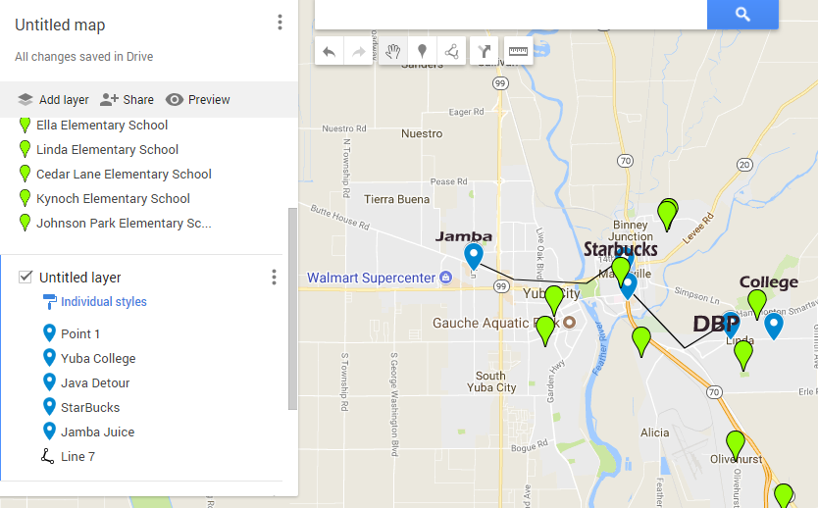

**Techniques**

Techniques used to formulate positioning are within the steps that will be necessary to develop this new business strategy.

1. Environmental Scan.
2. Do all analysis for business.
3. Clarify target customers, value proposition, and culture and strategic cultural advantage
4. Select staff is choosing the correct skills and capabilities., choose teamwork goals, leadership style, and work climate.
5. Solidify and select the competitive advantage style, vision, and mission statements.
6. Formulate and establish performance measures, scorecard, and benchmarks.
7. Set goals and milestones.
8. Improve from within by promoting education through tuition reimbursement.
9. For cost analysis please refer to appendix’s A and B.

**Strategic-Planning Process**

How we determine the organization’s mission and goals mirrors the same strategy we used to come up with the concept. The Hybrid method takes what we like and leaves the rest. Here are some of the current mission statements for the coffee/juice businesses.

Mission Statement Dutch Brothers

Love Abounds, and Dutch Bros are both about people first. Dutch Bros has established Love Abounds to engage its communities through giving and an action actively. Love Abounds supports programs and projects that build deeper connections through engagement in Four Core Areas. Youth Music Health Origins (Dutch, 2018).

Mission Statement Jamba Juice

OUR MISSION: To become the world's leading blender of fruit and other naturally healthy ingredients. Part of what makes Jamba Juice so successful is the passion both our customers and employees share for the product. ... OUR TIMELESS PURPOSE: To inspire and simplify healthy living (Brown, 2013).

Mission Statement Starbucks

To inspire and nurture the human spirit – one person, one cup and one neighborhood at a time (Balance, 2018).

Mission Statement DBP

To become our community’s leader in promoting health by presenting a quality product. Juices and smoothies that are naturally healthy, coffees that encourage, uplift and inspire the hearts of people, person by person, cup by cup, while supporting our community through giving, health, music, and friendliness.

**Industry Analysis**

Jamba Juice is reporting about 75 million in revenue with 22% of that being the EBIT or about 15 million (Jamba. 2018). Dutch Brothers coffee is running head to head with that (Dutch, 2018). The overall state of both industries is good. Juice bars are showing a 2-billion-dollar revenue with a margin of annual growth at about 2.3% (IBISWorld2, 2018). The coffee industry continues to boom with 37 billion a year and annual growth of 3.6% (IBISWorld, 2018). The upcoming generation is green, health conscience, and they are innovators. A generation of health conscience people creates a promising forecast for both the coffee industry and the juice bar industry. By creating a hybrid shop that sells both healthy juice and coffee the firm can expect a growth percentage shown by the mean of the two businesses--about 3%. Suppliers for coffee are everywhere. This firm will both roast its beans – mostly for the aromatic reasons and purchase pre-roasted beans from suppliers. In juicing, locally grown organic fruits and veggies will be the preference, then non-locally grown organic. Only in emergencies will non-organic fruits and veggies be used. We expect about 30%--50% of the clientele to come from the college. However, the road to which the firm is located is also a major inlet to the local air force base. As a result, we expect that service personnel will be a major portion of those who visit the establishment drive-thru.

Last but not least, are people going to work, or dropping kids off at one of the schools nearby. Currently, the only competitor is in the campus cafeteria. This is not accessible to neither the service personnel nor those going to work. The only other competition is downtown Marysville for coffee and two cities away from Juice [Map, Page 2].

**SWOT Analysis**

Before doing a SWOT on the business, I thought it prudent to perform one on myself.

Strengths

Educated in business. Very capable in mechanics, engineering, construction, electronics, appliances, heating and air, and music. All this knowledge will bring down startup costs by thousands of dollars. I have some equipment, and vehicles ready to go. I have some great connections in the construction trades. I know of several trustworthy people that would make great employees. I am currently employed.

Weaknesses

I only have about a total of six thousand in capital available on hand, of which only about $1500 is liquid. The location may have to be built from the ground up--this would be expensive.

Threats

At any moment a firm already in the industry may see this opportunity and beat me to it. If two coffee shops exist in this location sales may suffer, especially since a firm like Starbucks has the capital to build fast.

If the business goes in where the city has not yet put in sidewalks, the city may try to make me foot the bill for the installation of sidewalk and drainage in that location; this would drive entrance costs up to high to achieve.

Opportunities.

This is a great opportunity for me to begin my financial upswing. This vehicle is in the perfect location with a great idea for success. When successful this business would supply needed revenue for other ventures that lay ahead.

Now let us look at the businesses themselves.

Two more tools for internal analysis are the value chain and VRIO tools. The value chain dissects the organization and then identifies areas of unique strength or weakness, however, we will only be looking at VRIO.

**SWOT**

This is a comparable SWOT, inside is Jamba Juice and outside is Dutch Brothers. An expanded form of this is available in Appendix (C).

Weaknesses

Strengthss

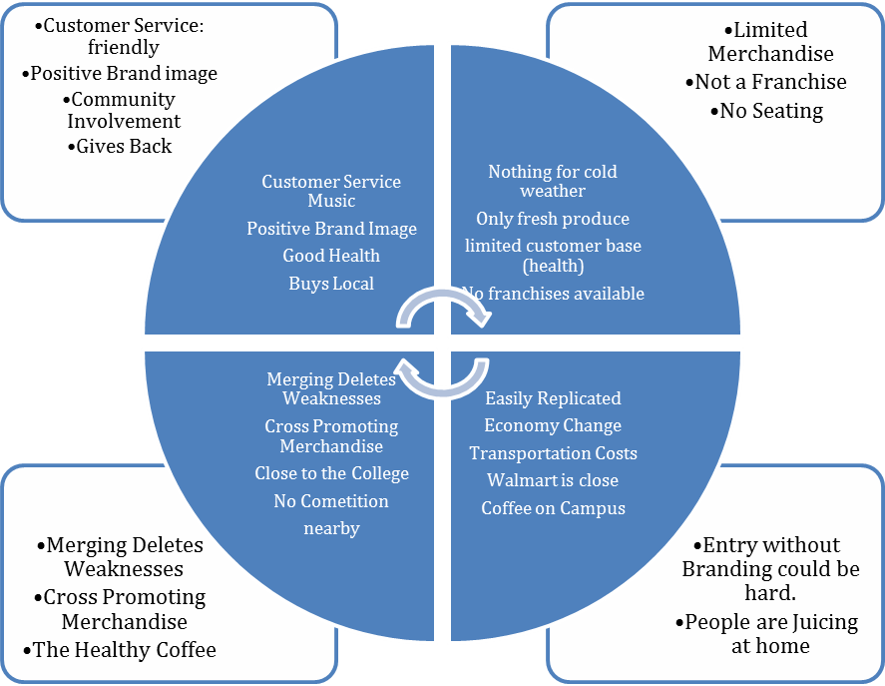

Opportunities

Threats

VRIO

Value chain functions are also called capabilities. VRIO—which stands for Value, Rarity, Imitability, and Organization—is a framework that advocates that a capability, or a resource, such as a branding or a great location, is likely to yield a competitive advantage. An organization has shown to be valuable, rare, difficult to imitate and supported by the organization create a competitive advantage. When looking at Dutch Brothers Plus (DBP), there is definite value seen through VRIO analysis.

Value:

First, people love their coffee, and they also love a place to relax. This behavior adds value. In addition, Dutch Brothers Coffees add value by offering beverages at a discount when compared to Starbucks, or Java Detour. Also, streaming music is a cornerstone of Dutch Brothers Coffees that DBP will continue adding even greater value. Music partnerships with companies such as iTunes have proven to create value for firms such as Starbucks. Jamba Juice creates value by cornering the market on the health front. Healthy, organic juice is a great supplement for coffee and a great alternative to soda pop. DBP plans on continuing creating value through this great service that supports both quality and friendliness.

Rarity:

DBP is very rare in that it is a hybrid coffee house and a juice bar. Also, it is rare because there are no other juice bars within the city, to add to this, the closest coffee house is in downtown Marysville.

Imitability:

This business is easily duplicated. While this may be a negative if another entrepreneur knows where to start one in competition, it is also positive for DBP in producing carbon copies in other locations as the firm grows. On the other hand, this business supply chain and Supply Management system will be costly to reproduce. There are only so many fresh organic fruits and vegetables grown locally, and since DBP is the first of its kind, it will have a strategic advantage through new product development. The first one gets all the contracts with the organic suppliers. Further, using Porter's Generic Competitive Strategies there is a competitive advantage from having a focus as well as having differentiation (Porter, 1980).

Organization:

DBP must organize its management systems, policies, organizational structure, processes, and culture to fully realize the potential of its valuable, rare and costly to imitate resources and capabilities. This will come through Total Quality Management, eventual Blue Ocean, and flexible product line.

PESTEL

Two primary tools examine the external environment for firms 1. PESTEL and 2. Industry Analysis. PESTEL is an acronym that stands for Political, Economic, Sociocultural, Technological, Environmental, and Legal Environments.

Political:

Currently the city is undergoing a facelift, and much effort is being put into updating the area, for this reason, its felt that favor from the city council will be given to any business that represents an uplift in the socioeconomic status of the current inhabitants of the community. Since DBP is focused on catering to those who currently have an academic vision for the future and has community involvement plans, we forecast political support. Also, the U.S. is currently experiencing some reprieve from the last recession as business is not only up in California but the U.S. In general, we forecast this will be the case for the next couple of years at least.

Economical:

Economically though the location has been economically repressed in the past, there is economic growth projected as sidewalks and drainage are being installed from the highway to the college. This will encourage more foot traffic as well as cyclists. Correspondingly, both companies that DBP is patterned after are doing well financially in both California, The U.S., including the locations currently doing business closest to our proposed location.

Social-cultural:

This is an area of targeted change. Though the current Social-cultural feel of the area is one of oppression in the area surrounding Yuba College it is our desire to change this by bringing a new thriving business that promotes health, by attracting patrons who have a vision for the future, by having a culture that focuses on success, music, honest, quality, and fellowship into the community. While we know that DBP will be unable to accomplish this community transformation on its own, DBP will help to pioneer efforts by continuing the Dutch Brothers commitment of annually giving back a percentage of its profits to improve the community in which it does business.

Technological:

DBP will use up to date supply systems to ensure Just-In-Time deliveries of produce ensuring the freshest organic supplies for juicing and coffees possible. Further, the music traditions of Dutch Brothers combined with patterns borrowed from Starbucks will help to keep DBP on the cutting edge of music. Offering Wi-Fi and high-speed internet access as well as computers on timed rentals will also keep DBP a valued location for study or out of office work. Lastly, DBP commitment to innovation will ensure that DBP is always on top of the technologies advancement.

Environmental:

The family feel and laid-back smooth work environment will be a cornerstone at DBP locations. Also, for those on the go, a drive-thru that focuses on satisfied repeat business will be offered.

Whereas PESTEL provides one with a good sense of the broader macro-environment, industry analysis informs one about the organization’s competitive environment and the key industry-level factors that seem to influence performance. In industry analysis of Starbucks, Dutch Brothers, Jamba Juice, and Planet Smoothie franchises show growth and sustainability over the board.

**Justifications**

We will justify our organization’s mission, and goals through the improvement the local of the community. Along with our mission we have our vision and our goals. Again, we take what we need and leave the rest. Organizational performance refers to how well DBP is doing in reaching its vision, mission, and goals it has adopted. For this reason, all goals will have a time factor.

**Core Values**

DBP is a people first firm. Honesty, Loyalty, Innovation, and Dedication are its chief values. Being a light in a dark community is its calling. Making sure its family of employees is paid fairly, have medical, dental, and a balanced home and work life are doctrines under which teach DBP will function.

DBP Vision

To inspire healthy living through providing a place where human connection and great health come together in song.

Our Goals

1. To have a positive impact on the community in 6 months through a marked increase in the socioeconomic status increase in the local community and through general community improvement efforts-at least two.
2. To break even in 12 months.
3. To have the second location opened or on its way to being opened within 24 months.

Two considerations we need to think of are (1) performance measures, and (2) performance referents. Performance measures are metrics along which DBP can be gauged. A performance referent is a benchmark used to make sense of DBP standing. The benchmarks in production, satisfaction, and quality we will use are supplied by Starbucks, Java Detour, Jamba Juice, and Planet Smoothie. DBP is not into remaking the wheel if one of these firms has found an innovation that works we will integrate the item and then evaluate its performance and quality by measuring the outcome against our mission, vision, and goals.

**Strengths Weaknesses and Strategies**

Most of the strengths have already been mentioned. However, we feel the biggest strength is our desire to improve each community we are placed in. In addition to this, the merging of Coffee and Juice next to an academic institution offers longevity and sustainability.

Porter’s Key Strategies and Ghemawat’s “AAA” Global strategies

• Focused differentiation.

While it is true that DBP will be selling coffees at prices near to Dutch Brothers, which is discounted compared to Starbucks and Java Detour, DBP will have to increase prices slightly to keep prices competitive on the Juice bar. Organic, fresh produce is at a premium even hear in the richest farm valley in the U.S. As a result, we will be focusing on Coffee and Juice Beverages, with only a small menu of food items. Using Porter's Generic Competitive Strategies this creates a competitive advantage from having a focus as well as having differentiation of being the only store of its kind around. (Porter, 1980)

Here is a breakdown of the “AAA” strategy given by Ghemawat (2011).

• Adaption.

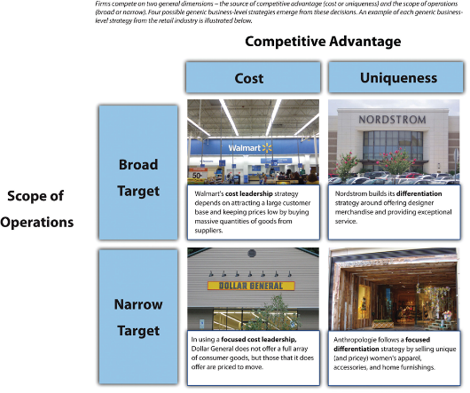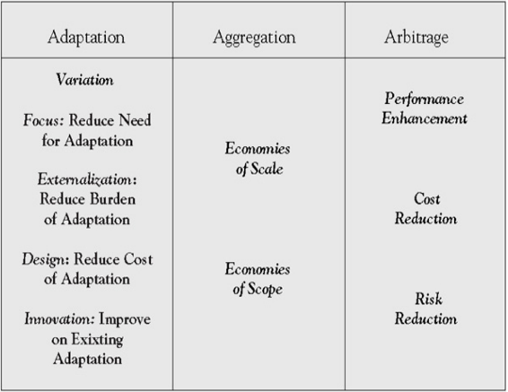

Being headed for franchise DBP will be employing mostly Adaption, as we seek to improve each community in which each DBP is placed.

• Aggregation.

This will have a place. Things such as the feel of the store, the greeting style, and the goal of improving communities will be carried into each store.

• Arbitrage.

Since the Juice end will depend on mostly local veggies and fruits, we may be able to leverage some prices when we find an overabundance of lower cost quality fruits and veggies in a location, if so, it may be possible to import/export those items that are not indigenous in a market for a profit.

DBP strategic plan will be implemented from the top down. While the firm cannot exist without profit, it is our strategy that communities grow in success as we do. We start with the mission and vision to effect change in the community that each store is located in by fostering a spirit of hope and success.

Tactical Plan

Our tactical plan is similar but involves our local suppliers. We will seek long-term partnerships with organic farmers who have a like mission and goal. Further, while we will be looking to save some money during purchasing, we also want to make sure that our local suppliers grow with us. As we grow in numbers of franchised stores, we hope to employ economies in scale for such things as cups and lids from suppliers outside our community. Lastly, DBP is green, and mostly in a red ocean, however, we hope that being the first of its kind we can move into a blue ocean due to our quality service and health conscious mindset.

Operational:

Our operational strategy is to make sure that all greeters make every experience make the customer feel like they are one of the most important people to visit, make every order a priority, and make everyone one family. Local produce will be preferred typically over shipped produce, with those supply partners managing and delivering just on time fruits, produce, and green supplies.

Contingency:

If local produce is not available orders will be fielded from the southern valley. In the event of competition moving in capitalization with media advertising and marketing will be enacted.

Crisis Planning:

In the event of a financial disaster, efforts to sell the establishment to rivals will be fielded.

**Financial Considerations**

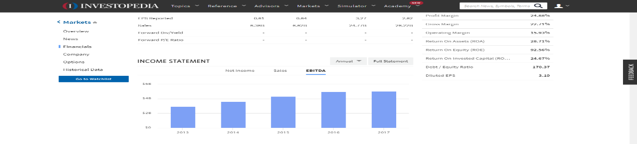Currently, Starbucks is reporting quiet and increase in profits.

However, Jamba Juice is showing decreasing sales.

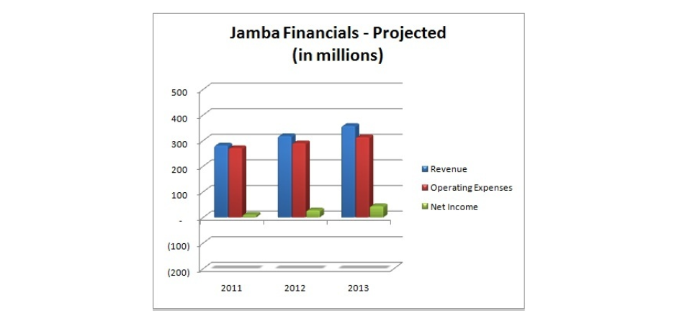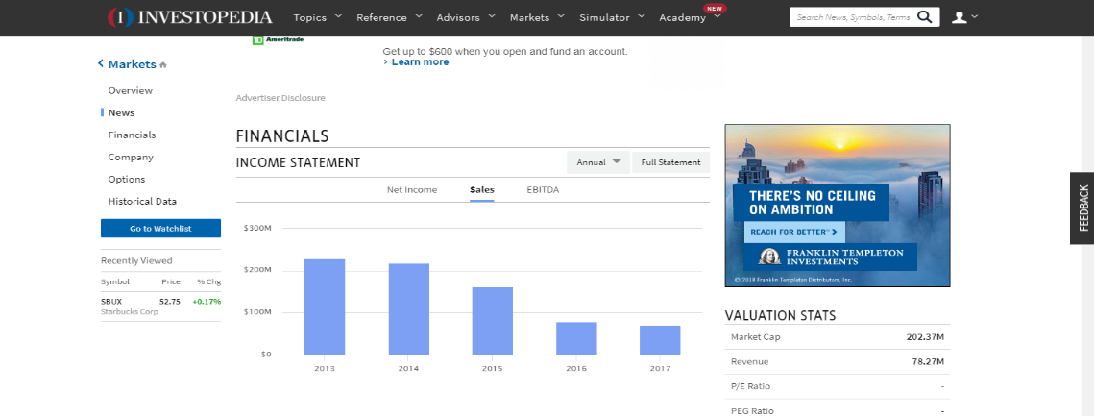

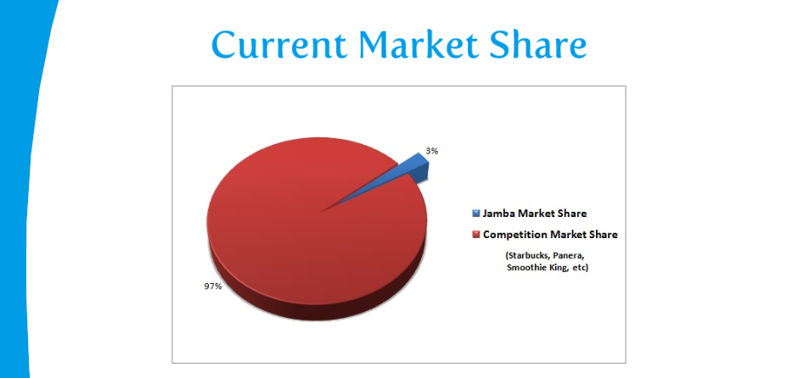This is due to 1. Lack of advertising and 2. Jamba Juices alliance with the now failed Golds Gym. We feel successful market penetration will drive Jamba’s former customer base to DBP as our advertising blankets the market. Further, alliances with up and coming gyms such as IN-Shape, and Planet Fitness will increase popularity--this may eventually result in DBP’s acquisition of Jamba Juice. One other financial consideration is the procurement of small business grants for startup. By using grants instead of loans, DBP will relieve financial stress during times of startup.

Organizational Structure:

DBP will reposition organizational structures to help promote creativity and innovation that will result in greater organizational effectiveness and efficiency. Since the merging of these two ideas is relatively new, finding procedures in common in the making of Coffee, Juice, and Smoothies is a must; once these commonalities are found aggregate procedures will be instituted to ensure quality and speed. Innovations in supply management are of great value also as without fresh produce profits fall. Finally, innovation is products will always be on the menu. New combinations of coffee beans, roast styles, and mixtures of healthy juices will be searched out for the delight of our customers.

Impact on Leadership Structures

Beginning leadership structures are simple as a top-down sole proprietorship, however, as the firm grows, and franchising begins leadership structure will begin to stretch to C structure management. Finally, when DBP incorporates and begins to be active on the stock market, a board of directors will take over in place of the CEO/Owner management style. At no time is more than 48% of the shares to be available on the market.

Franchise owners will be selected from individuals of whom were or are employed by DBP and are in good standing. For those who show outstanding accomplishments in community support and innovation opportunities for franchises will be made available at discounted rates. The use of Balance Score Cards will be the strategy used to keep a record of such accomplishments. A balanced scorecard is an approach to assessing performance that targets managers’ attention in four areas: (1) financial, (2) customer, (3) internal business process, and (4) learning and growth (Kaplan, 1992).

All franchises must adopt and actively adhere to the Mission, Vision, and Goals of DBP as stated or revised by the founding parties.

**Conclusion**

The triple bottom line emphasizes the three Ps of people, the planet, and profits (Ketchen, 2011). DBP represents each area uniquely and has the opportunity and potential to become a billion-dollar franchise easily. The idea of having hot coffees in cold weather and cold juices in warm weather ensures there will be no slump in seasonal sales. The location, “after the light and to the right,” being near several schools and the only local college and having the only competition miles away almost ensures success. The chosen mission, vision, and goals of this enterprise will make this firm a community favorite while providing the entrepreneur an eventual possible cash flow potential above and beyond the benchmark firms.

References

Balance, The (2018) Starbucks Mission Statement https://www.thebalancesmb.com/starbucks-mission-statement-2891826

Brown, T. (2013) Jamba External and Internal Environmental Analysis Paperhttp://customwritingtips.com/component/k2/item/14538-jamba-external-and-internal-environmental-analysis-paper.html?tmpl=component&print=1

Daley, J. (2012) New Franchises Team Up and Make Co-branding Work, Url https://www.nasdaq.com/article/new-franchises-team-up-and-make-cobranding-work-cm129748

Dutch Brothers (2017) America's Best Small Companies., Url https://www.forbes.com/companies/dutch-bros-coffee/

Essays, UK. (November 2013). Industry and marketing analysis of Starbucks Coffee. Retrieved from https://www.ukessays.com/essays/marketing/industry-and-marketing-analysis-of-starbucks-coffee-marketing-essay.php?vref=1

FactFinder, (2018) Url https://factfinder.census.gov/faces/nav/jsf/pages/community_facts.xhtml

Ghemawat, P. (2007). Redefining global strategy: Crossing borders in a world where differences still matter. Boston, MA: Harvard Business Review Press.

IBISWorld, (2018) The Retail Market for Coffee - US Market Research Report https://www.ibisworld.com/industry-trends/specialized-market-research-reports/retail-market-reports/the-retail-market-for-coffee.html

IBISWorld2, (2018) Juice & Smoothie Bars - US Market Research Reporthttps://www.ibisworld.com/industry-trends/specialized-market-research-reports/consumer-goods-services/food-service-drinking-places/juice-smoothie-bars.html

Invest, (2018) Url https://www.investopedia.com/markets/stocks/sbux/#Financials

Jamba Inc. (2018) Annual Report http://ir.jambajuice.com/phoenix.zhtml?c=192409&p=irol-newsArticle&id=2338420

Kaplan, R. S., & Norton, D. (1992, February). The balanced scorecard: Measures that drive performance. Harvard Business Review, 70–79.

Ketchen, D. & Short, J. (2011). Mastering Strategic Management. Washington, DC: Flat World Knowledge, Inc.

Planet Smoothie (2018) WHAT ARE MY STARTUP COSTS? <https://planetsmoothiefranchise.com/learn-planet-smoothie/startup-costs/>

Owler (2018) Owler.com Url https://www.owler.com/company/dutchbros

Porter, M. E. (1980). Competitive strategy: Techniques for analyzing industries and competitors. New York, NY: Free Press.

Rudnick, D. (2018) DUTCH BROS. RESEARCH TEAM CASE ANALYSIS

The Dynamics of the Company http://d0376.weebly.com/uploads/2/9/7/3/29730551/dutch_bros__case_analysis_report_final.pdf

**Appendix A DutchBro**

Franchise fee 30000

Lot 60000

Land improvements 15000

Land Scaping 5000

Building 100000

2 Blenders 2288

Expresso Machine 6250

Walkin Ref 10000

Walking Freezer 10000

Ice Machine 1779

Sound System 2000

Coffee Grinders 1878

Supplies

Cleaning Supplies 1000

Maintenance Supplies 1000

Inventory

Cups 400

Lids 200

Straws 200

Milk 2000

Syrups 1000

Smoothy Mix 1000

Rebel 300

Coffee Beans 1200

Juice 100

Sauces 1000

Chia 400

Soy 600

Coconut Milk 600

Tea 500

Sugar 800

Water 100

Soda Water 50

**Appendix B Planet Smoothie**

|  |  |  |  |  |
| --- | --- | --- | --- | --- |
| Initial Franchise Fee | $16,000 to $20,000 (Note 1) | Lump sum | Upon signing Franchise Agreement | Us |
| Lease Review Fee | $0 to 1,250 | Lump sum | Upon signing of Franchise Agreement | Us |
| Rent/Security Deposit (for three months) (Note 2) | $6,000 to $30,000 | As Incurred | Prior to Opening | Landlord(s) |
| Travel and Living Expenses (3 persons) while training, not including salaries, if any, for you and your employees | $3,750 to $7,500 | As Incurred | During Training | Airlines, Hotels, Restaurants, etc. |
| Real Estate | (Note 2) | (Note 2) | (Note 2) | (Note 2) |
| Architectural Fees (Note 3) | $5000 to $10,000 | As Incurred | Prior to Opening | Licensed and Approved Architect and Project Management Firm |
| Leasehold Improvements | $5,000 to $100,000 (Note 4) | As Incurred | Prior to Opening | Approved Contractors and Vendors (Notes 3 and 4) |
| Restaurant Equipment, Furniture, Small Wares, Interior Signage and Menu Panels (Note 5) | $12,000 to $30,000 | Lump sum | Prior to Opening | Approved Vendors and Suppliers |
| Exterior Signage | $9,000 to $12,000 | As Incurred | Prior to Opening | Approved Sign Company |
| Computer Hardware, Software (POS System) | $1,000 - $5,000 | Lump Sum | Prior to Opening | Approved Suppliers |
| PCI Compliance Costs | $150 to $1,300 | As billed by third party vendor | As billed by third party vendor | Approved Vendor |
| Opening Inventory (food and paper) (Note 6) | $2,500 to $5,000 | As Incurred | Prior to Opening | Approved Suppliers |
| Business Insurance (Note 7) | $1,000 to $5,000 | Lump Sum | Prior to Opening | Insurance Company/Agent |
| Miscellaneous Opening Costs (Note 8) | $4,750 to $17,200 | As Incurred | As incurred | Approved Suppliers, Utilities, etc. |
| Grand Opening | $2,000 to $6,000 | Lump Sum | Prior to Opening | Suppliers (Note 9) |
| Depository Account (Note 10) | $3,000 | Lump sum; Must be replenished on a regular basis | At signing of Franchise Agreement | Your bank (we have the right to withdraw from this account) |
| Additional Funds - 3-month initial period | $5,000 to $15,000 | As Incurred | As incurred | Us, Employees, Various Third Parties |

Global Smoothie Business Report.

https://globenewswire.com/news-release/2016/09/26/874430/0/en/Global-Smoothies-Strategic-Business-Report-2016-2022-Innovative-Healthy-and-Fortified-Smoothies-Flood-the-Market.html

**Appendix C—SWOT**

**SWOT**

Dutch Brothers Jamba Juice

Strengths:

Customer Service: Very friendly and affordable. Customer Service and Music

Positive Brand image Positive Brand Image

known for Community Involvement Known for good health

Gives back 1% to the community Buys local produce

Market entry costs are low Market entry costs are low

Weaknesses

Limited Merchandise No hot drinks for cold weather

Is not a Franchise only fresh produce

Drinks are limited limited customer base (health)

No Seating. No franchises available

Opportunities:

There is a great opportunity in the merging of these two industries. Weaknesses such as limited drinks and no drinks for cold weather are eliminated. Seating problems are also fixed along with limited customer base. The franchise issue is meet by not adopting the Jamba Juice franchise but instead just adding a clone under the current Dutch Brothers brand with the plus. This further allows the firm to adopt much of the Starbucks relaxed feel for those who wish to study, or commune. Another opportunity is cross-promoting merchandise. The Healthy Coffeehouse can promote health and serve caffeinated drinks (which is not considered healthy), both cold and hot beverages with a unique listing of menu items to eat. The last opportunity comes from the fact that there is neither a local coffee house or juice bar other than on the college campus. The cafeteria on the campus is always rumbling, busy, and loud. This startup will offer an alternative that is close enough to the college to be a desired quiet destination. Finally, promoting health will mean that DBP will actively partner with Gyms. By offering promotional items such as reward cards with free drinks after a number of visits. We will continue to promote health down the line after the DBP franchise chain is established as we would like to acquire a chain of gyms to stand along our commitment to health.

Threats:

* While the firm is unique, it is easily reproduced, and entry costs are low.
* A change in the economy might cause people to stop spending on unnecessary drinks.
* Market entry without an existing branding would be difficult.
* Transportation cost for fresh fruit would vary with fuel costs.
* There is an upswing in home juicing, and home espresso that are cheaper alternatives.
* Major supermarkets supply bottled juices and cold coffees, and both Food Max, and Walmart are nearby.
* The Campus has a Starbucks vendor in the cafeteria.