**Competitive Advantage Class Notes**

**Objective 1: Creating Low-Cost Competitive Advantage Through Value-Chain Management**

Value Analysis --- Video Water Project

Value Analysis Basics

**Value Analysis/Value Engineering Processes**

The ISM Glossary (2009) defines value analysis as a systematic and objective evaluation of the value of a good or service, focusing on an analysis of function relative to the cost of manufacturing or providing the item or service.

The terms “value analysis” and “value engineering” are used interchangeably in some environments

Value analysis relates to a management process that focuses on existing products and systems. It coordinates all functions in an operation with a view toward reducing the overall cost of the production and sale of the product. Value engineering is value analysis conducted at the design engineering stage of the product development process (ISM Glossary, 2009). It is a system by which one analyzes the functional requirements of a new product — the equipment, facilities, and procedures used in production, as well as the materials that comprise it. The goal is to achieve the lowest cost without loss of performance, quality, or reliability.

Value analysis involves the careful evaluation of a product, part, or service in all aspects of design and function. Every part or process is critically examined with a view toward finding a better alternative. Value analysis aims to eliminate, simplify, or combine parts, processes, or services to achieve more efficient and effective use of resources. Progressive supply management professionals do not buy parts, they buy functions. Value analysis leads to the redesign of parts and processes to achieve required functions for less cost. Value engineering involves designing new products with a value orientation.

Topic 2: Competitive and Cooperative Moves

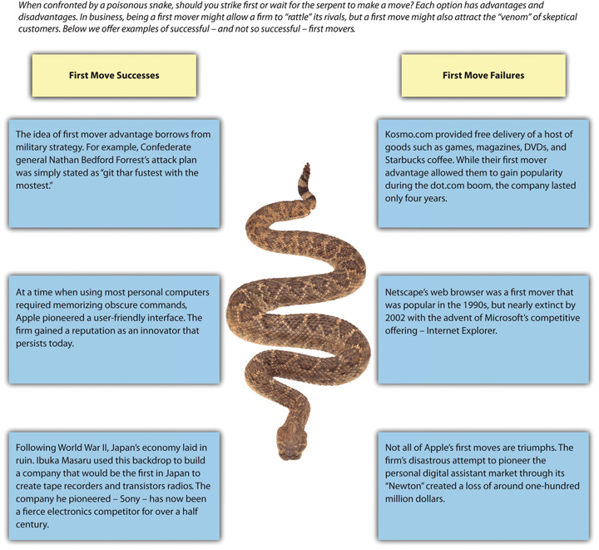

A first-mover advantage exists when making the initial move into a market allows a firm to establish a dominant position that other firms struggle to overcome. On the other hand, a first mover cannot be sure that customers will embrace its offering, making a first move inherently risky.

One caution is that first movers must be willing to commit sufficient resources to follow through on their pioneering efforts.

One research study of 1,226 businesses over a 55-year period found that first movers typically enjoy an advantage over rivals for about a decade, but other studies have suggested that first moving offers little or no advantages. (Couse quote)

**Disruptive Innovation**

Some firms have the opportunity to shake up their industry by introducing a disruptive innovation—an innovation that conflicts with, and threatens to replace, traditional approaches to competing within an industry.

First, owning a foothold can dissuade other armies from attacking in the region. Second, owning a foothold gives an army a quick strike capability in a territory if the army needs to expand its reach. Similarly, some organizations find it valuable to establish footholds in certain markets. Within the context of business, a foothold is a small position that a firm intentionally establishes within a market in which it does not yet compete (Upson, Ketchen, Connelly & Ranft, 2012)

blue ocean strategy is creating a new, untapped market rather than competing with rivals in an existing market (Chan Kim & Mauborgne, 2004). This strategy follows the approach recommended by the ancient master of strategy, Sun Tzu

Bricolage is a concept that is borrowed from the arts and that, like blue ocean strategy, stresses moves that create new markets. Bricolage means using whatever materials and resources happen to be available as the inputs into a creative process. A good example is offered by one of the greatest inventions in the history of civilization: the printing press. As noted in the Wall Street Journal, “The printing press is a classic combinatorial innovation. Actor Johnny Depp uses bricolage when creating a character. Captain Jack Sparrow, for example, combines aspects of Rolling Stones guitarist Keith Richards and cartoon skunk Pepé Le Pew.

What ideas can you combine for your new business plan?

Strategy at the Movies.. Love and Other Drugs was based on the nonfiction book Hard Sell: The Evolution of a Viagra Salesman (Reidy, 2005). Get the doc to proscribe Zoloft, others will follow suit.

**Note. Adapted from “Making Competitive Moves,” by D. Ketchen & J. Short, 2011, Mastering Strategic Management, Chapter 6, Section 1. Copyright 2011 Flat World Knowledge, Inc.**

**Responding to Competitors' Moves**

Competitive Advantage comes in many different forms and sometimes a defensive posture is needed.

Research indicates that three factors determine the likelihood that a firm will respond to a competitive move: awareness, motivation, and capability. These three factors together determine the level of competitive tension that exists between rivals.

Although examining a firm’s awareness, motivation, and capability is important, the results of a series of moves and countermoves are often difficult to predict and miscalculations can be costly. While the threat of Wal-mart growth was apparent to some observers, Kmart executives failed to respond. Competition with Wal-mart later drove Kmart into bankruptcy.

**Speed Kills**

If a firm is going to respond to a competitor’s move, doing so quickly is important. If there is a long delay between an attack and a response, this generally provides the attacker with an edge.

**So…We Meet Again**

Multipoint competition adds complexity to decisions about whether to respond to a rival’s moves. With multipoint competition, a firm faces the same rival in more than one market.

**Responding to a Disruptive Innovation**

First, executives may believe that the innovation will not replace established offerings entirely and thus may choose to focus on their traditional modes of business while ignoring the disruption.

Second, a firm can counter the challenge by attacking along a different dimension.

third possible response is to simply match the competitor’s move. How can you save money in your business by getting to disruptive innovation first?

**Fighting Brands: Get Ready to Rumble**

firm’s success can be undermined when a competitor tries to lure away its customers by charging lower prices for its goods or services. One possible response would be for the firm to lower its prices to prevent customers from abandoning it. This can be effective in the short term, but it creates a long-term problem. The creation of a fighting brand is a move that can prevent this problem. A fighting brand is a lower-end brand that a firm introduces to try to protect the firm’s market share without damaging the firm’s existing brands.

**Note. Adapted from “Responding to Competitors’ Moves,” by D. Ketchen & J. Short, 2011, Mastering Strategic Management, Chapter 6, Section 2. Copyright 2011 Flat World Knowledge, Inc.**

**Rival Effect and AMC –Video**

**Countering Competitors' Moves** site -- <http://news.thomasnet.com/IMT/2009/02/18/fight-or-flight-countering-competitors-moves-responding-to-competition/>

**Making Cooperative Moves**

Why might cooperative moves be preferable to competitive moves? So what if you are better at offense than defense? In addition to competitive moves, firms can benefit from cooperating with one another

Cooperative moves such as forming joint ventures and strategic alliances may allow firms to enjoy successes that might not otherwise be reached This is because cooperation enables firms to share (rather than duplicate) resources and to learn from one another’s strengths. (Ketchen et al., 2004).

A joint venture is a cooperative arrangement that involves two or more organizations

Strategic Alliances… A strategic alliance is a cooperative arrangement between two or more organizations that does not involve the creation of a new entity. (Global Industry Analysts, Inc., 2011).

Colocation occurs when goods and services offered under different brands are located close to one another.

Note. Adapted from “Making Cooperative Moves,” by D. Ketchen & J. Short, 2011, Mastering Strategic Management, Chapter 6, Section 3. Copyright 2011 Flat World Knowledge, Inc.

**Co-Ops Competing and Creating Change**-- <http://www.mainebiz.biz/article/20140310/CURRENTEDITION/303069996>

**Competitive and Cooperative Moves**—video

**Topic 3: PESTEL Analysis--** **Supply-Chain Agility and Resiliency**

**Evaluating the General Market--** **PESTEL stands for political, economic, social, technological, environmental, and legal.**

The Elements of the General Environment: PESTEL Analysis must be scrutinized over.

**PESTEL Environmental Analysis – video**

**Topic 4: Supply-Chain Agility and Resiliency for Competitive Advantage**

Agility—the ability to respond quickly and cost-effectively to unexpected change.

Agility and resiliency — being able to recover or bounce back from a negative effect to the business — have become more critical in recent years because sudden shocks to supply chains have become more frequent. Agility and resiliency help supply chains recover more quickly from such sudden setbacks.

Supply-chain agility and resiliency no longer implies merely the ability to manage risk. It now assumes that the ability to manage risk means being better positioned than competitors to deal with — and even gain advantage from — disruptions. Key to increasing agility and resiliency is building flexibility into the supply-chain structure, processes, and management (Sheffi, 2005).

**Note. Adapted from “Supply-Chain Agility and Resiliency,” by C. de Kluyver, 2012, Fundamentals of Global Strategy, Chapter 9, Section 3. Copyright 2012 Flat World Knowledge, Inc.**

Sustainability in the Supply Chain –Video

**Objective 2: Creating Competitive Advantage Through People and Quality Management**

**Topic 1: Outsourcing**

Is Outsourcing Right for You?

To Outsource or Not to Outsource. Which activities should be kept in house and which ones can effectively be outsourced depends on a host of factors, most prominently the nature of the company’s core strategy and dominant value discipline (Businessweek, 2006).

In principle, every functional or value-adding activity, from research to manufacturing to customer service, is a candidate for outsourcing—the performance of a functional or value-adding activity by an outside firm. It is hard to imagine, however, that operationally excellent companies would consider outsourcing activities that are critical to the efficacy of their supply chain. Similarly, companies operating with a customer-intimate business model should be reluctant to outsource customer-service-related functions, while product leaders should nurture their capacity to innovate. Firms tend to concentrate their investments in global value chain activities, which contribute directly to their competitive advantage and, at the same time, help the company retain the right amount of strategic flexibility.

Outsourcing and offshoring of component manufacturing and support services can offer compelling strategic and financial advantages including lower costs, greater flexibility, enhanced expertise, greater discipline, and the freedom to focus on core business activities.

**Note. Adapted from “To Outsource or Not to Outsource,” by C. de Kluyver, 2012, Fundamentals of Global Strategy, Chapter 8, Section 2. Copyright 2012 Flat World Knowledge, Inc.**

Outsourcing Must Be Competitive –Video

Case Study: Boeing's Multi-Billion Outsourcing Fiasco -- <http://www.nakedcapitalism.com/2011/02/boeings-multi-billion-outsourcing-fiasco.html>

**Topic 2: Porter's National Diamond for Competitive Advantage**

Part of your Final Assessment is to write a competitive advantage paper. For this paper, it’s important that you understand the distinctions between industry globalization, global competition, and the degree to which a company globalizes its operations.

One of the theories of competitive advantage is the **comparative economic theory**. This theory holds that, as a result of natural endowments, some countries or regions of the world are more efficient than others in producing particular goods.

In the absence of natural comparative advantages**, industrial clustering** occurs as a result of a relative advantage that is created by the industry itself (Krugman, 1993).

Producers tend to locate manufacturing facilities close to their primary customers. If transportation costs are not too high, and there are strong economies of scale in manufacturing, a large geographic area can be served from this single location. This, in turn, attracts suppliers to the industry. A labor market is likely to develop that begins to act like a magnate for “like” industries requiring similar skills. This colocation of “like” industries can lead to technological interdependencies, which further encourage clustering. Clustering, therefore, is the natural outcome of economic forces.

classical economic theory tells us why clustering occurs. However, it does not fully explain why particular regions attract certain global industries. Economist Michael Porter addressed this issue using a framework he calls a national diamond. The diamond has six components: factor conditions, home-country demand, related and supporting industries, competitiveness of the home industry, public policy, and chance. 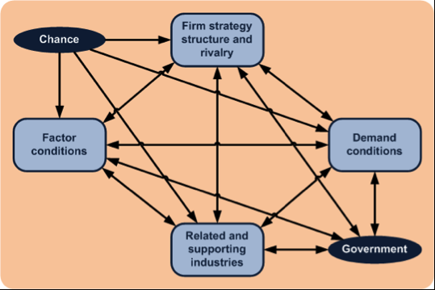

Factor Conditions

The explanation why particular regions attract particular industries begins with the degree to which a country or region’s endowments match the characteristics and requirements of an industry. Such factor conditions include natural (climate, minerals) as well as created (skill levels, capital, infrastructure) endowments.

Home-Country Demand

Porter’s second factor is the nature and size of the demand in the home country. Large home markets act as a stimulus for industry development.

Related and Supporting Industries

The presence of related and supporting industries is the third element of Porter’s framework. This is similar to our earlier observation about clustering.

Competitiveness of the Home Industry

Firm strategies, the structure, and the rivalry in the home industry define the fourth element of the national diamond model. In essence, this element summarizes the “five forces” competitive framework.

Public Policy and Chance

The two final components of Porter’s model are public policy and chance. There can be no doubt that government policy can—through infrastructure, incentives, subsidies, or temporary protection—nurture global industries.

**Note. Adapted from “Clustering: Porter’s National Diamond,” by C. de Kluyver, 2012, Fundamentals of Global Strategy, Chapter 2, Section 3. Copyright 2012 Flat World Knowledge, Inc.**

**Cluster Development –Video**

**Cluster Mapping for a Competitive Advantage--http://clustermapping.us/region**

**Topic 3: Project Quality for Competitive Advantage**

The History and Development of Quality Management as a Competitive Advantage

Quality management is an approach to competitive advantage that has become increasingly important as global cooperation competition increases.

Statistical Control Before World War II -- Prior to the late 1700s, products such as firearms and clocks were made as individual works where the parts were adjusted to each other so they could work together.

Statistical Control in the United States During World War II -- During World War II, factories converted from manufacturing consumer goods to weapons. Important improvements in quality control (QC)—the management of production standards through statistical interpretation of random product measurements, which emphasizes consistency and accuracy. Chance cause—a variation due to random events—and assignable cause—a variation that can be attributed to a particular event or influence. Shewhart introduced the control chart—because data are collected while the process is running. A control chart has time on the bottom axis and a plot of sample measurements. The mean, upper control limit, lower control limit, and warning lines that are two sigma from the mean are indicated by horizontal lines.

Deming and Postwar Japan

W. Edwards Deming -- After the war, while the United States occupied Japan, Deming was asked by the U.S. Department of the Army to assist with the statistics of the 1950 census in Japan. Deming went beyond Shewhart’s work and talked about his philosophy of quality manufacturing and how the responsibility for quality begins with management. He explained that a corporate culture devoted to producing high-quality products would result in less waste, lower costs, greater client loyalty, and greater market share. With Koyanagi’s support, Deming’s ideas were widely adopted by these influential leaders.

Deming described his philosophy as a system of profound knowledge, which has four parts:

1. *Appreciation of a system*. Understanding how suppliers, producers, and clients interact
2. *Knowledge of variation*. Understanding statistical variation
3. *Theory of knowledge*. Understanding what can be known and what cannot
4. *Knowledge of psychology*. Understanding human nature

In 1950, the Japanese created the **Deming prize** in Deming’s honor

Quality Management in America

Deming’s book was published and later retitled Out of Crisis (1986).

1. Create constancy of purpose toward improvement of product and service.
2. Adopt a new philosophy. We are in a new economic age. Western management must awaken to the challenge, learn their responsibilities, and take on leadership for a change.
3. Cease dependence on inspection to achieve quality. Eliminate the need for inspection on a mass basis by building quality into the product in the first place.
4. End the practice of awarding business on the basis of price tag. Instead, minimize cost. Move toward a single supplier for any one item, on a long-term relationship of loyalty and trust.
5. Improve constantly and forever the system of production and service to improve quality and productivity and thus constantly decrease costs.
6. Institute training on the job.
7. Institute leadership. The aim of supervision should be to help people and machines and gadgets to do a better job. Supervision of management is in need of overhaul, as well as supervision of production workers.
8. Drive out fear, so that everyone may work effectively for the company.
9. Break down barriers between departments.
10. Eliminate slogans, exhortations, and targets for the workforce asking for zero defects and new levels of productivity.
11. Eliminate work standards (quotas) on the factory floor. Substitute leadership.
12. Remove barriers that rob the hourly worker of his right to pride of workmanship.
13. Institute a vigorous program of education and self-improvement.
14. Put everybody in the company to work to accomplish the transformation. The transformation is everybody’s job.

Ford adopted an approach to quality known in America as **total quality management (TQM),** a philosophy of managing quality adapted from a Japanese method that includes *kaizen*, *atarimae hinshitsu*, *kansei*, and *miryokuteki hinshitsu*. TQM in Japan has four major components:

1. **Kaizen:**Improvement must involve all members of a company (Total Quality Control, n.d.).
2. **Atarimae hinshitsu:** Make things work the way they are supposed to work (NationMaster.com, 2005).
3. **Kansei:** Learn from the way a user applies the product to make improvements (*WASEDA University, n.d.).*
4. **Miryokuteki hinshitsu:** Things should have an aesthetic quality and be pleasing to use (NationMaster.com, 2005).

Another approach to quality management in the United States was formulated at Motorola in 1986 and was named Six Sigma (6σ)—a quality management system that give titles to specialists and requires a cost-benefit analysis. The Six Sigma practices were based on Deming’s work, TQM,

Cost of quality (COQ) must be determined.

* ost of prevention
  1. *Cost of conformance*. Cost to improve quality.
  2. *Cost of appraisal*. Cost to measure and evaluate quality.
* Cost of failure
  1. *Internal costs*. Repairing bad parts before shipment or retooling a manufacturing line to reduce failures.
  2. *External costs*. Managing returns, lawsuits, product recalls.

Six Sigma identified individuals as experts in quality and awarded titles like Champion and Master Black Belt.

 In 1948, the General Agreement on Tariffs and Trade (GATT) established the rules for international trade in the postwar world. Through years of negotiations based on GATT, the **World Trade Organization (WTO)**was created in 1995. The WTO is a negotiating forum where governments can discuss ways to help trade flow as freely as possible (World Trade Organization, n.d.).

an organization of 158 national standards groups formed the **International Organization for Standardization (ISO)**, which is headquartered in Switzerland.

* *ISO 9000*. Fundamentals and vocabulary for this group of quality standards.
* *ISO 9001*. Standards for evaluating the quality management processes in an organization. It has five parts:
  1. Overall requirements for the quality management system and documentation
  2. Management responsibility, focus, policy, planning and objectives
  3. Resource management and allocation
  4. Product realization and process management
  5. Measurement, monitoring, analysis, and improvement
* *ISO 9004*. Ways to extend benefits of ISO 9001 to employees, owners, suppliers, partners, and society in general. It is a guide for top management for overall quality improvement.
* *ISO 9011*. Guidance for auditing a quality system.

Recommended steps for implementing a quality management system (QMS) are as follows:

1. Fully engage top management.
2. Identify key processes and the interactions needed to meet quality objectives.
3. Implement and manage the QMS and its processes.
4. Build your ISO 9001-based QMS.
5. Implement the system, train company staff, and verify effective operation of your processes
6. Manage your QMS—focus on client satisfaction, strive for continual improvement.
7. If necessary, seek third-party certification and registration of the QMS, or alternatively, issue a self-declaration of conformity (International Organization for Standardization, 2005).

*Note*. Adapted from “Development of Quality as a Competitive Advantage,” by R. Darnall & J. Preston, 2012, *Project Management: from Simple to Complex*, Chapter 10, Section 2. Copyright 2012 Flat World Knowledge, Inc.

**Total Quality Management (TQM) – Video**

**Objective 3: Creating Competitive Advantage Through Innovation**

Topic 1: Innovation's Role in Competitive Advantage

Faulty Decision Making the concept of anchoring and adjustment biases.

In this section, we explain the biases of anchoring and adjustment, availability, escalation of commitment, fundamental attribution error, hindsight, judgments about correlation and causality, misunderstandings about sampling, overconfidence, framing, and satisficing.

Anchoring and Adjustment Bias-- Anchoring and adjustment bias refers to the tendency for individuals to rely too heavily on a single piece of information such as arbitrary numbers, irrelevant traits, or facts when making decisions.

Availability Bias-- Availability bias refers to a situation where information that is more readily available is seen as more likely to occur.

Escalation of Commitment Bias--Escalation of commitment bias occurs when individuals continue on a failing course of action after information reveals this may be a poor path to follow-- It is sometimes called sunk costs fallacy.

Fundamental Attribution Error -- Fundamental attribution error refers to a bias that exists when positive outcomes are seen as a function of personal characteristics, while negative outcomes are attributed to external circumstances.

Hindsight Bias -- Hindsight bias occurs when looking backward in time where mistakes made seem obvious after they have already occurred.

Judgments about Correlation and Causality Bias -- How does employee satisfaction impact a firm’s sales? Three elements are necessary to understand why one thing affects another. These elements, which show judgments about correlation and causality bias (a situation in which individuals make inaccurate attributions about the causes of events), include (1) correlation (Do sales increase when employees are satisfied? Do sales decrease when employees are dissatisfied?), (2) temporal order (Does an increase in employee satisfaction occur before sales increase?), and (3) ruling out other potential causes. (Is something else causing increases in both satisfaction of employees and firm sales?) The first two items can be easily tracked, while the third can be difficult to isolate.

Misunderstandings about Sampling Bias -- Sampling misunderstanding bias occurs when individuals make generalizations from a small sample (or a single source) of information rather than through large, randomly drawn samples that represent a wide audience.

Overconfidence Bias -- Overconfidence bias occurs when individuals overestimate their ability to predict future events.

Framing Bias -- Framing bias refers to the tendency of decision makers to be influenced by the way a situation or problem is presented.

Satisficing -- Satisficing refers to a situation in which individuals select the first acceptable alternative instead of seeking the best possible decision.

**Note. Adapted from “Faulty Decision Making,” by M. Carpenter, T. Bauer, B. Erdogan, & J. Short, 2013, Principles of Management, Chapter 10, Section 1. Copyright 2013 Flat World Knowledge, Inc.**

**Your Elusive, Creative Genius – Video**

**Topic 2: Creating a Culture for Innovation**

New products and services often create a competitive advantage for organizations. Creating new products and services often starts with innovation and one of the drivers in business innovation is sustainability. Organizations that focus on sustainability often find a serendipity with increased innovation.

**An Inconvenient Truth**

In 2007, former U.S. Vice President Al Gore’s documentary on climate change, An Inconvenient Truth, won an Oscar for best feature documentary, while Gore and the IPCC were jointly awarded the Nobel Peace Prize.

**Radical and Incremental Innovation - innovation can happen in two ways: radically or incrementally.**

Radical innovations are innovations that are very different or even revolutionary.

Incremental innovations are innovations that involve smaller improvements in ideas, products, services, and processes.

**Environmental Factors Affecting Creativity and Innovation**

Create a shared mission that is focused on a single goal.

Create an atmosphere that facilitates one-on-one collaboration.

Promote risk-taking and permit failure.

Allocate quiet time and solitude in order to help individuals think inside the box.

Make things by developing prototypes and experimenting.

Anyone can be creative.

* Have a mission and focus on a single goal
* Need one-on-one collaboration
* Take risks and permit failure
* Need quiet time and solitude
* Need to prototype and experiment
* Work hard

Note. Adapted from “Environmental Factors Affecting Creativity and Innovation,” by L. Sanders, 2012, Developing New Products and Services, Chapter 6, Section 4. Copyright 2012 Flat World Knowledge, Inc.

**Topic 3: Creating a Project Culture**

Project managers create a project culture, something organizational managers seldom have a chance to do.

Schein (1990) defined culture as a pattern of basic assumptions formed by a group on how to perceive and address problems associated with both internal adaptation and external integration. Schein also described organizational culture as an abstract concept that constrains, stabilizes, and provides structure to the organization. At the same time, culture is being constantly enacted, created, and shaped by leadership behavior. Write in your business plan how you will create a culture of innovation that spurs competitive advantage.

Characteristics of Project Culture

Culture is developed through the communication of:

* the priority
* the given status
* the alignment of official and operational rules

Creating a Culture of Safety

The first meeting that project team members attended upon joining the project was a safety orientation. Culture guides behavior and communicates what is important and is useful for establishing priorities.

Culture of Stakeholders

Stakeholders can include customers, employees, unions, suppliers, and non government organizations.

The following are three major aspects of cultural differences that can affect a project:

1. Communication
2. Negotiation
3. Decision making

Innovation on Projects

**Note. Adapted from “Creating a Project Culture,” by R. Darnall & J. Preston, 2012, Project Management: from Simple to Complex, Chapter 5, Section 3. Copyright 2012 Flat World Knowledge, Inc.**

**Objective 4: Creating Competitive Advantage Through Customer Focus**

Topic 1: Operations Management for Service Providers

Operations Management and Service Firms

One of the things that needs to become clear in order for you to create competitive advantage is how the U.S. economy has changed. As the U.S. economy has changed from a goods producer to a service provider (Peters & Payack, 2010; Strauss, 2010).

Intangibility. Manufacturers produce tangible products—things that can be touched or handled, such as automobiles and appliances. Service companies provide intangible products, such as banking, entertainment, or education.

Customization. Manufactured goods are generally standardized; one twelve-ounce bottle of Pepsi is the same as any other twelve-ounce bottle of Pepsi. Services, by contrast, are often customized to satisfy the specific needs of a customer.

Customer contact. You could spend your entire working life assembling cars in Detroit and never meet a customer who bought a car that you helped to make. But if you were a waitress, you’d interact with customers every day.

Competitive advantage can also be created through operations planning and efficiency.

**Operations Planning**

Is your business plan going to be providing a service or a product?

must make a number of decisions quite similar to those made by manufacturers:

* What services (and perhaps what goods) should they offer?
* How will they provide these services?
* Where will they locate their business, and what will their facilities look like?
* How will they forecast demand for their services?

Operations Processes -- They must produce a quality good and deliver it satisfactorily.

Service providers that produce goods can, like manufacturers, adopt either a make-to-order or a make-to-stock approach to manufacturing them.

Facilities -- For your business plan you are going to have to think about location.

Site Selection -- To be successful in a service industry, you need to be accessible to your customers.

Size and Layout -- must accommodate the needs of their customers while keeping costs as low as possible.

Capacity Planning –

* How many customers will I have?
* When will they want my services (which days of the week, which times of the day)?
* How long will it take to serve each customer?
* How will external factors, such as weather or holidays, affect the demand for my services?

Managing Operations -- must pay particular attention to employee work schedules and (in some cases) inventory management.

Scheduling -- focus on scheduling workers so that they’re available to handle fluctuating customer demand.

Inventory Control -- keeping levels too high costs money, while running out of inventory costs sales.

**Note. Adapted from “Operations Management for Service Providers,” by K. Collins, 2014, Exploring Business, Chapter 11, Section 6. Copyright 2014 Flat World Knowledge, Inc.**

**Topic 2: Innovation and Entrepreneurship in Sustainability**

entrepreneurship and entrepreneurial innovation can occur in a variety of settings including small or large companies, nonprofit organizations, and governmental agencies.

20th-century economist and entrepreneurship scholar Joseph Schumpeter, who pointed out that change in societies comes as a result of innovation created by entrepreneurs.

Peter Drucker, a 20th- and 21st-century scholar of entrepreneurship, echoed similar ideas many decades later. Entrepreneurship is innovative change through new venture creation; it is the creation of new goods and services, processes, technologies, markets, and ways of organizing that offer alternatives with the intention of better meeting people’s needs and improving their lives.

Innovation encompasses the creative combination of old and novel ideas that enables individuals and organizations to offer desired alternatives and replacements for existing products and services. These innovative products and ways of doing business, typically led by independent-thinking entrepreneurial individuals, constitute the substitutions that eventually replace older products and ways of doing things.

Business plans require elaboration on the market opportunity

**Analysis of Entrepreneurial Process**

Successful entrepreneurship occurs when creative individuals bring together a new way of meeting needs and a market opportunity. This is accomplished through a patterned process, one that mobilizes and directs resources to deliver a specific product or service to customers using a market entry strategy that shows investors financial promise of building enduring revenue and profitability streams.

Entrepreneurial innovation combined with sustainability principles can be broken down into the following five key pieces for analysis These five pieces are as follows:

* Opportunity
* Entrepreneur/team
* Product concept
* Resources
* Entry strategy

Successful ventures are characterized by coherence or “fit” across these pieces. The interests and skills of the entrepreneur must fit with the product design and offering; the team’s qualifications should match the required knowledge needed to launch the venture. The market opportunity must fit with the product concept in that there must be demand in the market for the product or service, and of course, early customers (those willing to purchase) have to be identified. Finally, sufficient resources, including financial resources (e.g., operating capital), office space, equipment, production facilities, components, materials, and expertise, must be identified and brought to bear. Each piece is discussed in more detail in the sections that follow.

**Note. Adapted from “Entrepreneurial Process,” by A. Larson, 2011, Sustainability, Innovation, and Entrepreneurship, Chapter 4, Section1. Copyright 2011 Flat World Knowledge, Inc.**

As a prospective entrepreneur, answer these key questions to address the opportunity for your idea. Record your responses in the Learning Journal.

* What are the conditions that have created a marketplace opportunity for my idea?
* Why do people want and need something new at this point in time?
* What are the factors that have opened up the opportunity?
* Will the opportunity be enduring; or is it a window that is open today but likely close tomorrow?
* If you perceive an unmet need, can you deliver what the customer wants while generating durable margins and profits?

**The Key to Entrepreneurial Success**

Sustainability considerations push this analysis further, asking how you can meet the market need with the smallest ecological footprint possible.

Ideally, this need is met through material and energy choices that enhance natural systems; such systems include healthy human bodies and communities as well as environmental systems.

The Entrepreneur

When you finish your business plan you will have officially taken the first step to becoming an entrepreneur.

The opportunity and the entrepreneur must be intertwined in a way that optimizes the probability for success. People often become entrepreneurs when they see an opportunity.

he individual’s capacities to execute on a given business plan. The components are as follows:

* **Values.** What motivates the individual? What does he or she care enough about to devote the time required to create a new venture?
* **Education.** What training has the individual received, what level of formal education, and how relevant is it to the tasks the venture requires to successfully launch?
* **Work experience.** Formal education may be less relevant than work experience. What prior jobs has the individual held, and what responsibilities did he have? How did he perform in those positions? What has he learned?
* **Life experience.** What exposure to life’s diversity has the individual had that might strengthen (or weaken) her competencies for building a viable business?
* **Networks.** What relationships does the individual bring to the venture? Have her prior experiences enabled her to be familiar and comfortable with a diverse mix of people and institutions so that she is able to call upon relevant outside resources that might assist with the venture’s execution?

 team members he or she brings to the project. The following are important questions to ask:

* Does the team as a unit have the background, skills, and understanding of the opportunity to overcome obstacles?
* Can the team act as a collaborative unit with strong decision-making ability under fluid conditions?
* Can the team deal with conflict and disagreement as a normal and healthy aspect of working through complex decisions under ambiguity?

**Resources**

What kinds of resources are needed? The following list provides guidance:

* **Capital.** What financial resources, in what form (e.g., equity, debt, family loans, angel capital, venture capital), are needed at the first stage? This requires an understanding of cash flow needs, break-even time frames, and other details. Back-of-the-envelope estimates must be converted to pro forma income statements to understand financial needs.
* **Know-how.** Record keeping and accounting and legal process and advice are essential resources that must be considered at the start of every venture. New ventures require legal incorporation, financial record keeping, and rudimentary systems. Resources to provide for these expenses must be built into the budget.
* **Facilities, equipment, and transport.** Does the venture need office space, production facilities, special equipment, or transportation? At the early stage of analysis, ownership of these resources does not need to be determined. The resource requirement, however, must be identified. Arrangements for leasing or owning, vendor negotiations, truck or rail transport, or temporary rental solutions are all decision options depending on the product or service provided. However, to start and launch the venture, the resources must be articulated and preliminary costs attached to them.

The Product/Service Concept

* What is the solution for which you want someone to pay?
* Is it a service or product, or some combination?
* To whom are you selling it? Is the buyer the actual user? Who makes the purchase decision?
* What is the customer’s problem and how does your service or product address it?

Understanding what you are selling is not as obvious as it might sound.

**Entry Strategy**

Another category to examine carefully at the outset of a venture is market entry strategy.

**Note. Adapted from “Entrepreneurial Process,” by A. Larson, 2011, Sustainability, Innovation, and Entrepreneurship, Chapter 4, Section1. Copyright 2011 Flat World Knowledge, Inc.**

**Topic 3: Analytical Approaches for Strategic Planning**

Value Chain and Supply Chain Analysis

alue chain analysis is a framework developed by Michael Porter that divides the company into primary and secondary activities related to delivering a product or service (Porter, 1985). The primary activities include inbound logistics, operations, sales and marketing, and outbound logistics. The secondary activities are supporting activities and include the firm infrastructure, human resources, information technology, and procurement. The Value Chain (adapted from Porter, Figure 4.1)

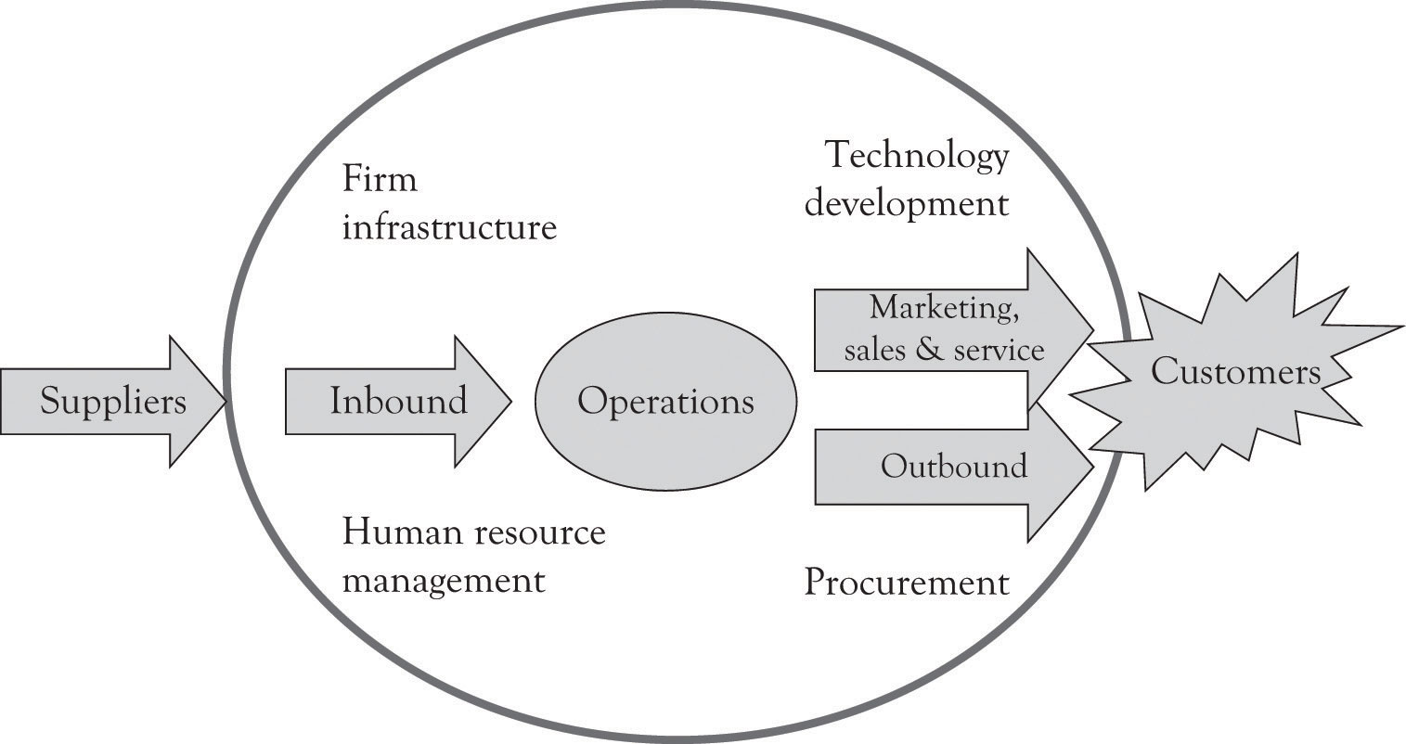

A supply chain is defined as the connected activities related to the creation of a product or service up through the delivery of the product to the customer. It includes upstream suppliers as well as downstream activities such as wholesalers and distribution warehouses. Figure 4.2 illustrates the supply chain.

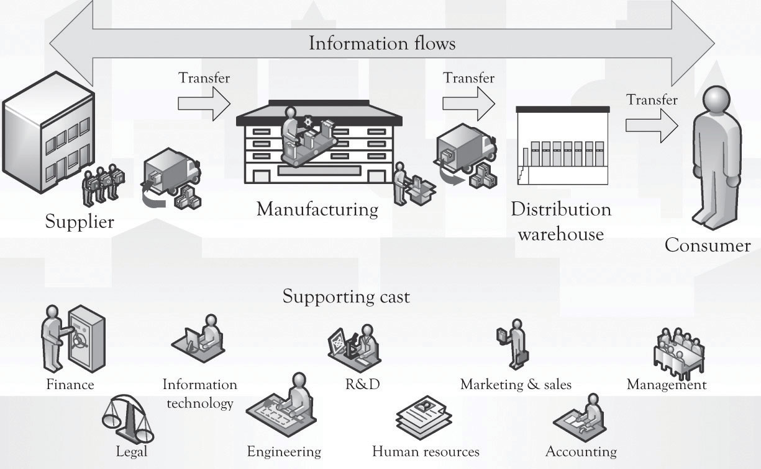

In general, the terms value chain and supply chain can be used interchangeably; although the value chain is rooted in the strategic planning literature, the supply chain is linked to the work in the operations management area.

That is, improvements can be made in connecting, coordinating, and controlling activities across linkages.

Transaction costs refer to the effort that goes into choosing, organizing, negotiating, and entering into agreements for products and services (Williamson, 1985). Transaction costs come in a variety of flavors and there is significant overlap among the various costs.

Search costs: In general, these costs are related to gathering information on a product or service, including the costs associated with locating a product and offering a product for sale.

Discovery costs: These costs are involved in locating an acceptable price for a product.

Decision costs: These costs are associated with making a decision on what product to purchase. These include personal cognitive effort and organizational decision processes related to selecting a product or service.

Negotiation costs: These costs are related to agreeing to the terms of a contract including the price, what will be delivered, how much, and when.

Acquisition costs: These costs are involved in transporting, receiving, infrastructure development, and managing the product in inventory.

Enforcement costs: These are the costs that the parties in the contract incur in order to enforce the terms of the contract.

Settlement costs: These are the costs related to paying and getting paid for a product or service.

Social costs: These include costs that are not necessarily picked up by the buyers and the sellers. Examples include pollution costs, health costs, privacy costs, and bankruptcy costs.

*Note*. Adapted from “Analytical Approaches for Strategic Planning,” by L. Sanders, 2012, *Developing New Products and Services*, Chapter 8, Section 3. Copyright 2012 Flat World Knowledge, Inc.

**Porter's Five-Forces Model**

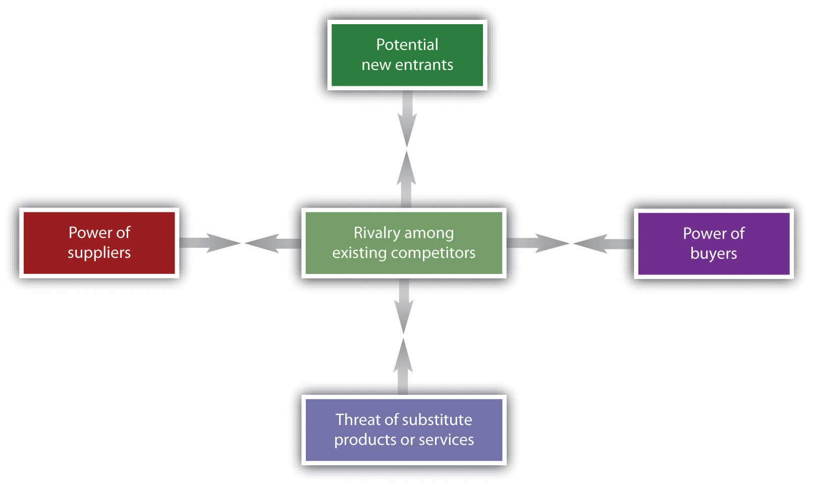

Porter’s five-forces framework, shown in the figure above, considers the buyers, the sellers, the suppliers, the current competition, and the threat of competition from substitute products. The key idea is that a firm can be more profitable by understanding how the five forces influence the competitive environment, as will be explained next.

Threat of new entrants. This is the degree to which entry into an industry is easy to accomplish.

Threat of substitute products. Substitute products are a constant threat in contemporary commerce. If another product can be substituted for a product in the industry under consideration, then there is a threat of substitute products.

Bargaining power of buyers. If individuals, companies, or groups of companies can influence the price and the features required in a product or service, then the buyers have the bargaining power. This often occurs when there are few buyers or when the buyer is large.

Bargaining power of suppliers. If a company supplying a product or service can dictate the terms of the transaction, then the supplier has the bargaining power. The bargaining power of suppliers can be derived from many factors including the scarcity of the resource or technology, the number of suppliers, the characteristics and features of the technology, whether the technology is proprietary, and even the brand image.

Rivalry among existing competitors. This is the degree to which there is competition among the firms.

**The Five-Forces Model in Practice**

he following steps are used for conducting an industry analysis:

1. Develop a brief description of the target industry
2. Identify the competitors, buyers, suppliers, potential entrants, and potential substitutes
3. Determine the strength and weaknesses of the forces
4. Identify any recent changes in the dynamics of the forces
5. Determine the potential for short- and long-term profitability
6. Ascertain who in the industry is positioned to be profitable
7. Determine where the organization should invest.

**several deficiencies. First of all, it takes a long time to conduct a full-blown exposé of the five forces because many devotees to the approach tend to overanalyze the industry and the competition. This in turn leads to organizational fatigue. Overanalysis is related to the second deficiency. The ideas are very abstract and broad, and the technique requires consulting expertise in order to be applied effectively. Finally, it takes too long to implement for small organizations. For the entrepreneur working under extreme pressure, under the umbrella of monopolistic competition, there is very little time to attend to apply the approach effectively. Even though Porter’s ideas are very powerful, they do not resonate with the entrepreneur because they are abstract and difficult to apply.**

**Note. Adapted from “Analytical Approaches for Strategic Planning,” by L. Sanders, 2012, Developing New Products and Services, Chapter 8, Section 3. Copyright 2012 Flat World Knowledge, Inc.**

**Resource-Based Framework**

The resource-based view, also referred to as RBV, is very popular with academics. The intellectual foundations for the RBV approach are many, but the work by Prahalad and Hamel (1990) on core competencies and the work by Barney (1991) on the link between resources and sustained competitive advantage established a strong foundation.

The basic idea of RBV is that some organizations are more competitive because they have access to unique resources or special capabilities and competencies.

the RBV approach suggests focusing on competitive arenas where the firm has unique resources and competencies. Core The RBV is a powerful idea for understanding strategic direction, but it has several deficiencies. First of all, it is very broad in scope and hard to implement as part of a concrete business plan. Delineating the unique capabilities, competencies, and resources and then using this information in strategic planning are time-consuming. In addition, there is little guidance on how to build competencies. Indeed, some theorists believe that core competencies cannot be built but simply emerge. For additional discussion on RBV, see Henry (2008) and Grant (1991).

**Note. Adapted from “Analytical Approaches for Strategic Planning,” by L. Sanders, 2012, Developing New Products and Services, Chapter 8, Section 3. Copyright 2012 Flat World Knowledge, Inc. competencies are the very critical skills that define an organization.**

**Strategy Maps**

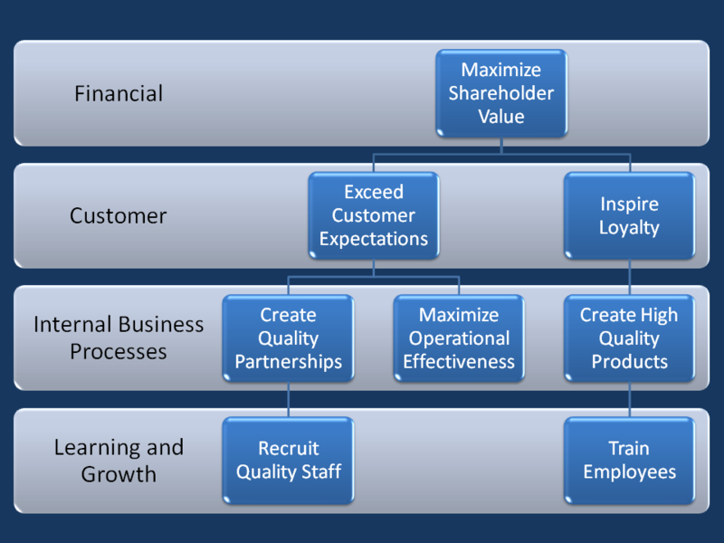

The strategy map is an outgrowth of the balanced scorecard approach developed by Kaplan and Norton (This content will be opened in a separate window or downloaded to your computer) (1996). The purpose of the balanced scorecard is to develop a series of measurable performance indicators that are linked and aligned with organizational missions and objectives. Measurement at the operational and tactical levels is a key part of the balanced scorecard approach and essential for developing and benchmarking best practices. Measurement can be used to identify where management should redirect its attention and also to identify whether best practices are already in place.

There are four primary areas where performance indicators can be used. They are the financial performance indicators, customer performance indicators, performance indicators related to internal organizational processes, and performance indicators related to the ability of the organization and employees to innovate and learn.

Note. Adapted from “Analytical Approaches for Strategic Planning,” by L. Sanders, 2012, Developing New Products and Services, Chapter 8, Section 3. Copyright 2012 Flat World Knowledge, Inc.

**Creating Blue Ocean Markets Using the Strategy Canvas**

We believe that the Blue Ocean concept is an important contribution to the strategic planning literature (Kim & Mauborgne, 2004).

traditional Red Ocean market spaces where there is a tendency to focus on either cost-cutting or differentiation. The Red versus Blue Ocean Strategy table illustrates how the concepts developed in the book with Midas, Atlas, and Hermes products relate to the Blue Ocean concepts.

A Blue Ocean strategy that is focused on intense innovation and on product differentiation and brand creation has been found to be profitable (Burke, Stel & Thurik, 2009). Blue Ocean approach apparently helps to insulate a firm from intense competition. In many instances, Blue Oceans are not completely blue, but rather have patches of red. The net effect is that it is sometimes necessary to find a niche in a large market and then use Porter’s five-forces model to assess the desirability of competing in a particular industry and how a firm can compete in that industry. The key idea is that a firm can be more profitable by understanding how the five forces influence the competitive environment. The most important part of the Blue Ocean approach is to assist in identifying strategic opportunities for product differentiation using the Strategy Canvas.

**SWOT Analysis**

**The Quick SWOT Supported With Strategy Canvas**

A SWOT analysis should be conducted very quickly, as illustrated below:

* Conduct a brief external industry analysis.
* Identify the competitors, buyers, suppliers, potential entrants, and potential substitutes.
* Understand the industry supply chain and how it works.
* Conduct a brief internal organizational analysis.
* Identify organizational capabilities/competencies related to manufacturing prowess, order fulfillment and delivery, customer service, marketing, finance, accounting, R&D, employees, and management. This is essentially the internal supply and value chains.
* Use a strategy canvas to identify how you can add or subtract features for product differentiation. The idea is to identify new opportunities and perhaps Blue Ocean markets.
* Develop a 4 × 4 SWOT diagram using the template. Try to limit the number of factors in each quadrant to four factors.
* Start the process over after four months.