The Competitive Advantage

Of

Dutch Brothers Plus

Jeffery Morse

Brandman University

The Competitive Advantage of Dutch Brothers Plus

Coffee remains a favorite beverage of the world. There is just something about waking up to the smell of fresh brewing coffee. As a result, the coffee industry continues to grow with an approximate income of 37 billion a year and an annual growth of about 3.6% (IBISWorld, 2018). On the flip side, todays health craze is the result of the current generation--the age of information. The upcoming generation is green, health conscience, and they are innovators who understanding that health is a product of diet. This understanding is the bread and butter of franchises offering juice blends and other health related items. As a result, Dutch Brothers Plus (DBP) has been envisioned to incapsulate the best of both worlds –the world’s first healthy coffee house. There are several was to attain competitive advantage. According to Darnall & Preston (2012), one might choose First Mover Advantage where a firm gains an advantage by being the first to offer a service or product. One research study of 1,226 businesses over a 55-year period found that the advantage over rivals first mover brings often lasted for a decade or more. (Darnall & Preston, 2012). Some other ways to achieve competitive advantage might be the Home-Country Demand. Knowing ones market is always an advantage. Still others may include Total Quality Management (TQM), Innovation, Joint Ventures (a cooperative arrangement that involves two or more organizations), Strategic Alliance (a cooperative arrangement between two or more firms) or Customer Focus (Darnall & Preston, 2012; Global Industry Analysts, Inc., 2011). In reality relying on just one item for competitive advantage is a death sentence. To be successful a firm must create a plan for competitive advantage that makes use of several areas. DBP’s plan was outlined in the Morse (2018b) “Strategic Fundamentals and Environment Plan for Business Upstart” available in the Appendices (see Appendix 2). The outline includes most the listed competitive advantage paths in one way or another. DBP will gain competitive advantage from First Mover and Innovation through Co-Branding (a sub type of Joint Ventures), Home-County Demand--by being a part of every community DBP is in, TQM employed at every step to ensure a high-quality product, Strategic Alliances by contracting with local farmers for high quality organic produce, and by Customer Focus. One thing is clear the U.S. economy has changed from a goods producer to a service provider (Peters & Payack, 2010; Strauss, 2010). In order to seriously consider competitive advantage, one must gear toward customer satisfaction.

**Industry Analysis**

Starbucks will serve as a bench mark company for DBP. Starbucks is a coffee chain company started in Seattle Washington. Now, Starbucks is recognized as an international organization whose fame for quality coffee reaches over the entire world. It has almost 16,120 stores in 49 different countries this makes Starbucks the largest coffee company in the world (Essays, 2013).

DBP will be purchasing trade mark rights from Dutch Brothers. Dutch Brothers had its inception in 1992. Owned by two brothers by the names of Dane and Travis Boersma, since then, it has transformed into a successful franchising company with Travis as the CEO (Dane passed away some years ago). Today, Dutch Bros allows all of their management to make the final say for their location as long as it falls in line with what Dane and Travis called the “Dutch Creed,” a short list of principles that help govern the business in its ethics and day-to-day business transactions (Dutch Bros, 2017).

Jamba Juice will first serve as a bench mark firm, and then DBP will acquire the firm at a point in the future. Jamba Juice is showing near 75 million in revenue with 22% of that being EBIT—that is about 15 million in yearly profit (Jamba. 2018). Dutch Brothers coffee is doing as good (Dutch, 2018). Overall, the state of both industries is good. Juice bars are showing a 2-billion-dollar revenue with a margin of annual growth at about 2.3% (IBISWorld2, 2018). Indeed, a generation of health conscience people creates a promising forecast for both the coffee and juice bar industries. By creating a hybrid that sells both healthy juice and coffee a firm can expect a growth percentage shown by the mean of these two industries—or about 3%.

**Porter's Five Force Model**

In the industry environment competition can be analyzed by using Porter's Five Force Model Technique. It consists of five forces used to measure industry competition. If competition is strong an industry is thought to be strong as well. The five forces are the threat of new entrants, bargaining power of customers, bargaining power of supplier, threat of substitutes and competitive rivalry within industry (Carpenter, Bauer, Erdogan, & Short, 2013). Starbucks will serve as the benchmark during the Porter Model analysis.

**New entrant's threats.**

The coffee industry environment in which Starbucks operates is very competitive. Coffee companies compete with the other brands in the market like McDonalds, and Burger King. They also must compete with other coffee companies a list of current companies might include Java Detour, Dutch Brothers, Iron Bean and Starbucks. Barriers to entry into the coffee market is relatively low due to the low capital investment needed for small kiosk centers, drive thru and storefronts. Since the likelihood of new entrants is a function to which barriers to entry exist new entrants are a threat (Geroski, 1999). In addition, if customers face few switching costs product substitutes present an even stronger threat to an existing firm (Carpenter et al, 2013).

**Customer's bargaining power.**

The profit of a sevice company is directly related to the number of its customers. Previously the bargaining power of a customer had less weight but due to brand competition. In addition, due to new entrants in the market franchise saturation has occurred (Wright & Frazer, 2007). Previously, coffee market customers had less bargaining power because of the Starbucks monopoly. Today, all the new entrees into the coffee market has increased the bargaining power of the customer. Substitute switching is now a factor of who is closest instead of a factor of loyalty. Competitive advantage is needed to retain customers.

**Supplier's bargaining power.**

Suppliers to the coffee house have high bargaining power. Coffee beans are essential for business. Gaining economies of scale is needed to supply profits. To gain these economies one must seek out strategic alliances with coffee suppliers, equipment suppliers, appliance repair firms, and general maintenance firms (Essays, 2013). Industrial coffee machines carry high bargaining power as a result of few suppliers in combination with growing number of entrants.

**Threat created by substitutes.**

The coffee market is full of substitutive products. Energy drinks, alcoholic beverages, smoothies, soft drinks, juices, and water can all replace coffee. As a result, all these products represent a threat. Also, the local supermarket sells cold coffee alternatives at rock bottom prices. One might add lounges, convenience stores, donut shops, as well as the kitchen faucet. Leaning not only to deal with but to capitalize on these threats will be integral to retailing products effectively and efficiently. Unfortunately, coffee houses traditionally have dips in sales during the hot months (Invest, 2018). In order to remove threats DBP must capitalize by removing them through filling this lull. In contrast, juice bars and smoothie houses have dips in sales in winter months (Invest, 2018) this gives opportunity to create competitive advantage through fulfilling product lull by offing both coffee and juice. Merging the two firms creates competitive advantage.

**Competitive rivalry in industry.**

All over the world Starbucks is recognized as a great brand name; they represent the biggest competitor in the coffee industry (Starbucks, 2018). Other competitors such as Java Detour, Gloria Jeans coffee, De Bella and McDonalds McCafé also have famous brand image all over the world. They all represent competitive rivalry. In addition, coffee suppliers such as Burger King’s cup of Joe and Dunkin’s Donuts brand coffees further increases competition.

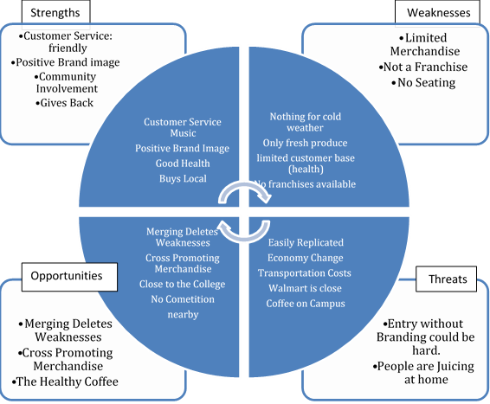**SWOT**

Figure 1: *SWOT. Supplied by Morse (2018) from Strategic Fundamentals paper (see Appendix B).*

**PESTEL --** Political, Economic, Sociocultural, Technological, Environmental, and Legal.

The PESTEL is offered here under the Industry Analysis but is also considered as part of the Market Analysis. Morse (2018b) reported the following;

**Political.**

According to Morse (2018b) DBP can expect favor from the city and since DBP is focused community involvement forecast political support. Also, the U.S. is currently experiencing reprieve from its last recession.

**Economical**

Economic growth projected as sidewalks and drainage are being installed from the highway to the college. Correspondingly, both companies that DBP is patterned after are doing well financially in both California and the U.S., including the locations currently doing business closest to the DBP proposed location.

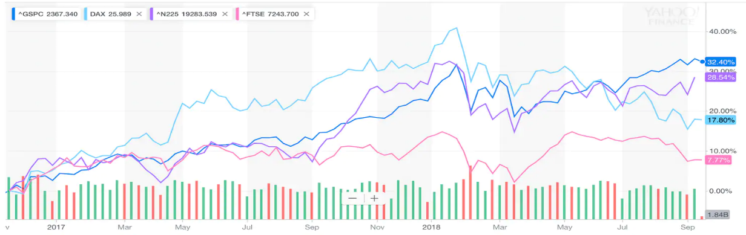

Figure 3 2

Figure 3: *Source Bureau of Land Statistics, The Washington Post (Kelly, 2018).*

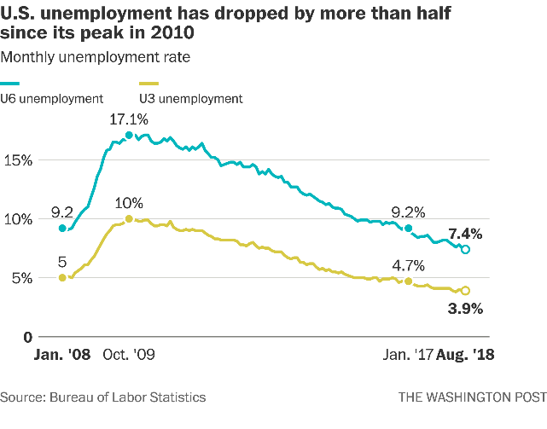

Figure 2

Figure 2: *Source Bureau of Land Statistics, The Washington Post (Kelly, 2018).*

In addition, The Washington Post reports unemployment is lower than it has been in years while the GDP continues to rise (Kelly, 2018).

**Social-cultural.**

Morse (2018b) reports that the Social-cultural feel of the area is one of oppression, however, by focusing on injecting success, music, honest, quality, and fellowship into the community DBP can help promote change. Congruently, the offering of healthy juices, and generally promoting health accords itself with the cultural swing toward health currently occurring in this generation.

**Technological.**

Ensuring Just-In-Time deliveries through Information Supply Systems to warrant the freshest organic produce for juicing, staying on the cutting edge of music, offering Wi-Fi and high-speed internet access will make DBP a valued location for study or out-of-office work. In addition, commitment to innovation will ensure that DBP stays on top. All the technologies needed are already readily available in the desired location.

**Environmental**

The overall environment is one of growth and new business ventures currently have opportunity for promise and sustainability. Morse (2018b) make a note that the PESTEL provides a good sense of the broader macro-environment. Complementary, Industry Analysis informs about an organization’s competitive environment as well as the key industry-level factors that seem to influence performance. Morse (2018b) reports that the industry analysis of Starbucks, Dutch Brothers, Jamba Juice, and Planet Smoothie franchises all show growth and sustainability across board. For more information concerning the industry analysis please refer to Morse (2018b) *“Strategic Fundamentals and Environment Plan for Business Upstart”* (see appendix B).

**Competitive Advantage**

Competitive advantage strategy and design plays a vital role as it brings sustainability and longevity. Starbucks is famous in its market and has generated a huge profits through creating a people centered culture to achieve a competitive advantage (Starbucks, 2018). Amazingly, people increased loyalty when Starbucks publicized how it treats employees and customers. Starbucks chose to an unconventional competitive advantage because sustainability can be affected by competitors when competitive advantage is found through the product line. Therefore, to survive in the market a company should find its competitive advantage not only in the product line but in as many unconventional ways possible.

**Co-Branding in the Franchising Industry**

In appendix (A) there resides a Literature Review with a theme that states, “Co-branding is considered by many to be a miracle competitive advantage solution.” Further, the review seeks to affirm that co-branding is an affective means DBP can employ to attain competitive advantage (Morse, 2018a).

Sun & Lee (2018) indicate that franchising itself offers benefits to franchisors by helping them develop competitive advantage. This advantage allows firms to outperform competitors. Morse (2018a) seeks to further that advantage though co-branding. At one time, the terms co-branding and co-franchising were synonymous. However, today the terms co-branding, or piggybacking represent multiple franchises operated by one owner in one location while the term co-franchising leans more toward multiple franchises operated in one location by different owners (Annual, 1987). Simply, co-branding is any franchise offering products from another franchise or retailing offerings outside the franchises traditional menu (Hurwitz, 1995; Charles, 1996).

The Literature Review (LR) in appendix (A) states that the greatest reason for co-branding is to create “leverage”. Hurwitz (1995) Defines leverage as the ability of co-branding partners to rely on each other. This points to the need for prospective co-brands to have the ability to work well together.

Morse (2018a) categorizes the two types of co-branding. The first leaning toward the name co-franchising--a joint venture where two or morse franchises operating at one location. The second is co-branding as a single owner, or brand expansion. Sherman (2012) states that a pioneer of co-franchising, Tricon Global Restaurants, used a tri-branded concept by co-branding KFC, Taco Bell, and Pizza Hut together, three separate franchises under one roof, unfortunately it did not gain much success (Young, Hoggatt & Paswan, 2001; Hamstra, 1998a). Sherman (2012) proclaims that this advantages represents cost savings in three ways. First, co-franchising offers shared costs in marketing, packaging, rent, and utilities. Secondly, co-branding achieves benefits through complementary services. Lastly, co-branding expedites expansion. In addition, co-franchising can ease achievement of brand recognition, create convenience, tap into national image and awareness, increase distribution networks, add clout, and it can double endorsement power and brand recognition. One co-franchising effort that met with success was McDonalds & Walmart as reported in Morse (2018a). Davis and Ritchie (1997) stated that one of the most successful co-franchising efforts from 1997 until now is McDonald’s and Wal-Mart. Davis and Ritchie (1997) conclude by saying that opportunities exist as long as partnerships are successful and profitable for both.

In comparison, co-branded efforts of the second type (non-franchising) tend to be less likely to fail. Morse (2018a) reports that co-branding through brand extension has met more success. The best documented case began in 1993 when McDonalds used the co-branding brand expansion method to add McCafé coffee. The key is that the mother franchise must be strong enough to carry a sub-brand. After its initial success McDonald's began encouraging franchisees to own the entire outlets containing the co-brands (Wright & Frazer, 2007). Success came after projected barriers were found to be false. For instance, co-branded firms showed increase in revenues in both brands while lowering operating costs instead of the projected losses due to choice (Wright & Frazer, 2007).

**Rules and regulations.**

In comparing the rules and regulations of the two type of co-branding reported on one stands out as a better solution for DBP. Co-franchising, having two separate franchises in one location, is subject to several regulations that increase startup costs, confusion, and administrative stress. While having a separation between franchises is a positive for major chains in book keeping, as well as, taxation record keeping--for the startup entrepreneur this would only adds startup costs. In extreme cases, such as the case where franchise licenses were unavailable, this may even prevent startup formation. Morse (2018a) gives endorsement for brand extension as a form of co-branding. Indeed, Cannon (1997) revealed that, while co-branding offered great benefit, the Federal Trade Commission’s fractional franchise exemption is the way to go. Due to struggling federal and state comprehensive regulation the better solution is brand extension with a “right of use” trade mark license instead of purchasing an actual franchise which is an in-house brand expansion form of co-branding. This choice is further supported by the success of McDonalds and McCafé co-branding reported by Wright & Frazer (2007).

**Market Conditions**

Morse (2018b) reports in the VRIO that since people love coffee and love to relax value and market share may be increased. Continuing, DBP offers beverages at a discount when compared to Starbucks, or Java Detour--this also improves marketing penetration. Jamba Juice creates value by cornering the market on the health front. As a result, DBP will be able to create a first mover competitive advantage through assessing products from both Jamba Juice and Dutch Brothers in a way that, in terms of co-branding, may be defined by product development. How? By expanding to include brand extension so a coffee shop will include healthy juice alternatives as a form of product development. Co-jointly, marketing in terms of market penetration as well as market development also apply. Markets already exist for both; however, a market were both intersect does not currently exist. In fact, it is very rare to find a hybrid coffee house and a juice bar co-brand. In addition, rarity is increased due to the lack of juice bars within the city. Though this firm may easily be duplicated, and new entrants do represent a major concern according to Porters Competitive Strategies it may also be a positive for DBP. As future plans for expansion into new markets come to fruition ease of duplication lowers startup costs of new franchises. One benefit of finding competitive advantage in more than one area is that it protects by creating loyalty which in turn stops substitutable firms from taking customers. Porter's Generic Competitive Strategies gives competitive advantage from having a focus as well as having differentiation (Porter, 1980). DBP is definitely different, focusing of customers will complete Porter’s Strategy.

In the industry analysis portion of this paper there was listed some data on current market standings for the benchmark businesses of DBP. To abbreviate, Jamba Juice is reporting 15 million in profit (Jamba. 2018), Dutch Brothers coffee is reporting about the same (Dutch, 2018), Juice bars in general show a 2-billion-dollar revenue with annual growth at about 2.3% (IBISWorld2, 2018), The coffee industry earns about 37 billion a year with annual growth of 3.6% (IBISWorld, 2018). DBP’s main competitor is listing its EBIT to be in the nationhood of 50 billion, with an astounding 92.56% return on equity (Morse, 2018b).

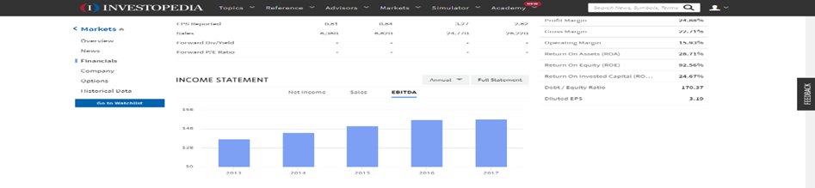

Figure 4

Figure 4: *Coffee industry EBIT, (IBISWorld2, 2018); Taken from (Morse, 2018b).*

**Competitive Advantage**

In describing five competitive advantages of DBP business startup the first one to mention is the First Mover advantage. A first-mover advantage exists when a firm establishes a dominant position by being the initial firm to enter a market or introduce a process that brings economies of scale (Upson, Ketchen, Connelly & Ranft, 2012). Owning the first foothold can dissuade other firms from becoming entrants. Also, initial footholds bring to firms the ability to have quick response capability within a competitor battle. Darnall and Preston (2012) put Customer Focus at the forefront in their article. Likewise, Starbucks has gain competitive advantage by their People First Culture (Starbucks, 2018). DBP will also follow suit in depending on a People First Culture (PFC) to provide competitive advantage. DBP will not only be outlining Starbucks culture but further addition of community involvement will be part of the pinnacle of DBP culture. The employee first motto which provides health care, education, and franchise opportunities to its employees is one way DBP will create PFC. Secondly, customer focus and making every customer feel like they are the most important; thirdly, DBP will be giving a percentage of its profits back to the community it is located in for humanitarian and community improvement projects. The fourth competitive advantage DBP will have is through Total Quality Management (TQM). TQM will result in quality products in tandem with reductions in cost by preventing waste by decreasing production time while spurring innovation. Fifth, innovation will bring competitive advantage as processes for this new co-brand technique are established and franchised. Strategic alliances with supply partners and value chain innovation will bring a further advantage (Darnall & Preston, 2012). Lastly, and the topic of the review in appendix (A), DBP will acquire competitive advantage through a superior hybrid brand extension co-branding technique. Morse (2018a) reveals that the FTC exemption is beneficial for competitive advantage due to struggling regulation between federal and state governments. The solution of brand extension in tandem with acquiring a simple trade mark use license instead of a franchise allows the gain of trade mark notoriety without major capital expenditure due to franchise purchases or regulation adherence costs. This is co-branding by way of in-house brand expansion. Wright & Frazer (2007) revealed the power of in-house brand expansion through the success story of the McDonalds and McCafé brand expansion. Daley (2012) revealed that co-branding can be successful if it is done between complementary brands. This is where the real heart of competitive advantage through the co-branding of Dutch Brothers Coffee and Jamba Juice come into play. By purchasing a Dutch Brothers trade mark usage license DBP is free to add the “Plus” to the name and incorporate Jamba Juice Product line items – though without the actual Jamba Juice Trade Mark. The original business plan cited in the tactical plan (see Appendix B) is to eventually acquire the Jamba Juice company. Shares and profits have been falling for years now for Jamba Juice and DBP plans on capitalizing through acquisition as a result (Morse. 2018b). Co-branding is useful for reinvigorating a failing brand (Morse, 2018a), as a result, the Jamba Juice brand will come back to life after the acquisition--provided DBP is strong enough to carry the co-brand. Since it is basically the “Plus” side of DBP already co-franchising officially at that time would be beneficial if DBP should choose to do so.

**Business Plan Descriptions**

**WHO**

Who is the customer of DBP? She is the most important person that visits the establishment, customers need to feel that way when they leave. Typically, customers are working class people in the middle or mid to low economic class, the working parent dropping off kids to school, the service person coming off or going on duty, or the college student attending college. They are also the kid that mom wants to provide a healthy juice drink to, the health conscience person looking to expand their diet to include healthy blended vegetable and fruit juices, the person on a cold morning in search of a hot beverage, or the person on a hot day searching for blended ice beverage.

**HOW**

How does the customer get information about available choices? DBP will be the “Healthy Coffee House”. The new style of coffee house filling a blue ocean niche. Media will play a big role in advertising, however like Starbucks, positive word of mouth will advertise as a result of the DBP people first culture. As DBP becomes people first by supporting people whose goal is to better life and society, in caring about the communities they are placed, in actively creating alliances with business that support health--like gyms and schools. DBP will seek to encourage vision, health, and hope through imagery, culture, its menu, and advertising. By creating an image that promotes success, hope, vision, and health DBP will become known for the caring of people; in this way DBP will find satisfaction in its target markets.

**WHY**

People are looking for a healthy choice, they want the firms they buy from to put them first. Consumers are tired of the profits first people second standard of business. One reason Starbucks has longevity is that it cares about its employees, and its customers. Starbucks provides health coverage for each employee whether part time or not (Starbucks, 2018). People will buy from firms that they feel care. Also, location plays a part. Since there are no local coffee houses or juice bars people are forced to drive out of their way or do without--simply as a matter of convenience people will purchase. Lastly, juicing at home is expensive and messy. Having an affordable, organic, juice alternative for the health conscious is something that is needed today. As the health craze in the U.S. grows the alternatives to meet the need are few. While a juice bar on a cold morning may not be the place to go, on a warm day, or before and after a workout or a run it is just what the doctor ordered.

**WHAT**

In answering the question of, what are the conditions that have created a marketplace opportunity for this idea? Those conditions are a lack of presents of a local coffee houses, no juice bars in Marysville at all, no convenient place for study groups and homework outside of the college nearby, and the health craze shouting for a juicing solution that is healthy, organic, and affordable. The factors that have opened up this opportunity are the same. Also, the fact that North Beale Road and the college district are currently undergoing a face lift have brought opportunity. The city is putting in sidewalks, street lamps, drainage, and promoting business startups in the location. With the establishment of DBP coffee lovers will no longer have to drive to downtown Marysville for a coffee, or to the next city over for a healthy juice alternative. Students will no longer have to study in the noisy cafeteria at the college, sure the library is available but no food or beverage or talking is allowed. DBP will provide a place designed for studying and homework, business meetings, or out-of-office work where a smile and thankful greeting are part of the received service. The perceived need can be delivered to the customer while generating durable margins and profits.

**WHEN**

The coffee drive thru of DBP will no doubt do most of its business in the mornings while people are traveling to school or work. However, during the day many will come to take advantage of the store front lounging area for the music, their social occasions, and their business occasions. Further, DBP expects the juice portion to be most popular in the afternoon, since predominantly people workout after work in the afternoons. This window of opportunity will be gone once the need in this area is filled. Once Starbucks, Java Detour, or one of the other coffee houses set up shop the opportunity will decrease significantly.

**WHERE**

The location chosen for the storefront and drive-thru kiosk is at the corner of North Beale Road and Hammonton Smartsville Road in the community of Linda in the city of Marysville Ca. A former location of a gas station that has been converted to a corner market. It is readily available by traffic coming from any of the four directions of the stop light, is within a mile from the college, and has no competition within the neighborhood. The commuter will choose the drive thru kiosk, while those who wish to take advantage of the storefront lounge will choose the storefront.

**Target Market**

The community of Marysville formally known as Linda California is financially oppressed. In fact, over 32% of the seventeen thousand people in this area are impoverished (FactFinder, 2018). On the other hand, people are making money as the median household income of the middle class is 37k a year (FactFinder, 2018). DBP target market is first these middle-class people who love coffee, but also want to be health conscious. There are several schools close by bringing a potential market from parents dropping off and picking up kids to and from school. Secondly, DBP will be catering to college students by providing a needed gathering spot. Yuba community college is very close to the location and there are no other coffee houses or juice bars around. Thirdly, North Beale road is the main gate accessing Beale Air Force Base. There exists a market of enlisted personal who live off base going off or coming on duty. Another market is produced by DBP being a hybrid coffee and juice bar. Demographic are changing in the area and in the nation in general. The new generations are more health conscious and want healthy alternatives. Students are also changing today as CNBC reports that more people are working and attending school (Rapacon, 2015). This helps to drive the market for coffees and caffeinated drinks. People are making more money too. Minimum wage has increased to $10.50 and is scheduled to increase to $15.00 per hour by 2023 (GovDocs, 2016).

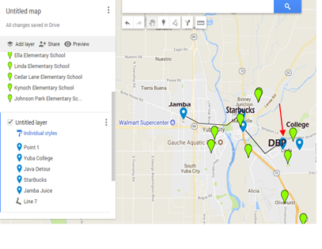

Figure 5: *Google Maps with locations of schools in the area.*

**Segmentation**

The segment of the population being targeted can be categorized under the different approaches of Geographic, Demographic, Psychographic, Behavioral, and Decision Maker. Under the Geographic approach the segments included are nations, states, regions, cities, neighborhoods, and zip codes. Of these cities and neighborhoods are selected. Under the Demographic approach the segments are age, gender, family size, income, occupation, education, religion, ethnicity, and nationality. Of these family size, income, occupation, and education are selected. Under Psychographic segments included are lifestyle, personality, attitudes, and social class. Of these social class, and lifestyle are selected. The segments listed under Behavioral include user status, purchase occasion, loyalty, and readiness to buy. Of these user status, purchase occasion, loyalty, and readiness to buy are selected. Lastly is the Decision Maker category which holds decision-making role or purchaser / influencer segments of which all are selected.

In explanation for selection the “geographic” this location is close to several markets. Parents traveling to drop off kids, college students, and military personnel. These are great markets for the sale of both coffees and healthy juices. The location for the startup is in the city of Marysville, in the neighborhood if Linda which is a location conducive to all three market without current competition. Also, it is close to the entrepreneurs place of residence, this helps in all parts of the business. Family size is considered as one of the segments. Since one of the target markets are parents taking their kids to and from school. Income is considered as middle class people are the target market who frequent coffee shops and juice bars the most. Occupation is considered a segment as military service personnel are one of the target markets. Education is further selected because of Yuba college. The student and the college are envisioned as being the bread and butter for this location of DBP. Social class, and lifestyle are selected because, again, the middle class are the ones who mostly frequent coffee houses. Lifestyle is selected for two reasons, first on the coffee side, the busy lifestyles of the college student, service personnel, and working parent demand the consumption of caffeinated products, and secondly, the healthy lifestyle creates a market for healthy juice-based beverages. User status and purchase occasion all have to do with those going to and from work or school; loyalty is chosen as the customers of both Dutch Brothers and Jamba Juice seem to show a lot of it, and the middle class is ready to buy products from the menu for all the reason listed above. Finally, the decision-making role is included as word of mouth travels and people chose DBP over driving to the next neighborhood.

**Conclusion**

In summarizing in one paragraph why this product has a competitive advantage the co-branding will create a niche that will fulfill a need. There is no local coffee house nor is there a local juice house. DBP will offer a solution to a cry for juicers and coffee drinkers both. Economies of scale will come from strategic alliances between DBP and its suppliers, as well as, cost reduction from co-branding. People first culture will create loyalty as people choose DBP as a result of community efforts and just caring for people. Buy co-branding lulls in sales will be filled. Startup costs will be eased by using this co-branding method as well. Finally, DBP will be able to take advantage of first mover advantage as it will have few if any close competitors while creating a blue ocean niche, i.e. The Healthy Coffee House.

References

Carpenter, M., Bauer, T., Erdogan, B., & Short, J. (2013). Principles of management. Washington, DC: Flat World Knowledge, Inc.

Daley, J. (2012) New Franchises Team Up and Make Co-branding Work, Url https://www.nasdaq.com/article/new-franchises-team-up-and-make-cobranding-work-cm129748

Darnall, R. & Preston, J. (2012). Project Management: from Simple to Complex. Washington, DC: Flat World Knowledge, Inc.

Dutch Brothers (2017) America's Best Small Companies., Url https://www.forbes.com/companies/dutch-bros-coffee/

Essays, UK. (November 2013). Industry and marketing analysis of Starbucks Coffee. Retrieved from https://www.ukessays.com/essays/marketing/industry-and-marketing-analysis-of-starbucks-coffee-marketing-essay.php?vref=1

Figure 5 (2018) Jeffery Morse, Brandman University, Google Maps with locations of schools in the area. Retrieved from https://www.google.com/search?q=google+maps+of+local+schools+95901&npsic=0&rflfq=1&rlha=0&rllag=39138347,-121557910,2630&tbm=lcl&ved=2ahUKEwjM8JzPy8HeAhUFjlQKHQ5eDk8QtgN6BAgGEAQ&tbs=lrf:!2m1!1e3!3sIAE,lf:1,lf_ui:4&rldoc=1#rlfi=hd:;si:,39.1258989082525,-121.54615279109424;mv:!3m8!1m3!1d8786.43112140018!2d-121.54775437738624!3d39.12005412852481!3m2!1i1010!2i545!4f13.1

Geroski, P. A. (1999). Early warning of new rivals. Sloan Management Review, 40(3), 107–116.

GovDocs (2016) California Minimum Wage Workers Will Receive $15 Per Hour By 2023 Share this entry Published April 8, 2016 https://www.govdocs.com/california-15-statewide-minimum-wage/

IBISWorld, (2018) The Retail Market for Coffee - US Market Research Report <https://www.ibisworld.com/industry-trends/specialized-market-research-reports/retail-market-reports/the-retail-market-for-coffee.html>

IBISWorld2, (2018) Juice & Smoothie Bars - US Market Research Reporthttps://www.ibisworld.com/industry-trends/specialized-market-research-reports/consumer-goods-services/food-service-drinking-places/juice-smoothie-bars.html

Invest, (2018) Url https://www.investopedia.com/markets/stocks/sbux/#Financials

Jamba Inc. (2018) Annual Report http://ir.jambajuice.com/phoenix.zhtml?c=192409&p=irol-newsArticle&id=2338420

Kelly, M. (2018) The ‘Trump economy’ vs. the ‘Obama economy’, The Washington Post (September 18)

Management, Pennsylvania State University, PA, USA and College of Hotel and Tourism Management, Kyung Hee University, Seoul, South Korea (Revised 21 June 2018) https://doi.org/10.1016/j.ijhm.2018.07.007

Porter, M. E. (1980). Competitive strategy: Techniques for analyzing industries and competitors. New York, NY: Free Press.

Rapacon, S. (2015) More college students are working while studying, special to CNBC.com Published 2:16 PM ET Thu, 29 Oct 2015 URL https://www.cnbc.com/2015/10/29/more-college-students-are-working-while-studying.html

Sun, K., & Lee, S. (2018) Competitive advantages of franchising firms and the moderating role of organizational characteristics: Evidence from the restaurant industry, International Journal of Hospitality Management. In Press Corrected Proof, School of Hospitality

Wright, O., Frazer, L. (2007) McCafé: The McDonald ’ s co-branding experience. *The Bill Merrilees Journal of Brand Management* pp442 – 457. Doi. 10.1057/palgrave.bm.2550088; published online 11 May 2007