The Competitive Advantage

Of

Dutch Brothers Plus

Jeffery Morse

Brandman University

The Competitive Advantage of Dutch Brothers Plus

Coffee remains a favorite beverage of the world. There is just something about waking up to the smell of fresh brewing coffee. As a result, the coffee industry continues to grow with an approximate income of 37 billion a year and an annual growth of about 3.6% (IBISWorld, 2018). On the flip side, today's health craze is the result of the current generation--the age of information. The upcoming generation is green, health conscience, and they are innovators who understand that health is a product of diet. This understanding is the bread and butter of franchises offering juice blends and other health-related items. As a result, Dutch Brothers Plus (DBP) has been envisioned to encapsulate the best of both worlds –the world’s first healthy coffee house. There are several ways to attain competitive advantage. According to Darnall & Preston (2012), one might choose First Mover Advantage where a firm gains an advantage by being the first to offer a service or product. One research study of 1,226 businesses over a 55-year period found that the advantage over rivals first mover brings often lasted for a decade or more. (Darnall & Preston, 2012). Some other ways to achieve a competitive advantage might be the Home-Country Demand. Knowing one's market is always an advantage. Still, others may include Total Quality Management (TQM), Innovation, Joint Ventures (a cooperative arrangement that involves two or more organizations), Strategic Alliance (a cooperative arrangement between two or more firms) or Customer Focus (Darnall & Preston, 2012; Global Industry Analysts, Inc., 2011). In reality, relying on just one item for competitive advantage is a death sentence. To be successful, a firm must create a plan for competitive advantage that makes use of several areas. DBP’s plan was outlined in the Morse (2018b) “Strategic Fundamentals and Environment Plan for Business Upstart” available in the Appendices (see Appendix 2). The outline includes most of the listed competitive advantage paths in one way or another. DBP will gain competitive advantage from First Mover, and Innovation through Co-Branding (a subtype of Joint Ventures), Home-County Demand--by being a part of every community DBP is in, TQM employed at every step to ensure a high-quality product, Strategic Alliances by contracting with local farmers for high-quality organic produce, and by Customer Focus. One thing is clear the U.S. economy has changed from a goods producer to a service provider (Peters & Payack, 2010; Strauss, 2010). In order to seriously consider competitive advantage, one must gear toward customer satisfaction.

**Industry Analysis**

Starbucks will serve as a benchmark company for DBP. Starbucks is a coffee chain company started in Seattle Washington. Now, Starbucks is recognized as an international organization whose fame for quality coffee reaches over the entire world. It has almost 16,120 stores in 49 different countries this makes Starbucks the largest coffee company in the world (Essays, 2013).

DBP will be purchasing trademark rights from Dutch Brothers. Dutch Brothers had its inception in 1992. Owned by two brothers by the names of Dane and Travis Boersma, since then, it has transformed into a successful franchising company with Travis as the CEO (Dane passed away some years ago). Today, Dutch Bros allows all of their management to make the final say for their location as long as it falls in line with what Dane and Travis called the “Dutch Creed,” a short list of principles that help govern the business in its ethics and day-to-day business transactions (Dutch Bros, 2017).

Jamba Juice will first serve as a benchmark firm, and then DBP will acquire the firm at a point in the future. Jamba Juice is showing near 75 million in revenue with 22% of that being EBIT—that is about 15 million in yearly profit (Jamba. 2018). Dutch Brothers coffee is doing as good (Dutch, 2018). Overall, the state of both industries is good. Juice bars are showing a 2-billion-dollar revenue with a margin of annual growth at about 2.3% (IBISWorld2, 2018). Indeed, a generation of health conscience people creates a promising forecast for both the coffee and juice bar industries. By creating a hybrid that sells both healthy juice and coffee, a firm can expect a growth percentage shown by the mean of these two industries—or about 3%.

**Porter's Five Force Model**

In the industry, environment competition can be analyzed by using Porter's Five Force Model Technique. It consists of five forces used to measure industry competition. If competition is strong, an industry is thought to be strong as well. The five forces are the threat of new entrants, bargaining power of customers, bargaining power of supplier, the threat of substitutes and competitive rivalry within the industry (Carpenter, Bauer, Erdogan, & Short, 2013). Starbucks will serve as the benchmark during the Porter Model analysis.

**New entrant's threats.**

The coffee industry environment in which Starbucks operates is very competitive. Coffee companies compete with the other brands in the market like McDonald's and Burger King. They also must compete with other coffee companies a list of current companies might include Java Detour, Dutch Brothers, Iron Bean, and Starbucks. Barriers to entry into the coffee market are relatively low due to the low capital investment needed for small kiosk centers, drive-thru, and storefronts. Since the likelihood of new entrants is a function to which barriers to entry exist new entrants are a threat (Geroski, 1999). In addition, if customers face few switching costs product substitutes present an even stronger threat to an existing firm (Carpenter et al, 2013).

**Customer's bargaining power.**

The profit of a service company is directly related to the number of its customers. Previously the bargaining power of a customer had less weight but due to brand competition. In addition, due to new entrants in the market franchise saturation has occurred (Wright & Frazer, 2007). Previously, coffee market customers had less bargaining power because of the Starbucks monopoly. Today, all the new entries into the coffee market have increased the bargaining power of the customer. Substitute switching is now a factor of who is closest instead of a factor of loyalty. Competitive advantage is needed to retain customers.

**Supplier's bargaining power.**

Suppliers to the coffee house have high bargaining power. Coffee beans are essential for business. Gaining economies of scale is needed to supply profits. To gain these economies one must seek out strategic alliances with coffee suppliers, equipment suppliers, appliance repair firms, and general maintenance firms (Essays, 2013). Industrial coffee machines carry high bargaining power as a result of few suppliers in combination with a growing number of entrants.

**Threat created by substitutes.**

The coffee market is full of substitutive products. Energy drinks, alcoholic beverages, smoothies, soft drinks, juices, and water can all replace coffee. As a result, all these products represent a threat. Also, the local supermarket sells cold coffee alternatives at rock bottom prices. One might add lounges, convenience stores, donut shops, as well as the kitchen faucet. Leaning not only to deal with but to capitalize on these threats will be integral to retailing products effectively and efficiently. Unfortunately, coffee houses traditionally have dips in sales during the hot months (Invest, 2018). In order to remove threats, DBP must capitalize by removing them through filling this lull. In contrast, juice bars and smoothie houses have dips in sales in winter months (Invest, 2018) this gives the opportunity to create competitive advantage through fulfilling product lull by offing both coffee and juice. Merging the two firms creates a competitive advantage.

**Competitive rivalry in industry.**

All over the world, Starbucks is recognized as a great brand name; they represent the biggest competitor in the coffee industry (Starbucks, 2018). Other competitors such as Java Detour, Gloria Jeans coffee, De Bella and McDonalds McCafé also have famous brand image all over the world. They all represent competitive rivalry. In addition, coffee suppliers such as Burger King’s cup of Joe and Dunkin’s Donuts brand coffees further increase competition.

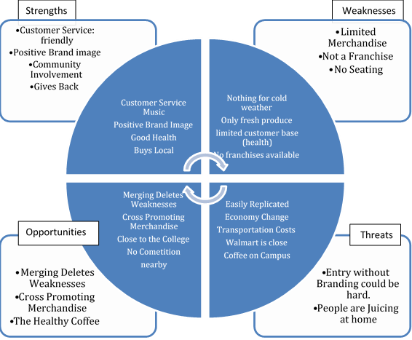**SWOT**

Figure 1: *SWOT. Supplied by Morse (2018) from Strategic Fundamentals paper (see Appendix B).*

**PESTEL --** Political, Economic, Sociocultural, Technological, Environmental, and Legal.

The PESTEL is offered here under the Industry Analysis but is also considered as part of the Market Analysis. Morse (2018b) reported the following;

**Political.**

According to Morse (2018b) DBP can expect favor from the city and since DBP is focused on community involvement forecast political support. Also, the U.S. is currently experiencing a reprieve from its last recession.

**Economical**

Economic growth projected as sidewalks and drainage are being installed from the highway to the college. Correspondingly, both companies that DBP is patterned after are doing well financially in both California, and the U.S., including the locations currently doing business closest to the DBP, proposed location.

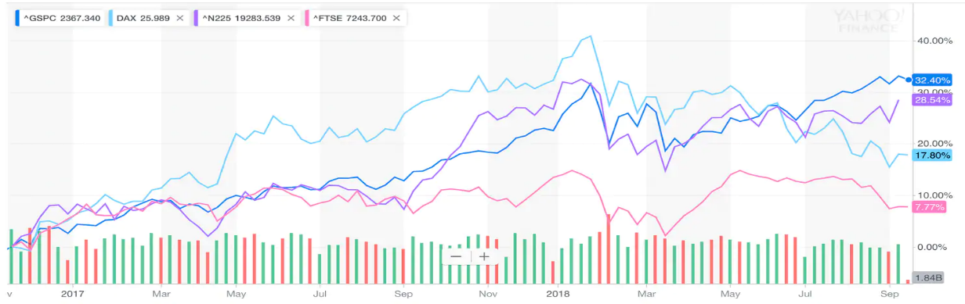

Figure 3 2

Figure 3: *Source Bureau of Land Statistics, The Washington Post (Kelly, 2018).*

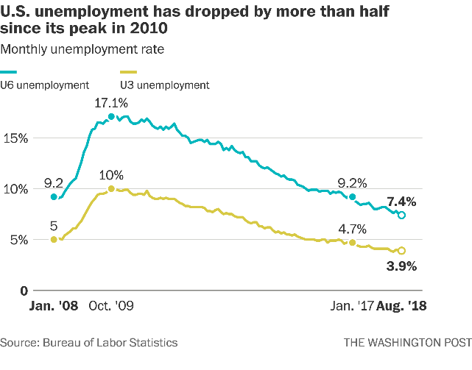

Figure 2

Figure 2: *Source Bureau of Land Statistics, The Washington Post (Kelly, 2018).*

In addition, The Washington Post reports unemployment is lower than it has been in years while the GDP continues to rise (Kelly, 2018).

**Social-cultural.**

Morse (2018b) reports that the Social-cultural feel of the area is one of oppression, however, by focusing on injecting success, music, honest, quality, and fellowship into the community DBP can help promote change. Congruently, the offering of healthy juices, and generally promoting health accords itself with the cultural swing toward health currently occurring in this generation.

**Technological.**

Ensuring Just-In-Time deliveries through Information Supply Systems to warrant the freshest organic produce for juicing, staying on the cutting edge of music, offering Wi-Fi and high-speed internet access will make DBP a valued location for study or out-of-office work. In addition, commitment to innovation will ensure that DBP stays on top. All the technologies needed are already readily available in the desired location.

**Environmental**

The overall environment is one of growth, and new business ventures currently have an opportunity for promise and sustainability. Morse (2018b) make a note that the PESTEL provides a good sense of the broader macro-environment. Complementary, Industry Analysis informs about an organization’s competitive environment as well as the key industry-level factors that seem to influence performance. Morse (2018b) reports that the industry analysis of Starbucks, Dutch Brothers, Jamba Juice, and Planet Smoothie franchises all show growth and sustainability across the board. For more information concerning the industry analysis, please refer to Morse (2018b) *“Strategic Fundamentals and Environment Plan for Business Upstart”* (see appendix B).

**Competitive Advantage**

Competitive advantage strategy and design play a vital role as it brings sustainability and longevity. Starbucks is famous in its market and has generated a huge profit through creating a people-centered culture to achieve a competitive advantage (Starbucks, 2018). Amazingly, people increased loyalty when Starbucks publicized how it treats employees and customers. Starbucks chose to an unconventional competitive advantage because sustainability can be affected by competitors when competitive advantage is found through the product line. Therefore, to survive in the market, a company should find its competitive advantage not only in the product line but in as many unconventional ways possible.

**Co-Branding in the Franchising Industry**

In appendix (A) there resides a Literature Review with a theme that states, “Co-branding is considered by many to be a miracle competitive advantage solution.” Further, the review seeks to affirm that co-branding is an effective means DBP can employ to attain competitive advantage (Morse, 2018a).

Sun & Lee (2018) indicate that franchising itself offers benefits to franchisors by helping them develop a competitive advantage. This advantage allows firms to outperform competitors. Morse (2018a) seeks to further that advantage through co-branding. At one time, the terms co-branding and co-franchising were synonymous. However, today the terms co-branding, or piggybacking represent multiple franchises operated by one owner in one location while the term co-franchising leans more toward multiple franchises operated in one location by different owners. Simply, co-branding is any franchise offering products from another franchise or retailing offerings outside the franchises traditional menu (Hurwitz, 1995). The Literature Review (LR) in appendix (A) states that the greatest reason for co-branding is to create “leverage.” Hurwitz (1995) Defines leverage as the ability of co-branding partners to rely on each other. This points to the need for prospective co-brands to have the ability to work well together.

Morse (2018a) categorizes the two types of co-branding. The first leaning toward the name co-franchising--a joint venture where two or more franchises are operating at one location. The second is co-branding as a single owner or brand expansion. Sherman (2012) states that a pioneer of co-franchising, Tricon Global Restaurants, used a tri-branded concept by co-branding KFC, Taco Bell, and Pizza Hut together, three separate franchises under one roof, unfortunately, it did not gain much success (Young, Hoggatt & Paswan, 2001; Hamstra, 1998a). Sherman (2012) proclaims that this advantage represents cost savings in three ways. First, co-franchising offers shared costs in marketing, packaging, rent, and utilities. Secondly, co-branding achieves benefits through complementary services. Lastly, co-branding expedites expansion. In addition, co-franchising can ease the achievement of brand recognition, create convenience, tap into national image and awareness, increase distribution networks, add clout, and it can double endorsement power and brand recognition. One co-franchising effort that met with success was McDonalds & Walmart as reported in Morse (2018a). Davis and Ritchie (1997) stated that one of the most successful co-franchising efforts from 1997 until now is McDonald’s and Wal-Mart. Davis and Ritchie (1997) conclude by saying that opportunities exist as long as partnerships are successful and profitable for both.

In comparison, co-branded efforts of the second type (non-franchising) tend to be less likely to fail. Morse (2018a) reports that co-branding through brand extension has met more success. The best-documented case began in 1993 when McDonald's used the co-branding brand expansion method to add McCafé coffee. The key is that the mother franchise must be strong enough to carry a sub-brand. After its initial success, McDonald's began encouraging franchisees to own the entire outlets containing the co-brands (Wright & Frazer, 2007). Success came after projected barriers were found to be false. For instance, co-branded firms showed an increase in revenues in both brands while lowering operating costs instead of the projected losses due to choice (Wright & Frazer, 2007).

**Rules and regulations.**

In comparing the rules and regulations of the two type of co-branding reported on one stands out as a better solution for DBP. Co-franchising, having two separate franchises in one location, is subject to several regulations that increase startup costs, confusion, and administrative stress. While having a separation between franchises is a positive for major chains in bookkeeping, as well as, taxation record keeping--for the startup entrepreneur, this would only add startup costs. In extreme cases, such as the case where franchise licenses were unavailable, this may even prevent startup formation. Morse (2018a) gives an endorsement for a brand extension as a form of co-branding. Indeed, Cannon (1997) revealed that, while co-branding offered great benefit, the Federal Trade Commission’s fractional franchise exemption is the way, to go. Due to struggling federal and state comprehensive regulation the better solution is a brand extension with a “right of use” trademark license instead of purchasing an actual franchise which is an in-house brand expansion form of co-branding. This choice is further supported by the success of McDonald's and McCafé co-branding reported by Wright & Frazer (2007).

**Market Conditions**

Morse (2018b) reports in the VRIO that since people love coffee and love to relax value and market share may be increased. Continuing, DBP offers beverages at a discount when compared to Starbucks, or Java Detour--this also improves marketing penetration. Jamba Juice creates value by cornering the market on the health front. As a result, DBP will be able to create a first-mover competitive advantage through assessing products from both Jamba Juice and Dutch Brothers in a way that, regarding co-branding, may be defined by product development. How? By expanding to include brand extension so a coffee shop will include healthy juice alternatives as a form of product development. Co-jointly, marketing regarding market penetration as well as market development also apply. Markets already exist for both; however, a market were both intersect does not currently exist. In fact, it is very rare to find a hybrid coffee house and a juice bar co-brand. In addition, rarity is increased due to the lack of juice bars within the city. Though this firm may easily be duplicated, and new entrants do represent a major concern according to Porters Competitive Strategies it may also be a positive for DBP. As future plans for expansion into new markets come to fruition ease of duplication lowers startup costs of new franchises. One benefit of finding competitive advantage in more than one area is that it protects by creating loyalty which in turn stops substitutable firms from taking customers. Porter's Generic Competitive Strategies gives competitive advantage from having a focus as well as having differentiation (Porter, 1980). DBP is definitely different, focusing on customers will complete Porter’s Strategy.

In the industry analysis portion of this paper, there was listed some data on current market standings for the benchmark businesses of DBP. To abbreviate, Jamba Juice is reporting 15 million in profit (Jamba. 2018), Dutch Brothers coffee is reporting about the same (Dutch, 2017), Juice bars, in general, show a 2-billion-dollar revenue with annual growth at about 2.3% (IBISWorld2, 2018), The coffee industry earns about 37 billion a year with an annual growth of 3.6% (IBISWorld, 2018). DBP’s main competitor is listing its EBIT to be in the nationhood of 50 billion, with an astounding 92.56% return on equity (Morse, 2018b).

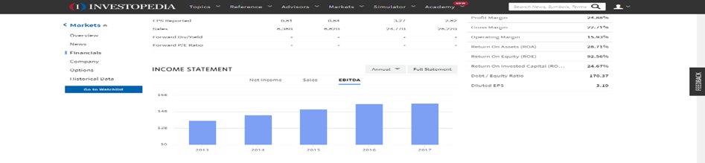

Figure 4

Figure 4: *Coffee industry EBIT, (IBISWorld2, 2018); Taken from (Morse, 2018b).*

**Competitive Advantage**

In describing five competitive advantages of DBP business startup the first one to mention is the First Mover advantage. A first-mover advantage exists when a firm establishes a dominant position by being the initial firm to enter a market or introduce a process that brings economies of scale (Upson, Ketchen, Connelly & Ranft, 2012). Owning the first foothold can dissuade other firms from becoming entrants. Also, initial footholds bring to firms the ability to have quick response capability within a competitor battle. Darnall and Preston (2012) put Customer Focus at the forefront in their article. Likewise, Starbucks has gained a competitive advantage from their People First Culture (Starbucks, 2018). DBP will also follow suit in depending on a People First Culture (PFC) to provide a competitive advantage. DBP will not only be outlining Starbucks culture, but further addition of community involvement will be part of the pinnacle of DBP culture. The employee first motto which provides health care, education, and franchise opportunities to its employees is one way DBP will create PFC. Secondly, customer focus and making every customer feel like they are the most important; thirdly, DBP will be giving a percentage of its profits back to the community it is located in for humanitarian and community improvement projects. The fourth competitive advantage DBP will have is through Total Quality Management (TQM). TQM will result in quality products in tandem with reductions in cost by preventing waste by decreasing production time while spurring innovation. Fifth, innovation will bring competitive advantage as processes for this new co-brand technique are established and franchised. Strategic alliances with supply partners and value chain innovation will bring a further advantage (Darnall & Preston, 2012). Lastly, and the topic of the review in appendix (A), DBP will acquire a competitive advantage through a superior hybrid brand extension co-branding technique. Morse (2018a) reveals that the FTC exemption is beneficial for competitive advantage due to struggling regulation between federal and state governments. The solution of brand extension in tandem with acquiring a simple trademark use license instead of a franchise allows the gain of trade mark notoriety without major capital expenditure due to franchise purchases or regulation adherence costs. This is co-branding by way of in-house brand expansion. Wright & Frazer (2007) revealed the power of in-house brand expansion through the success story of the McDonalds and McCafé brand expansion. Daley (2012) revealed that co-branding could be successful if it is done between complementary brands. This is where the real heart of competitive advantage through the co-branding of Dutch Brothers Coffee and Jamba Juice come into play. By purchasing a Dutch Brothers trademark usage license, DBP is free to add the “Plus” to the name and incorporate Jamba Juice Product line items – though without the actual Jamba Juice Trade Mark. The original business plan cited in the tactical plan (see Appendix B) is to eventually acquire the Jamba Juice company. Shares and profits have been falling for years now for Jamba Juice, and DBP plans on capitalizing through acquisition as a result (Morse. 2018b). Co-branding is useful for reinvigorating a failing brand (Morse, 2018a), as a result, the Jamba Juice brand will come back to life after the acquisition--provided DBP is strong enough to carry the co-brand. Since it is basically the “Plus” side of DBP already co-franchising officially at that time would be beneficial if DBP should choose to do so.

**Business Plan Descriptions**

**WHO**

Who is the customer of DBP? She is the most important person that visits the establishment; customers need to feel that way when they leave. Typically, customers are working class people in the middle or mid to low economic class, the working parent dropping off kids to school, the service person coming off or going on duty, or the college student attending college. They are also the kid that mom wants to provide a healthy juice drink to, the health-conscious person looking to expand their diet to include healthy blended vegetable and fruit juices, the person on a cold morning in search of a hot beverage, or the person on a hot day searching for blended ice beverage.

**HOW**

How does the customer get information about available choices? DBP will be the “Healthy Coffee House.” The new style of coffee house is filling a blue ocean niche. Media will play a big role in advertising, however, like Starbucks, positive word of mouth will advertise as a result of the DBP people first culture. As DBP becomes people first by supporting people whose goal is to better life and society, in caring about the communities they are placed, in actively creating alliances with businesses that support health--like gyms and schools. DBP will seek to encourage vision, health, and hope through imagery, culture, its menu, and advertising. By creating an image that promotes success, hope, vision, and health DBP will become known for the caring of people; in this way, DBP will find satisfaction in its target markets.

**WHY**

People are looking for a healthy choice; they want the firms they buy from to put them first. Consumers are tired of the profits first people second standard of business. One reason Starbucks has longevity is that it cares about its employees and its customers. Starbucks provides health coverage for each employee whether part-time or not (Starbucks, 2018). People will buy from firms that they feel care. Also, location plays a part. Since there are no local coffee houses or juice bars people are forced to drive out of their way or do without--simply as a matter of convenience people will purchase. Lastly, juicing at home is expensive and messy. Having an affordable, organic, juice alternative for the health conscious is something that is needed today. As the health craze in the U.S. grows the alternatives to meet the need are few. While a juice bar on a cold morning may not be the place to go, on a warm day, or before and after a workout or a run it is just what the doctor ordered.

**WHAT**

In answering the question of, what are the conditions that have created a marketplace opportunity for this idea? Those conditions are a lack of presence of local coffee houses, no juice bars in Marysville at all, no convenient place for study groups and homework outside of the college nearby, and the health craze shouting for a juicing solution that is healthy, organic, and affordable. The factors that have opened up this opportunity are the same. Also, the fact that North Beale Road and the college district are currently undergoing a facelift has brought opportunity. The city is putting in sidewalks, street lamps, drainage, and promoting business startups in the location. With the establishment of DBP coffee lovers will no longer have to drive to downtown Marysville for a coffee, or to the next city over for a healthy juice alternative. Students will no longer have to study in the noisy cafeteria at the college, sure the library is available, but no food or beverage or talking is allowed. DBP will provide a place designed for studying and homework, business meetings, or out-of-office work where a smile and thankful greeting are part of the received service. The perceived need can be delivered to the customer while generating durable margins and profits.

**WHEN**

The coffee drive-thru of DBP will no doubt do most of its business in the mornings while people are traveling to school or work. However, during the day many will come to take advantage of the store-front lounging area for the music, their social occasions, and their business occasions. Further, DBP expects the juice portion to be most popular in the afternoon since predominantly people workout after work in the afternoons. This window of opportunity will be gone once the need in this area is filled because once Starbucks, Java Detour, or one of the other coffee houses set up shop the opportunity will decrease significantly.

**WHERE**

The location was chosen for the storefront, and drive-thru kiosk is at the corner of North Beale Road and Hammonton Smartsville Road in the community of Linda in the city of Marysville Ca. A former location of a gas station that has been converted to a corner market. It is readily available by traffic coming from any of the four directions of the stop light, is within a mile from the college, and has no competition within the neighborhood. The commuter will choose the drive-thru kiosk, while those who wish to take advantage of the storefront lounge will choose the storefront.

**Target Market**

The community of Marysville formally known as Linda California is financially oppressed. In fact, over 32% of the seventeen thousand people in this area are impoverished (FactFinder, 2018). On the other hand, people are making money as the median household income of the middle class is 37k a year (FactFinder, 2018). DBP target market is first these middle-class people who love coffee, but also want to be health conscious. There are several schools close by bringing a potential market from parents dropping off and picking up kids to and from school. Secondly, DBP will be catering to college students by providing a needed gathering spot. Yuba community college is very close to the location, and there are no other coffee houses or juice bars around. Thirdly, North Beale road is the main gate accessing Beale Air Force Base. There exists a market of enlisted personnel who live off base going off or coming on duty. Another market is produced by DBP being a hybrid coffee and juice bar. Demographics are changing in the area and in the nation in general. The new generations are more health conscious and want healthy alternatives. Students are also changing today as CNBC reports that more people are working and attending school (Rapacon, 2015). This helps to drive the market for coffees and caffeinated drinks. People are making more money too. Minimum wage has increased to $10.50 and is scheduled to increase to $15.00 per hour by 2023 (GovDocs, 2016).

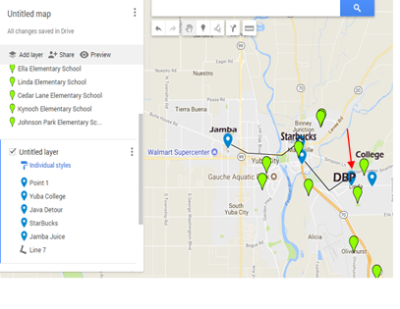

Figure 5: *Google Maps with locations of schools in the area.*

**Segmentation**

The segment of the population being targeted can be categorized under the different approaches of Geographic, Demographic, Psychographic, Behavioral, and Decision Maker. Under the Geographic approach, the segments included are nations, states, regions, cities, neighborhoods, and zip codes. Of these cities and neighborhoods are selected. Under the Demographic approach, the segments are age, gender, family size, income, occupation, education, religion, ethnicity, and nationality. Of these family size, income, occupation, and education are selected. Under Psychographic segments included are lifestyle, personality, attitudes, and social class. Of these social class, and lifestyle are selected. The segments listed under Behavioral include user status, purchase occasion, loyalty, and readiness to buy. Of these user status, purchase occasion, loyalty, and readiness to buy are selected. Lastly is the Decision Maker category which holds decision-making role or purchaser / influencer segments of which all are selected.

In explanation for selection the “geographic” this location is close to several markets. Parents are traveling to drop off kids, college students, and military personnel. These are great markets for the sale of both coffees and healthy juices. The location for the startup is in the city of Marysville, in the neighborhood if Linda which is a location conducive to all three markets without current competition. Also, it is close to the entrepreneur's place of residence; this helps in all parts of the business. Family size is considered as one of the segments since one of the target markets are parents taking their kids to and from school. Income is considered as middle-class people are the target market who frequent coffee shops and juice bars the most. Occupation is considered a segment as military service personnel are one of the target markets. Education is further selected because of Yuba college. The student and the college are envisioned as being the bread and butter for this location of DBP. Social class and lifestyle are selected because, again, the middle class are the ones who mostly frequent coffee houses. Lifestyle is selected for two reasons, first on the coffee side, the busy lifestyles of the college student, service personnel, and working parent demand the consumption of caffeinated products, and secondly, the healthy lifestyle creates a market for healthy juice-based beverages. User status and purchase occasion all have to do with those going to and from work or school; loyalty is chosen as the customers of both Dutch Brothers, and Jamba Juice seems to show a lot of it, and the middle class is ready to buy products from the menu for all the reason listed above. Finally, the decision-making role is included as word of mouth travels, and people chose DBP over driving to the next neighborhood.

**Conclusion**

In summarizing in one paragraph why this product has a competitive advantage the co-branding will create a niche that will fulfill a need. There is no local coffee house nor is there a local juice house. DBP will offer a solution to a cry for juicers and coffee drinkers both. Economies of scale will come from strategic alliances between DBP and its suppliers, as well as, cost reduction from co-branding. People first culture will create loyalty as people choose DBP as a result of community efforts and just caring for people. Buy co-branding lulls in sales will be filled. Startup costs will be eased by using this co-branding method as well. Finally, DBP will be able to take advantage of the first mover advantage as it will have few if any close competitors while creating a blue ocean niche, i.e., ”The Healthy Coffee House.”

References

Cannon, C. (1997) *Keys to Unshackling Co-Branding Alliances*. Federal Franchise Rule Compliance, Franchise Law Journal (1997 pp 39-48).

Carpenter, M., Bauer, T., Erdogan, B., & Short, J. (2013). *Principles of management*. Washington, DC: Flat World Knowledge, Inc.

Daley, J. (2012) *New Franchises Team Up and Make Co-branding Work*, Url https://www.nasdaq.com/article/new-franchises-team-up-and-make-cobranding-work-cm129748

Darnall, R. & Preston, J. (2012). *Project Management: from Simple to Complex*. Washington, DC: Flat World Knowledge, Inc.

Davis, A.W. & Ritchie, H. (1997) *The BRANDS. America Resource Guide to Foodservice Brands and Support Systems*, Win-Formation, Richmond, VA.

Dutch Brothers (2017) America's Best Small Companies., Url https://www.forbes.com/companies/dutch-bros-coffee/

Essays, UK. (November 2013). *Industry and marketing analysis of Starbucks Coffee*. Retrieved from https://www.ukessays.com/essays/marketing/industry-and-marketing-analysis-of-starbucks-coffee-marketing-essay.php?vref=1

FactFinder, (2018) Url https://factfinder.census.gov/faces/nav/jsf/pages/community_facts.xhtml

Figure 5 (2018) Jeffery Morse, Brandman University, Google Maps with locations of schools in the area. Retrieved from https://www.google.com/search?q=google+maps+of+local+schools+95901&npsic=0&rflfq=1&rlha=0&rllag=39138347,-121557910,2630&tbm=lcl&ved=2ahUKEwjM8JzPy8HeAhUFjlQKHQ5eDk8QtgN6BAgGEAQ&tbs=lrf:!2m1!1e3!3sIAE,lf:1,lf_ui:4&rldoc=1#rlfi=hd:;si:,39.1258989082525,-121.54615279109424;mv:!3m8!1m3!1d8786.43112140018!2d-121.54775437738624!3d39.12005412852481!3m2!1i1010!2i545!4f13.1

Geroski, P. A. (1999). *Early warning of new rivals*. Sloan Management Review, 40(3), 107–116.

Global Industry Analysts, Inc. (2011, February 15). *Global Biosimilars Market to Reach US$4.8 Billion by 2015, According to a New Report by Global Industry Analysts, Inc.* Retrieved from http://www.prweb.com/releases/biosimilars/human_growth _hormone/prweb8131268.htm

GovDocs (2016) California Minimum Wage Workers Will Receive $15 Per Hour By 2023 Share this entry Published April 8, 2016 https://www.govdocs.com/california-15-statewide-minimum-wage/

Hamstra, M. (1998a), *Operators see potential in Tricon’s newest prototype*. Nation’s Restaurant News, 32, 3, 170.

Hurwitz, A. (1995) *Co-Branding*: Managing Franchise Brand Associations, 20 Okla. City U. L. Rev. 373

IBISWorld, (2018) The Retail Market for Coffee - US Market Research Report <https://www.ibisworld.com/industry-trends/specialized-market-research-reports/retail-market-reports/the-retail-market-for-coffee.html>

IBISWorld2, (2018) Juice & Smoothie Bars - US Market Research Reporthttps://www.ibisworld.com/industry-trends/specialized-market-research-reports/consumer-goods-services/food-service-drinking-places/juice-smoothie-bars.html

Invest, (2018) Url https://www.investopedia.com/markets/stocks/sbux/#Financials

Jamba Inc. (2018) Annual Report http://ir.jambajuice.com/phoenix.zhtml?c=192409&p=irol-newsArticle&id=2338420

Kelly, M. (2018) The ‘Trump economy’ vs. the ‘Obama economy’, *The Washington Post* (September 18). Management, Pennsylvania State University, PA, USA and College of Hotel and Tourism Management, Kyung Hee University, Seoul, South Korea (Revised 21 June 2018) https://doi.org/10.1016/j.ijhm.2018.07.007

Morse, J (2018a) *Co-Branding for Competitive Advantage Literature Review*: Available in Appendix A.

Morse, J (2018b) *Strategic Fundamentals and Environment Plan for Business Upstart*: Available in Appendix B.

Peters, E., & Payack. P. (2010, November 3) Avoiding an American “Lost Decade.” *The Global Language Monitor*. Retrieved from http://www.languagemonitor.com/tag/percentage-of-the-non-farm-payroll-in-manufacturing/

Porter, M. E. (1980). Competitive strategy: *Techniques for analyzing industries and competitors*. New York, NY: Free Press.

Rapacon, S. (2015) *More college students are working while studying*, special to CNBC.com Published 2:16 PM ET Thu, 29 Oct 2015 URL https://www.cnbc.com/2015/10/29/more-college-students-are-working-while-studying.html

Sherman, J (2012) *Raising capital: get the money you need to grow your business*. AMACOM, Apr 18, 2012

Starbucks (2018) Starbucks.com (2018)

Strauss, W. (2010). Is U.S. *Manufacturing Disappearing*? [Blog post]. Retrieved from http://midwest.chicagofedblogs.org/archives/2010/08/bill_strauss_mf.html#footnote2

Sun, K., & Lee, S. (2018) *Competitive advantages of franchising firms and the moderating role of organizational characteristics*: Evidence from the restaurant industry, International Journal of Hospitality Management. In Press Corrected Proof, School of Hospitality

Upson, J. W., Ketchen, D. J., Connelly, B. L., & Ranft, A. L. (2012). *Antecedents to Foothold Moves*: Insights from Competitive Dynamics. Academy of Management Journal. 55(1), 93-110.

Wright, O., Frazer, L. (2007) McCafé: The McDonald ’ s co-branding experience. *The Bill Merrilees Journal of Brand Management* pp442 – 457. Doi. 10.1057/palgrave.bm.2550088; published online 11 May 2007

Young, J. A., Hoggatt, C. D., & Paswan, A.K. (2001) Foodservice franchisors and their co‐branding methods. Journal of Product & Brand Management, (Vol. 10 Issue: 4, pp.218-227), URL: <https://doi.org/10.1108/10610420110398167>

Appendices

Appendix A: Cobranding for Competitive Advantage (Literature Review).

Co-Branding for Competitive Advantage

Literature Review

Jeffery Morse

Brandman University

Co-Branding for Competitive Advantage

Competitive advantage is one of those things that almost guarantees success when it is done right. Every business person is looking high, low, right, left and under every rock a miracle competitive advantage. There are many approaches one might take such as; a Value Chain, First Mover, Blue Ocean, and Bricolage to name a few (Upson, Ketchen, Connelly & Ranft, 2012). Co-branding is considered by many to be a miracle competitive advantage solution. Another name for co-branding is “Piggy-Backing.” Basically, this is when two franchises operate at a single location. Is piggy-backing in franchising a means of competitive advantage? The miracle means by which co-branding brings competitive advantage is through cost reduction and the filling of product vacuums while creating economies of scale by employing first mover and blue ocean product advantages.

Co-branding was once thought to be a fix-all solution, however, after several attempts and failures, eventually it fell out of favor (Hurwitz, 1995). Today co-branding is making a comeback. There are questions to be answered. Are pairing of a brands beneficial? If they failed why did they fail? Researching the question, will the co-branding of Dutch Brother Coffee and Jamba Juice bring competitive advantage through co-branding? Before answering that question there are other foundational questions like what is co-branding? Why engage in co-branding? What are the procedures in co-branding? What are the types of co-branding?  One needs to know how to use co-branding; what the government rules are. One needs to know who is doing it and if it was successful and what was learned. What is effective co-branding and successful cobranding? What are the problems and barriers? While these questions stack up the conclusion will be that piggy-backing in franchising is a great way of producing competitive advantage.

**Co-Branding and Who Does it**

In the beginning, branding was a marketing concept identified with product manufacturers. Today brand pairing, or co-branding, is not limited to product manufacturers. Co-branding has now been successful in service-based organizations, for example, the credit card industry today partners with anyone and make money. Franchise companies have succumbed to the lure of success through co-branding as well (Hurwitz, 1995). Hurwitz (1995) reveals that the U.S. Department of Commerce reported in a 1987 report on franchising in the economy, "Many franchisors are currently involved in testing a new form of franchising comprised of different products under the same roof. In other words, a franchisor would sell products and/or services within the unit of another franchisor (U.S., 1987)." Thus, the term "combination franchising," which was adopted by early commentators is now the definition of co-branding (Annual, 1987). Boone (1997) also defines co-branding as two or more brands operating within one space.

There are many different types of co-branding (CB). CB can use various vehicles, like satellites, kiosks, modules, and carts. Franchise companies have also expanded CB to include non-franchised chains like schools, hospitals, and hotels, or other "special purpose" venues (Canon, 1997). Canon (1997) continues to report that significant benefits are obtained by using consumer focus, special purpose venues, and by supporting franchise co-branding at multiple locations in a single community. Hurwitz (1995) states piggybacking has now become well-known, in franchising lexicon, due to the profiting potential of cost-sharing opportunities, and increased volumes. According to Hurwitz (1995) and Canon (1997) co-branding is any franchise retailing products listed from any other franchise or retailing offering not included in the franchises traditional menu. Risks may be present, but they can be abridged by careful planning.

**Why Do It**

According to Hurwitz (1995) the greatest reason for co-branding is to create “leverage”. Leverage is defined as the ability of co-branding partners to rely on each other's image, products, and services to advance market penetration and market share. More directly, co-branding offers a franchise opportunity to expand. Products and services are added without incurring the expense nor the risks associated with the research and development. A new customer base can be added without risk of losing the existing one. This makes co-branding a favorite among companies like Yum or Pepsi Co who operate several franchise services.

Sherman (2012) states that there are three critical factors in franchise systems: the brand, the operating system and the support given by the franchise to the franchisee. The brand creates the demand, then the operating system presents the deliverables. Lastly, the support and training provide an incentive for growth. By franchising, these firms can obtain operating efficiencies and economies of scale; achieve more rapid market penetration at a lower capital cost; reach targeted consumers more effectively through cooperative advertising and promotion; sell products and services to a dedicated distributor network; replace the need for Internal personnel with motivated owner operators and shift the primary responsibility for site selection, employee training, personnel management, local advertising and other administrative concerns to the franchisee. Sherman (2012) gives several beneficial reasons for organizing Joint Ventures as a formal type of co-branding;

• Develop a new market (domestic or international).

• Develop a new product.

• Develop and share technology.

• Combine complementary technology.

• Pool resources to develop a production and distribution facility.

• Acquire capital.

• Execute a government contract.

• Access a distribution network or sales and marketing capability.

Joint Ventures are not usually considered co-branding. However, CB has many names and is two businesses operating under one roof and normally owned by a single owner. Under that definition joint ventures and co-branded frachises are alike but are concidered co-branded hhybrids in which each franchise is separately owned and is its own entity.

**Types and Procedures**

According to Sherman (2012), there are several types of co-branding. The types listed by Sherman are Joint Ventures and Co-Branding. Joint Ventures have been partially defined already but it is noted that they offer an alternative to capital formation for small and growing companies. A paraphrased list of the benefits of Joint Ventures include access to resources, relationships, and networks, or goodwill and reputation of a larger corporate partner. The key to these relationships is to define expectations and goals clearly in advance. A less formal method can be achieved by creating strategic alliances which is defined not by the term joint venture but by the term co-branding.

All successful joint-venture and strategic-alliance relationships include complementary unified force or purpose that binds the two or more companies together; management teams committed to the success of the venture, free from politics or personal agendas; genuine synergy in which the sum of the whole truly exceeds its individual parts; cooperative culture and spirit among the strategic partners that leads to trust, resource sharing, and friendly chemistry among the parties; a degree of flexibility in the objectives of the joint venture to allow for changes in the marketplace and evolution of technology; an actual alignment of management styles and operational methods, at least to the extent that it affects the underlying project (as in the case of a strategic alliance) or the management of the new company created (as in the case of a formal joint venture); and general levels of focus and leadership from all key parties that are necessary to the success of any new venture or business enterprise (Sherman, 2012).

**Co-Branding**

Sherman (2012) lists two other forms of co-branding including financial services co-branding, where credit card companies pioneered co-branding by pairing up with airlines or telecommunications companies, and retail business co-branding. Retail business co-branding is growing rapidly and includes the creation of complementary product lines to offset different consumer tastes (such as Baskin Robbins and Dunkin Donuts whose products are now offered at the same co-branded locations).

Co-branding has many leveraging options one of which is line extensions. Stretching a brand vertically in the existing product market and performing marketing penetration using push tactics is a form of co-branding that does not required the purchase of separate franchises.

Sherman (2012) says co-branding—not the joint venture type--ought to be considered for this list of reasons.

Co-branding is a way to leverage the company's Intangible assets (including brand awareness and customer loyalty) by entering another product class. It can provide added value in the form of customer convenience thereby creating a point of differentiation from competitive products and services. It is easier and less risky than trying to build a strong brand because there are many internal and external impediments, such as corporate bias against innovation, short-term orientation, price pressures, and competitive threats. It can gain marketplace visibility and create new customer interest, which helps a company maintain brand equity in light of competitors' new product introductions and declining brand awareness. It can change the perception of a brand. The company can create a new brand personality (for example, the use of Bart Simpson with Butterfingers), or at least update it. It can help a company gain access to new product categories that otherwise would have involved a significant investment of time, money and resources. It can provide greater assurance about product quality. A brand name assists consumers' understanding of a product's characteristics, and the presence of a second brand may signal to potential customers that another firm is willing to stake its reputation on the product. It can reach a new customer base far more quickly than a new brand launch, which usually takes several years (three to five years in the credit card industry, for example). It offers a shortcut to an Image upgrade, such as Ford's Special Eddie Bauer Editions. It offers a way to target a key demographic audience, such as MasterCard's creating a co-branded card with universities to reach college students and alumni.

Sherman (2012) also suggests that leveraging intangible assets and developing strategic relationships through co-branding are not just efficient ways to build brand awareness, but also are a cost-effective way for growth when compared to traditional strategies. Conscientious franchising is a must if growing firms and franchisees want to co-exist. Sherman (2012) gives these components for responsible franchising to create a secure foundation.

* A proven prototype location that will serve as a model.
* Models must have been tested, must be profitable, operated successfully.
* Have a strong management team.
* Adequate capitalization to sustain the franchising program.

**Advantages of co-branding.** Sherman (2012) states co-branding offers many advantages in cost savings for a business. First co-branding offers shared costs such as marketing, packaging, rent, and utilities through sharing the same location. Next, co-branding permits complementary services to achieve benefits. Thirdly, co-branding expedites expansion into international markets. It can make it easier to achieve brand recognition in foreign markets, it creates convenience for the customer, has the potential to tap into national image and awareness, can increase a firms distribution network, enhance market clout, and it can double brand recognition and endorsement power.

**How to use Co-Branding**

One of the pioneers of co-branding Tricon Global Restaurants who used a tri-branded concept of co-branding KFC, Taco Bell, and Pizza Hut together (Young, Hoggatt & Paswan, 2001; Hamstra, 1998a). Though this attempt did not end in great success, it still succeeds in the instruction of co-branding (Young et al., 2001). Industry insiders propose that opportunities for co-branding are increasingly flooded (Davis & Ritchie, 1997).

**Co-branding Methods**

Co-branding methods are revealed in history. According to Davis and Ritchie (1997), the most observable firms using co-branding partnerships in 1997 were McDonald’s with Wal-Mart and Little Caesars with Kmart. Daley (2012) shows that McDonalds and Wal-Mart are still thriving. Typically, Wal-Mart’s average McDonald’s is operated by a local franchisee. The franchisee pays both rent and royalties to Wal-Mart and still fights for exposure (Nations’ Restaurant News, 1997). Raithel (1999) reported that Little Caesars would be closing many of its stand-alone locations no doubt this was due to the looming bankruptcy of K-Mart (Isidore, 2018). Davis and Richie point out that what was learned from these pioneers. Four methods of co-branding were gleaned, internal development, the sale of a brand, the purchase of a brand, and the external development of a second brand. The internal development of a second brand for example Blimpie International (BI) who developed a quick-serve Italian concept called Pasta Central in over 200 Blimpie Subs (Zuber, 1999). Another, Dairy Queen, has its tri-branded concept of Dairy Queen, Orange Julius, and Karmelkorn (Shubart, 1999); 2. The sale of a brand in acquisition. One example of sell brand is Lay’s chips brand being sold in a grocery store, or a line of professional hair products at one's favorite hair stylists (Arkansas Business, 1997); 3. The purchase of a second brand through acquisition. An example of purchase brand is simply entering into a franchising agreement with another franchisor and its franchisees and then run both franchises in the same location. In 1996, Arby’s Inc. secured a franchise contract with T.J. Cinnamon that would place T.J. Cinnamon products inside Arby units (Kramer, 1996). Lastly, the external development of a second brand. An extreme of this is external development where both firms remain separate entities like with joint ventures.

**Collaboration and Its Effect**

Collaboration (e.g., joint action or decision making) for franchisors is not new territory. Problems may arise in trade dress (e.g. “the total visual image and overall appearance”) (Abbott & Lanza, 1994, p. 2) and may jeopardize the uniqueness of each franchise. As they say, “anything with two heads is a monster”. On the other hand, relinquishing administrative control to the franchisee may suggest managerial actions for the franchisors (Justis & Judd, 1998).

**Managerial Implications**

Davis and Ritchie (1997) conclude in saying that there are various methods available for co-branding as a possible approach to marketing. Franchisors should evaluate their expertise in brand development as well as the availability of resources. Evaluation will clarify if a franchisor should attempt to develop a second brand in-house or whether it should collaborate. As more franchisors become involved in co-branding relationships, new knowledge may emerge that documents reasons for success and failure.

**Government Rules**

The rules and regulation concerning franchises are a concern when determining if co-branding is viable for competitive advantage. It may be beneficial to use the brand expansion method of co-branding. Cannon (1997) is focuses mainly on the avoidance of franchise regulation and escapes regulation compliance of the pre-sale registration and disclosure law. However, Cannon (1997) offers many guides to help in the establishing of co-branded franchises. First, a franchisee should begin with a test phase. This allows partners to verify the concept, record operational compatibility, and add a working proposal. Regulatory issues include the fact that a franchise is regulated at both the federal and state levels. States that require full registration before the "offering" or the “selling” of a franchise are California, Illinois, Indiana, Maryland, Minnesota, New York, North Dakota, Rhode Island, South Dakota, Virginia, and Washington.

**The FTC**

The Federal Trade Commission (FTC) Rule places a minimum level of protection for prospective franchisees. There are no private rights of action under the FTC Rule, but the FTC itself may bring an enforcement action against a franchisor who fails to meet its requirements. Penalties for noncompliance include impoundments of assets, cease-and-desist orders, injunctions, mandated rescission and/or restitution for any injured franchisee which may include civil fines of up to $10,000 per violation. The FTC Rule regulates two types of offerings. First the package and product franchises and business opportunity ventures. Package and product franchises have common characteristics according to Cannon (1997) the first characteristic is that a franchisee must sell goods that meet the franchisor's quality standards. This is in cases where the franchisee operates under the franchisor's trademark, service mark, or trade name. The second is that a franchisor must exercises significant assistance in the franchisee's operation. Thirdly, a franchisee is required to make payment of $500 or more to the franchisor. Similarly, there are also rules for business ventures. Franchisees must sell goods or services that are supplied by the franchisor, a franchisor must assist the franchisee in any way in securing accounts or locations for the franchisee, and the franchisee is required to make payment of $500 or more to the franchisor. As a tag, Cannon (1997) notes that the FTC Rule exempts fractional franchises, leased department arrangements, and purely verbal agreements. These exemptions may be beneficial when considering co-branding through brand expansion.

**Exemptions.** Exemptions can prove rewarding. Non-franchise status can reduce transaction costs. Exemptions can be attained by simply avoiding any of the three elements and will not be subject to regulation as a franchise under the Franchise Rules. The firse rule is that the franchisee obtains the right to sell the franchisor's branded products or to operate under the franchisor's trade name. This is the right to use the Trade Mark without the franchise. Secondly, the franchisor might exercises significant control over the franchisee's operations or provide significant assistance to the franchisee. Lastly, the franchisee pays a fee (Cannon, 1997).

**Number one.** Since the motivation is to broaden the recognition of the brand name or service mark's exposure, there is no real incentive for avoiding this rule (Cannon, 1997).

**Numbers two and three.** Under the Franchise Rule's definition, a franchise will not develop unless the franchisor exerts or has authority to exert a significant degree of control over the franchisee's method of operation (Cannon, 1997). The third is a straightforward payment.

**Fractional Franchise Rule**

The rule that springs from the unfulfillment of theses is called “The Fractional Franchise Rule.” Generally, a franchise involves an ongoing commercial relationship in which fulfills these requirements. The fractional franchise rule offers a way out of being regulated as a franchise. Escaping from regulation may prove possible and even desirable. In most cases, the rewards of locating an escape route are justified financially (Cannon, 1997). Though the federal regulations are present, no state uses the definition of the franchise set forth by those federal regulations because of lack of a consistent pattern of exemptions. Several advisory opinions illustrate the rules for defining fractional franchises which are exempt from regulation. Cannon (1997) offers the following list:

The Franchise Rule defines a fractional franchise as: any relationship in which the person described therein as a franchisee, or any of the current directors or executive officers thereof, has been in the type of business represented by the franchise relationship for more than two years and the parties anticipated, or should have anticipated, at the time the agreement establishing the franchise relationship was reached, that the sales arising from the relationship would represent no more than 20 percent of the sales in dollar volume of the franchise. Further, because at least 80% of its sales are derived from other products, the franchisee is not substantially dependent on the sales of the franchised product for his success. (p. 40)

Thus, according to Cannon (1997), the fractional franchise definition has only two essential elements: 1. The franchisee or its management must have substantial experience (minimum of two years gained any time in the past except in Ca. where it is within the last seven years) in the same or a related line of business; 2. Projected sales of the franchisor's products or services by the franchisee may not exceed 20% of the total sales (Cannon, 1997). The 20% rule has a three-step process. First, projecting the sales of the guest products for at least a year from the date the relationship begins. Second, are the total gross revenues for the same period. The percentage is calculated by dividing by the first amount by the second. Cannon makes a point of saying that a fractional franchise acquiring a trademark license is essential in fractional franchise co-branding. The granting of a limited-right-to-use will suffice.

Finally, Canon (1997) exerts that it is easier to justify an exclusion for a simple concept that for a complicated one. Avoiding Franchise Rule compliance holds an attraction for co-branding especially for the future franchising's landscape. Identifying an exemption or exclusion using the fractional rule will be rewarding in the form of reduced transaction costs, increase flexibility, and in structuring. Despite countervailing factors, enough co-branding partnerships can benefit from franchise exclusion to justify the time and energy required to attain it. Further, acquiring a limited use trademark license jointly with the fraction franchise affords all the benefits of co-branding without state and federal franchise regulation.

**Who Is Doing It and What Was Learned**

Frumkin (2002) reports that Dunkin' Donuts is opening full-scale outlets in several Home Depot stores. This latest high-profile partnership between a national foodservice operator and a major retailer is touted as a success in more than one way. Not only will it save construction personnel time in a normal morning stop for coffee and donuts, but since many make a stop at Home Depot, profitability is twofold. Huddle House, in like kind, are placing franchises in major retailers as well. Other prominent foodservice chains that are placing franchises with U.S. retailers include McDonald's, Nathan's Famous and Little Caesars Pizza. Another sandwich chain operator, which is buying back its largest franchised territory and eyeing co-branding with a pizza chain is Schlotzshy’s (Ruggless, 2002). In fact, Ruggless (2002) declares that Schlotzsky's reported that its positive performance in 35 company-owned restaurants is connected to co-branding. Co-branding efforts in their area developer territory will make key markets more attractive and achievable. A further opinion presented is that future boosts in royalty and licensing through co-branding opportunities show potential increases in revenue. New concepts are developing to prove that co-branding is becoming a strategic plan to cut costs and broaden customer base (Ruggless, 2002).

Daley (2012) writes that co-branding can create a one-stop option for groups of people with different cravings. Yum is the holding company that owns and operates Taco Bell, KFC, Pizza Hut, A&W, and Long John Silver's. Daley reports that Yum hails co-branding as

the biggest sales and profit driver for the restaurant industry since the invention of the drive-thru window. In 2002, co-branded outlets credited $2 billion in sales on the books for Yum (Daley, 2012). Why? Because not only does co-branding save on operational but it evens out customer flow. The secret is making sure partnerships are jointly beneficial. Daley continues to warn that the last few years have been riddled with co-branding marriages that died. Co-branding can be successful if it's done between complementary brands. Economies of scale are found easy for those who succeed (Daley, 2012).

**Effective Co-Branding**

Roddy (2013) also reported on Schlotzsky’s who said, “We've also begun adding Carvel Ice Cream concepts to new Schlotzsky's, making them tri-branded franchise locations, and all future franchise agreements for a Schlotzsky's restaurant include both Cinnabon and Carvel concepts.” Roddy (2013) further reported that there are many economic and operational benefits to co-branding. The key to success is in pairing two brands that complementary. In addition, communication is key. Having the correct brand pairing should benefit the franchisee operationally, in Marketing and Identity Retention, and with Customer Service (Roddy, 2013).

**Successful Cobranding**

According to Roddy (2013) co-branding is effective, but can co-branding be successful? Wright & Frazer (2007) in a report about franchising in Australia note that franchising and co-branding are at a saturation point. They report that this saturation and maturity are the results of the macroeconomic forces and federal regulation on franchising. Early explanations of franchising foretold a resource constraints theory that argued franchising was the source of external capital needed for expansion while administrative efficiency theory stated that franchising was poised to overcome any agency problems associated with any rapid expansion.

The crux is that most agree that cobranding involves combining two brands to produce a single product or offering. The idea of co-branding by brand extension is not in center view. To define the lines between the two looking back to the foundations will serve useful.

**Brand Extension or Co-Branding**

The Golden Arches were truly strong enough to carry a sub-brand to start when they introduced McCafé in 1993 as a coffee pot on the counter of the McDonalds. McDonald's soon began encouraging franchisees to own the entire outlets containing all three brands (Wright & Frazer, 2007). McDonald's felt that McCafé was a great collaboration venture. Wright & Frazer (2007) reported that the McCafé / McDonalds success produced the following themes and propositions.

**Theme 1: Attracting customers.** For theme one interviewees reported that, after the introduction of McCafé, the struggle of competition between McDonalds and McCafé did not happen as expected. Instead, for every generated a dollar’s worth of sales in the McCafé, McDonald's generating between 50 cents to 2 dollars in additional sales.

**Theme 2: Competition.** In theme two different segments of the market were identified both as new and old customers. Also, encroachment has shown to be a motivating factor for franchisees to incorporate them. As a result, it is more likely that McCafé will continue to increase as it enhances sales and profitability (Wright & Frazer, 2007). As a bonus, lower operational costs for the franchisee are also apparent.

**Theme 3: Reinvigorated brand equity.** Theme three is where Wright & Frazer (2007) point out that the reinvigoration of a brand is a recognized motivation for co-branding. If a brand is dying co-branding may breathe new life into it. This could be beneficial to a brand that suffered a fallback but where the franchisee still wills to revive it.

**Theme 4: Growth incentives.** Co-branding brings unit-wide growth for McDonald's franchising; as a model for growth is fundamental to its culture. Focusing on increasing sales and profitability and acknowledgment of a significant return on investment (ROI) is also listed as a reason for franchisees to acquire McCafé.

**Theme 5: Culture.** Culture as an intangible aspect of any organization remains a more complex part of retail co-branding. However, culture-adapted well in each franchise. While co-branding will definitely affect firm culture, it is possible to capitalize on these effects. Simply choose the culture before choosing the partnership.

**Theme 7: Legal issues.** Both incentives and barriers appear as inhibiting legal issues and forces, however, in co-branding they are particularly significant. As a result, a considerably larger investment is required to help overcome any legal issue resulting from these cultural and system barriers (Wright & Frazer, 2007). Many times federal or state regulations are broken unknowingly, or a franchisor may feel infringed upon and file suit.

**Summary**

Wright and Frazer summarize that the first four themes represent a positive motivation in favor of co-branding. Essentially, incentives are founded on growth opportunities due to co-branding. Wright & Frazer (2007) offer the following four propositions here quoted from pages 454-455.

Proposition 1: The motivational forces for franchising co-branding relate to synergies across the brands and growth opportunities, in a similar way to other forms of co-branding.

Proposition 2: The inhibiting forces to franchising co-branding are particularly strong, requiring large investments in systems and cultural re-alignment.

Proposition 3: For an organizational cobrand to be successful within a franchised retail environment, the company involved might favor acquisition to minimize the investment costs against the barriers or inhibiting forces.

**Problems and Barriers**

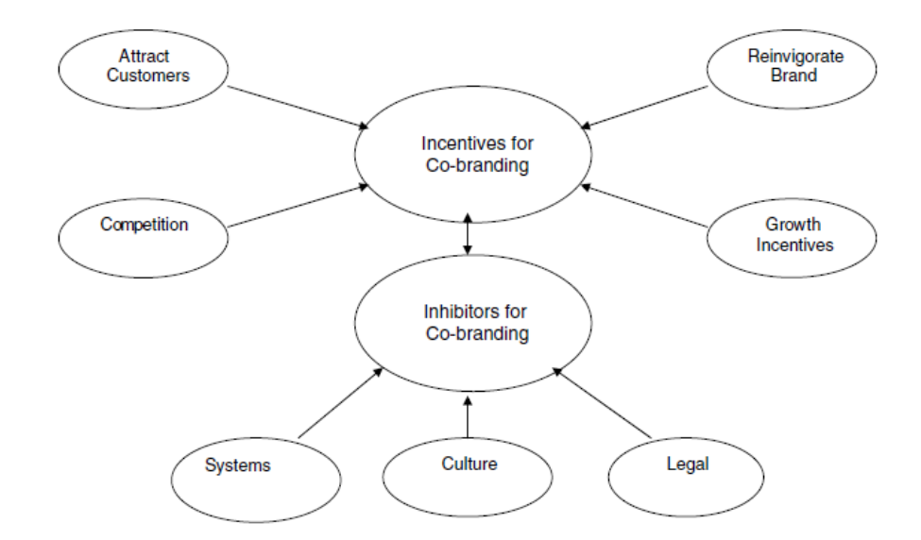

(Wright & Frazer, 2007 p 455)

Sherman (2012) reports that a poorly prepared business plan or inadequate capital structure is the main cause of franchise failure. For success one must access a distinctive and protected trade Identity, proprietary and proven methods of operation and management, make use of a comprehensive training program, comprehensive legal documents, a demand for the products and services, genuine understanding of competition, and good relationships with suppliers and lenders is a short list of the thing mentioned (Sherman, 2012).

**Conclusion**

Is piggy-backing in franchising a means of competitive advantage and will the co-branding of Dutch Brother Coffee and Jamba Juice bring competitive advantage through co-branding? Sherman (2012) gives almost an endless list of benefits. However, Cannon (1997) revealed that, while co-branding offered great benefit, the FTC exemption was worth having. Basically, due to the struggle and comprehensive regulation on both federal and state levels, the better solution seems to be a brand extension while acquiring a right of use trade mark license instead of a franchise. This is the same as co-branding but is an in-house brand expansion. Wright & Frazer (2007) revealed the power of this with their McDonalds and McCafé study. The benefits of co-branding by way of brand extension are presented as a superior provided the Trade Marking franchise is secure enough to support the venture. Daley (2012) revealed that co-branding can be successful if it's done between complementary brands. Economies of scale are found easy for those who succeed. The biggest inconsistency is that most of these papers of ten years old, there is a lack of information or peer-reviewed papers currently on the topic. Further study of current conditions in co-branding franchises is needed for an accurate and timely evaluation. Also, further study of this technique is needed. Single franchisees who extend their brand through co-branding while maintaining FTC exempt status. Lastly, will the piggybacking of Dutch Brothers Coffee with Jamba Juice bring a viable competitive advantage? Wright & Frazer (2007) reported heroic success for the McDonald’s and McCafé co-branding through brand expansion venture. Here is a comparison of some of the pros and cons.

|  |  |  |  |
| --- | --- | --- | --- |
| Pros of Co-branding | Cons | Pros of C-Franchise | Cons |

Less Cost Less Support Morse Support Cost More

Brand Extension No Separation Individual Franchise Rules and Regs

Possible to Franchise Must Build Rep. Comes with Clout Cannot Franchise

Partial Franchise Status Cannot Sell Franchises Comes with a Plan No Brand Extend

Possible Lower Taxes Entry Barriers are Low Entry Barrier Exist Taxes are Higher

The solution for DBP seems to be to acquire only the Dutch Brothers name rights and not the full franchise then uses co-branding expansion techniques to integrate Jamba Juice type franchise products without purchasing the franchise to create the branded extension of Dutch Brothers Plus. This allow DBP to eventually franchise while retaining some of the recognition that the Dutch Brothers Trade Mark brings. Further, this allow for the future acquisition of Jamba Juice at which time the possibility of conversion to a co-franchised firm is still a possibility.

References

Abbott, J. and Lanza, J. (February 1994). Thou Shalt Not Steal: Supreme Court Confirms Old Commandment. *Proceedings of The Society of Franchising and International Franchising Association Joint Conference*. Las Vegas, Nevada.

Arkansas Business (1997). Like some yogurt with that sandwich. *Arkansas Business*, (7 April, p. 1).

Boone, J.M. (1997). Hotel-restaurant co-branding – a preliminary study. *Cornell Hotel and Restaurant Administration Quarterly*, *38*, 34-43.

Cannon, C. (1997) Keys to Unshackling Co-Branding Alliances. *Federal Franchise Rule Compliance, Franchise Law Journal* (1997 pp 39-48).

Cannon, C., Goodhard, K. (1995) Non-Traditional Expansion. *The Use and Limitations of Trademark Licenses*, (A.B.A. Forum on Franchising 1995).

Daley, J. (2012) Co-Branding among franchises. *Entrepreneur* (April 2012).

Davis, A.W. & Ritchie, H. (1997) The BRANDS. *America Resource Guide to Foodservice Brands and Support Systems*, Win-Formation, Richmond, VA.

Davis, M., Blumenthal, G. (1987) Combination Franchising, *International Franchise Assassin 21st annual legal Symp*.

Frumkin, P. (2002) Home Depot builds ties with eateries. *Nation’s Restaurant News*, (September 2, 2002).

Hamstra, M. (1998a), Operators see potential in Tricon’s newest prototype. *Nation’s Restaurant News*, *32*, 3, 170.

Hurwitz, A. (1995) Co-Branding: Managing Franchise Brand Associations, 20 Okla. City U. L. Rev. 373

Isidore, C. (2018) *Things are bad at Sears. They're worse at Kmart,* CNN Business Updated 4:10 PM ET, Sun October 21, 2018 URL https://www.cnn.com/2018/10/21/business/sears-bankruptcy-kmart/index.html

Justis, R.T. and Judd, R.J. (1998) Franchising, Dame, Houston, TX.

Ketchen, D., Short J.(2011) *Making Competitive Moves*, Mastering Strategic Management, Chapter 6, Section 1. Copyright 2011 Flat World Knowledge, Inc.

Kramer, L. (1996), “Arby’s launches alliance with T.J. Cinnamons,” Nation’s Restaurant News, Vol 30, 5 February, pp. 1, 66.

Raithel, T. (1999), No pizza, no pizza. *Evansville Courier & Pres*s, (22 July, p. al.).

Roddy, K. (2013) Operating a Co-Branded Franchise Efficiently and Effectively. *Franchising World*, (July 2013).

Ruggless, R. (2002) Schlotzsky’s upscale tack aims to beef up franchise results, eyes pizza co-branding, *Nation’s Restaurant News* *36* (no35 S 2 2002 WN: 0224506626006).

Sherman, A.J., (2012) Raising Capital, Chapter 13: Franchising, Joint Ventures, Co-Branding, and Licensing*. Franchising, Joint Ventures, Co-Branding, and Licensing*. AMACOM Publishing.

Shubart, E. (1999), Simple co-branding: use one company with lots of brands. *Franchise Times*, (Vol. 5, March, p. 33).

Tannenbaum, J.A. (1997) Blimpie seeks to gain synergies from an acquisition. *Wall Street Journal*, (20 May p. b2).

U.S. Dept of Commerce (1987) Franchising in the Economy 1985-1987, at 5 (1987).

Wright, O., Frazer, L. (2007) McCafé: The McDonald ’ s co-branding experience. *The Bill Merrilees Journal of Brand Management* pp442 – 457. Doi. 10.1057/palgrave.bm.2550088; published online 11 May 2007

Young, J. A., Hoggatt, C. D., & Paswan, A.K. (2001) Foodservice franchisors and their co‐branding methods. *Journal of Product & Brand Management*, (Vol. 10 Issue: 4, pp.218-227), URL: https://doi.org/10.1108/10610420110398167

Zuber, A. (1999). Blimpie eyes higher-end QSR opens Pasta Central. *Nation’s Restaurant News*, (Vol. 33, 19 April, pp. 1, 6).

Appendix B:

Strategic Fundamentals and Environment Plan for Business Upstart

Jeffery Morse

Brandman University

Strategic Fundamentals and Environment Plan for Business Upstart

Concept

This is a strategic fundamental and environment plan for Dutch Brothers Plus (name may change in the future) upstart concept. Coffee houses traditionally have dips in sales during the hot months, in contrast, juice bars and smoothie houses have dips in sales in winter months (Invest, 2018). Here the concept is to merge the two into one functioning and profitable business successfully. Daley (2012) has this to say about this concept.

Co-branding (also known as piggyback franchising and dual or combination franchising) is, at face value, a brilliant idea: Take two franchise concepts, stick them in the same building and watch the revenue roll in. Not only does co-branding promise to save on operational costs like leasing, staff, kitchen equipment, building maintenance, and advertising, but it can also even out customer flow, especially if one concept appeals to the breakfast and lunch crowd and the other is destined for dinner. But franchise systems have touted co-branding's biggest advantage as providing a one-stop option for groups of people with different cravings. Tommy and Sally want chicken fingers, but Mom and Dad want pizza? Come on into our pizza parlor/chicken shack, and everyone will be happy. (para. 2) (Daley, 2012)

The community of Marysville formally known as Linda California suffers from financial oppression. The general mindset is one of poverty and lost hope. In fact, over 32% of the seventeen thousand people in this area are impoverished (FactFinder, 2018). On the other hand, it is not that people are not making money as the median household income of those that do work is 37k a year (FactFinder, 2018). Also, rejuvenation is the current aim of the city. Currently, the sidewalks, drainage, and new roads are all being installed. We believe that this proposed upstart is a step towards community transformation. First, it will bring people of vision out from the college. People on a track to success can shine a light in the darkness of financial oppression. Secondly, this will provide a needed gathering spot, that is quiet and professional for the student to meet and study. Thirdly, by being a hybrid and offering healthy juice-based drinks, the upstart will magnify health and a healthy lifestyle in the community. Lastly, the closest coffee shop is in the city of Marysville, quite a drive for a coffee beverage, and the closest juice bar, Jamba Juice, is two cities away.

**Role of Strategy**

The positioning of the new business will increase in value as time goes on. The strategy for increased value has been proven through Starbucks, Jamba Juice, and Burger King. Starbucks has made clear the importance it awards the planet in creating its environmental mission statement: “Starbucks is committed to a role of environmental leadership in all facets of our business,” (Starbucks, 2018.). Some may feel that a coffee house cannot be environmentally conscious. However, it is our feeling that environmental impact begins with a firm’s goals. Jamba juice includes this statement in both its vision and mission statements, “To inspire and simplify healthy living.” We believe that health is a great motivator for success. Oppression minister’s sickness, addiction, hopelessness, and much other unwelcomed community and environmental problems—people just stop caring about their community and their future and get lost in despair. Promoting health and education are in direct opposition to hopelessness. We also plan to adopt Burger King's strategy for success in location by stealing the slogan, “through the light and to the right.” By choosing a four-way stoplight, any hindrances in stopping for a drink will be addressed.

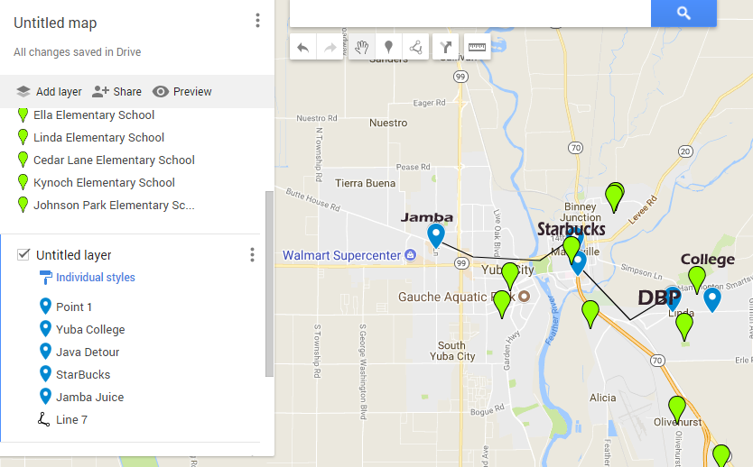

**Techniques**

Techniques used to formulate positioning are within the steps that will be necessary to develop this new business strategy.

1. Environmental Scan.
2. Do all analysis for business.
3. Clarify target customers, value proposition, and culture and strategic cultural advantage
4. Select staff is choosing the correct skills and capabilities., choose teamwork goals, leadership style, and work climate.
5. Solidify and select the competitive advantage style, vision, and mission statements.
6. Formulate and establish performance measures, scorecard, and benchmarks.
7. Set goals and milestones.
8. Improve from within by promoting education through tuition reimbursement.
9. For cost analysis please refer to appendix’s A and B.

**Strategic-Planning Process**

How we determine the organization’s mission and goals mirrors the same strategy we used to come up with the concept. The Hybrid method takes what we like and leaves the rest. Here are some of the current mission statements for the coffee/juice businesses.

Mission Statement Dutch Brothers

Love Abounds, and Dutch Bros are both about people first. Dutch Bros has established Love Abounds to engage its communities through giving and an action actively. Love Abounds supports programs and projects that build deeper connections through engagement in Four Core Areas. Youth Music Health Origins (Dutch, 2018).

Mission Statement Jamba Juice

OUR MISSION: To become the world's leading blender of fruit and other naturally healthy ingredients. Part of what makes Jamba Juice so successful is the passion both our customers and employees share for the product. ... OUR TIMELESS PURPOSE: To inspire and simplify healthy living (Brown, 2013).

Mission Statement Starbucks

To inspire and nurture the human spirit – one person, one cup and one neighborhood at a time (Balance, 2018).

Mission Statement DBP

To become our community’s leader in promoting health by presenting a quality product. Juices and smoothies that are naturally healthy, coffees that encourage, uplift and inspire the hearts of people, person by person, cup by cup, while supporting our community through giving, health, music, and friendliness.

**Industry Analysis**

Jamba Juice is reporting about 75 million in revenue with 22% of that being the EBIT or about 15 million (Jamba. 2018). Dutch Brothers coffee is running head to head with that (Dutch, 2018). The overall state of both industries is good. Juice bars are showing a 2-billion-dollar revenue with a margin of annual growth at about 2.3% (IBISWorld2, 2018). The coffee industry continues to boom with 37 billion a year and annual growth of 3.6% (IBISWorld, 2018). The upcoming generation is green, health conscience, and they are innovators. A generation of health conscience people creates a promising forecast for both the coffee industry and the juice bar industry. By creating a hybrid shop that sells both healthy juice and coffee the firm can expect a growth percentage shown by the mean of the two businesses--about 3%. Suppliers for coffee are everywhere. This firm will both roast its beans – mostly for the aromatic reasons and purchase pre-roasted beans from suppliers. In juicing, locally grown organic fruits and veggies will be the preference, then non-locally grown organic. Only in emergencies will non-organic fruits and veggies be used. We expect about 30%--50% of the clientele to come from the college. However, the road to which the firm is located is also a major inlet to the local air force base. As a result, we expect that service personnel will be a major portion of those who visit the establishment drive-thru.

Last but not least, are people going to work, or dropping kids off at one of the schools nearby. Currently, the only competitor is in the campus cafeteria. This is not accessible to neither the service personnel nor those going to work. The only other competition is downtown Marysville for coffee and two cities away from Juice [Map, Page 2].

**SWOT Analysis**

Before doing a SWOT on the business, I thought it prudent to perform one on myself.

Strengths

Educated in business. Very capable in mechanics, engineering, construction, electronics, appliances, heating and air, and music. All this knowledge will bring down startup costs by thousands of dollars. I have some equipment, and vehicles ready to go. I have some great connections in the construction trades. I know of several trustworthy people that would make great employees. I am currently employed.

Weaknesses

I only have about a total of six thousand in capital available on hand, of which only about $1500 is liquid. The location may have to be built from the ground up--this would be expensive.

Threats

At any moment a firm already in the industry may see this opportunity and beat me to it. If two coffee shops exist in this location sales may suffer, especially since a firm like Starbucks has the capital to build fast.

If the business goes in where the city has not yet put in sidewalks, the city may try to make me foot the bill for the installation of sidewalk and drainage in that location; this would drive entrance costs up to high to achieve.

Opportunities.

This is a great opportunity for me to begin my financial upswing. This vehicle is in the perfect location with a great idea for success. When successful this business would supply needed revenue for other ventures that lay ahead.

Now let us look at the businesses themselves.

Two more tools for internal analysis are the value chain and VRIO tools. The value chain dissects the organization and then identifies areas of unique strength or weakness, however, we will only be looking at VRIO.

**SWOT**

This is a comparable SWOT, inside is Jamba Juice and outside is Dutch Brothers. An expanded form of this is available in Appendix (C).

Weaknesses

Strengthss

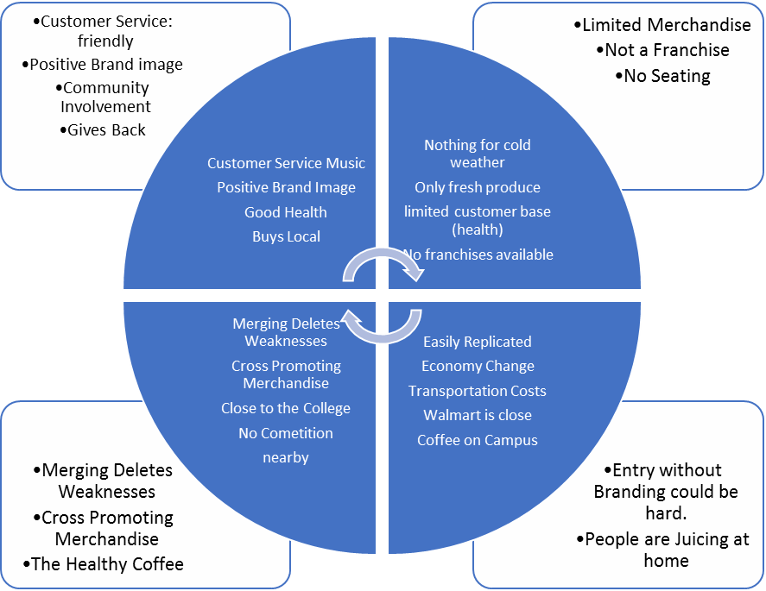

Opportunities

Threats

VRIO

Value chain functions are also called capabilities. VRIO—which stands for Value, Rarity, Imitability, and Organization—is a framework that advocates that a capability, or a resource, such as a branding or a great location, is likely to yield a competitive advantage. An organization has shown to be valuable, rare, difficult to imitate and supported by the organization create a competitive advantage. When looking at Dutch Brothers Plus (DBP), there is definite value seen through VRIO analysis.

Value:

First, people love their coffee, and they also love a place to relax. This behavior adds value. In addition, Dutch Brothers Coffees add value by offering beverages at a discount when compared to Starbucks, or Java Detour. Also, streaming music is a cornerstone of Dutch Brothers Coffees that DBP will continue adding even greater value. Music partnerships with companies such as iTunes have proven to create value for firms such as Starbucks. Jamba Juice creates value by cornering the market on the health front. Healthy, organic juice is a great supplement for coffee and a great alternative to soda pop. DBP plans on continuing creating value through this great service that supports both quality and friendliness.

Rarity:

DBP is very rare in that it is a hybrid coffee house and a juice bar. Also, it is rare because there are no other juice bars within the city, to add to this, the closest coffee house is in downtown Marysville.

Imitability:

This business is easily duplicated. While this may be a negative if another entrepreneur knows where to start one in competition, it is also positive for DBP in producing carbon copies in other locations as the firm grows. On the other hand, this business supply chain and Supply Management system will be costly to reproduce. There are only so many fresh organic fruits and vegetables grown locally, and since DBP is the first of its kind, it will have a strategic advantage through new product development. The first one gets all the contracts with the organic suppliers. Further, using Porter's Generic Competitive Strategies there is a competitive advantage from having a focus as well as having differentiation (Porter, 1980).

Organization:

DBP must organize its management systems, policies, organizational structure, processes, and culture to fully realize the potential of its valuable, rare and costly to imitate resources and capabilities. This will come through Total Quality Management, eventual Blue Ocean, and flexible product line.

PESTEL

Two primary tools examine the external environment for firms 1. PESTEL and 2. Industry Analysis. PESTEL is an acronym that stands for Political, Economic, Sociocultural, Technological, Environmental, and Legal Environments.

Political:

Currently the city is undergoing a facelift, and much effort is being put into updating the area, for this reason, its felt that favor from the city council will be given to any business that represents an uplift in the socioeconomic status of the current inhabitants of the community. Since DBP is focused on catering to those who currently have an academic vision for the future and has community involvement plans, we forecast political support. Also, the U.S. is currently experiencing some reprieve from the last recession as business is not only up in California but the U.S. In general, we forecast this will be the case for the next couple of years at least.

Economical:

Economically though the location has been economically repressed in the past, there is economic growth projected as sidewalks and drainage are being installed from the highway to the college. This will encourage more foot traffic as well as cyclists. Correspondingly, both companies that DBP is patterned after are doing well financially in both California, The U.S., including the locations currently doing business closest to our proposed location.

Social-cultural:

This is an area of targeted change. Though the current Social-cultural feel of the area is one of oppression in the area surrounding Yuba College it is our desire to change this by bringing a new thriving business that promotes health, by attracting patrons who have a vision for the future, by having a culture that focuses on success, music, honest, quality, and fellowship into the community. While we know that DBP will be unable to accomplish this community transformation on its own, DBP will help to pioneer efforts by continuing the Dutch Brothers commitment of annually giving back a percentage of its profits to improve the community in which it does business.

Technological:

DBP will use up to date supply systems to ensure Just-In-Time deliveries of produce ensuring the freshest organic supplies for juicing and coffees possible. Further, the music traditions of Dutch Brothers combined with patterns borrowed from Starbucks will help to keep DBP on the cutting edge of music. Offering Wi-Fi and high-speed internet access as well as computers on timed rentals will also keep DBP a valued location for study or out of office work. Lastly, DBP commitment to innovation will ensure that DBP is always on top of the technologies advancement.

Environmental:

The family feel and laid-back smooth work environment will be a cornerstone at DBP locations. Also, for those on the go, a drive-thru that focuses on satisfied repeat business will be offered.

Whereas PESTEL provides one with a good sense of the broader macro-environment, industry analysis informs one about the organization’s competitive environment and the key industry-level factors that seem to influence performance. In industry analysis of Starbucks, Dutch Brothers, Jamba Juice, and Planet Smoothie franchises show growth and sustainability over the board.

**Justifications**

We will justify our organization’s mission, and goals through the improvement the local of the community. Along with our mission we have our vision and our goals. Again, we take what we need and leave the rest. Organizational performance refers to how well DBP is doing in reaching its vision, mission, and goals it has adopted. For this reason, all goals will have a time factor.

**Core Values**

DBP is a people first firm. Honesty, Loyalty, Innovation, and Dedication are its chief values. Being a light in a dark community is its calling. Making sure its family of employees is paid fairly, have medical, dental, and a balanced home and work life are doctrines under which teach DBP will function.

DBP Vision

To inspire healthy living through providing a place where human connection and great health come together in song.

Our Goals

1. To have a positive impact on the community in 6 months through a marked increase in the socioeconomic status increase in the local community and through general community improvement efforts-at least two.
2. To break even in 12 months.
3. To have the second location opened or on its way to being opened within 24 months.

Two considerations we need to think of are (1) performance measures, and (2) performance referents. Performance measures are metrics along which DBP can be gauged. A performance referent is a benchmark used to make sense of DBP standing. The benchmarks in production, satisfaction, and quality we will use are supplied by Starbucks, Java Detour, Jamba Juice, and Planet Smoothie. DBP is not into remaking the wheel if one of these firms has found an innovation that works we will integrate the item and then evaluate its performance and quality by measuring the outcome against our mission, vision, and goals.

**Strengths Weaknesses and Strategies**

Most of the strengths have already been mentioned. However, we feel the biggest strength is our desire to improve each community we are placed in. In addition to this, the merging of Coffee and Juice next to an academic institution offers longevity and sustainability.

Porter’s Key Strategies and Ghemawat’s “AAA” Global strategies

• Focused differentiation.

While it is true that DBP will be selling coffees at prices near to Dutch Brothers, which is discounted compared to Starbucks and Java Detour, DBP will have to increase prices slightly to keep prices competitive on the Juice bar. Organic, fresh produce is at a premium even hear in the richest farm valley in the U.S. As a result, we will be focusing on Coffee and Juice Beverages, with only a small menu of food items. Using Porter's Generic Competitive Strategies this creates a competitive advantage from having a focus as well as having differentiation of being the only store of its kind around. (Porter, 1980)

Here is a breakdown of the “AAA” strategy given by Ghemawat (2011).

• Adaption.

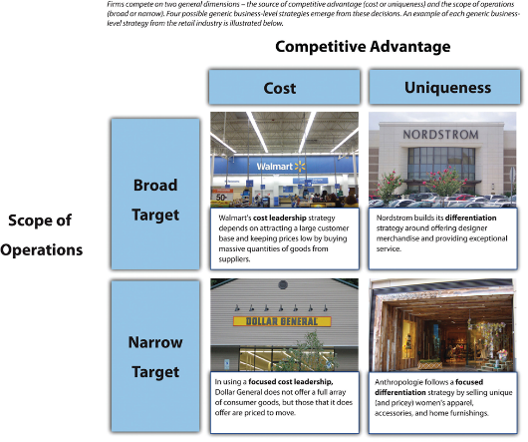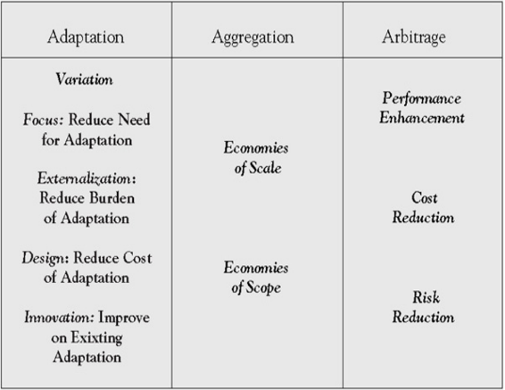

Being headed for franchise DBP will be employing mostly Adaption, as we seek to improve each community in which each DBP is placed.

• Aggregation.

This will have a place. Things such as the feel of the store, the greeting style, and the goal of improving communities will be carried into each store.

• Arbitrage.

Since the Juice end will depend on mostly local veggies and fruits, we may be able to leverage some prices when we find an overabundance of lower cost quality fruits and veggies in a location, if so, it may be possible to import/export those items that are not indigenous in a market for a profit.

DBP strategic plan will be implemented from the top down. While the firm cannot exist without profit, it is our strategy that communities grow in success as we do. We start with the mission and vision to effect change in the community that each store is located in by fostering a spirit of hope and success.

Tactical Plan

Our tactical plan is similar but involves our local suppliers. We will seek long-term partnerships with organic farmers who have a like mission and goal. Further, while we will be looking to save some money during purchasing, we also want to make sure that our local suppliers grow with us. As we grow in numbers of franchised stores, we hope to employ economies in scale for such things as cups and lids from suppliers outside our community. Lastly, DBP is green, and mostly in a red ocean, however, we hope that being the first of its kind we can move into a blue ocean due to our quality service and health conscious mindset.

Operational:

Our operational strategy is to make sure that all greeters make every experience make the customer feel like they are one of the most important people to visit, make every order a priority, and make everyone one family. Local produce will be preferred typically over shipped produce, with those supply partners managing and delivering just on time fruits, produce, and green supplies.

Contingency:

If local produce is not available orders will be fielded from the southern valley. In the event of competition moving in capitalization with media advertising and marketing will be enacted.

Crisis Planning:

In the event of a financial disaster, efforts to sell the establishment to rivals will be fielded.

**Financial Considerations**

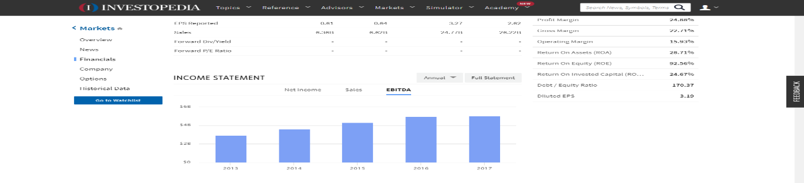Currently, Starbucks is reporting quiet and increase in profits.

However, Jamba Juice is showing decreasing sales.

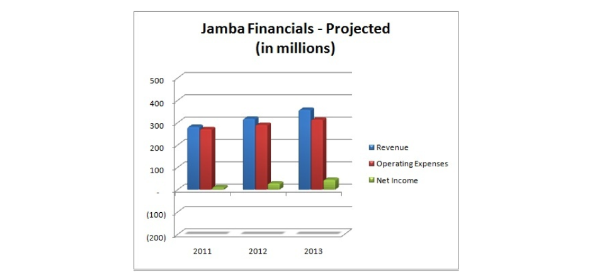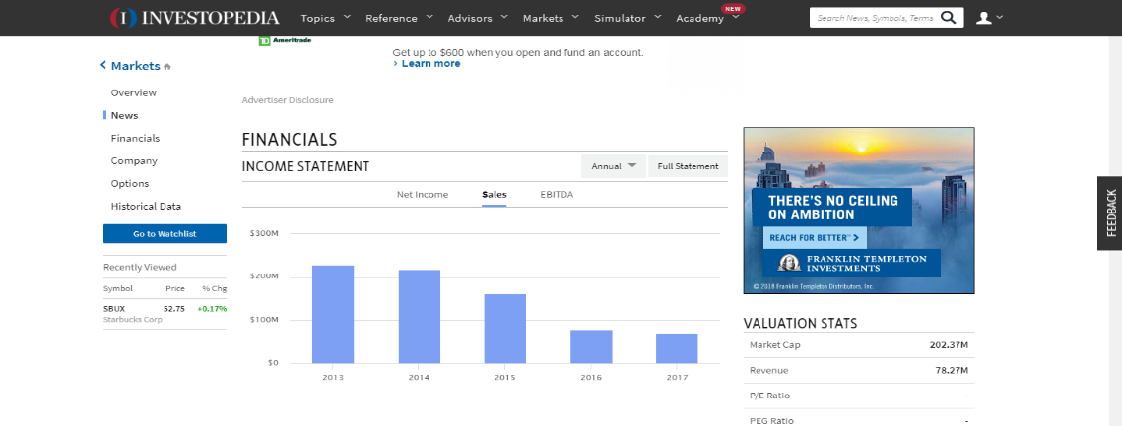

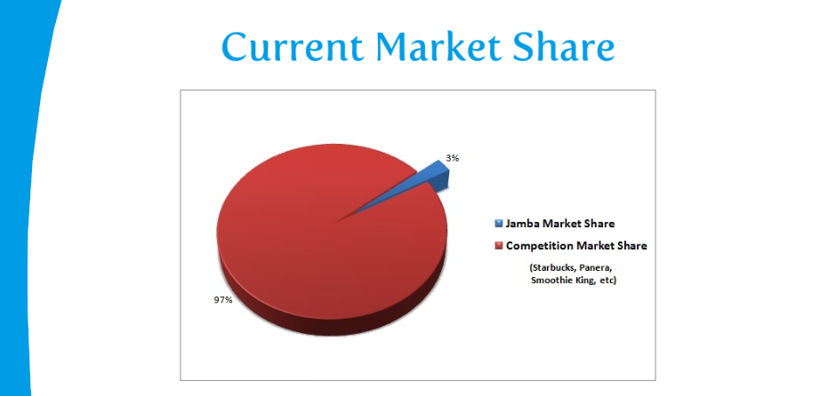This is due to 1. Lack of advertising and 2. Jamba Juices alliance with the now failed Golds Gym. We feel successful market penetration will drive Jamba’s former customer base to DBP as our advertising blankets the market. Further, alliances with up and coming gyms such as IN-Shape, and Planet Fitness will increase popularity--this may eventually result in DBP’s acquisition of Jamba Juice. One other financial consideration is the procurement of small business grants for startup. By using grants instead of loans, DBP will relieve financial stress during times of startup.

Organizational Structure:

DBP will reposition organizational structures to help promote creativity and innovation that will result in greater organizational effectiveness and efficiency. Since the merging of these two ideas is relatively new, finding procedures in common in the making of Coffee, Juice, and Smoothies is a must; once these commonalities are found aggregate procedures will be instituted to ensure quality and speed. Innovations in supply management are of great value also as without fresh produce profits fall. Finally, innovation is products will always be on the menu. New combinations of coffee beans, roast styles, and mixtures of healthy juices will be searched out for the delight of our customers.

Impact on Leadership Structures

Beginning leadership structures are simple as a top-down sole proprietorship, however, as the firm grows, and franchising begins leadership structure will begin to stretch to C structure management. Finally, when DBP incorporates and begins to be active on the stock market, a board of directors will take over in place of the CEO/Owner management style. At no time is more than 48% of the shares to be available on the market.

Franchise owners will be selected from individuals of whom were or are employed by DBP and are in good standing. For those who show outstanding accomplishments in community support and innovation opportunities for franchises will be made available at discounted rates. The use of Balance Score Cards will be the strategy used to keep a record of such accomplishments. A balanced scorecard is an approach to assessing performance that targets managers’ attention in four areas: (1) financial, (2) customer, (3) internal business process, and (4) learning and growth (Kaplan, 1992).

All franchises must adopt and actively adhere to the Mission, Vision, and Goals of DBP as stated or revised by the founding parties.

**Conclusion**

The triple bottom line emphasizes the three Ps of people, the planet, and profits (Ketchen, 2011). DBP represents each area uniquely and has the opportunity and potential to become a billion-dollar franchise easily. The idea of having hot coffees in cold weather and cold juices in warm weather ensures there will be no slump in seasonal sales. The location, “after the light and to the right,” being near several schools and the only local college and having the only competition miles away almost ensures success. The chosen mission, vision, and goals of this enterprise will make this firm a community favorite while providing the entrepreneur an eventual possible cash flow potential above and beyond the benchmark firms.

References

Balance, The (2018) Starbucks Mission Statement https://www.thebalancesmb.com/starbucks-mission-statement-2891826

Brown, T. (2013) Jamba External and Internal Environmental Analysis Paper http://customwritingtips.com/component/k2/item/14538-jamba-external-and-internal-environmental-analysis-paper.html?tmpl=component&print=1

Daley, J. (2012) New Franchises Team Up and Make Co-branding Work, Url https://www.nasdaq.com/article/new-franchises-team-up-and-make-cobranding-work-cm129748

Dutch Brothers (2017) America's Best Small Companies., Url https://www.forbes.com/companies/dutch-bros-coffee/

Essays, UK. (November 2013). Industry and marketing analysis of Starbucks Coffee. Retrieved from https://www.ukessays.com/essays/marketing/industry-and-marketing-analysis-of-starbucks-coffee-marketing-essay.php?vref=1

FactFinder, (2018) Url https://factfinder.census.gov/faces/nav/jsf/pages/community_facts.xhtml

Ghemawat, P. (2007). Redefining global strategy: Crossing borders in a world where differences still matter. Boston, MA: Harvard Business Review Press.

Global Smoothie (2016) Business Report. https://globenewswire.com/news-release/2016/09/26/874430/0/en/Global-Smoothies-Strategic-Business-Report-2016-2022-Innovative-Healthy-and-Fortified-Smoothies-Flood-the-Market.html

IBISWorld, (2018) The Retail Market for Coffee - US Market Research Report https://www.ibisworld.com/industry-trends/specialized-market-research-reports/retail-market-reports/the-retail-market-for-coffee.html

IBISWorld2, (2018) Juice & Smoothie Bars - US Market Research Reporthttps://www.ibisworld.com/industry-trends/specialized-market-research-reports/consumer-goods-services/food-service-drinking-places/juice-smoothie-bars.html

Invest, (2018) Url https://www.investopedia.com/markets/stocks/sbux/#Financials

Jamba Inc. (2018) Annual Report http://ir.jambajuice.com/phoenix.zhtml?c=192409&p=irol-newsArticle&id=2338420

Kaplan, R. S., & Norton, D. (1992, February). The balanced scorecard: Measures that drive performance. Harvard Business Review, 70–79.

Ketchen, D. & Short, J. (2011). Mastering Strategic Management. Washington, DC: Flat World Knowledge, Inc.

Planet Smoothie (2018) WHAT ARE MY STARTUP COSTS? <https://planetsmoothiefranchise.com/learn-planet-smoothie/startup-costs/>

Owler (2018) Owler.com Url https://www.owler.com/company/dutchbros

Porter, M. E. (1980). Competitive strategy: Techniques for analyzing industries and competitors. New York, NY: Free Press.

Rudnick, D. (2018) DUTCH BROS. RESEARCH TEAM CASE ANALYSIS

The Dynamics of the Company http://d0376.weebly.com/uploads/2/9/7/3/29730551/dutch_bros__case_analysis_report_final.pdf

Appendices

Appendix A: Dutch Brothers startup costs analysis

Franchise fee 30000

Lot 60000

Land improvements 15000

Land Scaping 5000

Building 100000

2 Blenders 2288

Expresso Machine 6250

Walkin Ref 10000

Walking Freezer 10000

Ice Machine 1779

Sound System 2000

Coffee Grinders 1878

Supplies

Cleaning Supplies 1000

Maintenance Supplies 1000

Inventory

Cups 400

Lids 200

Straws 200

Milk 2000

Syrups 1000

Smoothy Mix 1000

Rebel 300

Coffee Beans 1200

Juice 100

Sauces 1000

Chia 400

Soy 600

Coconut Milk 600

Tea 500

Sugar 800

Water 100

Soda Water 50

Appendix B: Planet Smoothie Startup Cost Analysis

|  |  |  |  |  |
| --- | --- | --- | --- | --- |
| Initial Franchise Fee | $16,000 to $20,000 (Note 1) | Lump sum | Upon signing Franchise Agreement | Us |
| Lease Review Fee | $0 to 1,250 | Lump sum | Upon signing of Franchise Agreement | Us |
| Rent/Security Deposit (for three months) (Note 2) | $6,000 to $30,000 | As Incurred | Prior to Opening | Landlord(s) |
| Travel and Living Expenses (3 persons) while training, not including salaries, if any, for you and your employees | $3,750 to $7,500 | As Incurred | During Training | Airlines, Hotels, Restaurants, etc. |
| Real Estate | (Note 2) | (Note 2) | (Note 2) | (Note 2) |
| Architectural Fees (Note 3) | $5000 to $10,000 | As Incurred | Prior to Opening | Licensed and Approved Architect and Project Management Firm |
| Leasehold Improvements | $5,000 to $100,000 (Note 4) | As Incurred | Prior to Opening | Approved Contractors and Vendors (Notes 3 and 4) |
| Restaurant Equipment, Furniture, Small Wares, Interior Signage and Menu Panels (Note 5) | $12,000 to $30,000 | Lump sum | Prior to Opening | Approved Vendors and Suppliers |
| Exterior Signage | $9,000 to $12,000 | As Incurred | Prior to Opening | Approved Sign Company |
| Computer Hardware, Software (POS System) | $1,000 - $5,000 | Lump Sum | Prior to Opening | Approved Suppliers |
| PCI Compliance Costs | $150 to $1,300 | As billed by third party vendor | As billed by third party vendor | Approved Vendor |
| Opening Inventory (food and paper) (Note 6) | $2,500 to $5,000 | As Incurred | Prior to Opening | Approved Suppliers |
| Business Insurance (Note 7) | $1,000 to $5,000 | Lump Sum | Prior to Opening | Insurance Company/Agent |
| Miscellaneous Opening Costs (Note 8) | $4,750 to $17,200 | As Incurred | As incurred | Approved Suppliers, Utilities, etc. |
| Grand Opening | $2,000 to $6,000 | Lump Sum | Prior to Opening | Suppliers (Note 9) |
| Depository Account (Note 10) | $3,000 | Lump sum; Must be replenished on a regular basis | At signing of Franchise Agreement | Your bank (we have the right to withdraw from this account) |
| Additional Funds - 3-month initial period | $5,000 to $15,000 | As Incurred | As incurred | Us, Employees, Various Third Parties |

Appendix C—SWOT

Dutch Brothers Jamba Juice

Strengths:

Customer Service: Very friendly and affordable. Customer Service and Music

Positive Brand image Positive Brand Image

known for Community Involvement Known for good health

Gives back 1% to the community Buys local produce

Market entry costs are low Market entry costs are low

Weaknesses

Limited Merchandise No hot drinks for cold weather

Is not a Franchise only fresh produce

Drinks are limited limited customer base (health)

No Seating. No franchises available

Opportunities:

There is a great opportunity in the merging of these two industries. Weaknesses such as limited drinks and no drinks for cold weather are eliminated. Seating problems are also fixed along with limited customer base. The franchise issue is meet by not adopting the Jamba Juice franchise but instead just adding a clone under the current Dutch Brothers brand with the plus. This further allows the firm to adopt much of the Starbucks relaxed feel for those who wish to study, or commune. Another opportunity is cross-promoting merchandise. The Healthy Coffeehouse can promote health and serve caffeinated drinks (which is not considered healthy), both cold and hot beverages with a unique listing of menu items to eat. The last opportunity comes from the fact that there is neither a local coffee house or juice bar other than on the college campus. The cafeteria on the campus is always rumbling, busy, and loud. This startup will offer an alternative that is close enough to the college to be a desired quiet destination. Finally, promoting health will mean that DBP will actively partner with Gyms. By offering promotional items such as reward cards with free drinks after a number of visits. We will continue to promote health down the line after the DBP franchise chain is established as we would like to acquire a chain of gyms to stand along our commitment to health.

Threats:

* While the firm is unique, it is easily reproduced, and entry costs are low.
* A change in the economy might cause people to stop spending on unnecessary drinks.
* Market entry without an existing branding would be difficult.
* Transportation cost for fresh fruit would vary with fuel costs.
* There is an upswing in home juicing, and home espresso that are cheaper alternatives.
* Major supermarkets supply bottled juices and cold coffees, and both Food Max, and Walmart are nearby.
* The Campus has a Starbucks vendor in the cafeteria.