**Financial Planning and Control**

Jeffery Morse

Brandman University

Author Note

For correspondence concerning this paper, Jeffery Morse can be reached at

jmorse@mail.brandman.edu

Problem #1: Proforma Statements

Prepare a common size income statement given the following information:

Revenues = $100,000

COGS = $43,000

SG&A = $22,000

Depreciation = $10,000

Interest Owed = $5,000

Tax Rate = 40%

What percent of sales are COGS and SG&A?

COGS / Sales = 43 / 100 = .43 or 43%

SG&A / Sales = 22 / 100 = .22 or 22%

Company Name

Common Size Income Statement

Amount Common Size

Revenue $100,000 100% COGS $43,000 43%

Gross Profits $57,000 57%

SG&A expenses $22,000 22%

Depreciation $10,000 10%

Operating Profit (EBIT) $25,000 25%

Interest Owed $5,000 5%

Earnings before Taxes (EBT) $20,000 20%

Taxes (40%) $8,000 8%

Net Earnings $12,000 12%

Problem #2: Proforma Statements

Prepare a pro forma income statement from the data and common size income statement from #1, assuming that the sales will grow by 5% and all expenses but interest and taxes will scale with sales.

Company Name

Proforma Income Statement

5% Growth

Amount (5%) Common Size

Revenue $105,000 100% COGS $45,150 43%

Gross Profits $59,850 57%

SG&A expenses $23,100 22%

Depreciation $10,500 10%

Operating Profit (EBIT) $26,250 25%

Interest Owed $5,000 5%

Earnings Before Taxes (EBT) $21,250 20%

Taxes (40%) $8,500 8%

Net Earnings $12,750 12%

Problem #3: Capital Budgets

Rambus Inc. would like to purchase a production machine for $325,000. The machine is expected to have a life of three years, and a salvage value of $50,000. Annual maintenance costs will total $12,500. Annual savings are predicted to be $112,500. The company's required rate of return is 12%.

Required:

**Ignoring the time value of money**, calculate the net cash inflow or outflow resulting from this investment opportunity.

Timeline Today year 1 year 2 year3

Purchase Price ($325,000)

Maintenance Cost ($12,500) ($12,500) ($12,500)

Annual Savings $112,500 $112,500 $112,500

Salvage Value $50,000

Totals ($325,000) $100,000 $100,000 $150,000 Sum Total: $25,000

Problem #4: Capital Budgets

Rambus Inc. would like to purchase a production machine for $325,000. The machine is expected to have a life of three years, and a salvage value of $50,000. Annual maintenance costs will total $12,500. Annual savings are predicted to be $112,500. The company's required rate of return is 12%.

Factors: Present Value of $1, (r = 12%)

Year 0: 1.0000, Year 1: 0.8929, Year 2: 0.7972, Year 3: 0.7118

Required:

(1) Using the Present Value Factors for $1, calculate the net present value of this investment (ignoring taxes).

(2) Based on your answer in requirement 1, should Rambus purchase the production machine?

1)

Timeline Today year 1 year 2 year3

Purchase Price ($325,000)

Maintenance Cost ($12,500) ($12,500) ($12,500)

Annual Savings $112,500 $112,500 $112,500

Salvage Value $50,000

Totals ($325,000) $100,000 $100,000 $150,000 Sum Total: $25,000

PV factor (r=12%) 1.0000 0.8929 0.7972 0.7118

Present Value ($325,000) $89,290 $79,720 $106,770 Sum Total ($49,220)

2) Based on this information Rambus should not purchase this machine as it sends the business in the Red $49,220.

Problem #5: Capital Budgets

Lockwood Company would like to purchase a production machine for $900,000. The machine is expected to have a life of five years, and a salvage value of $100,000. Annual maintenance costs will total $40,000. Annual savings are predicted to be $350,000. The company only accepts projects that have a payback period of fewer than three years.

Required:

(1) Calculate the **payback period** for this project rounded to the nearest month. Show your work.

Timeline Today year 1 year 2 year3 year4 year5

Purchase Price ($900,000)

Maintenance Cost ($40,000) ($40,000) ($40,000) ($40,000) ($40,000)

Annual Savings $350,000 $350,000 $350,000 $350,000 $350,000

Salvage Value $100,000

Totals ($900,000) $310,000 $310,000 $310,000 $310,000 $410,000

Sum Totals ($900,000) ($590,000) ($280,000) $30,000 $340,000 $750,000

PV factor (r=12%) 1.0000 0.8929 0.7972 0.7118 0.6355 0.5674

Present Value ($900,000) $276,799 $247,132 $220,658 $197,005 $232,634

Sum Totals ($900,000) ($623,201) ($376,069) ($155,411) $41,594 $274,228

Payback is within three years without using present value calculations

Month Calculations

310000/12 = 25833.3334 900000/35833.3334 = approx. 35 months

(2) Should the company accept this proposal? Explain.

Yes, the company should accept this proposal. Although Present value is not calculated due to no interest rate is given, if the r=12% rate of the last question is applied the purchase still shows a profit at end of life.

Problem #6: Operating Budgets

Cathy’s Cookies produces cookies for resale at local grocery stores. The company is currently in the process of establishing a master budget on a quarterly basis for this coming fiscal year, which ends December 31. Prior year quarterly sales were as follows (1 unit = 1 batch):

First quarter: 8,000 units

Second quarter: 9,600 units

Third quarter: 12,000 units

Fourth quarter: 10,400 units

Unit sales are expected to increase 20%, and each unit is expected to sell for $5. Management prefers to maintain ending finished goods inventory equal to 15% of next quarter's sales. Assume finished goods inventory at the end of the fourth quarter budget period is estimated to be 2,000 units.

Required:

1. Prepare a sales budget for Cathy’s Cookies.

Cathy’s Cookies

Sales Budget

Year Ending December 31

____________________________________________________________________________________

Quarter___________________________1___________2__________3__________4__________year__

20% x Sales in Units (1 unit = 1 batch) 9600 11520 14400 12480 48000

Sales Price per Unit $5 $5 $5 $5

Sales Revenue $48,000 $57,600 $72,000 $62,400 $240,000

___________________previous __Plus 20%________________Maintain 15%

First quarter: 8,000 units x 1.20 = 9600 .15 x 9600 = 1440

Second quarter: 9,600 units x 1.20 = 11520 .15 x 11520 = 1728

Third quarter: 12,000 units x 1.20 = 14400 .15 x 14400= 2160

Fourth quarter: 10,400 units x 1.20 =12480 .15 x 12480 = 1872

(2) Prepare a production budget for Cathy’s Cookies.

Cathy’s Cookies

Production Budget

Year Ending December 31

____________________________________________________________________________________

Quarter___________________________1___________2__________3__________4__________year__

Sales in Units (1 unit = 1 batch) 9600 11520 14400 12480 48000

Adding finishing amount 1728 2160 1872 2000 2000

(15% of next quarter's sales) __________________________________________________________

Total finished Goods 11328 13680 16727 14480 50000

Deduct finished Beginning (1440) (1728) (2160) (1872) (2000)

Units to be produced 9888 11952 14567 12608 48000

(3) What can you interpret about Cathy’s Cookies Sales Budget? Trends?

There seems to be a % increase per quarter except in the 4th quarter. Investigations should be made to find out why sales drop in the fourth quarter.

Problem #7: Operating Budgets

Marker Products, Inc. sells all of its products on credit. The company expects to collect 65%of sales in the quarter of sale and 35% the quarter following the sale. Accounts receivable at the end of last year totaled $3,000,000, all of which will be collected in the first quarter of the coming year. Marker's sales budget shows the following projected sales revenues:

Quarter 1: $8,800,000 .65 = 5,720,000 .35 = 3,080,000

Quarter 2: $11,000,000 .65 = 7,150,000 .35 = 3,850,000

Quarter 3: $11,440,000 .65 = 7,436,000 .35 = 4,004,000

Quarter 4: $10,560,000 .65 = 6,864,000 .35 = 3,696,000

Required:

Prepare a budget for cash collections from sales for each of the four quarters.

|  |  |  |  |  |  |
| --- | --- | --- | --- | --- | --- |
| Marker Products Inc. | | | | | |
| Budget for Expected Cash Collections | | | | | |
| For the Year Ending December 30, 2017 | | | | | |
|  | | | | | |
|  | Quarter | | | |  |
|  | 1 | 2 | 3 | 4 | Year |
| Beginning AR | $3,000,000 |  |  |  | $3,000,000 |
| Quarter 1 Sales | $5,720,000 | $3,080,000 |  |  | 8,800,000 |
| Quarter 2 Sales |  | $7,150,000 | $3,850,000 |  | 11,000,000 |
| Quarter 3 Sales |  |  | $7,436,000 | $4,004,000 | 11,440,000 |
| Quarter 4 Sales |  |  |  | $6,864,000 | 6,864,000 |
| Total Collections | $8,720,000 | $10,230,000 | $11,260,000 | $10,854,000 | $41,104,000 |

Accounts Receivable at the end of the year total $3,696,000 to be collected the first quarter of the next year, 2018.

Problem #8: Standard Costing and Variances

Jake’s Cheese Company produces gourmet cheese for resale at local grocery stores. The master budget indicates that the company expects to use 3.0 pounds of direct materials for each unit produced at a cost of $8.00 per pound (one unit = one batch of cheese). Each unit produced will require 0.50 direct labor hours at a cost of $10.00 per hour. Variable manufacturing overhead is applied based on direct labor hours at a rate of $5.00 per hour. Last year's sales were expected to total 50,000 units. Jake just received last year's actual results showing sales of 45,000 units.

Required:

(1) Calculate the standard cost per unit for direct materials, direct labor, and variable manufacturing overhead.

Standard Costs

Per Unit

Direct Materials (3 lbs * $8) per unit | $24.00

Direct Labor ($10 * .5 hrs) per unit | $5.00

Variable Overhead (.5 *5) per unit | $2.50

Standard variable production cost per unit $31.50

1. Prepare a flexible budget based on actual sales for direct materials, direct labor, and variable manufacturing overhead.

Flexible Budget

At 45K Units___

Direct Materials (45,000 * $24) | $1080,000.00

Direct Labor (45,000 * 5) | $225,000.00

Variable Overhead (45,000 *2.5) | $112,500.00

Total budgeted Variable Production costs at 45K units  **$1,417,500.00**

Problem #9: Standard Costing & Variances

Jake’s Cheese Company produces gourmet cheese for resale at local grocery stores. Jake’s expected to use 3.0 pounds of direct materials to produce one unit (batch) of product at a cost of $8 per pound. Actual results are in for last year, which indicates 45,000 batches of cheese were sold. The company purchased 160,000 pounds of materials at $7.50 per pound, and used 145,000 pounds in production.

Required:

1. Calculate the materials price variance.

Expected 3lbs per unit @ $8 per lbs

Expected DM 45,000 * 3 = 135,000 lbs * 8 = 1080000

Actual 145,000 lbs for 45,000 units @7.50 per lbs aprox 3.23 lbs per unit = $1,087,500

Actual Actual@Standard Flex____

3.23 @ 7.5 [3.23 @ 8](mailto:3.23@8) 3@8

45k 45k 45k

$1,087,500 $1,162,800 $1,080,000

Overall DM Variance is 1,087,500 – 1,080,000 = $7,500 Is Unfavorable

Material Price Variance is 1,162,800 – 1,087,500 = $75,300 Is Favorable.. Purchasers got a good deal.

(2) Calculate the materials quantity variance.

Material Quantity Variance is 1,162,800 – 1,080,000 = $82,800 Is Unfavorable.

1. Suggest several possible reasons for the materials price and quantity variances calculated in requirements (1) and (2).

The price variance is probably due to a reduced price due to a large quantity purchase or purchasing inferior sales products. The materials variance could be the waste resulting from using inferior sales products, or possibly machinery in need of servicing. Another possibility is we could possibly be training new employees.

Problem #10: Standard Costing & Variances

Jake’s Cheese Company produces gourmet cheese for resale at local grocery stores. Jake’s expected to use 0.50 direct labor hours to produce one unit (batch) of product at a cost of $10 per hour. Actual results are in for last year, which indicates 45,000 batches of cheese were sold. The company's direct labor workforce worked 27,500 hours at $9 per hour.

Required:

1. Calculate the labor rate variance.

Expected .5 hrs per unit @ $10 per hour = $5.00

Expected DL costs 45,000 * 5 = $225,000

Actual hour per unit 27500/45000 = .61111111111… .62 rounded up

Actual DL price per unit .62 * 9 = $5.50

Actual DL costs = 45,000 * 5.5 = $247,500

Actual @ Standard per unit = .62 * 10 = $6.20

Actual @ Standard DL costs. 6.2 * 45000 = $279,000

For 45,000 units

Actual Actual@Standard Flex____

Rate * hours 27,500 *9 27,500 *10 22,500 * 10

Total $247,500 $275,000 $225,000 __

Overall DL Variance is 247,500 – 225,000 = $22,500 Is Unfavorable

Labor Rate Variance is 275,000 – 247,500 = $27,500 Is Favorable. We paid less than 10 / hr

1. Calculate the labor efficiency variance.

Labor Efficiency Variance is 275,000 – 225,000 = $50,000, Is Unfavorable.

(3) Suggest several possible reasons for the labor rate and efficiency variances.

For the Labor rate variance, we might be paying less per hour. Maybe we are in economic stress with high unemployment rates allowing us to pay less per hour. Or we are training new employees.

For the Labor efficiency since we are training new employees, it is taking much longer than the .5 hours per unit. The .62 hours per unit is driving our per unit labor price to $6.20 per unit instead of the estimated .5. If this is due to lack training, or employee sickness this could be temporary.

Problem #11: Standard Costing & Variances

Jake’s cheese Company produces gourmet cheese for resale at local grocery stores. Jake’s expected to use 0.50 direct labor hours to produce one unit (batch) of the product, and the variable overhead rate is $5.00 per hour. Actual results are in for last year, which indicates 45,000 batches of cheese were produced and sold. The company's direct labor workforce worked 27,500 hours, and variable overhead costs totaled $144,000.

Required:

1. Calculate the variable overhead spending variance.

Variable Overhead Spending Variance = Actual Costs – (AH * SR)

144,000 – (27,500 * 5) = $6500 This is Unfavorable

1. Calculate the variable overhead efficiency variance.

Variable Overhead Efficiency Variance = (AH * SR) – (SH * SR)

(27,500 * 5) – (22,500* 5) = 25,000 is Unfavorable

(3) Suggest several possible reasons for the variable overhead spending and efficiency variances.

Since the machines are being used longer due to the longer production time per unit this caused MOH to go up. Also, the combined effort to train or the equipment being in need of servicing may also contribute. Further, the variable overhead rate may be estimated low as a result of any of the items previously stated. This may need to be adjusted.

Problem #12: Profitability & Cost Analysis

Car Deals Inc. has two divisions: New Cars and Used Cars. The following segmented financial information is for the most recent fiscal year:

New Cars Used Cars

Division Division__________

Sales $9,000,000 $18,000,000

Cost of goods sold 3,300,000 8,700,000

Allocated overhead 1,050,000 2,550,000

Selling and administrative expenses 585,000 630,000

The New Cars division had average operating assets totaling $17,400,000 for the year, and the Used Cars division had average operating assets of $22,800,000. Assume the cost of capital rate is 15%, and the company's tax rate is 40%.

Required:

1. Prepare a segmented income statement, including the profit margin ratio for each division at the bottom of the segmented income statement.
2. Calculate return on investment (ROI) for each division.

ROI = Operating Income / Average Operating Assets.

New Cars Division Used Cars Division

4,065,000/ 17,400,000 6,120,000/22,800,000

= 0.23362069 = 0.26842105

Or about 24% Or about 27%

1. Calculate residual income for each division.

RI = Operating Income – (Percent Cost of Capital * Average Operating Assets)

New Cars Division Used Cars Division

4,065,000-(.15*17,400,000) 6,120,000- (.15*22,800,000)

RI= $1,455,000 RI= $2,700,000

1. Summarize the answers to parts a, b, and c. What does this information tell you about each division?

Though the profit margin is 7% less for the Used Cars, due to the sheer volume of used cars sold compared to new cars it is worthwhile to keep this Division. The return on investment shows an increase of 3% compared to new cars, and the residual income is increased by $1,245,000. Indeed used cars are profitable.

Problem #13: Balanced Scorecard

1. List the four areas of a balanced scorecard. Describe each area clearly and concisely.

Financial, Internal Business Process, Learning and Growth, and Customer.

Financial effects areas such as gross margin ratio, Return on assets, Receivables turnover, Inventory turnover. Through a few relevant high-level financial measures, the financial area encourages identification. This helped inform when asking the questions designers were encouraged to ask such as "How do we look to shareholders.

Internal Business Process are things such as Defect-free rate, Customer response time, Capacity utilization, new product development time. It asks the question "What must we excel at?" This encourages the identification of measures that help us to excel in the Business Process.

Learning and Growth include such things as hours of employee training, employee satisfaction, employee turnover, and the number of employee accidents. Learning and growth ask the question, "how can we continue to improve, create value and innovate?".

Customer includes: customer satisfaction, the number of customers, market share, and the number of returned products. The customer area searches for answers to the question "What is important to our customers and stakeholders?"

1. Define a KPI

Within each area on a balanced scorecard (customer, learning and growth, financial, and internal business), many organizations center on specific goals for improvement. The use key performance indicators (KPIs) is a way to measure the degree to which an organization is successful in reaching its target goals. KPIs are performance measurements and are unique for the company or department choosing them. Choosing right KPI’s relies upon a good understanding of what is important to the organization or in the least a good understanding of the goal that is wanting to be reached.

1. Pick a real-world company and give an example of a KPI for each balanced scorecard area for that company.

Here is a Modified Scorecard for an HR manager. I find it interesting that this HR Manager re-worded the categories but thought this a good example of how one might modify this technique to fit one's needs.

On the bottom BCM Logic show some great examples of KPI’s. On the last page we look at a record company.

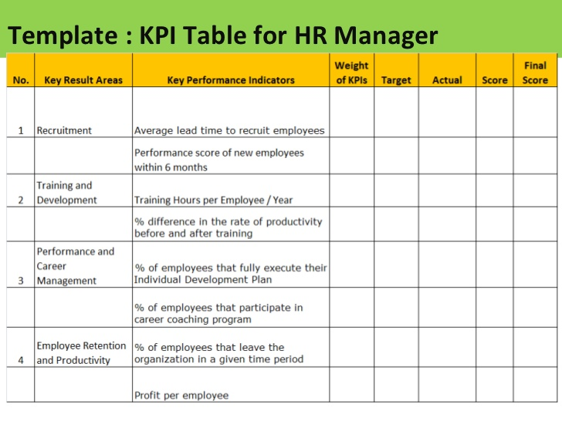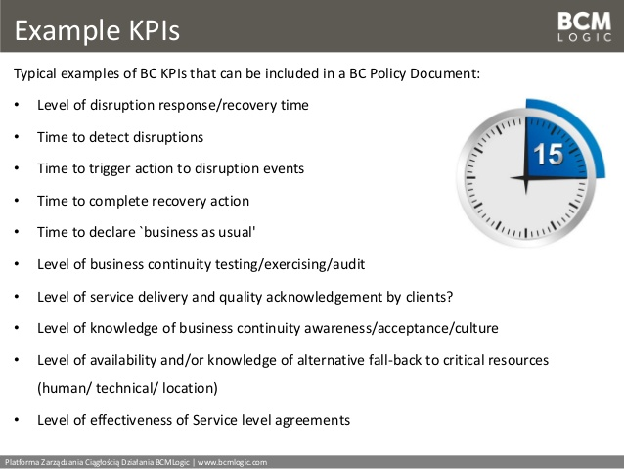

ByEveryWordProduction.com is a company that produces media, cd’s, video, and web pages.

<http://jefferymorseministries.com/bew>

Financial, KPI might be to reach a certain % growth in distribution of movie scores.

Internal Business Process, Might have a KPI to streamline the production of movie scores reducing DL time and costs.

Learning and Growth; Might include educating existing employees on software’s specific to movie-score production.

Customer; might have a KPI in customer satisfaction. They might be polling the film companies that they are working with in an attempt to create return customers.