The Economic Forecast of

Jeffery Morse Ministries LLC

Jeffery Morse

Brandman University

The Economic Forecast of Jeffery Morse Ministries LLC

Jeffery Morse Ministries LLC (JMM) is an Internationally based nonprofit startup with the goal of providing humanitarian aid throughout the world, delivering the Gospel of Jesus Christ, planting churches, training and raising up people to carry on the ministries in a similar fashion. JMM is both a product and service-based company. The product is free of charge and is the Gospel of Jesus Christ. Services range from providing food and the necessities of life, especially after a major crisis too, as well as, establishing churches and educational facilities around the world. JMM is a volunteer-based organization, as such, employees and volunteers rotate constantly, however, all who align themselves with JMM have one objective – to love people.

**The Six Steps in Problem Solving**

There are six steps that this paper will address in the decision-making process that can be universally broken as follows: Define the problem, Determine the objective, Explore the alternatives, Predict the consequences, Make a choice and Perform sensitivity analysis (Bruno, 2014).

**Define the Problem**

One issue that JMM is facing is the establishment of donations and grants. As a newer non-profit, data of historical giving is not available. In addition, it is unknown how much resource will come in and in what form that resource will take. This problem primarily impacts stakeholders and possible customers. On the flip side, internal impacts are present as well as all resource is from giving. Expenses including employee paychecks, and any overhead costs all are paid for through the generosity of others. However, without having some kind of forecast of probable income from grants and donations, there is no foundation to allocate any resource. There is no way to know if paid employees should be hired or plane tickets purchased. In addition, not having this information makes it impossible to successfully pursue humanitarian or relief efforts. This is a big problem since this is the reason the firm exists. JMM has been around for ten years—without growth. The web page is up, the giving portal is open, however, until recently the firm has been functioning under the Praise Chapel ministry umbrella. As a result, growth and vision for growth were put on the back burner as the leadership pursued other avenues in education and ministry. Recently JMM was classified as an LLC and is currently applying for its own non-profit status. Eventually, JMM will return to its former listing as a corporation once all hurdles are overcome. The origins of the business stall were the result of several factors, including a lack of attention by its founder, mentor instruction resulting in the founder waiting for a monetary need to establish the non-profit status which resulted in a general lack of direction. There are many other non-profit organizations like JMM. One, Action Against Hunger, exists to save the lives of malnourished children while providing access to safe water (Action, 2019). Items they have to overcome are logistics, monetary resource, agricultural resource, and technological resource. CARE​ dedicates itself to ending poverty, bringing social justice, and saving lives (Care, 2019). The CARE programs biggest hurdle is monetary resource. Many people in the US recognize the name CARE from the grant program they have to reduce electricity costs to low income households. Doctors Without Borders (DWB) is comprised of doctors and health professionals aiding those in distress, victims of disasters, or victims of armed conflict (Doctors, 2019). Today DWB’s biggest hurdles include staffing and logistics. While those called to medicine usually are up for such things as DWB, many times just getting the medical ship to port can be the factor that prevents medical care from happening. World Vision (WV) is a global Christian relief program working with children, families, and communities to overcome poverty (World, 2019). World vision strongest obstacles might include monetary resource, logistics, as well as, overcoming obstacles put in place by regimes caring more for power than people. Samaritan’s Purse (SP) Christian organization provides spiritual and physical aid to hurting people around the world; meeting the needs of people who are victims of war, poverty, natural disasters, disease, and famine while sharing God’s love through His Son, Jesus Christ. This is the organization that JMM hopes to use as a pattern, and as such forecasts will use historical data from this ministry at a three percent scale. Honestly, SP is not hurting for resource monetarily, one look at their financial lets one know that they are worth 750 billion dollars (SP, 2019). As a fledgling of Billy Graham ministries in its beginnings, SP has overgrown its parent by at least a net worth value of 250 billion (SP, 2019). SP calling is diverse; they work in every humanitarian effort while introducing Jesus Christ as their main resource supplier (Samaritan, 2019). For JMM, the biggest problem is the same as other humanitarian nonprofits--monetary resource. However, understanding the possible revenue forecast is also an issue – one that will be solved with this effort.

There should be no additional space between paragraphs. You should make these changes throughout your paper.

**Determine the Objective**

The JMM (2019) mission statement reads:

Connecting the Salvation Gospel to the World. To bring hope to the hopeless, food to the hungry, shelter to the homeless, and to bring all this by preaching the truth of the Gospel of Jesus Christ through evangelism, missions, music, worship, education, media, the establishing of Churches, in addition to, the training and ordination of Apostles, Prophets, Pastors, Evangelists, Teachers, Missionaries, Worship Leaders, Minstrels and any other office that is beneficiary to the Work of the Gospel of Jesus Christ. We will take advantage of every legal opportunity, and every legal resource to accomplish this end that we are able too. (p, 1)

While quite a mouth full one can sum this up with JMM’s definition as defined in the first paragraph. Having a goal to provide humanitarian aid, deliver the Gospel of Jesus Christ, plant churches and train people to carry on these ministries in a like fashion. Simply put this takes many things, firstly, God’s anointing and favor, and lastly monetary resource. These goals are why JMM exists, and while some may feel that these goals may conflict. JMM uses the principle, “Love God & Love People” to prioritize its goals. People are first and preaching is second. One might think that this means that God is second. However, the bible asked if the hungry are fed, the people are clothed, and the imprisoned are visited. JMM feels that by putting people first, they are glorifying God. In the end, the objective is to create a residual monetary resource which allows the organization to perform its primary reasons for existence. Secondly, to properly forecast and steward that resource enabling maximum impact. Forecasting can be difficult if history is not present. For this reason, JMM is using historical data from Samaritan’s Purse (SP) as a benchmark. The goal for JMM is to reach 3% of the donations of SP while performing up to .1% of its ministries. One might think this too meager until one reviews the revenue and expenses of SP.

**Explore the Alternatives**

Since currently, JMM is an LLC, there is no board. As a single LLC, the CEO has full control to make any decisions in financing or otherwise. However, one should understand that this is very labor-intensive, has no monetary reward in the early stages, and in fact, normally is linked to high sunk costs. That said, the decision of which alternatives to pursue are entirely under the discretion of the CEO.

There is no alternative to having a good forecast for the resource. The cost of not having a good forecast is the failure of the ministry. On the other hand, alternatives to where that resource comes from are present. One source of revenue that people think of first are ther government grants. Many non-profits function with their resource attained through the public grant avenue. Unfortunately, the nature of the public grant precludes the use of funds in the religious promotion. Other areas of conflict when considering public grants is Roe v. Wade (Blackmun, 1972) and the right to life stance of the ministry. The costs of perusing government grants include a departure from the existing mission and vision statements. Another possible avenue is the for-profit avenue. While incorporating and selling stock would provide a substantial income, JMM would have to create products for sale and charge for services rendered. Doing this is opposite the JMM stance that the gospel of Jesus Christ should be free. Monetizing the gospel is outside the JMM constitution and belief. In addition, the costs of creating and marketing products are currently outside JMM fiscal ability as this could easily range into the hundreds of thousands of dollars. The last avenue that would work is from becoming a enterprise that is supported mainly through private foundations. Truly this is an option that is worthy of more consideration. The biggest hurdle is finding a successful firm for foundation that will give to a single LLC. There are plenty of foundations currently giving. The Bill & Melinda Gates Foundation—who mostly bring medicine to third world countries (Gates, 2019)( Koch, Roa, Pyda, Kerrigan, Barthélemy, & Meara, 2019), The Ford Foundation—who list mostly small community grants (Ford, 2019), Robert Wood Johnson Foundation—who mostly fund education (Johnson, 2019), Glasser Family Foundation—currently mostly supporting through scholarships (Glasser, 2019), Andrew W. Mellon Foundation—who support the Arts (Mellon, 2019), The Streisand Foundation—which is by invitation only (Streisand, 2019) and the Ben and Jerry's Foundation—who promote social and environmental justice and support sustainable food systems (Ben, 2019). These are just a few of the foundations that are out there giving grants. These foundations require a historical track record of past successful humanitarian efforts as part of a grant application. Many require that the grantee supply a large percent of the overall budget, and many are item specific. But, the biggest thing is that foundations like to give to corporations, not LLCs. While it is true that such foundations will no doubt eventually be included as resource avenues, currently, this is less likely do to the long period of no activity and the LLC that JMM has. The upside to pursuing foundations as a source of revenue is that costs are not monetarily measured—it is cheaper to seek for. The downside is that in such cases first impression is everything. JMM must be able to put its best foot forward and be sure that a positive reputation is prominent before approaching any foundation, as procurement of a negative reputation would be the end of any hope of such an avenue to the resource.

**Predict the Consequences**

Based on the alternative listed above, there are potential consequences for each. First, without an accurate fiscal forecast, the future of the firm is in question. Based on the goal and alternative listed above when JMM is able to reach for 80% of its revenue goal it will be operating with cash on hand. If these goals are not met, JMM will not have a financial loss as long as monetary commitments are not made without confirmation of funds. Currently, everything is paid for, and there is no debt. Unfortunately, if revenue goals are not met, this will mean that the ministry and humanitarian goals of JMM will also go unmet and the sole employee does not get paid. In that outcome, JMM must pursue one of the alternatives listed above. Firstly, JMM will begin to apply to foundations for grant revenue. Using a larger revenue from grant monies would more than likely have a consequence of earlier incorporation which increases expense. Most grant providers want to have some sort of say in how their moneys are dispersed. Many times, this requires a board of directors with seat available to representatives from granting foundations. This is a planned change for the future; however, it would remove the CEO as the major decision-maker and put the board in control of major decisions and expense from employee costs would multiply.

In any case, as time goes forward and revenue comes in and is tracked a more accurate picture of just how JMM will operate will emerge. Financially speaking, as JMM becomes known in the non-profit humanitarian community, it is expected that greater revenue sources will emerge. This will create better financial forecasts, ministerial forecasts, and educational forecasts. Below are the expected Revenues and Costs Forecast if revenues are supplied from gifts, donations, and grants from foundations over a five-year forecast. Notice the “Non-Personal Costs” are in the 744K area. This information is from the excel sheet in this portfolio.



Table 1: Forecast Revenue

Please note what is not shown is the fact that there are costs attributed to incorporation and added employees like a board of directors unaccounted for in the table. If JMM where to hire four board members at 100K each per year, in the beginning, this would put JMM in a deficit of 100k to 200k per year seen in blue. By not listing it in the general figures this allows itemization of costs reflected from publications and other efforts only due to the pursuit of none grant monies. The next table shows the same income, but with the added costs of pursuing donations as a source of revenue, a five year plan for incorporation, and added employees . One may feel that asking for money is free but not so, according to SP, who attribute expenses in excess of 40 million every year (SP, 2019). Further, please note that the above income sheet does not include outreach, marketing, or further employee growth expenses, but shows that JMM is not able to support incorporation even without these added expenses. Below the Multi-Year Budget lists it all. Here one can see that the added cost of pursuing donation income only as the revenue stream has a cost of approximately 20 thousand dollars, which is .1% of SP’s costs.



Table 2: Forecasted Budget

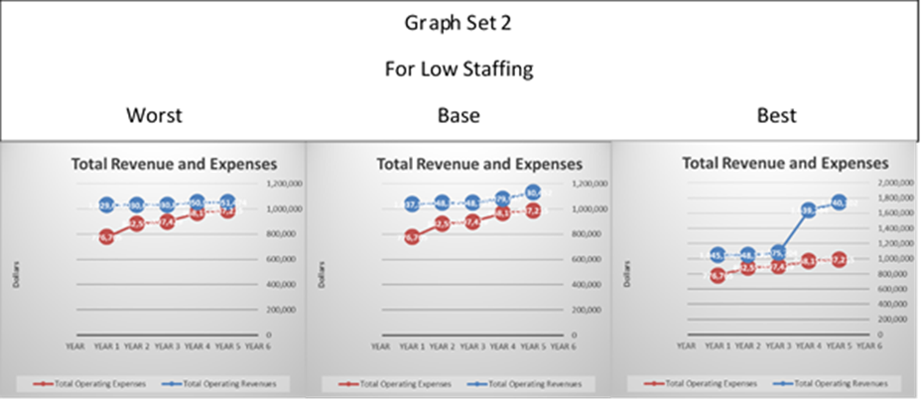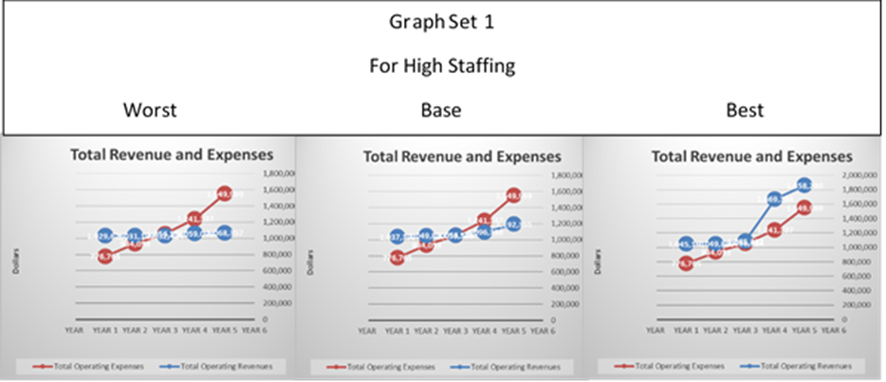The following scatterplots are taken from the spreadsheet in this portfolio and show linear relationships in Worst, Base, and Best income variations in both high employee growth and low. These scatterplots show a linear expense relationship in all circumstances and in income for most circumstances. There is a spike in both “Best” scenarios produced by the expectation of revenues from private grant sources.

**Make a Choice**

Although the table 1 shows a 20k cost increase by using donation revenue alone, the cost of the 400k in adding board members is the expense that is not financially responsible at this time. Other reasons for remaining an LLC and not incorporating are the loss of control from the vision provider. In addition, studies done by Giving USA found that foundations represent only 16% of the monies donated to organizations (Giving, 2015). For this reason, JMM will continue down a path that does not include applying for grants from foundations at this time. However, it is prudent to perform due diligence and prepare for such an alternative in the event that this first choice proves unfruitful. Further plans for incorporation are set out in the distance to such a time it is affordable to do so.

**Perform a Sensitivity Analysis**

Some of the factors that might impact this decision follow.

1. Foundation is found that will allow grant applications from single nonprofit LLCs who have a history of approving such applications.

In this case, revenue would greatly increase while avoiding the added costs of incorporation and a board of directors. This would be something in favor of JMM and its goal.

1. The IRS could refuse 501c3 status.

This could happen as an LLC cannot be a church, and if the IRS feels that the licensing of ministers is under the definition of a church, it may reject the 501c3 status. In this case, JMM would have to incorporate and apply for non-profit status as a California corporation. This would increase sunk costs, which would prolong the effective startup by a year or more as sunk costs would be an out of pocket expense supplied by the current CEO of JMM LLC.

1. No grants or revenue comes in at all.

Again, this is actually where the firm is currently at. As long as the CEO is willing to pay for expenses, the firm will exist. However, will it ever perform the ministries it was intended to do? It may be prudent to place a time limit on the ministry becoming self-supportive or close.

**Recommendations**

It is the recommendation that JMM proceed down the avenues listed in this paper. JMM should continue as an LLC, but apply for grants from foundations as an LLC if, after research, it is found that the granting foundation has a history of approving grants to humanitarian nonprofit LLCs. However, do not proceed with any grants without research. The harm done in reputation is something JMM cannot afford as there is a five-year projected time of incorporation that is to be done, those foundations that only grant to nonprofit corporations will be shortlisted and in that event JMM’s reputation needs to be intact. It is further recommended that JMM begin to contact and align itself with the organization of like vision. There is no reason not to work to fulfill its goals through other firms already in the field and doing the work. The added experience and the mentoring may allow insight in further revenue streams.

**Conclusion**

The Forecasting of JMM has been looked at in this paper. The six steps, as provided by Bruno (2014), were defined as 1. Define the problem-The forecasting and establishing of revenue. 2. Determine the objective – the revenue to fulfill its purpose and then to fulfill its humanitarian and ministerial goals. 3. Explore the alternatives—LLC or Incorporation and revenue from gift versus revenue from foundation grants. 4. Predict the consequences—the financial consequences and the loss of power. 5. Make a choice—The choice was made to remain an LLC but look for granting foundations that have a history of approving grants to nonprofit humanitarian LLCs. 6. Perform sensitivity analysis—looking at some good possibilities and some bad ones that may happen in order to have a plan of action just in case. By covering all six, this paper was able to suggest several options that may help to ensure the success of JMM LLC.

References

Action (2019) *Action Against Hunger, About*. Retrieved from: https://www.actionagainsthunger.org/about

Ben (2019) *Ben & Jerry's Foundation*. Retrieved from: https://benandjerrysfoundation.org/

Blackmun, H. A. & Supreme Court Of The United States. (1972) *U.S. Reports: Roe v. Wade, 410 U.S. 113*. [Periodical] Retrieved from the Library of Congress, https://www.loc.gov/item/usrep410113/.

Bruno, C. (2014*) Management Economics, Objective 1, Topic 1*. Retrieved from Flat World Knowledge, Inc: https://cognify.sagencelearning.com/plus/#/student/competencies/307/activities

Care (2019) *Care. About*. Retrieved from: https://www.care.org/about

Doctors (2019) *Doctors Without Borders, Principles*. Retrieved from: https://www.doctorswithoutborders.org/who-we-are/principles

Ford (2019) *Ford Foundation, Grant qualifications.* Retrieved from: https://www.tfff.org/how-we-work/grants/current-funding-opportunities

Gates (2018) *Bill & Melinda Gates Foundation.* Retrieved from. https://www.gatesfoundation.org.

Giving (2015) USA: 2015 Was America’s Most-Generous Year Ever, Givingusa.org. Retrieved from Giving USA: https://givingusa.org/giving-usa-2016/

Glasser (2019) *The Glasser Family Foundation. About*. Retrieved from: http://www.gfcf.org/

JMM (2019) *Jeffery Morse Ministries, Mission Statement*. Retrieved from: http://www.jefferymorseministries.com/files/JMMconstandbylawsLLC/Jeffery%20Morse%20Ministries%20Ms.pdf

Johnson (2019) Robert Woods Johnson Foundation, Grants explorer. Retrieved from: https://www.rwjf.org/en/how-we-work/grants-explorer.html#closed=false

Koch, R.. Roa, L., Pyda, J., Kerrigan, M., Barthélemy, E., Meara, J. (2019) *Surgery, Elsevier.com.* August 2018 (165)(p 273–280)/ Retrieved from: http://www.elsevier.com/locate/surg

Mellon (2019) Andrew W. Mellon Foundation, Grants. Retrieved from: https://mellon.org/grants/grants-database/

Samaritan (2019) *Samaritans Purse, About.* Retrieved from: https://www.samaritanspurse.org/our-ministry/about-us/

SP (2019) *Samaritans Purse, Financial Audit, 2018*. Retrieved from: https://s3.amazonaws.com/static.samaritanspurse.org/pdfs/SPConsolidFin2018-PublicDisclosureCopy.pdf

Streisand (2019)*The Streisand Foundation.* Retrieved from: https://www.barbrastreisand.com/streisand-foundation/

World (2019) *World Vision, About*. Retrieved from: https://www.worldvision.org/about-us?campaign=119351214&gclid=EAIaIQobChMI7Ovd1dnq4wIVVBx9Ch3cLwXcEAAYASABEgJyMfD_BwE