Managing Economics Class Notes

Objective 1: The Six Steps to Decision-Making

Topic 1: Define the Problem

The Six Steps to Decision-Making

Successful leaders follow a six-step process to make these decisions and ensure effective solutions.

The decision-making process can be universally broken down into six logical steps:

1. Define the problem.
2. Determine the objective.
3. Explore the alternatives.
4. Predict the consequences.
5. Make a choice.
6. Perform sensitivity analysis.

*Note.* The material in this section was written by Cindy Bruno. Copyright 2014 by Flat World Knowledge, Inc.

Step 1: Define the Problem

it is necessary to first have a clear understanding of the problem, including who will be making the decision and how it will affect the objectives of management. Included in analyzing the problem is the knowledge of whether it has arisen as a result of the regular planning process or a new business opportunity. Nowhere is this more evident than at organizations within the public sector. For example, changes in public school policy might require approval from numerous local, state, and federal agencies. It is also necessary to determine how narrowly or broadly to define a problem.

Note. The material in this section was written by Cindy Bruno. Copyright 2014 by Flat World Knowledge, Inc.

Defining Real-World Problems---side work..

Topic 2: Determine the Objective

Once the problem has been defined, it is important to determine the objective management wants to achieve—such as profit or advancing an organization’s mission.

Step 2: Determine the Objective--After gaining as clear as possible an understanding of the problem at hand, the next step is to determine the goal that management would like to achieve and, if there are multiple goals, whether they conflict. determine the value of the outcomes with respect to the goal or goals. In general, the bottom line for the private sector is usually profit, whereas for the public sector, goals tend to be far more expansive. Uncertainty and risk are also complicating factors when determining the goals of a particular decision. For example, when faced with what type of restaurant to open, the degree of risk is very different when buying into a franchise versus opening an independent restaurant.

Note. The material in this section was written by Cindy Bruno. Copyright 2014 by Flat World Knowledge, Inc.

What are the Business Objectives? --- assignment

Topic 3: Explore the Alternatives

An organization must consider various courses of action and explore the best options for moving forward.

Step 3: Explore the Alternatives

Once a problem has been analyzed and objectives have been determined, it is necessary to consider various courses of action to solving the problem and achieving the stated goals. Within this realm, it is important to keep in mind which variables are under the decision-maker’s control and if there are any particular restrictions that might limit the decision-maker’s options. After these questions are answered, the next step is to explore the best possible options for moving forward, using a solid decision framework. Rather than a once-and-for-all decision scenario, often managers will also face a sequence of decisions within a particular framework, such as when conducting negotiations that frequently encompass a back-and-forth series of discussions, each one hammering out a small part of the overall deal.

Note. The material in this section was written by Cindy Bruno. Copyright 2014 by Flat World Knowledge, Inc

Exploring the Alternatives in a Real-World Example –assignment

Topic 4: Predicting the Consequences

Business managers try to predict the consequences of each option in order to identify the best course of action, often using models.

Step 4: Predict the Consequences--- After the most feasible options are determined, it is necessary to map out the consequences of each course of action, including the likelihood of each consequence if the outcome is uncertain. It is also necessary to determine if the uncertainties can be reduced and how the outcome will be impacted if conditions change.

Other models are based on different relationships, for example:

1. **Statistical**: Major construction projects rely heavily on engineering predictions.
2. **Legal**: When a corporation is determining how aggressively to pursue collections, interpretation of legal statutes and precedents as well as analysis of future legal costs may dictate the company’s policy.
3. **Scientific**: Corporate research and development teams use the scientific method to assess how a product is being developed and the positive or negative reaction it elicits during the product testing phase. Another example can be seen in the growing demand for Greek yogurt, whose makers regularly utilize scientific models to evaluate the market success of their product.

Models can also be based on the likelihood of outcomes, such as a **deterministic model**, where the outcome is fairly certain, versus a **probabilistic model**, where the probability of a series of outcomes is predicted.

Note. The material in this section was written by Cindy Bruno. Copyright 2014 by Flat World Knowledge, Inc.

Topic 5: Make a Choice

After modeling the consequences for each option, management should be prepared to make a choice for the path to pursue.

Step 5: Make a Choice

making the actual decision, is based on all the steps taken thus far that have put the situation in context. The problem has been clarified, the crucial objectives and alternatives have been identified, and the consequences have been predicted, hence the time has come to take action.

Note. The material in this section was written by Cindy Bruno. Copyright 2014 by Flat World Knowledge, Inc.

Topic 6: Perform Sensitivity Analysis

Sensitivity analysis allows managers to consider how the outcomes of a decision would vary if circumstances of the problem changed.

Step 6: Perform Sensitivity Analysis

if the circumstances of the problem were to change and to determine just how vulnerable to uncertain economic variables the decision actually is. A sensitivity analysis, which enables the decision-maker to convey his or her reasons behind the decision (such as the objectives, the structure of the problem, the options that were under consideration, and the method of predicting outcomes), serves the important function of understanding the core determinants of profit.

Note. The material in this section was written by Cindy Bruno. Copyright 2014 by Flat World Knowledge, Inc.

Creating Financial Scenarios in Excel

This video demonstrates how to create different financial scenarios – in other words, conduct a sensitivity analysis – in Excel. May help with final..

Topic 7: Sample Application of Six-Step Decision-Making Process

Sample Analysis

**Objective 2: Decision Making Using Marginal Analysis**

Topic 1: Marginal Revenue

Marginal Revenue Product and Derived Demand

The principle for profit maximization states that, absent constraints on production, the optimal output levels for goods and services occur when marginal revenue equals marginal cost.

The marginal product of a production input is the amount of additional output that would be created if one more unit of the input were obtained and processed.

The marginal revenue product of a production input is the marginal revenue created from the marginal product resulting from one additional unit of the input. The marginal revenue product would be the result of multiplying the marginal product of the input times the marginal revenue of the output

In determining if a firm is using the optimal level on an input, the marginal revenue product for an additional unit of input can be compared to the marginal cost of a unit of the input. If the marginal revenue product exceeds the marginal input cost, the firm can improve profitability by increasing the use of that input and the resulting increase in output.

The marginal revenue will change as output is increased, usually declining as output levels increase. Correspondingly, the marginal revenue product will generally decrease as the input and corresponding output continue to be increased.

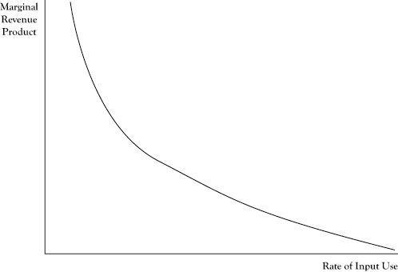

One difficulty in comparing marginal revenue product to the marginal cost of an input is that the mere increase in any single input is usually not enough in itself to create more units of output.

*Note*. Adapted from “Marginal Revenue Product and Derived Demand,” by D.N. Stengel, 2012, *Principles of Managerial Economics,*Chapter 4, Section 5. Copyright 2012 by Flat World Knowledge, Inc.

Topic 1: Activity 2 of 8 Employee Motivation

In recent decades, economists have addressed employee motivation from a new perspective. In times past Ensuring good performance by employees was basically a matter of appropriate supervision, encouragement, and feedback. be notified of the problem, possibly disciplined, or even dismissed and replaced. From this perspective, managing employees is much like managing military troops,

The new perspective on employee motivation is to consider the employee more like an individual contractor rather than an enlisted soldier.

One contribution from this economic perspective is the notion of an efficiency wage (Milgrom and Roberts, 1992). The classical approach to setting wages is that the wage paid to an employee should be no more than the marginal revenue product corresponding to her effort. However, if an employee is paid barely what her efforts are worth to the firm at the margin and if there is a competitive market for the employee’s services in other firms, the employee may not be motivated to work at maximum capacity or avoid engaging in behaviors that are detrimental to the firm because she can earn as much elsewhere if she is dismissed.

Another contribution of this economic viewpoint of employee motivation is an examination of employee contracts to deal with what is called the principal-agent problem. In this context, the hiring business is a principal that hires an employee (agent) to act on its behalf.

A third interesting contribution of this perspective on employee motivation is the concept of signaling (Spence, 1974). When employers hire, they choose from a pool of possible employees. Some employees will perform well, whereas others will not due to either lack of skills or lack of character.

*Note*. Adapted from “Employee Motivation,” by D.N. Stengel, 2012, *Principles of Managerial Economics,*Chapter 5, Section 10. Copyright 2012 by Flat World Knowledge, Inc.

Ranked and Yanked The Economist: [Ranked and Yanked](http://www.economist.com/news/business/21589866-firms-keep-grading-their-staff-ruthlessly-may-not-get-best-them-ranked-and-yanked)

Topic 1: Activity 4 of 8--Firm Supply Curves and Market Supply Curves

think about the relationship between average cost curves, marginal cost curves, and firm supply curves.

The demand curve describes how either one consumer or a group of consumers would change the amount to be purchased if the price were to change. Producers may also adjust the amounts they sell if the market price changes.

A firm should operate in the short run if they can achieve an economic profit; otherwise the firm should shut down in the short run. If the firm decides it is profitable to operate, the firm should increase production up to the level where marginal cost equals marginal revenue.

In the case of a flat demand curve, the marginal revenue to a firm is equal to the market price. Based on this principle, we can prescribe the best operating level for the firm in response to the market price as follows:

* If the price is too low to earn an economic profit at any possible operating level, shut down.
* If the price is higher than the marginal cost when production is at the maximum possible level in the short run, the firm should operate at that maximum level.
* Otherwise, the firm should operate at the level where price is equal to marginal cost.

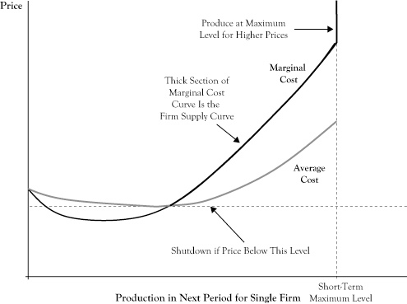Figure 2.2 shows a generic situation with average (economic) cost and marginal cost curves. Based on the preceding rule, a relationship between the market price and the optimal quantity supplied is the segment of the marginal cost curve that is above the shutdown price level and where the marginal cost curve is increasing, up to the point of maximum production.

This curve segment, called the firm supply curve, provides an analogue to the demand curve to describe the best response of sellers to market prices. As is done with demand curves, the convention in economics is to place the quantity on the horizontal axis and price on the vertical axis. Note that although demand curves are typically downward sloping to reflect that consumers’ utility for a good diminishes with increased consumption, firm supply curves are generally upward sloping. The upward sloping character reflects that firms will be willing to increase production in response to a higher market price because the higher price may make additional production profitable. Due to differences in capacities and production technologies, seller firms may have different firm supply curves.

If we were to examine all firm supply curves to determine the total quantity that sellers would provide at any given price and determined the relationship between the total quantity provided and the market price, the result would be the market supply curve. As with firm supply curves, market supply curves are generally upward sloping and reflect both the willingness of firms to push production higher in relation to improved profitability and the willingness of some firms to come out of a short-run shutdown when the price improves sufficiently.

*Note*. Adapted from “Firm Supply Curves and Market Supply Curves,” by D.N. Stengel, 2012, *Principles of Managerial Economics,*Chapter 6, Section 4. Copyright 2012 by Flat World Knowledge, Inc.

Topic 1: Activity 5 of 8 Monopoly

Often, the main deterrent to a highly competitive market is market power possessed by sellers. In this section, we will consider the strongest form of seller market power, called a monopoly. In a monopoly there is only one seller, called a monopolist. Research and find one example of a monopoly or a monopolist and share your findings in Social Learning.

In perfect competition, each firm sees the demand curve it faces as a flat line, so it presumes it can sell as much as it wants, up to its production limit, at the prevailing market price. Even though the overall market demand curve decreases with increased sales volume, the single firm in perfect competition has a different perception because it is a small participant in the market and takes prices as given. In the case of flat demand curves, price and marginal revenue are the same, and since a profit-maximizing producer decides whether to increase or decrease production volume by comparing its marginal cost to marginal revenue, in this case the producer in perfect competition will sell more (if it has the capability) up the point where marginal cost equals price.

In a monopoly, the demand curve seen by the single selling firm is the entire market demand curve. If the market demand curve is downward sloping, the monopolist knows that marginal revenue will not equal price. When the demand curve is downward sloping, the marginal revenue corresponding to any quantity and price on the demand curve is less than the price (see Figure 2.3). Because the condition for optimal seller profit is where marginal revenue equals marginal cost, the monopolist will elect to operate at a quantity where those two quantities are in balance, which will be at volume marked QM in the graph.

Since the monopolist has complete control on sales, it will only sell at the quantity where marginal revenue equals marginal cost but will sell at the higher price associated with that quantity on the demand curve, PM, rather than the marginal cost at a quantity of QM.

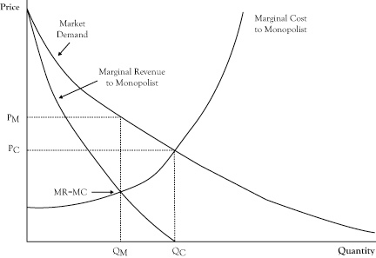

If the marginal cost curve for the monopolist were instead the combined marginal cost curves of small firms in perfect competition, the marginal cost curve would correspond to the market supply curve. The perfect competition market equilibrium would occur at a volume QC, with a price PC. The monopolist could afford to function at this same volume and price and may even earn some economic profit. However, at this volume, marginal cost is greater than marginal revenue, indicating greater profit by operating at a lower volume at a higher price. The highest profit will result from selling QM units at a price of PM. Unfortunately, consumers do worse at the monopolist’s optimal operation as they pay a higher price and purchase fewer units. The loss in consumer surplus will exceed the profit gain to the monopolist. This is the main reason monopolies are discouraged, if not outlawed, by governments.

*Note*. Adapted from “Firm Competition and Market Structure,” by D.N. Stengel, 2012, *Principles of Managerial Economics,*Chapter 7. Copyright 2012 by Flat World Knowledge, Inc.

Topic 1: Activity 6 of 8--Oligopoly and Cartels

Unless a monopoly is allowed to exist due to a government license or protection from a strong patent, markets have at least a few sellers. When a market has multiple sellers, at least some of which provide a significant portion of sales and recognize (like the monopolist) that their decisions on output volume will have an effect on market price, the arrangement is called an oligopoly. Read this section to learn about oligopolies and cartels.

At the extreme, sellers in an oligopoly could wield as much market power as a monopolist. This occurs in an oligopoly arrangement called a cartel, where the sellers coordinate their activities so well that they behave, in effect, like divisions of one enterprise, rather than as competing businesses that make independent decisions on quantity and price. (You may be familiar with the term cartel from the OPEC oil exporting group that is frequently described as a cartel. However, though OPEC has considerable market power and influence on prices, other oil exporters exist in the market that are not in OPEC, and internally OPEC only sets member targets rather than fully coordinating their operations.)

In theory, a cartel would operate at the same production volume and price as it would if its productive resources were all run by a monopolist. In a cartel, every member firm would sell at the same price and each firm would set its individual production volume such that every firm operates at the same marginal cost.

*Note*. Adapted from “Firm Competition and Market Structure,” by D.N. Stengel, 2012, *Principles of Managerial Economics,*Chapter 7. Copyright 2012 by Flat World Knowledge, Inc.

Topic 1: Activity 7 of 8—s it an Oligopoly?

Topic 1: Activity 8 of 8-- Production Decisions in Noncartel Oligopolies

An oligopoly falls somewhere between perfect competition and a cartel. Read this section to learn about two approaches economists have used to model the behavior of oligopoly firms: the Bertrand model or price competition, and the Cournot model or quantity competition.

Oligopolies exist widely in modern economies, though they do not function as cartels. Still, since these markets have relatively few sellers and each has a significant share of market sales, in many cases the total market production by oligopoly firms is less than would be expected if the market were perfectly competitive, and prices will be somewhat higher.

From the point of theory, the expected operation of a firm in perfect competition or in monopoly/cartel is straightforward. Assuming the firm in perfect competition sufficiently understands its production costs, it will increase volume up to the point where its marginal cost exceeds the price. For a monopolist or cartel, production should increase up to point where marginal cost equals marginal revenue.

Oligopolies fall somewhere in between perfect competition and a cartel.

One approach that economists have used to model the behavior of oligopoly firms, known as the **Bertrand model** or **price competition**, is to assume all firms can anticipate the prices that will be charged by their competitors.

Another approach for modeling oligopoly behavior, known as the **Cournot model** or **quantity competition**, is to assume all firms can determine the upcoming production levels or operating capacities of their competitors.

*Note*. Adapted from “Firm Competition and Market Structure,” by D.N. Stengel, 2012, *Principles of Managerial Economics,*Chapter 7. Copyright 2012 by Flat World Knowledge, Inc.

Topic 2: Marginal Cost

Topic 2: Activity 1 of 17 **Cost Approach Versus Resources Approach to Production Planning**

The conventional approach to planning production is to start with the goods and services that a firm intends to provide and then decide what production configuration will achieve the intended output at the lowest cost. This is the cost approach to production planning. Once output goals are set, the expected revenue is essentially determined, so any remaining opportunity for profit requires reducing the cost as much as possible.

Although the principle of cost minimization is simple, actually achieving true minimization in practice is not feasible for most ventures of any complexity. Rather, minimization of costs is a target that is not fully realized because the range of production options is wide and the actual resulting costs may differ from what was expected in the planning phase.

Additionally, the decision about whether to provide a good or service and how much to provide requires an assessment of marginal cost. Due to scale effects, this marginal cost may vary with the output level, so firms may face a circular problem of needing to know the marginal cost to decide on the outputs, but the marginal cost may change depending on the output level selected. This dilemma may be addressed by iteration between output planning and production/procurement planning until there is consistency. Another option is to use sophisticated computer models that determine the optimal output levels and minimum cost production configurations simultaneously.

Among the range of procurement and production activities that a business conducts to create its goods and services, the firm may be more proficient or expert in some of the activities, at least relative to its competition. (Wernerfelt, 1984).

Conceptually, either planning approach will lead to similar decisions about what goods and services to provide and how to arrange production to do that. However, given the wide range of possible outputs and organizations of production to provide them, firms are not likely to attain truly optimal organization, particularly after the fact. The cost approach is often easier to conduct, particularly for a firm that is already in a particular line of business and can make incremental improvements to reduce cost. However, in solving the problem of how to create the goods and services at minimal cost, there is some risk of myopic focus that dismisses opportunities to make the best use of core competencies. The resource approach encourages more out-of-the-box thinking that may lead a business toward a major restructuring.

Note. Adapted from “Cost Approach Versus Resource Approach to Production Planning,” by D.N. Stengel, 2012, Principles of Managerial Economics, Chapter 4, Section 4. Copyright 2012 by Flat World Knowledge, Inc.

Topic 2: Activity 2 of 17 Productivity and the Learning Curve

The resource view of production management is to make sure that all resources employed in the creation of goods and services are used as effectively as possible. Smart businesses assess the productivity of key production resources as a means of tracking improvements and in comparing their operations to those of other firms.

Marginal product reflects how productive an additional unit of that input would be in creating additional output. However, for some inputs, there are differences in marginal productivity across units. At any given input price, firms will seek to employ those units with the highest marginal product first.

In looking at the collective performance of a production operation, we need a measure of productivity that applies to all inputs being used rather than the last unit acquired. One means of doing this is using the measure of average productivity, which is a ratio of the total number of units of output divided by the total units of input.

An alternative measure of average productivity would be the total dollars in revenue or profit divided by the total units of an input.

The productivity of firms may change over time. In the case of labor, the productivity of individual workers will rise as they gain experience and new workers can be trained more effectively. There is also an improvement in overall productivity from the increased knowledge of management in how to employ productive resources better. These productivity gains from experience and improved knowledge are sometimes called learning by doing (Arrow, 1962).

Improvements due to productivity gains will usually result in decreased average costs. The relationship between cumulative production experience and average cost is called the learning curve.

*Note*. Adapted from “Productivity and the Learning Curve,” by D.N. Stengel, 2012, *Principles of Managerial Economics,*Chapter 4, Section 7. Copyright 2012 by Flat World Knowledge, Inc.

Topic 2: Activity 3 of 17-- How Can Productivity Be Increased?—Activity

Topic 2: Activity 4 of 17 Transfer Pricing

The profit center model treats a corporate division as if it were an autonomous business within a business. However, often the reason for having multiple divisions in an enterprise is because there is vertical integration, meaning that some divisions are providing goods and services to other divisions in the enterprise.

If the two divisions in an exchange are to be treated as if they were separate businesses, what price should be charged by the supplying division? Even if there is no actual cash being tendered by the acquiring division, some measurement of value for the exchange is needed to serve as the revenue for the selling division and the cost for the acquiring division. The established value assigned to the exchanged item is called a transfer price.

One possibility for establishing a transfer price is for the two divisions to negotiate a price as they would if they were indeed independent businesses. Unfortunately, this approach sacrifices one of the benefits of vertical integration—namely, the avoidance of the transaction costs that are incurred on external changes—without avoiding all the internal transaction costs.

Another approach to the problem of pricing interdivision exchanges is to base prices on principles rather than negotiation. Academic research has concluded a number of principles for different kinds of situations. In this section, we will limit our consideration to two of these situations.

*Note*. Adapted from “Transfer Pricing,” by D.N. Stengel, 2012, *Principles of Managerial Economics,*Chapter 5, Section 9. Copyright 2012 by Flat World Knowledge, Inc.

Topic 2: Activity 5 of 17 Shifts in Supply and Demand Curves

Changes in the behavior of buyers or the operations of sellers cause a shift in the demand curve or the supply curve, respectively.

In addition to the factors that cause fluctuations in the market equilibrium, some developments may lead to sustained changes in the market equilibrium. For example, if a new product becomes available that is a viable substitute for an existing product, there is likely to be either a persistent drop in the quantity consumed of the existing good or a reduction in the market price for the existing good.

The impact of these persistent changes can be viewed in the context of changes in the behavior of buyers or the operations of sellers that cause a shift in the demand curve or the supply curve, respectively. In the case of the new availability of a close substitute for an existing product, we would expect the demand curve to shift to the left, indicating that at any market price for the existing good, demand will be less than it was prior to introduction of the substitute.

The examination of the impact of a change on the equilibrium point is known in economics as comparative statics.

In the case of a shifting demand curve, since the supply curve is generally upward sloping, a shift of the demand curve either upward or to the right will result in both a higher equilibrium price and equilibrium quantity. Likewise, a shift in the demand curve either downward or to the left will usually result in a lower equilibrium price and a lower equilibrium quantity. So in response to the introduction of a new substitute good where we would expect a leftward shift in the demand curve, both the equilibrium price and quantity for the existing good can be expected to decrease (see Figure 2.5).

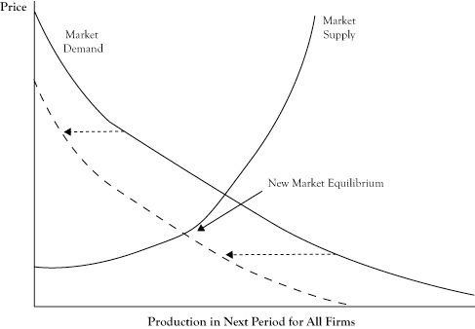

Whether a shift in the demand curve results in a greater relative change in the equilibrium price or the equilibrium quantity depends on the shape of the supply curve. If the supply curve is fairly flat, or elastic, the change will be primarily in the equilibrium quantity (see Figure 2.6).

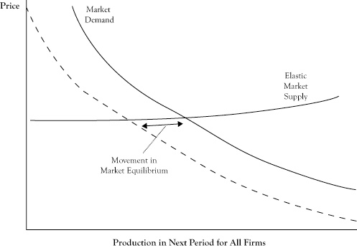

The shift is generally in terms of the quantity when the supply curve is elastic.

An elastic supply curve means that a small change in price typically results in a greater response in the provided quantity. If the supply curve is fairly vertical, or inelastic, the change in equilibrium will be mostly seen as a price change (see Figure 2.7).

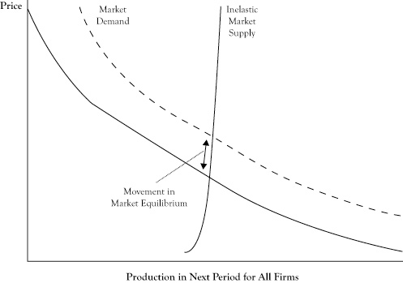

A shift in the supply curve has a different effect on the equilibrium. Because the demand curve is generally downward sloping, a shift in the supply curve either upward or to the left will result in a higher equilibrium price and a lower equilibrium quantity. However, a shift in the supply either downward or to the right will result in a lower equilibrium price and a higher equilibrium quantity. So for the example of the gasoline market where the supply curve shifts upward, we can expect prices to rise and the quantity sold to decrease (see Figure 2.8).

The shape of the demand curve dictates whether a shift in the supply curve will result in more change in the equilibrium price or the equilibrium quantity. With a demand curve that is flat, or elastic, a shift in supply curve will change the equilibrium quantity more than the price (see Figure 2.9).

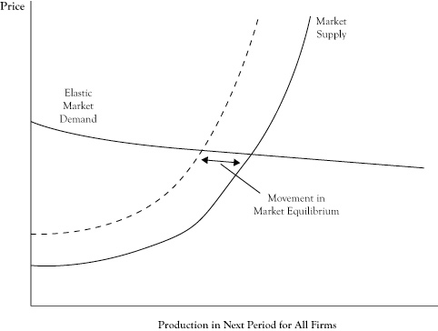

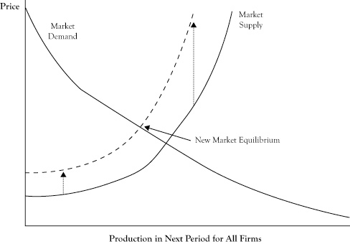

With a demand curve that is vertical, or inelastic, a shift in the supply curve will change the equilibrium price more than the equilibrium quantity (see Figure 2.10).

The characterization of a demand curve as being elastic or inelastic corresponds to the measure of price elasticity. In the short run, customers are limited in their options by their consumption patterns and technologies. This is particularly true in the case of gasoline consumption. Consequently, short-run demand curves for gasoline tend to be very inelastic. As a result, if changing crude oil prices results in an upward shift in the supply curve for gasoline, we should expect the result to be a substantial increase in the price of gasoline and only a fairly modest decrease in the amount of gasoline consumed.

*Note*. Adapted from “Shifts in Supply and Demand Curves,” by D.N. Stengel, 2012, *Principles of Managerial Economics,*Chapter 6, Section 6. Copyright 2012 by Flat World Knowledge, Inc.

Topic 2: Activity 6 of 17 Changes in Market Equilibrium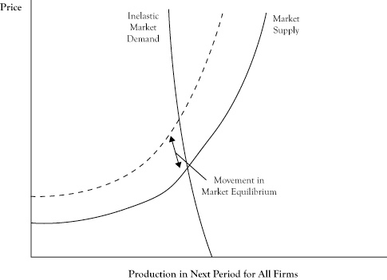—Video

<https://www.youtube.com/watch?time_continue=259&v=NgPqyM3I_8o>

Topic 2: Activity 7 of 17 Why Perfect Competition Is Desirable

In a simple market under perfect competition, equilibrium occurs at a quantity and price where the marginal cost of attracting one more unit from one supplier is equal to the highest price that will attract the purchase of one more unit from a buyer.

t the price charged at equilibrium, some buyers are getting a bargain of sorts because they would have been willing to purchase at least some units even if the price had been somewhat higher. The fact that market demand curves are downward sloping rather than perfectly flat reflects willingness of customers to make purchases at higher prices.

At least in theory, we could imagine taking all the units that would be purchased at the equilibrium price and using the location of each unit purchase on the demand curve to determine the maximum amount that the buyer would have been willing to pay to purchase that unit. The difference between what the customer would have paid to buy a unit and the lower equilibrium price he or she actually paid constitutes a kind of surplus that goes to the buyer. If we determined this surplus for each item purchased and accumulated the surplus, we would have a quantity called consumer surplus. Using a graph of a demand curve, we can view consumer surplus as the area under the demand curve down to the horizontal line corresponding to the price being charged, as shown in Figure 2.11.

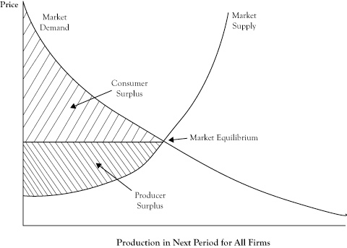

On the supplier side, there is also a potential for a kind of surplus. Since market supply curves are usually upward sloping, there are some sellers who would have been willing to sell the product even if the price had been lower because the marginal cost of the item was below the market price, and in perfect competition, a producer will always sell another item if the price is at least as high as the marginal cost. If, as before, we assessed each item sold in terms of its marginal cost, calculated the difference between the price and the marginal cost, and then accumulated those differences, the sum would be a quantity called the producer surplus.

The producer surplus reflects the combined economic profit of all sellers in the short run. For a graph of the supply curve, the producer surplus corresponds to the area above the supply curve up to the horizontal line at the market price, as shown in Figure 2.11.

Consumer surplus will increase as the price gets lower (assuming sellers are willing to supply at the level on the demand curve), and producer surplus will increase as the prices gets higher (assuming buyers are willing to purchase the added amount moving up the supply curve)

To support this claim, suppose sellers decided to increase the price above the equilibrium price. Since consumers would purchase fewer items, the quantity that could be sold is dictated by the demand curve. The new producer surplus, as seen in Figure 2.12, might be higher than the producer surplus at the equilibrium price, but the consumer surplus would be decidedly lower. So any increase in producer surplus comes from what had been consumer surplus. However, there is a triangular area in the graph, between the supply and demand curve and to the right of the new quantity level, which represents former surplus that no longer goes to either consumers or producers. Economists call this lost surplus a deadweight loss.

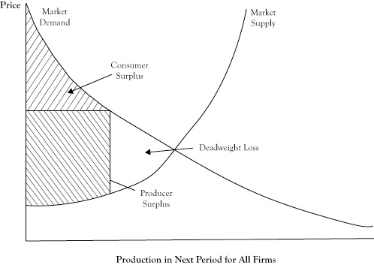

If the price were lower than the equilibrium price, we encounter a situation where producer surplus decreases and at best only some of that decrease transfers to consumers. The rest of the lost producer surplus is again a deadweight loss, as seen in Figure 2.13.

The important point is that changing the price is worse than just a shift of surplus from consumers to producers, or vice versa. If the entire sum of consumer surplus and producer surplus could grow at a different price, it could be argued that the government could use a tax to take some of the excess received by one group and redistribute it to the other party so everyone would be as well off or better off. Unfortunately, due to the deadweight loss, the gain to one of two parties will not offset the loss to the other party. So the equilibrium point is not only a price and quantity where we have agreement between the demand curve and supply curve, but also the point at which the greatest collective surplus is realized.

Note. Adapted from “Why Perfect Competition Is Desirable,” by D.N. Stengel, 2012, Principles of Managerial Economics, Chapter 6, Section 7. Copyright 2012 by Flat World Knowledge, Inc.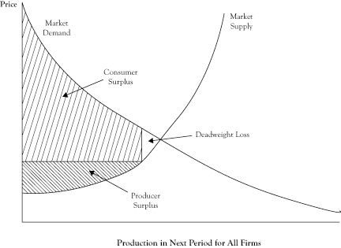

Topic 2: Activity 8 of 17 What Happens to the Supply and Demand Curves in These Situations?

Activity

Topic 2: Activity 9 of 17 Competing in Tight Oligopolies: Pricing Strategies

In recent decades, economists have employed the applied mathematical tools of **game theory** to try to capture the dynamics of oligopoly markets. The initial research papers are generally abstract and very technical, but the acquired insights from some of this research have been presented in textbooks geared to nontechnical readers (Brandenburger and Nalebuff, 1996). Game theory is outside the scope of this discussion, but we will consider some of the insights gained from the application of game theory in discussions about strategy in this and the following sections.

In this section, we will consider the economics underlying some pricing strategies used by firms in monopolies and tight oligopolies.

1. **Deep discounting**. One exercise of seller power is to try to drive out existing competition. Deep discounting attempts to achieve this by setting the firm’s price below cost, or at least below the average cost of a competitor. The intent is to attract customers from the competitor so that the competitor faces a dilemma of losses from either lost sales or being forced to follow suit and also set its price below cost. The firm initiating the deep discounting hopes that the competitor will decide that the best reaction is to exit the market. In a market with economies of scale, a large firm can better handle the lower price, and the technique may be especially effective in driving away a small competitor with a higher average cost. If and when the competitor is driven out of the market, the initiating firm will have a greater market share and increased market power that it can exploit in the form of higher prices and greater profits than before.
2. **Limit pricing**. A related technique for keeping out new firms is the technique of limit pricing. Again, the basic idea is to use a low price, but this time to ward off a new entrant rather than scare away an existing competitor. Existing firms typically have lower costs than a new entrant will initially, particularly if there are economies of scale and high volume needed for minimum efficient scale. A limit price is enough for the existing firm to make a small profit, but a new entrant that needs to match the price to compete in the market will lose money. Again, when the new entrant is no longer a threat, the existing firm can reassert its seller power and raise prices for a sustained period well above average cost. In this game of strategy, the new entrant may reason that if it is willing to enter the market anyway and incur an initial loss, once its presence is established, the existing firm will realize its use of limit pricing did not work and decide it would be better to let prices go higher so that profits will increase, even if that allows the new entrant to remain in the market.

*Note*. Adapted from “Competing in Tight Oligopolies: Pricing Strategies,” by D.N. Stengel, 2012, *Principles of Managerial Economics,*Chapter 7, Section 6. Copyright 2012 by Flat World Knowledge, Inc.

Topic 2: Activity 10 of 17 Game Theory in Practice

Article

The Economist: [Game Theory In Practice](http://www.economist.com/node/21527025)

If you don't have log-in credentials for The Economist website, you can locate the article in the [Brandman Virtual Library](http://www1.chapman.edu/library/centers/index.html).

Topic 2: Activity 11 of 17-- Buyer Power

In markets with a few buyers that individually make a sizeable fraction of total market purchases, buyers can exercise power that will influence the market price and quantity.

The most extreme form of buyer power is a single buyer, called a monopsony. If there is no market power among the sellers, the buyer is in a position to push the price down to the minimum amount needed to induce a seller to produce the last unit. The supply curve for seller designates this price for any given level of quantity. Although the monopsonist could justify purchasing additional units up to the point where the supply curve crosses its demand curve, the monopsonist can usually get a higher value by purchasing a smaller amount at a lower price at another point on the supply curve.

The monopsonist will maximize its value gained from the purchases (amount paid plus consumer surplus) at the point where the marginal cost of added consumption equals the marginal value of that additional unit, as reflected in its demand curve. This optimal solution is depicted in Figure 2.14, with the quantity QS being the amount the monopsonist will purchase and price PS being the price it can impose on the sellers. Note, as with the solution with a seller monopoly, the quantity is less than would occur if the market demand curve were the composite of small buyers with no market power. However, the monopsonist price is less than the monopoly price because the monopsonist can force the price down to the supply curve rather than to what a unit is worth on the demand curve.

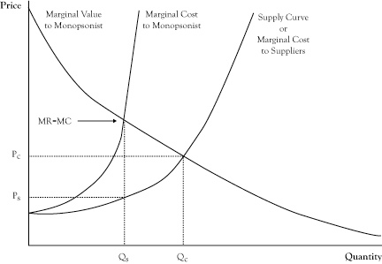

When there are multiple large buyers, there will be increased competition that will generally result in movement along the supply curve toward the point where it crosses the market demand curve. However, unless these buyers are aggressively competitive, they are likely to pay less than under the perfect competition solution by either cooperating with other buyers to keep prices low or taking other actions intended to keep other buyers out of the market.

*Note*. Adapted from “Buyer Power,” by D.N. Stengel, 2012, *Principles of Managerial Economics,*Chapter 7, Section 8. Copyright 2012 by Flat World Knowledge, Inc.

Topic 2: Activity 12 of 17 What Would a Monopsonist Look Like?

Activity

Topic 2: Activity 13 of 17 Natural Monopoly

When total costs are very high but marginal costs are low, a situation economists call natural monopoly occurs.

In industries where the minimum efficient scale is very high, it may be that the lowest average cost is achieved if only one seller provides all the goods or services.

Unfortunately, if just one firm is allowed to serve the entire market, the firm will be tempted to exploit the monopoly position rather than pass its lower cost to buyers in the form of lower prices.

A potential concern when a single provider is allowed to operate as a regulated monopoly is that, without competition, the provider has little incentive for innovation or cost cutting.

*Note*. Adapted from “Natural Monopoly,” by D.N. Stengel, 2012, *Principles of Managerial Economics,*Chapter 8, Section 5. Copyright 2012 by Flat World Knowledge, Inc.

Topic 2: Activity 14 of 17 Externality Taxes

The most practiced economic instrument to address market externality is a tax. Those who purchase gasoline are likely to pay the sum of the price required by the gasoline station owner to cover his costs (and any economic profit he has the power to generate) plus a tax on each unit of gasoline that covers the externality cost of gasoline consumption such as air pollution, wear and tear on existing public roads, needs for expanding public roads to support more driving, and policing of roads.

Theoretically, there is an optimal level for setting a tax. The optimum tax is the value of the marginal externality damage created by consumption of an additional item from a market exchange. If each gallon of gasoline causes $1.50 worth of externality damage, that would be the correct tax.

In the case of positive externalities, the optimum tax is negative. In other words, the government actually pays the seller an amount per unit in exchange for a reduction of an equal amount in the price. Theoretically, the optimum tax would be the negative of the marginal value of a unit of consumption to third parties.

A tax has the impact of either raising the supply curve upward (if the seller pays the tax) or moving the demand curve downward (if the buyer pays the tax). See Figure 2.15 for a graphic illustration of a tax charged to the buyer. To the extent that the supply and demand curves are price elastic, the tax will lower the amount consumed, thereby diminishing the externality somewhat and possibly changing the marginal externality cost. Consequently, actual externality taxes require considerable public transaction costs and may not be at the correct level for the best improvement of market efficiency. Note the tax may cause a decrease in the equilibrium quantity, which may change the optimal externality tax.

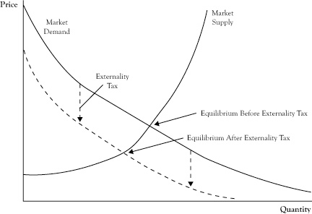

*Note*. Adapted from “Externality Taxes,” by D.N. Stengel, 2012, *Principles of Managerial Economics,*Chapter 8, Section 7. Copyright 2012 by Flat World Knowledge, Inc.

Topic 2: Activity 15 of 17 High Cost to Initial Entrant and the Risk of Free Rider Producers

In this section we will consider a generic type of market failure, or the inability for a market to form or sustain operation due to free riders, by looking at two causes of this kind of failure. Although the sources are different, each involves a situation where some party benefits from the market exchange without incurring the same cost as other sellers or buyers.

New products and services are expensive when the first firm brings them to market. There may be initial failures in the development of a commercial product that add to the cost.

One of the main regulatory measures to address this problem is to guarantee the initial entrant a high enough price and sufficient volume of sales to justify the up-front investment. Patents are a means by which a product or service that incorporates a new idea or process gives the developer a monopoly, at least for production that uses that process or idea, for a certain period of time. Patents are an important element in the pharmaceutical industry to motivate the development of new drugs because there is a long period of development and testing and a high rate of failure. Companies selling patent-protected drugs will sell those products at monopoly prices.

n cases where there is not a patentable process, but nonetheless a high risk of market failure due to scaring away the initial entrant, government authorities may decide to give exclusive operating rights for at least a period of time. This tool was used to encourage the expansion of cable television to the initial entrant in a region to justify the high up-front expenses.

Another government intervention is the provision of subsidies to an initial entrant, to get it to market a new product. The government may decide to fund the up-front research and development and then make the acquired knowledge available to any firm that enters the market so there is not such a difference between being the initial entrant or a subsequent entrant. Another option is for the government itself to serve in the role of initial entrant and then, when commercial viability is demonstrated, privatize the product or service.

*Note*. Adapted from “High Cost to Initial Entrant and the Risk of Free Rider Producers” & “Public Goods and the Risk of Free Rider Consumers,” by D.N. Stengel, 2012, *Principles of Managerial Economics,*Chapter 8, Section 9 & 10. Copyright 2012 by Flat World Knowledge, Inc.

Topic 2: Activity 16 of 17 What Is the Cost of Failure? -activity

Topic 2: Activity 17 of 17 Public Goods and the Risk of Free Rider Consumers

Most goods and services that are purchased are such that one person or a very limited group of persons can enjoy the consumption of the good or, for a durable good, the use of that good at a specific time.

n the case of rival goods, the party consuming the product is easily linked to the party that will purchase the product. Whether the party purchases the product depends on whether the value obtained is at least as high as the price.

However, there are other goods that are largely nonrival. This means that several people might benefit from an item produced and sold in the market without diminishing the benefit to others, especially the party that actually made the purchase.

In perfect competition, the optimal price to be charged is the marginal cost of serving another customer. However, in the case of public goods, the marginal cost of serving an additional benefactor can be essentially zero. This creates an interesting dilemma whereby the theoretical optimal pricing for the good is to charge a price of zero. Of course, that adds to the market failure problem because the production cost of the good or service is not zero, so it is not feasible to operate a market of private sellers and buyers in this manner.

*Note*. Adapted from “High Cost to Initial Entrant and the Risk of Free Rider Producers” & “Public Goods and the Risk of Free Rider Consumers,” by D.N. Stengel, 2012, *Principles of Managerial Economics,*Chapter 8, Section 9 & 10. Copyright 2012 by Flat World Knowledge, Inc.

Topic 3: Marginal Analysis

Topic 3: Activity 1 of 4 Conducting a Marginal Analysis

Economists analyze relationships like revenue functions from the perspective of how the function changes in response to a small change in the quantity. These marginal measurements not only provide a numerical value to the responsiveness of the function to changes in the quantity but also can indicate whether the business would benefit from increasing or decreasing the planned production volume and in some cases can even help determine the optimal level of planned production. This type of analysis is called marginal analysis.

The marginal revenue measures the change in revenue in response to a unit increase in production level or quantity. The marginal cost measures the change in cost corresponding to a unit increase in the production level. The marginal profit measures the change in profit resulting from a unit increase in the quantity. Marginal measures for economic functions are related to the operating volume and may change if assessed at a different operating volume level.

There are multiple computational techniques for calculating these marginal measures. If the relationships have been expressed in the form of algebraic equations, one approach is to evaluate the function at the quantity level of interest, evaluate the function if the quantity level is increased by one, and determine the change from the first value to the second.

Suppose we want to evaluate the marginal revenue for the revenue function derived at last summer’s operating level of 36,000 ice cream bars. For a value of Q = 36,000, the revenue function returns a value of $54,000. For a value of Q = 36,001, the revenue function returns a value of $53,999.70. So, with this approach, the marginal revenue would be $53,999.70 − $54,000, or –$0.30. What does this tell us? First, it tells us that for a modest increase in production volume.

Marginal measures often can be used to assess the change if quantity is decreased by changing sign on the marginal measure. Thus, if the marginal revenue is –$0.30 at Q = 36,000, we can estimate that for modest decreases in planned quantity level (and adjustment of the price upward based on the demand function), revenue will rise $0.30 per unit of decrease in Q.

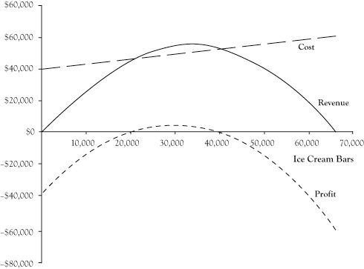At first glance, the fact that a higher production volume can result in lower revenue seems counterintuitive, if not flawed.

**onclusion for Our Students**

Our students will look at this analysis and decide not only to go forward with the ice cream business on the beach but also to charge $1.80 per unit, since that is the price on the demand curve corresponding to a sales volume of 30,000 ice cream bars. Their expected revenue will be $54,000, which coincidentally is the same as in the original plan, but the economic costs will be only $49,000, which is lower than in the original analysis, and their economic profit will be slightly higher, at $5000.

At first glance, a $5000 profit does not seem like much. However, bear in mind that we already assigned an opportunity cost to the students’ time based on the income foregone by not accepting the corporate internships. So the students can expect to complete the summer with $10,000 each to compensate for the lost internship income and still have an additional $5000 to split between them.

*Note*. Adapted from “Marginal Analysis,” by D.N. Stengel, 2012, *Principles of Managerial Economics,*Chapter 2, Section 6. Copyright 2012 by Flat World Knowledge, Inc.

Topic 3: Activity 2 of 4--Match the Marginal Analysis Term.--activity

Topic 3: Activity 3 of 4--Marginal Revenue and Marginal Cost—video

<https://youtu.be/xGkE0oHyNhk>

Objective 3: Forecasting Models

Topic 1: Regression Analysis

Topic 1: Activity 1 of 8-- Correlation and Regression

In this section, we look at situations and measurements of x and y where x predicts the value of y. You will learn statistical methods for analyzing the relationship between variables x and y in this context. You will also learn what it means for two variables to exhibit a relationship that is close to linear but which contains an element of randomness.

Introductory Statistics

Our interest is in situations in which we can associate two measurements to each element of a population or sample: x and y. In particular, it is of interest to use the value of x to predict the value of y. For example, the population could be the air in automobile garages, x could be the electrical current produced by an electrochemical reaction taking place in a carbon monoxide meter, and y could be the concentration of carbon monoxide in the air.

Linear Relationships Between Variables

A plot of these data is shown in Figure 3.2, "Plot of Height and Weight Pairs." Such a plot is called a scatter diagram or scatter plot. Looking at the plot, it is evident that there exists a linear relationship between height x and weight y, but not a perfect one. The points appear to be following a line, but not exactly. There is an element of randomness present.

**Summary**

* Two variables *x* and *y* have a deterministic linear relationship if points plotted from (*x*,*y*) pairs lie exactly along a single straight line.
* In practice, it is common for two variables to exhibit a relationship that is close to linear but which contains an element, possibly large, of randomness.

*Note*. Adapted from “Linear Relationships Between Variables,” by D.S. Shafer & Z. Zhang, 2012, *Introductory statistics,*Chapter 10, Section 1. Copyright 2012 by Flat World Knowledge, Inc.

Topic 1: Activity 2 of 8 Linear Relationships Between Variables Exercise.

Topic 1: Activity 3 of 8 The Linear Correlation Coefficient.

The linear correlation coefficient measures the strength and direction of the linear relationship between the two variables x and y. There can be linear relationships between x and y that vary in strength. Read this section to learn about these linear relationships, as well as the linear correlations coefficient and its properties.

"Linear Relationships of Varying Strengths" (Figure 3.3) illustrates linear relationships between two variables *x*and *y* of varying strengths. It is visually apparent that in the situation in panel (a), *x* could serve as a useful predictor of *y*, it would be less useful in the situation illustrated in panel (b), and in the situation of panel (c), the linear relationship is so weak as to be practically nonexistent. The **linear correlation coefficient** is a number computed directly from the data that measures the strength of the linear relationship between the two variables *x* and *y*.

**Figure 3.3 Linear Relationships of Varying Strengths**

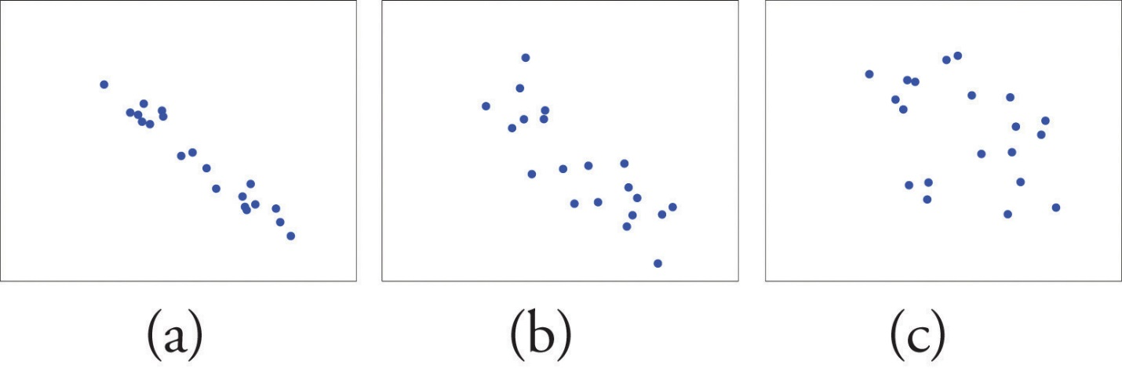

Definition

The linear correlation coefficient for a collection of *n* pairs (x,y) of numbers in a sample is the number *r* given by the formula

where

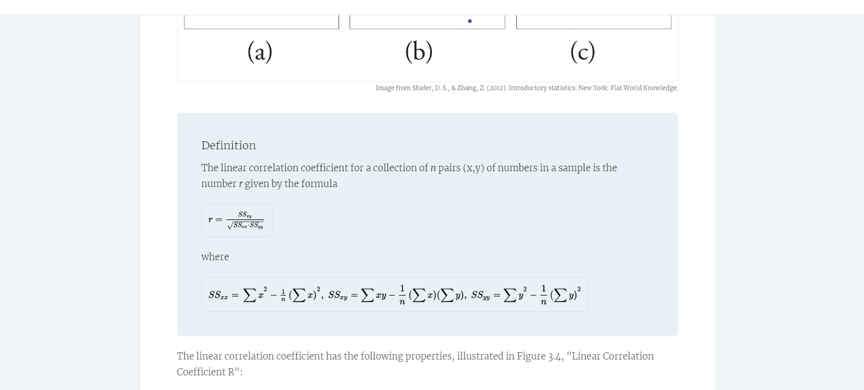

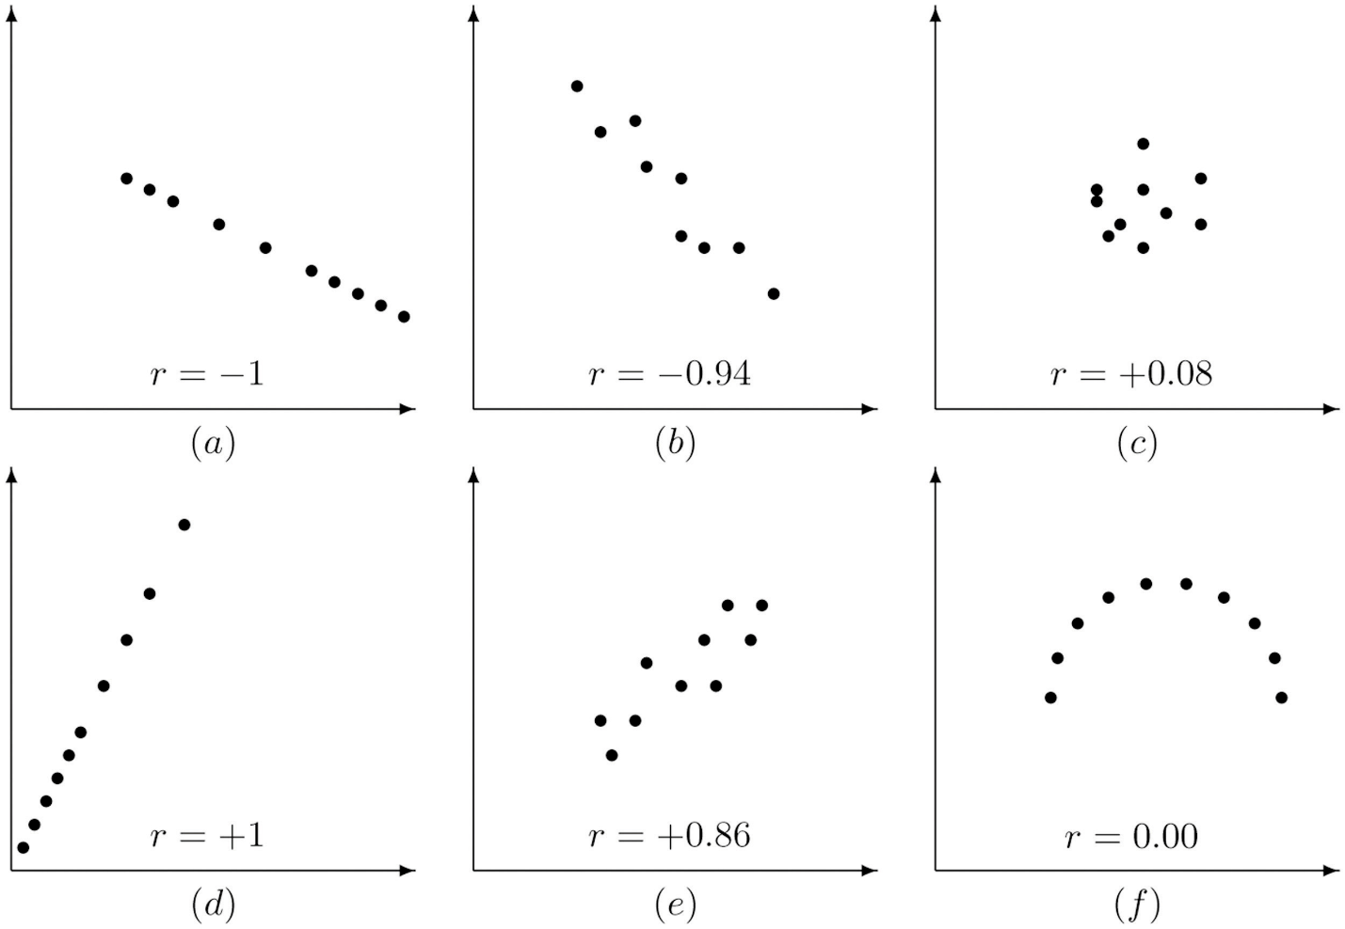

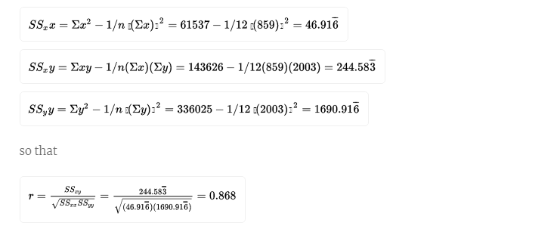**Summary**

* The linear correlation coefficient measures the strength and direction of the linear relationship between two variables *x* and *y*.
* The sign of the linear correlation coefficient indicates the direction of the linear relationship between *x* and *y*.
* When *r* is near 1 or −1 the linear relationship is strong; when it is near 0 the linear relationship is weak.

*Note*. Adapted from “The Linear Correlation Coefficient,” by D.S. Shafer & Z. Zhang, 2012, *Introductory statistics,*Chapter 10, Section 2. Copyright 2012 by Flat World Knowledge, Inc.

Topic 1: Activity 4 of 8 The Linear Correlation Coefficient Exercises

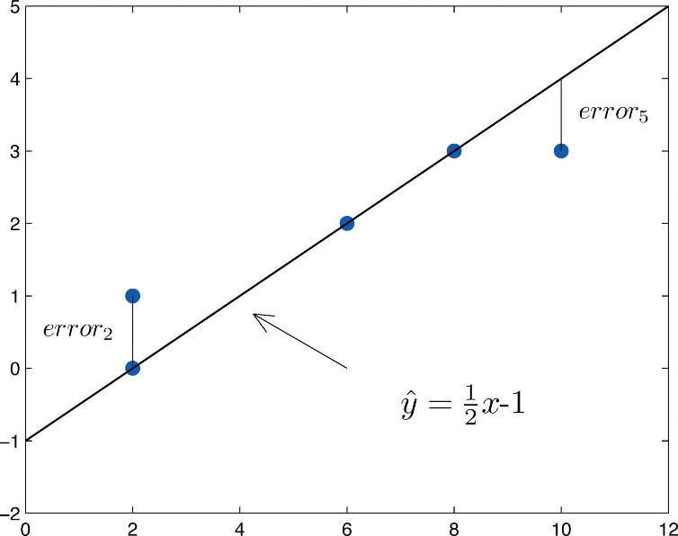Topic 1: Activity 5 of 8 Goodness of Fit of a Straight Line to Data

Once the scatter diagram of the data has been drawn and the model assumptions verified (and perhaps the correlation coefficient r computed to quantitatively verify the linear trend), the next step in the analysis is to find the straight line that best fits the data.

Topic 1: Activity 6 of 8 The Least Squares Regression Line

Given any collection of pairs of numbers (except when all the x-values are the same) and the corresponding scatter diagram, there always exists exactly one straight line that fits the data better than any other, in the sense of minimizing the sum of the squared errors. It is called the least squares regression line. There are formulas for its slope and y-intercept.

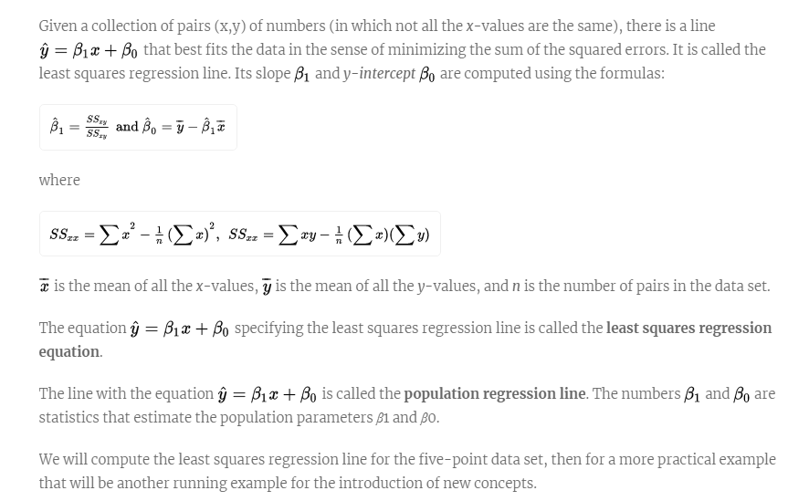

Solution:

The scatter diagram is shown in "Scatter Diagram for Age and Value of Used Automobiles" (Figure 3.7).

Using the values of Σx and Σy computed in part (b),

1. The slope −2.05 means that for each unit increase in *x* (additional year of age) the average value of this make and model vehicle decreases by about 2.05 units (about $2,050).
2. Since we know nothing about the automobile other than its age, we assume that it is of about average value and use the average value of all four-year-old vehicles of this make and model as our estimate. The average value is simply the value of  obtained when the number 4 is inserted for *x* in the least squares regression equation:

 −2.05(4)+32.83=24.63

which corresponds to $24,630.

1. Now we insert *x*=20 into the least squares regression equation, to obtain

=−2.05(20)+32.83=−8.17

which corresponds to −$8,170. Something is wrong here, since a negative makes no sense. The error arose from applying the regression equation to a value of *x* not in the range of *x*-values in the original data, from two to six years.

Applying the regression equation  to a value of *x* outside the range of *x*-values in the data set is called *extrapolation*. It is an invalid use of the regression equation and should be avoided.

1. The price of a brand new vehicle of this make and model is the value of the automobile at age 0. If the value *x*=0 is inserted into the regression equation the result is always  , the *y*-intercept, in this case 32.83, which corresponds to $32,830. But this is a case of extrapolation, just as part (f) was, hence this result is invalid, although not obviously so. In the context of the problem, since automobiles tend to lose value much more quickly immediately after they are purchased than they do after they are several years old, the number $32,830 is probably an underestimate of the price of a new automobile of this make and model.

For emphasis we highlight the points raised by parts (f) and (g) of the example.

The process of using the least squares regression equation to estimate the value of *y* at a value of *x* that does not lie in the range of the *x*-values in the data set that was used to form the regression line is called **extrapolation**. It is an invalid use of the regression equation that can lead to errors, hence should be avoided.

*Note*. Adapted from “The Least Squares Regression Line,” by D.S. Shafer & Z. Zhang, 2012, *Introductory statistics,*Chapter 10, Section 4. Copyright 2012 by Flat World Knowledge, Inc.

Topic 1: Activity 7 of 8 The Sum of the Squared Errors SSE

In general, in order to measure the goodness of fit of a line to a set of data, we must compute the predicted y-value at every point in the data set, compute each error, square it, and then add up all the squares. In the case of the least squares regression line, however, the line that best fits the data, the sum of the squared errors, can be computed directly from the data using a special formula, which will be reviewed in this section.

The sum of the squared errors for the least squares regression line is denoted by SSE. It can be computed using the formula

**Summary**

* How well a straight line fits a data set is measured by the sum of the squared errors.
* The least squares regression line is the line that best fits the data. Its slope and *y*-intercept are computed from the data using formulas.
* The slope  of the least squares regression line estimates the size and direction of the mean change in the dependent variable *y* when the independent variable *x* is increased by one unit.
* The sum of the squared errors *SSE* of the least squares regression line can be computed using a formula, without having to compute all the individual errors.

*Note*. Adapted from “The Least Squares Regression Line,” by D.S. Shafer & Z. Zhang, 2012, *Introductory statistics,*Chapter 10, Section 4. Copyright 2012 by Flat World Knowledge, Inc.

Topic 1: Activity 8 of 8--The Coefficient of Determination

The coefficient of determination is computed through any of three expressions. It is measured by the proportion of variability in y that is accounted for by the linear relationship between x and y, as you will learn about in this section.

The coefficient of determination is computed through any of three expressions. It is measured by the proportion of variability in y that is accounted for by the linear relationship between x and y, as you will learn about in this section.

**Solution:**

The proportion of the variability in value *y* that is accounted for by the linear relationship between it and age *x* is given by the coefficient of determination, *r*2because the correlation coefficient *r* was already computed as *r*=−0.819, *r*2=(−0.819)2=0.671. About 67% of the variability in the value of this vehicle can be explained by its age.

**Summary**

* The coefficient of determination *r*2 estimates the proportion of the variability in the variable *y* that is explained by the linear relationship between *y* and the variable *x*.
* There are several formulas for computing *r*2. The choice of which one to use can be based on which quantities have already been computed so far.

*Note*. Adapted from “The Least Squares Regression Line” & “The Coefficient of Determination,” by D.S. Shafer & Z. Zhang, 2012, *Introductory statistics,*Chapter 10, Section 4 & 6. Copyright 2012 by Flat World Knowledge, Inc.

Topic 2: Forecasting Models

Topic 2: Activity 1 of 3 Forecasting Demand

For a business to better understand its customers, it’s important to forecast the demand of its products and services

Identifying the key determinants of demand and developing demand functions gives a business manager a better understanding of his customers. A benefit of that understanding is an improved accuracy in forecasting the demand levels for their products and services in an upcoming period. Most businesses need to plan production activities well in advance of when the goods and services are actually provided to the consumer. Businesses need to have an adequately sized operation, have a sufficient staff in terms of size and training, and obtain any necessary resources for production. These capabilities are usually not possible to achieve overnight. For some goods, production is a process that takes significant time from initiation to completion, such as constructing apartments or office space that will be leased to customers. Even businesses that provide products or services “made to order,” where most of the direct organization or production activities occur after a purchase is made, usually need to have supplies, trained labor, and management structures in place in advance of the order to be in a position to negotiate a sale.

**Figure 3.12 Shift in Demand Curve for Broadband Service Caused by Increase of Competitor Price From $25/month to $35/month**

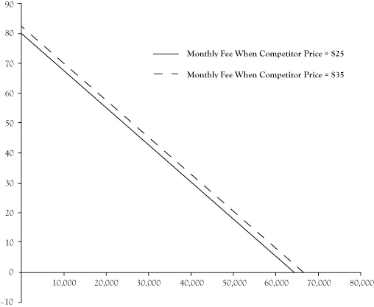Image from Stengel, D. N. (2012). Principles of managerial economics. New York: Flat World Knowledge.

Without some concrete estimate of what level of demand will result after these planning, designing, and production activities, a business may find itself with an excess of unused capacity or unable to serve the demand that follows. Excess capability is costly because idle resources have an opportunity cost but do not contribute to sales or revenue, especially when the unused resources spoil and cannot be used at a later time. When businesses set production targets too low, they discover missed opportunities for profit and unmet demand that is likely to discourage those consumers from being customers in the future.

To a limited extent, a business may be able to alter future demand to be more in line with its capacity because it has control over some determinants of demand, like pricing, promotion, and location. If the business is surprised by demand levels that are higher or lower than expected, these market strategy elements can be adjusted to either stimulate or diminish demand to conform to its production capabilities. Still, the financial performance of an enterprise is improved when the demand is consistent with the levels anticipated in the initial planning stages.

Further, most businesses are not in control of all the key determinants of demand. The business cannot control the direction of the overall economy and consumer incomes. The business may be able to guess at, but not control, actions by other companies that sell substitute and complementary goods and services. Anticipating the impact of these outside forces is critical.

Businesses can improve demand forecasting with their demand functions using the future values of determinant variables in those demand functions. Forecasts for widely followed economic indicators like disposable income are available from public releases or private forecasting services. If the business has a record of data for these uncontrollable variables, they can apply quantitative forecasting techniques like time series analysis or develop casual models that relate these factors to other variables that can be forecast. Readers are encouraged to look at a text in business forecasting for assistance in doing quantitative forecasts.

For variables where past patterns may not continue into the future, like competitor actions on pricing and promotion or unexpected climate events, a business can construct scenarios in which management postulates settings for these factors and then develops a demand forecast for each scenario. Although the future will almost certainly not conform exactly to any single scenario, the exercise prepares them to monitor for changes in these factors and be ready to make a prompt response whenever a similar scenario emerges.

*Note*. Adapted from “Marginal Analysis,” by D.N. Stengel, 2012, *Principles of Managerial Economics,*Chapter 3, Section 5. Copyright 2012 by Flat World Knowledge, Inc.

Topic 2: Activity 2 of 3

Demand Forecasting: Going Beyond Historical Shipment Data

Forbes: [Demand Forecasting: Going Beyond Historical Shipment Data](http://www.forbes.com/sites/stevebanker/2013/09/16/demand-forecasting-going-beyond-historical-shipment-data/)