<https://www.collectivecampus.com.au/blog/10-companies-that-were-too-slow-to-respond-to-change>

10 COMPANIES THAT FAILED TO INNOVATE, RESULTING IN BUSINESS FAILURE

By:

[Frances Goh](https://www.collectivecampus.com.au/authors/frances-goh)

on

[Enterprise Innovation](https://www.collectivecampus.com.au/category/enterprise-innovation)



October 20, 2017

[Tweet](https://twitter.com/intent/tweet?via=CollCampus&text=It%E2%80%99s%20crazy%20to%20think%20that%2088%25%20of%20the%20Fortune%20500%20firms%20that%20existed%20in%201955%20are%20gone.%20These%20companies%20have%20either%20gone%20bankrupt,%20merged,%20or%20still%20exist%20but%20have%20fallen%20from%20the%20top%20Fortune%20500%20companies.%20Most%20of%20the%20companies%20on%20the%20list%20in%201955%20are%20unrecognizable,%20forgotten%20companies%20today.)

Share

It’s crazy to think that[88% of the Fortune 500](http://www.aei.org/publication/fortune-500-firms-in-1955-vs-2014-89-are-gone-and-were-all-better-off-because-of-that-dynamic-creative-destruction/) firms that existed in 1955 are gone. These companies have either gone bankrupt, merged, or still exist but have fallen from the top Fortune 500 companies. Most of the companies on the list in 1955 are unrecognizable, forgotten companies today. As the life expectancies of companies continue to shrink, organisations must be more vigilant than ever in remaining innovative and future-proofing their businesses.

Here are 10 famous companies that failed to innovate, resulting in business failure.

1. Blockbuster (1985 – 2010)

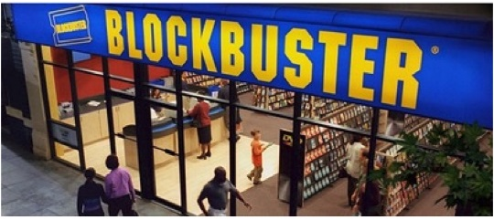

Home movie and video game rental services giant, Blockbuster Video, was founded in 1985 and arguably one of the most iconic brands in the video rental space.  At its peak in 2004, Blockbuster employed 84,300 people worldwide and had 9,094 stores. Unable to transition towards a digital model, Blockbuster filed for bankruptcy in 2010.

In 2000, Netflix approached Blockbuster with an offer to sell their company to Blockbuster for US$50 million. The Blockbuster CEO, was not interested in the offer because he thought it was a "very small niche business" and it was losing money at the time. As of July 2017, Netflix had 103.95 million subscribers worldwide and a revenue of US$8.8bn.

2. Polaroid (1937 – 2001)

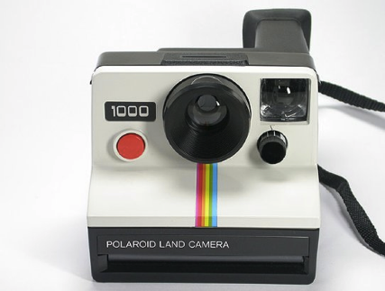

Founded in 1937, Polaroid is best known for its Polaroid instant film and cameras. Despite its early success in capturing a market that had few competitors, Polaroid was unable to anticipate the impact that digital cameras would have on its film business. Falling into the ‘success trap’ by exploiting only their (historically successful) business activities, Polaroid neglected the need to explore new territory and enhance their long-term viability.

The original Polaroid Corporation was declared bankrupt in 2001 and its brand and assets were sold off. In May 2017, the brand and intellectual property of the Polaroid corporation was acquired by the largest shareholder of the Impossible Project, which had originally started out in 2008 by producing new instant films for Polaroid cameras Impossible Project was renamed Polaroid Originals in September 2017.

3.Toys R Us (1948 – 2017)

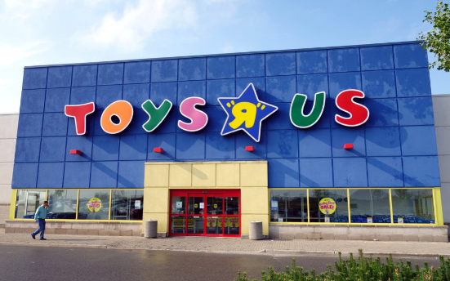

Toys “R” Us is a more recent story about the financial struggle one of the world’s largest toy store chains.  With the benefit of hindsight, Toys "R" Us may have led to its own undoing when it signed a 10-year contract to be the exclusive vendor of toys on Amazon in 2000. Amazon began to allow other toy vendors to sell on its site in spite of the deal, and Toys "R" Us sued Amazon to end the agreement in 2004. As a result, Toys "R" Us missed the opportunity to develop its own e-commerce presence early on. Far too late, Toys “R” Us announced in May 2017 its plan to revamp its website as part of a $100 million, three-year investment to jump-start its e-commerce business.

While filing for bankruptcy in September 2017 under pressure from its debt of US$1bn and fierce online retail competition, it has continued to keep its physical stores open.

4.  Pan Am (1927 – 1991)



Pan American World Airways (aka Pan Am), founded in 1927, was the largest international air carrier in the United States. The company was known as an industry innovator and was the first airline to offer computerised reservation systems and jumbo jets.

The downfall of Pan Am is attributed to was a combination of corporate mismanagement, government indifference to protecting its prime international carrier, and flawed regulatory policy. By over-investing in its existing business model and not investing in future, horizon 3, innovations, Pan Am filed for bankruptcy in 1991. Pan Am is survived only in pop culture through its iconic blue logo, which continues to be printed on purses and T-shirts and as the subject of a TV show on ABC starring Christina Ricci.

5. Borders (1971 – 2011)



Borders was an international book and music retailer, founded by two entrepreneurial brothers while at university. With locations all around the world but mounting debt, Border was unable to transition to the new business environment of digital and online books. Its missteps included holding too much debt, opening too many stores as well as jumping into the e-reader business to late.

Sadly, Borders closed all of its retail locations and sold off its customer loyalty list, comprising millions of names, to competitor Barnes & Noble for US$13.9 million. Borders' locations have since been purchased and repurposed by other large retailers.

6. [Pets.com](http://pets.com/) (1998 – 2000)



[Pets.com](http://pets.com/) was an online business that sold pet accessories and supplies direct to consumers over the World Wide Web. Although short-lived, [Pets.com](http://pets.com/) managed to find some success during a time when there were no plug and play solutions for ecommerce/warehouse management and customer service that could scale. [Pets.com](http://pets.com/) launched in August 1998 and went from an IPO on the Nasdaq stock exchange to liquidation in 268 days.

Its high public profile during its brief existence made it one of the more noteworthy failures of the dot-com bubble of the early 2000s. US$300 million of investment capital vanished with the company's failure. [Pets.com](http://pets.com/) is a memorable cautionary tale of a high-profile marketing campaign coupled with weak fundamentals (and poor timing). Today, the [Pets.com](http://pets.com/) URL redirects users to PetSmart's website.

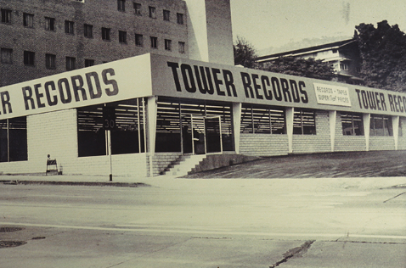7. Tower Records (1960 – 2004)

A pioneer in its time, Tower Records was the first to create the concept of the retail music mega-store. Founded by Russell Solomon in 1960, Tower Records sold CDs, cassette tapes, DVDs, electronic gadgets, video games, accessories and toys. Ahead of its time for a fleeting moment, [Tower.com](http://tower.com/) launched in 1995, making it one of the first retailers to move online. It seems the company’s foresights stopped short there as it fell prey excessive debts and ultimately bankruptcy in 2004. Tower Records could not keep up with digital disruptions such as music piracy, iTunes and streaming businesses such as Spotify and Pandora. Its legacy is remembered in the form of the movie '[Empire Records](http://www.imdb.com/title/tt0112950/),' which was written by a former Tower Records employee.

8. Compaq (1982 – 2002)

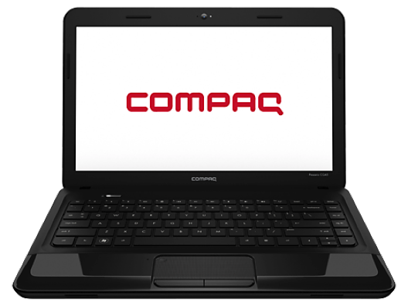

Compaq was one of the largest sellers of PCs in the entire world in the 1980s and 1990s. The company produced some of the first IBM PC compatible computers, being the first company to legally reverse engineer the IBM Personal Computer. Compaq ultimately struggled to keep up in the price wars against Dell and was acquired for US$25 billion by HP in 2002. The Compaq brand remained in use by HP for lower-end systems until 2013 when it was discontinued.

9. General Motors (1908 – 2009)



After being one of the most important car manufacturers for more than 100 years, and one of the largest companies in the world, General Motors also resulted in one of history’s largest bankruptcies. Failure to innovate and blatantly ignoring competition were key to the company’s demise. As GM focused predominantly on profiting from finance, the business neglected to improve the quality of its product, failed to adapt GM to changes in customer needs and did not invest in new technologies. Through a major bailout from the US  government, the current company, General Motors Company ("new GM"), was formed in 2009 and purchased the majority of the assets of the old GM, including the brand "General Motors".

10. Kodak (1889-2012)‘

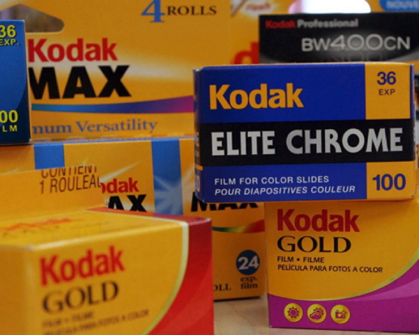

At one time the world’s biggest film company, Kodak could not keep up with the digital revolution, for fear of cannibalizing its strongest product lines. The leader of design, production and marketing of photographic equipment had a number of[opportunities to steer the company in the right direction](https://hbr.org/2016/07/kodaks-downfall-wasnt-about-technology) but its hesitation to fully embrace the transition to digital led to its demise. For example, Kodak invested  billions of dollars into developing technology for taking pictures using mobile phones and other digital devices. However, it held back from developing digital cameras for the mass market for fear of eradicating its all-important film business. Competitors, such as the Japanese firm Canon, grasped this opportunity and has consequently outlived the giant. Another example is Kodak’s acquisition of a photo sharing site called Ofoto in 2001. However, instead of pioneering what might have been a predecessor of Instagram, Kodak used Ofoto to try to get more people to print digital images. Kodak filed for bankruptcy in 2012 and after exiting most of its product streams, re-emerged in 2013 as a much smaller, consolidated company focused on serving commercial customers.