Notes for management and Leadership class. Objective One

**Types of Managers**

***Top managers*** are responsible for developing the organization’s strategy and being stewards for its vision and mission.

***Functional managers***are responsible for the efficiency and effectiveness of an area, such as accounting or marketing.

***Supervisory managers*,** or ***team managers***, are responsible for coordinating a subgroup of a particular division or a team composed of members from different parts of the organization.

*Line managers*, often called product or service managers, lead teams that contribute directly to the products or services the organization creates. For example, a line manager at Procter & Gamble (P&G) is responsible for the production, marketing, and profitability of the Tide detergent product line.

***Staff managers*** lead functions that create indirect inputs. For example, finance and accounting are critical organizational functions but do not typically provide a clear input into the final product or service a customer buys, such as a box of Tide detergent. Instead, they serve a supporting role.

***Project managers***are responsible for the planning, execution, and conclusion of projects. Project managers are often found in construction, architecture, consulting, computer networking, telecommunications, and software development.

***General managers*** are responsible for managing clearly identifiable revenue-producing units, such as a store, business unit, or product line. Typically, general managers make decisions across various functions and their rewards are tied to the performance of the entire unit. General managers take direction from their top executives and must first understand the executives’ overall plan for the company. Then, they set specific goals for their own departments to fit in with the plan. The general manager of production, for example, might have to increase certain product lines and phase out others. Moreover, general managers must describe their goals clearly to their support staff and ensure these goals are met.

Traditional managers are the pyramid that is upright with top level managers at the top

Contemporary manager are the inverted pyramid style. With top level managers at the bottom supporting the rest.

**Leadership** is defined as the social and informal sources of influence that you use to inspire action taken by others.

**Entrepreneurship** is the recognition of opportunities, needs, wants, problems, challenges, and the use or creation of resources to implement innovative ideas for newly planned ventures. Entrepreneurship is best understood as a process because it often involves more than simply coming up with a good idea—someone also has to convert that idea into action.

**Strategy** is the creation of an organization’s long-term purpose, articulated by clear goals and objectives that can be incorporated into a coherent plan of action.

Individual-level performance draws upon those things you have to do in your job, or **in-role performance**, and those things that add value but are not part of a formal job description.

Generally, in-role performance relates to productivity and quality dimensions associated with certain standards that you must meet to do your job. In contrast, OCBs can be understood as individual behaviors that are beneficial to the organization and are discretionary, but not directly or explicitly recognized by the formal reward system (Organ, 1988).

A **group** is a collection of individuals who interact with each other such that one person’s actions have an impact on other informal groups.

 A **team** is a cohesive coalition of people working together to achieve mutual goals.

**Learning Styles**

For example, if you notice that you retain more information by reading and seeing diagrams and flow charts, you may be a *visual learner*. If you primarily learn by listening to others, such as in lectures, conversations, and videos, you may be an *auditory learner*. Finally, if you have a preference for actually doing things and learning from trial and error, you may be a *kinesthetic learner*.

**Gauge-Discover-Reflect, Enhanced Learning**

***gauge***—take stock of your knowledge and capabilities about a topic; (b) ***discover***—learn enough about a topic so that you can set specific development goals that you can apply and practice, and later gauge again your progress toward your set goals; and (c**)*reflect***—step back and look at the ways you have achieved your goals. You can chronicle this experience and thought process in a daily journal.

**Empowerment** It is the process of enabling or authorizing an individual to think, behave, take action, and control work and decision making in autonomous ways.

**Foyles 14 principles of management**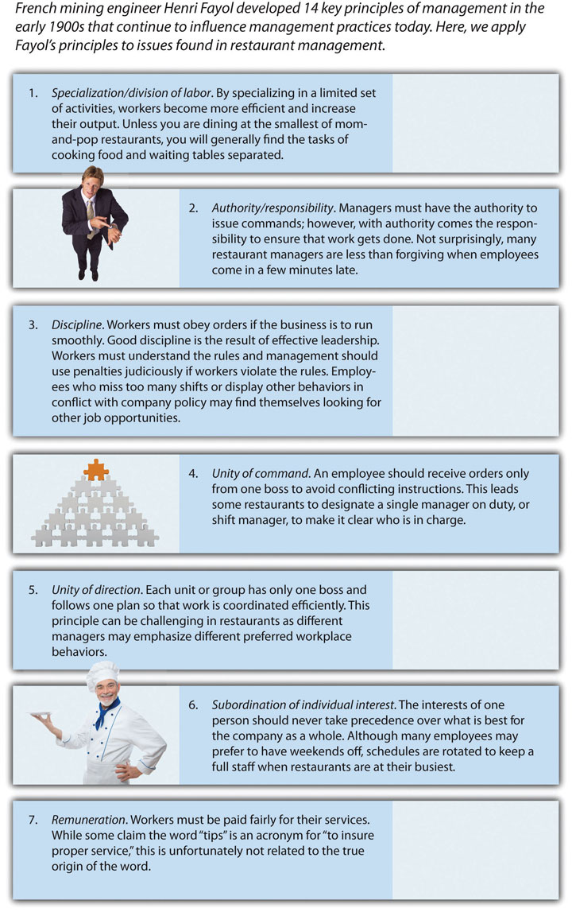

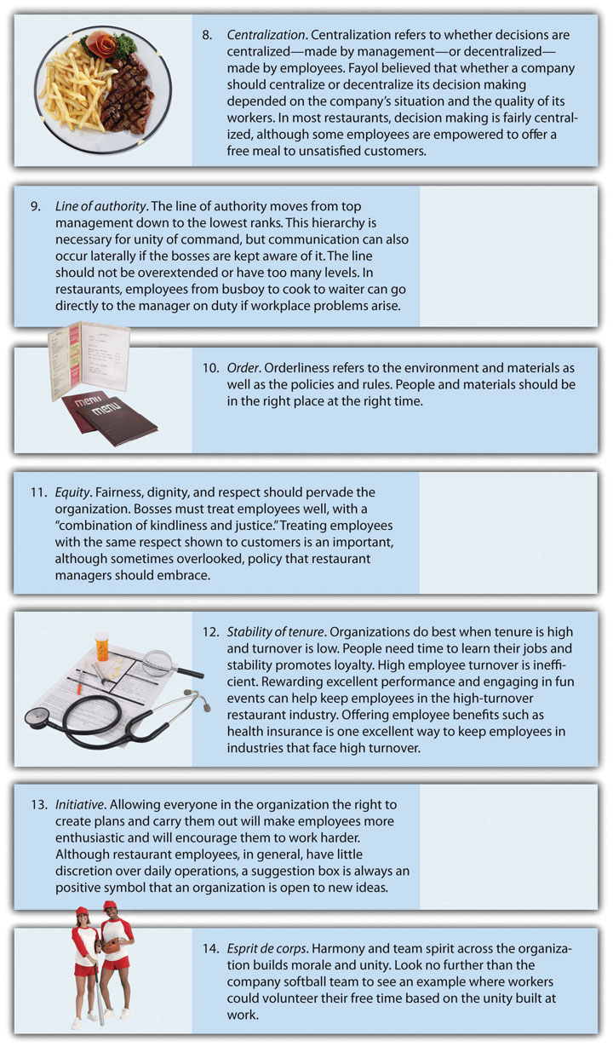

**Early views of management**

those views presumed that managers were overseeing manual labor tasks.

A services-based economy requires interactions between employees and customers.

Early views of management were heavily oriented toward efficiency at the expense of attention to the manager-as-leader.

1. **Managing Ambiguity and Paradox** The ability of managers to hold two opposing ideas in mind at the same time and still be able to function effectively.
2. **A Bias for Action** A culture of impatience with lethargy and inertia that otherwise leaves organizations unresponsive.
3. **Close to the Customer** Staying close to the customer to understand and anticipate customer needs and wants.
4. **Autonomy and Entrepreneurship** Actions that foster innovation and nurture customer and product champions.
5. **Productivity Through People** Treating rank-and-file employees as a source of quality.
6. **Hands-On, Value-Driven** A management philosophy that guides everyday practice and shows management’s commitment.
7. **Stick to the Knitting** Stay with what you do well and the businesses you know best.
8. **Simple Form, Lean Staff** The best companies have very minimal, lean headquarters staff.
9. **Simultaneous Loose-Tight Properties** Autonomy in shop-floor activities plus centralized values.

**An effective leader** was defined as someone with the ability to influence and motivate others not only to perform work tasks but also to support the organization’s values and meet the organization’s goals.

**Social movements**

**social movement** is a type of group action that is focused on specific political or social issues;

 Leaders of social movements depend on charisma rather than authority to motivate participants to action.

**Social networking** systems allow members of a specific site to learn about other members’ skills, talents, knowledge, or preferences. Companies use these systems internally to help identify experts.

Social networks involve groups of individuals who share a common interest or passion

In the corporate world, a social network is made up of individuals who share an employer and, potentially, other interests as well.

Today, social networks are starting points for corporate innovation:

***Learning Organizations***

A learning organization is “an organization skilled at creating, acquiring, and transferring knowledge, and at modifying its behavior to reflect new knowledge and insights”

1. *Systematic problem solving*. The company must have a consistent method for solving problems, using data and statistical tools rather than assumptions.
2. *Experimentation*. Experiments are a way to test ideas in small steps. Experiments let companies hunt for and test new knowledge, such as new ways of recycling waste or of structuring an incentive program.
3. *Learning from past experience*. It’s essential for companies to review projects and products to learn what worked and what didn’t. Boeing, for example, systematically gathered hundreds of “lessons learned” from previous airplane models, such as the 737 and 747, which it applied to the 757 and 767, making those the most successful, error-free launches in Boeing’s history.
4. *Learning from others*. Recognizing that good ideas come from anywhere, not just inside the company, learning organizations network with other companies in a continual search for good ideas to adapt and adopt.
5. *Transferring knowledge*. Sharing knowledge quickly throughout the organization is the way to make everyone a smart, contributing member.

***Virtual Organizations***

A **virtual organization** is one in which employees work remotely—sometimes within the same city, but more often across a country and across national borders.

POLC Framework OBJECTIVE TWO

Planning, Organizing, Leading, Controlling

**Planning**,, Has measurable objectives, and a course of action.

Create a Swot Analysis for internal and external. Then Perform Strategic Planning.

**Organizing** .. Job Design, Job Enrichment and Teamwork, discuss Ideas and form teams.

**Leading**… Encourage action, Motivate, Influence, Inspire.

**Controlling**…. Establish Performance Standards. Then Compare performance against standards. Then take corrective action.

**Planning** is the function of management that involves setting objectives and determining a course of action for achieving those objectives. Planning requires that managers are aware of environmental conditions facing their organization and forecast future conditions.

**Strategic planning** involves analyzing competitive opportunities and threats, as well as the strengths and weaknesses of the organization, and then determining how to position the organization to compete effectively in its environment. Strategic planning has a long timeframe, often three years or more, generally includes the entire organization, and includes formulation of objectives. Strategic planning is often based on the organization’s mission, which is its fundamental reason for existence. An organization’s top management most often conducts strategic planning.

**Tactical planning** is intermediate-range (one to three years) planning that is designed to develop relatively concrete and specific means to implement the strategic plan. Middle-level managers often engage in tactical planning.

**Operational planning**generally assumes the existence of organization-wide or sub-unit goals and objectives and specifies ways to achieve them. Operational planning is short-range (less than a year) planning that is designed to develop specific action steps that support the strategic and tactical plans.

***Organizing***

Organizing is the function of management that involves developing an organizational structure and allocating human resources to ensure the accomplishment of objectives.

***Leading***

**Leading** involves the social and informal sources of influence that you use to inspire action taken by others. If managers are effective leaders, their subordinates will be enthusiastic about exerting effort to attain organizational objectives.

**Controlling** involves ensuring that performance does not deviate from standards. Controlling consists of three steps, which include (a) establishing performance standards, (b) comparing actual performance against standards, and (c) taking corrective action when necessary.

*Strategic management*reflects what a firm is doing to achieve its mission and vision as seen by its achievement of specific goals and objectives. The *strategic management process* is a comprehensive and ongoing management process aimed at formulating and implementing effective strategies; it is a way of approaching business opportunities and challenges such that the firm achieves its vision and mission

**Synergy and Diversification in Strategy**

The logic behind corporate strategy involves the concepts of synergy and diversification.

 Synergy exists when the interaction of two or more activities, such as those in a business, create a combined effect greater than the sum of their individual effects

Diversification is the number of different businesses that an organization is engaged in and the extent to which these businesses are related to one another.

There are two major diversification types. **Related diversification** occurs when a firm operates multiple businesses within the same industry. For example, Estée Lauder engages in multiple cosmetics-related businesses. In contrast, **unrelated diversification** occurs when a firm engages in businesses in different industries that lack similarities between each other.

**The Six Step approach to problem solving.**

1. ***Identify the problem you want to work on****.* Step one is getting to know your problem, which you can formulate by asking yourself a basic question: How can I improve my grades?
2. ***Gather relevant data****.* Step two is gathering information that will shed light on the problem. Let us rehash some of the relevant information that you’ve already identified: (a) you did poorly on your finals because you didn’t spend enough time studying; (b) you did not study because you went to see your girlfriend (who lives about three hours from campus) over the weekend before your exams (and on most other weekends, as a matter of fact); (c) what little studying you got in came at the expense of your team project and lacrosse practice; and (d) while you were away for the weekend, you forgot to tell members of the mountain-biking club that you had to cancel the planned meeting.
3. ***Clarify the problem.***Once you review all the given facts, you should see that your problem is bigger than simply getting your grades up; your life is pretty much out of control. You can’t handle everything to which you’ve committed yourself. Something has to give. You clarify the problem by summing it up with another basic question: What can I do to get my life back in order?
4. ***Generate possible solutions****.* If you thought defining the problem was tough, wait until you’ve moved on to this stage. Let’s say that you’ve come up with the following possible solutions to your problem: (a) quit the lacrosse team, (b) step down as president of the mountain-biking club, (c) let team members do your share of work on the business project, and (d) stop visiting your girlfriend so frequently. The solution to your main problem—how to get your life back in order—will probably require multiple actions.
5. ***Select the best option.*** This is clearly the toughest part of the process. Working your way through your various options, you arrive at the following conclusions: (a) you can’t quit the lacrosse team because you’d lose your scholarship; (b) you can resign your post in the mountain-biking club, but that won’t free up much time; (c) you can’t let your business-project team down (and besides, you’d just get a low grade); and (d) she wouldn’t like the idea, but you could visit your girlfriend, say, once a month rather than once a week. So what’s the most feasible (if not necessarily perfect) solution? Probably visiting your girlfriend once a month and giving up the presidency of the mountain-biking club.
6. ***Implement your decision and monitor your choice.***When you call your girlfriend, you’re pleasantly surprised to find that she understands. The vice president is happy to take over the mountain-biking club. After the first week, you’re able to attend lacrosse practice, get caught up on your team business project, and catch up in all your other classes. The real test of your solution will be the results of the semester’s finals.

**Objective 3**

A **mission statement** is a statement of purpose, describing who the company is and what it does. The mission statement communicates the organization’s reason for being, and how it aims to serve its key stakeholders. Customers, employees, and investors are the stakeholders most often emphasized, but other stakeholders like government or communities (i.e., in the form of social or environmental impact) can also be discussed. Mission statements sometimes include a summation of the firm’s values. **Values** (shared principles, standards, and goals) are the beliefs of an individual, group, or organization, in which they are emotionally invested. In many ways, you can say that the mission statement lays out the organization’s “purpose for being,” and the vision statement then says, “based on that purpose, this is what we want to become.”

**Vision statements** typically take the form of relatively brief, future-oriented statements. Vision statements answer the question “where is this organization going?” A vision statement is a future-oriented declaration of the organization’s purpose and aspirations. The strategy should flow directly from the vision, since the strategy is intended to achieve the vision and thus satisfy the organization’s mission. Typically, vision statements are relatively brief, as in the case of Starbucks’ vision statement, which reads: “Our mission: to inspire and nurture the human spirit – one person, one cup and one neighborhood at a time” (Starbucks, 2014). Or advertising firm Ogilvy & Mather, which states its vision as “an agency defined by its devotion to brands” (Ogilvy & Mather, 2008). Similarly, Walmart’s tag-line version of its vision statement is “Save money. Live better” (Walmart, 2008).

**Roles Played by Mission and Vision**

Mission and vision statements play three critical roles: (a) communicate the purpose of the organization to stakeholders, (b) inform strategy development, and (c) develop the measurable goals and objectives by which to gauge the success of the organization’s strategy.

First, mission and vision are vehicles for communicating an organization’s purpose and values to all key stakeholders.

Second, mission and vision create a target for strategy development.

Third, mission and vision provide a high-level guide,

Mission and vision both relate to an organization’s purpose and aspirations. Typically, mission and vision are communicated in some form of brief written statements. A mission statement communicates the organization’s reason for being and how it aspires to serve its key stakeholders. The vision statement is a narrower, future-oriented declaration of the organization’s purpose and aspirations. Together, mission and vision guide strategy development, help communicate the organization’s purpose to stakeholders, and inform the goals and objectives set to determine whether the strategy is on track.

**Organizing: Organizational Structure, Design, and Culture**

The function of management involves developing an organizational structure and allocating human resources to ensure the accomplishment of objectives. The **organizing** facet of the P-O-L-C framework typically includes subjects such as organizational design, staffing, and organizational culture. With regard to organizing, it is useful to think about alignment between the mission and vision and various organizing activities.

**Organizational design** is a formal, guided process for integrating the people, information, and technology of an organization.

**Strategy** unifies the intent of the organizational structure. The strategy of an organization encourages actions that support the purpose and discourages those that do not.

**Organizational culture** is a system of shared assumptions, values, and beliefs showing people what is appropriate and inappropriate behavior.

A broader definition of **visionary leadership** suggests that, if many or most of an organization’s employees understand and identify with the mission and vision, efficiency will increase because the organization’s members “on the front lines” will be making decisions fully aligned with the organization’s goals.

**Controlling** ensures that performance does not deviate from standards. Controlling consists of three steps, which include (a) establishing performance standards, (b) comparing actual performance against standards, and (c) taking corrective action when necessary.

**Strategic human resources management (SHRM)** reflects the aim of tying the organization’s human capital, its people, into the mission and vision.

**Setting Personal Missions and Visions**

***BHAG***

First, set out a bold vision.

Five guiding criteria for good BHAGs are the following:

1. **Set with understanding, not bravado**.
2. Fit squarely in the **three circles** of (a) what you are deeply passionate about (including **your core values and purpose)**, (b) what drives **your economic logic,** and (c) what differentiates you (**what you can be the best in the world** at).
3. Have a **long time frame**—10 to 30 years.
4. Are **clear, compelling, and easy** to grasp.
5. **Directly reflect your core values and core purpose.**

**The Process to set Personal Missions and Visions**

* ***Step 1: Identify Past Successes.*** Spend some time identifying four or five examples of personal success in recent years. These successes could be at work, in your community, or at home. Write them down. Try to identify whether there is a common theme—or themes—to these examples. Write that down too.
* ***Step 2: Identify Core Values****.*Develop a list of attributes that you believe identify who you are and what your priorities are. The list can be as long as you need. Once your list is complete, see whether you can narrow your values to five or six most important values. Finally, see whether you can choose the one value that is most important to you. We have added “Generating Ideas for Your Mission and Vision” to help jog your memory and brainstorm about what you do well and really like to do.
* ***Step 3: Make a list of the ways you could make a difference****.* In an ideal situation, think about how you could contribute best to the following:
  + The world, in general
  + Your family
  + Your employer or future employers
  + Your friends
  + Your community

Try these tools for generating valuable information about yourself:

* *Step 1.* ***Describe your ideal day.*** This is not about being practical. It is designed to include as many sides of you and your enthusiasms as possible: creative, competent, artistic, introverted, extroverted, athletic, playful, nurturing, contemplative, and so on.
* *Step 2****. Imagine yourself 132 years old*** *and surrounded by your descendants or the descendants of your friends*. You are in a warm and relaxed atmosphere (such as around a fireplace). **What would you say to them about what is important in life**? This exercise is designed to access the values and principles that guide your life.
* *Step 3. Imagine that it is your 70th birthday (or another milestone in your life).* You have been asked by national print media to write a press release about your achievements. **Consider what you would want your family, friends, coworkers in your profession and in your community to say about you.** What difference would you like to have made in their lives? How do you want to be remembered? This is designed to inventory your actions and accomplishments in all areas of your life.
* *Step 4****: Identify Goals****.* Spend some time thinking about your priorities in life and the goals you have for yourself. Make a list of your personal goals, perhaps in the short term (up to three years) and the long term (beyond three years).
* *Step 5:* ***Write Mission and Vision Statements****.* On the basis of the first four steps and a better understanding of yourself, begin writing your personal mission and vision statements.

**Objective 4**

**Ethics**

Managers face these kinds of issues all the time. Ethical dilemmas can arise from a variety of areas, such as the following:

* advertising (the desire to present your product or service in the best light);
* sourcing of raw materials (whether the company buys from a supplier who may be underpaying their people or damaging the environment);
* privacy (whether the company should monitor private e-mails that employees write on company time or the Web sites they visit during work hours);
* safety (employee and community);
* pay scales (relation of the pay of top executives to the rest of the company);
* product pricing policies (variable pricing, discounts);
* communication (with stockholders, announcements of plant closings, etc.).
* pressure to meet unrealistic business objectives/deadlines,
* a desire to further one’s career,
* a desire to protect one’s livelihood.

**Steps in an Ethical Decision-Making Process**

1. Assess the situation. What are you being asked to do? Is it illegal? Is it unethical? Who might be harmed?
2. Identify the stakeholders and consider the situation from their point of view. For example, consider the point of view of the company’s employees, top management, stockholders, customers, suppliers, and community.
3. Consider the alternatives you have available to you and how they affect the stakeholders:
   * consequences;
   * duties, rights, and principles;
   * implications for personal integrity and character.
4. How does the action make you feel about yourself? How would you feel if your actions were reported tomorrow in the *Wall Street Journal* (or your daily newspaper)? How would you explain your actions to your mother or to your 10-year-old child?
5. Make a decision. This might involve going to your boss or to a neutral third party (such as an ombudsman or ethics committee). Know your values and your limits. If the company does nothing to rectify the situation, do you want to continue working for the company?
6. Monitor outcomes. How did the decision work out? How did it turn out for all concerned? If you had it to do over again, what would you do differently (Hartman & DesJardins, 2008)?

**Ethical Theories**

Three possible answers run through three distinct ethical theories: duty theory, consequentialist-utilitarian theory, and egoism:

1. **Duty Theory** affirms that right and wrong are determined by a set **of unchanging rules**, which typically include *do not steal*, *do not lie*, and similar directives. This kind of ethics *starts* from the proposition that dishonesty is wrong. It is difficult to see a non-frivolous way of justifying the fish seller’s deceit.
2. **Consequentialist-Utilitarian Theory** is oriented by the common welfare. Acts in business—including lying—are defined as acceptable or reproachable depending on whether they end up doing the most **good for the most people**.

Consequentialist-Utilitarian theory affirms that any act that ultimately makes more people happier is good. In this case, we can imagine an organization promoting lying as a common operating principal and making the case that the ethical stance is, in fact, good. Every Christmas, department stores deploy heavy men in red suits to proclaim that they live at the North Pole and ride a sleigh pulled by reindeer. The stores promote these fictions—addressed to children—to make money. Almost no one finds that ethically objectionable, however. One reason is that the public implicitly accepts the affirmation that an act that makes people happier in the end is good, even if it’s dishonest.

1. **Egoism** is a coherent ethical approach to the world that does offer some justification for a deceitful fish trader. On this account, the ethical good for organizations and individuals in the economic world is defined as just **whatever serves the organization’s or the individual’s interest**. And switching in the farmed stuff for the wild is good for the fish sellers. It’s difficult to find any other explanation for this; as the *New York Times* discovered, fully 75 percent of the places where fish was sold had some switching going on. The dealing is ethically justifiable under this theory. Of course, most proponents of egoism in the business world don’t stop there. They go on to note that other, honest dealers who are pursuing*their* interests have a good reason to reveal the fraud. And, as it turns out, that’s just what honest dealer Randy Hartnell did, while presumably helping his own business in the process.Dishonesty within organizational cultures does exist as an acceptable part of day-to-day business. Whether or not these cultures are ethically justifiable depends on the deep theoretical stances people adopt when going into business.

A Corporate Culture Ethics Audit

Combined (and with additions, subtractions, and modifications), the following corporate ethics audit emerges. (As a quick note, this test could be nuanced by changing the responses from yes or no to agree or disagree on a one-through-five scale. Some audits also add a section for comments.) Answer yes or no.

**Part 1: Corporate Culture as Defined and Understood Throughout the Organization**

1. Are codes of ethics and business practices clearly communicated to employees?
2. Are there rules or procedures in company publications that may be consulted?
3. Is there a value system and an understanding of what constitutes appropriate behavior within the organization that is shared by members at all levels of the organization?
4. Is there open communication going both ways between superiors and subordinates on questions concerning ethics and organizational practices and goals?
5. Have employees ever received advice on how to bring behavior into closer alignment with the organization’s values and norms?
6. Does the organization have methods for detecting ethical and behavioral concerns?
7. Are there penalties that are publicly discussed for transgressions of the organization’s rules and values?
8. Are there rewards for decisions corresponding with the organization’s culture (even if they don’t result in a profit)?
9. Do people at work act in a way that’s consistent with what they say are the organization’s values?
10. Do employees spend their time working in a cohesive way that is in accord with the organization’s values?
11. Does the organization clearly and directly represent its activities and goals in its public communications?

**Part 2: Corporate Culture as Organic and Encompassing**

1. Does the company recognize the importance of creating a culture that is concerned about people and their self-development as participants in the organization’s values?
2. Do employees treat each other with respect, honesty, and fairness that corresponds to the organization’s values?
3. Are leadership decisions made with an opportunity for input from all relevant sources?
4. To what extent does leadership, the board of trustees or executive committee, view its responsibility as one to represent the entire organization?
5. Are leadership positions open to all members (insofar as such openness coincides with the organization’s values)?
6. Does the professional staff provide services to all members in accordance with organizational policy and regardless of board or leadership status?
7. Are employees satisfied that day-to-day responsibilities correspond with what the organization’s culture has led them to expect?
8. Is turnover low?
9. Are emotional outbursts springing from ambiguity about responsibilities within the organization rare? (I’m in charge here!)
10. Is there an absence of open hostility and severe conflict that goes beyond the internal competition provided for by the organization’s culture?
11. Does the organization address contract negotiations, work expectations, and compensation levels in a way that corresponds with the organization’s values?
12. Are there shared and commonly held beliefs about how to succeed in the organization?
13. Are there day-to-day rituals, habits, and practices within the organization that create direction and prevent confusion on ethical and business matters?
14. Do the dress, speech, and physical work setting prevent an environment of fragmentation or inconsistency about what is right and appropriate for the organization?
15. Does the organization’s involvement in community activities correspond with the effects of the organization’s day-to-day activities?

**Tragedy of the commons** is a dilemma that occurs when several people, acting independently and rationally for their own self-interest, will use up a shared limited resource even when it is not in anyone's long-term interest.

**Styles and Values of Management**

A leadership persona is the image and values a leader chooses to project across the workplace. This image is essentially the kind of person you decide to be when you stand in front of others as a director. What values will be most important to your particular leadership role, and how will they be transmitted? Psychologist Daniel Goleman has identified the following leadership styles in his book *Primal Leadership* *(2002)*:

* Visionary: This leader guides an organization’s members toward a shared vision. Establishing and communicating that vision become the primary leadership task, and subordinates are granted significant leeway to reach the vision.
* Coach: This leader challenges members of an organization to meet specific, relatively accessible goals under close supervision.
* Affiliative: This leader fosters social harmony within the organization and focuses on the human and emotional dynamic of the workplace over immediate work requirements. Nurturing a well-integrated team that works well together is considered the best way to reach the organization’s goals.
* Democratic: These leaders seek active participation from an organization’s members and value consensus in decision making.
* Pacesetter: This leader challenges members of the organization to work and meet goals by setting a strong example, possibly one that most members will be unable to match.
* Commander: This leader gives clear directions and expects compliance.

Elements of a Code of Conduct

1. Conflicts of interest
2. Acceptance of gifts, services, or entertainment
3. Protection of confidential information
4. Use of company funds or assets for personal purposes
5. Competing fairly and ethically
6. Adherence to code

**Objective 5**

**Leadership** is the ability to influence followers to achieve common goals through shared purposes (Rost, 1993; Rost & Barker, 2000).

**Influence** refers to a person’s ability to affect or change the actions, behaviors, and opinions of others. Leaders motivate others to perform certain tasks and can even influence them to act ethically (Provitera, 2003).

**Self-concept** is a person’s overall understanding about herself or himself that includes attitudes, feelings, self-esteem, and self-confidence

***Locus of Control***

Why do some leaders tend to take credit for success but blame others for mistakes, while other leaders assume responsibility for whatever happens under their leadership? This tendency can be described in terms of an individual’s **locus of control**. *Locus* is another word for *site* or *location*, so *locus of control* literally refers to where a person thinks control, or responsibility, lies. Leaders with a high **internal locus of control**believe what happens to them is a result of their own actions and take responsibility. Leaders with a high**external locus of control** believe outside forces determine what happens to them and tend to blame others for mistakes and mishaps. These people are less likely to succeed in effectively leading others.

***Narcissism***

**Narcissists** have a grandiose sense of self-importance. They are arrogant and are always seeking admiration and attention. To the more extreme narcissist, the world revolves around him or her. Oracle’s CEO Larry Ellison has been described as having a high level of narcissistic tendencies. One of his executives said, “The difference between God and Larry is that God does not believe he is Larry” (Maccoby, 2000, p. 70).

**Machiavellianism** is named after Niccolò Machiavelli, who, in a 16th-century book, wrote about how to get and use power. The term *Mach* (short for Machiavellianism) refers to those who gain and use power without regard to the consequences: As Machiavelli wrote, let the ends justify the means; if it works, use it.

**Entrepreneurial leaders** organize and initiate new, innovative ventures and business practices, assuming much of the responsibility and risk in hope of maximum reward (Daft, 2011; Kuratko & Hodgetts, 1998).

**CVF**

For a “big picture” view of the *context* of leaders and managers, we turn to the **Competing Values Framework (CVF)**, a model that brings together the organization, its changing environment, and leaders’ competing roles, and also enables a descriptive and prescriptive examination of leaders’ roles and activities with regard to their effectiveness. Here we will focus on the framework’s relevance to leaders and followers. Leaders must perform, or at least know how to manage, all eight roles within the four quadrants of the organization to be effective.

**Objective 6**

There are four building blocks of competitive advantage.

* 1. **Innovation**
  2. **Quality**
  3. **Efficiency**
  4. **Responsiveness**

**Efficiency** is doing whatever we are doing as simply and easily as possible.

**Innovation** is creating value through offering a new product, applying a new technique or technology, opening a new market, or developing a new form of organization for the purpose of producing or enhancing a product.

**Quality** is a product or service free of deficiencies, or the characteristic of a product or service that satisfies customer needs. ***Quality Management*** is a business approach that encompasses many functional areas and activities both within and across companies.

**Responsiveness to customers** includes providing the customer with a large selection of quality items to choose from, ease of purchase, quick shipping times, and a liberal and easy-to-understand return policy.

**Internal Analysis**

By exploiting internal resources and capabilities and meeting the demanding standards of global competition, firms create value for customers

**Resources**

Broad in scope, *resources* cover a spectrum of individual, social, and organizational assets

Instead, **core competencies** that yield a competitive advantage are often created through the *unique bundling of several resources*

***Tangible Versus Intangible Resources***

Some resources are tangible; others are intangible. *Tangible resources* are assets that can be seen and quantified. Production equipment, manufacturing plants, and formal reporting structures are examples of tangible resources. *Intangible resources* typically include assets that are rooted deeply in the firm’s history and have accumulated over time. Because they are embedded in unique patterns of routines, intangible resources are relatively difficult for competitors to analyze and imitate.

***Capabilities***are the firm’s capacity to deploy resources that have been purposely integrated to achieve a desired end state (Helfat & Raubitschek, 2000, pp. 961–979). Capabilities emerge over time through complex interactions among tangible and intangible resources.

**Capabilitie**s are often developed in specific functional areas

The **value chain** is the primary and support activities that an organization uses to create value in the form of products or services, popularized by Michael Porter’s book *Competitive Advantage* (1985)

**VRIO** is an acronym for *valuable*, *rare*,*inimitable*, and *organized*. VRIO analysis is at the core of the resource-based view of the firm

***Valuable***

A resource or capability is said to be valuable if it allows the firm to exploit opportunities or negate threats in the environment.

***Rare***

A resource is rare simply if it is not widely possessed by other competitors.

***Inimitable***

An inimitable (the opposite of *imitable*) resource is difficult to imitate or to create ready substitutes for. A resource is inimitable and non-substitutable if it is difficult for another firm to acquire it or to substitute something else in its place.

***Organized***

The fourth and final VRIO criterion that determines whether a resource or capability is the source of competitive advantage recognizes that mere possession or control is necessary but not sufficient to gain an advantage. The firm must likewise have the *organizational* capability to exploit the resources.

What are core competencies? They are resources and capabilities that serve as a source of a firm's competitive advantage over rivals.

Pick the point that explains core competencies. They distinguish a company competitively and reflect its personality.

Which of the following best describes core competencies? The activities through which a firm adds unique value to its goods or services over a long period of time

Select the accurate point that characterizes capabilities. B

Capabilities are often based on developing, carrying, and exchanging information through a firm's human capital.

**Pick the correct statement regarding resources.** They cover a spectrum of individual, social, and organizational assets.

In the context of VRIO criteria, when does a valuable but widely held resource lead to competitive parity for a firm? When the firm possesses the capabilities to exploit the resource

**Pick the correct statement regarding the VRIO analysis.** **B.** It is a way to distinguish resources and capabilities from core competencies.