**Notes from Competency.**

**Objective 1: Theoretical Concepts That Influence Organizational Behavior**

1a..

What Is Organizational Behavior?(Recycle)

Organizational behavior (OB) is the systematic study and application of knowledge about how individuals and groups act within the organizations where they work. OB is defined as the systematic study and application of knowledge about how individuals and groups act within the organizations where they work. As you will see throughout this competency, definitions are important. They are important because they tell us what something is as well as what it is not.

A distinction is made in OB regarding which level of the organization is being studied at any given time. There are three key levels of analysis: individual, the group, and the organization.

*Why is journaling a good idea*? (recycle)

Survival skills

1. Appreciate new technology.
2. Embrace ambiguity.
3. Keep your skills fresh.
4. Network.
5. Master something.

*Note.* Adapted from "Understanding Organizational Behavior," by T. Bauer & B. Erdogan, 2010, *Organizational Behavior*, Chapter 1.2. Copyright 2010 by Flat World Knowledge, Inc.

**1b**

OB Methods

**Surveys** are research tools that are used to elicit respondents’ reactions to specific questions and are one of the primary methods management researchers use to learn about OB. A basic survey involves asking individuals to respond to a number of questions.

A **field study** is research conducted in actual organizations.

Experiment Design, Control Group, Treatment Group.

**Laboratory Studies** Research is conducted under controlled conditions and may include observation, interviews, surveys, or experiments. An experiment is a study in which one group is assigned one condition and the other group is assigned the control condition (generally the control condition involves no change at all).

**Case studies** are in-depth descriptions of a single industry or company. Case writers typically employ a systematic approach to gathering data and explaining an event or situation in great detail. The benefits of case studies are that they provide rich information for drawing conclusions.

**Meta-analysis** is the process of summarizing research findings from studies on related topics. It is a technique used by researchers to summarize what other researchers have found on a given topic.

# Trends, Changes, Challenges, and Opportunities

# **Ethical Challenges..**

**Business ethics** refers to applying ethical principles to situations that arise at work. It feels like it has been one ethical scandal after the other.

The front page test.. And others.

*Do you integrate ethics into your day-to-day decisions at work*?

*Do you take the “front page” test when making important decisions at work*?

*Do you role model ethics at work*?

*Do you consider if rewards are distributed ethically at work*?

*Have you held a “risk brainstorm” at work*?

**Lack of Employee Engagement**

A person who is fully involved in and enthusiastic about their work is engaged.

Engaged employees are those who are performing at the top of their abilities and happy about it.

* Customers would be 70% more loyal.
* Turnover would drop by 70%.
* Profits would jump by 40%.
* Only 20% feel very passionate about their jobs.
* Less than 15% agree that they feel strongly energized by their work.
* Only 31% (strongly or moderately) believe that their employer inspires the best in them.

**Technology.**

Digital Footprint.

To combat the overuse of e-mail, companies such as Intel have instituted “no e-mail Fridays,” in which all communication is done via other communication channels. The technology trend contains challenges for organizational behavior.

**Flattening World--**an environment in which there is a more level playing field in terms of access to information.

**Sustainability and Green Business Practices**--

**The triple bottom line** involves evaluating organizations against three performance criteria including economic, social, and environmental viability.

“**greenwashing**,” which refers to the marketing of products or processes as green to gain customers without truly engaging in sustainable business practices.

**Sustainable business practices** meet the current needs of businesses without compromising the needs of future generations.

**Aging Workforce and the Millennial Generation baby boomer 1964--1965genX**

The Millennial Generation (which includes those born between 1980 and 2000) differs from previous generations in terms of technology and multitasking as a way of life. Having never known anything different, this population has technology embedded in their lives.

**Outsourcing** has become a way of life for many organizations

**Offshoring** refers to some or all of a business process being moved from one country to another country.

Charles Handy, author of *The Age of Paradox*, coined the term **shamrock organization**, which is an organization comprising one-third regular employees, one-third temporary employees, and one-third consultants and contractors.

**1c**

**How do employees engage in work?(recycle)**

**Motivation and Performance**

if someone is not performing well, what could be the reason?

**Job performance** According to this equation, motivation, ability, and environment are the major influences over employee performance.

Motivation*ability*environmental=performance

**Motivation** is the desire to achieve a goal or a certain performance level, leading to goal-directed behavior. Factors such as having the resources, information, and support one needs to perform well are critical to determining performance.

*Note.* Adapted from "Theories of Motivation," by T. Bauer and B. Erdogan, 2010, *Organizational Behavior*, Chapter 5. Copyright 2010 by Flat World Knowledge, Inc.

**Objective 2: Factors That Influence Organizational Behavior**

How Diversity Influences Organizational Behavior

What are the benefits of a diverse workforce?(recycle)

Diversity refers to the ways in which people are similar or different from each other. It may be defined by gender, race, age, education, tenure, or functional background (such as being an engineer versus being an accountant). It is easier to understand that diversity has several levels. We tend to use surface-level diversity to make judgments about deep-level diversity.

Research shows that **surface-level traits** affect our interactions with other people early in our acquaintance with them, but as we get to know people, the influence of surface-level traits is replaced by deep-level traits such as similarity in values and attitudes.

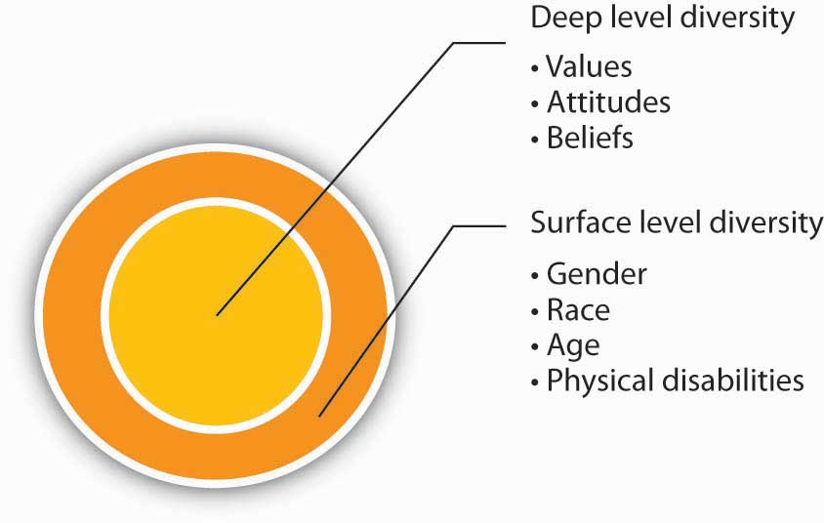

**Benefits of Diversity**

many find it challenging to manage diversity effectively. In the United States, the Age Discrimination Act of 1975 and Title VII of the Civil Rights Act of 1964 outlaw discrimination based on age, gender, race, national origin, or religion. The 1990 Americans with Disabilities Act prohibits discrimination of otherwise capable employees based on physical or mental disabilities. In 2008, over 95,000 individuals filed a complaint claiming that they were discriminated based on these protected characteristics. What is the business case for diversity? Having a diverse workforce and managing it effectively have the potential to bring about a number of benefits to organizations.

**Higher Creativity in Decision-Making**

Important potential benefit of having a diverse workforce is the ability to make higher quality decisions.

**Better Understanding and Service of Customers.**

A company with a diverse workforce may create products or services that appeal to a broader customer base.

**More Satisfied Workforce**

When employees feel that they are fairly treated, they tend to be more satisfied.

**Higher Stock Prices**

Companies that do a better job of managing a diverse workforce are often rewarded in the stock market, indicating that investors use this information to judge how well a company is being managed.

**Lower Litigation Expenses…**

**Higher Company Performance.**

Research shows that in companies pursuing a growth strategy, there was a positive relationship between racial diversity of the company and firm performance.

**Challenges of Diversity**

**Similarity-Attraction Phenomenon** the tendency for individuals to be attracted to similar individuals. The **similarity-attraction phenomenon** may explain some of the potentially unfair treatment based on demographic traits.

Why are we more attracted to those who share our demographic attributes? Demographic traits are part of what makes up **surface-level diversity**.

Researchers believe that people pay attention to surface diversity because they are assumed to be related to **deep-level diversity**, which includes values, beliefs, and attitudes.

**Suggestions for Managing Demographic Diversity**

***Build a Culture of Respecting Diversity, Make Managers Accountable for Diversity, Diversity Training Programs…***

***Invest in building effective relationships. Choose your mentor carefully. Investigate company resources. Know your rights.***

*Note.* Adapted from "Managing Demographic and Cultural Diversity," by T. Bauer and B. Erdogan, 2010, *Organizational Behavior*, Chapter 2. Copyright 2010 by Flat World Knowledge, Inc.

**How Diversity Influences Organizational Behavior**

**Diversity and Ethics..** ensuring the ethicality of organizational behavior will require special effort. This is because employees with different backgrounds or demographic traits may vary in their standards of ethics. When dealing with unethical behavior overseas, companies will need to consider the ethical context.

*Note.* Adapted from "The Role of Ethics and National Culture," by T. Bauer and B. Erdogan, 2010, *Organizational Behavior*, Chapter 2.4. Copyright 2010 by Flat World Knowledge, Inc.

**2b**

**How Structure and Change Influence Organizational Culture**

**Organizational Structure and Change** Organizational structure refers to how the work of individuals and teams within an organization are coordinated. Organizational structure outlines how this coordination will be managed. There are five main elements of organizational structure (Robbins & Coulter, 2002). They include:Work specialization

1. Departmentalization
2. Chain of command
3. Span of control
4. Centralization and decentralization

**Work specialization** refers to how the actual tasks in an organization are broken down. **Departmentalization** refers to how jobs are grouped together within the company. **Chain of command** refers to who reports to whom. **Span of control** refers to how many employees each manager is responsible for overseeing. The extent of **centralization and decentralization** refers to how decisions are made.

Organizational structures differ based on four main factors:

1. Business strategy
2. Organization size
3. Use of technology
4. Environment

**Work specialization** can contribute to higher productivity, but can reduce job satisfaction due to repetitive tasks (Rama Rao, 2008).

it is important to consider the benefits of a strong **organizational culture**, which is based on the organizational structure (Society for Human Resource Management, 2012).

* Which structure can enhance trust and cooperation?
* Which structure can create fewer disagreements?
* Which structure can assist in efficient decision-making processes?
* What informal control mechanisms (e.g., clan control) can be implemented to avoid too many procedures and rules?
* Which structure will allow for greater open communication?
* Which structure allows us to effectively manage telecommuting and virtual work arrangements?

*Note.* Adapted from "Organizational Structure and Change," by T. Bauer and B. Erdogan, 2010, *Organizational Behavior*, Chapter 14. Copyright 2010 by Flat World Knowledge, Inc.

**2c**

**Topic 3: How Do Ethical Considerations Impact Organizational Behavior?**

**Making Ethical Decisions**

**Job Attitudes, Behaviors, and Ethics**

**What factors contribute to unethical employee behavior?(recycle)**

**Job Attitudes, Behaviors, and Ethics**

the presence of an **ethical climate** will attach people to a company. An ethical climate is related to performing citizenship behaviors in which employees help each other and their supervisors, and perform many behaviors that are not part of their job descriptions.

**Whistleblowers**, or people who reported wrongdoing,

**Designing a Motivating Work Environment and Ethics**

The design components of an organization’s internal environment, such as the presence of goal setting, performance appraisals, and the use of incentive-based reward systems, have a direct connection with the level of ethical or unethical behaviors demonstrated within a company. employees will have two basic options: Work hard to reach the goals, or cheat.

**Ethics and Communication**

The alternative to a clear message is seen as a **communication blocker,** Upfront vs hide it for as long as possible .

**Ethics and Decision Making**

1. Is this decision fair?
2. Will I feel better or worse about myself after I make this decision?
3. Does this decision break any organizational rules?
4. Does this decision break any laws?
5. How would I feel if this decision were broadcast on the news?

**Leadership and Ethics**

The role of leadership as a driver of ethical behavior is receiving a lot of scholarly attention as well as acknowledgement in the popular press.

Unfortunately, research shows that people tend to follow leaders or other authority figures even when doing so can put others at risk. The famous Milgram experiments support this point. Leaders influence the level of ethical behaviors demonstrated in a company by setting the tone of the organizational climate. Leaders who have high levels of moral development create a more ethical organizational climate.

**Organizational Culture and Ethics**

A recent study of 3000 employees and managers in the United States confirms that the degree to which employees in an organization behave ethically depends on the culture of the organization.

*Note.* Adapted from "The Role of Ethics and National Culture," by T. Bauer and B. Erdogan, 2010, *Organizational Behavior*, Chapter 3.5. Copyright 2010 by Flat World Knowledge, Inc.

**2D..Topic 4: External Factors Influencing the Organization**

Factors within and outside the organization can affect employees’ motivation and productivity.

Many factors influence an employee’s behavior.

**Outlook in life:** Workers who have positive outlook in life are more motivated.

**Social support:** Human beings are social animals, and we all need social interactions with others. Social support can come from your spouse, friends, family members, neighbors, colleagues, and coworkers.

**Physical well-being:** Healthy employees are more productive because they do not get sick often, and therefore have lower level of absenteeism.

**Stress level**: We live in a fast-paced world, and many employees are juggling multiple roles.

**Value beliefs**: Using rewards is a great way to motivate employees and to show them appreciation. There are two types of rewards, intrinsic and extrinsic. Some examples of intrinsic awards are commitment to a meaningful purpose, choosing the way to fulfill this purpose, sense of accomplishment, and sense of belonging. Most extrinsic rewards are material things, like bonus, prizes, and gifts.

**Goal setting:** Goal setting is a commonly used motivational strategy.

**Objective 3: Organizational and Leadership Processes**

**Topic 1: Leading Organizational Behavior**

**How is a leader defined, and what behaviors constitute leadership?(recycle)**

**Leading People within Organizations**

Leadership is the act of influencing others toward a goal. Leaders exist at all levels of an organization. Some leaders hold a position of authority and may utilize the power that comes from their position, as well as their personal power to influence others.

I**nformal leaders** are those without a formal position of authority within the organization.

**formal leaders**. Those who hold a position of authority and may utilize the power that comes from their position, as well as their personal power to influence others.

If a person is relying on force and punishment, the person is a **dictator**, not a leader.

What makes leaders effective? What distinguishes people who are perceived as leaders from those who are not perceived as leaders? More importantly, how do we train future leaders and improve our own leadership ability? (recycle)

3b**Topic 2: Leader Communication**

**Communication, perhaps more than any other factor, impacts workplace successes and failures.**

**Understanding Communication..** Communication is the process by which information is exchanged between individuals through a common system of symbols, signs, or behavior. It is vital to organizations. We know that 50% to 90% of a manager’s time is spent communicating, Poor communication can also lead to lawsuits.

**The Communication Process**

Communication fulfills three main functions within an organization, including coordination, transmission of information, and sharing emotions and feelings. All these functions are vital to a successful organization.

A **sender**: The person initiating a communication, such as a boss, coworker, or customer, originates the message with a thought. The sender encodes the thought into a message by translating the idea into words.

The **medium**: The way that a sender’s message is conveyed; may be spoken words, written words, or signs.

The **receiver**: The person to whom a message is intended to reach.

**Noise** is anything that interferes with or distorts the message being transformed.

**Barriers to Effective Communication**

Examples include filtering, selective perception, information overload, emotional disconnects, lack of source credibility, workplace gossip, gender differences, and semantics.

**Filtering** is the distortion or withholding of information to manage a person’s reactions.

criteria that individuals may use when deciding whether to filter a message:*Past experience*: *Knowledge and perception of the speaker: Emotional state, involvement with the topic, and level of attention:*

**Emotional Disconnects**

An effective communication requires a sender and a receiver who are open to speaking and listening to one another, despite possible differences in opinion or personality.

***Lack of Source Familiarity or Credibility--*** Sarcasm and irony are subtle and, therefore, they are potentially hurtful commodities in business.

***Semantics--***Words can mean different things to different people.

**Or business jargon.**

***Poor Listening***

**Communication Freezers**

Communication freezers put an end to effective communication by making the receiver feel judged or defensive.

1. Telling the other person what to do:
   * “You must…”
   * “You cannot…”
2. Threatening with “or else” implied:
   * “You had better…”
   * “If you don’t…”
3. Making suggestions or telling the other person what they ought to do:
   * “You should…”
   * “It’s your responsibility to…”
4. Attempting to educate the other person:
   * “Let me give you the facts.”
   * “Experience tells us that…”
5. Judging the other person negatively:
   * “You’re not thinking straight.”
   * “You’re wrong.”
6. Giving insincere praise:
   * “You have so much potential.”
   * “I know you can do better than this.”
7. Psychoanalyzing the other person:
   * “You’re jealous.”
   * “You have problems with authority.”
8. Making light of the other person’s problems by generalizing:
   * “Things will get better.”
   * “Behind every cloud is a silver lining.”
9. Asking excessive or inappropriate questions:
   * “Why did you do that?”
   * “Who has influenced you?”
10. Making light of the problem by kidding:
    * “Think about the positive side.”
    * “You think *you’ve* got problems!”

**Nonverbal Communication--**Research shows that nonverbal cues can also affect whether or not you get a job offer.

***Don’t Use That Tone With Me!***

Body Language, *Eye Contact, Facial Expressions, Posture, Touch, Space or proxemics*

**Communication Channels**

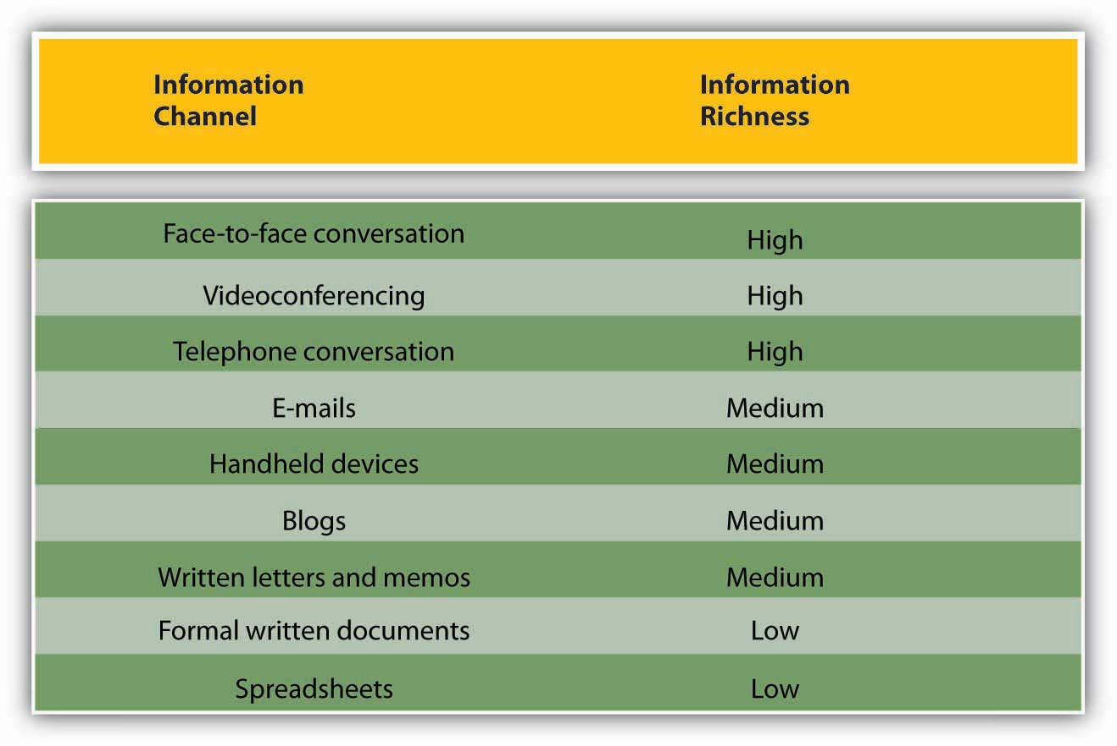

OB Toolbox: Business E-mail Dos and Don'ts  
  
DON’T send or forward chain e-mails.  
DON’T put anything in an e-mail that you don’t want the world to see.  
DON’T write a message in capital letters—this is the equivalent of SHOUTING.  
DON’T routinely CC everyone. Reducing inbox clutter is a great way to increase communication.  
DON’T hit send until you have spell-checked your e-mail.  
DO use a subject line that summarizes your message, adjusting it as the message changes over time.  
DO make your request in the first line of your e-mail. (And if that is all you need to say, stop there!)  
DO end your e-mail with a brief sign-off such as, “Thank you,” followed by your name and contact information.  
DO think of a work e-mail as a binding communication.  
DO let others know if you have received an e-mail in error.

***Note.* Adapted from "Understanding Communication," by T. Bauer and B. Erdogan, 2010, *Organizational Behavior*, Chapter 8.2. Copyright 2010 by Flat World Knowledge, Inc.**

**3c Topic 3: How Internal Power Structures Influence the Organization**

**What is power and how does one acquire it? (Recycle)**

power is the ability to influence the behavior of others to get what you want.

***Positive and Negative Consequences of Power***

The fact that we can see and succumb to power means that power has both positive and negative consequences. On one hand, powerful CEOs can align an entire organization to move together to achieve goals.

***Conformity***

**Conformity** refers to people’s tendencies to behave consistently with social norms.

**The Milgram Studies**

**The Asch Studies --**found that individuals could be influenced to say that two lines were the same length when one was clearly shorter than the other.

**The Zimbardo Study--**Researchers randomly assigned 18 individuals to the role of prisoner or guard. Those assigned the role of “prisoners” were surprised when they were picked up by actual police officers and then transferred to a prison that had been created in the basement of the Stanford psychology building. Zimbardo was shocked with how quickly the expected roles emerged. Prisoners began to feel depressed and helpless. Guards began to be aggressive and abusive. The original experiment was scheduled to last 2 weeks, but Zimbardo ended it after only 6 days.

**The Relationship Between Dependency and Power**

***Dependency***

**Dependency** is directly related to power. The more that a person or unit is dependent on you, the more power you have.

***Scarcity***

In the context of dependency, **scarcity** refers to the uniqueness of a resource. The more difficult something is to obtain, the more valuable it tends to be.

***Importance***

**Importance** refers to the value of the resource. The key question here is “How important is this?” If the resources or skills you control are vital to the organization, you will gain some power.

***Substitutability***

Finally, **substitutability** refers to one’s ability to find another option that works as well as the one offered.

*Note.* Adapted from "The Basics of Power," by T. Bauer and B. Erdogan, 2010, *Organizational Behavior*, Chapter 13.2. Copyright 2010 by Flat World Knowledge, Inc.

**The Power to Influence**

**different types of power, as well as the different types of influence tactics used by those with power.**

***Bases of Power***

Having power and using power are two different things.

***Legitimate Power***

**Legitimate power** is power that comes from one’s organizational role or position.

***Reward Power***

**Reward power** is the ability to grant a reward, such as an increase in pay, a perk, or an attractive job assignment.

***Coercive Power***

In contrast, **coercive power** is the ability to take something away or punish someone for noncompliance.

***Expert Power***

**Expert power** comes from knowledge and skill.

***Information Power***

**Information power** is similar to expert power but differs in its source.

***Referent Power-***

**Referent power** stems from the personal characteristics of the person such as the degree to which we like, respect, and want to be like them. Referent power is often called **charisma.**

**What Is Influence?**

By the time you hit the workplace, you have had vast experience with influence techniques. You have probably picked out a few that you use most often. To be effective in a wide number of situations, however, it is best to expand your repertoire of skills and become competent in several techniques, knowing how and when to use them as well as understanding when they are being used on you.

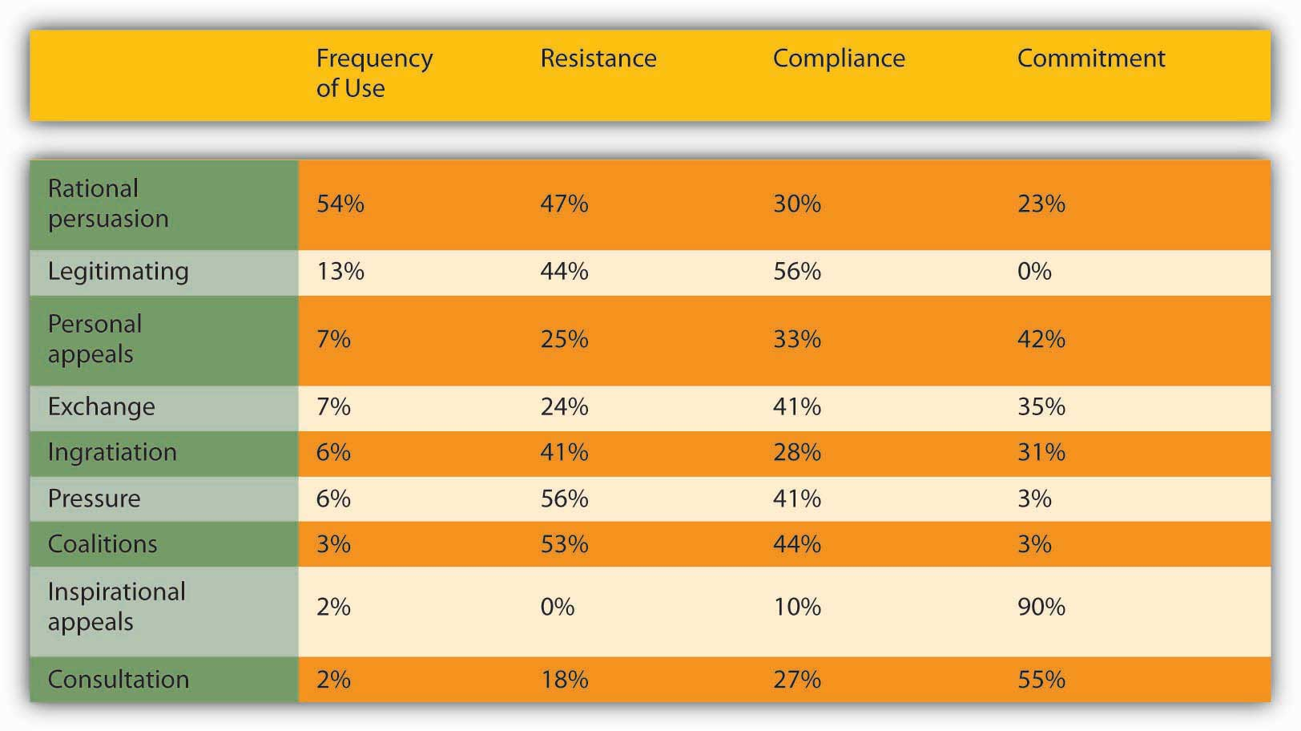

**Resistance** occurs when the influence target does not wish to comply with the request and either passively or actively repels the influence attempt. **Compliance** occurs when the target does not necessarily want to obey, but they do. **Commitment** occurs when the target not only agrees to the request but also actively supports it as well.

* **Rational persuasion** includes using facts, data, and logical arguments to try to convince others that your point of view is the best alternative. This is the most commonly applied influence tactic. One experiment illustrates the power of reason. People were lined up at a copy machine and another person, after joining the line asked, “May I go to the head of the line?” Amazingly, 63% of the people in the line agreed to let the requester jump ahead. When the line jumper makes a slight change in the request by asking, “May I go to the head of the line because I have copies to make?” the number of people who agreed jumped to over 90%. The word *because* was the only difference. Effective rational persuasion includes the presentation of factual information that is clear and specific, relevant, and timely. Across studies summarized in a meta-analysis, rationality was related to positive work outcomes.
* **Inspirational appeals** seek to tap into our values, emotions, and beliefs to gain support for a request or course of action. When President John F. Kennedy said, “Ask not what your country can do for you, ask what you can do for your country,” he appealed to the higher selves of an entire nation. Effective inspirational appeals are authentic, personal, big-thinking, and enthusiastic.
* **Consultation** refers to the influence agent’s asking others for help in directly influencing or planning to influence another person or group. Consultation is most effective in organizations and cultures that value democratic decision making.
* **Ingratiation** includes any form of flattery done either before or during the influence attempt. Research shows that ingratiation can affect individuals. For example, in a study of résumés, those résumés that were accompanied with a cover letter containing ingratiating information were rated higher than résumés without this information. Other than the cover letter accompanying them, the résumés were identical. Effective ingratiation is honest, infrequent, and well-intended.
* **Personal appeal** refers to helping another person because you like them and they asked for your help. We enjoy saying yes to people we know and like. A famous psychological experiment showed that in dorms, the most well-liked people were those who lived by the stairwell—they were the most often seen by others who entered and left the hallway. The repeated contact brought a level of familiarity and comfort. Therefore, personal appeals are most effective with people who know and like you.
* **Exchange** refers to give-and-take in which someone does something for you, and you do something for them in return. The rule of reciprocation says that “we should try to repay, in kind, what another person has provided us.” The application of the rule obliges us and makes us indebted to the giver. One experiment illustrates how a small initial gift can open people to a substantially larger request at a later time. One group of subjects was given a bottle of Coke. Later, all subjects were asked to buy raffle tickets. On the average, people who had been given the drink bought twice as many raffle tickets as those who had not been given the unsolicited drinks.
* **Coalition tactics** refer to a group of individuals working together toward a common goal to influence others. Common examples of coalitions within organizations are unions that may threaten to strike if their demands are not met. Coalitions also take advantage of peer pressure. The influencer tries to build a case by bringing in the unseen as allies to convince someone to think, feel, or do something. A well-known psychology experiment draws upon this tactic. The experimenters stare at the top of a building in the middle of a busy street. Within moments, people who were walking by in a hurry stop and also look at the top of the building, trying to figure out what the others are looking at. When the experimenters leave, the pattern continues, often for hours. This tactic is also extremely popular among advertisers and businesses that use client lists to promote their goods and services. The fact that a client bought from the company is a silent testimonial.
* **Pressure** refers to exerting undue influence on someone to do what you want or else something undesirable will occur. This often includes threats and frequent interactions until the target agrees. Research shows that managers with low referent power tend to use pressure tactics more frequently than those with higher referent power. Pressure tactics are most effective when used in a crisis situation and when they come from someone who has the other’s best interests in mind, such as getting an employee to an employee assistance program to deal with a substance abuse problem.
* **Legitimating tactics** occur when the appeal is based on legitimate or position power. “By the power vested in me…”: This tactic relies upon compliance with rules, laws, and regulations. It is not intended to motivate people but to align them behind a direction. Obedience to authority is filled with both positive and negative images. Position, title, knowledge, experience, and demeanor grant authority, and it is easy to see how it can be abused. If someone hides behind people’s rightful authority to assert themselves, it can seem heavy-handed and without choice. You must come across as an authority figure by the way you act, speak, and look. Think about the number of commercials with doctors, lawyers, and other professionals who look and sound the part, even if they are actors. People want to be convinced that the person is an authority worth heeding. Authority is often used as a last resort. If it does not work, you will not have much else to draw from in your goal to persuade someone.

**Direction of Influence**

The type of influence tactic used tends to vary based on the target.

***Upward Influence***

**Upward influence**, as the name implies, is the ability to influence your boss and others in positions higher than yours.

***Downward Influence***

**Downward influence** is the ability to influence employees lower than you.

***Peer Influence***

**Peer influence** occurs all the time. But, to be effective within organizations, peers need to be willing to influence each other without being destructively competitive.

### **OB Toolbox: Getting Comfortable With Power**

Now that you have learned a great deal about power and influence within organizations, consider asking yourself how comfortable you are with the three statements below:

1. Are you comfortable saying, “I want to be powerful” to yourself? Why or why not?
2. Are you comfortable saying, “I want to be powerful” to someone else? Why or why not?
3. Are you comfortable having someone say, “You are powerful” to you? Why or why not?

Discomfort with power reduces your power.

*Note.* Adapted from "The Power to Influence," by T. Bauer and B. Erdogan, 2010, *Organizational Behavior*, Chapter 13.3. Copyright 2010 by Flat World Knowledge, Inc.

**3d Topic 4: Decision-Making**

**Vroom and Yetton’s Normative Decision Model**

1. *Decision Significance*. The decision has high significance because the approach chosen needs to be effective at reducing employee stress for the insurance premiums to be lowered. In other words, there is a quality requirement to the decision. Follow the path through H.
2. *Importance of Commitment*. Does the leader need employee cooperation to implement the decision? In our example, the answer is high, because employees may simply ignore the resources if they do not like them. Follow the path through H.
3. *Leader expertise*. Does the leader have all the information needed to make a high quality decision? In our example, leader expertise is low. You do not have information regarding what your employees need or what kinds of stress reduction resources they would prefer. Follow the path through L.
4. *Likelihood of commitment*. If the leader makes the decision alone, what is the likelihood that the employees would accept it? Let us assume that the answer is low. Based on the leader’s experience with this group, they would likely ignore the decision if the leader makes it alone. Follow the path from L.
5. *Goal alignment*. Are the employee goals aligned with organizational goals? In this instance, employee and organizational goals may be aligned because you both want to ensure that employees are healthier. So let us say the alignment is high, and follow H.
6. *Group expertise*. Does the group have expertise in this decision-making area? The group in question has little information about which alternatives are costlier, or more user friendly. We will say group expertise is low. Follow the path from L.
7. *Team competence*. What is the ability of this particular team to solve the problem? Let us imagine that this is a new team that just got together and they have little demonstrated expertise to work together effectively. We will answer this as low or L.
8. Based on the answers to the questions we gave, the normative approach recommends consulting employees as a group. In other words, the leader may make the decision alone after gathering information from employees and is not advised to delegate the decision to the team or to make the decision alone.

**Decision-Making Styles**

* *Decide*. The leader makes the decision alone using available information.
* *Consult individually*. The leader obtains additional information from group members before making the decision alone.
* *Consult as a group*. The leader shares the problem with group members individually and makes the final decision alone.
* *Facilitate*. The leader shares information about the problem with group members collectively and acts as a facilitator. The leader sets the parameters of the decision.
* *Delegate*. The leader lets the team make the decision.

**Steps to Ethical Decision-Making**

Many models provide several steps to the decision-making process. One such model was created in the late 1990s for the counseling profession but can apply to nearly every profession from health care to business (Corey, Corey, & Callanan, 1998; Syracuse School of Education, n.d.). In this model, the authors propose eight steps to the decision-making process. As you will note, the process is similar to Josephson’s model, with a few variations:

1. **Step 1:** Identify the problem. Sometimes just realizing a particular situation is ethical can be the important first step. Occasionally in our organizations, we may feel that it is just the “way of doing business” and not think to question the ethical nature.
2. **Step 2:** Identify the potential issues involved. Who could get hurt? What are the issues that could negatively impact people and/or the company? What is the worst-case scenario if we choose to do nothing?
3. **Step 3:** Review relevant ethical guidelines. Does the organization have policies and procedures in place to handle this situation? For example, if a client gives you a gift, there may be a rule in place as to whether you can accept gifts and if so, the value limit of the gift you can accept.
4. **Step 4:** Know relevant laws and regulations. If the company does not necessarily have a rule against it, could it be looked at as illegal?
5. **Step 5:** Obtain consultation. Seek support from supervisors, coworkers, friends, and family, and especially seek advice from people who you feel are moral and ethical.
6. **Step 6:** Consider possible and probable courses of action. What are all of the possible solutions for solving the problem? Brainstorm a list of solutions—all solutions are options during this phase.
7. **Step 7:** List the consequences of the probable courses of action. What are both the positive and negative benefits of each proposed solution? Who can the decision affect?
8. **Step 8:** Decide on what appears to be the best course of action. With the facts we have and the analysis done, choosing the best course of action is the final step. There may not always be a “perfect” solution, but the best solution is the one that seems to create the most good and the least harm.

**Understanding Decision-Making**

**Decision-making** refers to making choices among alternative courses of action—which may also include inaction.

**Types of Decisions**

straightforward decisions are termed **programmed decisions**, which are decisions that occur frequently enough that we develop an automated response to them. Unique and important decisions require conscious thinking, information gathering, and careful consideration of alternatives. These are called **non-programmed decisions**.

**Strategic decisions** are decisions that are made to set the course of an organization. **Tactical decisions** are decisions about how things will get done. Finally, **operational decisions** are decisions employees make each day to make the organization function.

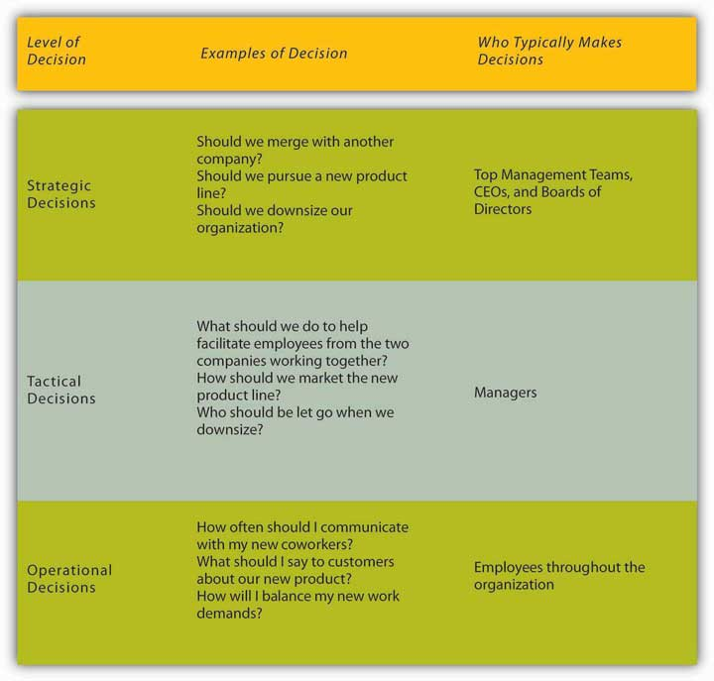

**Making Rational Decisions**

The **rational decision-making model** is a series of steps that decision-makers should consider if their goal is to maximize their outcome and make the best choice. In other words, if you want to make sure that you make the best choice, going through the formal steps of the rational decision-making model may make sense.

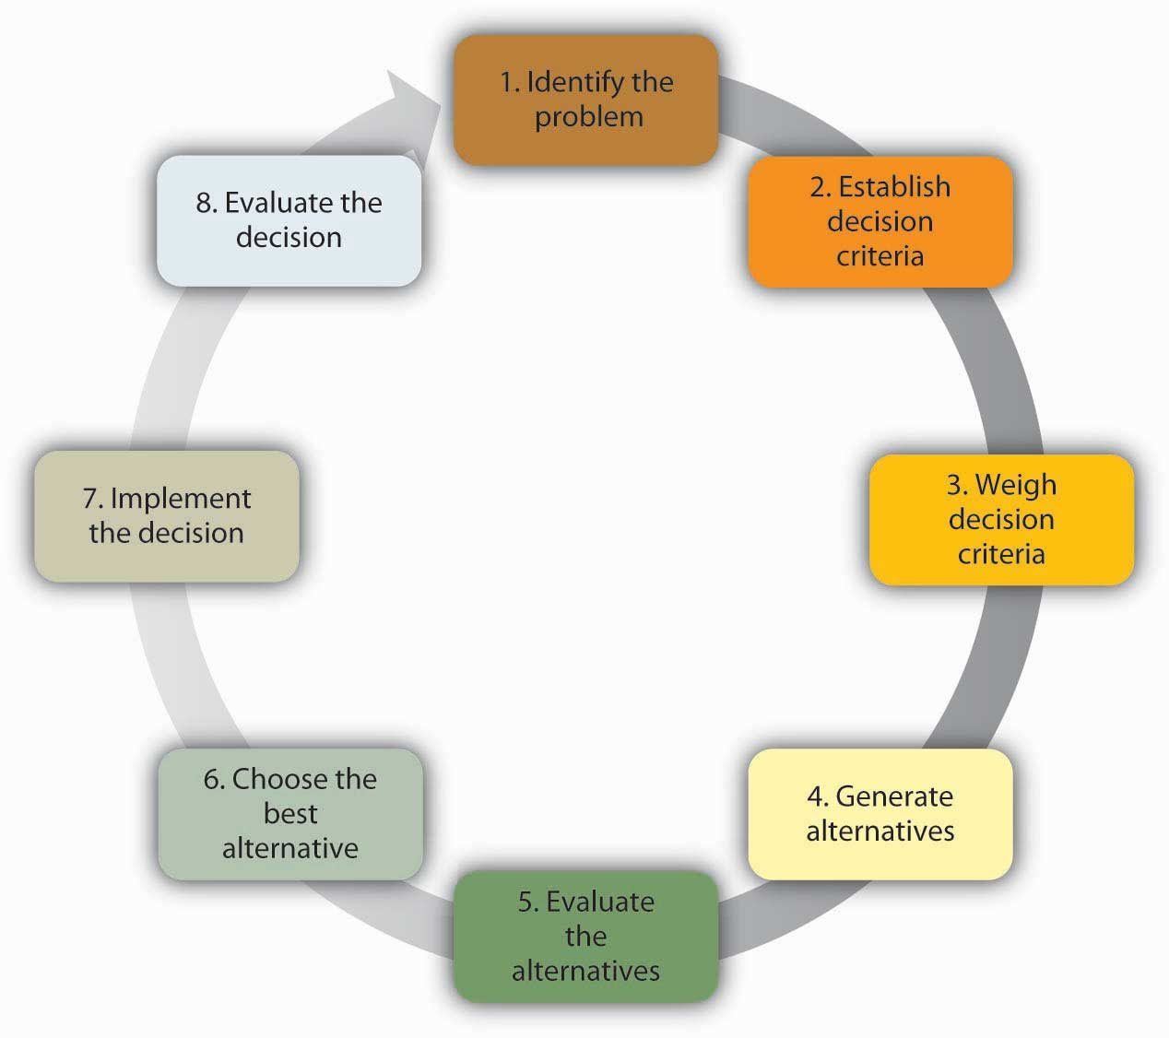

**Making “Good Enough” Decisions**

The **bounded rationality model** of decision-making recognizes the limitations of our decision-making processes.

**Making Intuitive Decisions**

The **intuitive decision-making model** argues that in a given situation, experts making decisions scan the environment for cues to recognize patterns that have emerged as alternatives to other decision-making processes.

**Making Creative Decisions**

In addition to the rational decision-making, bounded rationality, and intuitive decision-making models, creative decision-making is a vital part of being an effective decision-maker. **Creativity** is the generation of new ideas that are original, fluent, and flexible.

**Innovation** begins with creative ideas, but also involves realistic planning and follow-through.

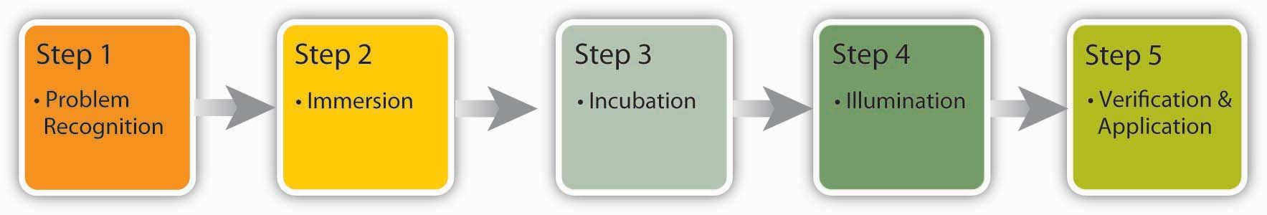

***Note.* Adapted from "What Is the Role of the Context? Contingency Approaches to Leadership," by T. Bauer and B. Erdogan, 2010, *Organizational Behavior*, Chapter 12.4. Copyright 2010 by Flat World Knowledge, Inc.**

**Avoiding Decision-Making Traps**

**Overconfidence bias** occurs when individuals overestimate their ability to predict future events.

**Hindsight bias** is the opposite of overconfidence bias, as it occurs when looking backward in time, making past mistakes seem obvious.

**Anchoring** refers to the tendency of individuals to rely too heavily on a single piece of information. Job seekers often fall into this trap by focusing on a desired salary while ignoring other aspects.

**Framing bias** is another concern for decision-makers. Framing bias refers to the tendency of decision-makers to be influenced by the way that a situation or problem is presented.

**Escalation** of commitment occurs when individuals continue on a failing course of action after information reveals it may be a poor path to follow. It is sometimes called the “**sunken costs fallacy**”

**Decision-Making in Groups**

***When It Comes to Decision-Making, Are Two Heads Better Than One?***

If the group is diverse, better decisions may be made because different group members may have different ideas based on their backgrounds and experiences.

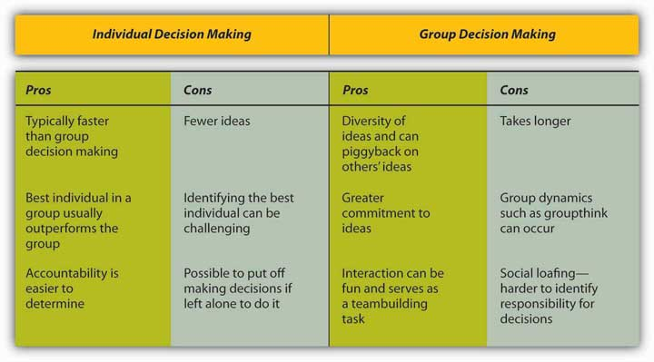

***Groupthink***

**groupthink**. Groupthink is a tendency to avoid a critical evaluation of ideas the group favors.

1. **llusion of invulnerability** is shared by most or all of the group members, which creates excessive optimism and encourages them to take extreme risks.
2. **Collective rationalizations** occur, in which members downplay negative information or warnings that might cause them to reconsider their assumptions.
3. **An unquestioned belief in the group’s inherent morality** occurs, which may incline members to ignore ethical or moral consequences of their actions.
4. **Stereotyped views of outgroups** are seen when groups discount rivals’ abilities to make effective responses.
5. **Direct pressure** is exerted on any members who express strong arguments against any of the group’s stereotypes, illusions, or commitments.
6. **Self-censorship** occurs when members of the group minimize their own doubts and counterarguments.
7. **Illusions of unanimity** occur, based on self-censorship and direct pressure on the group. The lack of dissent is viewed as unanimity.
8. **The emergence of self-appointed mindguards** happens when one or more members protect the group from information that runs counter to the group’s assumptions and course of action.

**Tools and Techniques for Making Better Decisions**

**Nominal Group Technique** (NGT) was developed to help with group decision-making by ensuring that all members participate fully.

**Delphi Technique** is unique because it is a group process using written responses to a series of questionnaires instead of physically bringing individuals together to make a decision. The first questionnaire asks individuals to respond to a broad question such as stating the problem.

**Majority rule** refers to a decision-making rule in which each member of the group is given a single vote, and the option receiving the greatest number of votes is selected.

**Consensus** is a decision-making rule that groups may use when the goal is to gain support for an idea or plan of action.

A **premortem** is a way to imagine what might go wrong and avoid it before spending a cent or having to change course along the way.

**Group Decision Support Systems** (GDSS) are interactive computer-based systems that are able to combine communication and decision technologies to help groups make better decisions.

*Note.* Adapted from "Faulty Decision-Making," by T. Bauer and B. Erdogan, 2010, *Organizational Behavior*, Chapter 11.3. Copyright 2010 by Flat World Knowledge, Inc.

**Objective 4: Organizational Effectiveness and Productivity**

**Topic 1: How Individual Differences Impact Organizational Behavior**

**Work Attitudes**

An **attitude** refers to our opinions, beliefs, and feelings about aspects of our environment. At work, two particular job attitudes have the greatest potential to influence how we behave. These are **job satisfaction** and **organizational commitment**.

### **OB Toolbox: How Can You Be Happier at Work?**

1. *Have a positive attitude about it*. Your personality is a big part of your happiness. If you are always looking for the negative side of everything, you will find it.
2. *A good fit with the job and company is important to your happiness*. This starts with knowing yourself: What do you want from the job? What do you enjoy doing? Be honest with yourself and do a self-assessment.
3. *Get accurate information about the job and the company*. Ask detailed questions about what life is like in this company. Do your research: Read about the company, and use your social network to understand the company’s culture.
4. *Develop good relationships at work*. Make friends. Try to get a mentor. Approach a person you admire and attempt to build a relationship with this person. An experienced mentor can be a great help in navigating life at a company. Your social network can help you weather the bad days and provide you emotional and instrumental support during your time at the company as well as afterward.
5. *Pay is important, but job characteristics matter more to your job satisfaction*. Do not sacrifice the job itself for a little bit more money. When choosing a job, look at the level of challenge, and the potential of the job to make you engaged.
6. *Be proactive in managing organizational life*. If the job is stressful, cope with it by effective time management and having a good social network, as well as being proactive in getting to the source of stress. If you do not have enough direction, ask for it!
7. *Know when to leave*. If the job makes you unhappy over an extended period of time and there is little hope of solving the problems, it may be time to look elsewhere.

**What Causes Positive Work Attitudes?**

### **Figure 4.1 Factors Contributing to Job Satisfaction and Organizational Commitment**

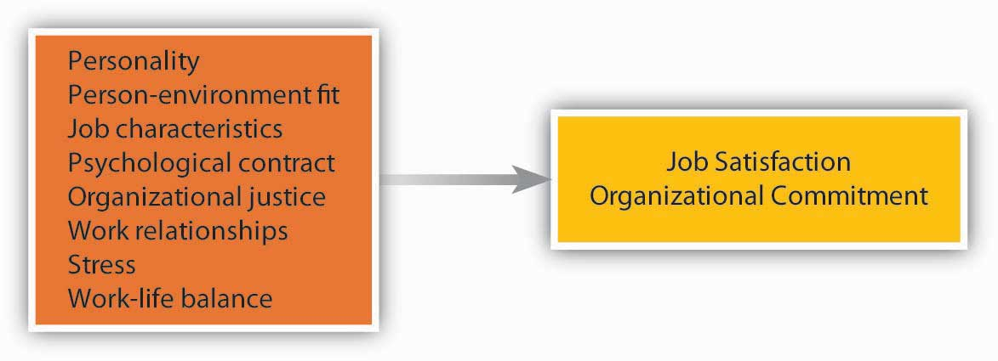

**Personality**

ob satisfaction is not purely environmental and is partially due to our personality.

**Job Characteristics**

The presence of certain characteristics on the job seems to make employees more satisfied and more committed.

**Relationships at Work**

Two strong predictors of our happiness at work and commitment to the company are our relationships with coworkers and managers.

**Stress.**

Not surprisingly, the amount of stress present in our job is related to our satisfaction and commitment.

**Consequences of Positive Work Attitudes**

It seems that happy workers have an inclination to be more engaged at work.

**Person–organization fit**refers to the degree to which a person’s values, personality, goals, and other characteristics match those of the organization. **Person–job fit** is the degree to which a person’s skill, knowledge, abilities, and other characteristics match the job demands.

**Individual Differences: How Values and Personality Impact Organizational Effectiveness and Productivity**

***Values***

**Values** refer to stable life goals that people have, reflecting what is most important to them. Values are established throughout one’s life as a result of the accumulating life experiences and tend to be relatively stable.

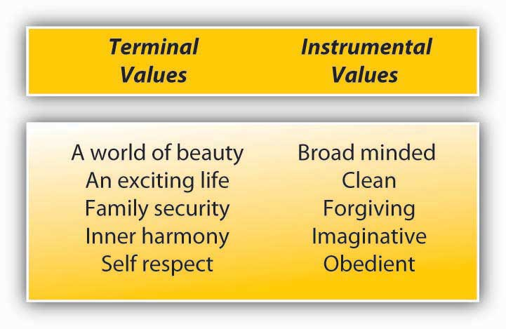

***Personality***

**Personality** encompasses the relatively stable feelings, thoughts, and behavioral patterns a person has. Our personality differentiates us from other people, and understanding someone’s personality gives us clues about how that person is likely to act and feel in a variety of situations.

### **OB Toolbox: Help, I Work With a Negative Person!**

Employees who have high levels of neuroticism or high levels of negative affectivity may act overly negative at work, criticize others, complain about trivial things, or create an overall negative work environment. Here are some tips for how to work with them effectively.

1. *Understand that you are unlikely to change someone else’s personality*. Personality is relatively stable and criticizing someone’s personality will not bring about change. If the behavior is truly disruptive, focus on behavior, not personality.
2. *Keep an open mind*. Just because a person is constantly negative does not mean that they are not sometimes right. Listen to the feedback they are giving you.
3. *Set a time limit*. If you are dealing with someone who constantly complains about things, you may want to limit these conversations to prevent them from consuming your time at work.
4. *You may also empower them to act on the negatives they mention*. The next time an overly negative individual complains about something, ask that person to think of ways to change the situation and get back to you.
5. *Ask for specifics*. If someone has a negative tone in general, you may want to ask for specific examples for what the problem is.

***Proactive Personality***

**Proactive personality** refers to a person’s inclination to fix what is perceived as wrong, change the status quo, and use initiative to solve problems.

***Self-Esteem***

**Self-esteem** is the degree to which a person has overall positive feelings about his or herself.

***Self-Efficacy***

**Self-efficacy** is a belief that one can perform a specific task successfully.

### **OB Toolbox: Ways to Build Your Self-Confidence**

Having high self-efficacy and self-esteem are boons to your career. People who have an overall positive view of themselves and those who have positive attitudes toward their abilities project an aura of confidence. How do you achieve higher self-confidence?

* *Take a self-inventory*. What are the areas in which you lack confidence? Then consciously tackle these areas. Take part in training programs; seek opportunities to practice these skills. Confront your fears head-on.
* *Set manageable goals*. Success in challenging goals will breed self-confidence, but do not make your goals impossible to reach. If a task seems daunting, break it apart and set mini goals.
* *Find a mentor*. A mentor can point out areas in need of improvement, provide accurate feedback, and point to ways of improving yourself.
* *Do not judge yourself by your failures*. Everyone fails, and the most successful people have more failures in life. Instead of assessing your self-worth by your failures, learn from mistakes and move on.
* *Until you can feel confident, be sure to act confident*. Acting confident will influence how others treat you, which will boost your confidence level. Pay attention to how you talk and behave, and act like someone who has high confidence.
* *Know when to ignore negative advice*. If you receive negative feedback from someone who is usually negative, try to ignore it. Surrounding yourself with naysayers is not good for your self-esteem. This does not mean that you should ignore all negative feedback, but be sure to look at a person’s overall attitude before making serious judgments based on that feedback.

***Locus of Control***

Locus of control deals with the degree to which people feel accountable for their own behaviors. Individuals with high **internal locus of control** believe that they control their own destiny and what happens to them is their own doing, while those with high **external locus of control** feel that things happen to them because of other people, luck, or a powerful being. Internals feel greater control over their own lives and therefore they act in ways that will increase their chances of success.

*Note.* Adapted from "Work Attitudes," by T. Bauer and B. Erdogan, 2010, *Organizational Behavior*, Chapter 4.2. Copyright 2010 by Flat World Knowledge, Inc.

**4b Topic 2: How Group Dynamics Impact Organizational Behavior, Effectiveness, and Productivity**

**Group Dynamics**

**Leadership**

There are many possible causes for poor group dynamics.

**Group Roles and Structure**

A second challenging factor in group dynamics can be based upon group roles and overall structure of the group, such as group size.

Another effect on productivity within a group is often a result of **blocking**. Blocking is a behavior that disrupts the flow of information and decision making within a group. There are three types of blocks that can happen:

* **Aggressor**: This person often disagrees with others, or is too outspoken with strong opinions.
* **Negator**: This person points out what is wrong with others’ ideas.
* **Joker**: This person introduces humor at the wrong time—when serious discussions are needed

When these blocking situations occur, it makes it impossible to move forward and have meaningful discussion around the topic at hand. **Initiators,** on the other hand, tend to contribute positively to group dynamics, in that they provide new ideas and are optimistic.

Another detriment in group dynamics that can impact productivity and effectiveness is the concept of **social loafing**. Social loafing refers to when team members choose not to volunteer to do their share of the work.

**Group Norms**

**Group norms** are acceptable standards of behavior within a group

**Group Cohesiveness and Groupthink**

Surprisingly, a challenge in some group dynamics could be the level of **group cohesiveness**.

If it is found that groupthink is affecting productivity and efficiency within a team, the following might help attain a more productive workplace:

* Welcome outsiders into the group
* Continually change the make-up of a team
* Use smaller groups within the larger team to independently work to solve problems
* Encourage diversity
* Encourage development of individual team members, and development of the team as a whole
* Always question “why” things are done in a certain way

*Note.* Adapted from "Work Attitudes," by T. Bauer and B. Erdogan, 2010, *Organizational Behavior*, Chapter 4.2. Copyright 2010 by Flat World Knowledge, Inc.

**4c Topic 3: How Organizational Culture Impacts Work Behavior**

**relationship between an organization’s culture and the work behaviors demonstrated by its employees.**

**Organizational culture refers to the beliefs and values that have existed in an organization for long periods of time, and to the beliefs of the employees (Tsai, 2011).**

**Elements of Organizational Culture.**

Organizational culture consists of four main elements: **leadership, decision making and structure, the people, and work processes and systems** (the Bridgespan Group, n. d.).

**Developing Culture for Effective Work Behaviors.**

Effective work behaviors begin with the core values of the organization. For example, Zappos.

**Objective 5: Applying the Theoretical Concepts of Organizational Behavior**

**Topic 1: Application: Ethics and Motivation**

**Ethical Dilemma**

Companies are interested in motivating employees: Work hard, be productive, behave ethically—and stay healthy.

**Topic 2: Application: Motivational Theory**

**Zappos case study, Transparency**

**Topic 3: Organizational Leadership Theories**

**Taking on the Pepsi Challenge: The Case of Indra Nooyi**