our presentation must demonstrate how well you apply operations management theories, including 1) distribution of goods, 2) continuous process improvement, 3) resource management, and 4) current practices. You must also include an analysis of strengths and weaknesses of Corus' five-year plan as outlined in the case study provided, along with your personal and/or professional experiences related to the operations management theories discussed.

-An accurate analysis of the strengths and weaknesses of current plans and practices of the mill as they relate to the operations management theories of distribution of goods, management of resources, continuous process improvement, and current practices.

• Personal and/or professional experiences as they relate to the operations management theories, either as a consumer or on the job. For example, prepare to discuss your own experience on a continuous improvement team, or as a consumer trying to purchase an out-of-stock item or purchased items delivered late.

• A plan of recommendations to change Corus’ distribution strategy, continuous improvement, and resource management that clearly address the weaknesses you analyzed in the Corus case study.

• An implementation schedule you are recommending to put your proposed changes into action over the next two weeks. Ensure that suggestions relate to distribution of goods, management of resources, and continuous process improvement.

• Accountability plan (a breakdown of managers’ and employees’ responsibilities) to put your proposed changes into action. Include what additional tools Corus can use to measure productivity. Ensure that suggestions relate to distribution of goods, management of resources, and continuous process improvement.

comp notes

Operations for a hospital involve determining the size of the facility, deciding the type and quantity of equipment to purchase, arranging the facility and equipment for efficiency, determining staffing levels and schedules to provide quality care, and managing inventories of medicines and bedding. Operations, therefore, refers to the processes within organizations that acquire inputs and transform them into outputs that the public can consume.

Manufacturing is a specific term referring to the production of goods. Throughout the text, the term product is used to refer to either services or goods.

Operations management refers to decision-making processes for the design, planning, and management of the many factors that affect operations. Decisions can include which products to produce, how large a facility to build, how many people to hire, and what methods to use to improve quality and efficiency. Operations managers apply ideas and knowledge to:

Decrease production time.

Increase the speed of bringing new services and goods to market.

Improve flexibility to meet rapidly changing customer needs.

Enhance product quality.

Improve customer service.

Increase productivity.

Reduce costs.

Operations management includes many aspects, from production to scheduling and distribution, with productivity being perhaps one of the most important areas within operations management. Most organizations attempt to increase productivity within their operations.

Productivity is affected by:

Design of operations including the number, size, location, and capacity of the facilities providing the service or producing the good.

Equipment and methods used.

Detailed analysis of the individual jobs and activities.

1. Productivity and the Design of Operations

2. Productivity and Equipment and Methods

3. Productivity and Detailed Analysis of Work

--Technology Innovation

--Automation

--Economies of Scale

--Learning and Experience

--Business Process Redesign

--Job Design and Work Measurement

--Human Resources

Note. Adapted from "Enhancing Productivity," by M. Vonderembse & G. White, 2013, Operations Management, Chapter 3. Copyright 2013 by Bridgepoint Education, Inc.

one objective of supply chain management is to reduce inventory throughout the supply chain

Cross docking seeks to coordinate inbound and outbound shipments so that little inventory is kept at the distribution center. As a shipment is received from the factory and broken down, each unit of the inbound shipment is moved to a location awaiting outbound shipment to a retailer. After each outbound shipment is fully assembled, it is sent on to the retailer.

Note. Adapted from "Supply Chain Management: A Strategy Perspective," by M. Vonderembse & G. White, 2013, Operations Management, Chapter 5. Copyright 2013 by Bridgepoint Education, Inc.

Just In Time Supply Chain Strategy

In terms of productivity, the concept of just in time (JIT) applies to both productivity and the management of inventory.

JIT allows materials to flow in an assembly process similar to a continuous flow process

Simplified Production Process

Note. Adapted from "Just-in-Time and Lean Systems," by M. Vonderembse & G. White, 2013, Operations Management, Chapter 11. Copyright 2013 by Bridgepoint Education, Inc.

MileStone Info

Watch the video and respond to the following. According to the video, what are the benefits of a JIT supply chain?

According to the video the benefits to why some firms can make jit work are:

why it works for some

1. JIT came from Asian manufacturers. It works for automotive manufacturers

--they have a fixed materials

--small product lines with large volumes

--able to ramp up production to value forecast

--they have linear and constant demand for products

--vendor base that is close, and they are the vender's main customer

--they can match their payables to their receivables short times for investments in inventory

Provide an example presented in the video.

The example giving in the video is an Asian car manufacturer. These did not have the backing to keep inventory in stock so had to come up with a way to manufacture autos with little inventory and little financial backing.

Next, what did you find most interesting about what the presenter said about a JIT supply chain? Explain your answer.

I found it interesting that the presenter stated that very few firms could make JIT work. The other studies seem to taste JIT as the way to do business. However, this presenter presents this model as an impossibility if all six benefits are not present.

Lastly, provide an example of when a JIT supply chain would work or when it would not.

Jit would work for small product lines, which are linear and constant in demand. One such business might be A toilet paper manufacturer. Toilet paper is a product that never really has seasons, and product lines can be linear.

JIT would not work for A bicycle manufacturer. Though the product and process line could be linear, the item itself is seasonal so JIT would be difficult. If, however, economies of scale could be maintained by cutting out per item shipping, by transporting the inventory from the vender (who would have to be very close for this to work) themselves in their own trucks, Production could ramp up easily during a season, and with the savings from economies of scale JIT should work.

drawbacks JIT

--delays equal stockout which equals lost sales and lack of inventory

--managing shipments, and per unit freight costs. Unable to use economies to scale.

Technology and Manufacturing

Computer-based control systems can be combined with manufacturing technology, such as robots, machine tools, and automated guided vehicles, to improve manufacturing operations.

Note. Adapted from "Gaining Competitive Advantage Through Operations," by M. Vonderembse & G. White, 2013, Operations Management, Chapter 2. Copyright 2013 by Bridgepoint Education, Inc.

Qualitative and Quantitative Considerations

Quantitative factors for manufacturers include:

labor costs,

material costs,

transportation,

utilities, taxes, real estate costs, and construction costs, and

government incentives.

Qualitative factors include:

labor climate,

quality of life,

proximity to customers and markets for faster distribution, and

proximity to suppliers and resources.

Note. Adapted from "Facility Location and Process Selection," by M. Vonderembse & G. White, 2013, Operations Management, Chapter 7. Copyright 2013 by Bridgepoint Education, Inc.

Flexible Manufacturing System Considerations

Manufacturing cells and FMS are process options that offer the potential to manufacture low-cost products that meet varying customer requirements. Manufacturing cells rely on group technology to build a family of parts with similar design and processing characteristics.

Note. Adapted from "Facility Location and Process Selection," by M. Vonderembse & G. White, 2013, Operations Management, Chapter 7. Copyright 2013 by Bridgepoint Education, Inc.

Manufacturing Resource Planning (MRP II) Considerations

MRP also forces companies to better coordinate the activities of operations, marketing, and purchasing. The master schedule will have implications for finance, personnel, distribution, workforce requirements, and purchases of materials. Manufacturing resource planning, or MRP II, as it is commonly called to differentiate it from material requirements planning, is a way of tying all parts of an organization together to build on the strategic plan. The strategic plan is an overall blueprint that specifies the company’s objectives and how it plans to reach them.

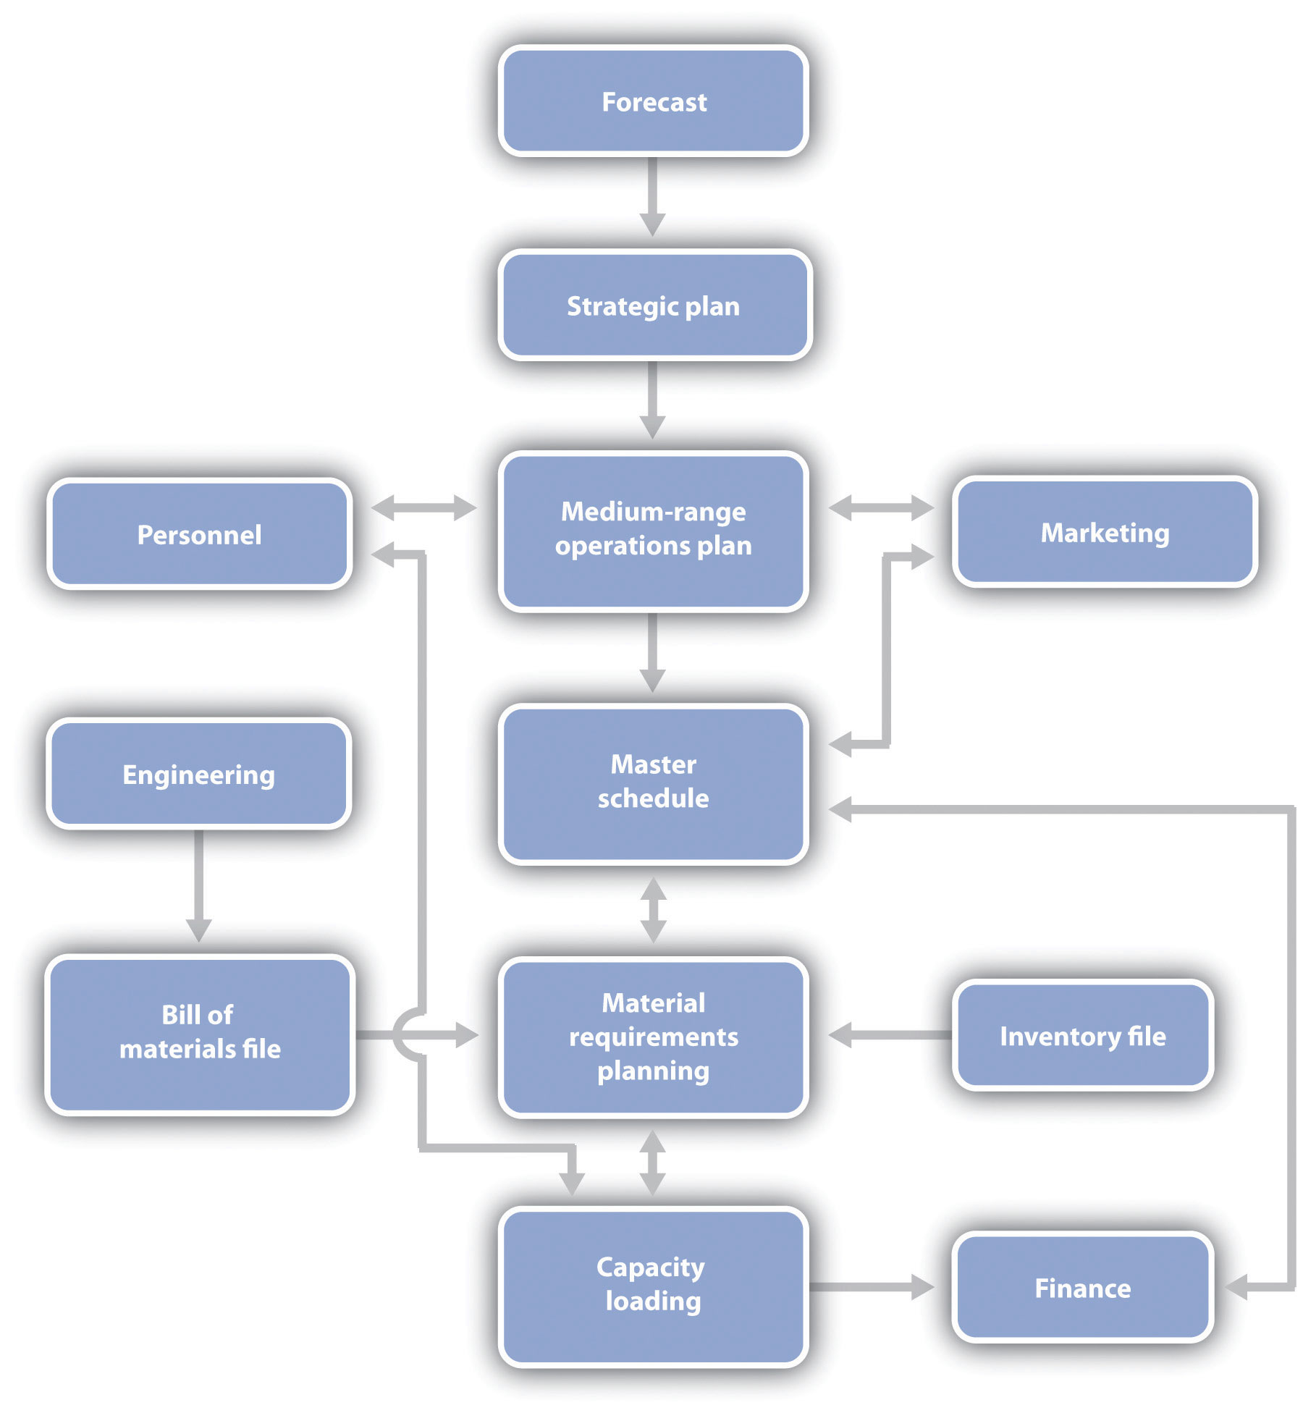

*Note*. Adapted from "Scheduling," by M. Vonderembse & G. White, 2013, *Operations Management,* Chapter 12. Copyright 2013 by Bridgepoint Education, Inc.

**High Quality and Low Costs: The Ideal**

**Moving Toward the Ideal Through Technology**

**Moving Toward the Ideal Through Better Management**

Higher quality and lower costs can also be achieved through better management practices, including quality and cost-management programs that trim waste from operations, better training and motivation for employees, and greater attention to machine maintenance.

**Time**

Time-based competition is a strategy of seeking competitive advantage by quickening the pace of critical organizational processes, such as product development, order entry, production, distribution, and service. The emphasis is on end-to-end time (i.e., aggregate time).

*Note*. Adapted from "Gaining Competitive Advantage Through Operations," by M. Vonderembse & G. White, 2013, *Operations Management,* Chapter 2. Copyright 2013 by Bridgepoint Education, Inc.

Quality Management

Price and quality are two critical dimensions when deciding to purchase a good or service because these are key elements in the **value proposition**.

**Quality of Goods**

* Performance—primary operating characteristics of a product.
* Features—secondary characteristics that supplement the product’s basic functioning.
* Reliability—length of time a product will function before it fails, or the probability it will function for a stated period of time.
* Conformance—degree to which a product’s design and operating characteristics match pre-established standards.
* Durability—ability of a product to function when subjected to hard and frequent use.
* Serviceability—speed, courtesy, and competence of repair.
* Aesthetics—how a product looks, feels, sounds, tastes, or smells.
* Perceived Quality—image, advertising, or brand name of a product.

*Note*. Adapted from "Introduction to Quality Management," by M. Vonderembse & G. White, 2013, *Operations Management,* Chapter 4. Copyright 2013 by Bridgepoint Education, Inc.

Costs of Quality

Despite the best efforts to produce high-quality products, operations managers must also be concerned with the cost of quality—that is, what are the production costs and the costs to NOT having a high-quality product.

* Failure costs—can be internal to the organization or external involving the customer.
* Appraisal costs—investment in measuring quality and assessing customer satisfaction.
* Prevention costs—put a stop to the quality problem.

**Failure Costs**

**Appraisal Costs**

Appraisal costs are the costs incurred to measure quality, assess customer satisfaction, and inspect and test products.

**Prevention Costs**

Prevention costs result from activities designed to prevent defects from occurring. Prevention costs can include activities such as employee training, quality control procedures, special efforts when designing products, or administrative systems to prevent defects.

*Note*. Adapted from "Introduction to Quality Management," by M. Vonderembse & G. White, 2013, *Operations Management,* Chapter 4. Copyright 2013 by Bridgepoint Education, Inc.

**Foundations of Quality Management**

**Building Quality into Products**

Design for manufacture and assembly (DFMA) emphasizes that products should be designed so they are simple and inexpensive to produce.

**Product Design: This is how the product, either a good or a service, functions.**

**Process Design: This is how the product, either a good or a service, is produced.**

**Work Execution: This is the performance of the plan created in the product and process design.**

**Inspection: This is an assessment of the quality of the good or service.**

Note. Adapted from "Introduction to Quality Management," by M. Vonderembse & G. White, 2013, Operations Management, Chapter 4. Copyright 2013 by Bridgepoint Education, Inc.

Total Quality Management (TQM)-- This approach to quality management originated in Japan and was adopted successfully by many companies throughout the world, including American Express and GE.

* Focus on the customer
* Quality function deployment
* Responsibility for quality
* Team problem solving
* Employee training
* Fact-based management
* Philosophy of continuous improvement

**Focus on the Customer**

**Quality Function Deployment**

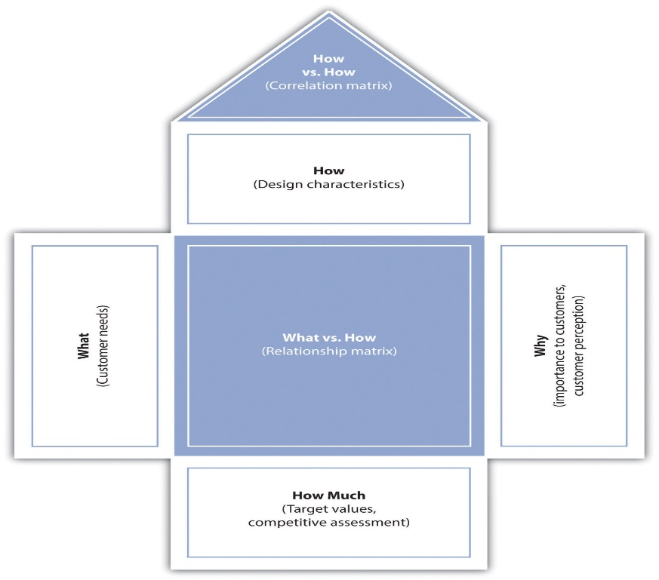

**Figure 1.5 Successive Houses of Quality Deploy the Voice of the Customer Throughout the Organization**

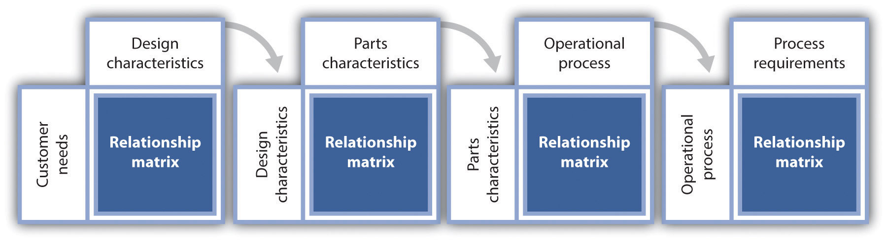

**Responsibility for Quality**

In the past, many companies used quality control (QC) departments to ensure quality. Unfortunately, this practice allowed others in the organization to assume that the QC department was solely responsible for quality.

**Team Problem Solving**

**Employee Training**

**Fact-Based Management**

**Benchmarking**

**Broader Measures of Performance**

**Philosophy of Continuous Improvement**

* Standardize and document procedures.
* Assign teams to identify areas for improvement.
* Use methods analysis and problem-solving tools.
* Use the Plan-Do-Check-Act cycle (discussed later).
* Document improved procedures.

**Standardizing and Documenting Procedures**

**Identify Areas for Improvement**

**Methods Analysis and Problem-Solving Tools**

**The Plan-Do-Check-Act Cycle**

**Plan**—Before making any changes, be sure everything is documented and standardized. Use appropriate tools to identify problems or opportunities for improvement. Develop a plan to make changes.

**Do**—Implement the plan and document any changes made.

**Check**—Analyze the revised process to determine if goals have been achieved.

**Act**—If the goals have been achieved, then standardize and document the changes. Communicate the results to others that could benefit from similar changes. If the goals have not been achieved, determine why not, and proceed accordingly.

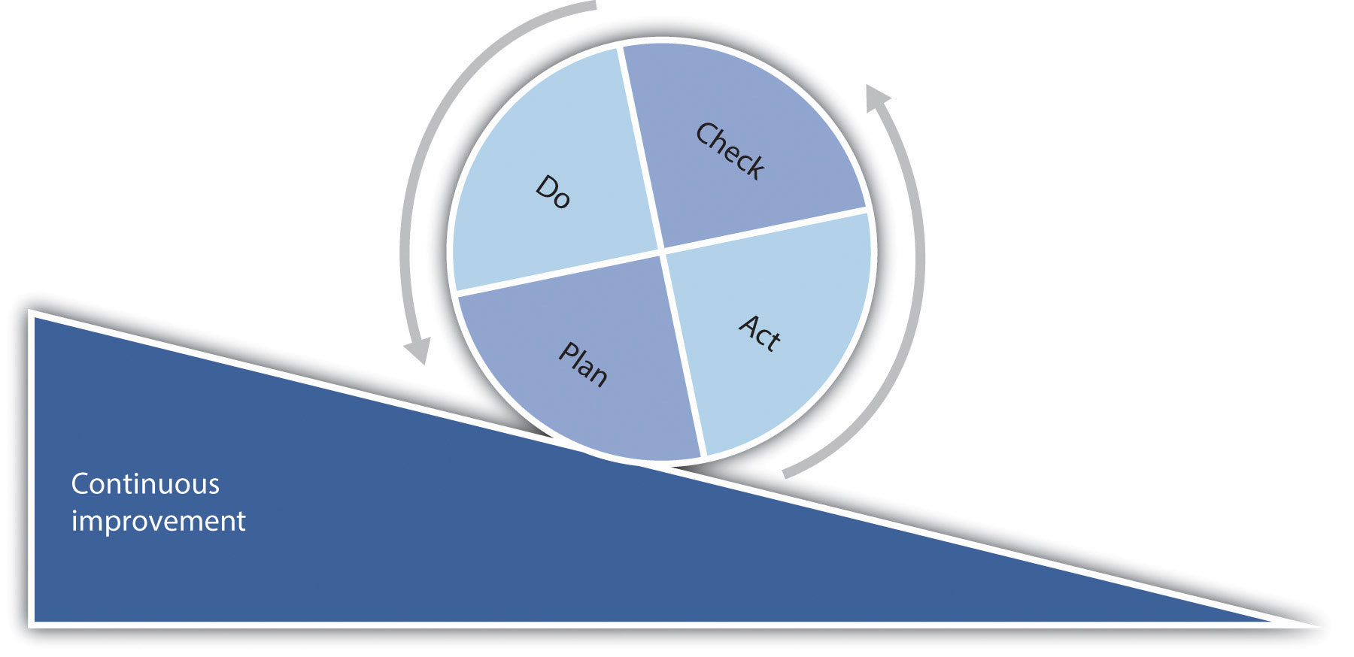

**Document Improved Procedures**

*Note*. Adapted from "Introduction to Quality Management," by M. Vonderembse & G. White, 2013, *Operations Management,* Chapter 4. Copyright 2013 by Bridgepoint Education, Inc.

Quality management is an important component in **continuous process improvement.**

**Quality Management**

1. Customer satisfaction
2. Employee involvement
3. Continuous improvement

*Note*. Adapted from “Producing for Quality,” by K. Collins, 2012, *Exploring Business*, v. 2.0, Chapter 11. Copyright 2012 by Flat World Knowledge, Inc.

Building Quality Into Products

**Six Sigma**

Tools such as a **fishbone chart** allow the firm to trace a problem that the customer sees to the root cause of the problem.

**Supplier Considerations in Operations Management**

***Supplier Workshops***

* certifications and standards,
* social responsibility,
* environmental responsibility, and
* continuous improvement.

*Note*. Adapted from "Quality Management," by M. Vonderembse & G. White, 2013, *Operations Management*, Chapter 4. Copyright 2013 by Bridgepoint Education, Inc.

Benchmarking

**Benchmarking** is a process by which a company compares its performance to the performance of other companies.

*Note*. Adapted from "Quality Management," by M. Vonderembse & G. White, 2013, *Operations Management*, Chapter 4. Copyright 2013 by Bridgepoint Education, Inc.

Maturity Models Overview

Organizations may use **maturity models** to assess their core processes based on best practices and benchmarks.

**Capability Maturity Model (CMM)** is a model to manage and improve an organization’s performance level, especially its software development processes.

The **Contract Management Maturity Model** (CMMM) is used to assess and improve an organization’s contract management process capability. According to the Institute of Supply Management, CMMM helps an organization visualize the steps that must be accomplished when buying products, services, or integrated solutions (ISM, n.d.).

Milestone text.

Now, think of a company that you support and describe the company. I often think of having my own Jamba Juice / Coffeehouse hybrid shop. I looked into Franchises for Each. Unfortunately, Jamba Juice keeps close rain on who they sell a franchise too and choose specific locations. Starbucks offers no franchises in the U.S. at all; all stores are company stores. Jamba Juice is well known for fast and great tasting healthy juices and blends. Menu Items are tailored to a clientele that chooses a healthy lifestyle. JIT is very important with Jamba Juice as, all fruits and veggies have to be fresh, thus storing for any length of time is not a possibility. Starbucks is the best know coffee house in the U.S. In the business world Starbucks is not best known for its coffee but for caring for people. Salespeople are put through training, teaching them to put the customer first, and show concern for peoples lives other than what their order is. Starbuck also pioneered the Part-time, full benefits health package for its employees. No matter full time or part time all employees have full health coverage. What company would you use to benchmark that company and why? What would be your goal? Since Jamba Juice franchise is not available, and since I have not found and alternative I will just have to make and Jamba esk juice shop. And since Starbuck does not have Franchises, I will have to choose a Java Detour Franchise instead, to buy a Dutch Brothers Franchise one has to have a net worth of 500,000. Minimum. Or I may just also create one. However, name recognition is very important in coffee shops. As a result, I would have to use the Jamba/ Starbucks as benchmark companies, using the JIT processes of Jamba, mixed with the people-centered culture of Starbucks. To further the healthy culture of Jamba location could come into play. I corner intersection the main street of the town, as close as possible to a gym. This will also benefit the Coffee part of the store. In continuing the people first culture of Starbucks, the shop needs to be close to a college campus. Wifi will be available for lounging areas and booths that make the study and work comfortably. While coffee keeps well in storage, a fresh roast would require JIT inventory systems. TQM is important also as the quality of the product is what will create return customers. Further, the smile and concern for people and their lives will make people feel at home just as one does at their local Starbucks.

JIT in Service Operations and Process Mapping

**Process mapping** (a visual representation of the actions that make up a process) is an important step in the operations management process, because it allows the organization to see its various processes and how they fit into the bigger picture of the organization. In addition, the process mapping can help managers see gaps, slowdowns, or other production problems.

One type of process mapping, **value stream mapping,** is a technique used to analyze the flow of materials, ideas, and information to understand how processes function.

1. Identify the product or service that should be mapped.
2. Draw a rough, current state, value stream map, which shows the current steps, delays, and information flows required to deliver the target product or service.
3. Estimate the cost and timing at each point, as well as the value added.
4. Assess the current-state value stream map to understand its flow and points where waste occurs to determine where processes can be improved.
5. Create a future-state value stream map using a team of people.
6. Prepare a plan to implement these improvements.
7. Work toward this future state.

**Just in Time (JIT) in Service Operations**

Although just in time (JIT) originated in manufacturing, and most of the initial implementations occurred there, service organizations are now widely adopting many of its basic ideas. JIT is one of the goals of process mapping. Here are some examples of JIT and process mapping:

* Service organizations may have an advantage because of their lack of work-in-process and finished goods inventories.
* Retailers focus on maintaining smaller inventories by being able to replenish their inventory more quickly and in smaller quantities.
* Insurance companies find ways to eliminate unnecessary steps in their claims processing procedures so that customer claims are processed more quickly.
* Airlines use yield management to level the demand for their flights. The JIT techniques that are most immediately relevant to services include elimination of waste in any form, such as unneeded steps in a process to review applications for insurance or improving the productivity of people who are reviewing mortgage applications.

**Simplified Production Process**

* Service operations often differ from manufacturing because customers are more directly involved, and are often active participants, in the production process.

*Note*. Adapted from "Just-in-Time and Lean Systems," by M. Vonderembse & G. White, 2013, *Operations Management*, Chapter 11. Copyright 2013 by Bridgepoint Education, Inc.

Increasing Employee Motivation

* Organizations can tap into talent that already exists in their workforce.
* People work harder and smarter.
* Workforces are more receptive to training and new ideas.

*Note*. Adapted from "Capacity Decisions," by M. Vonderembse & G. White, 2013, *Operations Management*, Chapter 8. Copyright 2013 by Bridgepoint Education, Inc.

**Developing Process Metrics**

Instead of just thinking about quality in terms of whether a product meets specifications, it is also helpful to think about quality in terms of measuring process and ways to improve those steps.

Examples of improvement models are the Baldridge National Quality Award (BNQA) and ISO 9000, which both have criteria for measurement and analysis.

Wagoner mentions two sides of process and their outputs:

1. Process output quality cannot be forced.
2. Processes aren’t controlled by tracking outputs.

Inventory Control

Inventory represents a significant investment of working capital for manufacturing companies such as Sony, wholesale and retail organizations such as Wal-Mart, and food service providers such as Red Lobster.

Many firms keep a cushion or “safety stock” of inventory to protect against unexpected demand.

**Types of Inventory**

Several common types of inventory are:

1. Raw materials: These parts and materials are obtained from suppliers and are used in the production process.
2. Work-in-process (WIP): These are partly finished parts, components, subassemblies, or modules.
3. Finished goods: Items are ready to ship to the customer. No more work is required.
4. Replacement parts: These are maintained to replace other parts in machinery or equipment as those parts wear out.
5. Supplies: Parts or materials are used to support the production process, but are not usually a component of the product. These items, such as lubricant and cutting tools, are consumed in the production process.
6. Transportation (pipeline): The portion of inventory that is in the process of being shipped through the distribution system.

**Information Systems for Inventory Management**

**Perpetual Inventory Systems**

**perpetual inventory system** continuously monitors inventory levels.

**Periodic Inventory Systems**

To be effective, the **periodic inventory system** is designed to place an order only when on-hand inventory information is available and the supplier is willing to deliver; in other words, when the order window is open.

*Note*. Adapted from "Inventory Management," by M. Vonderembse & G. White, 2013, *Operations Management*, Chapter 10. Copyright 2013 by Bridgepoint Education, Inc.

Scheduling

Scheduling is coordinating work tasks, people, materials, facilities, and equipment needed to create goods and services at a specific point in time.

**Data Collection**

Collecting the data needed for scheduling begins with orders from the customer.

**Order Entry**

Order entry drives the scheduling process.

For a **make-to-order** company, one that produces only to customer orders or that provides services, this occurs when a customer places an order.

In a **make-to-stock** company, one that produces for inventory and meets customer orders from inventory, production orders are entered by the company based on the inventory level of each item in stock and the expected future demand of that item.

In an MRP environment, the MRP system will generate planned order releases based on the master schedule. This is another form of order entry—in this case, for individual parts or subassemblies.

**Orders Released for Production**

The planning process involves a continual movement from strategic plans for the distant future toward more detailed plans for the less-distant future.

Scheduling addresses the very near future because it is the last step in production planning.

**Managerial Considerations**

The task of scheduling can be quite complex; These six criteria may be used when evaluating possible schedules:

* Provides the good or service when the customer wants it
* Length of time it takes to produce that good or service (flow time), which includes both processing and waiting time
* Level of work-in-process (WIP) inventories
* Amount of time equipment is idle
* Amount of time employees are idle
* Overall costs

*Note*. Adapted from "Scheduling," by M. Vonderembse & G. White, 2013, *Operations Management*, Chapter 12. Copyright 2013 by Bridgepoint Education, Inc.

When scheduling, two key questions are:

1. When should a given job, order, or product be processed?
2. How many units should be processed at one time?

**Balancing an Assembly Line**

An assembly-line process is similar to continuous flow, but instead of the products flowing continuously, such as a stream of gasoline or a roll of paper, the products are discrete, individual items, such as automobiles.

**Sequencing**

Sequencing an assembly involves determining the order for making different products. In some cases, the differences are small, such as painting a car red versus silver, or mounting 16-inch steel wheels versus 17-inch aluminum wheels.

**Scheduling Batch Processes**

In batch processes, the number of possible products is greater than can be produced in line-flow processes.

**Flexible Manufacturing Systems**

There is a trade-off between product changeover costs (or set-up costs) and inventory carrying costs.

**Dispatching Rules**

**Earliest Due Date. Shortest Processing Time, Longest Processing Time, First-Come, First-Served.**

*Note*. Adapted from "Scheduling," by M. Vonderembse & G. White, 2013, *Operations Management*, Chapter 12. Copyright 2013 by Bridgepoint Education, Inc.

**Special Problems in Scheduling Services**

**Schedule for Peak Demand**

**Chase Demand**

There are two methods that companies can use to adjust production rates to match demand—varying the workforce and using overtime. Either of these strategies can be very useful for service companies if they can estimate expected demand with reasonable accuracy.

*Note*. Adapted from "Scheduling," by M. Vonderembse & G. White, 2013, *Operations Management*, Chapter 12. Copyright 2013 by Bridgepoint Education, Inc.

MileStone Text

Refer to the “Introduction to Scheduling” Learning Activity. Conduct external research and select a scheduling method. One Scheduling method is First Come First Served. However, I usually would hybrid this with the option of moving some to the front of the line according to the importance of completion date. Describe this scheduling methodology, I have my own Service based business. Services are usually first come first served. However, in the overall picture, this business must compete for my time. Scheduling "Side Work" often is put behind other things that compete for my time. For instance homework. As a result, a hybrid of First come first serve, and deadline urgency is the outcome. Today I worked on an electric job but left early to complete a milestone with Brandman. Brandman homework got moved to the front of the line because of the 3-day limit. Some form of homework must be submitted every three days. Tomorrow a full day will be put on the Electric Side Job because it is first come on the list of jobs. then select one of the steps in the scheduling process presented in the text. Ordering supplies for side jobs is a batch process. It is also Just-in-time inventory. What happens is this. When a Request for Service is processed, the initial service call is scheduled. One of the main purposes of the initial service call is to evaluate and inventory or supplies needed, Evaluate lead time in delivery of all inventory items, and schedule the 2nd call within a week of the expected delivery of the longes lead time inventory item. In the case of the current electric job, all inventory is readily available at the local Home Depot. Next, evaluate if any extra Logistics is needed for Inventory. In this case, yes. One 20 foot 2x10 is needed on the site, this will cause delivery problems for any normal pickup as the board is too long to be legally transported without a lumber rack. As a result, the search is on for a delivery vehicle, for tomorrows work. This rearranges the processing of the job and moves the electric wiring to the front of the job, and the repair of the eve that holds the electric to the back. This will revert back to the front on the arrival of the board. Why did you select the model you selected and did you find applying the scheduling stage to it easy to do? Explain your response. In the Sevice arena, first come first serve is expected by the customers. However, when employee time is at a premium due to competing demands costs go up. On the flip side, customers have the opportunity to hire someone that has less demand for their time. For this reason, before any scheduling is done a customer is informed that the job may take some time to get to. In the case of the job I am currently working, the customer scheduled the work months ago. Quality work is the secret to customer satisfaction. Do it right the first time, and people are willing to wait. Working with little overhead, no inventory on hand, and scheduling employee time seems to be the only way that these side jobs can be done. Currently, I have a job at a middle school, am on staff at a church where I minister as part of the worship team, am taking some Bible courses, and am in Brandman. To add to this, I must find time to workout, and admin several web pages. It is a wonder I can schedule the side work at all.

Weaknesses

So I would list: waste, poor product quality, excessive rework time, inadequate response time, high costs, and non-innovative products and services as weaknesses and/or opportunities for improvement

Strengths

I would say that a strength or opportunity would be that “steel is everywhere in our homes” (p. 57), and there are other uses listed on this page.