**Creating an effective organizational structure A Coca-Cola Great Britain case study**

The Coca-Cola Company is truly global, and its main product is recognized and consumed worldwide. The Company organizes and structures itself in a way that reflects that fact. At the same time, the Company looks to meet the particular needs of regional markets sensitively and its structure also needs to reflect that fact**.**

## http://legacy.businesscasestudies.co.uk/company_images/3/182/11115115793.jpgPage 1: Introduction

The Coca-Cola Company is truly global, and its main product is recognized and consumed worldwide. The Company organizes and structures itself in a way that reflects that fact. At the same time, the Company looks to meet the particular needs of regional markets sensitively and its structure also needs to reflect that fact.   
This Case Study illustrates the way in which the Company has built an organizational structure that is robust and yet also flexible enough to meet these particular requirements.  
  
Page 2: A global and local strategy  
The Coca-Cola Company is the world's largest beverage company and is the leading producer and marketer of soft drinks. The Company markets four of the world's top five soft drinks brands: Coca-Cola, Diet Coke, Fanta and Sprite.  
The success of The Coca-Cola Company revolves around five main factors:  
1. A unique and recognized brand - Coca-Cola is among the most recognized trademarks around the globe.

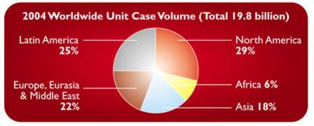2. Quality - consistently offering consumers products of the highest quality  
3. Marketing - delivering creative and innovative marketing programs worldwide  
4. Global availability - Coca-Cola products are bottled and distributed worldwide  
5. Ongoing innovation - continually providing consumers with new product offerings e.g. Diet Coke (1982), Coca-Cola Vanilla (2002).  
   
The illustration shows the worldwide distribution of sales of Coca-Cola products by quantity in 2003. Although Coca-Cola is a global product with universal appeal, the 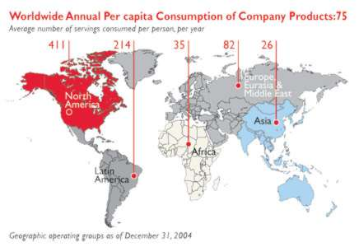Company actually operates in local environments around the world, with each country having its own unique needs and requirements.  
So while Coca-Cola is probably the only product in the world that is universally relevant in every corner of the globe, the Company feels that its responsibility is to ensure that with every single can or bottle of Coca-Cola sold and enjoyed, individual connections are made with their consumer. That can only be achieved at a local level.

The challenge facing The Coca-Cola Company today is therefore to continue to build an organizational structure that will deliver a global and local strategy.

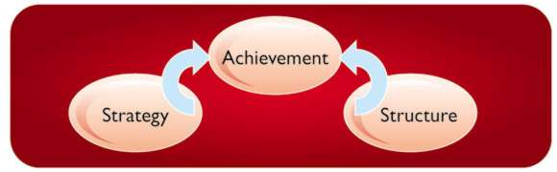Page 3: The relationship between strategy and structure.  
An organization's strategy is its plan for the whole business that sets out how the organization will use its major resources. An organization's structure is the way the pieces of the organization fit together internally. It also covers the links with external organizations such as partners.

For the organization to deliver its plans, the strategy and the structure must be woven together seamlessly.

The goal of The Coca-Cola Company is 'to be the world's leading provider of branded beverage solutions, to deliver consistent and profitable growth, and to have the highest quality products and processes.'

To achieve this goal, the Company has established six strategic priorities and has built these into every aspect of its business:

* Accelerate carbonated soft drinks growth, led by Coca-Cola
* Broaden the family of products, wherever appropriate e.g. bottled water, tea, coffee, juices, energy drinks.
* Grow system profitability & capability together with the bottlers
* Creatively serve customers (e.g. retailers) to build their businesses
* Invest intelligently in market growth
* Drive efficiency & cost effectiveness by using technology and large scale production to control costs enabling our people to achieve extraordinary results everyday.

There are many ways to structure an organization. For example, a structure may be built around:

* Function: reflecting main specialisms e.g. marketing, finance, production, distribution.
* Product: reflecting product categories e.g. bread, pies, cakes, biscuits.
* Process: reflecting different processes e.g. storage, manufacturing, packing, delivery.

Organizational structures need to be designed to meet aims. They involve combining flexibility of decision making, and the sharing of best ideas across the organization, with appropriate levels of management and control from the center.

Modern organizations like The Coca-Cola Company, have built flexible structures which, wherever possible, encourage teamwork. For example, at Coca-Cola Great Britain any new product development (e.g. Coca-Cola Vanilla) brings together teams of employees with different specialisms.

At such team meetings, marketing specialists clarify the results of their market research and testing, food technologists describe what changes to a product are feasible, financial experts reports on the cost implications of change.  
  
Page 4: The corporate segment -Head Office  
The Coca-Cola Company has a corporate (Head Office) segment that is responsible for giving the Company an overall direction and providing support to the regional structure.

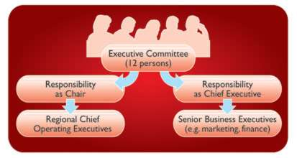Key strategic decisions at The Coca-Cola Company are made by an Executive Committee of 12 Company Officers. This Committee helped to shape the six strategic priorities set out earlier. The Chair of the Executive Committee acts as a figurehead for the Company and chairs the board meetings. He is also the Chief Executive Officer (CEO) and as such he is the senior decision maker. Other executives are responsible either for the major regions (e.g. Africa) or have an important business specialism e.g. the Chief Financial Officer.

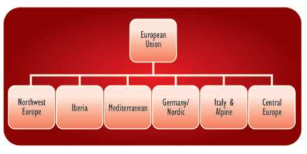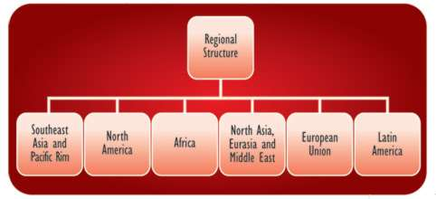As a company whose success rests on its ability to connect with local consumers, it makes sense for The Coca-Cola Company to be organized into a regional structure which combines centralization and localization. The Company operates six geographic operating segments - also called Strategic Business Units (SBUs) - as well as the corporate (Head Office) segment.

Each of these regional SBUs is sub-divided into divisions. Take the European Union, SBU, for example. The UK fits into the Northwest Europe division. This geographical structure recognizes that:

* Markets are geographically separated
* Tastes and lifestyles vary from area to area. As do incomes and consumption patterns.
* Markets are at different stages of development.

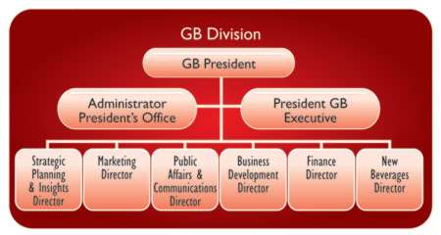At a more local level the management of The Coca-Cola Company involves a number of functional specialisms. The management structure for Great Britain illustrates this.

The structure of Coca-Cola Great Britain combines elements of centralization and decentralization. Divisions and regions operate as business unit teams, with each Director reporting to the General Manager, i.e. Division President.

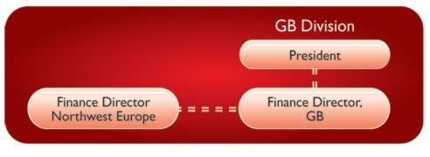However, there is a matrix structure for each function e.g. the Finance Director in the GB Division reports to the GB President, but also to (dotted line) the Finance Director of North West Europe Division. In addition, functions within the Company operate across geographical boundaries to share best practice.

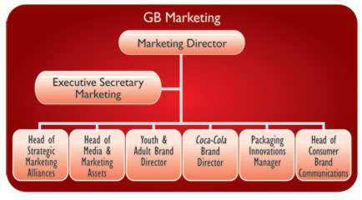To take another example of local decision making at a regional (local) level the various SBUs are responsible for region-specific market research, and for developing local advertising, e.g. using the languages of the countries in which The Coca-Cola Company operates. A major region like Great Britain has its own marketing structure, organized as shown on the diagram.

Product support  
The way The Coca-Cola Company works reflects the many countries and cultures in which it does business. It owns or licenses nearly 400 brands in non-alcoholic beverages serving consumers in over 200 countries. An essential part of the organization's structure therefore focuses on ensuring that individual products are given the best possible support in regional markets.  
Within the Company, different teams concentrate on particular products and use their specialist knowledge of the brands and consumer needs to support the sales and promotional effort. In some cases a product is developed solely for local consumption and an example of this is the product Lilt, which is only available in Great Britain and Ireland.

Examples of other products available in Great Britain include:

* Carbonated soft drinks- Coca-Cola, Fanta, Sprite
* Juice & juice drinks- Schweppes' Tomato Juice Cocktail, Oasis, Five Alive
* Waters- Malvern
* Energy drinks- Burn
* Sports drinks- PowerAde
* Squashes/cordials- Kia-Ora, Rose's Lime Cordial.

## Page 5: Structure and culture

Structuring an organization is not only about organizing internal relationships, it also involves external ones. The Coca-Cola Company has built well-structured relationships with a range of external groups including bottling partners.  
People often assume that The Coca-Cola Company bottles and distributes its own beverages. For the most part, it does not. The Company's primary business consists of manufacturing and selling beverage concentrates and syrups - as well as some finished beverages - to bottling and canning operations and other distributors.  
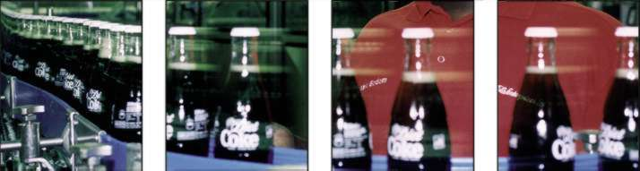

The concentrates and syrups are generally sold to bottling partners, which are authorized to manufacture, distribute and sell branded products. The business system consisting of The Coca-Cola Company and bottling partners is referred to as 'the Coca-Cola system'.

The relationship The Coca-Cola Company has with its bottlers worldwide is a key source of strength. The Company works together with them to ensure that concentrates and syrups are made into finished beverages that are produced and distributed to consumers around the globe with unmatched quality and service.

Every organization has not only a structure but also a culture. 'Culture' describes the typical way an organization does things, including patterns of behavior and relationships.

Important aspects of culture at Coca-Cola Great Britain (which reflect the culture of The Coca-Cola Company as a whole) are an emphasis on teamwork, and empowerment. Coca-Cola Great Britain sees its employees as its most important asset.

Motivated employees provide the engine that drives the Company's growth. Organizing people into teams (e.g. marketing, sales or product teams) encourages people to feel valued. Within a team they are encouraged to contribute ideas and to be innovative. If they feel that something could be done better they are encouraged to voice that opinion.

By creating a friendly, innovative culture, Coca-Cola Great Britain is able to depend on a high quality workforce that helps it to maintain brand leadership in Great Britain and in every other market in which it operates. Trust is at the heart of every relationship, whether it be:

* Customers' and consumers' trust that the Company will provide the highest level of service and attention to their needs
* Bottling partners' trust that the Company is operating in the best interests of the Coca-Cola system
* Employees' trust that their contribution is being valued in an open culture.

Open communication channels provide the means to support a culture based on relationships. Coca-Cola has a number of communication channels, including:

* Monthly leadership team meeting (involving function heads)
* Weekly department team meetings
* Monthly employee team briefing sessions
* Consultative employee groups for each region (with representatives meeting in a European Council)
* Surveys to monitor employee views and feelings.

Page 6: Conclusion  
The Coca-Cola Company has built internal and external structures to support the delivery of its business goals. The regional structure is the best way of supporting this growth, allowing attention to local requirements while at the same time building on a clear strategic direction from the center.

A culture of innovation, teamwork and partnership means that the Company has a firm foundation of relationships and open communication channels on which to build its growth.