Notes from Organizational Structure Competency.

# STRUCTURE

**Organizational Structure:** which elements of a company’s structure make a difference in how we behave and how work is coordinated?

four aspects of structure that have been frequently studied these four elements as the building blocks, or elements, making up a company’s structure. And how these building blocks come together to form two different configurations of structures.

Centralization: is the degree to which decision-making authority is concentrated at higher levels in an organization. In centralized companies, many important decisions are made at higher levels of the hierarchy.

Decentralized companies give more authority to lower level employees, resulting in a sense of empowerment. Decisions are often faster, and employees believe that decentralized companies provide greater levels of procedural fairness to employees (Ambrose & Cropanzano, 2000; Miller, Droge, & Toulouse, 1988; Oldham & Hackman, 1981; Pierce & Delbecq, 1977; Schminke, Ambrose, & Cropanzano, 2000; Turban & Keon, 1993; Wally & Baum, J. R., 1994).

**Formalization:** is the extent to which policies, procedures, job descriptions, and rules are written and explicitly articulated. In other words, formalized structures are those in which there are many written rules and regulations. These structures control employee behavior using written rules, and employees have little autonomy to make decisions on a case-by-case basis. Formalization makes employee behavior more predictable.

 A high degree of formalization may actually lead to reduced innovativeness, because employees are used to behaving in a certain manner. In fact, strategic decision making in such organizations often occurs only when there is a crisis. A formalized structure is associated with reduced motivation and job satisfaction as well as a slower pace of decision making (Fredrickson, 1986; Oldham & Hackman, 1981; Pierce & Delbecq, 1977; Wally & Baum, R. J., 1994).

**Hierarchical Levels:**

**Tall structures** have several layers of management between frontline employees and the top level.

**flat structures** consist of few layers.

**Span of control**, or the number of employees reporting to a single manager.

In tall structures, span of control tends to be smaller, resulting in greater opportunities for managers to supervise and monitor employee activities. In contrast, flat structures involve a wider span of control. In such a structure, managers will be relatively unable to provide close supervision, leading to greater levels of freedom of action for each employee. Research indicates that flat organizations provide greater need satisfaction for employees, and greater levels of self-actualization (Ghiselli & Johnson, 1970; Porter & Siegel, 2006).

**Departmentalization:**

**Functional structures** group jobs based on similarity in functions.

**Divisional structures** departments represent the unique products, services, customers, or geographic locations the company is serving. In other words, each unique product or service the company is producing will have its own department.

In reality, many structures are a hybrid of functional and divisional forms. For example, if the company has multiple product lines, departmentalizing by product may increase innovativeness and reduce response times.

**Functional Departments**

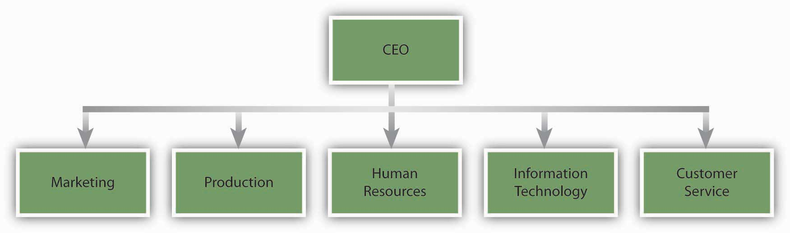

### Product Departments

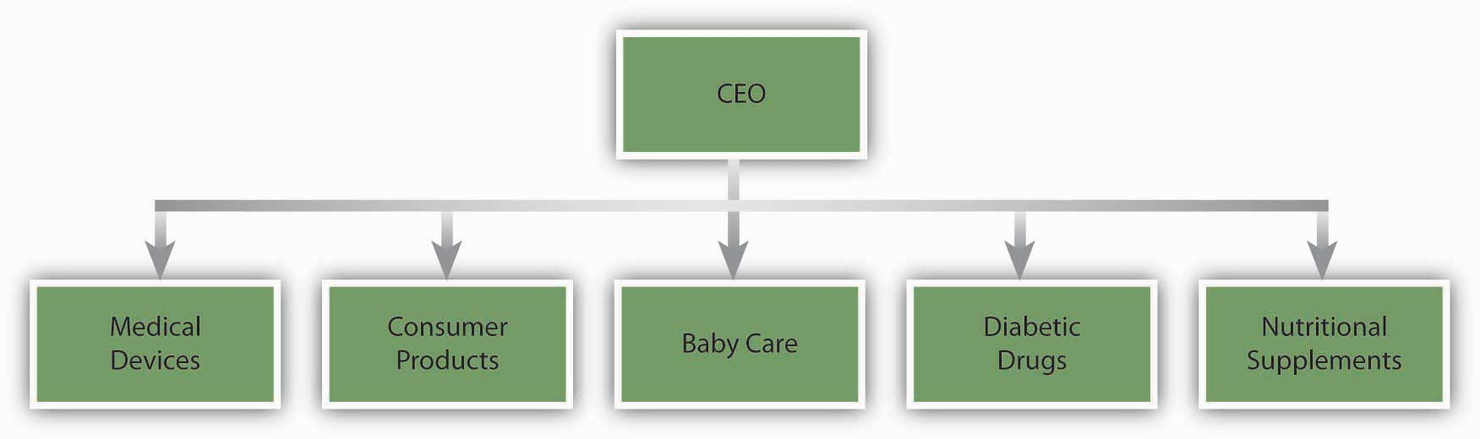 Functional structures tend to be effective when an organization does not have a large number of products and services requiring special attention, Functional structures are also more effective in stable environments that are slower to change. Organizations using product departments are more agile and can perform better in turbulent environments. The type of employee who will succeed under each structure is also different. Research shows that when employees work in product departments in turbulent environments, because activities are diverse and complex, their performance depends on their general mental abilities (Hollenbeck, Moon, Ellis, West, & Ilgen, 2002).

**Two Configurations: Mechanistic and Organic Structures:**

The different elements making up organizational structures in the form of formalization, centralization, number of levels in the hierarchy, and departmentalization often coexist.

**Mechanistic structures** are similar to bureaucracies, as they are highly formalized and centralized. Communication tends to follow formal channels, and employees are given specific job descriptions delineating their roles and responsibilities. Mechanistic organizations are often rigid and resist change, making them unsuitable for being innovative and taking quick action. These forms have the downside of inhibiting entrepreneurial action and discouraging the use of individual initiative on the part of employees. Not only do mechanistic structures have disadvantages for innovativeness, they also limit individual autonomy and self-determination, which will likely lead to lower levels of intrinsic motivation on the job (Burns & Stalker, 1961; Covin & Slevin, 1988; Schollhammer, 1982; Sherman & Smith, 1984; Slevin & Covin, 1990).

**Organic structures** are flexible, decentralized structures with low levels of formalization. Communication lines are more fluid and flexible. Employee job descriptions are broader, and employees are asked to perform duties based on the specific needs of the organization at the time as well as their own expertise levels. Organic structures tend to be related to higher levels of job satisfaction on the part of employees. These structures are conducive to entrepreneurial behavior and innovativeness (Burns & Stalker, 1961; Covin & Slevin, 1988).

ANALYSIS; TO DETERMINE WHAT KIND OF STRUCTURE LOOK IN THESE CATAGORIES. Control, Coordination, Flexibility.

2. **Matrix organizations** cross a traditional functional structure with a product structure. Specifically, employees reporting to department managers are also pooled together to form project or product teams. As a result, each person reports to a department manager as well as a project or product manager. In this structure, product managers have control and say over product-related matters.

Using the matrix structure as opposed to product departments may increase communication and cooperation among departments, because project managers will need to coordinate their actions with department managers. In fact, research shows that matrix structure increases the frequency of informal and formal communication within the organization (Joyce, 1986).

In a matrix, each employee reports to at least two or more managers. In other words, the matrix organization violates the **unity of command** principle that is often prevalent in traditional organizations.

**Matrix Structure at a Software Development Company**

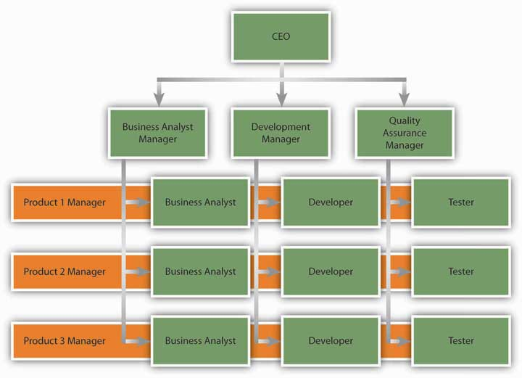

**Boundary less Organizations:**  is a term coined by Jack Welch of General Electric Company and refers to an organization that eliminates traditional barriers between departments, as well as barriers between the organization and the external environment. Many different types of boundary less organizations exist.

**Modular organization** where all the nonessential functions are outsourced. The idea behind this format is to retain only the value-generating and strategic functions in-house.

**Strategic alliances** constitute another form of boundary less design. Here, similar to a joint venture, two or more companies find an area of collaboration and combine their efforts to create a partnership that is beneficial for both parties.

Boundary less organizations may involve eliminating the barriers separating employees, such as traditional management layers or walls between different departments. Structures such as self-managing teams create an environment where employees coordinate their efforts and change their own roles to suit the demands of the situation, as opposed to insisting that something is “not my job” (Dess, Rasheed, McLaughlin, & Priem, 1995; Rosenbloom, 2003).

**Learning Organizations:** is one in which acquiring knowledge and changing behavior as a result of the newly gained knowledge are part of an organization’s design. In these structures, experimenting, learning new things, and reflecting on new knowledge are the norms.

# CULTURE

**Organizational culture** refers to a system of shared assumptions, values, and beliefs that show employees what is appropriate and inappropriate behavior (Chatman & Eunyoung Cha, 2003; Kerr & Slocum, 2005). An organization's culture may be one of its strongest assets, as well as its biggest liability. In fact, it has been argued that organizations that have a rare and hard-to-imitate organizational culture benefit from it as a competitive advantage (Barney, 1986).

**Levels of Organizational Culture**

Organizational culture consists of some aspects that are relatively more visible, as well as aspects that may lie below one's conscious awareness. Organizational culture can be thought of as consisting of three interrelated levels (Schein, 1992).

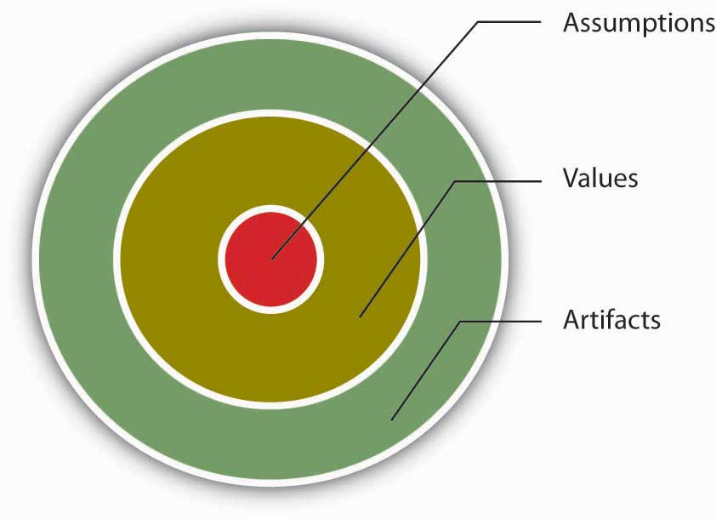At the deepest level, below our awareness, lie basic assumptions. Assumptions are taken for granted, and they reflect beliefs about human nature and reality. At the second level, values exist. Values are shared principles, standards, and goals. Finally, at the surface we have artifacts, or visible, tangible aspects of organizational culture.

**Characteristics of Organizational Culture**

Nine different dimensions, or values, can be used to define and classify organizational cultures.

### a web with the term Dimensions of the Organizational Culture Profile (OCP)

***Innovative Cultures***

According to the OCP framework, companies that have innovative cultures are flexible and adaptable, and experiment with new ideas. These companies are characterized by a flat hierarchy in which titles and other status distinctions tend to be downplayed.

***Aggressive Cultures***

Companies with aggressive cultures value competitiveness and outperforming competitors: By emphasizing this, they may fall short in the area of corporate social responsibility. For example, Microsoft

***Outcome-Oriented Cultures***

The OCP framework describes outcome-oriented cultures as those that emphasize achievement, results, and action as important values. A good example of an outcome-oriented culture may be Best Buy Co. Inc. Having a culture emphasizing sales performance, Best Buy tallies revenues and other relevant figures daily by department.

***Stable Cultures***

Stable cultures are predictable, rule-oriented, and bureaucratic. These organizations aim to coordinate and align individual effort for greatest levels of efficiency. When the environment is stable and certain, these cultures may help the organization be effective by providing stable and constant levels of output (Westrum, 2004).

***People-Oriented Cultures***

People-oriented cultures value fairness, supportiveness, and respect for individual rights. These organizations truly live the mantra that "people are their greatest asset." In addition to having fair procedures and management styles, these companies create an atmosphere where work is fun and employees do not feel required to choose between work and other aspects of their lives. In these organizations, there is a greater emphasis on and expectation of treating people with respect and dignity (Erdogan, Liden, & Kraimer, 2006).

***Team-Oriented Cultures***

Companies with team-oriented cultures are collaborative and emphasize cooperation among employees. For example, Southwest Airlines Company facilitates a team-oriented culture by cross-training its employees so that they are capable of helping each other when needed. The company also places emphasis on training intact work teams (Bolino & Turnley, 2003).

***Detail-Oriented Cultures***

Organizations with **detail-oriented cultures** are characterized in the OCP framework as emphasizing precision and paying attention to details. Such a culture gives a competitive advantage to companies in the hospitality industry by helping them differentiate themselves from others. For example, Four Seasons Hotels Ltd.

***Service Culture***

**Service culture** is not one of the dimensions of the OCP, but given the importance of the retail industry in the overall economy, having a service culture can make or break an organization. Some of the organizations we have illustrated in this section, such as Nordstrom. Southwest became the most profitable by employing this culture.

***Safety Culture***

Some jobs are safety sensitive. For example, logger, aircraft pilot, fishing worker, steel worker, and roofer are among the top 10 most dangerous jobs in the United States (Christie, 2005). In organizations where safety-sensitive jobs are performed, creating and maintaining a **safety culture** provides a competitive advantage, because the organization can reduce accidents, maintain high levels of morale and employee retention, and increase profitability by cutting workers' compensation insurance costs. Some companies suffer severe consequences when they are unable to develop such a culture. For example, British Petroleum

**Strength of Culture**

A **strong culture** is one that is shared by organizational members (Arogyaswamy & Byles, 1987; Chatman & Eunyoung Cha, 2003). In other words, if most employees in the organization show consensus regarding the values of the company, it is possible to talk about the existence of a strong culture. A culture's content is more likely to affect the way employees think and behave when the culture in question is strong. For example, cultural values emphasizing customer service will lead to higher quality customer service if there is widespread agreement among employees on the importance of customer service-related values (Schneider, Salvaggio, & Subirats, 2002).

A strong culture may sometimes outperform a weak culture because of the consistency of expectations. One limitation of a strong culture is the difficulty of changing it. A strong culture may also be a liability during a merger.

**Subcultures**: may arise from the personal characteristics of employees and managers, as well as the different conditions under which work is performed. Within the same organization, marketing and manufacturing departments often have different cultures.

**Counterculture**: Defined as shared values and beliefs that are in direct opposition to the values of the broader organizational culture (Kerr & Slocum, 2005), countercultures are often shaped around a charismatic leader.

### A flowchart showing Culture Creation and Maintenance

***Founder's Values***

A company's culture, particularly during its early years, is inevitably tied to the personality, background, and values of its founder or founders, as well as their vision for the future of the organization.

***Industry Demands***

While founders undoubtedly exert a powerful influence over corporate cultures, industry characteristics also play a role. Industry characteristics and demands act as a force to create similarities among organizational cultures. For example, despite some differences, many companies in the insurance and banking industries are stable and rule-oriented, many companies in the high-tech industry have innovative cultures, and companies in the nonprofit industry tend to be people-oriented.

**How Are Cultures Maintained?**

t is possible to think of organizational culture as an organism that protects itself from external forces. Organizational culture determines what types of people are hired by an organization and what types are left out. Moreover, once new employees are hired, the company assimilates new employees and teaches them the way things are done in the organization. We call these processes the *attraction-selection-attrition* and *onboarding* processes.

***Attraction-Selection-Attrition (ASA)***

Organizational culture is maintained through a process known as attraction-selection-attrition. First, employees are *attracted* to organizations where they will fit in. In other words, different job applicants will find different cultures to be attractive. Someone who has a competitive nature may feel comfortable and prefer to work in a company where interpersonal competition is the norm. Others may prefer to work in a team-oriented workplace. Research shows that employees with different personality traits find different cultures attractive. For example, out of the Big Five personality traits, employees who demonstrate neurotic personalities were less likely to be attracted to innovative cultures, whereas those who had openness to experience were more likely to be attracted to innovative cultures (Judge & Cable, 1997).

***New Employee Onboarding***

Another way in which an organization's values, norms, and behavioral patterns are transmitted to employees is through onboarding (also referred to as the **organizational socialization** process). Onboarding refers to the process through which new employees learn the attitudes, knowledge, skills, and behaviors required to function effectively within an organization. If an organization can successfully socialize new employees into becoming organizational insiders, new employees feel confident regarding their ability to perform, sense that they will feel accepted by their peers, and understand and share the assumptions, norms, and values that are part of the organization's culture. This understanding and confidence in turn translate into more effective new employees who perform better and have higher job satisfaction, stronger organizational commitment, and longer tenure within the company (Bauer, Bodner, Erdogan, Truxillo, & Tucker, 2007).

A **formal orientation program** indoctrinates new employees to the company culture, as well as introducing them to their new jobs and colleagues.

***Leadership*** Leaders are instrumental in creating and changing an organization's culture. There is a direct correspondence between a leader's style and an organization's culture.

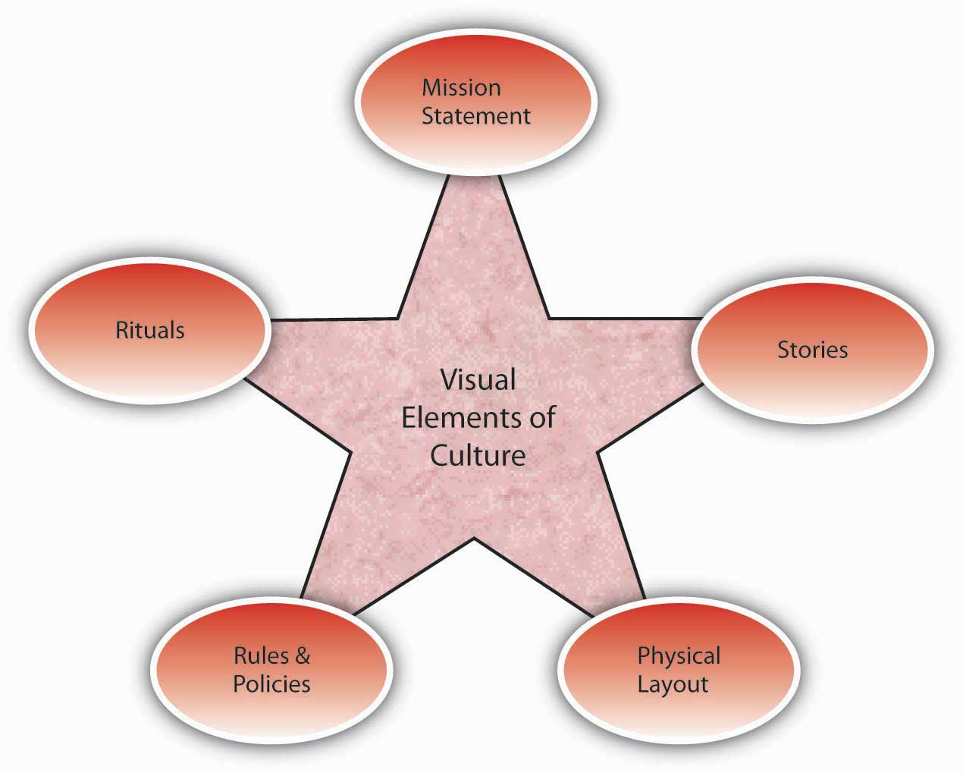 ***Reward Systems*** Finally, the company culture is shaped by the type of reward systems used in the organization, and the kinds of behaviors and outcomes it chooses to reward and punish. One relevant element of the reward system is whether the organization rewards behaviors or results.

A **mission statement** is a statement of purpose, describing who the company is and what it does. Many companies have mission statements, but they do not always reflect the company's values and its purpose. An effective mission statement is well known by employees, is transmitted to all employees starting from their first day at work, and influences employee behavior.

***Rituals:*** Rituals refer to repetitive activities within an organization that have symbolic meaning (Anand, 2005). Usually rituals have their roots in the history of a company's culture. They create camaraderie and a sense of belonging among employees. They also serve to teach employees corporate values and create identification with the organization.

***Rules and Policies:*** rules and policies. Companies create rules to determine acceptable and unacceptable behavior, and thus the rules that exist in a company will signal the type of values it has. Policies about issues such as decision making, human resources, and employee privacy reveal what the company values and emphasizes.

***Physical Layout:*** building, including the layout of employee offices and other work spaces, communicates important messages about the company's culture. The building architecture may indicate the core values of an organization’s culture.

***Stories:*** the skillful use of stories. A story can highlight a critical event an organization faced and the collective response to it, or can emphasize a heroic effort of a single employee illustrating the company’s values. The stories usually engage employee emotions and generate employee identification with the company or the heroes of the tale. A compelling story may be a key mechanism through which managers motivate employees by giving their behavior direction and energizing them toward a certain goal (Beslin, 2007). Moreover, stories shared with new employees communicate the company’s history, indicate its values and priorities, and serve the purpose of creating a bond between the new employee and the organization.