Social Responsibility and Risk Class Notes

The Importance of Business Ethics in Supply Management Conduct

Topic 1: Activity 1 -- Socially Responsible Supply Chain Management

Video.. Module 8: Socially Responsible Supply Chain Management - ASU's W. P. Carey School <https://www.youtube.com/watch?v=VdbKvXh6sLU>

People in business are forced to become educated in Social Responsibility. The bottom line firms need to make a profit.

Social Responsibility includes Ethics, Sustainability, and Community Interactions

Companies in the past have Hired children, abused employees, dangerous or unhealthy work environments, depleting natural resources, manufacturing dangerous or low quality products, pollutions, unfair deals, shutting down causing communities to crumble..

But being socially responsible can fix the worlds problems, force governments to do right also.

Supply chain managers are the key to a better world.

(W. P. Carey School of Business, 2010)

Topic 1: Activity 2 of 8 -- Business Ethics

the importance of business ethics pertaining to supply management conduct stems from the moral and ethical discussions and questions that can be put forward for deliberation.

What Is Business Ethics? pass the smell test?

Doing business ethics means providing reasons for how things ought to be in the economic world. This requires the following:

* **Arranging** **values** **to guide decisions.** There needs to be a clearly defined and well-justified set of priorities about what is worth seeking and protecting and what other things we are willing to compromise or give up. For example, what is more important and valuable: consumers (in this case students paying for an education) getting their books cheaply, or protecting the right of the university to run the business side of its operation as it sees fit?
* **Carefully defining the situation itself.**Who, for example, is involved in the textbook conflict? Students, clearly, as well as university administrators. What about parents who frequently subsidize their college children? Are they participants or just spectators? What about those childless men and women in Alabama whose taxes go to the university? Are *they* involved? And how much money are we talking about? Where does it go? Why? How and when did all this get started?
* **Constructing** **arguments.** This shows how, given the facts, one action serves our values better than other actions. Although the complexities of real life frequently disallow absolute proofs, there remains an absolute requirement of comprehensible reasoning. Arguments need to make sense to outside observers. In simple, practical terms, the test of an ethical argument resembles the test of a recipe for a cook: others need to be able to follow it and come to the same result. There may remain disagreements about facts and values at the end of an argument in ethics, but others need to understand the reasoning marking each step taken on the way to your conclusion.

*Note*. Adapted from “What Is Business Ethics?” by J. Brusseau, 2011, *The Business Ethics Workshop,*Chapter 1, Section 1. Copyright 2011 by Flat World Knowledge, Inc.

Topic 1: Activity 3 of 8 ---Try This Ethics Checklist. Online Article.

<https://www.inc.com/harvey-mackay/the-only-ethics-guide-you-need.html>

Is it legal?, How will it make you feel about yourself? How do others feel about it? How would you feel if your actions were made public?  Does the behavior make sense?  Will it hurt others? Will people in authority approve? How would you feel if someone did the same thing to you? Will something negative happen if you don't make a decision? Would you do this is your mother was watching?

Topic 1: Activity 4 of 8 -- Why Be Ethical?

**Why Should an Individual or a Business Entity Be Ethical?**

The usual answer is that good ethics is good business. In the long run, businesses that pay attention to ethics as well as law do better; they are viewed more favorably by customers.

Your reputation, individually or corporately, depends on how others regard your actions. Goodwill is hard to measure or quantify; but, it is real nonetheless and can best be protected by acting ethically.

*Note*. Adapted from “What Is Ethics?” by D. Mayer, D. M. Warner, G. J. Siedel, & J. K. Lieberman, 2011, *Business Law and the Legal Environment,*Chapter 2, Section 1. Copyright 2011 by Flat World Knowledge, Inc.

Topic 1: Activity 5 of 8--The Place of Business Ethics

The Boundaries and History of Business Ethics

Delineating the specific place of today’s business ethics involves:

* distinguishing between morality and ethics,
* dividing normative from descriptive ethics,
* comparing ethics against other forms of decision making, and
* sketching some inflection points in the histories of ethics and business ethics.

**Morality and Ethics: What Is the Difference?**

*Note*. Adapted from “The Place of Business Ethics,” by J. Brusseau, 2011, *The Business Ethics Workshop,*Chapter 1, Section 2. Copyright 2011 by Flat World Knowledge, Inc.

Topic 1: Activity 6 of 8 -- Is Business Ethics Necessary?

Two Extreme Views of the Business World

* Business needs policing, because it is a dirty enterprise, featuring people who get ahead by being selfish liars.
* Successful businesses work well to enrich society, and business ethicists are interfering and annoying scolds, threatening to ruin our economic welfare.

t is not true that doing business equals being deceitful; so, it is false to assert that business ethics is necessary to cure the ills of commerce. It is true that the business world may be left to control its own excesses through marketplace pressure, but that does not mean business escapes ethics.

Business Ethics Is Inevitable

the only real and durable difference between those who understand ethics and those who do not, is that the former achieve a level of self-understanding about what they want: they have compared their values with other possibilities and molded their actions to their decisions. The latter are doing the same thing, without fully realizing it. The question about whether ethics is necessary becomes a false one. You can choose to not understand the ethics you are doing (you can always drop this class), but you cannot choose to not do ethics.

*Note*. Adapted from “Is Business Ethics Necessary?” by J. Brusseau, 2011, *The Business Ethics Workshop,*Chapter 1, Section 3. Copyright 2011 by Flat World Knowledge, Inc.

Topic 1: Activity 7 of 8 -- Do the Ends Justify the Means?

A Foundational Question – still being debated

*Note*. Adapted from “The Means Justify the Ends versus the Ends Justify the Means,” by J. Brusseau, 2011, *The Business Ethics Workshop,*Chapter 2, Section 1. Copyright 2011 by Flat World Knowledge, Inc.

Topic 1: Activity 8 of 8 -- Sustainable and Ethical Supply Chains – article

<https://www.forbes.com/sites/dougguthrie/2012/03/09/building-sustainable-and-ethical-supply-chains/#1c16f2f64179>

By exhibiting a genuine commitment to social responsibility and ethical business practices, corporations like Apple have the power to not only transform their organizations but also their supply chains. A robust corporate citizenship isn’t limited by the vision of its shareholders and customers, and its reach certainly doesn’t end with its company headquarters.

**Topic 2: Principles of Sustainability and Social Responsibility**

**Topic 2: Activity 1 of 7 -- Three Approaches to Sustainability and Social Responsibilit**

**Understanding the principles of sustainability and social responsibility is key to doing business ethically.**

**Corporations as Responsible**

**One of the movie’s messages is that many corporations are like greedy lawyers—they have little sense of right and wrong, and their behavior can only be modified by money.**

**Three Approaches to Sustainability and Social Responsibility**

**there are three theoretical approaches to these new responsibilities: 1. corporate social responsibility (CSR), 2. the triple bottom line, and 3. stakeholder theory.**

***Corporate Social Responsibility (CSR)***

corporate social responsibility, has two meanings. First, it is a general name for any theory of the corporation that emphasizes both the responsibility to make money and the responsibility to interact ethically with the surrounding community. Second, corporate social responsibility is a specific conception of that responsibility to profit, while playing a role in broader questions of community welfare.

corporate social responsibility (CSR) is composed of four obligations:

1. The **economic responsibility** to make money.
2. The **legal responsibility** to adhere to rules and regulations.
3. The **ethical responsibility** to do what is right even when not required by the letter or spirit of the law.
4. The **philanthropic responsibility** to contribute to society’s projects even when they are independent of the particular business.

***The Triple Bottom Line***

**The triple bottom line is a form of corporate social responsibility dictating that corporate leaders tabulate bottom-line results not only in economic terms (costs versus revenue), but also in terms of company effects in the social realm, and with respect to the environment. There are two keys to this idea. First, the three columns of responsibility musAt the intersection of ethics and economics, sustainability means the long-term maintenance of balance. t be kept separate, with results reported independently for each. Second, in all three of these areas, the company should obtain sustainable results.**

* **Economic sustainability values long-term financial solidity over more volatile, short-term profits, no matter how high. According to the triple-bottom-line model, large corporations have a responsibility to create business plans allowing stable and prolonged action.**
* **Social sustainability values balance in people’s lives and the way we live.**
* **Environmental sustainability begins from the affirmation that natural resources—especially the oil fueling our engines, the clean air we breathe, and the water we drink—are limited.**

***Stakeholder Theory***

**Stakeholder theory, which has been described by Edward Freeman and others, is the mirror image of corporate social responsibility. Instead of starting with a business and looking out into the world to see what ethical obligations there are, stakeholder theory starts in the world. It lists and describes those individuals and groups who will be affected by (or affect) the company’s actions and asks, “What are their legitimate claims on the business?”**

**the stakeholders include:**

* **company owners, whether a private individual or shareholders,**
* **company workers,**
* **customers and potential customers of the company,**
* **suppliers and potential suppliers to the company,**
* **everyone living in the town who may be affected by contamination from workplace operations,**
* **creditors, whose money or loaned goods are mixed into the company’s actions,**
* **government entities involved in regulation and taxation,**
* **local businesses that cater to company employees (restaurants where workers have lunch, grocery stores where employee families shop, etc.),**
* **other companies in the same line of work competing for market share, and**
* **other companies that may find themselves subjected to new, and potentially burdensome regulations, because of contamination at that one Massachusetts plant.**

***Note*. Adapted from “Three Theories of Corporate Social Responsibility,” by J. Brusseau, 2011, *The Business Ethics Workshop,* Chapter 13, Section 2. Copyright 2011 by Flat World Knowledge, Inc.**

**Topic 2: Activity 2 of 7--Sustainability and Stakeholder Theory**

**Video ---**Business Ethics: Corporate Social Responsibility

<https://www.youtube.com/watch?v=xoE8XlcDUI8>

companies are now conserned obout social welfare. Sustainability, if a company helps socielty then they will have success. Supporting charity. Products that will create improvement in societ over time. Stakeholder theory. is wider aproach. greater reaching. including, suppliers, customers, employees.

**(Education Portal, 2013)**

**Topic 2: Activity 3 of 7 -- The Benefits of Corporate Social Responsibility--article**

**Why CSR? The Benefits of Corporate Social Responsibility Will Move You to Act**

[**https://www.forbes.com/sites/devinthorpe/2013/05/18/why-csr-the-benefits-of-corporate-social-responsibility-will-move-you-to-act/**](https://www.forbes.com/sites/devinthorpe/2013/05/18/why-csr-the-benefits-of-corporate-social-responsibility-will-move-you-to-act/)

**He concludes by saying, “Our CSR policy is at the core of our daily operations and guides our future progress. We benefit from these efforts in a number of ways.**

**Topic 2: Activity 4 of 7--Why Companies Should Be Socially Responsible**

**This section covers three broad arguments in favor of corporate social responsibility: it is morally required, it is required by externalities, and it serves the interests of the corporation.**

**Corporations and Social Responsibility**

**There are three kinds of arguments in favor of placing corporations, especially large and fully developed ones, within an ethical context of social and environmental responsibilities:**

1. **Corporations are morally required to accept those responsibilities.**
2. **The existence of externalities attaches companies, in operational and economic terms, to those responsibilities.**
3. **Enlightened self-interest leads to voluntarily embracing those responsibilities.**

***The Moral Requirement Argument***

**The moral requir**

**ement that business goals go beyond the bottom line to include the shared world is built on the following arguments:**

* **Corporations are already involved in the broad social world and its ethical dilemmas.**
* **Corporations, at least well established and successful ones, can be involved in the effective resolution of broad social problems, and that ability implies an obligation.**
* **Because businesses cause problems in the larger world, they should help to resolve those problems.**

***The Externality Argument***

**The second type of argument favoring corporate social responsibility considers around *externalities*. These attach corporations to social responsibilities not morally but operationally.**

***The Enlightened Self-Interest Argument***

**Enlightened self-interest means businesses take on broad responsibilities because that public generosity also benefits the company. The benefits include:**

* **Corporations perceived as socially engaged may be rewarded with more and more satisfied customers.**
* **Organizations positively engaged with society or the environment may find it easier to hire top employees. Employees want job satisfaction, which may go beyond just salary to include pride in joining a company that is socially responsible.**
* **Organizations taking the initiative in regulating themselves for social betterment may delay more strict requirements that might otherwise be imposed by governmental authorities.**

***Note*. Adapted from “Should Corporations Have Social Responsibilites? The Arguments in Favor,” by J. Brusseau, 2011, *The Business Ethics Workshop,* Chapter 13, Section 3. Copyright 2011 by Flat World Knowledge, Inc.**

**Topic 2: Activity 5 of 7--Social Responsibility and the Supply Chain**

**When managing their supply chains, organizations should comply with environmental standards and develop codes of conduct.**

**Firms need to develop codes of conduct that address legal and ethical standards in relation to suppliers, communities, nongovernmental organizations (NGOs), and government entities. Codes and policies vary widely across organizations, but certain matters that affect supply chain management should always be included. The three key areas are: (1) organizational and supply chain safety, (2) environmental compliance and responsibility in the supply chain and life cycle, and (3) ethical standards in the conduct of supply management. Each of these three areas will be discussed in greater detail in this competency.**

**he current ISM *Principles and Standards of Ethical Supply Management Conduct* (Global) were updated and approved in 2012 (ISM, 2012a). The ISM principles are covered in detail in ISM’s *Principles of Sustainability and Social Responsibility* (ISM, 2012b).**

**The NAPA principles and standards are:**

1. **Organizational Policies**
2. **industry Codes of Conduct**
3. **International Issues**

***Human Rights principle 1*: Businesses should support and respect the protection of internationally proclaimed human rights within their sphere of influence; and**

***Principle 2*: make sure that they are not complicit in human rights abuses.**

***Labor***

***Principle 3*: Businesses should uphold the freedom of association and the effective recognition of the right to collective bargaining;**

***Principle 4*: the elimination of all forms of forced and compulsory labour;**

***Principle 5*: the effective abolition of child labour; and**

***Principle 6*: eliminate discrimination in respect of employment and occupation.**

***Environment***

***Principle 7*: Businesses should support a precautionary approach to environmental challenges;**

***Principle 8*: undertake initiatives to promote greater environmental responsibility; and**

***Principle 9*: encourage the development and diffusion of environmentally friendly technologies.**

***Anti-Corruption***

***Principle 10*: Businesses should work against corruption in all its forms, including extortion and bribery.**

**The Foreign Corrupt Practices Act (FCPA) was passed in 1977 (amended in 1988 and again in 2000) to prohibit bribes of foreign officials as well as members of non-governmental organizations (NGOs). Under the FCPA, it is a felony (for both the company and the employee/manager) to offer any payment, offer, gift or promise to a foreign or NGO official with the intent to influence the award of business.**

**4. Communication and Training to Key Stakeholder**

**Professionals and organizations are viewing the importance of communicating and providing training in the principles, values, goals, ethical standards and objectives of the organization, as an ethical responsibility. International Organization for Standardization (ISO) standards no longer permit just the statement of objectives (**[**www.iso.org(This content will be opened in a separate window or downloaded to your computer)**](http://www.iso.org/)**).**

**5. Laws Governing Issues in Ethics**

**Certain areas of law and standards delineate or affect the ethical conduct of supply management professionals. These areas include libel, slander, disparagement, bribery, and extortion.**

**Libel is a tort claim based on making defamatory statements about others in writing (Flynn et al., 2009).**

**Slander is a tort claim based on making oral statements of a defamatory nature (Flynn et al., 2009).**

**Disparagement is making malicious or false statements of fact as to the quality or performance of an organization’s products (Flynn et al., 2009).**

**Bribery is giving cash, gifts or other types of favors in exchange for the award of business or favors. Commercial bribery is a felony in many U.S. states, and both the giver and the recipient can be prosecuted.**

**Extortion refers to the unlawful act of obtaining assets through coercion. Because extortion has received limited attention in current legal frameworks against corruption, the International Chamber of Commerce, Transparency International, United Nations Global Compact, and the World Economic Forum Partnering Against Corruption Initiative, developed RESIST. RESIST stands for Resisting Extortion and Solicitation in International Transactions.**

**6. Customer-Driven Requirements**

**Often, the organization may be subject to contractual terms stipulated by customers.**

**Against this background, ISM has developed the following *Principles of Sustainability and Social Responsibility* (2012b):**

**1. Anti-Corruption: Corruption in all of its forms, including extortion and bribery, will not be tolerated.**

**2. Diversity and Inclusiveness—Workforce and Supply Base:**

**. Environment: Supply management promotes protection, preservation and vitality of the natural environment.**

**4.Ethics and Business Conduct: Every supply management professional is responsible for behaving ethically and actively promoting ethical conduct throughout the supply chain.**

**5. Financial Integrity and Transparency: Financially responsible supply management is characterized by integrity and transparency in all supply-related dealings and decisions.**

**6. Global Citizenship: Global citizenship is the ethical and moral obligation to act for the benefit of society locally, globally and virtually.**

**7. Health and Safety: Health and safety is the condition of being protected or free from the occurrence of risk of injury, danger, failure, error, accident, harm and loss of life.**

**8. Human Rights: Human beings have universal and natural rights and status regardless of legal jurisdiction and local factors.**

**9. Labor Rights: Supply management is committed to protecting and respecting labor rights globally.**

**10. Sustainability: Sustai U.snability is the ability to meet current needs without hindering the ability to meet the needs of future generations in terms of economic, environmental, and social challenges.**

***Note*. Adapted from *C.P.M. Study Guide*, by Institute for Supply Management, 2001. Copyright 2001 by Institute for Supply Management.**

**Topic 2: Activity 6 of 7--Patagonia: Social Responsibility and the Supply Chain**

**Video--**Patagonia Supports Paid Leave

[**https://www.youtube.com/watch?v=3LFJCvOfmV8**](https://www.youtube.com/watch?v=3LFJCvOfmV8)

**only 13% of employees have access to paid leave-- The U.S. is behind most developed countries.--**

**Topic 3: Organizational Policies**

**Topic 3: Activity 1 of 4----Organizational Policies and Ethics**

**Organizations and supply management departments should clearly document organizational policies and procedures related to ethics, safety, and the environment.**

**basic content should include the following:**

* **code of ethics with provisions that relate to the supply management professional, such as specific guidelines on gratuities, conflicts, reciprocity, human rights, safety, environmental management and compliance with the law,**
* **document retention and control policies,**
* **environmental management systems, developed pursuant to ISO 14001,**
* **organizational structure and reporting lines,**
* **procurement process and authority, including types of transactions that require special approval, and**
* **commitment to community philosophy, including philanthropic goals.**

**Environmental Management Systems (EMS)**

**The foundation for an EMS is the organization’s statement of values and policies. Such a statement should include the following elements:**

* **compliance with all international, federal, state, and local environmental laws and regulations,**
* **prevention of harm to the environment,**
* **dedication to preservation of the environment through the exploration of recycling and renewable resources,**
* **commitment to meeting goals and targets and to measuring adherence to values and compliance with established policies, and**
* **with ISO modifications, a commitment to measuring results and performance, and implementing changes where necessary to achieve goals.**

**The ISM standards of supply management conduct (global) provide the following guidelines for organizations to develop policies:**

1. **Impropriety. Prevent the intent and appearance of unethical or compromising conduct in relationships, actions and communications.**
2. **Conflict of Interest. Ensure that any personal, business and other activities do not conflict with the lawful interests of your employer.**
3. **Influence. Avoid behaviors or actions that may negatively influence, or appear to influence, supply management decisions.**
4. **Responsibilities to Your Employer. Uphold fiduciary and other responsibilities using reasonable care and granted authority to deliver value to your employer.**
5. **Supplier and Customer Relationships. Promote positive supplier and customer relationships.**
6. **Sustainability and Social Responsibility. Champion social responsibility and sustainability practices in supply management.**
7. **Confidential and Proprietary Information. Protect confidential and proprietary information.**
8. **Reciprocity. Avoid improper reciprocal agreements.**
9. **Applicable Laws, Regulations, and Trade Agreements. Know and obey the letter and spirit of laws, regulations, and trade agreements applicable to supply management.**
10. **Professional Competence. Develop skills, expand knowledge and conduct business that demonstrates competence and promotes the supply management profession.**

***Note*. Adapted from *C.P.M. Study Guide*, by Institute for Supply Management, 2001. Copyright 2001 by Institute for Supply Management.**

**Topic 3: Activity 2 of 4--Creating and Maintaining Organizational Culture**

**An organization's culture informs the organizational policies that it develops.**

**Organizational cultures are created by a variety of factors, including founders’ values and preferences, industry demands, and early values, goals, and assumptions. Signs of a company’s culture include the organization’s mission statement, stories, physical layout, rules and policies, and rituals. Values, preferences, and industry demands provide a framework from which organizational cultures become organizational policies and procedures.**

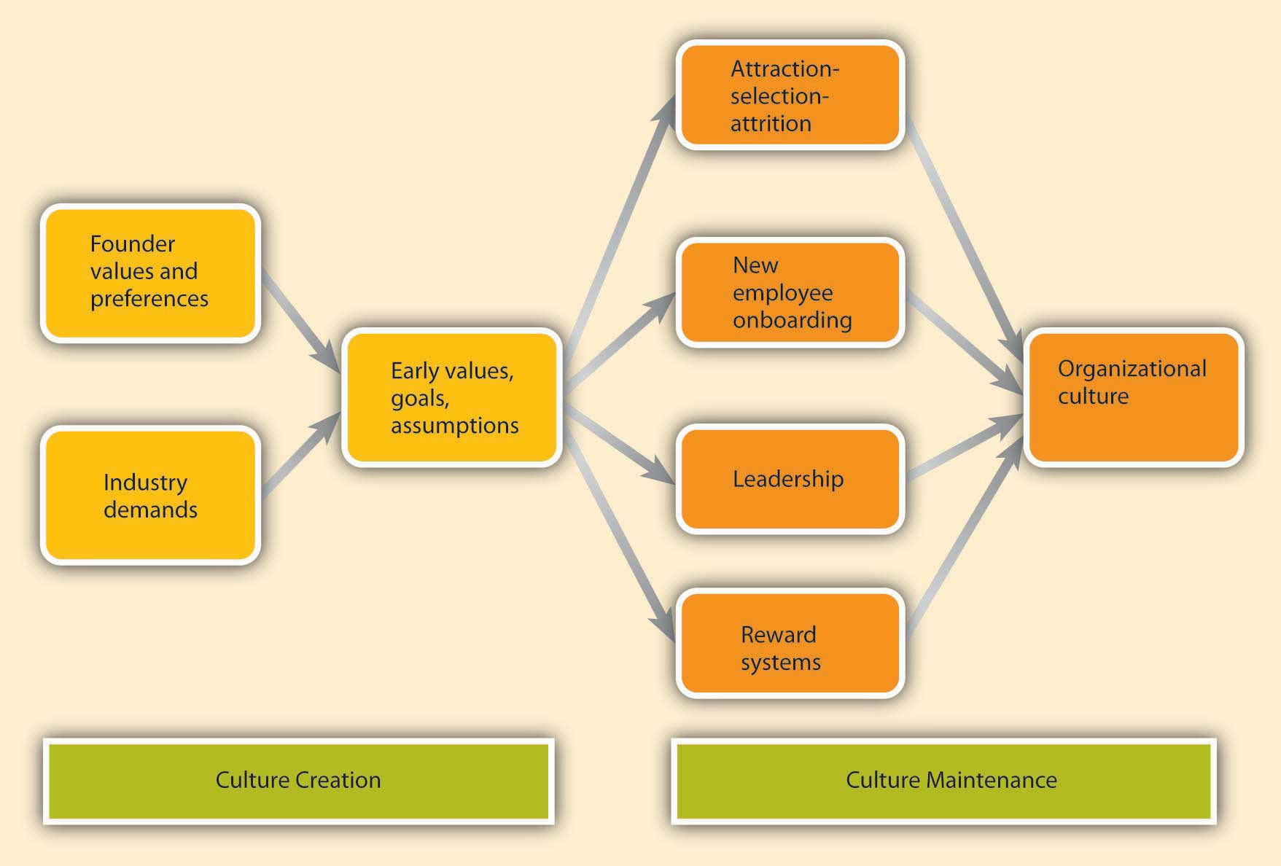

**culture creation and maintenance**

**arpenter, M., Bauer, T., & Erdogan, B. (2013). Principles of Management, v. 2.0. Irvington, NY: Flat World Knowledge, Inc.**

***Founder Values***

**A company’s culture, particularly during its early years, is inevitably tied to the personality, background, and values of its founder or founders, as well as their vision for the future of the organization.**

***Industry Demands***

**Although founders undoubtedly exert a powerful influence over corporate cultures, the industry characteristics also play a role.**

**How Are Cultures Maintained?**

**rganizational culture determines what types of people are hired by an organization and what types of people are left out. Moreover, once new employees are hired, the company assimilates the new employees and teaches them the way things are done in the organization**

***Leadership***

**Leaders are instrumental in creating and changing an organization’s culture.**

**Many studies have suggested that leader behavior, the consistency between organizational policy and leader actions, and leader role modeling determine the degree to which the organization’s culture emphasizes ethics (Driscoll & McKee, 2007). The leader’s own behaviors will signal to individuals what is acceptable behavior and what is unacceptable. Leaders also shape culture by their reactions to the actions of others around them.**

***Reward Systems***

**Finally, the company culture is shaped by the type of reward systems used in the organization and the kinds of behaviors and outcomes it chooses to reward and punish. One relevant element of the reward system is *whether the organization rewards behaviors or results*.**

**Signs of Organizational Culture**

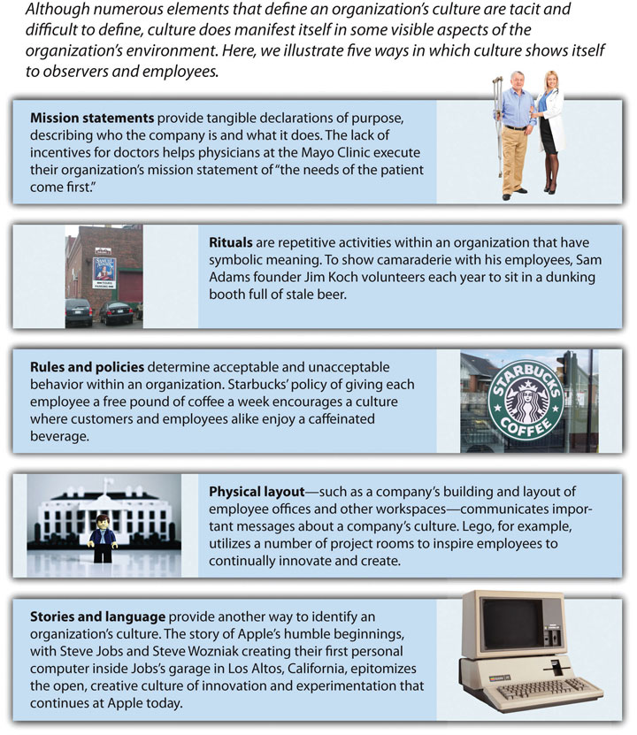

***Rituals***

**Rituals are repetitive activities within an organization that have symbolic meaning (Anand, 2005).**

***Mission Statement***

**A mission statement is a statement of purpose, describing who the company is and what it does.**

***Rules and Policies***

**Another way in which an observer may find out about a company’s culture is to examine its rules and policies.**

***Physical Layout***

**A company’s building, layout of employee offices, common areas, and other workspaces communicate important messages about a company’s culture.**

***Stories and Language***

**Perhaps the most colorful and effective way in which organizations communicate their culture to new employees and organizational members is through the skillful use of stories.**

**Language is another way to identify an organization’s culture. Companies often have their own acronyms and buzzwords that are clear to them and help set apart organizational insiders from outsiders.**

***Note*. Adapted from “Creating and Maintaining Organizational Culture,” by M. Carpenter, T. Bauer, B. Erdogan, & J. Short, 2013, *Principles of Management,* Chapter 8, Section 3. Copyright 2013 by Flat World Knowledge, Inc.**

**Topic 3: Activity 3 of 4--Organizational Culture and Ethics-- article** [**Organizational Culture’s Influence in Ethical Policies**](http://smallbusiness.chron.com/organizational-cultures-influence-ethical-policies-37308.html)

**Topic 3: Activity 4 of 4--ing Ethical Cultures-- video--**Creating ethical cultures in business: Brooke Deterline at TEDxPresidio

[**https://www.youtube.com/watch?v=wzicXbnmllc**](https://www.youtube.com/watch?v=wzicXbnmllc)

**Courage to stand up for what is right is business.**

**Objective 2: ISM Principles**

Topic 1: The ISM Principles--Sustainability and Social Responsibility: The Guiding Principles

The Institute for Supply Management (ISM) Principles of Sustainability and Social Responsibility are the foundation for best practices in a sustainable and socially responsible program.

**Sustainability and Social Responsibility--An understanding of the terms**

**Sustainability** is the ability to meet current needs without hindering the ability to meet the needs of future generations in terms of economic, environmental, and social challenges.

**Social responsibility** is a framework of measurable organization policies and procedures and resulting behavior designed to benefit the workplace and, by extension, the individual, the organization and society.

**Principles of Sustainability and Social Responsibility**

The ISM Principles of Sustainability and Social Responsibility are designed to enable both supply management and the organization to customize a framework specific to industry and supplier needs in the following areas: anti-corruption; diversity and inclusiveness—workforce and supply base; environment; ethics and business conduct; financial integrity and transparency; global citizenship; health and safety; human rights; labor rights; and sustainability. Statements and content are not all-encompassing but provide a solid foundation to express important characteristics of each principle. Often a statement for one principle is applicable to others. Visit [ISM (This content will be opened in a separate window or downloaded to your computer)(This content will be opened in a separate window or downloaded to your computer)](http://www.ism.ws/sr/)

*Note*. Adapted from “ISM Principles of Sustainability and Social Responsibility,” by Institute for Supply Management, 2012. Copyright 2012 by Institute for Supply Management.

Topic 1: Activity 2 of 4--ISM Principles--worksheet

Topic 1: Activity 3 of 4 -- Sustainability 2.0--video--Sustainability 2.0 - What Comes Next

What is the difference between Sustainability 1.0 and Sustainability 2.0?

How can supply management professionals be both profitable and socially responsible?

<https://www.youtube.com/watch?v=JbzsUQpsh6U>

2.0 is about value creation. create products that create sustainability. 2.0 challenges the current business model.

topic 1: Activity 4 of 4--McDonald's: Social Responsibility--Starbucks social responsibility.

[Ten ISM Principles](http://www.ism.ws/files/SR/PSSRprintable.pdf) link

Topic 2: Business Strategies, Policies, and Procedures --

Topic 2: Activity 1 of 5--Sustainability and Social Responsibility: Mission, Objectives, and Roles and Responsibilities.

there is a need to continue to engage business professionals and suppliers to further sustainability and social responsibility initiatives. Supply management professionals have the responsibility to (1) share knowledge, (2) learn and collaborate and (3) make a difference.

**Sustainability and Social Responsibility Mission**

It is part of the mission of the Institute of Supply Management (ISM) to foster and drive sustainability and social responsibility excellence across the supply chain through the development and communication of principles and the sharing of tools, information, and best practices.

**Sustainability and Social Responsibility Objectives**

For the organization to succeed, best-in-class organizations lead the organization’s sustainability and social responsibility initiative. In support of their efforts, ISM will:

1. Reinforce that supply professionals fulfill a front-line role to lead, drive and influence sustainability and social responsibility initiatives within the organization and through the supply chain.
2. Commit resources to support sustainability and social responsibility practices and education.
3. Increase supply management professionals’ awareness of sustainability and social responsibility.
4. Champion the business case for sustainability and social responsibility.
5. Advocate that sustainability and social responsibility initiatives are about more than short-term financial decisions.
6. Educate the supply chain community and others on sustainability and social responsibility subjects.
7. Encourage supply professionals to embed relevant sustainability and social responsibility language in internal strategic sourcing policies and procedures and throughout supplier documents to foster commitment throughout the strategic sourcing process and into the supply base.
8. Reinforce the value of personal commitment and contributions including how they positively impact sustainability and social responsibility initiatives and outcomes.
9. Collaborate and share strategies, policies, procedures, best practices and other relevant material related to sustainability and social responsibility both internally and with suppliers.
10. Promote the adoption of these principles throughout the supply chain.
11. Raise the strategic value of supply management through the promotion of sustainability and social responsibility initiatives and results.

**The Organization’s Sustainability and Social Responsibility Roles and Responsibilities**

Best-in-class organizations in sustainability and social responsibility incorporate specific and measurable practices across the supply chain. They will:

1. Support sustainability and social responsibility principles and initiatives.
2. Commit resources to support of sustainability and social responsibility principles, practices and education.
3. Build and integrate programs throughout the organization and cascade them throughout the supply chain.
4. Engage and involve executive management to ensure sustainability and social responsibility initiatives are integral to the culture and decision-making of the organization.
5. Ensure the sharing of strategies, policies, procedures, best practices and other relevant material to assist organizations working to improve sustainability and social responsibility behavior internally and with suppliers.
6. Encourage building and integrating a program throughout the organization and the supply chain.
7. Make enlightened business decisions that often move beyond the “letter of the law.”

*Note*. Adapted from “ISM Principles of Sustainability and Social Responsibility with a Guide to Adoption and Implementation,” by Institute for Supply Management, 2012. Copyright 2012 by Institute for Supply Management.

topic 2: Activity 2 of 5--Sustainability and Social Responsibility Business Plan

To help organizations integrate sustainability and social responsibility throughout the supply chain, the Institute for Supply Management (ISM) created the business plan outline, which identifies best practices in terms of policy planning, processes/procedures, measurement, tracking, reporting, and dedicated resources.

this business plan outline provides a starting point for organizations beginning this journey and a review for those with a program in place.

**Implementation Process**

***Policy***

Executive management defines and establishes the organization’s program policies, including goals, standards, acceptable actions, rewards for exemplary behavior and sanctions for improper behavior. Some of the key best-practice policy elements include:

* **Organizational Policy.** Executive management has established, documented and is maintaining a program policy as a means of ensuring behavior reflecting the organization’s values. The policy is aligned with the organization’s values and all applicable laws. It is updated as new challenges emerge.
* **Management Support**. Executive management subscribes to the program policy and acts accordingly. Further, it communicates, both internally and externally, its expectations for compliance with program standards.
* **Management Review.** Executive management reviews the organization’s policy and its impact at defined intervals to ensure continuing suitability and effectiveness.
* It maintains records of reviews.
* **Policy Considerations**. Executive management recognizes the need to accommodate different cultural and legal systems and changing technologies. It also appreciates the value of engaging others such as the board of directors or other social responsibility functions.

***Planning***

Best practices in program planning include:

1. Developing clear definitions of organizational values
2. Defining who should have input into the program
3. Securing adequate funding and staffing
4. Establishing program components; for example:
5. a. Policy and/or code of conduct
6. b. Internal and external communications
7. c. Training
8. d. Rewards and sanctions
9. e. Whistle-blowing
10. f. Hotline or help line
11. g. Assessment and evaluation programs
12. h. Reporting and tracking mechanisms

***Processes/Procedures***

The organization has a clearly defined and documented process to manage implementation of policy and practice, to achieve goals and influence supplier behavior.

Some best-practice processes include:

* **Training**. The organization has developed a comprehensive training program that enables employees to become active participants in their own learning.
* Training is regularly updated and includes practice in preventing, eliminating and resolving problems. It is an ongoing, not one-time, occurrence. As applicable, the organization has developed a comprehensive training program to educate and develop suppliers and other members of the supply chain.
* **Internal communication**. The organization integrates program sensitivity into all aspects of communication to demonstrate that it is an integral part of all operations and decision-making. It has identified a person responsible for the program who monitors and implements the initiative internally and externally. It may have established a hotline or help line. The organization ensures that the program is a regular agenda item for the board of directors.
* **External communication**. The organization publishes its program policy and incorporates it into its communications with customers, suppliers and the public.
* It regularly publishes detailed reports on performance and responds openly to inquiries from stakeholders, investors and activist groups. The organization assesses practices of its suppliers to ensure that its trading partners are aligned with its values.

***Measurement, Tracking and Reporting***

The organization has established a system to monitor, document and report adherence to the program. Key elements include:

* **Performance**. The organization includes program elements as a dimension both in employee and supplier performance appraisals. It recognizes the value of having a program committee within its leadership core.
* **Evaluation**. The organization follows up on training with regular evaluations to ensure employees retain and act on what they have learned. It also demands compliant behavior from its suppliers and considers this in supplier selection.
* **Assessment**. The organization has established and maintains documented procedures for the assessment of both internal and external programs to determine the effectiveness of program policy, planning, processes and metrics. It tracks changes and enhancements as required due to assessment findings.

Assessments are used for learning and enhancing performance. The organization also has established mechanisms for investigating potential program lapses and holding management, employees and suppliers accountable for transgressions.

***Dedicated Resources***

The organization determines requirements for and then allocates sufficient staff and funding to coordinate, lead and promote its program.

*Note*. Adapted from “ISM Principles of Sustainability and Social Responsibility with a Guide to Adoption and Implementation,” by Institute for Supply Management, 2012. Copyright 2012 by Institute for Supply Management.

Topic 2: Activity 3 of 5--Adopting and Implementing the ISM Principles

Integrating sustainability and social responsibility concepts throughout supply management, the business and the supply chain is critical to success. These questions are designed to help.

1. Are you and your organization aware of sustainability and social responsibility standards and trends in your industry?
2. Does your organization comply with applicable laws and regulations covering sustainability and social responsibility?
3. Does your organization have written policies in place that cover the principles?
4. Are goals in place for each principle? What are they? How are improvements incorporated?
5. How does your organization disperse and communicate information on its sustainability and social responsibility standards internally and to suppliers for adoption, understanding and compliance?
6. Is training provided covering each area? What is the frequency and to whom is training provided? Is training also provided for suppliers?
7. Has your organization set minimum standards that suppliers are required to meet? Are suppliers required to provide information and identify how they support each element?
8. Are sustainability and social responsibility contractual obligations in place with those with whom the organization does business?
9. Does your organization measure its performance against standards and report results? Are auditable processes in place?
10. Are managers and appropriate employees measured on meeting goals? What are the rewards for outstanding performance and sanctions for not meeting goals?
11. Are responsibilities for sustainability and social responsibility assigned to specific individuals or groups of individuals? What is the level of accountability for “making something happen” within the organization? Are those accountable made known within the organization?
12. Is there a champion or accountable process owner?
13. What is the highest level of oversight/accountability within the organization? Within each supplier organization?
14. Are financial and human resources committed in support of each standard? To whom do the human “resources” report?
15. How is each element measured within the organization? Within each supplier?
16. Is annual tracking in place? Does the organization communicate accomplishments within the organization, with stakeholders and with the community?
17. Are internal and/or external recognition programs in place?
18. How are sustainability and social responsibility standards and philosophies integrated into your organization’s code(s) of conduct?
19. Does the organization use external resources to help ensure standards are being met? Does the organization align itself with industry groups?
20. Are core values, specific to the organization/industry/business, incorporated into human resources policies, manuals and job descriptions?
21. Are business continuity contingency plans in place to manage natural disasters, terrorist actions and the like?
22. Does your organization seek out suppliers with sustainability and social responsibility practices embedded in their practices, products, services and business philosophies?

**Adoption and Implementation: Each Principle**

These principles are designed to enable both supply management and the organization to customize a framework specific to industry and supplier needs: anti-corruption; diversity and inclusiveness—workforce and supply base; environment ethics and business conduct; financial integrity and transparency; global citizenship; health and safety; human rights; labor rights; and sustainability. Again, statements and content are not all-encompassing but provide a solid foundation to express important characteristics of each principle.

1. **Anti-Corruption**

1. Are there clear guidelines and policies in place to address ethical and legal dimensions?
2. What practices are in place to defend against corrupt practices within the organization, with suppliers and through the supply chain?
3. What training does the organization have in place?

2. **Diversity and Inclusiveness—Workforce and Supply Base**

*Workforce*

1. Does the leadership of the organization support hiring a diverse internal workforce?
2. Does the organization have a formal tracking system to assess the impact of diversity efforts within the organization? Within the supply base?
3. Are supplier policies and programs reviewed?
4. How does the organization ensure equal access to employment and promotion opportunities?

*Supply Base*

1. Does the leadership support having a diverse supply base?
2. Does the organization have a formal supplier diversity program? How is the program communicated internally and to the supplier community?
3. Does the organization have a formal tracking system to assess the impact of diversity efforts within the organization and across the supply chain?
4. Are copies of supplier diversity policies and programs gathered from suppliers? Are they reviewed and approved by the supply management organization?

3. ***Environment***

1. Does the organization behave in environmentally responsible ways? What specific programs and procedures are in place?
2. Does the organization have programs to reduce, reuse and recycle? What percent of disposable waste is recycled? What does the organization do to reduce the volume of waste created that must then be recycled? How does the organization reduce waste? Reuse equipment and supplies?
3. How does the organization comply with laws and regulations in the handling of hazardous waste?
4. How does the organization report its environmental results?
5. How does the organization continue to learn what it needs to know about environmental and waste issues?
6. Does the organization collect copies of suppliers’ environmental plans? Are the plans of suppliers assessed and approved by the supply management organization?
7. Does the organization work with engineering in the design of products for disassembly, reuse and recycling?

4. ***Ethics and Business Conduct***

1. Does the organization have a formal code of ethics in place? How is the code communicated to employees and suppliers? How does the organization’s code align with ISM’s Principles and Standards of Ethical Supply Management Conduct?
2. What corrective action and compliance processes exist?
3. Is ethics a part of each individual’s job responsibilities and objectives? How are results measured?
4. Are suppliers required to have a code of ethics in place to address unethical behavior and a methodology to support action and compliance? Does this flow through the supplier tiers?

5. ***Financial Integrity and Transparency***

1. Does the organization educate employees about appropriate financial responsibilities? Is there a process in place that promotes and acknowledges employees who, through their actions, demonstrate a strong commitment to financial responsibility?
2. What corrective action and compliance processes exist?
3. Has the organization, and have its suppliers, implemented fiscal policies, financial management systems and accounting controls that help ensure fiscal responsibility and long-term viability?

6. ***Global Citizenship***

1. What specific programs and activities are in place to demonstrate the organization’s commitment to society and the communities it serves? Locally? Regionally? Nationally? Globally? Virtually?
2. Are relevant actions and activities acknowledged and recognized by the organization?
3. Does the organization allow time for people to be away from the job to work and volunteer?
4. Are charitable donations and support of economic development programs a part of the organization’s efforts?
5. Has the organization set goals and objectives for philanthropic practices, if applicable?

7. ***Health and Safety***

1. Does the organization have a formal health and safety program? How is the plan communicated internally and externally?
2. Does the organization have a formal tracking system? What does it measure?
3. How does the organization assess and continually review supplier/subcontractor health and safety policies and procedures?
4. Are safety specifications embedded within statements of work documents and contracts?

8. ***Human Rights***

1. Does the organization assess human rights conditions internally, and those of the first-tier suppliers and suppliers beyond the first tier?
2. How are policies being enforced internally? With suppliers?
3. Are human rights laws understood and applied?
4. What does the organization do to promote an environment in which everyone is treated with dignity and respect?
5. What organizational and supplier policies and procedures are in place to assure protection of personal data?

9. ***Labor Rights***

1. Does the organization require freedom of association and recognition of the right to collective bargaining?
2. Does the organization ensure no forms of forced and compulsory labor are allowed?
3. Are child labor policies written and communicated internally and with suppliers?
4. How are employment and occupation discrimination practices identified and eliminated?

10. ***Sustainability***

1. Has the organization developed a position on sustainability? If so, how is this position communicated to the world at large? To suppliers?
2. How is sustainability integrated within the organization down through individual job responsibilities?
3. Are policies and procedures embedded throughout the internal supply process? With suppliers?
4. Does the organization periodically review and update its goals and objectives? Are the updates published?
5. How does the organization work to support initiatives of suppliers and others in the communities it serves?

**Resources, References, and Metrics**

1. ISM’s Sustainability and Social Responsibility Metrics and Performance Criteria for Initiatives. The development and implementation of metrics and performance criteria is important to the success of sustainability and social responsibility programs. Integrating goals and objectives with relevant measurements will ensure the ability to track and report progress against various initiatives. Often an annual sustainability and social responsibility report, sometimes called a citizenship report, is issued or results are included in the organization’s annual report.
2. [CAPS Research Focus Studies and Benchmarking Reports(This content will be opened in a separate window or downloaded to your computer)](http://www.capsresearch.org/).
3. The ISM Guide to Sustainability and Social Responsibility (free web-based self-study course).
4. ISM Principles and Standards of Ethical Supply Management Conduct With Guidelines (free web-based self-study course).
5. ISM Sustainability and Social Responsibility Handbook, 2011.
6. [ISM Special Sustainability and Social Responsibility(This content will be opened in a separate window or downloaded to your computer)](http://www.ism.ws/sr).
7. Applicable Laws, Regulations and Trade Agreements Information.
8. Agency laws.
9. Contract and commercial laws.
10. Electronic commerce laws.
11. Antitrust laws.
12. Trade agreements.
13. Trade regulations.
14. Industry-specific laws and regulations.
15. Government procurement regulations.
16. Patent, copyright, trade secret and trademark laws.
17. Environmental laws.
18. Employment laws and regulations.
19. Worker health and safety laws.
20. Transportation and logistics laws and regulations.
21. Financial laws and regulations.
22. Other laws as applicable.
23. The United Nations Framework Convention on Climate Change (UNFCCC).
24. The following chart provides a hierarchy the supply professional can use to understand possible consequences or outcomes from behaviors and decisions.

|  |  |  |
| --- | --- | --- |
| **Element** | **Entity** | **Risk of …** |
| Laws and Regulations | State | Jail and Fines |
| Policies and Procedures | Company | Loss of Employment |
| Standards, Guidelines, Requirements | Groups | Social Rejection |
| Norms, Morals | Society | Loss of Self-Respect |

*Note*. Adapted from “ISM Principles of Sustainability and Social Responsibility with a Guide to Adoption and Implementation,” by Institute for Supply Management, 2012. Copyright 2012 by Institute for Supply Management.

Topic 2: Activity 4 of 5--Primark: Case Study

Business Case Studies: [Providing Consumers with Ethically Sourced Garments](http://businesscasestudies.co.uk/primark/providing-consumers-with-ethically-sourced-garments/ethics-in-practice.html)

**Objective 3: Communicating and Training Key Stakeholders**

Topic 1: The Importance of Communicating Social Responsibility Within Organizational Structure

Topic 2: Activity 1 of 6--Training and Development in Sustainability

It is no longer enough to say you have a code of ethics. Organizations must show that employees have been trained and that standards are enforced.

In the United States, with the passage of the [Sarbanes-Oxley Act(This content will be opened in a separate window or downloaded to your computer)(This content will be opened in a separate window or downloaded to your computer)](http://smallbusiness.chron.com/sarbanes-oxley-code-conduct-requirements-4060.html), the adoption of codes of ethics and provision of training in those codes are critical.

**Sustainability Training**

**Use Your Business Skills to Make a Difference**

**There are a number of nonprofit organizations that seek out business persons to donate their valuable professional skills:**

* **Business Council for Peace**
* **CEOs Without Borders**
* **Diplomats Without Borders**
* **Financial Services Volunteer Corp**
* **Geekcorps**
* **International Executive Service Corps**
* **MBA-Nonprofit Connection**
* **MBAs Without Borders**
* **Net Impact**
* **New Ventures**
* **Taproot Foundation**
* **TeamMBA**
* **TechnoServ**
* **Wall Street Without Walls**

***Note*. Adapted from *C.P.M. Study Guide*, by Institute for Supply Management, 2001. Copyright 2001 by Institute for Supply Management.**

**Adapted from “Training and Development,” by N. E. Landrum & S. Edwards, 2012, *A Primer on Sustainable Business,* Chapter 3, Section 2. Copyright 2012 by Flat World Knowledge, Inc.**

**Topic 2: Activity 2 of 6--Research: Eastman Chemical**

**Eastman Chemical Company:** [**Sustainability Report**](http://www.eastman.com/Literature_Center/Misc/2013ProgressReport.pdf)

**opic 2: Activity 3 of 6--Real-Life Example: Training in Triple Bottom Line**

**The triple bottom line (TBL) accounting framework goes beyond conventional measures of profit to include the planet and people.**

**USAID Asia:** [**“Triple Bottom Line” Training Helps Participants Assess Value of Protected Areas**](http://www.leafasia.org/events/triple-bottom-line-valuation-methods-natural-resource-areas-training-program)

**Topic 2: Activity 4 of 6--Performance Appraisal and Sustainability**

As part of their efforts at greater sustainability, some organizations have linked performance appraisal and sustainability performance measures.

Most companies engage in the traditional performance appraisal system where the employee’s performance is measured on some prescribed criteria. The purpose of performance appraisals is generally to provide feedback to the employee on his or her performance in order to correct any deficiencies and to create increased opportunities.

Trait, behavioral, and outcome appraisal instruments can be altered to include sustainability criteria.

rganizations can use Web-based performance appraisal software such as [Halogen eAppraisal (This content will be opened in a separate window or downloaded to your computer)](http://www.halogensoftware.com/)or [EmpXTrack(This content will be opened in a separate window or downloaded to your computer)](http://www.empxtrack.com/) to prevent excess use of paper products and to increase transparency of the process.

Essential to the success of performance appraisal systems on sustainable performance is the cooperation and approval of the employees.

*Note*. Adapted from “Performance Appraisal and Feedback,” by N. E. Landrum & S. Edwards, 2012, *A Primer on Sustainable Business,* Chapter 3, Section 3. Copyright 2012 by Flat World Knowledge, Inc.

Topic 2: Activity 5 of 6--Performance Feedback in the Supply Chain--video

Supply chain performance - Measuring performance in supply chains

<https://www.youtube.com/watch?v=Tja3CFEIYh8>

your metrics must be effective, efficient, and adaptive.

Objective 4: Six Types of Risk

Topic 1: Risk Overview--Topic 1: Activity 1 of 7--Risk Management Basics--video

Risk management basics: What exactly is it?

<https://www.youtube.com/watch?v=BLAEuVSAlVM>

asking six basic questions

1. what are we trying to do -- leads into the risk process
2. what might affect me -- are there things in the future -- risk ident
3. which of those things are most important - risk analysis.
4. what shall we do about it -- risk plan
5. did it work -- risk plan evaluation.
6. what has changed.

Topic 1: Activity 2 of 7--What Is Risk Management?

Risk management is a process whereby an organization identifies risks and establishes controls and countermeasures to manage the risks. Risk management includes the methods and processes used by organizations to manage risks and take advantage of opportunities related to achieving their objectives.

**About Risk Management Systems**

Risk management systems include methods of sensing, understanding, and responding to risks, and they are designed to reduce or eliminate risks and lessen the impact those risks may have on businesses.

Risks vary depending on a company’s size and industry, but they may fall into one of six categories:

1. **Financial:** Risks that involve a company’s profits, growth, and value.
2. **Operational:** Risks that arise from a company’s employees, systems, and processes through which it operates.
3. **Brand/Reputation:** Risks related but not limited to human rights, labor rights, and environmental stewardship.
4. **Legal:** Risks related to a company’s legal position, such as regulations, government relations, and foreign politics for international corporations.
5. **Technical:** Risks associated with an execution of technical processes, engineering, or manufacturing procedures.
6. **Environmental:** Risks related but not limited to environmental sustainability as a result of adverse effects on living organisms and the environment.

A risk management system includes several elements that play a role in a company’s response to risk, such as supply management, strategic planning, marketing, quality assurance, customer service, and accounting. Companies will often perform an internal audit of these elements to evaluate their effectiveness.

**Risk Management Assessment**

***Note*. Adapted from *Corporate Social Responsibility as Risk Management: A Model for Multinationals*, by B. Kytle & J. G. Ruggie, 2005. Copyright 2005 by Harvard University.**

**Adapted from “Risk Management Planning,” by A. Watt, 2012, *Project Managetment,* Chapter 16. Copyright 2012 by Adrienne Watt.**

**Adapted from “Strategic Risk Assessment,” by M. L. Frigo & R. J. Anderson, 2009, *Strategic Finance*. Copyright 2009 by Strategic Finance.**

**Topic 1: Activity 3 of 7--CFOs and Managing Risk--video**

**What Does a CFO Do, Risk Management & Governance**

[**https://www.youtube.com/watch?v=TEJTUFmVBVI**](https://www.youtube.com/watch?v=TEJTUFmVBVI)

**The CFO’s role risk managment can be done in a strutured enveiromnet even in small businesses.**

1. **determining the appropriate insurence coverage. --legal affiars are managed.**
2. **assessing creditors and debtors.**

**Topic 1: Activity 4 of 7--Minimizing Threats and Maximizing Opportunities-- video**

**Risk and Opportunity: How can risk be good?**

[**https://www.youtube.com/watch?v=mEuXOtY8k9s**](https://www.youtube.com/watch?v=mEuXOtY8k9s)

The risk doctor..

Risk is uncertainty that matters -- these need to be managed.

upside and downside if both good and bad, opportunities and threats.

prioritize and come up with a plan. One process that handle both at once is much more efficient. we can go actively look for upside risk. remember opportunity is the same as a threat.

Topic 1: Activity 5 of 7--ISM Risk Management Proceedings

. **Keys to Narrowing Business Continuity Planning Gaps: Training, Testing & Audits**

**You Have a Business Continuity Plan . . . Now What?**

**Disaster Communication. --Training and Testing . . .**

**The Perpetual Work In Progress.**

**Summary. In today’s world, everyone in the organization has responsibility for their own safety and security and that of others, as well as a responsibility to help prevent and protect the organization from disasters. Through a program of training and testing that includes all employees, we can help ensure that everyone is aware of the part they play and understands what the organization is prepared to do. Exercises and tests provide the best possibility reality check for your plans other than an actual disaster. Plans must be reviewed and updated frequently to ensure that the information they contain is accurate and current. The overall result is better prepared organization and a stronger line of defense against future disasters.**

***Note*. Adapted from “Keys to Narrowing Business Continuity Planning Gaps: Training, Testing & Audits,” by B. A. Kildow, 2010. Copyright 2010 by Institute for Supply Management.**

**2. The Transaction Review Process: Identifying Risk in Supply Chain Contracts**

**Conclusion. As with any new process, there are growing pains. It will take time and communication for all supply chain associates to feel comfortable with decisions around required reviews and for reviewers to speak-up when asked to perform a review that is not necessary. Hopefully, it will take less time for the business units to see the positive effects of the review process in cost savings and risk avoidance. The control environment clearly benefits from the creation of a single repository for signed contracts, a single version of the truth for works in progress and an audit trail of reviewer comments.**

***Note*. Adapted from “The Transaction Review Process: Identifying Risk in Supply Chain Contracts,” by L. Brooks, 2010. Copyright 2010 by Institute for Supply Management.**

**3. Risk Management: What Could Impact Your Company’s Reputation?**

**Warren Buffett is also quoted for saying: “Risk comes from not knowing what you're doing.” Don’t let risk to your company’s supply chain impact your company’s reputation. Know what you are doing. . . . And exercise responsible supply chain risk management!**

***Note*. Adapted from “Risk Management: What Could Impact Your Company’s Reputation,” by C. Herr, 2010. Copyright 2010 by Institute for Supply Management.**

**4. Proactively Managing Supplier Risk**

**The Opportunity. The understanding of why and how to manage supply base risk will help supply managers to:**

* **Ensure supply continuity**
* **Reduce unexpected delays in meeting customer requirements**
* **Provide effective methods to minimize costs associated with supplier failures**
* **Begin to develop a mind-set within supply department that risk is an important element of the purchasing/supply management job.**

**Objectives. The objectives of presentation are to: 1) provide an understanding of the concept of risk and risk management, 2) discover why risk management needs to be part of the strategic sourcing process and how this can be accomplished, 3) learn about the advantages of utilizing various third party providers of supplier financial information to track the changing conditions in the supply base and to predict supplier financial performance, 4) improve supply management's ability to respond in a timely and effective manner to supplier risk, and 5) present preliminary findings of field research with companies who have implemented risk management practices.**

**What Is Risk?**

**Risk is the combination of uncertain events and outcomes associated with those events. Supplier risk focuses on events that have outcomes detrimental to the sourcing plans that have been put in place with the supply base.**

**What Is Risk Management?**

Risk management is the process of identifying potential negative events, assessing the likelihood of their occurrence, heading off these events before they occur, if possible, and making contingency plans to mitigate the consequences if they do occur.

* Pay early to help with supplier cash flow
* Take early delivery to move supplier payments forward
* Buy raw material for suppliers
* Visit the supplier to see if more long-term help, rather than just a quick fix, can be provided
* Asking a larger supplier to lend a hand to a smaller supplier
* Direct investment
* Help with third-party buyouts
* Move the business
* Buy the business

**Third Party Providers of Risk Management Information**

**Using Risk Management Tools in Supply Management**

***Note*. Adapted from “Proactively Managing Supplier Risk,” by L. Giunipero & P. L. Carter, 2010. Copyright 2010 by Institute for Supply Management.**

**5. The Supply Chain and Business Continuity: Preparing to Survive the Next Disaster**

**Abstract**. Today more than ever before every business and organization faces emergencies daily. In most instances these situations are handled relatively easily and are transparent to the world outside, and we move forward. Unfortunately, some of these situations expand to the crisis level. Natural disasters can strike with no warning, wreaking havoc and destruction in their wake. Recent financial challenges have heightened the impact of these challenges on operations and employees.

Technological and human-caused disasters are an area of continuing concern for all organizations. In our rapidly-changing world, new threats arise on a regular basis, ones we have never previously considered. If not dealt with effectively and quickly, these events can threaten the reputation and future success of your organization, even its very survival.

**Summary**. More than ever before a comprehensive business continuity program that includes all internal and external links in the supply chain is essential if the business is to survive following a major disaster. For employees having a comprehensive business continuity program in place may mean protecting their livelihood and paycheck by helping to ensure that the business will continue and thrive. Neglecting to fully consider the supply chain in the business continuity planning process will result in a business continuity plan that will likely fail when the next disaster strikes.

*Note*. Adapted from “The Supply Chain and Business Continuity: Preparing to Survive the Next Disaster,” by B. A. Kildow, 2010. Copyright 2010 by Institute for Supply Management.

Topic 1: Activity 6 of 7--Supply Chain Operations Reference (SCOR) Model

Because of the challenge of building and maintaining a safe, effective supply chain, the better the organization responds to and documents risk, and aligns its processes with its suppliers, the better the outcome.

the **Supply Chain Operations Reference-model (SCOR®)** **model**. A

**Plan:** Supply chain systems require well-designed plans. Each plan has direct relevance to the elements of a manufacturer's product safety system, which covers:

* a planning process for product concept and design,
* risk assessment, including hazard analysis,
* materials specification,
* production procedures,
* testing and certification protocols,
* supplier auditing,
* product recall and retrieval planning and management, and
* documentation.

**The plan** should be part of a greater organizational design that integrates international standards. Two examples are ISO 9001 for quality and [ISO 31000(This content will be opened in a separate window or downloaded to your computer)](http://www.iso.org/iso/home/standards/iso31000.htm) for risk management. ISO 31000:2009

**Buy**: The supplier purchases materials and components for a finished product. Customers typically define the materials and parts, but the product is expected to comply with applicable regulatory statutes.

**Make**: The supplier controls the production process, and a system that does not have consistency and reliability threatens the entire supply chain. In order to ensure consistency and reliability, regulatory agencies have put standard procedures in place (i.e., testing and certificate programs) that are agreed to and verified by importers.

* **Distribute**: Responsibility must be clear to avoid questionable situations when a product leaves the place of manufacturing and moves into distribution. All proper certificates and documentation must be finished because the product will be inspected once it leaves its home port.

**Retrieve**: If manufacturers find that a product could be hazardous—through such things as market surveillance or customer complaints—they should report it to government regulators.

**Finance**: The elements of cost include:

* supply chain remanufacture,
* repair,
* replacement,
* refund, and
* costs of a recall.

*Note*. Adapted from “Supply Chain Management: Blending Safe Products with Profit,” by Consumer Product Safety Commission, n.d., *CPSC.gov*. Copyright by Consumer Product Safety Commission.

Topic 1: Activity 7 of 7--ISO 31000 Standard

risk identification,

risk analysis,

risk evaluation,

risk treatment, and

monitoring and review.

[ISO 31000 Standard](https://www.iso.org/iso-31000-risk-management.html)

Topic 2: Six Risk Categories

Topic 2: Activity 1 of 11--Financial Risk

Conditions or circumstances that may impact a company’s economic standing or value are *financial risks*. What steps can an organization take to mitigate financial risk?

Conducting an audit of your supply management chain will enable you to identify the risks involved in an effort to adopt more socially responsible and sustainable processes.

Financial risk refers to conditions or circumstances that may impact a company’s economic standing or value. Different types of financial risk exist:

Market risks affect the value of investments. These include:

Changes in equity, such as stock price changes. Investments that carry a high equity risk may pay investors an equity premium for taking on a high-risk investment.

Changes in interest rates on investments or debts due to market fluctuations.

Changes in foreign currency exchange rates, also called exchange rate risk, that can happen when assets are traded in foreign currencies.

Changes to the prices for commodities, which include raw materials such as grain, metal, and oil. Unexpected changes in commodity prices affect the producers of those commodities and their investors.

Credit risk describes the risk that a borrower will default on a debt. Examples of credit risk include consumers unable to pay loans related to a home or credit card, employers unable to pay employee wages, or a business unable to pay a trade invoice for products or services rendered.

Liquidity risk is the risk that an asset cannot be quickly converted into cash. In finance, this describes the risk related to investments that cannot be bought or sold quickly enough to prevent a loss. Businesses may be considered to have high liquidity risk if they do not have enough cash or cash equivalents to meet short-term financial demands.

In response to managing financial risks, a company will develop policies and strategies for cash management and management of collections, disbursements, and investments.

Note. Adapted from “Types of Risk,” by Boundless, n.d., Boundless Finance, Chapter 8, Section 4. Copyright by Boundless.

Adapted from “The Risk Management Process,” by M. Upton, 2013, Understanding and Managing Risk, Chapter 2, Section 2. Copyright 2013 by The Open University.

Topic 2: Activity 2 of 11--Operational Risk--

Technology and economics aside, companies must still consider the risk posed by operational failures. This type of risk, called operational risk, is a broad category of non-financial risk that encompasses all aspects of a company’s risk not related to markets, finance, or technology.

Operational risk may not be considered a financial risk, but operational risk management failures can have a significant financial impact on companies and the financial markets.

perational Risk Management

Although this risk will vary between companies and industries, it is an essential consideration when developing a risk management system. Companies wishing to mitigate or reduce operational risk must evaluate:

The adequacy of staffing. Companies with high turnover and poorly trained or unqualified workers are vulnerable to operational failure.

The reliability of systems. Contingency plans and backups for downed systems, along with established procedures for testing and implementing new systems, greatly reduce operational risk.

Internal controls. An internal procedures manual detailing staffing structures, business operations, and the reporting of business activities reduces operational risks and their financial impact.

Note. Adapted from Operational Risk Management, by Global Association of Risk Professionals, 2011. Copyright 2011 by Global Association of Risk Professionals.

Adapted from “The Implications of Operational Risk,” by M. Upton, 2013, Understanding and Managing Risk, Chapter 3, Section 1. Copyright 2013 by The Open University. (This content will be opened in a separate window or downloaded to your computer)

Adapted from “The Risk Management Process,” by M. Upton, 2013, Understanding and Managing Risk, Chapter 2, Section 2. Copyright 2013 by The Open University. (This content will be opened in a separate window or downloaded to your computer)

Adapted from The 2008 Financial Crisis: A Wake-Up Call for Enterprise Risk Management, by B. Coffin, 2009. Copyright 2009 by Risk and Insurance Management Society, Inc.

Topic 2: Activity 3 of 11--Brand Reputation Risk

**Reputation risk** is the risk of financial loss or decreased value related to damages to a company’s reputation.

**Evaluating Reputation Risk**

To manage risk, companies must consider:

1. how quickly an event or circumstance will affect the business,
2. how long the event or circumstance will last, and
3. how resilient the company is to the effects of the event or circumstance.

An additional reputation risk is today’s global economy and the potential for a company to be affected by suppliers and other affiliates that fail to adhere to the laws and regulations to which the company is subject. Issues like product recalls and environmental hazards can quickly damage a company’s reputation.

**Responding to Risk Through Sustainability and CSR Initiatives**

In response to these risks, companies develop sustainability and corporate social responsibility (CSR) initiatives. These initiatives are self-regulated within a company, promote a company’s reputation, and support responsible business practices with suppliers and partners. Although CSR initiatives are focused on compliance with ethical and legal standards and requirements, many companies expand their CSR initiatives to include positively contributing to society to build and maintain a positive reputation.

*Note*. Adapted from “Three Steps Toward Managing Reputational Risk,” by Deloitte Insights, 2013, *Wall Street Journal*. Copyright 2013 by Deloitte Development LLC.

Adapted from “Reputation and Its Risks,” by R. G. Eccles, S. C. Newquist, & R. Schatz, 2007, *Harvard Business Review*. Copyright 2007 by Harvard Business Review.[(This content will be opened in a separate window or downloaded to your computer)](http://deloitte.wsj.com/riskandcompliance/2013/04/25/three-steps-toward-managing-reputational-risk/)

Adapted from “Managing Reputation Risk,” by J. DeLoach, 2013, *NACD Library*. Copyright 2013 by National Association of Corporate Directors.[(This content will be opened in a separate window or downloaded to your computer)](http://hbr.org/2007/02/reputation-and-its-risks/ar/1)

Adapted from “#McDStories: When a Hashtag Becomes a Bashtag,” by K. Hill, 2012, *Forbes*. Copyright 2012 by Forbes.

Topic 2: Activity 4 of 11--Mills Paper: Responsible Business Practices--video

Mills Basics Sustainability/Social & Corporate Responsibility Mills

Basics

<https://www.youtube.com/watch?v=4oBG_Egbz-s>

sustain ability, carbon neutral, soy based ink.

we think we live in the best place of the world and we do whatever we can to make it the best place in the world.

Topic 2: Activity 5 of 11--Coca-Cola's Reputation in India--video

# Coca Cola's unethical practices in India - HRM project

<https://www.youtube.com/watch?v=qlsyjfwkIwU>

India Coca cola water depletion issues.

Topic 2: Activity 6 of 11--Legal Risk

Legal risk involves the risk of loss to an organization caused by a defective transaction or a claim.

As a subset of operational risk, legal risk has no standard definition, but most sources agree it involves the risk of loss to an institution caused by a defective transaction or a claim (including a defense to a claim or a counterclaim).

More recent history has seen an uptick in litigious behavior in both the public and private sectors. As a result, legal risk has become a topic of greater regular interest for all organizations.

*Note*. Adapted from “The Risk Management Process,” by M. Upton, 2013, *Understanding and Managing Risk,* Chapter 2, Section 2. Copyright 2013 by The Open University.[(This content will be opened in a separate window or downloaded to your computer)](http://www.open.edu/openlearn/money-management/management/understanding-and-managing-risk/content-section-2.2.1)

Adapted from “FAQ About the McDonalds Coffee Case,” n.d., *Hot Coffee*. Copyright by Hot Coffee.[(This content will be opened in a separate window or downloaded to your computer)](http://www.hotcoffeethemovie.com/default.asp?pg=mcdonalds_case)

Adapted from “The Management of Legal Risk by Financial Institutions,” by R. McCormick, 2004. Copyright 2004 by Board of Governors of the Federal Reserve System.

organizations are seeing increased environmental risk.

Topic 2: Activity 7 of 11--Environmental Risk

**Environmental risk** is the actual or potential threat of adverse effects on living organisms and the environment by effluents, emissions, wastes, resource depletion, or other by-products created as a result of an organization’s activities.

Topic 2: Activity 8 of 11--Environmental Risk Transfer

A successful supply chain relies on mitigating technical risk, because data security is linked to commerce. As you read, consider other examples of technical risks and how supply chain managers can mitigate these risks.

Contractual Transfers of Risk

A generator of toxic or hazardous waste that hires an organization to haul away and dispose of the material cannot escape liability, even if the contract specifies that the disposal organization assumes full responsibility for compliance with environmental standards. Under CERCLA, generators are responsible for the conduct of suppliers hired to dispose of toxic or hazardous waste.

**Insurance** **Transfers of Risk**

Insurance may provide some protection for the buying organization. However, insurance policies must be carefully negotiated because general indemnity and premises liability policies often exclude environmental issue coverage.

**Legal Transfers of Risk**

The transfer of environmental risk remains a risky proposition. Because of the public policy behind cleanup laws, there is little case law supporting release of a party from liability. Insurance may mitigate, and a hold-harmless clause can offer the potential of recovery, but there are no legal guarantees that a buying organization will escape environmental cleanup liability.

*Note*. Adapted from *C.P.M. Study Guide*, by Institute for Supply Management, 2001. Copyright 2001 by Institute for Supply Management.

Topic 2: Activity 9 of 11--Technical Risk

A successful supply chain relies on mitigating technical risk because data security is linked to commerce.

**Technical risk** assessment requires the examination of the probability of loss incurred through the execution of a technical process with an uncertain outcome. Untested engineering, technological, or manufacturing procedures always entail some level of technical risk resulting in the loss of time and resources. These processes may also cause harm to individuals and facilities. Technical risk is measured as an expected value derived from prior experience with undesirable results.

Technical risk exists if the system may fail to meet operability requirements or if it may fail to meet testability requirements. It exists if the system may fail to meet integration requirements or environmental protection requirements. A potential failure to meet any requirement expressed in technical terms is a source of technical risk.

*Note*. Adapted from “Leveraging with Information Technology: What Is Risk Management,” by Global Text Project, 2010. Copyright 2010 by OpenStax CNX. Download for free at [http://cnx.org/contents/a8440520-18c4-4390-89f8-4fd40b934475@4(This content will be opened in a separate window or downloaded to your computer)](http://cnx.org/contents/a8440520-18c4-4390-89f8-4fd40b934475@4)

Adapted from “Security Issues in Electronic Communication,” by Lumen Learning, n.d., *INTR BUS OCF*. Copyright by Lumen Learning.

Adapted from “Technical Risk Management,” by S. G. Sapp, 2014, *Sociology 415: The Dynamics of Social Change*. Copyright 2014 by Iowa State University.

Topic 2: Activity 10 of 11--JPMorgan: Managing Risk

JPMorgan Chase & Co.: [Corporate Social Responsibility Report](http://www.jpmorganchase.com/corporate/Corporate-Responsibility/corporate-responsibility.htm)

**Objective 5: Risk Exposure: Storage/Disposal of Hazardous/Regulated Materials**

Topic 1: Regulations and Risk Exposure

Topic 1: Activity 1 of 3--Laws and Regulations for Hazardous or Regulated Materials

Supply management professionals need to understand national and international laws and regulations, in order to mitigate risk when dealing with the storage and/or disposal of hazardous and/or regulated materials.

**Environmental Law**

Any organization has a social responsibility to act sustainably, encompassing the health and safety of the community in which they operate.

Medieval England had smoke control laws that established the seasons when soft coal could be burned. Nuisance laws give private individuals limited control over polluting activities of adjacent landowners.

***National Environmental Policy Act***

Signed into law by President Nixon on January 1, 1970, the National Environmental Policy Act (NEPA) declared that it shall be the policy of the federal government, in cooperation with state and local governments, “to create and maintain conditions under which man and nature can exist in productive harmony, and fulfill the social, economic, and other requirements of present and future generations of Americans.

***Environmental Protection Agency***

The Environmental Protection Agency (EPA) has been in the forefront of the news since its creation in 1970.

The EPA is especially active in regulating water and air pollution and in overseeing the disposition of toxic wastes and chemicals.

***Private Industry***

The Clean Water Act governs private industry and imposes stringent standards on the discharge of pollutants into waterways and publicly owned sewage systems.

***Other EPA Water Activities***

Federal law governs, and the EPA regulates, a number of other water control measures. Ocean dumping, for example, is the subject of the Marine Protection, Research, and Sanctuaries Act of 1972, which gives the EPA jurisdiction over wastes discharged into the oceans.

***Waste Disposal***

Though pollution of the air by highly toxic substances like benzene or vinyl chloride may seem a problem removed from that of the ordinary person, we are all in fact polluters.

***Resource Conservation and Recovery Act***

Put simply, a hazardous waste is a waste that poses substantial or potential threats to public health or the environment. It exhibits one or more of these characteristics:

* ignitable (for example, flammable),
* oxidizing,
* corrosive,
* toxic,
* reactive, or
* exo-toxic **(U.S. EPA).**

**The RCRA expresses a “cradle-to-grave**” philosophy: hazardous wastes must be tracked at every stage, from the time they are generated until they are ultimately disposed of or recycled. This tracking reduces the amount of hazardous waste illegally disposed of.

***Comprehensive Environmental Response, Compensation, and Liability Act***

CERCLA, also known as the Superfund, gives the EPA emergency powers to respond to public health or environmental dangers from faulty hazardous waste disposal, currently estimated to occur at more than 17,000 sites around the country. In addition, CERCLA provides for the cleanup and remediation of closed and abandoned hazardous waste sites.

***Chemical Hazards and the Toxic Substances Control Act (TSCA)***

Chemical substances that decades ago promised to improve the quality of life have lately shown their negative side—they have serious adverse side effects. For example, asbestos, in use for half a century, causes cancer and asbestosis, a debilitating lung disease, in workers who breathed in fibers decades ago.

***Pesticide Regulation***

The United States is a major user of pesticides, substances that eliminate troublesome insects, rodents, fungi, and bacteria, consuming more than a billion pounds a year in the form of 35,000 separate chemicals.

*Note*. Adapted from “Environmental Law,” by D. Mayer, D. Warner, G. Siedel, & J. K. Lieberman, 2011, *Business Law and the Legal Environment*, Chapter 33, Section 5. Copyright 2011 by Flat World Knowledge, Inc.

*Note*. Adapted from *C.P.M. Study Guide*, by Institute for Supply Management, 2001. Copyright 2001 by Institute for Supply Management.

Topic 1: Activity 2 of 3--Walmart: Mishandling of Hazardous Wastes--article

*The New York Times*: [Wal-Mart Is Fined $82 Million Over Mishandling of Hazardous Waste](http://www.nytimes.com/2013/05/29/business/wal-mart-is-fined-82-million-over-mishandling-of-hazardous-wastes.html?_r=0)

**Topic 2: Organizational Response to Risk**

Topic 2: Activity 1 of 3--Hazardous Material Management Plan

The University of Northern Colorado’s (UNC) Hazardous Materials Management Plan provides a good example of how an organization processes its hazardous/regulated material.

**Hazardous Materials Management Plan**

1. General
2. Responsibilities
3. Definition of Hazardous Materials
4. Shipment of Hazardous Materials
5. Identifying Hazardous Waste
6. Hazardous Waste Handling
7. Labeling
   1. UNC Hazardous Material / Waste Tag
8. Packaging
9. Waste Storage Areas
   1. Pick-up Schedule
10. Waste Profile / Analysis
11. Recordkeeping
12. Training
13. Emergency Procedures

Topic 2: Activity 2 of 3--UCLA: Hazardous Waste Management Safety--video

Hazardous Waste Management Safety Video

<https://www.youtube.com/watch?v=0tLJFb3YrWA>

Topic 2: Activity 3 of 3--Global Materials Compliance Handbook

Brandman Virtual Library: [Leatherby Libraries](http://ehis.ebscohost.com.libproxy.chapman.edu/ehost/ebookviewer/ebook/bmxlYmtfXzEwOTMzMF9fQU41?sid=f3fa37e7-1676-4329-9474-83df9a6515c7@sessionmgr4003&vid=1&format=EB&lpid=lp_i&rid=0)

**Objective 6: Customer-Driven Requirements and Laws Related to Supply Management**

Topic 1: Customer-Driven Requirements, Laws, and Regulations

Topic 1: Activity 1 of 4--Customer-Driven Requirements: Minimizing Waste.

If organizations do not take their own initiatives toward greater sustainability within their supply management systems, then customer-driven requirements, laws, and regulations will inevitably direct these efforts.

Businesses and consumers are increasingly seeking, even demanding, safer and nontoxic products.

Companies are applying systems and molecular thinking approaches, green chemistry concepts, cradle-to-cradle design ideas, and sustainable supply chain practices to meet the growing demand for “clean” products.

It is important to understand that an individual company’s “clean” and “green” operations and strategy may be real and laudable, but sustainability is a systems concept that, at a minimum, applies to the network of suppliers and buyers composing the value chain.

**Customer-Driven Requirements**

There is an expectation from customers that the suppliers and organizations with which they do business will act in an environmentally compliant and responsible manner.

**Minimization of Waste**

It is every organization’s responsibility to minimize the waste and by-products resulting from their activities. A sustainable supply chain strategy focuses on fundamental principles as a starting point.

reduce, re use and recycle

**Cradle-to-cradle design**—The *ISM Glossary* (Flynn et al., 2009) describes cradle-to-cradle as a principle in which products and services are designed with a goal of an efficient and essentially waste-free life cycle for all components.

**Zero Waste concept**—Zero Waste is a concept designed to guide people in changing their lifestyles and practices to emulate sustainable natural cycles, where all discarded materials are designed to become resources for others to use (Zero Waste International Alliance, 2013).

**Waste from Electrical and Electronic Equipment (WEEE)**—Waste from Electrical and Electronic Equipment (WEEE) is an EU directive, the purpose of which is to prevent the emergence of electrical and electronic equipment waste, and to promote the reuse, recycling, and other forms or recovery of such waste (Flynn et al., 2009).

**End of Life Cycle**

A. **Disposal options**—Prior to the end of life cycle, a supply management professional should be seeking disposal options for waste. These options must be in compliance with all laws.

B. **Sell to another organization**—Organizations are responsible for the wastes and by-products resulting from their activities, from cradle to grave. The organization may use the wastes and by-products elsewhere in the organization, sell them to another organization, utilize scrap brokers, dispose of the materials by some legal means, or destroy the wastes or by-products.

*Note*. Adapted from “Green Supply Chains,” by A. Larson, 2011, *Sustainablity, Innovation, and Entrepreneurship*, Chapter 6, Section 1. Copyright 2011 by Flat World Knowledge, Inc.

Adapted from *C.P.M. Study Guide*, by Institute for Supply Management, 2001. Copyright 2001 by Institute for Supply Management.

Topic 1: Activity 2 of 4 --Customer-Driven Requirements

Many organizations have developed supplier conduct principles, to which suppliers must adhere if they want to win and retain the organization’s business. These principles cover such issues as health and safety, ethics, business conduct, and labor laws. From the supplier’s viewpoint, the organization’s expectations are customer-driven requirements.

BM Supplier Conduct Principles,” which covers a wide range of issues similar to the ones addressed in the ISM principles. IBM holds its suppliers responsible for not practicing forced or child labor; implementing fair wages, benefits, and work hours; and ensuring health and safety. IBM also holds its suppliers accountable for protecting the environment and conducting their businesses in an ethical manner.

**health and Safety Issues**

The supply management professional must be aware of the policies and procedures of health and safety-related matters for their own organizations as well as their suppliers.

**Laws Governing Ethical Issues**

There are many applicable laws and regulations, but laws that pertain to supply management ethics involve primarily four areas of concerns: (1) defamation (libel and slander), (2) disparagement, (3) bribery, and (4) extortion. *Defamation* is a “publicly made, false and malicious statement, either oral or written, that injures another’s character, fame or reputation” (Flynn et al., 2009). When these statements are made in writing, it is called libel. When made orally, it is called slander. *Disparagement*, applied to supply management, refers to “making malicious or false statements of fact as to the quality or performance of an organization’s products” (Flynn et al., 2009). Disparagement attempts to influence others (for example, the public) to not buy those goods or services.

Because supply management professionals hold power to affect procurement decisions, bribery often becomes an important issue. *Commercial bribery* refers to “a gift of greater than nominal value given in advance of a transaction or service for the purpose of influencing the behavior of the other party. A purchaser’s acceptance of bribes from suppliers in unethical and illegal behavior” (Flynn et al., 2009). Rulings on commercial bribery rest on the *doctrine of agency*, by which any breach of faith on the part of the agent, who is recognized by law as keeping a fiduciary position, is not permitted. A supply management professional generally is considered an agent of the organization. When crossing national and cultural boundaries, however, the issue of bribery and gifting often gets blurred. For instance, China has very strict laws against taking bribes. Nonetheless, expensive gifts are exchanged quite frequently, and when these gifts are refused, the offering party may, in fact, take offense.

*Extortion* involves obtaining assets, typically money through coercion such as threats of violence. For example, extortion might involve paying money to government officials to ensure that shipments arrive safely, they pass quickly through customs, or necessary government approvals are given. The International Chamber of Commerce, Transparency International, the United Nations Global Compact, and the World Economic Forum developed a scenario-based training tool to reduce extortion (International Chamber of Commerce, n.d.). This tool, RESIST (Resisting Extortion and Solicitation in International Transactions), provides 22 example situations and responses, and is available free of charge at the [International Chamber of Commerce(This content will be opened in a separate window or downloaded to your computer)](http://www.iccwbo.org/products-and-services/fighting-commercial-crime/resist/).

*Note*. Adapted from *Effective Supply Management Performance*, by L. L. Stanley, 2014. Copyright 2014 by Institute for Supply Management.

Topic 2: Sustainable Supply Chain

Topic 2: Activity 1 of 2--The Advantages of Sustainable Supply Chains

Sustainable thinking can improve supply chain management, saving money, improving products, and enhancing brands. After you read this section, use your Learning Journal to note two or three examples of improvements to supply chain management through sustainability.

**More Sustainable Supply Chains: Accelerating Response to Changed Context**

**Sustainable supply chains (SSCs)**—approaches to sourcing and production that consider sustainability for every participant at every step, from design to manufacture, transportation, storage, and use to eventual disposal or recycling—became *Supply Chain Digest*’s number-one supply chain trend of 2006 as more companies such as Walmart embraced them (Gilmore, 2006). Fully developed sustainable supply chains consider sustainability for every participant at every step, from design to manufacture, transportation, storage, and use to eventual disposal or recycling.

Total quality management and conventional supply chain management adapted to address some of these challenges in “a paradigm shift [that] occurred when the scope of analysis was broadened beyond what was customary [for operations analysts] at the time” (Corbett & Klassen, 2006). These broader management practices and ISO 9001 in turn laid the foundation for green supply chain management and ISO 14001. ISO 9001 provides “requirements for a quality management system where an organization needs to demonstrate its ability to consistently provide a product that meets customer and applicable statutory and regulatory requirements, and aims to enhance customer satisfaction through the effective application of the system” (International Organization for Standardization, n.d.).

**Successful Green Supply Chains Manage Added Complexity**

**ading Extrinsic Challenges**

Finally, green supply chains had to overcome institutional inertia and confusion. First, large companies with financial and political resources tended to resist change, especially at the outset, because of the large capital and infrastructural **investments in the status quo. Walmart’s green initiative, however, appears to be the turning point that moves other large enterprises toward green supply chains.**

**Green Supply Chains Improve Performance**

**Green supply chains yield a wide range of benefits. They can reduce a company’s negative environmental or social impact, decrease operating costs, increase customer service and sales, promote innovation, and mitigate regulatory risk. The most immediate benefits of green supply chains are reduced environmental harm and operations costs.**

**Conclusion**

Green supply chains have arisen in response to multiple, often interwoven problems: environmental degradation, rising prices for energy and raw materials, and global supply chains that link labor and environmental standards in one country with legal and consumer expectations in another. Green supply chains strive to ensure that value creation, rather than risk and waste, accumulates at each step from design to disposal and recovery. They have gained audience with large and small organizations across cultures, regions, and industries. Managing complex relationships and flows of materials across companies and cultures may pose a key challenge for green supply chains. Nonetheless, those challenges are not insurmountable, and the effort to green a supply chain can provide significant benefits.

*Note*. Adapted from “Green Supply Chains,” by A. Larson, 2011, *Sustainability, Innovation, and Entrepreneurship*, Chapter 6, Section 1. Copyright 2011 by Flat World Knowledge, Inc.

Topic 2: Activity 2 of 2--Improving Conventional Supply Chains

In its simplest form, a conventional supply chain assumes that firms take raw materials at the beginning of the supply chain and transform them into a product at the end of the supply chain.

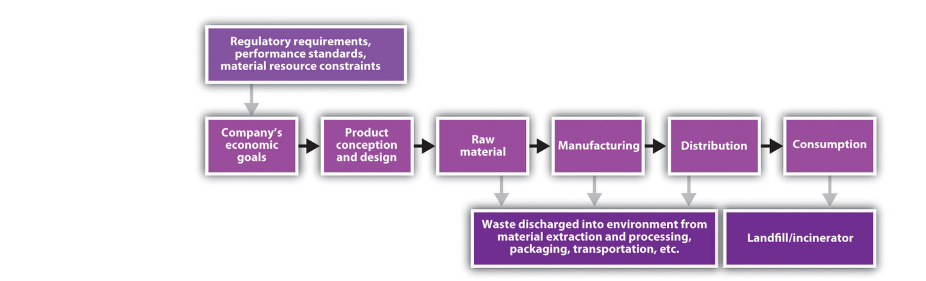

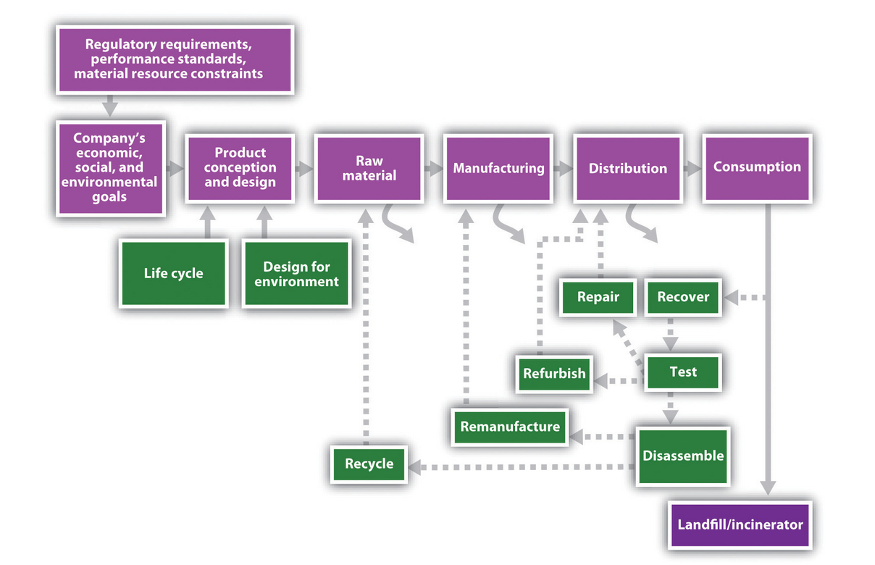

Improving Logistics

A company can select various ways to improve the sustainability of its logistics systems. The company may communicate sustainability standards backward to suppliers and require them to adopt environmental management systems or certifications, such as ISO 14001

Reverse Logistics

In addition to dramatically improving conventional supply chain logistics, sustainable supply chains extend past the point of product use, where conventional chains end, and consider how to recover and reuse materials—questions of reverse logistics (the part of the supply chain that takes used products from consumers and recycles, refurbishes, or otherwise disposes of those products).

Life Cycle Assessment and Design for Environment

The same techniques that improve the sustainability of conventional logistics also aid reverse logistics. In addition, sustainable supply chains fundamentally require two tools: life cycle assessment (LCA) and design for environment (DfE). According to the U.S. Environmental Protection Agency’s National Risk Management Research Laboratory, LCA takes the viewpoint of a product, process, or service by “(1) compiling an inventory of relevant energy and material inputs and environmental releases; (2) evaluating the potential environmental impacts associated with identified inputs and releases; [and] (3) interpreting the results to help you make an informed decision,” typically to minimize negative impacts across the entire life of the product (U.S. Environmental Protection Agency, n.d.; for examples, see Bevilacqua, Ciarapica, & Giacchetta, 2007; Matos & Hall, 2007).

*Note*. Adapted from “Green Supply Chains,” by A. Larson, 2011, *Sustainability, Innovation, and Entrepreneurship*, Chapter 6, Section 1. Copyright 2011 by Flat World Knowledge, Inc.

**Topic 3: "Cradle to Grave" or "Cradle to Cradle"**

**Topic 3: Activity 1 of 9--The World's Biggest Electronics Waste Dump --Video**

# China's 'Amazing Economic Growth

<https://www.youtube.com/watch?v=2tDx5lTTmF4>

1. Workers rights and health in China, problem with e waste

Topic 3: Activity 2 of 9--Cradle to Cradle

Various factors, like stricter enforcement of environmental laws, limited resources, and fewer disposal options, are creating the need for research and development (R&D) departments to rethink plans, policies, and procedures.

**Cradle to Cradle**

Products and processes have historically been designed for **cradle to grave**. That is, design has only considered the product from the point of manufacture to disposal. With growing awareness of environmental impacts and companies’ tendency to externalize costs, there has been a shift in thinking about design in terms of cradle to cradle. **Cradle-to-cradle** design requires a shift in thinking about traditional manufacturing, recycling, and environmentalism. Cradle-to-cradle design encourages us not to choose the least environmentally damaging approach but rather to create and design a better approach. It encourages the integration of nature into the design process with a goal of zero waste. Products and processes integrating this design philosophy can receive Cradle to Cradle certification (McDonough Braungart Design Chemistry, 2008).

Cradle to cradle is a design philosophy articulated in the book of the same name by William McDonough and Michael Braungart in 2002 (McDonough & Braungart, 2002). As of 2005, Cradle to Cradle is also a certification system for products tested by McDonough Braungart Design Chemistry (MBDC) to meet cradle-to-cradle principles.

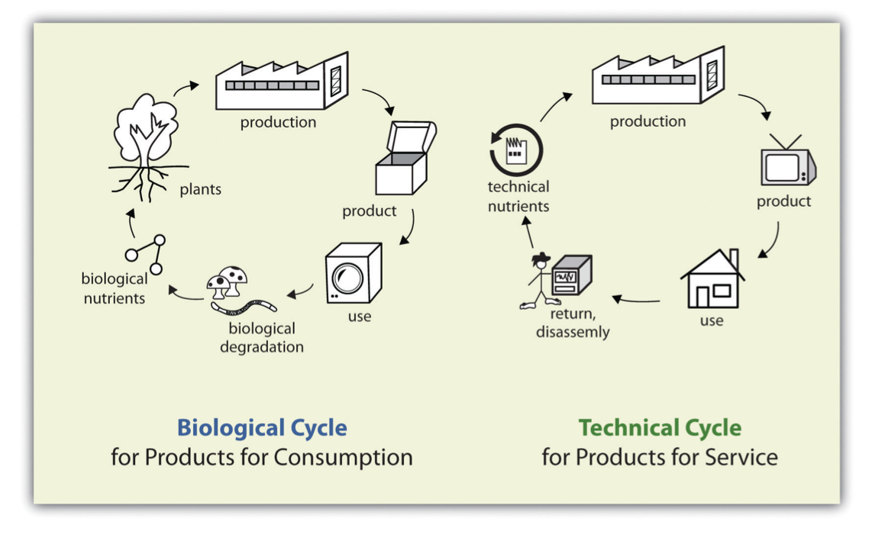

All toxic chemicals would contain chemical markers that identify the chemical’s owner, and the owner would be responsible for retrieving, mitigating, or cleaning up its toxins should they be discovered in lakes, wells, soil, birds, or people (Hawken & McDonough, 1993; Braungart, 1994).

The second principle of ecological intelligence, “use current solar income,” is derived from the second law of thermodynamics. Though the earth is a closed system with respect to matter, it is an open system with respect to energy, thanks to the sun.

The third principle of ecological intelligence is “respect diversity.” Biodiversity, the characteristic that sustains the natural metabolism, must be encouraged through conscious design.

Finally, cradle-to-cradle eco-effectiveness “sees commerce as the engine of change” rather than the inherent enemy of the environment and “honors its ability to function quickly and productively” (McDonough & Braungart, 2002, 150). Companies should make money, but they must also protect local cultural and environmental diversity, promote justice, and in McDonough’s world, be fun.

*Note*. Adapted from “Cradle to Cradle,” by N.E. Landrum & S. Edwards, 2012, *A Primer on Sustainable Business*, Chapter 5, Section 1. Copyright 2012 by Flat World Knowledge, Inc.

Topic 3: Activity 3 of 9--Understanding Life Cycle Analysis

Life cycle analysis (LCA, sometimes referred to as life cycle assessment) measures the environmental impact of specific products or processes from cradle to grave. LCA provides a snapshot in time of a specific product from a specific manufacturer, and it may be difficult to generalize findings. However, LCA is a useful tool for making product and process decisions that consider environmental criteria. The benefit of LCA is that businesses can identify the most effective improvements to reduce cumulative environmental impacts resulting from all stages in the product life cycle, often including upstream and downstream impacts not considered in more traditional analyses (e.g., raw material extraction, material transportation, ultimate product disposal, etc.). e greatest benefit of LCA is that it allows scientific comparison of products or processes in order to determine the most environmentally friendly option from cradle to grave.

**Concurrent Engineering**

**Concurrent engineering is a design philosophy that brings together the players in a product’s life cycle during the design stage.**

**ompanies that employ a concurrent engineering design philosophy feature empowered design teams that are open to interaction, new ideas, and differing viewpoints (Carlson-Skalak, 1997). Concurrent engineering then is an effective vehicle to implement product design frameworks such as DfE, sustainable design, and even the process-oriented tool TNS, which is not a design framework *per se* but can be used effectively as a guide to change decision making during design.**

***Note*. Adapted from “Life Cycle Analysis,” by N.E. Landrum & S. Edwards, 2012, *A Primer on Sustainable Business*, Chapter 5, Section 3. Copyright 2012 by Flat World Knowledge, Inc.**

**Topic 3: Activity 4 of 9--Green Mountain Coffee: Life Cycle Analysis--video**

# SB Interviews- Green Mountain Coffee on Supply Chain Analysis

[**https://www.youtube.com/watch?v=9CqzGqfvFWk**](https://www.youtube.com/watch?v=9CqzGqfvFWk)

**What is the biggest environmental impact. Look at the life cycle and find it. find ways to reduce environmental impact.**

**Topic 3: Activity 5 of 9--Life Cycle Management and Sustainability**

Sustainability involves taking a holistic perspective to understand the true short-term and long-term impacts of a business activity. Life cycle thinking has emerged as a useful tool in sustainability to consider the total impacts of an activity, product, or service from its origin to its end. This differs from conventional business practices in which the focus has traditionally been on more immediate factors, such as cost, quality, and availability in the supply chain. Life cycle thinking still takes into account these factors but considers them over a product’s lifetime. Although conventional business practices have given limited consideration to disposal costs, life cycle thinking considers the impacts of disposal to be an important part of the overall process of product or service provision.

Life cycle thinking in a business context considers business activities using a “cradle to grave” perspective. Cradle to grave starts by considering the impacts of raw material extraction and other inputs.

**Life Cycle Management**

The management philosophy that integrates a comprehensive life cycle approach for organizations in managing their value chain is called life cycle management (LCM).

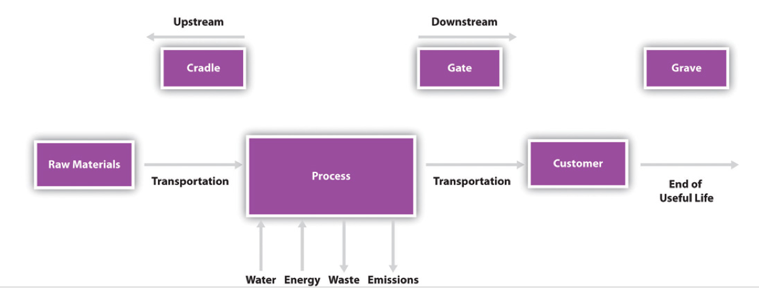

Different types of life cycle management include the following:

* Cradle to grave includes the whole product life cycle from beginning to disposal.
* Cradle to gate focuses on the phase from input extraction through the organization output, but not downstream impact.
* Cradle to cradle specifically focuses on the end-of-life step being recycling. This type of life cycle management is becoming more in focus, where considerable attention is paid in designing products so that they can become part of another beneficial use and not be disposed of as waste.

*Note*. Adapted from “Sustainable Financing,” by N.E. Landrum & S. Edwards, 2012, *A Primer on Sustainable Business*, Chapter 4, Section 5. Copyright 2012 by Flat World Knowledge, Inc.

Topic 3: Activity 6 of 9--Biomimicry

**Biomimicry** is an innovative method that searches for sustainable solutions by imitating features naturally found in the environment into the design of products. Using biomimicry, sustainable businesses can look at nature in new ways to understand how it can be used to help solve problems. Nature can be seen in three different perspectives: nature as model, nature as measure, and nature as mentor (Benyus, 1997).

*Note*. Adapted from “Biomimicry,” by N.E. Landrum & S. Edwards, 2012, *A Primer on Sustainable Business*, Chapter 5, Section 2. Copyright 2012 by Flat World Knowledge, Inc.

Topic 3: Activity 7 of 9--Biomimicry in Action--video

# Janine Benyus: Biomimicry in action

TED

<https://www.youtube.com/watch?v=k_GFq12w5WU>

Topic 3: Activity 8 of 9--Practical Frameworks and Tools

For example, **The Natural Step (TNS)** is a broad framework used by firms, municipalities, and nonprofit organizations, whereas industrial ecology is an academic field that has provided overarching concepts as well as developed product design tools. Natural capitalism is a framework developed by well-known energy and systems expert Amory Lovins together with L. Hunter Lovins and author-consultant Paul Hawken. Ecological economics is a branch of economics that combines analysis of environmental systems with economic systems, while cradle-to-cradle is a design protocol with conceptual roots in the field of industrial ecology. Nature’s services refers to the ability of natural systems to ameliorate human waste impacts, and the related concept of ecosystem service markets references the burgeoning arena of markets for the services natural systems provide to business and society. The biomimicry approach calls for greater appreciation of nature’s design models as the inspiration for human-designed technology. Green chemistry is a fast-expanding challenge to the conventional field of chemistry. It invites use of a set of 12 principles for the design of chemical compounds. Green engineering offers guiding design parameters for sustainability applied to engineering education. Life cycle analysis, design for environment, concurrent engineering, and carbon footprint analysis are tools for analysis and decision making at various levels of business activity including within the firm and extending to supply chains. There is no “right” framework or tool. It depends on the specific task at hand. Furthermore, some of these tools share common assumptions and may overlap. However, this is a useful sample of the types of frameworks and tools in use. Reviewing the list provides the reader with insights into the nature and direction of sustainability innovation and entrepreneurship.

**The Natural Step**

TNS is both a framework for understanding ecological principles and environmental problems and an international nonprofit education, consultation, and research institution based in Sweden.

**The Natural Step for Business**

To summarize, although the earth is a closed system with regard to matter, it is an open system with respect to energy. This is the reason why the system has not already run down with all of its resources being converted to waste. The earth receives light from the sun and emits heat into space. The difference between these two forms of energy creates the physical conditions for order in the biosphere—the thin surface layer in the path of the sun’s energy flow, in which all of the necessary ingredients for life as we know it are mingled (Nattrass & Altomare, 1999, 35).

Cyclical systems lie at the heart of TNS framework. Although the natural world operates in a continuously regenerative cyclical process—photosynthesis produces oxygen and absorbs CO2; plants are consumed, die, and decay, becoming food for microbial life; and the cycle continues—humankind has typically used resources in a linear fashion, producing waste streams both visible and molecular (invisible) that cannot all be absorbed and reassimilated by nature, at least not within time frames relevant for preservation of human health and extension of prosperity to billions more who demand a better life. The result is increasing accumulations of pollution and waste coupled with a declining stock of natural resources (Larson & Reichert, 1998, 18). In the case of oil, global society must address both declining resources and control of existing resources by either unstable governments or regimes whose aims can oppose their own populations’ and other countries’ well-being.

**TNS System Conditions**

With foundational scientific principles dictating a compelling logic that guides decision making, a framework of system conditions followed to form *TNS system conditions*:

1. The first system condition states that “substances from the earth’s crust must not systematically increase in the ecosphere.” This means that the rate of extraction of fossil fuels, metals, and other minerals must not exceed the pace of their slow redeposit and reintegration into the earth’s crust. The phrase “systematically increase” in the systems conditions deserves elaboration. The natural system complexity that has built and sustains the biosphere maintains systemic equilibrium within a certain range. We now recognize that humans contribute to CO2 atmospheric buildup, potentially tipping climate to a new equilibrium to which we must adapt.
2. The second system condition requires that “substances produced by society must not systematically increase in the ecosphere.” These substances, synthetic compounds created in laboratories, must be produced, used, and released at a rate that does not exceed the rate with which they can be broken down and integrated into natural cycles or safely incorporated in the earth’s crust (soil, water).
3. The third condition states that “the physical basis for productivity and diversity of nature must not be systematically diminished.” This requirement protects the productive capacity and diversity of the earth’s ecosystems as well as the green plant cells, the photosynthesizers on which the larger ecological systems depend.
4. Finally, the fourth system condition, a consideration of justice, calls for the “fair and efficient use of resources with respect to meeting human needs.”

Under the TNS framework, these four system conditions act as a compass that can guide companies, governments, nonprofit organizations, and even individuals toward sustainability practices and innovation (Robèrt et al., 1996). Here, “sustainability” explicitly refers to a carrying capacity or ability of natural systems to continue the age-old regenerative processes that have maintained the requisite chemistry and systems balance to support life as we know it.

### Figure 6.6 TNS System Conditions

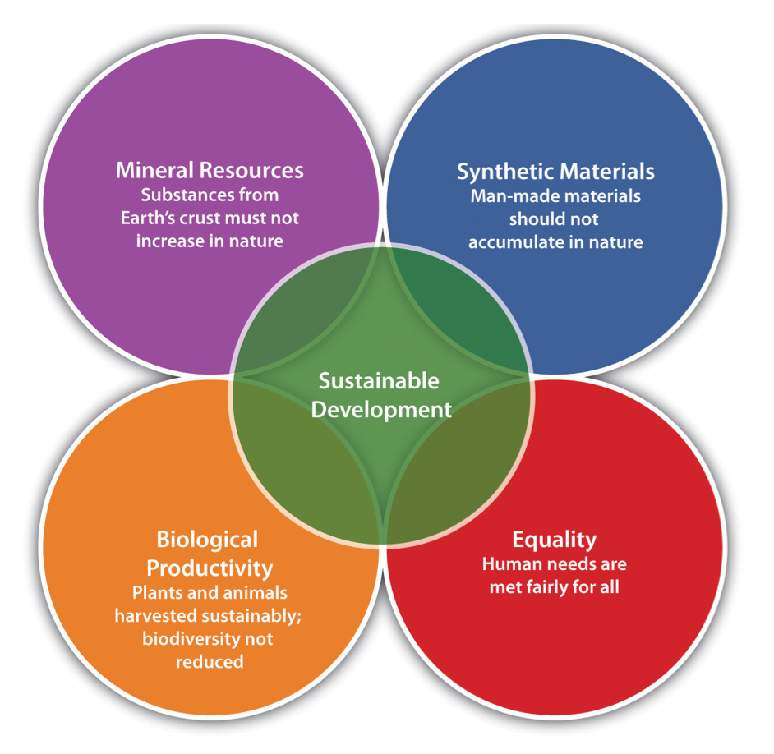"How We Avoid the Climate Change Confusion: We Follow the Principles of ‘The Natural Step,’” by Green Business Ratings. Available at http://www.greenbusinessratings.com/page6/page6.html. Copyright 2008 by Green Business Ratings. Reproduced with permission.

TNS framework has been applied in many corporations and is seen by some as a logical extension of quality management and strategic systems thinking (Larson & Warren, 1997, 2). It incorporates environmental and health protection into decision making by using scientific principles. TNS allows a company to understand the physical laws that drive environmental problems and defines the broad system conditions that form a “sustainable” society. These conditions provide a vehicle to assess progress, and from them companies can develop a strategy applicable to their products and services. Design teams can ask whether particular product designs, materials selection, and manufacturing processes meet each of the system conditions and can adjust in “natural steps”—that is, steps that are consistent with financially sound decision making in the direction of meeting the system conditions. TNS does not provide a detailed how-to regarding specific product design; however, with the knowledge and framework provided by TNS, companies can develop a more informed approach and strategic position and begin to take concrete steps customized to their unique circumstance with respect to natural resource use and waste streams.

**The Natural Step as an Institution**

To learn more about The Natural Step as a framework or institution, visit [Natural Step(This content will be opened in a separate window or downloaded to your computer)](http://www.thenaturalstep.org/).

**Industrial Ecology**

Business activity currently generates waste and by-products. Unlike natural systems, modern human societies process resources in a linear fashion, creating waste faster than it can be reconstituted into reusable resources. According to the National Academy of Engineering, on average 94% of raw materials used in a product ends up as waste; only 6% ends up in the final product. Whereas pollution control and prevention focus on minimizing waste, industrial ecology allows for inevitable waste streams because they become useful inputs to other industrial and commercial processes. Continued provision of needed goods and services to growing populations in a finite biosphere becomes at least conceptually possible if all waste generated by business and consumer behavior is taken up by other industrial and commercial processes or safely returned to nature.

The challenges to establishing a sophisticated industrial ecosystem are many, including identifying appropriate input opportunities for waste products amid ownership, geographic, jurisdictional, informational, operational, regulatory, and economic hurdles. Although industrial ecology could theoretically link industries around the globe, it has also been used at a local scale to mitigate some of these challenges. Several eco-industrial parks are currently in development (Kallundborg, Denmark, is the well-known historical example) where industries are intentionally sited together based on their waste products and input material requirements. If the interdependent system components at the site are functioning properly, the emissions from the industrial park are zero or almost zero. Problems arise when companies change processes, move facilities, or go out of business. This disrupts the ordered and tightly coupled chain of interdependency, much as when a species disappears from a natural ecosystem. Industrial ecology thus provides a broad framework and suggests practical solutions.

**Natural Capitalism**

Natural capitalism is a broad social and economic framework that attempts to integrate insights from eco-efficiency, nature’s services, biomimicry, and other realms to create a plan for a sustainable, more equitable, and productive world. Paul Hawken, author of *The Ecology of Commerce*, and Amory Lovins and L. Hunter Lovins, cofounders of the Rocky Mountain Institute for resource analysis and coauthors with Ernest von Weizsäcker of *Factor Four: Doubling Wealth, Halving Resource Use*, were independently looking for an overall framework to implement the environmental business gains they had studied and advocated. After learning of each other’s projects, they decided in 1994 to collaborate on *Natural Capitalism.*

Some very simple changes to the way we run our businesses, built on advanced techniques for making resources more productive, can yield startling benefits both for today’s shareholders and for future generations. This approach is called *natural capitalism* because it’s what capitalism might become if its largest category of capital—the “natural capital” of ecosystem services—were properly valued. The journey to natural capitalism involves four major shifts in business practices, all vitally interlinked:

* dramatically increase the productivity of natural resources,
* shift to biologically inspired production models,
* move to a solution-based business model, and
* reinvest in natural capital (Lovins, Lovins, & Hawken, 1999).

**Ecological Economics**

Ecological economics as a field of study was formalized in 1989 with the foundation of the International Society for Ecological Economics (ISEE) and the first publication of the journal *Ecological Economics*. The move toward ecological economics had roots in the classical economics, natural sciences, and sociology of the mid-19th century but gained significant momentum in the 1970s (Martinez-Alier, 1987) as the strain between human activity (economics) and natural systems (ecology) intensified but no discipline or even group of disciplines examined the interaction of those two systems specifically. Robert Costanza (1989) commented on the problem and the need for a new approach: “Environmental and resource economics, as it is currently practiced, covers only the application of neoclassical economics to environmental and resource problems. Ecology, as it is currently practiced, sometimes deals with human impacts on ecosystems, but the more common tendency is to stick to ‘natural’ systems. . . [Ecological economics] is intended to be a new approach to *both* ecology and economics that recognizes the need to make economics more cognizant of ecological impacts and dependencies; the need to make ecology more sensitive to economic forces, incentives, and constraints.”

Ecological economics examines how economies influence ecologies and vice versa. It sees economic activity as occurring only within the confines of earth’s processes for maintaining life and equilibrium and ecology as overwhelmingly influenced by humans, even if they are but one species among many. In short, the global economy is a subset of earth systems, not a distinct, unfettered entity. Earth’s processes and resultant equilibrium are threatened by massive material extraction from and waste disposal into the environment, while material inequality among societies and people threatens long-term prosperity and social stability. Hence the constitution of the ISEE propounds the “advancement of our understanding of the relationships among ecological, social, and economic systems and the application of this understanding to the mutual well-being of nature and people, especially that of the most vulnerable including future generations” (International Society for Ecological Economics, n.d.). The field continues to emphasize broadly and rigorously investigating interdependent systems and their material and energy flows.

**Nature’s Services**

The nature’s services philosophy emerged in the late 1990s as a practical framework to put a monetary value on the services that ecosystems provide to humans to better weigh the trade-offs involved with preserving an ecosystem or converting it to a different use. The nature’s services outlook posits two things. First, “the goods and services flowing from natural ecosystems are greatly undervalued by society . . . [and] the benefits of those ecosystems are not traded in formal markets and do not send price signals” (Daily, 1997, 2). Second, we are rapidly reaching a point of no return, where we will have despoiled or destroyed so many ecosystems that the earth can no longer sustain the burgeoning human population. Nature’s systems are too complex for humans to understand entirely, let alone replace if the systems fail. Indeed, Stanford biology professor Gretchen Daily was inspired to edit the book *Nature’s Services*, published in 1997, after “a small group of us [scientists] gathered to lament the near total lack of public appreciation of societal dependence upon natural ecosystems” (Daily, 1997, xv; Daily expanded on these concepts in Daily & Ellison, 2002).

**Ecosystem Survival Is Human Survival**

*Note*. Adapted from “Practical Frameworks and Tools,” by A. Larson, 2011, *Sustainability, Innovation, and Entrepreneurship*, Chapter 3, Section 4. Copyright 2011 by Flat World Knowledge, Inc.

Topic 3: Activity 9 of 9-- Better Way to Recycle Plastics

# Mike Biddle: We can recycle plastic

<https://www.youtube.com/watch?v=RD07GkmM2fc>