Social Responsibility and Risk Final

Paper Two

Ford Motors

Jeffery Morse

Brandman University

Social Responsibility and Risk of Ford Motors

Most of the information for this paper was acquired at sustainability.ford.com (Sustain, 2018). Further, such items as the Annual Report, Supply Chain Audits, and Sustainability Report are all available from shareholder.ford.com (Investors, 2019). This paper is in question-answer format, with most questions taken directly from the instructions for this paper (CBE, 2019).

**Step One: Identify Two Companies.**

The companies chosen for this assignment are General Motors, which is currently number thirteen on Fortune 500 companies and Ford Motor Company, which is presently number twelve (Fortune, 2019). Last year GM was number ten and Ford number eleven.

**Step Two: Research Ford**

Using the thirteen questions listed, comprehensive research was performed and reported in a question and answer format using a three to eight sentence response with at least one reference.

• Describe, in general terms, the organization’s approach to supply management and risk. What steps has the organization taken to achieve sustainability and social responsibility while addressing risk exposure?

**Supply Chain Management and Risk**

Ford touts 350 thousand employees in 200 countries with revenue of 260 billion a year (Whalan, 2006). Fords list of risks in their Annual Report (AR) includes such items as competitiveness and sales. Ford then says that they may need to substantially modify product plans to comply with the safety, emissions, fuel economy regulations in the future. This is quite the lie since cars in the 20th century produced by Shell Oil got 49.73 mpg in 1939, 149.95 mpg in 1949, 244.35 mpg in 1968 and the larges, 376.59 mpg in 1973 (Shell Oil, 1977). The economy regulation referred to must be limits on mpg instead of advances. Though Ford does have risk in the supply chain, not one mention of an Environmental Management Plan (EMP) is in the Sustainability Report. The plans that Ford does have in place are, Partnership for A Cleaner Environment (PACE) program and Fords new flexible manufacturing strategy in which they build a supplier campus close to their productions plant and then move to Lean Production standards and Just in Time Supplier Management. Also, on the other side of the chain, Ford has introduced “Auto-xchange,” where all info is available at once to all the supply chain. This prevents overstocking and reduces lead times that were produced by the former way where information traveled from partner to partner (Karuku, 2016).

• Identify two activities the organization conducts in terms of the audit to ensure sustainable and socially responsible behavior in its supply chain.

**Audits to Ensure Sustainability**

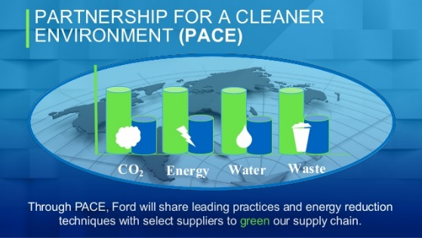Ford uses a variety of systems to manage the different aspects of sustainability in the supply chain. Overseen by the Value Roadmap, which outlines the processes to follow to improve performance, these ensure responsible actions and keep Ford accountable to society. One process is the Global Reporting Initiative (GRI) Content Index, and another is the Partnership for a Cleaner Environment (PACE) (Allen, 2017; AR, 2018). Also, third-party social responsibility audits inform suppliers if they are meeting the legal requirements and expectations. Since 2003, Ford had performed 1,163 supplier audits. Also, Ford has adopted the RBA’s Validated Audit Protocol (VAP). This audit which contains 90 questions spanning labor, health and safety, management systems, ethics, and the environment. In 2018, continued this trend by conducting 30 audits using the VAP methodology. For identified non-conformances, Ford expects action plans itemizing root causes and solutions. For more serious fault, immediate monitored corrective and containment plans are required. This process is working with results showing only 6 percent of identified non-conformances required immediate containment in 2018, of which:

— 48 percent associated with working hours and consecutive days of work

— 20 percents were health and safety issues

— 15 percent related to discriminatory practices

(Sustain, 2018)

• Briefly describe the organization’s culture. Include in your description of how the organization addresses sustainability and social responsibility as part of its culture.

**Sustainability as Part of Culture**

Ford’s culture page lists put people first, do the right thing, be curious, create tomorrow, built ford tough, play to win, and one ford as their initiatives for culture. Ford’s Vision & Strategic Areas of Focus is: “Our Diversity and Inclusion Vision is to have a diverse and inclusive environment that fosters skilled and motivated people working together to drive innovation and deliver results in support of our core business and emerging opportunities” (Culture, 2018). Ford takes sustainability and culture as many major firms do, with the company in mind first and then the people. The culture is one that might include the term, “a company man.” Though Ford’s cultural score is a B- at 68 percent, its Employee Net Promoter Score (eNPS) is (-17) (Comparability, 2017). Through PACE, Ford shared its best processes implemented with 50 suppliers to reduce overall environmental impact (AR, 2017). One item repeated over and over again is the Paris Accord, which requires a reduction in vehicle emissions Paris Accord. In the Paris Accord, 195 countries committed to help reduce climate change by such things as reducing CO2, a greenhouse gas (GHG). However, this accord does little to solve global warming as it only cuts global greenhouse gas emissions by half of the necessary amount (Davenport, 2015). In 2017, Ford achieved its emissions reduction goal ahead of schedule--by eight years, reducing its global CO2 emissions by 30 percent per vehicle. On the human rights front, Ford has used blockchain technology to show that it's material sourcing agrees with OCED standards so as not to contribute to forced or child labor. In addition, Ford launched a revolutionary program in Jeddah, Saudi Arabia, called Driving Skills for Life for Her. The first-of-its-kind in Saudi Arabia as until recently, women were not allowed to drive. Ford is also very active in the STEAM program all over the world. As a result, one might say Ford is socially responsible when it comes to human rights but are not pushing too hard away from fossil fuels. Although they do have zero emission programs in which they have dumped billions into, the main focus seems to be on hybrid and gas technologies (Sustain, 2018; AR, 2018).

• How many audits has the organization conducted in the past five years? Provide two specific examples of audits conducted and identify the steps the organization took based on audit findings. Be sure to explain the relevance of the organization’s actions.

**Audits a Way of Life**

Ford does perform quarterly reports and is motivated to have all its information available on the web at sustainability.ford.com. Some of the reports available there is the Global Reporting Initiative (GRI) Content Index, Climate Change Scenario Report, UN Global Compact Communication on Progress Index, United Nations Sustainable Development Goals Index, UN Guiding Principles Reporting Framework on Human Rights Index, Sustainability Accounting Standards Board (SASB) Index, and Task Force on Climate-related Financial Disclosures. Each one of these reports is produced through the findings of an audit centered on that specific area (Sustain, 2018). The Index Reporting Progress (TCFD) is another auditing process where

suppliers are required to submit Conflict Minerals Reports annually to Ford. A Conflict Mineral might be gold, columbite-tantalite (coltan), cassiterite, wolframite or their derivatives, tantalum, tin, and tungsten. In 2012, the U.S. Securities and Exchange Commission (SEC) approved the final rule implementing reporting. As a result, since 2014, the US Dodd-Frank Act requires public companies to determine the origin of conflict minerals and then report annually to the SEC. Already mentioned above, GRI Content Index and PACE requires suppliers to report and be audited regularly (Allen, 2017; AR, 2018).

• Describe the organization’s use of transparency in its approach to audit, both within the industry and in terms of the public in general. Incorporate sustainability and social responsibility in your discussion.

**Transparency and Sustainability**

First of all, Ford was one of the first to pursue sustainability and had been publishing an annual sustainability report for the past 20 years. Also, Ford regularly has several third-party indices and climate change reporting organizations perform audits (Sustain, 2018). Ethics and compliance at the heart of the business. In addition, Ford’s Corporate Compliance Office has communication tools and developed training teaching partners how to comply with both policies and the law. The creation of “The Right Way” is a free mobile app that provides answers to frequently asked questions. The app also has the ability to contact the Compliance Office directly and is available in seven languages, “The Right Way” is publicly accessible, helping Ford’s suppliers and other partners maintain accountability policies and practices with the public. Further, the app is open source allowing other companies and groups to make use of it (Sustain, 2018). Finally, sustainability, ford.com is open to the public with all the reports available mentioned in the “Audits a way of life” section above.

• Identify whether the organization has a supplier code of conduct and, if so, how the organization uses it in the supply management system to ensure a sustainable and socially responsible outcome.

**Supplier Code of Conduct**

Ford does not have a Code of Conduct for suppliers but has what they call the next evolutionary step called an Aligned Business Framework (ABF). This strategic purchasing model began in 2005. Ford sought after long-term agreements with strategic suppliers increasing openness, dialogue within a partnership attitude. Moving away of non-compliance rules that could mean the end of Ford’s orders to non-complying suppliers. ABF agreements establish working boundaries for both Ford and the supplier in comprehensive business practices designed to increase future collaboration – of which extended sourcing and data transparency is one. The ABF agreement results in Ford’s supplier partners taking greater responsibility in ensuring proper working conditions and environmental management systems in their value chain. Suppliers are expected to adopt a working conditions code similar to Ford’s and proceed to develop training and compliance systems for their supply chains (UN, 2014).

• Briefly describe how the organization approaches communication and training, both within the organization and throughout the supply chain.

**Training**

Ford prefers the one on one model and provides training within their AFB supplier management framework. Further, Ford provides training through the special supplier web portal. The Ford Supplier Portal (FSP) allows Ford to share information and conduct business with its suppliers in a secure web environment (Portal 2019). Additionally, Ford sponsors many internships. Ford’s work to address human rights extends throughout the supply chain. Ford feels that training on human rights is essential. Fords approach to training has been developed and launched through the AIAG, which involves e-learning module and face-to-face workshops. These workshops stress the role of human rights and legal obligations, as well as industry guidelines and international best practice. Participants must verify training is performed (Sustain, 2019).

• Using evidence from training and communication efforts, describe the philosophy of your organization concerning people, planet, and profit.

**Philosophy**

* Listed next are the categories which identify GM’s corporate approach to risk management:

1. Financial Risk. First, Ford is very diversified. This is the most prominent feature for managing financial risk for Ford.
2. Operational Risk Ford is streamlining the assembly line, lean productions with just in time supply lines reduces operational risk (Whalan, 2006).
3. Brand/Reputation Risk; Ford is the sixth largest automotive provider in the world (Jones, 2019) with not many other brands under them. Built Ford tough is well known. Though the Mustang II was the worst car ever, the pinto outperformed the Chevy Vega which saved face for Ford. Ford is the go to truck of choice for the farming community; as such, it is likely Ford will remain a world favorite.
4. Legal Risk; Ford handles Legal risk with first being fully transparent, then, hiring a third-party company to oversee financial audits, while keeping friendly relationships with governments and taxing authorities. Another way Ford is managing legal risk is to innovate the supply chain relationship—introducing AFB with strict boundaries. Lastly, they are well represented by many legal entities.
5. Environmental Risk; Ford’s Issue-Specific Strategies include a Climate Change Strategy, Sustainable Materials Strategy, Renewable Energy Strategy, Human Rights Strategy, and Circular Economy Strategy. Further, Ford touts the following items listed form the Sustainability Report.

ACCESS-- We aspire to drive human progress by providing mobility and accessibility for all.

CLIMATE CHANGE --We support CO2 reductions consistent with the Paris Climate Accord.

AIR-- We aspire to achieve zero air emissions from our facilities.

ENERGY-- We will use 100 percent renewable energy for all manufacturing plants globally by 2035.

WASTE-- We will achieve true zero waste to landfill across our operations. We will eliminate single-use plastics from our operations by 2030.

WATER-- We will make zero water withdrawals for manufacturing processes We aspire to use freshwater for human consumption only.

MATERIALS-- We aspire only to use recycled and renewable plastics in our vehicles globally.

HUMAN RIGHTS-- We aspire to responsibly source all raw materials used within our vehicles globally.

DIVERSITY-- We aspire to become the most inclusive and diverse global company (Sustain, 2018).

1. Technical Risk. Ford manages technical risk though structure. All operational facilities are structured in a way to promote safety and efficiency.

* Does the corporation’s attitude embrace a sustainable and socially responsible framework in addressing risk assessment?

1. **Attitude of Sustainability**

Honestly, I am amazed at the lack of attitude of sustainability. However social responsibility makes of for it company. Ford is approaching zero-emission electric cars in a keep up with the Jones type of way. Ford is putting money in an AI, and electric, and automated vehicles but Ford is focused more on a holistic approach to electrification. This includes electrifying our most popular models, such as SUVs and commercial vehicles and trucks. Not fully electric but a profitable portfolio of hybrids and plug-in hybrids rather than all-electric vehicles (Sustain, 2018).

• Identify one specific strategy the organization has adopted to meet customer-driven requirements and expectations for a sustainable and socially responsible supply chain. How does this strategy contribute to success in overall supply management?

**Supply Chain Portal**

Ford’s Supply Chain Portal and Phone App are two way they are meeting customer-driven requirements. This process disseminates information to the entire value chain at once greatly accelerating customer service and performance. The phone app allows for immediate answers to questions and a way to contact management. In terms of the success of supply management, this is an evolutionary step when compared to older information dissemination processes. This supercharges the supply chain like never before (Portal 2019).

• Does your organization deal with hazardous/regulated materials? If so, use outside sources such as the Wall Street Journal, Bloomberg, and The New York Times to complete the following items (a through c). If your organization does not currently deal with hazardous/regulated materials, chose one that might be an issue in the foreseeable future to complete the following items.

**Hazardous Materials.**

Ford began monitoring and tracking the materials we used to make vehicles. This ensures relevant local and global regulations are met. This has led to notable reductions in a range of materials including hex chrome, lead, mercury, and copper. Ford’s Go Green initiative gave birth to the Dealer Sustainability Program. Though Ford does not sponsor any auto dismantling sites, many U.S. dealership service centers collect the parts for potential reprocessing. Also, Ford is committed to Green Buildings in its Go Green initiative. Additional areas of reduction listed in the sustainability report are: Paint sludge: 10 percent reduction over three years - Wastewater treatment plant sludge: 10 percent reduction over three years - General trash: 15 percent reduction over three years - Eliminating single-use plastics across our global operations — Continuing to send less waste to landfill globally: - Annual reduction in waste to landfill of seven percent per vehicle - Additional facilities to achieve true zero waste to landfill (ZWTL) status Going for Zero When a facility acquires ZWTL status, it means that absolutely no waste goes to a landfill site. To date, 88 Ford sites have achieved ZWTL (Sustain, 2018).

o Identify one policy or law related to hazardous/regulated materials that affect the organization’s supply management operations. Think about self-regulation, local jurisdictional requirements (could be state or federal policy), as well as international acts and laws that may have jurisdiction. Identify a risk associated with this policy or law; such as brand/reputation.

**Water**

One policy is the Resource Conservation and Recovery Act (RCRA). Ford continues the effort and in up to 10% reduction over three years.

o Identify one example of the organization addressing hazardous/regulated materials through its supply chain.

**Sustainability in the Supply Chain**

Ford’s goal is to eliminate waste from value streams and to deliver defect-free vehicles. To date, 88 Ford sites have achieved ZWTL (Sustain, 2018). As such, they require all their supply chain partners to adopt the same goals and offering training and help in succeeding in those goals which are required by Ford’s AFB supplier management framework (Sustain, 2018).

o Identify one specific documentation requirement related to hazardous/regulated materials that affect supply management strategies for the organization.

**Data Sheets**

Extensive use of safety data sheets which log the management of GHGs and regulatory requirements for air, waste, and water is just one way that Ford tracks and documents all regulated materials (Data Sheets, 2019).

• Briefly describe your organization’s supply chain in the simplest context as it relates to the concept of cradle to cradle. For example, how does it approach “reverse supply chain management”?

Ford tinkers with Cradle to Cradle and Reverse Supply Chain Management. First, William McDonough, signed a contract in 1999 with the automaker to re-design the River Rouge complex in Michigan with a living green roof. This was met by some reluctance at first until the EPA developing new stormwater regulations which would have cost Ford $50 million. McDonough’s natural stormwater management system cost only $15 million. As a result, Ford installed its first living green roof. More recently, Ford was noticed once more when it unveiled its “Model U” concept car a vehicle powered by a hydrogen engine and including Milliken & Co. upholstery fabric, chosen for their environmental health assets, and capable of perpetual recycling (MacArthur, 2010).

• Summarize in a list the steps your organization has taken (a track record) to achieve sustainability and social responsibility and address risk.

**Track Record**

Ford has a pretty good track record. Ford did not have to be bailed out but instead took a loan from someone other than TARP for only about six billion (Amadeo, 2019). Also, Ford has a good record of human rights as they actively fight for them. Ford’s biggest push in their firm is for diversity throughout the company and the supply chain (AR, 2018). However, the most impressive thing to me is the early involvement with sustainability management diagramed in Pic (1).

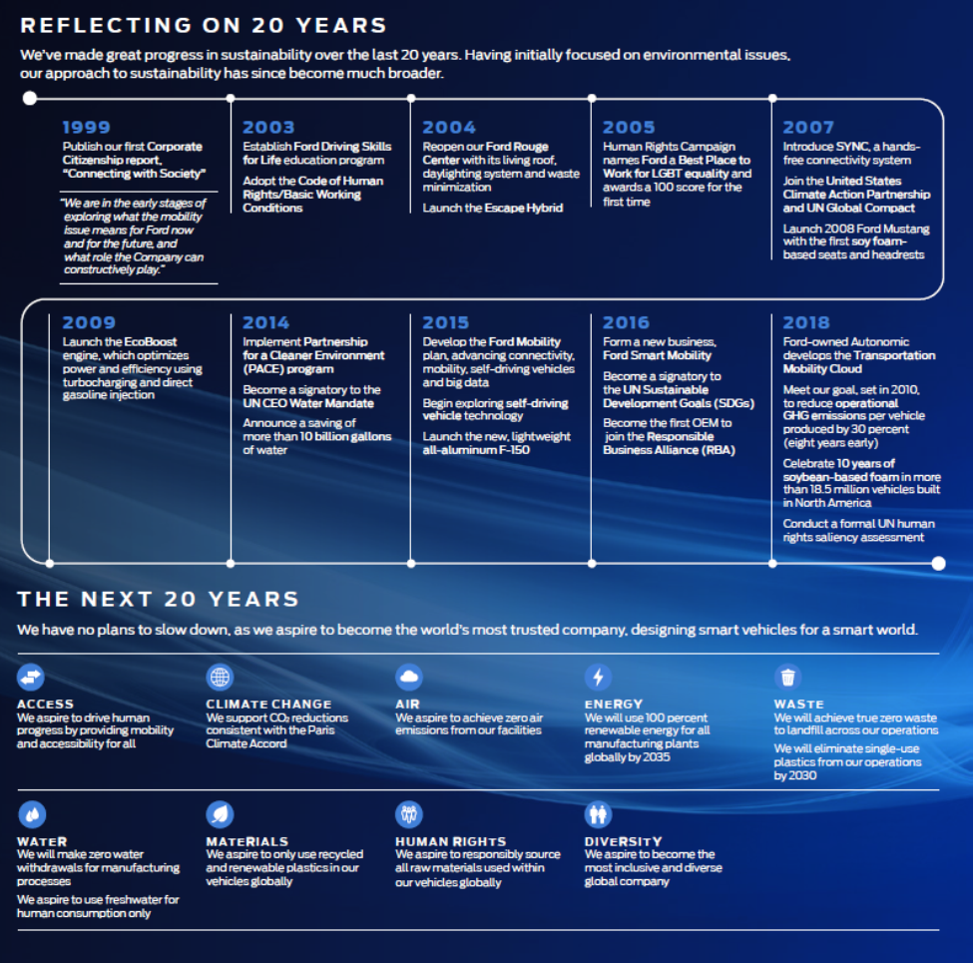

Pic 1

Retrieved From (Sustain 2018)

References

Allen, A. (2017) *Ford grows sustainable supply chain initiative*, Supply Management, Retrieved from: https://www.cips.org/supply-management/news/2017/april/ford-expands-sustainable-supply-chain-initiative/

Amadeo, K. (2019) *Auto Industry Bailout. Was the Big 3 Bailout Worth It?*, The Balance. Retrieved from: https://www.thebalance.com/auto-industry-bailout-gm-ford-chrysler-3305670

Annual Report(AR) (2018) *Annual Reports*, ford.com, Retrieved from: https://s22.q4cdn.com/857684434/files/doc_financials/2018/annual/2018-Annual-Report.pdf

CBE (2019) *Social Responsibility and Risk Final Assessment*: Outline and Rubric, Brandman, Retrieved from: https://brandman-cbeupload.s3.amazonaws.com/assets/16265/Social_Responsibility_and_Risk_Final_Assessment.pdf

Comparably (2017) *Ford Motor Company Culture - October 2017*, video, Retrieved from: https://www.youtube.com/watch?v=iwxVAl50Y7U

Culture (2019) *Our Culture*, Ford Corporate, Retrieved from https://corporate.ford.com/careers/culture.html

Data Sheets (2019) *Material Safety Data Sheet*, Ford Motor Company, Retrieved from: https://performanceparts.ford.com/download/PDFS/MSDS%20M-19546-A12%20US%20ENGLISH%202-24-2011.pdf

Davenport, C. (2015) *Nations Approve Landmark Climate Accord in Paris*, the Associated Press, December 12, 2015. Retrieved from: http://www.ssgates.com/climate-change-textcoding.pdf

Ford.com (2019) WebPage Url https://corporate.ford.com

Fortune (2019) *Fortune 500 top 100*, fortune .com, Retrieved from: http://fortune.com/fortune500/general-motors/

Investors (2018) Investors, ford.com, Retrieved from: https://www.shareholder.ford.com/home/default.aspx

Jones, J. (2019) *10 Largest Automakers in the World*, Largest.org, Retrieved from: https://largest.org/technology/automakers/

Karuku, S. (2016) *Ford Supply Chain Management*, video, Retrieved from: https://www.youtube.com/watch?v=OaDhAnxEDdU

MacArthur, E (2010) *Ford Motor Company River Rouge production plant* (Michigan, USA), the Ellen MacArthur Foundation, Retrieved from: https://www.ellenmacarthurfoundation.org/news/ford-motor-company-river-rouge-production-plant-michigan-usa

Portal (2019) *Ford Supplier Portal*, Url https://fsp.portal.covisint.com/web/portal/

Shell Oil (1977). *Fuel Economy of the Gasoline Engine*, John Wiley & Sons, New York. (ISBN 0-470-99132-1)

Sustain (2018) *Sustainability Report*, ford.com, Retrieved from: https://corporate.ford.com/microsites/sustainability-report-2018-19/assets/files/sr18.pdf

UN (2014*) Ford Motor Company: The Aligned Business Framework*, United Nations Global Compact Sustainable Supply chains: Resources & Practices: Retrieved from http://supply-chain.unglobalcompact.org/site/article/50

Whalan, M. (2006) *Ford Manufacturing Supply Chain*, video, https://www.youtube.com/watch?time_continue=23&v=qyO9QSo0FjU