**Strategic Fundamentals and Environment Plan for Business Upstart**

**Concept Introduction**

This is a strategic fundamental and environment plan Dutch Brothers Plus (name may change in the future) upstart concept. Coffee houses traditionally have dips in sales during the hot months, in contrast, juice bars and smoothie houses have dips in sales in winter months (Invest, 2018). Here the concept is to merge the two into one functioning and profitable business successfully. Nasdaq.com had this to say about this concept.

Co-branding (also known as piggyback franchising and dual or combination franchising) is, at face value, a brilliant idea: Take two franchise concepts, stick them in the same building and watch the revenue roll in. Not only does co-branding promise to save on operational costs like leasing, staff, kitchen equipment, building maintenance, and advertising, but it can also even out customer flow, especially if one concept appeals to the breakfast and lunch crowd and the other is destined for dinner. But franchise systems have touted co-branding's biggest advantage as providing a one-stop option for groups of people with different cravings. Tommy and Sally want chicken fingers, but Mom and Dad want pizza? Come on into our pizza parlor/chicken shack, and everyone will be happy (Nas, 2018).

The community of Marysville formally known as Linda California suffers from financial oppression. The general mindset is one of poverty and lost hope. In fact, according to Factfinder.gov over 32% of the seventeen thousand people are impoverished (FactFinder, 2018). It is not that people are not making money as the median household income of those that do work is 37k a year (FactFinder, 2018). Also, current efforts of the city are aimed at rejuvenation. Currently, the sidewalks, drainage, and new roads are all being installed. We believe that this proposed upstart are steps toward community transformation on more than one front. First, it will bring people of vision out from the college. People on a track to success can shine a light in the darkness of financial oppression. Secondly, this will provide a needed gathering spot, that is quiet and professional for the student to meet and study. Thirdly, by being a hybrid and offering a healthy juice-based drinks the upstart will magnify health and a healthy lifestyle in the community. Lastly, the closest coffee shop is in the city of Marysville, quite a drive for a coffee beverage, and the closest juice bar, Jamba Juice, is two cities away.

**Role of Strategy**

The positioning of the new business will increase in value as time goes on. The strategy for increased value has been proven through both Starbucks, Jamba Juice, and Burger King. Starbucks has made clear the importance it awards the planet in creating its environmental mission statement: “Starbucks is committed to a role of environmental leadership in all facets of our business,” (Starbucks, n.d.). Some may feel that a coffee house cannot be environmentally conscious. However, it is our feeling that environmental impact begins with a firm’s goals. Jamba juice includes this statement in both its vision and mission statements, “To inspire and simplify healthy living.” We believe that health is a great motivator for success. Oppression minister’s sickness, addiction, hopelessness, and much other unwelcomed communities and environmental problems—people just stop caring about their community and their future and get lost in despair. Promoting health and education are in direct opposition to hopelessness. We also plan to adopt Burger King's strategy for success in location by stealing the slogan, “through the light and to the right.” By choosing a four-way stoplight hindrances in stopping for a drink will be addressed.

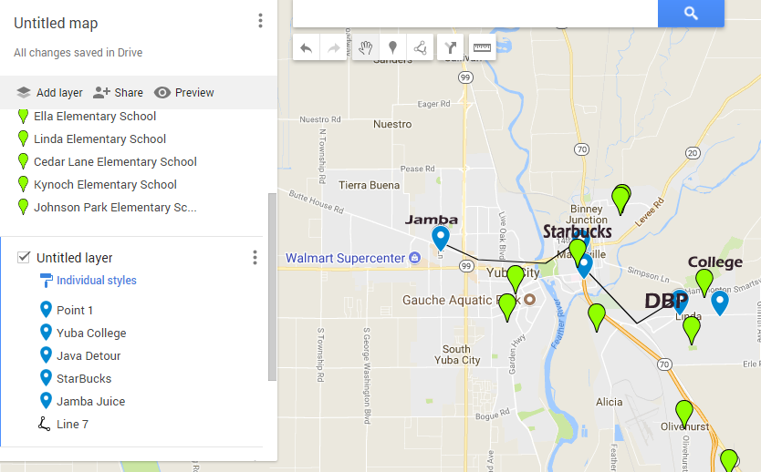

**Techniques**

Techniques used to formulate positioning are within the steps that will be necessary to develop this new businesses strategy.

1. Environmental Scan.
2. Do all analysis for business.
3. Clarify target customers, value proposition, and culture and strategic cultural advantage
4. Select staff is choosing the correct skills and capabilities., choose teamwork goals, leadership style, and work climate.
5. Solidify and select the competitive advantage style, vision, and mission statements.
6. Formulate and establish performance measures, scorecard, and benchmarks.
7. Set goals and milestones.
8. Improve from within by promoting education through tuition reimbursement.

**Strategic-Planning Process:**

How we determine the organization’s mission and goals is along the same strategy as we came up with the concept. The Hybrid method takes what we like and leave the rest. Here are some of the current mission statements for the coffee/juice businesses.

Mission Statement Dutch Brothers:

Love Abounds, and Dutch Bros are both about people first. Dutch Bros has established Love Abounds to engage its communities through giving and an action actively. Love Abounds supports programs and projects that build deeper connections through engagement in Four Core Areas. Youth Music Health Origins (Dutch, 2018).

Mission Statement Jamba Juice:

OUR MISSION: To become the world's leading blender of fruit aa nd other naturally healthy ingredients. Part of what makes Jamba Juice so successful is the passion both our customers and employees share for the product. ... OUR TIMELESS PURPOSE: To inspire and simplify healthy living (Jamba, 2018).

Mission Statement Starbucks:

To inspire and nurture the human spirit – one person, one cup and one neighborhood at a time (SB, 2018).

**Mission Statement DBP**

To become our community’s leader in promoting health by presenting a quality product. Juices and smoothies that are naturally healthy, coffees that encourage, and to uplift and inspire the hearts of people, person by person, cup by cup, while supporting our community through giving, health, music, and friendliness.

**Industry analysis**

Jamba Juice is reporting about 75 million in revenue with 22% of that being the EBIT or about 15 million (Jamba. 2018). Dutch Brothers coffee is running head to head with that (Dutch, 2018). The overall state of both industries is good. Juice bars are showing a 2 billion dollar revenue with a margin of annual growth at about 2.3% (Juice, 2018). The coffee industry continues to boom with 37 billion a year and an annual growth of 3.6% (Coffee, 2018). The upcoming generation is green, health conscience, and innovators. This means the forecast for both the coffee industry as well as the juice bar industry is one of promise. By creating a hybrid shop that sells both healthy juice and coffee the firm can expect growth in the area of the mean of the two which is nearing 3%. Suppliers for coffee are everywhere. This firm will both roast its beans – mostly for the aromatic reasons, and purchase from suppliers pre-roasted beans. For juicing locally grown organic fruits and veggies will always have a preference, then non-locally grown organic. Only in emergencies will non-organic fruits and veggies be used. We expect about 30%--50% of the clientele to come from the college. However, the road to which the firm is located is also a major inlet to the local air force base. As a result, we expect that service personnel will be a major portion of those who visit the establishment drive-thru.

Last but not least, are people going to work, or dropping kids off at one of the schools nearby. Currently, the only competitor is in the campus cafeteria. This is not accessible to neither the service personnel nor those going to work. The only other competition is downtown Marysville for coffee and two cities away for Juice.

**Analysis**

Before doing a SWOT on the business, I thought it prudent to perform one on myself.

**Strengths**

Educated in business.

Very capable in mechanics, engineering, construction, electronics, appliances, heating and air, and music. All this knowledge will bring down startup costs by thousands of dollars.

Have some equipment, and vehicles ready to go.

I have some great connections in the construction trades.

I know of several trustworthy people that would make great employees.

I am currently employed.

**Weaknesses**

I only have about a total of Six thousand in capital available on hand, of which only about 1500 is liquid.

Location may have to be built from the ground up; this would be expensive.

**Threats**

At any moment a firm already in the industry may see this opportunity and beat me to it. If two coffee shops exist in this location sales may suffer, especially since a firm like Starbucks has the capital to build fast.

If the business goes in where the city has not yet put in sidewalks, they may try to make me foot the bill in that location; this would drive entrance costs up to high to achieve.

**Opportunities.**

This is a great opportunity for me to begin my financial upswing. This vehicle is in the perfect location with a great idea for success. When successful this business would supply needed revenue for other ventures that lay ahead.

Now let’s look at the businesses themselves.

SWOT What are the strengths, weaknesses, opportunities, and threats for this business***?***

**Dutch Brothers**  **Jamba Juice**

**Strengths:**

Customer Service: Very friendly and affordable. Customer Service and Music

Positive Brand image Positive Brand Image

known for Community Involvement Known for good health

Gives back 1% to the community Buys local produce

Market entry costs are low Market entry costs are low

**Weaknesses**

Limited Merchandise No hot drinks for cold weather

Is not a Franchise only fresh produce

Drinks are limited limited customer base (health)

No Seating. No franchises available

**Opportunities:**

There is a great opportunity in the merging of these two industries. Weaknesses such as limited drinks and no drinks for cold weather are eliminated. Seating problems are also fixed along with limited customer base. The franchise issue is meet by not adopting the Jamba Juice franchise but instead just adding it under the current Dutch Brothers brand with the plus. This further allows the firm to adopt much of the Starbucks relaxed feel for those who wish to study, or commune. Another opportunity is cross-promoting merchandise. The Healthy Coffeehouse can promote health and serve caffeinated drinks, both cold and hot beverages with a unique listing of menu items to eat. The last opportunity comes from the fact that there is neither a local coffee house or juice bar other than on the college campus. The cafeteria on the campus is always rumbling, busy, and loud. This startup will offer an alternative that is close enough to the college to be a desired destination. Finally, promoting health will mean that DBP will actively partner with Gyms. By offering promotional items such as reward cards with free drinks after so many visits, we will continue to promote health. Down the line DBP after the franchise chain is established, we would like to acquire a chain of gyms to stand along our commitment to health.

**Threats**

* While the firm is unique, it is easily reproduced, and entry costs are low.
* A change in the economy might cause people to stop spending on unnecessary drinks.
* Market entry without an existing brand would be difficult.
* Transportation cost for fresh fruit would vary with fuel costs.
* There is an upswing in home juicing, and home espresso that is cheaper alternatives
* Major supermarkets supply bottled juices and cold coffees, and both Food Max, and Walmart are nearby
* The Campus has a Starbucks vendor in the cafeteria.

Two more tools for internal analysis are the value chain and VRIO tools. The value chain dissects the organization and then identifies areas of unique strength or weakness but since we just performed a SWOT.

**VRIO**

Value chain functions are also called capabilities. VRIO—which stands for Value, Rarity, Imitability, and Organization—is a framework that advocates that a capability, or a resource, such as a branding or a great location, is likely to yield a competitive advantage. An organization has shown to be valuable, rare, difficult to imitate and supported by the organization create a competitive advantage. When looking at Dutch Brothers Plus (DBP), there is definite value seen through VRIO analysis.

Value: First people love their coffee, and they also love a place to relax. Value is found in this area. However, Dutch Brothers Coffees add value by offering beverages at a discount when compared to Starbucks, or Java Detour. Also, streaming music is a cornerstone of Dutch Brothers Coffees that DBP will continue. Music partnerships with companies such as iTunes have proven to create value already by StarBucks. Jamba Juice creates value by cornering the market on the health front. Healthy, organic juice is a great supplement for coffee and a great alternative to soda pop. DBP plans on continuing creating value through great service that has both quality and friendliness.

Rarity: DBP is very rare in that it is a hybrid coffee house and a juice bar. Also, it is rare because there are no other juice bars within the city, to add the closest coffee house is in downtown Marysville.

Imitability: This business is easily duplicated while this is a negative if another entrepreneur where to start one in competition it is also positive for producing carbon copies in other location as the firm grows. On the other hand, this business supply chain and SCM system will be costly to reproduce. There are only so many fresh organic fruits and vegetables grown locally, and since DBP is the first of its kind, it will have a strategic advantage through new product development. Further, using Porter's Generic Competitive Strategies there is a competitive advantage from being a cost leader as well as having differentiation.

Organization: DBP must organize its management systems, policies, organizational structure, processes, and culture to fully realize the potential of its valuable, rare and costly to imitate resources and capabilities. This will come through Total Quality Management, Blue Ocean, and flexible product line.

**PESTEL**

Two primary tools examine the external environment for firms 1. PESTEL and 2. Industry Analysis. PESTEL is an acronym that stands for Political, Economic, Sociocultural, Technological, Environmental, and Legal Environments.

Political: Currently the city is in a facelift mode, and much effort is being put in to update the area of location, for this reason, its felt that favor from the city council will be given to any business that represents an uplift in the socioeconomic status of the current inhabitants of the community. Since DBP is focused on catering to those who currently have an academic vision for the future in tandem with DBP community involvement plans we forecast political support. Also, the U.S. Is currently experiencing some reprove from the last repression and business is not only up in California but the U.S. In general and we forecast this will be the case for the next couple of years at least.

Economical: Economically though the location has been economically repressed in the past, there is economic growth projected as sidewalks and drainage are being installed from the highway to the college. This will encourage more foot traffic as well as cyclists. Both companies that DBP is patterned after are doing well financially in both California, The U.S., including the locations currently doing business closest to our proposed location.

Social-cultural: This is an area of targeted change. Though the current Social-cultural feel of the area is one of oppression in the area surrounding Yuba College it is our desire to change this by bringing a new thriving business that promotes health, by attracting patrons who have a vision for the future, by have a culture that focuses on success, music, honest, quality, and fellowship into the community. While we know that DBP will be unable to accomplish this community transformation on its own, DBP will help to pioneer efforts by continuing the Dutch Brothers commitment of annually giving back a percentage of its profits to improve the community it does business in.

Technological: DBP will use up to date supply systems to ensure Just-In-Time deliveries of produce to ensure the fresher organic supplies for juicing and coffees possible. Further, the music traditions of Dutch Brothers combined with patterns borrowed from Starbucks will help to keep DBP on the cutting edge of music. Offering wifi and high-speed internet access as well as computers on timed rentals will also keep DBP a valued location for study or out of office work. Lastly, DBP commitment to innovation will ensure that DBP is a lays on top of the technologies advancement.

Environmental: The family felt and laid back smooth work environment will be a cornerstone at DBP locations. Also, for those on the go, a drive-thru that focuses on satisfied repeat business will be offered.

Whereas PESTEL provides you with a good sense of the broader macro-environment, industry analysis informs you about the organization’s competitive environment and the key industry-level factors that seem to influence performance. In industry analysis of Starbucks, Dutch Brothers, Jamba Juice, and Planet Smoothie franchises show growth and sustainability over the board.

**Justifications**

We will justify our organization’s mission, and goals through the improvement of the community DBP is placed in. Along with the mission we have our visions and our goals. Again we take what we need and leave the rest. Organizational performance refers to how well DBP is doing in reaching its vision, mission, and goals. For this reason, all goals will have a time factor.

Core Values

DBP is a people first firm. Honesty, Loyalty, Innovation, and Dedication are its chief values. Being light in a dark community is its calling. Making sure its family of employees is paid fairly, have medical, dental and a balanced home and work life are doctrines that each DBP will function under.

DBP Vision

To inspire healthy living through providing a place where human connection and great health come together in song.

Our Goals

1. Show a positive impact on the community in 6 months through a marked increase in the socioeconomic status increase in the local community. Through general community improvement efforts-at least two.
2. Break Even in 12 months.
3. The second Location opened in 24 months.

Two considerations we need to think of are (1) performance measures, and (2) performance referents. Performance measures are metrics along which DBP can be gauged. A performance referent is a benchmark used to make sense of DBP standing. The benchmarks we will look is Starbucks, Java Detour, Jamba Juice, and Planet Smoothie. DBP is not into remaking the wheel if one of these pioneers has found an innovation that works we will integrate the item and then evaluate its performance and quality by measuring the outcome against our mission, vision, and goals.

**Strengths Weaknesses and Strategies**

Most of the strengths have already been mentioned. However, we feel the biggest strength is our desire to improve each community we are placed in. In addition to this, the merging of Coffee and Juice next to an academic institution offers longevity and sustainability.

**Porter’s Key Strategies and Ghemawat’s “AAA” Global strategies**

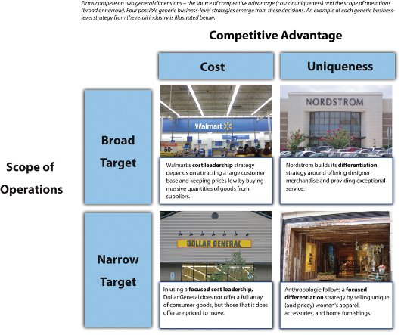 • Focused differentiation. While it is true that DBP will be selling coffees at prices near to Dutch Brothers, which is discounted compared to Starbucks and Java Detour, DBP will have to increase prices slightly to keep prices competitive on the Juice bar. Organic, fresh produce is at a premium even hear in the richest farm valley in the U.S. As a result, we will be focusing on Coffee and Juice Beverages, with only a small menu of food items.

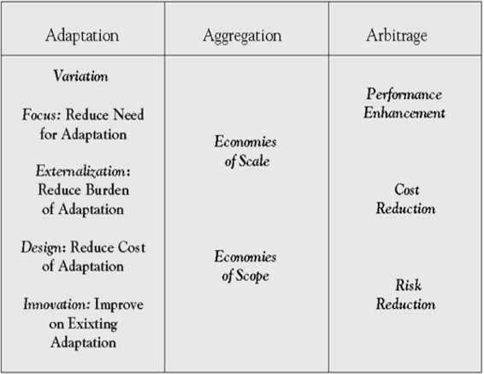• Adaption. Being headed for franchise DBP will be employing mostly Adaption, as we seek to improve each community we are placed in.

• Aggregation. This will have a place. Things such as the feel of the store, the greeting style, and the goal of improving communities will be carried into each store.

• Arbitrage. Since the Juice end will depend on mostly local veggies and fruits, we may be able to leverage some prices when we find an overabundance lower cost quality fruits and veggies in a location, if so it may be possible to import/export those items that are not indigenous in a market for a profit.

DBP strategic plan will be implemented from the top down. While the firm cannot exist without profit, it is our strategy that communities grow in success as we do. We start with the mission and vision to effect change in the community each store is located in by fostering a spirit of hope and success.

• Tactical: Our tactical plan is similar but involves our local suppliers. We will seek long-term partnerships with organic farmers who have a like mission and goal. Further, while we will be looking to save some money during purchasing, we also want to make sure that our local suppliers grow with us. As for those suppliers outside our community as we grow in numbers of franchised stores we hope to employ economies in scale for such things as cups, and lids. Lastly, DBP is green, and mostly in a red ocean, however, we hope that being the first of its kind we can move into a blue ocean due to our quality service and health conscience mindset/

• Operational: Our operational strategy is to make sure that all greeters make every experience like you are one of the most important people to visit, make every order a priority, and make everyone one family. Local produce will be preferred typically over shipped produce, with those supply partners managing and delivering just on time fruits, produce, and green supplies.

• Contingency: If local produce is not available orders will be fielded from the southern valley. In the event of competition moving in capitalization on media marketing will be enacted.

• Crisis Planning: In the event of a financial disaster, efforts to sell the establishment to rivals will be fielded.

**Financial Considerations:**

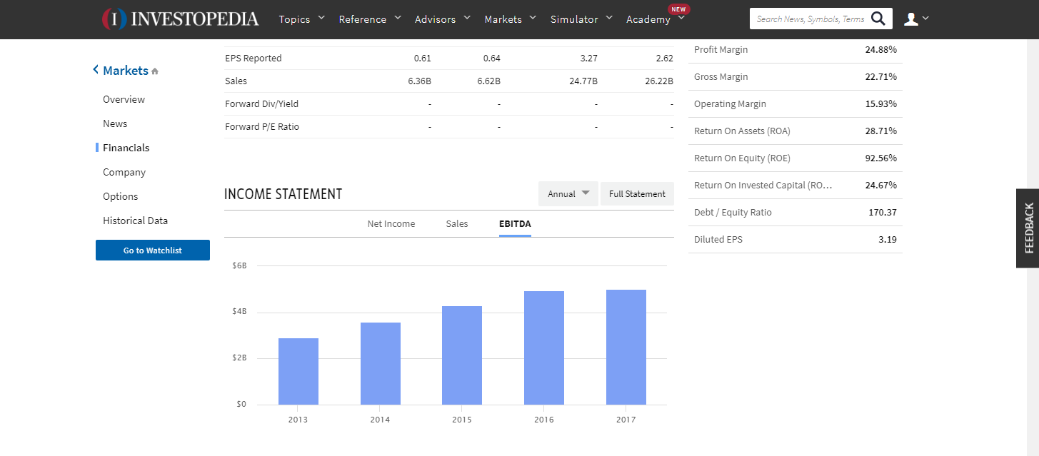Currently, Starbucks is reporting quiet and increase in profits.

However, Jamba Juice is showing decreasing sales.

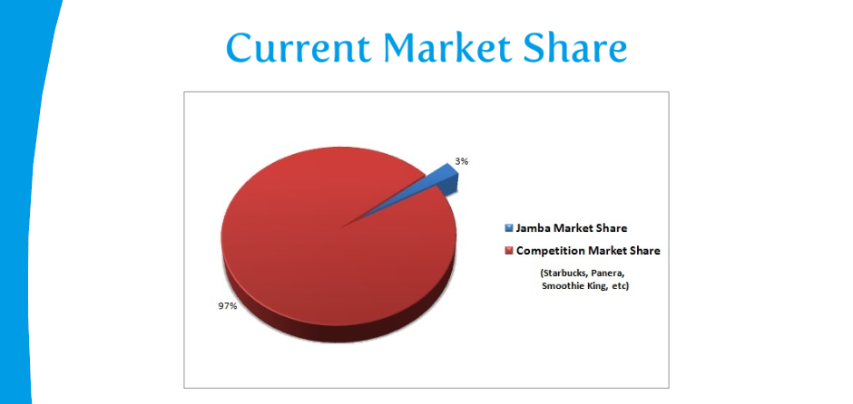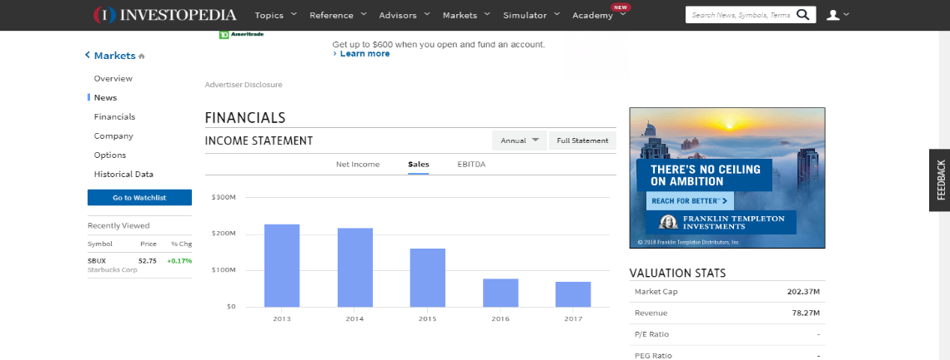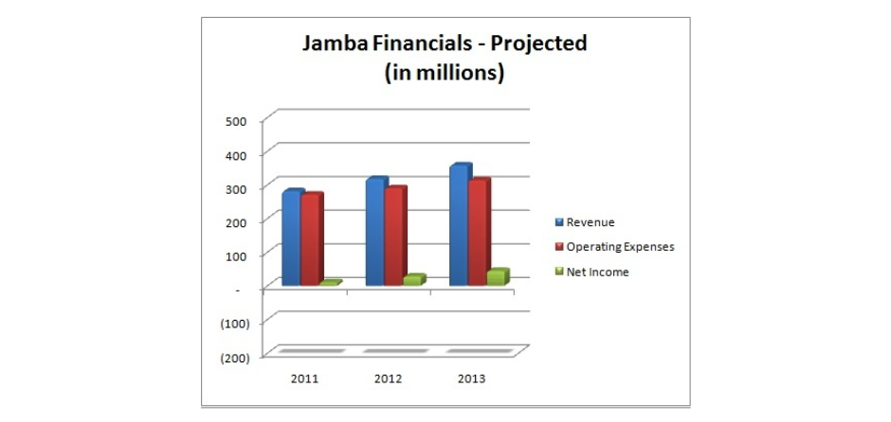This is due to 1. Lack of advertising and 2. Jamba Juices alliance with the now failed Golds Gym. We feel successful market penetration will drive Jamba’s former customer base to DBP as our advertising blankets the market. Further, alliances with up and coming gyms such as IN-Shape, and Planet Fitness. Lastly, this may eventually result in DBP’s acquisition of Jamba Juice. One other financial consideration is the procurement of small business grants for startup. By using grants instead of loans, DBP will relieve financial stress during times of startup.

**Organizational Structure:**

DBP will reposition organizational structures to help promote creativity and innovation that will result in greater organizational effectiveness and efficiency. Since the merging of these two ideas is relatively new, finding procedures in common in the making of Coffee, Juice, and Smoothing beverages is a must once these commonalities are found aggregate procedures will be instituted to ensure quality and speed. Innovations in supply management are of great value also as without fresh produce profits fall. Finally, innovation is products will always be on the menu. New combinations of coffee beans, roast styles, and mixtures of healthy juices will be searched out for the delight of our customers.

**Impact on Leadership Structures**

Beginning leadership structures are simple as a top-down sole proprietorship, however, as the firm grows, and franchising begins leadership structure will begin to stretch to C structure management finally when DBP incorporates and begins to be active on the market board of directors will take over in place of the CEO/Owner management style. At no time is more than 48% of shares to be available on the market.

Franchise owners will be selected from individuals of whom were or are employed by DBP and are in good standing. For those who show outstanding accomplishments in community support and innovation opportunities for franchises will be made available at discounted rates. The use of Balance Score Cards will be the strategy used to keep a record of such accomplishments. A balanced scorecard is an approach to assessing performance that targets managers’ attention in four areas: (1) financial, (2) customer, (3) internal business process, and (4) learning and growth.

All franchises must adopt and actively adhere to the Mission, Vision, and goals of DBP as stated or revised by the founding parties.

**Conclusion:**

The triple bottom line emphasizes the three Ps of, the planet, and profits. DBP represents each area uniquely and has the opportunity and potential to become a billion-dollar franchise easily. The idea of having hot coffee’s in cold weather and cold juices in warm weather ensures there will be no slump in seasonal sales. The location after the light and to the right near several schools and the only local college with the only competition miles away almost ensures success. The chosen mission, vision, and goals of this enterprise will make this firm a community favorite while providing the entrepreneur cash flow potential in the above the benchmark firms.

Reference

Coffee <https://www.ibisworld.com/industry-trends/specialized-market-research-reports/retail-market-reports/the-retail-market-for-coffee.html>

DBReport, (2018) <http://d0376.weebly.com/uploads/2/9/7/3/29730551/dutch_bros__case_analysis_report_final.pdf>

Dutch Brothers (2018) Url <https://www.forbes.com/companies/dutch-bros-coffee/>

Essays, UK. (November 2013). Industry and marketing analysis of Starbucks Coffee. Retrieved from <https://www.ukessays.com/essays/marketing/industry-and-marketing-analysis-of-starbucks-coffee-marketing-essay.php?vref=1>

FactFinder, (2018) Url <https://factfinder.census.gov/faces/nav/jsf/pages/community_facts.xhtml>

Invest, (2018) Url <https://www.investopedia.com/markets/stocks/sbux/#Financials>

Juice, (2018) <https://www.ibisworld.com/industry-trends/specialized-market-research-reports/consumer-goods-services/food-service-drinking-places/juice-smoothie-bars.html>

Jamba Insernal<http://customwritingtips.com/component/k2/item/14538-jamba-external-and-internal-environmental-analysis-paper.html?tmpl=component&print=1>

Jamba Juice <http://ir.jambajuice.com/phoenix.zhtml?c=192409&p=irol-newsArticle&id=2338420>

Nas, (2018) Url https://www.nasdaq.com/article/new-franchises-team-up-and-make-cobranding-work-cm129748

Planet Smoothie<https://planetsmoothiefranchise.com/learn-planet-smoothie/startup-costs/>

SB 2018 https://www.thebalancesmb.com/starbucks-mission-statement-2891826

Appendix A

Franchise fee 30000

Lot 60000

Land improvements 15000

Land Scaping 5000

Building 100000

2 Blenders 2288

Expresso Machine 6250

Walkin Ref 10000

Walking Freezer 10000

Ice Machine 1779

Sound System 2000

Coffee Grinders 1878

Supplies

Cleaning Supplies 1000

Maintenance Supplies 1000

Inventory

Cups 400

Lids 200

Straws 200

Milk 2000

Syrups 1000

Smoothy Mix 1000

Rebel 300

Coffee Beans 1200

Juice 100

Sauses 1000

Chia 400

Soy 600

Coconut Milk 600

Tea 500

Sugar 800

Water 100

Soda Water 50