Team Building Class Notes

Objective 1: Fundamentals of Team Building

Topic 1: Why Teams?

Topic 1: Activity 1 of 5 --Why Organizations Build Teams

Teams have a positive impact on the overall performance of organizations.

teams don’t always work. Indeed, according to one study, team-based projects fail 50 to 70% of the time (Greenberg & Baron, 2008, p. 316; Thomson, 2008, p. 5).

**The Effect of Teams on Performance**

Research shows that companies build and support teams because of their effect on overall workplace performance, both organizational and individual. If we examine the impact of team-based operations according to a wide range of relevant criteria—including product quality, worker satisfaction, and quality of work life, among others—we find that overall organizational performance improves.

Teams are not a cure-all for organizations. To determine whether a team is needed, organizations should consider whether a variety of knowledge, skills, and abilities are needed, whether ideas and feedback are needed from different teams within the organization, how interdependent the tasks are, if wide cooperation is needed to get things done, and whether the organization would benefit from shared goals (Rees, 1997).

*Note*. Adapted from "The Team and the Organization," by K. Collins, 2014, *Exploring Business*, Chapter 8, Section 1. Copyright 2014 by Flat World Knowledge, Inc.; "Understanding Team Design Characteristics," by M. Carpenter, T. Bauer, B. Erdogan, & J. Short, 2013, *Principles of Management*, Chapter 12, Section 2. Copyright 2013 by Flat World Knowledge, Inc.

Topic 1: Activity 2 of 5--Seven Key Benefits of Teamwork—article

[Advantages of Teamwork](http://www.workplace-communication.com/advantages-teamwork.html)

Topic 1: Activity 3 of 5--Expected Outcomes of Teams—activity

Topic 1: Activity 4 of 5 --Why and Where Is Teamwork Important?—article

*Forbes*: [Why and Where Is Teamwork Important?](http://www.forbes.com/sites/quora/2013/01/23/why-and-where-is-teamwork-important/)

Topic 1: Activity 5 of 5 –milestone

Topic 2: What Is a Team?

Topic 2: Activity 1 of 6--Groups and Teams

Differences Between Groups and Teams

A group is a collection of individuals. Within an organization, groups might consist of project-related groups, such as a product group or division, or they can encompass an entire store or branch of a company. The performance of a group consists of the inputs of the group minus any process losses, such as the quality of a product, ramp-up time to production, or the sales for a given month. Process loss is any aspect of group interaction that inhibits group functioning. is a bunch of people in an elevator.

A team is a particular type of group: a cohesive coalition of people working together to achieve mutual goals. Being on a team does not equate to a total suppression of personal agendas, but it does require a commitment to a shared vision and involves each individual working toward accomplishing the team’s objective. Teams differ from other types of groups in that members are focused on a joint goal or product, such as a presentation, discussing a topic, writing a report, creating a new design or prototype, or winning a team Olympic medal. Moreover, teams also tend to be defined by their relatively smaller size. For instance, according to one definition, “A team is a small number of people with complementary skills who are committed to a common purpose, performance goals, and approach for which they are mutually accountable” (Katzenbach & Smith, 1993). A team is also a bunch of people in an elevator, but the elevator is broken.

Informal work groups are made up of two or more individuals who are associated with one another in ways not prescribed by the formal organization. For example, a few people in the company who get together to play tennis on the weekend would be considered an informal group. A formal work group is made up of managers, subordinates, or both—with close associations among group members that influence the behavior of individuals in the group.

Teams, by contrast, are responsible for achieving specific common goals, and they’re generally empowered to make the decisions needed to complete their authorized tasks.

The purpose of assembling a team is to accomplish larger, more complex goals than what would be possible for an individual working alone or even the simple sum of several individuals working independently.

**Some Key Characteristics of Teams**

To keep matters in perspective, it helps to identify five key characteristics of work teams (Thompson, 2008; Alderfer, 2007):

1. **Teams are accountable for achieving specific common goals.** Members are collectively responsible for achieving team goals and, if they succeed, they’re rewarded collectively.
2. **Teams function interdependently.** Members cannot achieve goals independently and must rely on each other for information, input, and expertise.
3. **Teams are stable.** Teams remain intact long enough to finish their assigned tasks, and each member remains on board long enough to get to know every other member.
4. **Teams have authority.** Teams possess the decision-making power to pursue their goals and to manage the activities through which they complete their assignments.
5. **Teams operate in a social context.** Teams are assembled to do specific work for larger organizations and have the advantage of access to resources available from other areas of their organizations.

*Note*. Adapted from "The Team and the Organization," by K. Collins, 2014, *Exploring Business*, Chapter 8, Section 1. Copyright 2014 by Flat World Knowledge, Inc.; "Understanding Team Design Characteristics," by M. Carpenter, T. Bauer, B. Erdogan, & J. Short, 2013, *Principles of Management*, Chapter 12, Section 2. Copyright 2013 by Flat World Knowledge, Inc.

Topic 2: Activity 2 of 6--Differences Between Groups and Teams—article

[Differences Between Groups and Teams](https://www.bizjournals.com/bizjournals/how-to/growth-strategies/2013/06/the-difference-between-a-group-and-a.html)

Topic 2: Activity 3 of 6--Characteristics of Groups and Teams—activity

Topic 2: Activity 4 of 6--Characteristics of Effective Teams—article

Stanford University: [Characteristics of Effective Teams](http://web.stanford.edu/class/e145/2007_fall/materials/collins_effective_teams.html)

Topic 2: Activity 5 of 6--Identifying Types of Groups—activity

Topic 2: Activity 6 of 6—Milestone

Topic 3: Types of Teams

Topic 3: Activity 1 of 5--Types of Teams

Teams are effective in several situations:

* When no one person has the knowledge, skills, and abilities to either understand or solve the problem
* When a commitment to the solution is needed by large portions of the project team
* When the problem and solution cross project functions
* When innovation is required

Individuals can outperform teams on some occasions. An individual tackling a problem consumes fewer resources than a team and can operate more efficiently—as long as the solution meets the project’s needs. A person is most appropriate in the following situations:

* When speed is important
* When one person has the knowledge, skills, and resources to solve the problem
* When the activities involved in solving the problem are very detailed
* When the actual document needs to be written (Teams can provide input, but writing is a solitary task.)

Functional Teams

A functional team refers to the team approach related to the project functions. The engineering team, the procurement team, and the project controls team are examples of functional teams within the project. On a project with a low complexity profile that includes low technological challenges, good team member experience, and a clear scope of work, the project manager can utilize well-defined functional teams with clear expectations, direction, and strong vertical communication.

Cross-functional Teams

Cross-functional teams address issues and work processes that include two or more of the functional teams. The team members are selected to bring their functional expertise to addressing project opportunities.

Problem-Solving Teams

Problem-solving teams are assigned to address specific issues that arise during the life of the project. The project leadership includes members that have the expertise to address the problem. The team is chartered to address that problem and then disband.

Virtual Teams

“Teamwork doesn’t tolerate the inconvenience of distance.” —Author Unknown

Virtual teams are teams in which members are not located in the same physical place. They may be in different cities, states, or even different countries. Some virtual teams are formed by necessity, such as to take advantage of lower labor costs in different countries with upwards of 8.4 million individuals working virtually in at least one team (Ahuja, 2003). Often, virtual teams are formed to take advantage of distributed expertise or time: the needed experts may be living in different cities. (Alexander, 2000).

Despite potential benefits, virtual teams present special management challenges. Managers often think that they have to see team members working in order to believe that work is being done. Because this kind of oversight is impossible in virtual team situations, it is important to devise evaluation schemes that focus on deliverables. Another special challenge of virtual teams is building trust. Finally, communication is especially important in virtual teams, be it through e-mail, phone calls, conference calls, or project management tools that help organize work. If individuals in a virtual team are not fully engaged and tend to avoid conflict, team performance can suffer (Montoya-Weiss, Massey & Song, 2001). Additionally, team size does not seem to be an obstacle when it comes to calling virtual-team meetings.

**Top Management Teams.**

Top management teams are appointed by the chief executive officer (CEO) and, ideally, reflect the skills and areas that the CEO considers vital for the company. There are no formal rules about top management team design or structure. The top team often includes representatives from functional areas, such as finance, human resources, and marketing, or key geographic areas, such as Europe, Asia, and North America. Depending on the company, other areas may be represented, such as legal counsel or the company’s chief technologist (Carpenter, Geletkanycz & Sanders, 2004).

*Note*. Adapted from "Working with Groups and Teams," by R. Darnall & J. M. Preston, 2012, *Project Management: From Simple to Complex*, Chapter 5, Section 2. Copyright 2012 by Flat World Knowledge, Inc.; "The Team and the Organization," by K. Collins, 2014, *Exploring Business*, Chapter 8, Section 1. Copyright 2014 by Flat World Knowledge, Inc.; "Understanding Team Design Characteristics," by T. Bauer & B. Erdogan, 2010, *Organizational Behavior*, Chapter 9, Section 3. Copyright 2010 by Flat World Knowledge, Inc.

Topic 3: Activity 2 of 5--Situations in Which Teams Are Effective—activity

Topic 3: Activity 3 of 5--Developing Real Skills for Virtual Teams—article

MBA@UNC: [Developing Real Skills for Virtual Teams](http://onlinemba.unc.edu/research-and-insights/developing-real-skills-for-virtual-teams/introduction/)

Topic 3: Activity 4 of 5 -- **Managing Virtual Teams: Ten Tips—article**

*Forbes*: [Managing Virtual Teams: Ten Tips](http://www.forbes.com/sites/iese/2013/06/20/managing-virtual-teams-ten-tips/)

Topic 3: Activity 5 of 5 – Milestone

Objective 2: Managing Teams

Topic 1: Team Dynamics

Topic 1: Activity 1 of 5 --Team Dynamics

Teams progress through a series of stages, and each stage is characterized by dynamics that can either strengthen or weaken them. Leaders are responsible for ensuring that the dynamics serve to strengthen their teams.

**Stages of Team Development -- Forming, Storming, Norming, and Performing**

American organizational psychologist Bruce Tuckman presented a robust model in 1965 that is still widely used today. Based on his observations of team behavior in a variety of settings, he proposed a four-stage map of team evolution, also known as the forming-storming-norming-performing model (Tuckman, 1965). Later he enhanced the model by adding a fifth and final stage, the adjourning phase. Interestingly enough, just as an individual moves through developmental stages such as childhood, adolescence, and adulthood, so does a team, although in a much shorter period of time.

According to this theory, in order to successfully facilitate a team, the leader needs to move through various leadership styles over time. Generally, this is accomplished by first being more directive, eventually serving as a coach, and later, once the team is able to assume more power and responsibility for itself, shifting to a delegator.

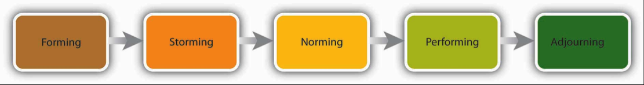

Forming

In the forming stage, the team comes together for the first time. The members may already know each other or they may be total strangers. In either case, there is a level of formality, some anxiety, and a degree of guardedness as team members are not sure what is going to happen next.

Because of the large amount of uncertainty, members tend to be polite, conflict avoidant, and observant. They are trying to figure out the “rules of the game” without being too vulnerable. At this point, they may also be quite excited and optimistic about the task at hand, perhaps experiencing a level of pride at being chosen to join a particular team. Team members are trying to achieve several goals at this stage, although this may not necessarily be done consciously.

First, they are trying to get to know each other. Often this can be accomplished by finding some common ground. Members also begin to explore team boundaries to determine what will be considered acceptable behavior. “Can I interrupt? Can I leave when I feel like it?” This trial phase may also involve testing the appointed leader or seeing if a leader emerges from the team. At this point, team members are also discovering how the team will work in terms of what needs to be done and who will be responsible for each task. This stage is often characterized by abstract discussions about issues to be addressed by the team; those who like to get moving can become impatient with this part of the process. This phase is usually short in duration, perhaps a meeting or two.

**Storming**

Once team members feel sufficiently safe and included, they tend to enter the storming phase. Participants focus less on keeping their guard up as they shed social façades, becoming more authentic and more argumentative. Team members begin to explore their power and influence, and they often stake out their territory by differentiating themselves from the other team members rather than seeking common ground. Discussions can become heated as participants raise contending points of view and values, or argue over how tasks should be done and who is assigned to them. It is not unusual for team members to become defensive, competitive, or jealous. They may even take sides or begin to form cliques within the team. Questioning and resisting direction from the leader is also quite common.

The storming phase of team development can involve conflict. It’s the period when a team can be off task; members are uncertain and/or cannot find agreement. There are several steps you can take to avoid getting stuck in the storming phase and move your team from the storming phase to the norming phase of team development.

Try the following if you feel the team process you are involved in is not progressing:

* *Normalize conflict*. Let members know this is a natural phase in the team-formation process.
* *Be inclusive*. Continue to make all members feel included and invite all views into the room. Mention how diverse ideas and opinions help foster creativity and innovation.
* *Make sure everyone is heard*. Facilitate heated discussions and help participants understand each other.
* *Support all team members*. This is especially important for those who feel more insecure.
* *Remain positive*. This is a key point to remember about the team’s ability to accomplish its goal.
* *Don’t rush the team’s development*. Remember that working through the storming stage can take several meetings. Once team members discover that they can be authentic and that the team is capable of handling differences without dissolving, they are ready to enter the next stage, norming.

**Norming**

“We survived!” is the common sentiment at the norming stage. Team members often feel elated at this point, and they are much more committed to each other and the team’s goal. Feeling energized by knowing they can handle the “tough stuff,” team members are now ready to get to work. Finding themselves more cohesive and cooperative, participants find it easy to establish their own ground rules (or norms) and define their operating procedures and goals. The team tends to make big decisions, while subteams or individuals handle the smaller decisions. Hopefully, at this point the team is more open and respectful toward each other, and members ask each other for both help and feedback. They may even begin to form friendships and share more personal information with each other.

Performing

Galvanized by a sense of shared vision and a feeling of unity, the team is ready to go into high gear. Members are more interdependent, individuality and differences are respected, and team members feel themselves to be part of a greater entity. At the performing stage, participants are not only getting the work done, but they also pay greater attention to how they are doing it.

Adjourning

Just as teams form, so do they end. For example, many teams or teams formed in a business context are project oriented and therefore are temporary in nature. Alternatively, a working team may dissolve due to an organizational restructuring. Just as when we graduate from school or leave home for the first time, these endings can be bittersweet, with team members feeling a combination of victory, grief, and insecurity about what is coming next

The Punctuated-Equilibrium Model

As you may have noted, the five-stage model we have just reviewed is a linear process. According to the model, a team progresses to the performing stage, at which point it finds itself in an ongoing, smooth-sailing situation until the team dissolves. In reality, subsequent researchers, most notably Joy H. Karriker, have found that the life of a team is much more dynamic and cyclical in nature (Karriker, 2005). For example, a team may operate in the performing stage for several months. Then, because of a disruption, such as a competing emerging technology that changes the rules of the game or the introduction of a new CEO, the team may move back into the storming phase before returning to performing. Ideally, any regression in the linear team progression will ultimately result in a higher level of functioning. Proponents of this cyclical model draw from behavioral scientist Connie Gersick’s study of punctuated equilibrium (Gersick, 1991).

The concept of punctuated equilibrium was first proposed in 1972 by paleontologists Niles Eldredge and Stephen Jay Gould, who both believed that evolution occurred in rapid, radical spurts rather than gradually over time. Identifying numerous examples of this pattern in social behavior, Gersick found that the concept applied to organizational change. She proposed that teams remain fairly static, maintaining a certain equilibrium for long periods of time. Change during these periods is incremental, largely due to the resistance to change that arises when systems take root and processes become institutionalized. In this model, revolutionary change occurs in brief, punctuated bursts, generally catalyzed by a crisis or problem that breaks through the systemic inertia and shakes up the deep organizational structures in place. At this point, the organization or team has the opportunity to learn and create new structures that are better aligned with current realities. Whether the team does this is not guaranteed. In sum, in Gersick’s model, teams can repeatedly cycle through the storming and performing stages, with revolutionary change taking place during short transitional windows. For organizations and teams who understand that disruption, conflict, and chaos are inevitable in the life of a social system, these disruptions represent opportunities for innovation and creativity.

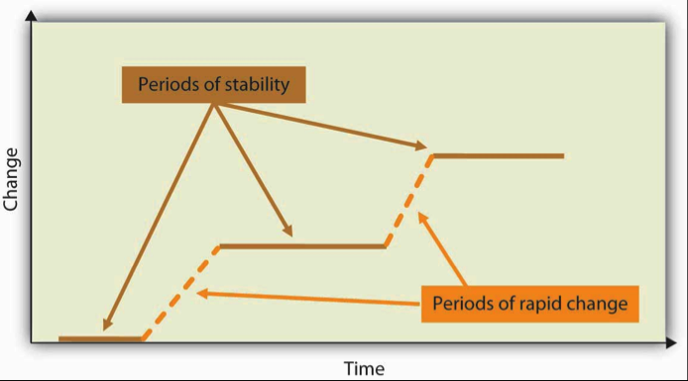

**Cohesion**

Cohesion can be thought of as a kind of social glue. It refers to the degree of camaraderie within the team. Cohesive teams are those in which members are attached to each other and act as one unit. Generally speaking, the more cohesive a team is, the more productive it will be and the more rewarding the experience will be for the team’s members (Beal, Cohen, Burke & McLendon, 2003; Evans & Dion, 1991)[.](http://catalog.flatworldknowledge.com/bookhub/reader/4?e=fwk-122425-ch09#ftn.fn-4)Members of cohesive teams tend to have the following characteristics: They have a collective identity; they experience a moral bond and a desire to remain part of the team; they share a sense of purpose, working together on a meaningful task or cause; and they establish a structured pattern of communication.

The fundamental factors affecting team cohesion include the following:

* *Similarity*. The more similar team members are in terms of age, sex, education, skills, attitudes, values, and beliefs, the more likely the team will bond.
* *Stability*. The longer a team stays together, the more cohesive it becomes.
* *Size*. Smaller teams tend to have higher levels of cohesion.
* *Support*. When team members receive coaching and are encouraged to support their fellow team members, team identity strengthens.
* *Satisfaction*. Cohesion is correlated with how pleased team members are with each other’s performance, behavior, and conformity to team norms.

As you might imagine, there are many benefits in creating a cohesive team. Members are generally more personally satisfied and feel greater self-confidence and self-esteem when in a team where they feel they belong. For many, membership in such a team can be a buffer against stress, which can improve mental and physical well-being. Because members are invested in the team and its work, they are more likely to regularly attend and actively participate in the team, taking more responsibility for the team’s functioning. In addition, members can draw on the strength of the team to persevere through challenging situations that might otherwise be too hard to tackle alone.

**Steps to Creating and Maintaining a Cohesive Team**

There are several steps you can take as a manager to help build a cohesive team. For example, you can work to do the following:

* *Align the team with the greater organization*. Establish common objectives in which members can get involved.
* *Let members have choices in setting their own goals*. Include them in decision making at the organizational level.
* *Define clear roles*. Demonstrate how each person’s contribution furthers the team goal—everyone is responsible for a special piece of the puzzle.
* *Situate team members in close proximity to each other*. This builds familiarity.
* *Give frequent praise*. Both individuals and teams benefit from praise. Also encourage them to praise each other. This builds individual self-confidence, reaffirms positive behavior, and creates an overall positive atmosphere.
* *Treat all members with dignity and respect*. This demonstrates that there are no favorites and everyone is valued.
* *Celebrate differences*. This highlights each individual’s contribution while also making diversity a norm.
* *Establish common rituals*. Thursday morning coffee, monthly potlucks—these reaffirm team identity and create shared experiences.

**Can a Team Have Too Much Cohesion?**

Keep in mind that teams can have too much cohesion. Because members can come to value belonging over all else, an internal pressure to conform may arise, causing some members to modify their behavior to adhere to team norms. Members may become conflict avoidant, focusing more on trying to please each other so as not to be ostracized. In some cases, members might censor themselves to maintain the party line. As such, there is a superficial sense of harmony and less diversity of thought. Having less tolerance for deviants, who threaten the team’s static identity, cohesive teams will often excommunicate members who dare to disagree. Members attempting to make a change may even be criticized or undermined by other members, who perceive this as a threat to the status quo. The painful possibility of being marginalized can keep many members in line with the majority.

The more strongly members identify with the team, the easier it is to see outsiders as inferior, or enemies in extreme cases, which can lead to increased insularity. This form of prejudice can have a downward spiral effect. Not only is the team not getting corrective feedback from within its own confines, it is also closing itself off from input and a cross-fertilization of ideas from the outside. In such an environment, teams can easily adopt extreme ideas that will not be challenged. Denial increases as problems are ignored and failures are blamed on external factors. With limited, often biased, information and no internal or external opposition, teams like these can make disastrous decisions. **Teamthink** is a team pressure phenomenon that increases the risk of the team making flawed decisions by allowing reductions in mental efficiency, reality testing, and moral judgment. Teamthink is most common in highly cohesive teams (Janis, 1972).

Cohesive teams can go awry in much milder ways. For example, team members can value their social interactions so much that they have fun together, but spend little time on accomplishing their assigned task. Or a team’s goal may begin to diverge from the larger organization’s goal and those trying to uphold the organization’s goal may be ostracized (e.g., teasing the class “brain” for doing well in school).

In addition, research shows that cohesion leads to acceptance of team norms (Goodman, Ravlin & Schminke,1987). Teams with high task commitment do well, but imagine a team where the norms are to work as little as possible? As you might imagine, these teams get little accomplished and can actually work together against the organization’s goals.

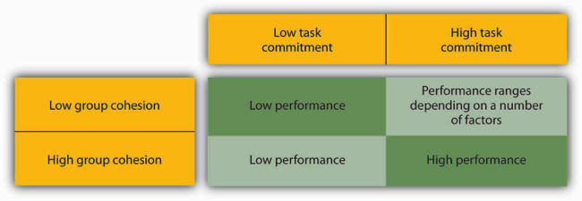Teams with high cohesion and high task commitment tend to be the most effective.Reprinted with permission from from Organizational behavior. Section 9.2, by Carpenter, Bauer & Erdogan, 2010, New York, NY: Flat World Knowledge.

**Collective Efficacy**

Collective efficacy refers to a team’s perception of its ability to successfully perform well (Bandura, 1997). Collective efficacy is influenced by a number of factors, including watching others (“that team did it and we’re better than them”), verbal persuasion (“we can do this”), and how a person feels (“this is a good team”). Research shows that a team’s collective efficacy is related to its performance (Gully, Incalcaterra, Joshi, & Beaubien, 2002; Porter, 2005; Tasa, Taggar, & Seijts, 2007). In addition, this relationship is higher when **task interdependence** (the degree an individual’s task is linked to someone else’s work) is high rather than low.

*Note*. Adapted from "The Profession: Ethics and Opportunities," by K. Collins, 2014, *Exploring Business*, Chapter 12, Section 5. Copyright 2014 by Flat World Knowledge, Inc.; "What Do Leaders Do? Behavioral Approaches to Leadership," by M. Carpenter, T. Bauer, B. Erdogan, & J. Short, 2013, *Principles of Management*, Chapter 9, Section 2. Copyright 2013 by Flat World Knowledge, Inc.

Topic 1: Activity 2 of 5--Teamwork and Collaboration—Video

<https://youtu.be/9WX7BNnYTf8>

Topic 1: Activity 3 of 5--Creating and Maintaining a Cohesive Team—activity

Topic 1: Activity 4 of 5 --Building a Collaborative Environment—article

OPM.gov: [Performance Management](http://www.opm.gov/policy-data-oversight/performance-management/teams/building-a-collaborative-team-environment/)

Topic 1: Activity 5 of 5 –Milestone

Topic 2: Barriers to Effective Teams

Topic 2: Activity 1 of 5 --Barriers to Effective Communication

Understanding why teams fail can help you avoid common pitfalls that undermine team success.

Why Teams Fail

Teams don’t always work. To learn why, it helps to take a quick look at four common obstacles to success in introducing teams into an organization (Greenberg & Baron, 2008, pp. 317–318):

Unwillingness to cooperate. Failure to cooperate can occur when members don’t or won’t commit to a common goal or set of activities. What if, for example, half the members of a product development team want to create a brand-new product and half want to improve an existing product? The entire team may get stuck on this point of contention for weeks or even months.

Lack of managerial support. Every team requires organizational resources to achieve its goals, and if management isn’t willing to commit the needed resources—say, funding or key personnel—a team will probably fall short of those goals.

Failure of managers to delegate authority. Team leaders are often chosen from the ranks of successful supervisors—first-line managers who give instructions on a day-to-day basis and expect to have them carried out. This approach to workplace activities may not work very well in leading a team—a position in which success depends on building a consensus and letting people make their own decisions.

Failure of teams to cooperate. If you’re on a workplace team, your employer probably depends on teams to perform much of the organization’s work and meet many of its goals. In other words, it is, to some extent, a team-based organization, and reaching its overall goals requires a high level of cooperation among teams (Thompson, 2008, pp. 323–324). When teams can’t agree on mutual goals (or when they duplicate efforts), neither the teams nor the organization is likely to meet with much success.

Common Problems Faced By Teams

Problems can arise in any team that will hurt the team’s effectiveness. Here are some common problems faced by teams and how to deal with them.

1. Challenges of Knowing Where to Begin

At the start of a project, team members may be at a loss as to how to begin. Also, they may have reached the end of a task, but are unable to move on to the next step or put the task to rest. Floundering often results from a lack of clear goals, so the remedy is to go back to the team’s mission or plan and make sure that it is clear to everyone. Team leaders can help move the team past floundering by asking, “What is holding us up? Do we need more data? Do we need assurances or support? Does anyone feel that we’ve missed something important?”

2. Dominating Team Members

Some team members may have a dominating personality that encroaches on the participation or air time of others. This overbearing behavior may hurt the team morale or the momentum of the team. A good way to overcome this barrier is to design a team evaluation to include a “balance of participation” in meetings. Knowing that fair and equitable participation by all will affect the team’s performance evaluation will help team members limit domination by one member and encourage participation from all members, even shy or reluctant ones. Team members can say, “We’ve heard from Mary on this issue, so let’s hear from others about their ideas.”

3. Poor Performance of Team Members

Research shows that teams deal with poor performers in different ways, depending on members’ perceptions of the reasons for poor performance (Jackson & LePine, 2003). In situations in which the poor performer is perceived as lacking in ability, teams are more likely to train the member. When members perceive the individual as simply being low on motivation, they are more likely to try to motivate or reject the poor performer. Keep in mind that justice is an important part of keeping individuals working hard for the team (Colquitt, 2004). Be sure that poor performers are dealt with in a way that is deemed fair by all the team members.

4. Social Loafing

Social loafing refers to the tendency of individuals to put in less effort when working in a team context. This phenomenon, also known as the Ringelmann effect, was first noted by French agricultural engineer Max Ringelmann in 1913. In one study, he had people pull on a rope individually and in teams. He found that as the number of people pulling increased, the team’s total pulling force was less than the individual efforts had been when measured alone (Karau & Williams, 1993).

5. Poorly Managed Team Conflict

Disagreements among team members are normal and should be expected. Healthy teams raise issues and discuss differing points of view, because that will ultimately help the team reach stronger, more well-reasoned decisions. Unfortunately, sometimes disagreements arise owing to personality issues or feuds that predated a team’s formation. Ideally, teams should be designed to avoid bringing adversaries together on the same team.

6. Groupthink

It’s easier for leaders to direct members toward team goals when members are all on the same page—when there’s a basic willingness to conform to the team’s rules and guidelines. When there’s too much conformity, however, the group can become ineffective: It may resist change and fresh ideas and, what’s worse, may end up adopting its own dysfunctional tendencies as its way of doing things. Such tendencies may also encourage a phenomenon known as **groupthink**—the tendency to conform to group pressure in making decisions, while failing to think critically or to consider outside influences.

Groupthink is often cited as a factor in the explosion of the space shuttle Challenger in January 1986: Engineers from a supplier of components for the rocket booster warned that the launch might be risky because of the weather, but were persuaded to reverse their recommendation by NASA officials who wanted the launch to proceed as scheduled (Griffin, 1997).

7. Motivation and Frustration

Finally, remember that teams are composed of people, and whatever the roles they happen to be playing at a given time, people are subject to psychological ups and downs. As members of workplace teams, they need motivation, and when motivation is down, so are effectiveness and productivity. As you can see in Figure 2.1, the difficulty of maintaining a high level of motivation is the chief cause of frustration among members of teams. As such, it’s also a chief cause of ineffective teamwork, and that’s one reason why more employers now look for the ability to develop and sustain motivation when they’re hiring new managers (Thompson, 2008, pp. 323–324).

**Figure 2.1 Sources of Frustration**

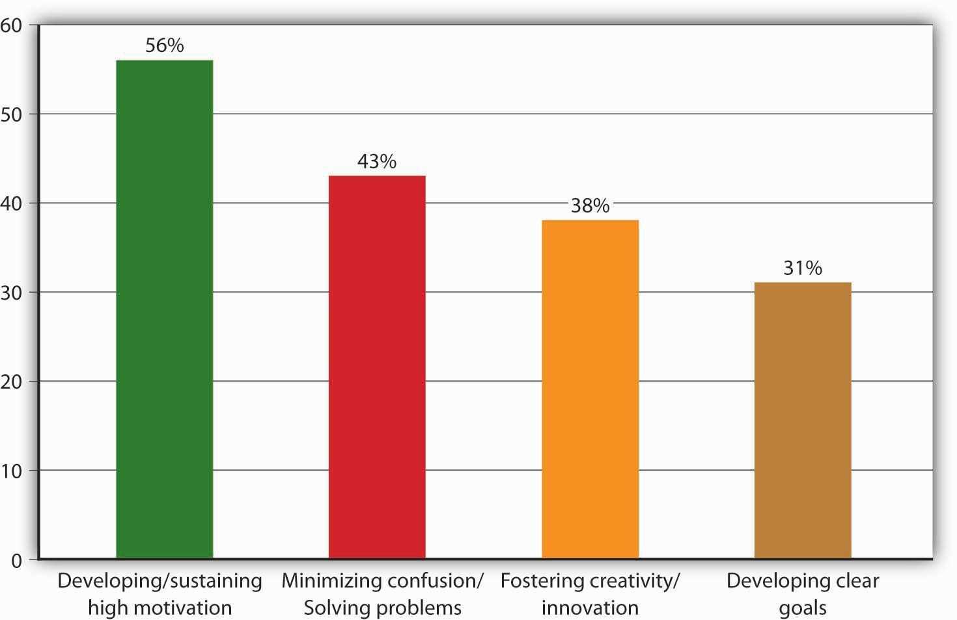Reprinted with permission from *Exploring business*. Section 8.1, by K. Collins, 2014, New York, NY: Flat World Knowledge.

*Note*. Adapted from "Why Teamwork Works," by K. Collins, 2014, *Exploring Business*, Chapter 8, Section 2. Copyright 2014 by Flat World Knowledge, Inc.; "What Do Leaders Do? Behavioral Approaches to Leadership" & "Developing Your Leadership Skills," by M. Carpenter, T. Bauer, B. Erdogan, & J. Short, 2013, Principles of Management, Chapter 9, Section 2 & 5. Copyright 2013 by Flat World Knowledge, Inc.

Topic 2: Activity 2 of 5--Five Dysfunctions of a Team—video

<https://youtu.be/6sqvWEI1CVg>

Topic 2: Activity 3 of 5--Managing Conflict—article

Penn State University: [Building Blocks for Teams: Conflicts](https://knowhownonprofit.org/people/people-management-skills/teams/effectiveteam/developing)

Topic 2: Activity 4 of 5 --Preventing Social Loafing

Social loafing refers to an individual team member's act of putting in less effort than his counterparts. One suggested way to prevent or reduce social loafing is to discuss individual tasks, responsibilities, and expectations with the entire team, so that each person has a clear understanding of everyone's roles.

Topic 2: Activity 5 of 5 –MileStone

Topic 3: Organizing Effective Teams

Topic 3: Activity 1 of 7--Designing Effective Teams

Strategies for designing effective teams include creating diversity, assembling complementary skills and managing team size. Knowing these strategies can help you create highly successful teams and, more immediately, prepare for your Final Assessment.

**Designing an Effective Team**

Designing an effective team means making decisions about team composition (who should be on the team), team size (the optimal number of people on the team), and team diversity (should team members be of similar background, such as all engineers, or of different backgrounds). Answering these questions will depend, to a large extent, on the type of task that the team will be performing. Teams can be charged with a variety of tasks, from problem solving to generating creative and innovative ideas to managing the daily operations of a manufacturing plant.

**Who Are the Best Individuals for the Team?**

A key consideration when forming a team is to ensure that all team members are qualified for the roles they will fill for the team. This process often entails understanding the knowledge, skills, and abilities (KSAs) of team members as well as the personality traits needed before starting the selection process (Humphrey, Hollenbeck, Myer & Ilgen, 2007). In addition to task knowledge, research has shown that individuals who understand the concepts covered in this competency actually perform better on their jobs. This finding holds for a variety of jobs, including being an officer in the U.S. Air Force, an employee at a pulp mill, or a team member at a box manufacturing plant (Hirschfeld, Jordan, Field, Giles & Armenakis, 2006; Stevens & Campion, 1999).

How Large Should My Team Be?

Research has shown that regardless of team size, the most active team member speaks 43% of the time. The difference is that the team member who participates the least in a three-person team is still active 23% of the time versus only 3% in a 10-person team (McGrath, 1984; Solomon, 1960). When deciding team size, a good rule of thumb is a size of two to 20 members. Research shows that teams with more than 20 members have less cooperation (Graton & Erickson, 2007). The majority of teams have 10 members or fewer, because the larger the team, the harder it is to coordinate and interact as a team. With fewer individuals, team members are more able to work through differences and agree on a common plan of action. They have a clearer understanding of others’ roles and greater accountability to fulfill their roles (remember social loafing?)

How Diverse Should My Team Be?

Team composition and team diversity often go hand in hand. Teams whose members have complementary skills are often more successful, because members can see each other’s blind spots. One team member’s strengths can compensate for another’s weaknesses (Jackson, Joshi & Erhardt, 2003; van Knippenberg, De Dreu, & Homan, 2004).

Diversity in team composition can help teams come up with more creative and effective solutions. Research shows that teams that believe in the value of diversity performed better than teams that do not (Homan, van Knippenberg, Van Kleef & De Dreu, 2007). The more diverse a team is in terms of expertise, gender, age, and background, the more ability the team has to avoid the problems of groupthink (Surowiecki, 2005).

*Note.*Adapted from "Understanding Team Design Characteristics," by T. Bauer & B. Erdogan, 2010, *Organizational Behavior*, Chapter 9, Section 3. Copyright 2010 by Flat World Knowledge, Inc.

Topic 3: Activity 2 of 7--Keys to Building Great Teams—article

Agile Connection: [Seven Keys to Building Great Work Teams](http://www.agileconnection.com/article/7-keys-building-great-work-teams)

Topic 3: Activity 3 of 7--Build a Team—activity

Topic 3: Activity 4 of 7-- Trust and Communication

Trust is a vital component of interdependent relationships such as teams.

Trust

Trust is the foundation for all relationships within a project. Without a minimum level of trust, communication breaks down and, eventually, the project suffers. communication breakdown is associated with a breakdown in trust.

Filters

On projects, trust is the filter through which we screen information that is shared and the filter we use to screen information we receive. The more trust that exists, the easier it is for information to flow through the filters. As trust diminishes, the filters become stronger and information has a harder time getting through, and projects that are highly dependent on an information-rich environment will suffer from information deprivation.

Contracts and Trust Relationships

The project typically begins with a charter or contract. A contract is a legal agreement that includes penalties for any behavior or results not achieved. Contracts are based on an adversarial paradigm and do not lend themselves to creating an environment of trust. Contracts and charters are necessary to clearly establish, among other things, the scope of the project, but they are not conducive to establishing a trusting project culture.

Types of Trust

Svenn Lindskold (1978) describes four kinds of trust:

Objective credibility. A personal characteristic that reflects the truthfulness of an individual that can be checked against observable facts.

Attribution of benevolence. A form of trust that is built on the examination of the person's motives and the conclusion that they are not hostile.

Nonmanipulative trust. A form of trust that correlates to a person's self-interest and the predictability of a person's behavior in acting consistent in that self-interest.

High cost of lying. The type of trust that emerges when persons in authority raise the cost of lying so high that people will not lie because the penalty will be too high.

Creating Trust

Building trust on a project begins with the project manager. On complex projects, the assignment of a project manager with a high trust reputation can help establish the trust level needed. The project manager can also establish the cost of lying in a way that communicates an expectation and a value for trust on the project. Project managers can also assure that the official goals (stated goals) and operational goals (goals that are reinforced) are aligned. The project manager can create an atmosphere where informal communication is expected and reinforced.

The informal communication is important to establishing personal trust among team members and with the client. Allotting time during project start-up meetings to allow team members to develop a personal relationship is important to establishing the team trust. The informal discussion allows for a deeper understanding of the whole person and creates an atmosphere where trust can emerge.

Project managers can also establish expectations of team members to respect individual differences and skills, look and react to the positives, recognize each other’s accomplishments, and value people’s self-esteem to increase a sense of the benevolent intent.

Establishing Team Norms and Contracts

A key to successful team design is to have clear norms, roles, and expectations among team members. Problems such as social loafing or groupthink can be avoided by paying careful attention to team member differences and providing clear definitions for roles, expectancy, measurement, and rewards.

Team Norms

Norms are shared expectations about how things operate within a group or team. Just as new employees learn to understand and share the assumptions, norms, and values that are part of an organization’s culture, they also must learn the norms of their immediate team. This understanding helps teams be more cohesive and perform better. Norms are a powerful way of ensuring coordination within a team. For example, is it acceptable to be late to meetings? How prepared are you supposed to be at the meetings? Is it acceptable to criticize someone else’s work? These norms are shaped early during the life of a team and affect whether the team is productive, cohesive, and successful.

Team Contracts

Scientific research, as well as experience working with thousands of teams, shows that teams that are able to articulate and agree on established ground rules, goals, and roles and develop a team contract around these standards are better equipped to face challenges that may arise within the team (Katzenbach & Smith, 1993; Porter & Lilly, 1996).

Team values and goals. What are our shared team values? What is our team goal?

Team roles and leadership. Who does what within this team? (Who takes notes at the meeting? Who sets the agenda? Who assigns tasks? Who runs the meetings?) Does the team have a formal leader? If so, what are his or her roles?

Team decision making. How are minor decisions made? How are major decisions made?

Team communication. Who do you contact if you cannot make a meeting? Who communicates with whom? How often will the team meet?

Team performance. What constitutes good team performance? What if a team member tries hard, but does not seem to be producing quality work? How will poor attendance/work quality be dealt with?

Types of Team Meetings

Team meetings are conducted differently depending on the purpose of the meeting, the leadership style that is appropriate for the meeting, and the personality types of the members of the team.

Action Item Meetings

Action item meetings are short meetings to develop a common understanding of what the short-term priorities are for the project, individual roles, and expectations for specific activities.

Management Meetings: How to Inspire Cooperation

Management meetings are longer in duration and are oriented toward developing plans, tracking progress of existing plans, making adjustments to plans in response to new information across the organization.

These meetings include focused discussion on generating a common understanding of the progress of the existing plan. This discussion is based on quantitative information provided on the progress of the schedule and other data, but the discussion is qualitative in evaluating the data to develop a more complete understanding of the data. The experience and opinions of the project leaders are solicited, and disagreement about meaning of the data is even encouraged to develop a deeper understanding of the data.

The following are some examples of goals during the conceptual phase:

Developing a list of the procurement long lead items and defining critical dates

Developing a human resources plan that identifies critical positions

Developing and building agreement with the client on the project scope of the work

Each of these goals is measurable and time framed. They can be developed as positive motivators and will take the project leaders and most of the project team to accomplish. They develop a general understanding of the priorities and are easy to remember.

Communication in Leadership Meetings

Leadership meetings are held less frequently and are longer in length because of the amount and complexity of the information that must be shared. These meetings are used by the project manager to reflect on the project, to explore the larger issues of the project, and to back away from the day-to-day problem solving.

Effective Team Meetings

Anyone who has been involved in a team knows it involves team meetings. While few individuals relish meetings, they serve an important function in terms of information sharing and decision making.

Before the Meeting Communications

Much of the effectiveness of a meeting is determined before the team gathers. There are three key things you can do to ensure that the team members get the most out of their meeting.

First, ask yourself, “Is a meeting needed?” Leaders should do a number of things before the meeting to help make it effective.

second, create and distribute an agenda. An agenda is important in helping to inform those invited about the purpose of the meeting. It also helps organize the flow of the meeting and keep the team on track.

Third, send a reminder before the meeting. Reminding everyone of the purpose, time, and location of the meeting helps everyone prepare themselves. Anyone who has attended a team meeting only to find there is no reason to meet because members haven’t completed their agreed-upon tasks knows that, as a result, team performance or morale can be negatively affected. Follow up to make sure everyone is prepared. As a team member, inform others immediately if you will not be ready with your tasks so they can determine whether the meeting should be postponed.

During the Meeting Communication

During the meeting, there are several things you can do to make sure the team starts and keeps on track.

Start the meeting on time. Follow the meeting agenda. Manage team dynamics for full participation. Summarize the meeting with action items. End the meeting on time. After the Meeting Communications

Follow up on action items.

*Note*. Adapted from "Working with Groups and Teams," by R. Darnall & J. M. Preston, 2012, *Project Management: From Simple to Complex*, Chapter 5, Section 2. Copyright 2012 by Flat World Knowledge, Inc.; "Organizing Effective Teams," by M. Carpenter, T. Bauer, B. Erdogan, & J. Short, 2013, *Principles of Management*, Chapter 12, Section 3. Copyright 2013 by Flat World Knowledge, Inc.

Topic 3: Activity 5 of 7--Building Trust—article

Building Trust Inside your Team

Topic 3: Activity 6 of 7—Effective Communication—Article

[20 Ways to Communicate Effectively with your Team](http://businessgross.com/2013/04/05/communicate-effectively/)

Topic 3: Activity 7 of 7 – Milestone

Topic 4: Team Leadership

Topic 4: Activity 1 of 2--Team Leadership

three primary team leadership styles: manager-led, self-managed, and self-directed.

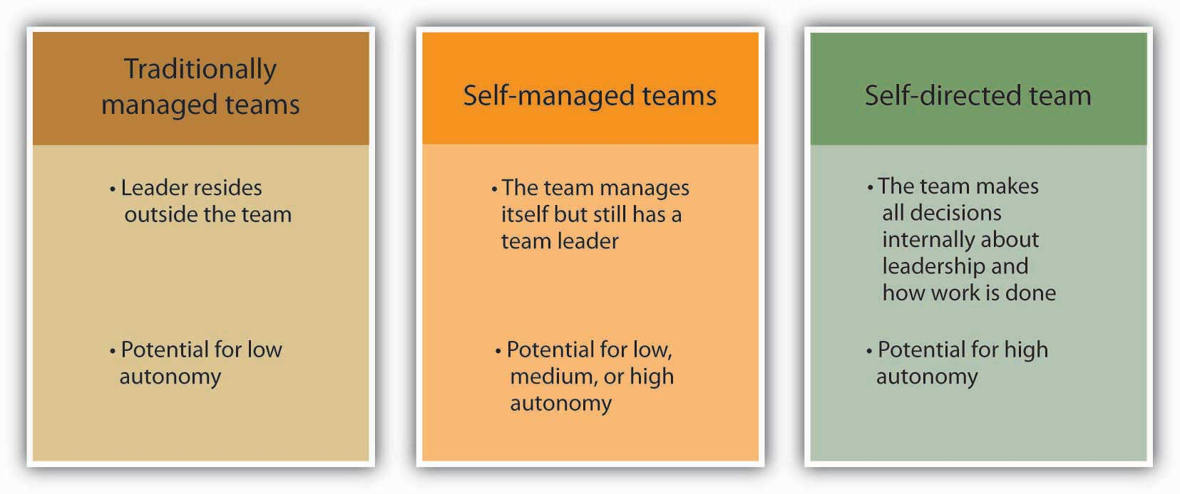

Traditional Manager-Led

Teams vary in terms of how they are led. Traditional manager-led teams are teams in which the manager serves as the team leader. The manager assigns work to other team members. These types of teams are the most natural to form, with managers having the power to hire and fire team members and being held accountable for the team’s results.

Self-Managed

Self-managed teams are a new form of team that rose in popularity with the Total Quality Movement in the 1980s. Unlike manager-led teams, these teams manage themselves and do not report directly to a supervisor. Instead, team members select their own leader, and they may even take turns in the leadership role. Self-managed teams also have the power to select new team members. As a whole, the team shares responsibility for a significant task, such as assembly of an entire car. The task is ongoing rather than a temporary task such as a charity fund drive for a given year.

ypical team goals are improving quality, reducing costs, and meeting deadlines. Teams also have a “stretch” goal—a goal that is difficult to reach, but important to the business unit. Many teams also have special project goals. Texas Instruments (TI), a company that makes semiconductors, used self-directed teams to make improvements in work processes (Welins, Byham & Dixon, 1994). Teams were allowed to set their own goals in conjunction with managers and other teams.

elf-managed teams are empowered teams, which means that they have the responsibility as well as the authority to achieve their goals. Team members have the power to control tasks and processes and to make decisions. Research shows that self-managed teams may be at a higher risk of suffering from negative outcomes due to conflict, so it is important that they are supported with training to help them deal with conflict effectively (Alper, Tjosvold & Law, 2000; Langfred, 2007). Self-managed teams may still have a leader who helps them coordinate with the larger organization (Morgeson, 2005). For a product team composed of engineering, production, and marketing employees, being empowered means that the team can decide everything about a product’s appearance, production, and cost without having to get permission or sign-off from higher management. As a result, empowered teams can more effectively meet tighter deadlines. At AT&T Inc., for example, the model-4200 phone team cut development time in half while lowering costs and improving quality by using the empowered team approach (Parker, 1994). A special form of self-managed teams are self-directed teams, which also determine who will lead them with no external oversight.

Rewarding Workers

Rewarding workers beyond their pay and benefit packages seems like an obvious best practice; still, some leaders don’t. It’s possible they think that showing appreciation would undermine their authority. Maybe they worry about stoking jealousy between team members. Maybe they think they don’t have the time. Or perhaps they’re embarrassed to offer direct praise.

What achievements they want rewarded.

What reward they want to receive, both individually and as a team.

Whether they’d prefer to be recognized at milestones throughout the project, or have a bigger celebration at the end.

Improving Teamwork

If your employees work together as a team, your business has a better chance of succeeding. If you’d like to improve teamwork at your business, you have to be able to find and remove existing problems in communication and workflow. Here are some tips to help you identify such problems, and to retrain employees as you move to address them.

Begin by examining your expectations.

ddressing such issues:

To address insufficient product knowledge, hold a product training seminar. Many manufacturers and suppliers will host these seminars free of charge, believing it will strengthen the business relationship and thus them, too.

To address gaps or lack in skill, organize training meetings. Include opportunities for role-playing, both one-on-one and in the larger group. Wherever possible, pair less-skilled employees with a more experienced partner.

To address gossip that has become problematic, separate the relevant team members, if possible. If not, consider more direct actions with the source of the gossip: warnings, retraining, or counseling. If your office doesn't have a code of conduct, use the occasion to develop one. It might prove a cathartic way to help your employees deal with bad office politics. In general, take gossip seriously and act on it quickly, because it spreads quickly and can be destructive to a workplace.

*Note*. Adapted from "The Team and the Organization," by K. Collins, 2014, *Exploring Business*, Chapter 8, Section 1. Copyright 2014 by Flat World Knowledge, Inc.; "Understanding Team Design Characteristics," by T. Bauer & B. Erdogan, 2010, *Organizational Behavior*, Chapter 9, Section 3. Copyright 2013 by Flat World Knowledge, Inc.

Topic 4: Activity 2 of 2 Rewarding Team Members With Positive Feedback

Activty