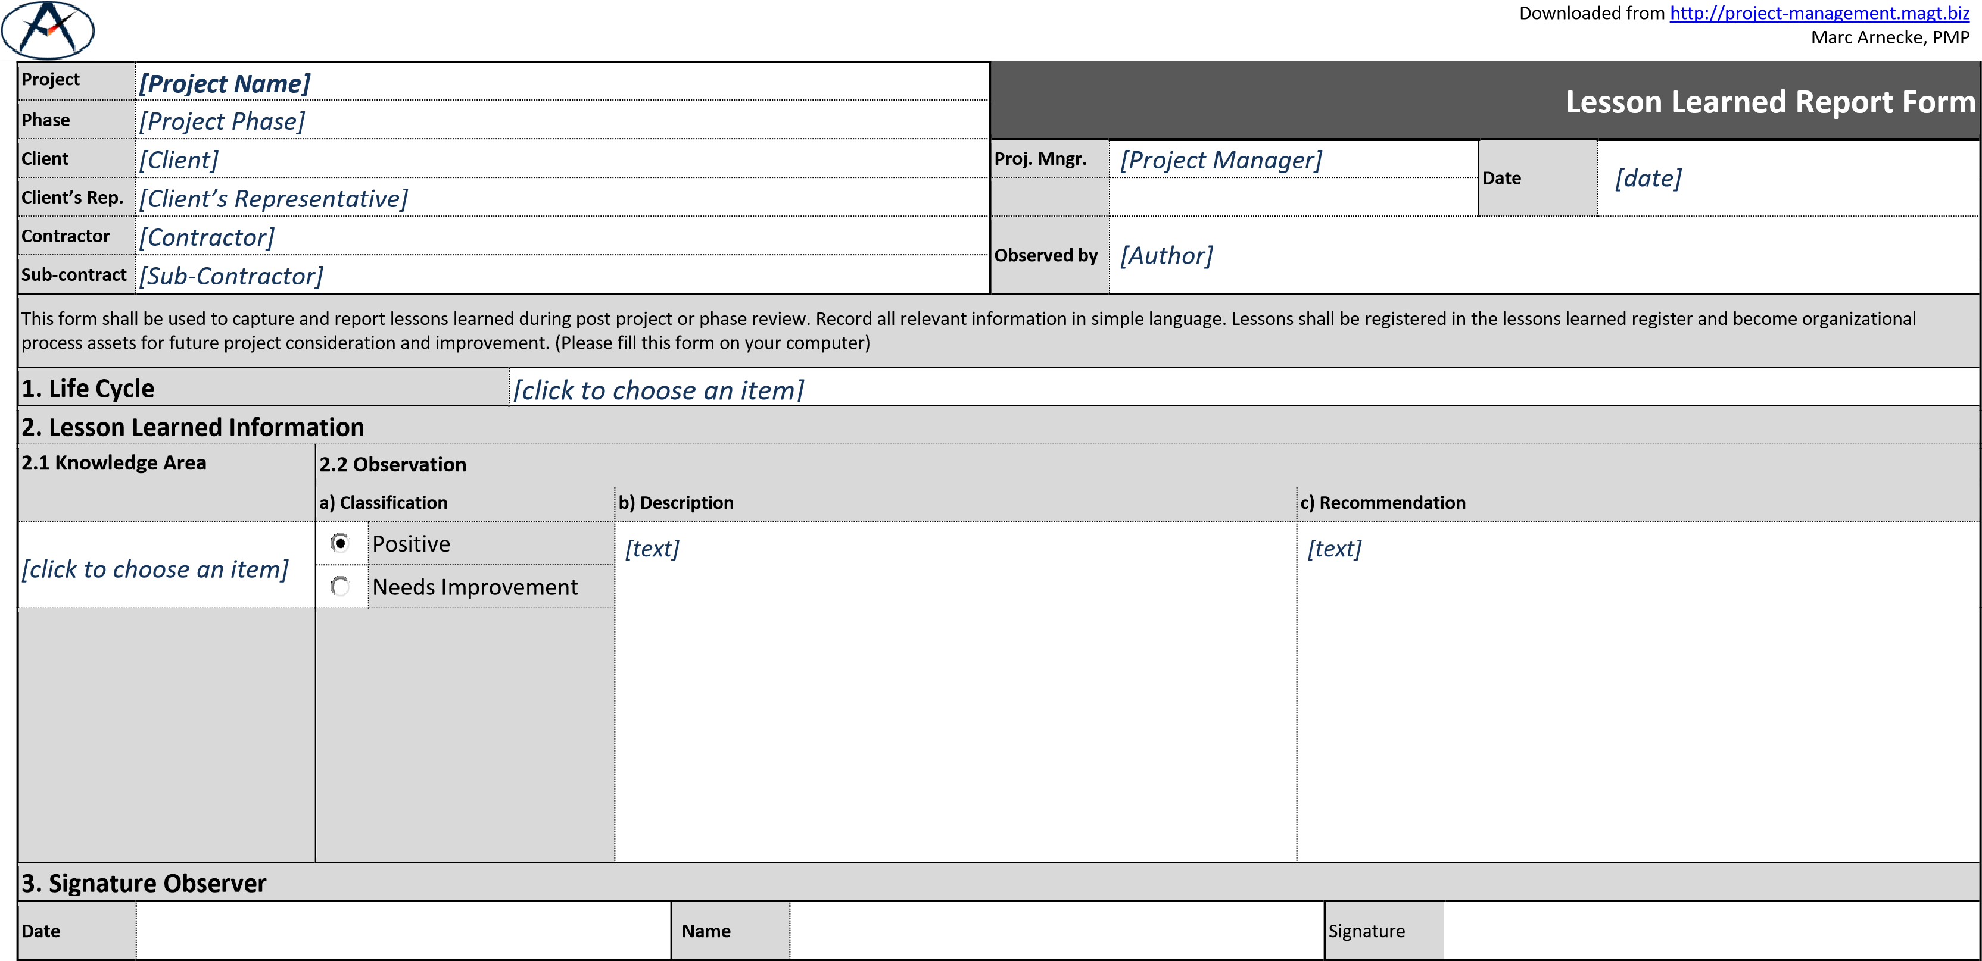

|  |  |  |  |  |  |  |  |  |  |  |
| --- | --- | --- | --- | --- | --- | --- | --- | --- | --- | --- |
| **4. Review** |  | **Referred to Change Control Board** | |  | **No** |  | **Yes, under change request number** | | |  |
| **Review**  **Board**  **Recommen-**  **dation** |  | | |  | |  | | | | |
| **Date** |  | **Name** |  |  | |  | | Signature |  | |

|  |  |  |  |  |  |  |  |
| --- | --- | --- | --- | --- | --- | --- | --- |
| **5. Registration** |  | |  | |  | | |
| **Recorded in Lessons Learned**  **Register under registration number** |  | **Name** |  | **Date** |  | **Signature** |  |

01-600-lessons-learned