Class Notes and Outline

Objective 1: Fundamentals of Project Management

Topic 1: What Is a Project?

How Is a Project Defined?

The Project Management Institute (PMI) defines a project by two key characteristics. All projects are (1) temporary and (2) undertaken to create a product, service, or result that is unique (Project Managements Institute Inc., 2008).

Because projects are temporary, they have a defined beginning and end. Project managers must manage start-up activities and project closeout activities.

**Project Attributes**

The project is completed when its goals and objectives are accomplished.

**Project Characteristics**

A successful project is one that meets or exceeds the expectations of the stakeholders.

confusing projects with ongoing operations happens often

Note. Adapted from "Introduction to Project Management," by R. Darnall & J. M. Preston, 2012, Project Management: From Simple to Complex, Chapter 1, Section 2. Copyright 2012 by Flat World Knowledge Inc.

Project Management Lessons Learned in the Kitchen

* Mini cook Project Objective: Feed 2 kids + 2 adults healthy food that (almost) everyone will like
* Deadline: 6:30pm, no later (everyone gets hangry!)
* Resources: Whatever is in the fridge and pantry
* Work Breakdown Structure: All the steps to get the meal on the table, can vary widely in number
* Schedule Set By: The longest thing it takes to cook, taking into account dependencies
* Risk Management: Identify ways to salvage the things you screw up along the way
* Post-Mortem: Dinner table conversation about how everything tastes.

1. Read the recipe all the way through.
   1. find a way to get on the same page with them about their expectations for the project – and in as much detail as the two of you can stomach. Get them in writing if you can. But above all, make sure YOU understand the requirements,
2. The order in which you do things matters.
   1. Rice first then veggies.
3. Watch the clock.
   1. If you estimate some work to be 10-15 hours of effort and find, a few hours in, that it will be more like 15-30 hours, it’s time to raise the flag.
4. Don’t overcommit.
   1. Be extremely careful about what you sign up for. More importantly, be realistic about what you can accomplish given your resources and the time you have.
5. Fill the gaps.
   1. Your best bet is finding a scheduling tool that automatically looks for ways to fill gaps caused by dependencies.

Topic 2: What Is Project Management?

Project Management Defined

“Project management is the application of knowledge, skills, tools, and techniques to project activities to meet the project requirements” (Project Management Institute, Inc., 2008, p. 5).

A Guide to the Project Management Body of Knowledge (PMBOK Guide)

Jack Meredith and Samuel Mantel (2006) Project managers are then expected to develop and execute a project plan that meets cost, schedule, and specification parameters.

Meredith and Mantel added a fourth aspect of project management—the expectations of the client (Darnall, 1996). Meredith and Mantel discussed a tendency noted by Darnall (1996) that expectations often increase during the life of a project. Meredith and Mantel suggest that this is a form of scope increase.

**What Is Project Management?**

Jim Johnson, chairman of the Standish Group, had stated that “this year’s results show a marked decrease in project success rates, with 32% of all projects succeeding, which are delivered on time, on budget, with required features and functions;

Note. Adapted from "Introduction to Project Management," by R. Darnall & J. M. Preston, 2012, Project Management: From Simple to Complex, Chapter 1, Section 1. Copyright 2012 by Flat World Knowledge Inc.

Core Concepts of Project Management – Video

This you can add to make sure your project is a success

1. Six P’s.
2. Make sure all deliverables are agreed on by stake holders
3. Crisis planning.
4. Report on what was done well and what could be done better.
5. Watch out for scope creep.

Do You Have a Strong Project Management Culture?

Article.. The meaning and importance of culture for project success

A strong culture shapes an organization's decision patterns, guides actions, and drives individual behavior of all members.

Project leaders who lack cultural awareness can become restricted and handicapped by the values and beliefs of the base organization's culture.

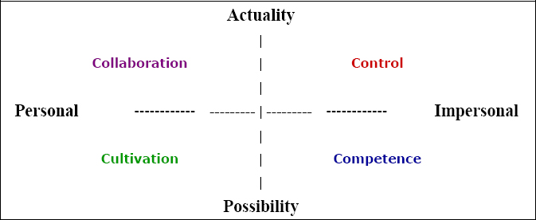

Suda, L. V. (2007). The meaning and importance of culture for project success. Paper presented at PMI® Global Congress 2007—EMEA, Budapest, Hungary. Newtown Square, PA: Project Management Institute.

**Objective 2: Project Management Knowledge Areas**

Topic 1: Project Management Knowledge

What Are Project Management Knowledge Areas?

The 10 knowledge areas of project management are:

1. Managing integration: Projects have all types of activities going on and there is a need to keep the “whole” thing moving collectively together—integrating all of the dynamics that take place. It is about developing the project charter, scope statement, and plan to direct, manage, monitor, and control project change.

2. Managing scope: Projects need to have a defined parameter or scope and this must be broken down and managed through something called a work breakdown structure (WBS). It is about planning, definition, WBS creation, verification, and control.

3. Managing time/schedule: Projects have a definite beginning and a definite ending date. Therefore, there is a need to manage the budgeted time according to a project schedule. It is about definition, sequencing, resource and duration estimating, schedule development, and schedule control.

4. Managing costs: Projects consume resources and therefore, there is a need to manage the investment with the realization of creating value (i.e., the benefits derived exceed the amount spent). It is about resource planning, cost estimating, budgeting, and control.

5. Managing quality: Projects involve specific deliverables or work products. These deliverables need to meet project objectives and performance standards. It is about quality planning, quality assurance, and quality control.

6. Managing human resources: Projects consist of teams, and project team(s) need to be managed during the life cycle of the project. Finding the right people, managing their outputs, and keeping them on schedule is a big part of managing a project. It is about human resources planning, hiring, developing, and managing the project team.

7. Managing communication: Projects invariably touch lots of people, not just the end users (customers) who benefit directly from the project outcomes. This can include project participants, managers who oversee the project, and external stakeholders who have an interest in the success of the project. It is about communications planning, information distribution, performance reporting, and managing stakeholders.

8. Managing risk: Projects are a discovery driven process, often uncovering new customer needs and identifying critical issues not previously disclosed. Projects also encounter unexpected events, such as when project team members resign, budgeted resources are suddenly changed, the organization becomes unstable, and newer technologies are introduced. There is a real need to properly identify various risks and manage these risks. It is about risk planning and identification, risk analysis (qualitative and quantitative), risk response (action) planning, and risk monitoring and control.

9. Managing procurement: Projects will procure the services of outside vendors and contractors, including the purchase of equipment. There is a need to manage how vendors are selected and managed within the project life cycle. It is about the acquisition and contracting plan, sellers' responses and selection, contract administration, and contract closure.

10. Managing stakeholders: Projects involve input and approval from many people along the way. The success of projects sometimes hinges on the appropriate management of stakeholder expectations or agreements.

Note. Adapted from "Overview of Project Planning," by A. Watt, 2013, Project Management, Chapter 8, Sections 1–2. Copyright 2013 by BC Open Textbook Project.

Topic 2: Project Start-Up and Integration

The start-up of a project is similar to the start-up of a new organization. What Is Project Integration Management? During project start-up, the project management team refines the scope of work and develops a preliminary schedule and conceptual budget. The plan for developing and tracking the detailed schedule, the procurement plan, and the plan for building the budget and estimating and tracking costs are developed during the start-up. The plans for information technology, communication, and tracking client satisfaction are all developed during the start-up phase of the project. Flowcharts, diagrams, and responsibility matrices are tools used. The project start-up phase on complex projects can be chaotic, and until plans are developed, the project manager becomes the source of information and direction. The project manager creates an environment that encourages team members to fully engage in the project and encourages innovative approaches to developing the project plan.

Note. Adapted from "Overview of Project Planning," by A. Watt, 2013, Project Management, Chapter 8, Sections 1–2. Copyright 2013 by BC Open Textbook Project.

Integration Management, In-Depth --Video

Integration: One Piece of a Large Puzzle

the planning aspects of project integration management, and how they fit into the larger picture of the project and the organization, as a whole.

Integration Management Plan Templates

Project Integration Management

The most important document in Project Integrations Management is the Project Management Plan including the Project Charter. The Project Management Plan is prepared by the project manager and describes how the project shall be accomplished. It is created during the project initiating phase and is developed further during the project planning phase. Later changes and updates are possible in compliance with the applicable procedures.

The Project Management Plan includes the

* Project Charter,
* Project Definition,
* Project Objectives,
* Budget,
* Project Schedule,
* Resources needed to accomplish the project,
* Management Approach,
* Further Management Plans, and
* The initial Risk Assessment.

Definition of Project Integration Management

**The**[**PMI™**](http://www.pmi.org/)**defines Project Integration Management as:**

*Project Integration Management* includes the processes and activities to identify, define, combine, unify, and coordinate the various processes and project management activities within the project management process groups. In the project management context, integration includes characteristics of unification, consolidation, communication, and integrative actions that are crucial to controlled project execution through completion, successfully managing stakeholder expectations, and meeting requirements.  
Project integration management includes making choices about resource allocation, making trade-offs among competing objectives and alternatives, and managing the inter dependencies among the project management knowledge areas. The project management processes are usually presented as discrete processes with defined interfaces while, in practice, they overlap and interact in ways that cannot be completely detailed in the PMBOK® Guide.

Project Integration Management Processes

**The**[**PMI™**](http://www.pmi.org/)**defines the processes as follows:**

**Develop Project Charter**

Develop project charter is the process of developing a document that formally authorizes the existence of a project and provides the project manager with the authority to apply organizational resources to project activities.

**Create Project Management Plan**

Create project management plan is the process of defining, preparing, and coordinating all plan components and consolidating them into an integrated project management plan.

**Direct and manage project work**

Direct and manage project work is the process of leading and performing the work defined in the project management plan and implementing approved changes to achieve the project’s objectives.

**Manage Project Knowledge**

Manage project knowledge is the process of using existing knowledge and creating new knowledge to achieve the project’s objectives and contribute to organizational learning.

**Monitor and Control Project Work**

Monitor and control project work is the process of tracking, reviewing, and reporting overall progress to meet the performance objectives defined in the project management plan.

**Perform Integrated Change Control**

Perform integrated change control is the process of reviewing all change requests; approving changes and managing changes to deliverables, organizational process assets, project documents, and the project management plan; and communicating the decisions.

**Close Project or Phase**

Close project or phase is the process of finalizing all activities for the project, phase, or the contract.

Topic 3: Project Scope

What Is Scope?

**Scope Planning**

The scope planning process is the very first thing you do to manage your scope. Project scope planning is concerned with the definition of all the work needed to successfully meet the project objectives. The whole idea here is that when you start the project, you need to have a clear picture of all the work that needs to happen on your project, and as the project progresses, you need to keep that scope up-to-date and written down in the project’s scope management plan.

***Defining the Scope***

In scope planning) you need to plan further and write down all the intermediate and final deliverables that you and your team are going to produce over the course of the project. They include every intermediate document, plan, schedule, budget, blueprint, and anything else that will be made along the way, including all of the project management documents you put together. One of the project manager’s primary functions is to accurately document the deliverables of the project and then manage the project so that they are produced according to the agreed upon criteria.

**The Scope Document**

The scope document defines what tasks the project team is expected to accomplish and, just as importantly, what is not part of the project.

***Uses of a Scope Document***

A well-developed project scope statement provides the project team with information the team needs to design and implement the project execution plan.

***Development of a Scope Document***

The project manager will often develop the first draft and will attempt to develop consensus around the project scope project scope document can be a short discussion between the project manager and the client, or on a large, complex project.

***Managing Changes to the Scope Document***

Changes are to be expected. Changes to the project scope are necessary to reflect new information.

**Deviation Versus Change**

**A** minor change is made to the schedule that does not affect the completion date of the project is a deviation.

Note. Adapted from "Quality Planning," by A. Watt, 2013, Project Management, Chapter 14. Copyright 2013 by BC Open Textbook Project.

What Is Scope Creep?

To avoid scope creep, the project manager needs to ensure that everyone has the same image of the project in their mind. Sometimes, scope creep can be when you add new features or when your group goes completely off track.

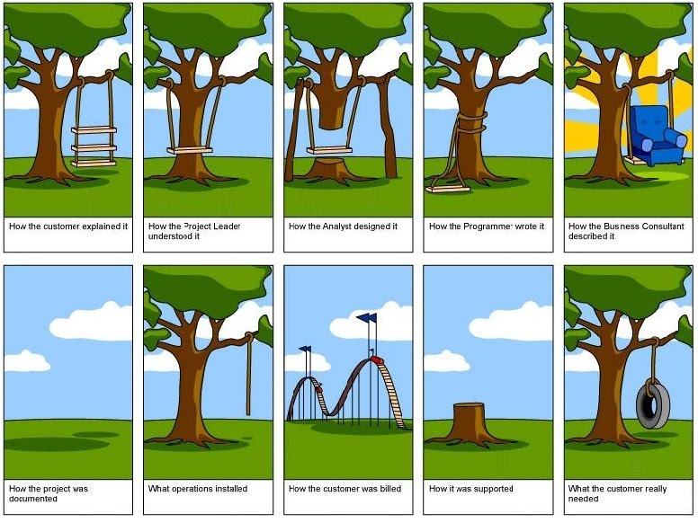

We must listen to what is needed and not to what we have done in the past.

Project Requirements

The requirements of the deliverable(s) are part of the scope plan, and they are documented early in the project. After all the deliverables are identified, t Requirements describe the characteristics of the final deliverable, either a product or a service. the project manager needs to document all the requirements of the project. All the functionality or characteristics of those requirements. A requirement is an objective that must be met. The project’s requirements, defined in the scope plan, describe what a project is supposed to accomplish and how the project is supposed to be created and implemented. Requirements may include attributes like dimensions, ease of use, color, specific ingredients, and so on. They can be divided into six basic categories: functional, non-functional, technical, user, business, and regulatory requirements.

**Functional Requirements**

Functional requirements describe the characteristics of the final deliverable; what emerges from the project in ordinary nontechnical language.

**Non-Functional Requirements**

Non-functional requirements specify criteria that can be used to judge the final product or service that your project delivers. They are restrictions or constraints to be placed on the deliverable and how to build it.

performance constraints:

Due to government incentives, the purchased trucks should be American-made. The load area must be covered. The load area must have a height of at least 10 feet.

**Technical Requirements**

Technical requirements emerge from the functional requirements, they answer the questions: how the problem will be solved this time and will it be solved technologically and/or procedurally.

**Business Requirements**

Business requirements are the needs of the sponsoring organization, always from a management perspective. Business requirements are statements of the business rationale for the project.

**User Requirements**

User requirements describe what the users need to do with the system or product.

**Regulatory Requirements**

Regulatory requirements can be internal or external and are usually non-negotiable. They are the restrictions, licenses, and laws that are applicable to a product or business, imposed by the government.

**Software Requirement Fundamentals**

A software requirement is a property that must be exhibited by software developed or adapted to solve a particular problem.

**Measuring Requirements**

|  |  |
| --- | --- |
| Table 2.1 Requirements Measure | |
| Property | Measure |
| Size | MB/GB throughput |
| Ease of Use | User acceptance test  Help system |
| Reliability | Rate of failure occurrence  Availability  Mean time to failure  Number of occurrences |
| Robustness | Time to restart after failure  Number of users on the system |
| Scalability | Number of users on the system |
| Portability | Percentage of target dependents statements  Number of target systems |
| Speed | Transactions per second  Response time  Refresh time |

*Note.*Adapted from "Quality Planning," by A. Watt, 2013, *Project Management,*Chapter 14. Copyright 2013 by BC Open Textbook Project.

Scope Inputs, Tools, and Techniques

Project managers use a variety of inputs, tools, and techniques when planning scope.

**Scope Inputs**

The project manager gathers initial project facts from the project charter. Moreover, background information on the stakeholder’s workplace, existing business model, rules, and more assist in creating the vision of the final product/service, and consequently, the project scope.

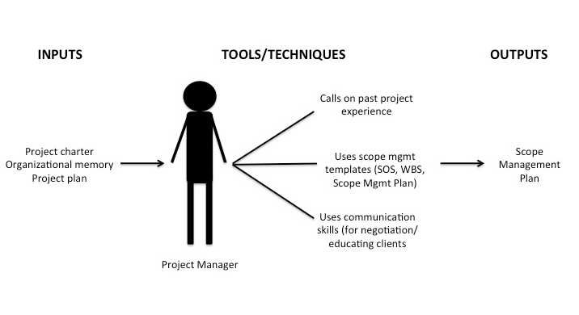

**Techniques**

Gathering requirements is part of scope definition, and it can be done using one or more of following techniques:

* Interviews
* Focus groups
* Facilitated groups—Joint Application Development (JAD) versus Quality Function Deployment (QFD)
* Group creativity techniques: brainstorming, nominal groups, delphi, mind map, affinity diagnose
* Prototyping
* Observation
* Questions and surveys
* Group decision-making techniques: unanimity, majority, plurality, dictatorship

**Requirements Traceability Matrix**

The requirements traceability matrix is a table that links requirements to their origin and traces them throughout the project life cycle.  Each requirement adds business value by linking it to the business and project objectives.

* requirements to business needs, opportunities, goals, and objectives;
* requirements to project objectives;
* requirements to project scope/work breakdown structure deliverables;
* requirements to product design;
* requirements to product development;
* requirements to test strategy and test scenarios; and
* high-level requirements to more detailed requirements.

Attributes associated with each requirement can be recorded in the requirements traceability matrix.

***Matrix Fields***

These are suggestions only and will vary based on organizational and project requirements.

* A unique identification number containing the general category of the requirement (e.g., SYSADM) and a number assigned in ascending order (e.g., 1.0, 1.1, 1.2)
* The requirement statement
* Requirement source (donference, configuration control board, task assignment, etc.)
* Software requirements specification/functional requirements document paragraph number containing the requirement
* Design specification paragraph number containing the requirement
* Program module containing the requirement
* Test specification containing the requirement test
* Test case number(s) where requirement is to be tested (optional)
* Verification of successful testing of requirements
* Modification field. If requirement was changed, eliminated, or replaced, indicate disposition and authority for modification.

**Work Breakdown Structure (WBS)**

The work breakdown structure (WBS) defines the scope of the project and breaks the work down into components that can be scheduled and estimated and easily monitored and controlled.

Overview

The WBS creation involves:

* Listing all the project outputs (deliverables and other direct results).
* The identification of all the activities required to deliver the outputs.
* The subdivision of these activities into subactivities and tasks.
* The identification of the deliverable and milestone(s) of each task
* The identification of the time usage of all the resources (personnel and material) required to complete each task.

The purpose of developing a WBS is to:

* Allow easier management of each component.
* Allow accurate estimation of time, cost, and resource requirements.
* Allow easier assignment of human resources.
* Allow easier assignment of responsibility for activities.

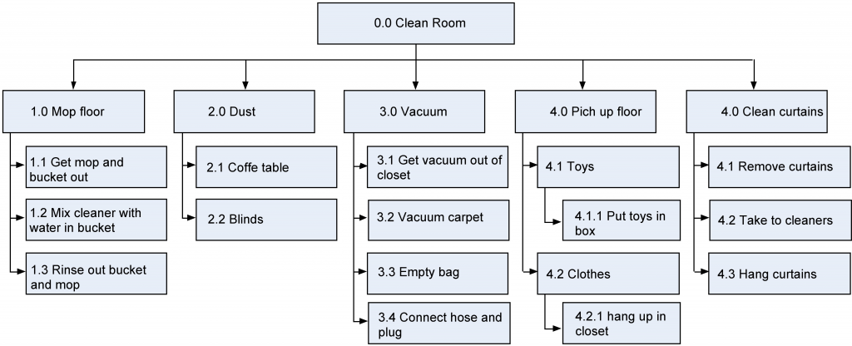

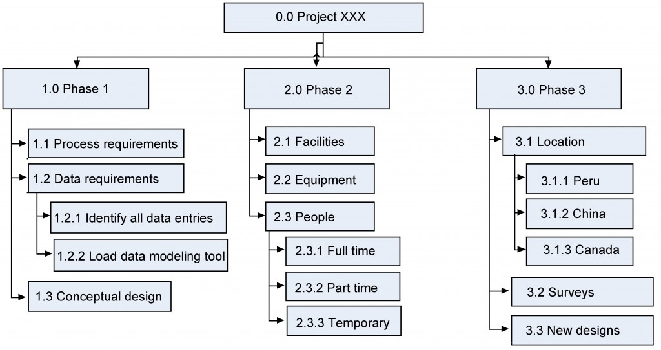

Or another is the sticky note wbs.

**One Hundred Percent Rule**

The "One Hundred Percent Rule" is the most important criterion in developing and evaluating the WBS. The rule states that each decomposed level (child) must represent 100% of the work applicable to the next higher (parent) element. In other words, if each level of the WBS follows the 100% rule down to the activities, then we are confident that 100% of the activities will have been identified when we develop the project schedule.

**Scope Statement**

The scope statement details the project deliverables and describes the major objectives. The objectives should include measurable success criteria for the project. A scope statement captures, in very broad terms, the product of the project

As a baseline, scope statements should contain:

* the project name
* the project charter
* the project owner, sponsors, and stakeholders
* the problem statement
* the project goals and objectives
* the project requirements
* the project deliverables
* the project non-goals (what is out of scope)
* milestones
* cost estimates

In more project-oriented organizations, the scope statement may also contain these and other sections:

* project scope management plan
* approved change requests
* project assumptions and risks
* project acceptance criteria

*Note.*Adapted from "Quality Planning," by A. Watt, 2013, *Project Management,*Chapter 14. Copyright 2013 by BC Open Textbook Project.

Using Sticky Notes to Create the WBS -- video

Benefits of a Scope Management Plan – Article

` the Scope Management Plan (SMP). This document is a best practice, but is often forgotten once a project transitions from the planning phase to execution or monitoring and controlling phases due to of the number of activities needing a PM’s attention.

What Is A Scope Management Plan

* Documents the process to evaluate whether or not a request is within the contract’s scope
* Defines how approved requests are prioritized and scheduled
* Explains the roles and responsibilities for each participant in the scope management process

Benefits Of A Scope Management Plan

When used properly, an SMP helps effectively manage the triple constraint elements (time/schedule, budget, and quality) as well as other factors:

* Applicable to public (government) and private organizations and projects
* Helps prioritize and reduce ad hoc work requests, which can save time and money
* Allows for quantitative analysis to validate the need of an ad hoc request
* Facilitates productive communications with stakeholders and their team
* Serves as a tool to manage client expectations, work load balancing, and team morale

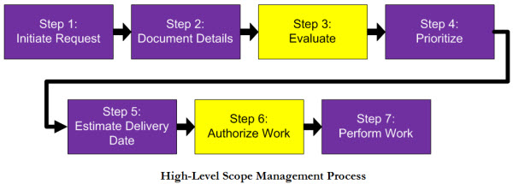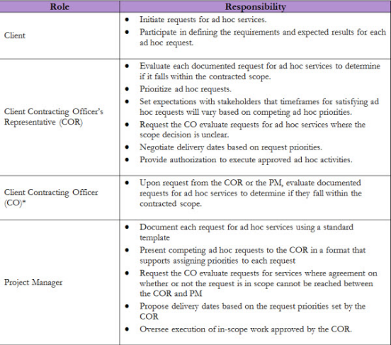

Scope Management Plan Templates

Project Scope

Project scope is the work that needs to be accomplished to deliver a product, service, or result with the specified features and functions.

Product Scope

Product scope are the features and functions that characterize a product, service, or result.

**Project Scope Management Processes**

Definition of the processes by PMI™:

Plan Project Scope Management

Plan project scope management is the process of creating a scope management plan that documents how the project and product scope will be defined, validated, and controlled.

Collect Requirements>

Collect requirements is the process of determining, documenting, and managing stakeholder needs and requirements to meet project objectives.

Define Scope

Define scope is the process of developing a detailed description of the project and product.

Create WBS

Create WBS is the process of subdividing project deliverables and project work into smaller, more manageable components.

Validate Scope

Validate scope is the process of formalizing acceptance of the completed project deliverables.

Control Scope

Control scope is the process of monitoring the status of the project and product scope and managing changes to the scope baseline.

Topic 4: Project Schedule and Time Management

Overview of Time Management

The project scope document is used to create a master schedule that identifies important dates and activities. Project planning and scheduling are both an art and a science. The master schedule is a summary level schedule that encompasses the entire project scope—that includes major events and provides a view of the entire project. The schedule continues to evolve during the life of the project.

To develop the project schedule, the project team does an analysis of the project scope, contract, and other information that helps the team define the project deliverables. Based on this information, the project team develops a milestone schedule. The milestone schedule establishes key dates throughout the life of a project that must be met for the project to finish on time. The key dates are often established to meet contractual obligations or intervals are established that will reflect appropriate progress for the project.

Note. Adapted from "Project Time Management," by R. Darnall & J. M. Preston, 2012, Project Management: From Simple to Complex, Chapter 8. Copyright 2012 by Flat World Knowledge Inc.

Adapted from "Overview of Project Planning" by A. Watt, 2013, Project Management, Chapter 8, Sections 1–2. Copyright 2013 by BC Open Textbook Project.

Managing the Schedule

To manage a schedule, the project manager must know how the work is progressing compared to the master schedule and, if necessary, make changes to keep the project on time.

**Tracking and Reporting Progress**

Tracking the schedule performance involves measuring the work performed against the work expected to be performed with a given expenditure of resources.

***Reporting Percentage Completed***

To determine the percentage of a project that has been completed, the project manager must determine what to measure. Some percentages are misleading.

**Managing Schedules Using Milestones**

Milestones provide the opportunity for project management to focus on completing activities that will have the greatest impact on the schedule.

**Informing Stakeholders**

A schedule update is distributed regularly to provide project stakeholders with an assessment of the progress of the project against the master schedule.

**Resource Leveling**

The schedule of activities is constrained by the availability of resources. If you apply the resource calendar to each activity to be sure the people and equipment are available on those dates, you can still miss an important constraint.

**Accelerating the Schedule**

The project manager must know how to accelerate a schedule to compensate for unanticipated events.

***Contingency Resources***

One method of accelerating the schedule is to add activities to the critical path that are empty or that are optional.

***Reassigning Resources***

Activities that are not on the critical path that have free float can be delayed without delaying the end date of the project if they start by the late start date.

***Changing Scope***

The unit cost of work to be performed on a project is calculated at the beginning of the project based on the execution strategy of the project to meet the project completion date.

***Additional Resources***

Another option is to allocate funds that can be used to add resources if necessary.

***Changing Quality***

Another option for accelerating the schedule is the changing of the quality specifications of the product. This is usually done as a scope change.

Note. Adapted from "Project Time Management," by R. Darnall & J. M. Preston, 2012, Project Management: From Simple to Complex, Chapter 8, Section 4. Copyright 2012 by Flat World Knowledge Inc.

Time Management Plan Template

Project Schedule Management Processes

Definition of the processes by PMI™:

Plan Schedule Management

Plan schedule management is the process of establishing the policies, procedures, and documentation for planning, developing, managing, executing, and controlling the project schedule.

Define Activities

Define activities is the process of identifying and documenting the specific actions to be performed to produce the project deliverables.

Sequence Activities

Sequence activities is the process of identifying and documenting relationships among the project activities.

Estimate Activity Durations

Estimate activity durations is the process of estimating the number of work periods needed to complete individual activities with the estimated resources.

Develop Schedule

Develop schedule is the process of analyzing activity sequences, durations, resource requirements, and schedule constraints to create the project schedule model for project execution and monitoring & controlling.

Control Schedule

Control schedule is the process of controlling the status of the project to update the project schedule and manage changes to the schedule baseline.

Topic 5: Project Costs

What Is Cost Management?

The definition of project success often includes completing the project within budget. Developing and controlling a project budget that will accomplish the project objectives is a critical project management skill. The accuracy of the project budget is related to the amount of information known by the project team. The first estimate of cost is the conceptual estimate (or “ballpark estimate”) is developed with the least amount of knowledge and usually from experience. After a project design is more complete, a project detailed estimate can be developed. The project manager is responsible for assuring that the project team develops cost estimates based on the best information available. When more information is known, the project team can develop a rough order of magnitude (ROM) estimate.

Note. Adapted from "Overview of Project Planning" by A. Watt, 2013, Project Management, Chapters 8, Sections 1–2. Copyright 2013 by BC Open Textbook Project.

Estimating Costs

**Estimating Costs to Compare and Select Projects**

The estimates must be accurate enough so that the comparisons are meaningful. The methods used to estimate the cost of the project during the selection phase are generally faster and consume fewer resources than those used to create detailed estimates in later phases.

***Analogous Estimates***

An estimate that is based on other project estimates is an analogous estimate.

***Parametric Estimate***

If the project consists of activities that are common to many other projects, average costs are available per unit.

**Estimating Costs to Initiate Projects**

Once the project is selected, more accurate estimates are often needed to raise funds and agree on contracts with vendors in the initiation phase.

**Vendor Bid Analysis**

If services or products will be provided by vendors, the cost of those services can be determined by issuing a request for proposal (RFP).

**Bottom-Up Estimating**

The most accurate and time-consuming estimating method is to identify the cost of each item in each activity of the schedule, including labor and materials. The detail can be rolled up—subtotaled—to display less detail.

**Activity-Based Estimates**

Detailed estimates from all sources can be reorganized so those costs that are associated with a particular activity can be grouped by adding the activity code to the detailed estimate

**Establishing a Budget**

Once the cost of each activity is estimated, it is possible to determine how much money is needed for each group of tasks and for the whole project.

***Cost of Tasks***

The cost of each group of activities of the project can be estimated by summing the costs of the components of each activity in the group. This process of subtotaling costs by category or activity is called cost aggregation.

Budget Timeline

it is possible to calculate how much money needs to be spent by any particular date during the project.

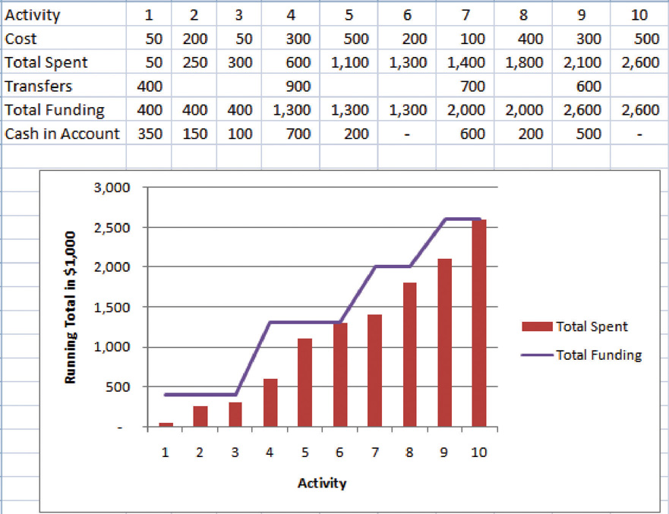

Contractual agreements with vendors often require partial payment of their costs during the project.

Note. Adapted from "Estimating and Managing Costs," by R. Darnall & J. M. Preston, 2012, Project Management: From Simple to Complex, Chapter 9, Section 1. Copyright 2012 by Flat World Knowledge Inc.

Cost Management Plan Template

Project Cost Management Processes

**The**[**PMI™**](http://www.pmi.org/)**defines the processes as follows:**

**Plan Cost Management**

Plan cost management is the process of defining how the project costs will be estimated, budgeted, managed, monitored, and controlled.

**Estimate Cost**

Estimate cost is the process of developing and approximation of the monetary resources needed to complete the project works.

**Determine Budget**

Determine budget is the process of aggregating the estimated costs of individual activities or work packages to establish an authorized cost baseline.

**Control Cost**

Control cost is the process of monitoring the status of the project, to update the project costs, and manage changes to the cost baseline.

Topic 6: Project Quality

What Is Project Quality?

Quality is the degree to which a product or service fulfills requirements and provides value for its price.

**Project Quality**

Project quality focuses on the end product or service deliverables that reflect the purpose of the project.

Definitions of Quality and Grade

The International Organization for Standardization (ISO), quality is “the degree to which a set of inherent characteristics fulfill requirements.” The requirements of a product or process can be categorized or given a grade.

Quality: Two Aspects of the Project

Both project and process quality management require commitment from all employees, including top management. Project quality refers to two distinct aspects of the project. Project quality can refer to the quality of the product or service delivered by the project. Project quality can also refer to managing the project efficiently and effectively.

Note. Adapted from "Managing Project Quality," by R. Darnall & J. M. Preston, 2012, Project Management: From Simple to Complex, Chapter 10, Section 3. Copyright 2012 by Flat World Knowledge Inc.

Planning and Controlling Project Quality

The quality planning process uses initial scope, budget, and schedule estimates to identify areas that need quality management. Planning for quality is part of the initial planning process. Several different tools and techniques are available for planning and controlling the quality of a project. High quality is achieved by planning for it.

**Measurement Terminology**

During the execution phase of the project, services and products are sampled and measured to determine if the quality is within control limits for the requirements and to analyze causes for variations.

**Defining and Meeting Client Expectations**

Clients provide specifications for the project that must be met for the project to be successful. Meeting project specifications is one definition of a project success.

**Quality Management Methodology**

The quality management methodology required by the client is used. Following are several methodologies.

***Benchmarking***

In modern management practice, if a particular method or product is a standard of quality, comparing your organization’s quality plan to it is called benchmarking.

***Cost-to-Benefit Analysis—measuring value***

Some quality management programs, like Six Sigma, require that expenditures for quality are justified using a cost-to-benefit analysis that is similar to calculating the cost of quality, except that it is a ratio of cost of increasing quality to the resulting benefit. A cost-benefit analysis in some quality programs can take into account nonfinancial factors such as client loyalty and improvements to corporate image and the cost-to-benefit analysis takes the form of a written analysis rather than a simple numeric ratio. It is similar to determining the cost of quality (COQ).

Note. Adapted from "Managing Project Quality," by R. Darnall & J. M. Preston, 2012, Project Management: From Simple to Complex, Chapter 10, Section 4. Copyright 2012 by Flat World Knowledge Inc.

Cost-Benefit Analysis: In-Depth – full paper is saved…

Quality Management Plan Templates

Project Quality Management Processes

**The**[**PMI™**](http://www.pmi.org/)**defines the processes as follows:**

**Plan Quality Management**

Plan quality management is the process of identifying quality requirements and/or standards for the project deliverables, and documenting how the project will demonstrate compliance with quality requirements and/or standards.

**Manage Quality**

Manage quality is the process of translating the quality management plan into executable quality activities that incorporate the organization’s quality policies into the project.

**Control Quality**

Control quality is the process of monitoring and recording the results of executing the quality management activities to assess performance and ensure the project outputs are complete, correct, and meet customer expectations.

Topic 7: Project Team: Human Resources

What Is Human Resources Management for Projects?

The most important resource of a project is its people. The staffing plan for a project typically reflects two important elements. First, it outlines the long-term goals of skilled team members needed for the project. It also describes the short-term commitment that reflects the nature of the project. Each phase of the project has staffing requirements. Team members needed in the early or conceptual phases of the project are often not needed during the later or project closeout phases. Typically, a core project management team is dedicated to the project from start-up to closeout. his staffing approach allows the project manager to create the project organizational culture. Some project cultures are more structured and detail-oriented, and some are less structured with less formal roles and communication requirements. The type of culture the project manager creates depends greatly on the type of project.

Note. Adapted from "Overview of Project Planning" by A. Watt, 2013, Project Management, Chapter 8, Sections 1–2. Copyright 2013 by BC Open Textbook Project.

HumaProject Resource Management Processes

**The**[**PMI™**](http://www.pmi.org/)**defines the processes as follows:**

**Plan Resource Management**

Plan resource management is the process of defining how to estimate, acquire, manage, and utilize physical and team resources.

**Estimate Activity Resources**

Estimate activity resources is the process of estimating team resources, and the type and quantities of material, equipment, and supplies necessary to perform project work.

**Acquire Resources**

Acquire resources is the process of acquiring team members, facilities, equipment, materials, supplies, and other resources necessary to complete project work.

**Develop Team**

Develop team is the process of improving competencies, team member interaction, and the overall team environment to enhance project performance.

**Manage Team**

Manage team is the process of tracking team member performance, providing feedback, resolving issues, and managing team changes to optimize project performance.

**Control Resources**

Control resources is the project of ensuring that the physical resources assigned and allocated to the project are available as planned, as well as monitoring the planned versus the actual use of resources, and performing corrective action as necessary.

Topic 8: Communications

Communications Planning

The flow of information between team members and stakeholders is managed by rules set forth in a communications plan, which is part of the overall project plan. Typically, the generation, flow, and storage of information reflects the organizational culture, and to effectively communicate in an organization, a person must be able to develop communication styles and processes consistent with that organization.

The project leadership team develops an understanding of the information needs of the various members and stakeholders of the projects and develops a communications plan that provides the right information, at the right time, to the right people.

**Communication Matrix**

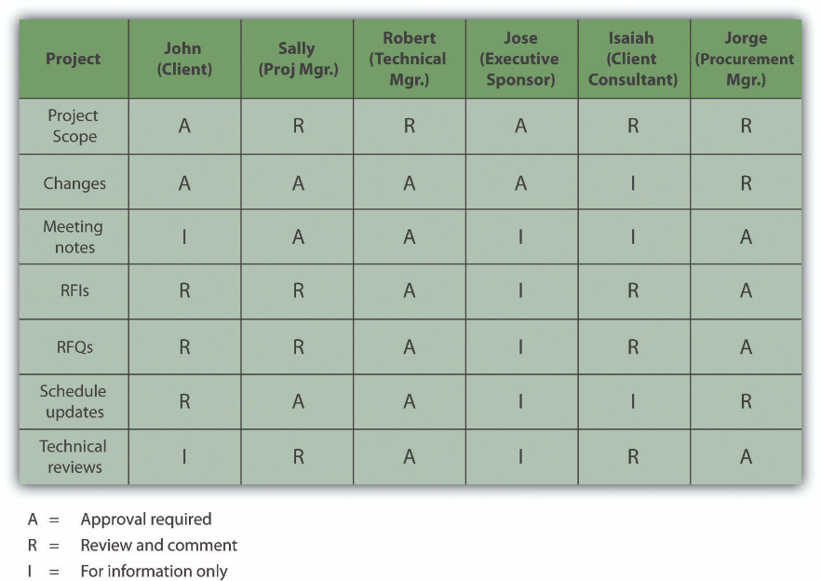A Guide to the Project Management Body of Knowledge (PMBOK Guide) describes tools and techniques for identifying project stakeholders, defining their information requirements, and determining the appropriate communication technology. The project leadership team develops a list of communication methods for gathering and communicating project information. These include a list of reports, meetings, and document flowcharts.

**Document Control**

On large, complex projects, organizing the creation, distribution, and storage of documents is a major and important activity. Document control systems distribute, store, and retrieve information that is needed by the project team.

**Document Naming Provides Information About the Content**

On a complex project, document names were chosen to indicate the category, location, purpose, author, and date. For example, a file named 323RFQDewateringPump_Darnall_10.08.2012 rev 3. When a document is expected to be revised over the course of the project, version control becomes important. To assure that everyone who should either review or approve the document received a copy, document control develops a distribution list for each type of documents. Each person reviews and signs the distribution list and then sends the document to the next person on the list.

Note. Adapted from "Starting a Project," by R. Darnall & J. M. Preston, 2012, Project Management: From Simple to Complex, Chapter 7, Section 5. Copyright 2012 by Flat World Knowledge Inc.

Types of Communication

Many projects are performed by teams that interact primarily through electronic communication and are, therefore, called virtual teams (“Virtual Team,” n.d.)

**Synchronous Communications**

All the parties to the communication are taking part in the exchange at the same time, the communication is synchronous.

**Time Zones**

If something must be done by the start of business tomorrow, team members in Asia can work on the problem during their normal work hours while team members in North America get some sleep.

Asynchronous Communications

All the parties to the communication are NOT taking part in the exchange at the same time, the communication is asynchronous.

Note. Adapted from "Communication Technologies," by R. Darnall & J. M. Preston, 2012, Project Management: From Simple to Complex, Chapter 6, Section 1. Copyright 2012 by Flat World Knowledge Inc.

Communication Management Plan Template

Project Communications Management Processes

The PMI™ defines the Project Communications Management processes as follows:

Plan Communications Management

Plan communications management is the process of developing an appropriate approach and plan for project communication activities based on the information needs of each stakeholder group, available organizational assets, and the needs of the project.

Manage Communications

Manage communications is the process of timely and appropriate collection, creation, distribution, storage, retrieval, management, monitoring, and the ultimate disposition of project information.

Monitor Communications

Monitor communications is the process of ensuring the information needs of the project and its stakeholders are met.

Topic 9: Project Risk

Defining Risk

Risk is the possibility of loss or injury (“Risk,” n.d.). Project risk is an uncertain event or condition that, if it occurs, has an effect on at least one project objective (Project Management Institute, Inc., 2008). Risk management focuses on identifying and assessing the risks to the project and managing those risks to minimize the impact on the project.

Note. Adapted from "Starting a Project," by R. Darnall & J. M. Preston, 2012, Project Management: From Simple to Complex, Chapter 11, Section 1. Copyright 2012 by Flat World Knowledge Inc.

Adapted from "Overview of Project Planning" by A. Watt, 2013, Project Management, Chapter 8, Sections 1–2. Copyright 2013 by BC Open Textbook Project.

Risk Management Plan Templates

Project Risk Management Processes

**The**[**PMI™**](http://www.pmi.org/)**defines the processes as follows:**

**Plan Risk Management**

Plan risk management is the process of defining how to conduct risk management activities for a project.

**Identify Risks**

Identify risks is the process of identifying individual project risks as well as overall sources of project risk, and documenting their characteristics.

**Perform Qualitative Risk Analysis**

Perform qualitative risk analysis is the process of prioritizing individual project risks for further analysis or action by assessing their probability of occurrence and impact as well as other characteristics.

**Perform Quantitative Risk Analysis**

Perform quantitative risk analysis is the process of numerically analyzing the combined effect of identified individual project risks and other sources of uncertainty on overall project objectives.

**Plan Risk Responses**

Plan risk responses is the process of developing options, selecting strategies, and agreeing on actions to address overall project risk exposure, as well as to treat individual project risks.

**Implement Risk Responses**

Implement risk responses is the process of applying agreed-upon risk response plans.

**Monitor Risks**

Monitor risks is the process of monitoring the implementation of agreed-upon risk response plans, tracking identified risks, identifying and analyzing new risks, and evaluating risk process effectiveness throughout the project.

Topic 10: Project Procurement

What Is Procurement?

The process of obtaining goods and services from providers who are outside of the organization is procurement. Often the client organization will provide procurement services on less complex projects. On larger, more complex projects, personnel are dedicated to procuring and managing the equipment, supplies, and materials needed by the project. Commodities are common products that are purchased based on the lowest bid. The second type of procurement includes products that are specified for the project. Vendors who can produce these products bid for a contract. The third procurement approach is the development of one or more partners.

| Table 2.2 Project Management process groups and knowledge area mapping | | | | | |
| --- | --- | --- | --- | --- | --- |
| **PM Process Groups** | | | | | |
| **Knowledge Area** | **Initiating** | **Planning** | **Executing** | **Monitoring and Controlling** | **Closing** |
| Project Integration | Develop Project Charter | Develop PM Plan | Direct and Manage Project Execution | Monitor and control project work, manage and change control | Close project |
| Scope Management |  | Collect requirements  Define scope  Create WBS |  | Verify Scope  Control Scope |  |
| Time Management |  | Define activities, sequence activities, Estimate resources and durations, develop schedule |  | Control Schedule |  |
| Cost Management |  | Estimate Costs, determine budget |  | Control Costs |  |
| Quality Management |  | Plan Quality | Perform Quality Assurance | Perform Quality Control |  |
| HR Management |  | Develop Human Resource Plan | Acquire Team, develop and manage |  |  |
| Communications Management | Identify stakeholders | Plan communications | Distribute Information Management expectations | Report Performance |  |
| Risk Management |  | Identifying risk, perform qualitative rick analysis, perform quantitative risk analysis, plan risk analysis |  | Monitor and control risk |  |
| Procurement Management |  | Plan Procurements | Conduct Procurements | Administer Procurements | Close Procurements |

Adapted from Watt, A. (2013). Overview of project planning. In Project management. BC Open Textbook Project. Retrieved from http://opentextbc.ca/projectmanagement/chapter/chapter-4-framework-for-project-management-project-management/

*Note.*Adapted from "Overview of Project Planning" by A. Watt, 2013, *Project Management,*Chapter 8, Sections 1–2. Copyright 2013 by BC Open Textbook Project.

Procurement Management Plan Templates

Project Procurement Management Processes

**The**[**PMI™**](http://www.pmi.org/)**defines the processes as follows:**

**Plan Procurement Management**

Plan procurement management is the process of documenting project procurement decisions, specifying the approach, and identifying potential sellers.

**Conduct Procurement**

Conduct procurement is the process of obtaining seller responses, selecting sellers, and awarding contracts.

**Control Procurement…**

… is the process of managing procurement relationships, monitoring contract performance, making changes and corrections as appropriate, and closing out contracts.

Topic 11: Stakeholder Management

What Is Stakeholder Management?

Stakeholders play a critical role in the project and its success. The management of stakeholders supports an organization's strategic objectives through the appropriate management of stakeholder expectations or agreements that are typically signed by stakeholder representatives.

Why Stakeholder Management?

Stakeholder management is influenced by:

* Stakeholder identification—Catalogs interested parties either internal or external to the organization or project. A stakeholder map is helpful for identifying the stakeholders (Llewellyn, 2009).
* Stakeholder analysis—Recognizes and acknowledges the needs, concerns, wants, authority, common relationships, and interfaces to stakeholders and aligns this information within the stakeholder matrix.
* Stakeholder matrix—Positions stakeholders according to the level of influence, impact, or enhancement they may provide to the business or its projects. There are many simple 2 x 2 models in the literature and a few more sophisticated tools such as the Stakeholder Circle (Bourne, 2007). Figure 2.21 shows an example of a stakeholder matrix.
* Stakeholder engagement—Different from stakeholder management is that engagement does not seek to develop the project/business requirements, delineate problems, create solutions, or establish roles and responsibilities. It is primarily focused at getting to know and understand each other at the executive level. Engagement is the opportunity to discuss and agree on expectations of communication and, primarily, to agree on a set of values and principles that all stakeholders will abide by.
* Communicating information—Expectations are established and agreed to for the manner in which communications are managed between stakeholders—who receives communications, when, how, and to what level of detail. Protocols may be established, including security and 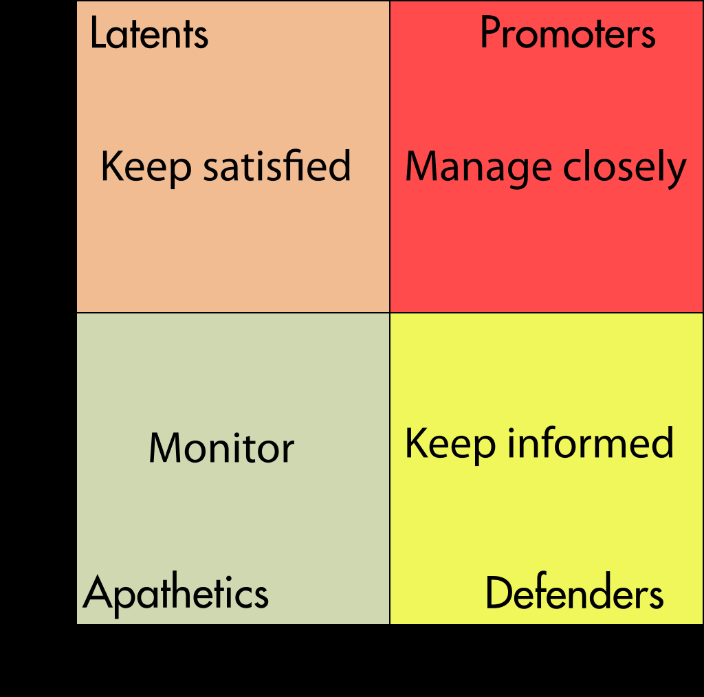confidentiality classifications.

good article http://www.corpedgroup.com/resources/pm/WhatMustKnowStakeholder.asp

Stakeholder Management Plan Template

Project Stakeholder Management Processes

Definition of the processes by PMI™:

Identify Stakeholders

Identify stakeholders is the process of identifying project stakeholders regularly and analyzing and documenting relevant information regarding their interests, involvement, inter-dependencies, influence, and potential impact on project success.

Plan Stakeholder Engagement

Plan stakeholder engagement is the process of developing approaches to involve project stakeholders based on their needs, expectations, interests, and potential impact on the project.

Manage Stakeholder Engagement

Manage stakeholder engagement is the process of communicating and working with stakeholders to meet their needs and expectations, address issues, and foster appropriate stakeholder engagement involvement.

Monitor Stakeholder Engagement

Monitor stakeholder engagement is the process of monitoring stakeholder relationships and tailoring strategies for engaging stakeholders through the modification of engagement strategies and plans.

Objective 3: How Projects Evolve

Topic 1: The Triple Constraint. What Is the Triple Constraint?

One side of the triangle cannot be changed without affecting the others. “triple constraint,” which traditionally only consisted of time, cost, and scope. a triangle to visualize the project work and to see the relationship between the scope/quality, schedule/time, and cost/resource (Figure 3.1).

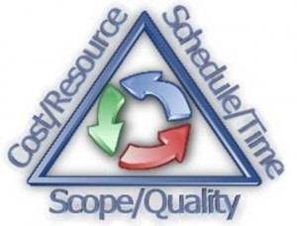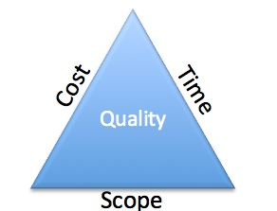

Here is an example of a project that cut quality because the project costs were fixed. The P-36 oil platform (Figure 3.4) The platform sunk as a result of removes what was believed to be outdated safety constraints. While the company had some increase do to not adhering to the safety constraints, the end was the loss of the entire platform, which cost billions.

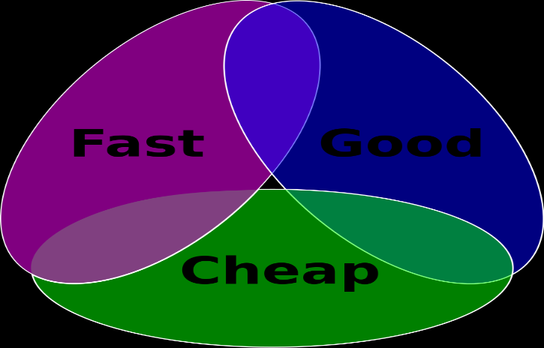

Please refer to milestone here. For fast cheap good comparison.

Milestone Activity: The Triple Constraint

Topic 2: The Project Life Cycle

Project Phases

"Project Initiation," by A. Watt, 2013, Project Management, Chapter 7. Copyright 2013 by BC Open Textbook Project.

The project manager and project team have one shared goal: to carry out the work of the project for the purpose of meeting the project’s objectives.

Phases are also typically sequential, where the prior phase is essentially complete before the beginning of the next phase.

The initiation phase of a project represents the activities associated with starting up the project. initiation phase include project kickoff meetings, identifying the project team, developing the resources needed to develop the project plan, and identifying and acquiring the project management infrastructure (space, computers). he initiation phase typically begins with the assignment of the project manager and ends when the project team has sufficient information to begin developing a detailed schedule and budget. On a large project, lasting 2 or more years, it is common to see the project management team change leadership to provide skills that are appropriate to the final phases of the project.

the Project Management Institute (2008) identifies four major phases of a project as characteristics of the project life cycle. These four life-cycle phases are **initiation, planning, execution, and project closeout.**

The planning phase, which PMI labels “organizing and preparing,” includes the development of more detailed schedules and a budget. The planning also includes developing detailed staffing, procurement, and project controls plans.

The execution phase, labeled by PMI as “carrying out the work,” includes the major activities needed to accomplish the work of the project in addition to monitoring and controlling project work. On a construction project, this would include the design and construction activities.

The closeout phase—or using PMI’s nomenclature, “closing of the project”—represents the final stage of a project. Project staff is transferred off the project, project documents are archived, and the final few items or punch list is completed. The project client takes control of the product of the project, and the project office is closed down.

Objective 4: Other Views of Project Management

Topic 1: The System View of Project Management -- Systemic project management

take notes in your Learning Journal so that you can reference them when completing your Final Assessment.

It consists of a set of core principles or assumptions; a learning environment in which project management professionals can share stories with each other, invent new tools and methods together, reflect on and practice the new methods in action and feel connected and supported by a community of professional peers who share the same purpose, and finally, a set of practice guides and execution methods aimed at producing specific outcomes at each step of the project management lifecycle. Figure 4.1 depicts such a system.

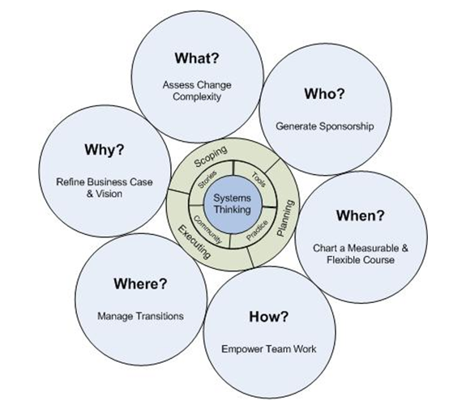

Over time, such a system will lead to the organic growth and transformation of individual mental complexity and deliver superior and more sustainable organizational performance.

**A Practice Guide to Systemic Project Management**

***Set the Stage***

All projects are about making changes that the organization deems important and/or necessary. The central challenge of making such changes is to align the assumptions and actions of the players involved. As a general rule, we should expect that such assumptions and actions are not aligned unless and until they are managed. The Ladder of Inference tool (Senge, et al. 1994, p. 242)

***Assess Change Complexity—What?***

It is not uncommon for a project to be initiated with a specific problem or outcome in mind, such hidden complexities are the main cause of notoriously high project failure rates known in the industry. Once assigned, the project management professional must assess carefully the complexity of his or her assignment to the extent of his or her mental complexity. The quality of the project plan and its execution is determined primarily by the alignment between these two sets of complexities. Learning comes through overcoming these complexities.

***Generate Effective Sponsorship—Who?***

human beings and organizations are tremendously resistant to change for systemic reasons. we must generate a willingness and commitment to change. Systemic project management advocates aligning the project objectives, tasks and execution with the direction of energy flows of the organization. Specifically, project management professionals should become facilitative leaders (Schwarz 2002) who connect all the important parts of the organization with the project goals and objectives (vision).

***Create a Measurable and Flexible Course—When?***

Once the vision (why), the terrain (what), and the players (who) are understood, the next project management task is to define a path of least resistance to goal achievement. Traditional project management techniques such as work breakdown structures, cost, and schedule estimation are still very valuable, but with a twist.

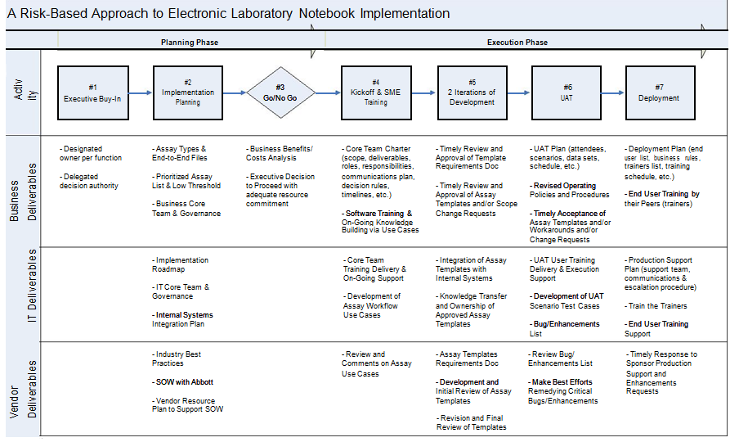Systems Project Management, Defined

The key challenge of the project is to balance the speeds of learning the capabilities of new software and its implementation.

***Empower Teamwork—How?***

Lecioni (2002) describes the “five dysfunctions” faced by teams. More importantly, he traces the root cause of all team dysfunctions to the lack of mutual trust.

Manage Transitions—Where?

successful project almost always generates a great deal of momentum for more work, usually with a larger scope

Topic 2: Information Systems Development Cycle

What Are Information Systems?

Information systems are used by every functional area of business: marketing, management, finance, and accounting. Well-designed information systems keep the user in mind at each step of the process.

**What Are Information Systems?** **They Are More Than Just Computers**

Information systems are the combination of people, information technology, and business processes to accomplish a business objective.

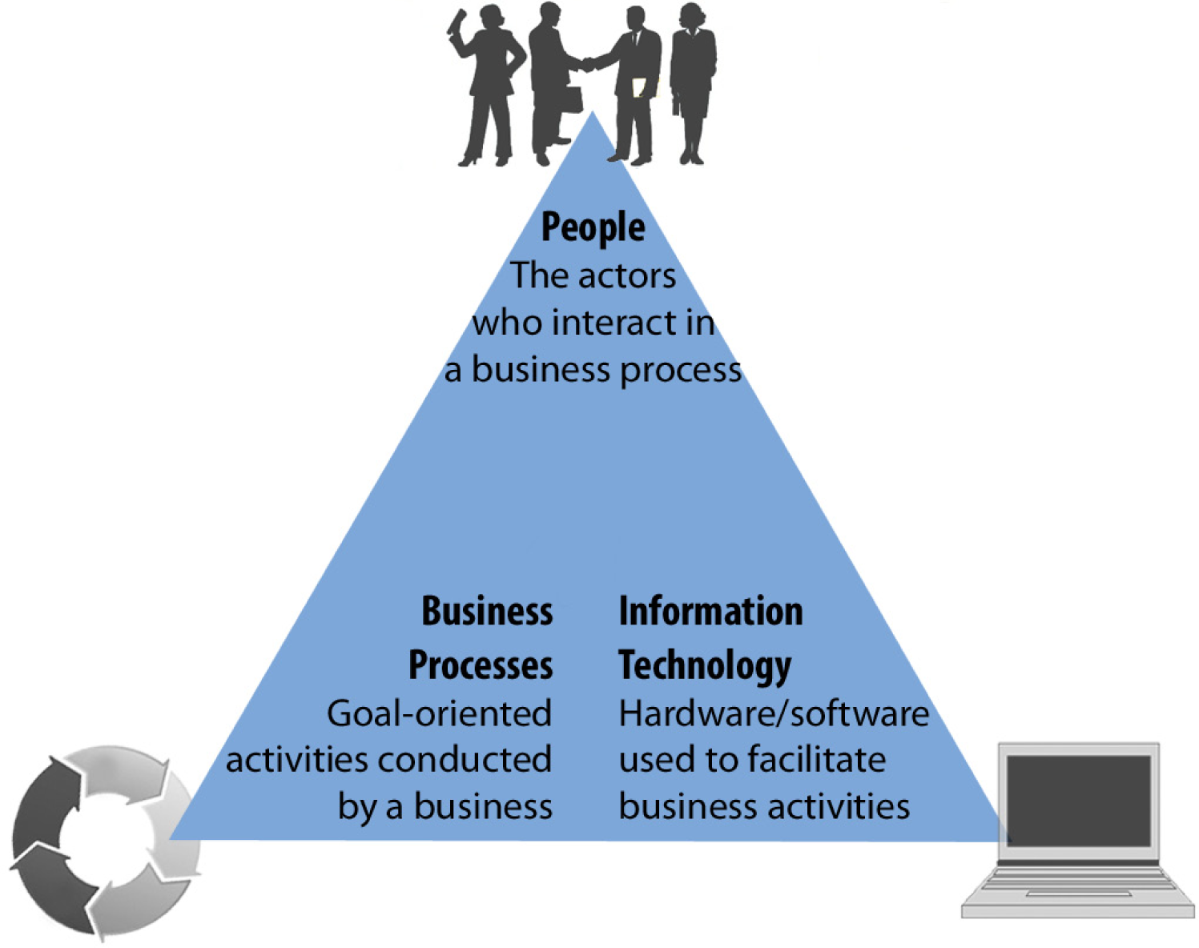

Information systems are designed using the systems development life cycle (SDLC).

1. Analysis
2. Requirements (vision of future state)
3. Design
4. Development
5. Implementatio n

Systems Development Life Cycle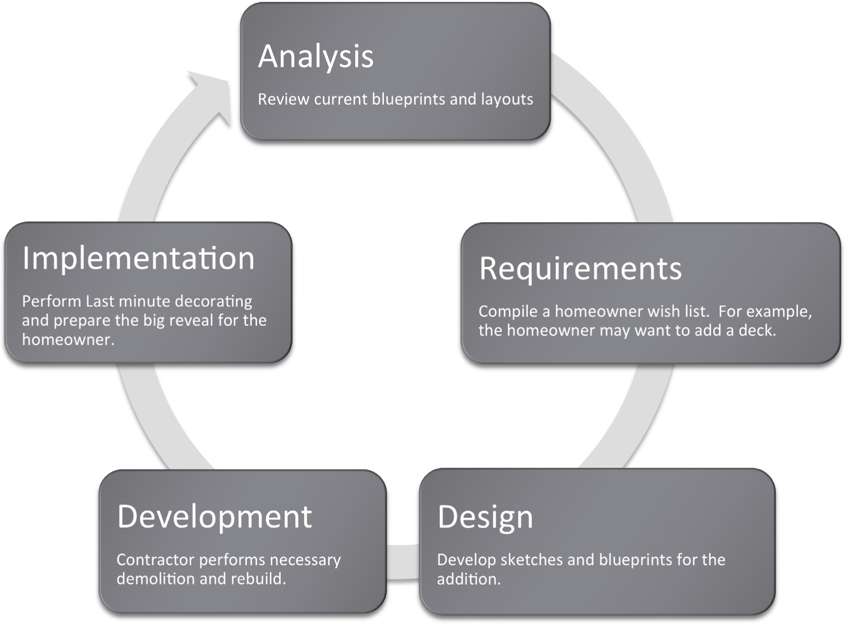

Note. Adapted from "Information Systems in Your Life: Types of Systems and Careers," by R. Frost, J. Pike, L. Kenyo, & S. Pels, 2011, Business Information Systems: Design an App for That, Chapter 1, Sections 1–2. Copyright 2011 by Open Textbook Library.

Systems Development Life Cycle Checklists – paper in class docs.

Objective 5: The Project Plan

Components of a Project Plan

A project plan, according to the PMBOK (Project Management Body of Knowledge), is: "...a formal, approved document used to guide both project execution and project control.” The project plan is primarily used to document planning assumptions and decisions, facilitate communication among stakeholders, and document approved scope, cost, and schedule baselines. Project plans vary in size and scope; some are detailed and some are summaries.

The level of detail in a project management plan will vary from project to project, but it often includes a number of subsidiary management plans focused on specific phases of the Project Life Cycle (PLC) and additional management/planning documents.

The project management plan template you will use for your Final Assessment contains 19 sections described briefly here. The sections are as follows:

The **introduction** should provide an overview of the project and briefly explain what product or service the project will produce, the viability of the project, and an explanation of the content contained in the project management plan. This introduction can often be very high level, as the following sections of the project management plan will provide further detail.

**The project management approach** will define roles and responsibilities of the project stakeholders. A RACI Matrix is one method of representing this information. RACI stands for responsible, accountable, consulted, informed. You identify specific elements of the project work, including individuals responsible or accountable for those elements, and also individuals who should be consulted or informed. Project management approach should also describe the flow of resources you will use for the project work, and identify any limitations or constraints that could affect workflow.

**Project scope** describes exactly what work you will do during the project. Although a scope statement may already be available from the initiation phase of the project, the project scope section will be more detailed. You may include a list of assumptions to ensure no disparity of expectations exists among the project stakeholders and the project team. This section is one of the most important components of effectively managing expectations as a project manager.

**Milestone list** provides a high-level overview of the major milestones related to the project work. Detailed schedule information is not necessary here, as that will come in the following section. The content in this section may relate to a payment structure for the project work.

The goal of **schedule baseline** and **work breakdown structure** is to establish a timeline that the project stakeholders and project team can agree to in the beginning of the project. This section will also include the work breakdown structure (WBS), which breaks down the project work into packages that you can easily track against the schedule baseline. These packages are then defined in a WBS dictionary that you should also include here.

The **change management plan** may vary greatly between projects, and will include detailed instructions through which a project manager can initiate changes to almost any aspect of the project. One key feature in this plan will be a detailed process for obtaining approval to implement changes, usually from the project sponsor or a change control board (CCB), and then the process for proceeding with implementation.

Communication is one of the most important focuses of effective and efficient project management. The **communications management plan** will describe the reporting process between the project team and the project manager, as well as between the project manager and stakeholders. This plan will also outline a method for stakeholders to initiate contact and provide feedback. The more detailed and robust the communications management plan, the more risks and issues you can avoid, as this plan is a project manager’s key tool for managing expectations.

The **cost management** **plan** will describe how you will measure, track, and assess all project costs to ensure the project work stays on budget. This plan will identify the responsible entity for every project cost, and the reporting process that you will use to ensure you identify any risks and issues as early as possible.

The **procurement management plan** describes procurement responsibilities and processes from the start of the project through to completion. Procurement activities may relate to the achievement of milestones in the milestone list, but this will vary between projects. Communication is key to ensuring the project manager and any other entities involved in the procurement process have the information needed to prevent this portion of the project progression from getting off track.

The**project scope management** **plan** closely relates to the project scope section in the beginning of the project management plan. Both project sponsors and the project team must take the time to define exactly what work the project will involve and exactly what work the project will not involve. The project scope management plan will include a process for reviewing scope as a project progresses and ensuring that time, effort, and funds are not expended on work that falls outside the bounds of the project scope.

The **schedule management plan** will describe the project schedule, and the reporting and reviewing processes you will use to identify any deviations from the schedule. Communication and identifying any risks early are key to getting a project back on track if you miss schedule milestones.

The **quality management plan** can be one of the most important sections of a project management plan. You find little achievement from completing project work on schedule and on budget if the final product is not of acceptable quality. This section should clearly define what the work product should be at the end of the Project Life Cycle (PLC), and the process through which you will assess it against quality standards for approval before handoff to the project sponsor or client.

The **risk management plan** will describe the processes for reporting and categorizing risks, escalating risks to the appropriate authority, and requesting changes to prevent impact to project scope, schedule, cost, or quality.

The **risk register** is where you will log and categorize all identified risks during the project. This will often include a system for categorizing the degree of impact a risk can have, and the authority responsible for acting on the information.

**Staffing management plan** will describe how you will acquire, manage, and structure resources for the duration of the project work.

A **resource calendar** is a tool for visually describing resource needs, restrictions, and limitations over the course of the project work. As you may only need some resources for a short time, this can assist with planning and ensure you do not waste funds because a resource is sitting idle, or no longer needed. A resource calendar is often useful to a project management office (PMO) when planning the distribution of resources across multiple projects in a matrix environment.

**Cost baseline** will describe the cost management plan, and include detailed information on the tracking and reporting of costs.

**Quality** must be a measurable characteristic of the work product. The **quality baseline**section describes the baseline against which you will assess project work as part of the quality management plan.

The last section of any project management plan, **sponsor acceptance,** should require the **project sponsor** to sign and indicate acceptance. This protects both the sponsor and the project manager, as it provides a way for the project management plan to be a go-to resource for managing risks, implementing changes, and resolving disputes.

Primer: Creating a Project Management Plan

Creating a Clear Project Plan

**One of the critical factors for project success is having a well-developed project plan**

Here is a six-step approach to creating a project plan. It not only provides a road map for project managers to follow, but also acts as the project manager's premier communications and control tool throughout the project.

* **Step 1: Explain the project plan to key stakeholders and discuss its key components.** Unfortunately, the "project plan" is one of the most misunderstood terms in project management. Hardly a fixed object, the project plan is a set of living documents that can be expected to change over the life of the project. Like a road map, it provides the direction for the project. And like the traveller, the project manager needs to set the course for the project, which in project management terms means creating the project plan. Just as a driver may encounter road construction or new routes to the final destination, the project manager may need to correct the project course as well. A common misconception is that the plan equates to the project time line, which is only one of the components of the plan. The project plan is the major work product from the entire planning process, so it contains all the planning documents. For example, a project plan for constructing a new office building needs to include not only the specifications for the building, the budget and the schedule, but also the risks, quality metrics, environmental impact, and so on. Components of the project plan include: Baselines: These are sometimes called performance measures because the performance of the entire project is measured against them. They are the project's three approved starting points for scope, schedule and cost. These provide the stakes in the ground, and are used to determine whether or not the project is on track during execution. Baseline management plans: These include documentation on how variances will be handled throughout the project. Other work products from the planning process: These include plans for risk management, quality, procurement, staffing and communications.   
  **Read**[**How to create a risk register**](http://www.cio.com.au/article/401244/how_create_risk_register/)**.**
* **Step 2: Define roles and responsibilities.**Identifying stakeholders - those who have a vested interest in either the project or the project outcome - is challenging and especially difficult on large, risky, high-impact projects. There are likely to be conflicting agendas and requirements among stakeholders, as well as different slants on who needs to be included. For example, the stakeholder list of the city council where a new office building is being constructed could differ from that of an engineering consulting firm. It would certainly include the developer who wants to build the office complex, the engineering firm that will build the office building, citizens who would prefer a city park, consultants to study the environmental impacts, the city council itself, and so on. The engineering firm may have a more limited view. It is important for the project manager to get clarity and agreement on what work needs to be done by whom, as well as which decisions each stakeholder will make.
* **Step 3: Develop a scope statement.**The scope statement is arguably the most important document in the project plan. It is used to get common agreement among the stakeholders about the project definition. It is the basis for getting the buy-in and agreement from the sponsor and other stakeholders and decreases the chances of miscommunication. This document will most likely grow and change with the life of the project. The scope statement should include: Business need and business problem Project objectives, stating what will occur within the project to solve the business problem Benefits of completing the project, as well as the project justification Project scope, stated as which deliverables will be included and excluded from the project Key milestones, the approach and other components as dictated by the size and nature of the project. It can be treated like a contract between the project manager and sponsor, one that can only be changed with sponsor approval.
* **Step 4: Develop the project baselines.**Scope baseline. Once the deliverables are confirmed in the scope statement, they need to be developed into a work breakdown structure (WBS) of all the deliverables in the project. The scope baseline includes all the deliverables produced on the project, and therefore identifies all the work to be done. These deliverables should be inclusive. Building an office building, for example, would include a variety of deliverables related to the building itself, as well as such things as impact studies, recommendations, landscaping plans, and so on. Schedule and cost baselines. 1. Identify activities and tasks needed to produce each of the deliverables identified in the scope baseline. How detailed the task list needs to be depends on many factors, including the experience of the team, project risk and uncertainties, ambiguity of specifications, amount of buy-in expected, etc. 2. Identify resources for each task, if known. 3. Estimate how many hours it will take to complete each task. 4. Estimate cost of each task, using an average hourly rate for each resource. 5. Consider resource constraints, or how much time each resource can realistically devote to this one project. 6. Determine which tasks are dependent on other tasks, and develop critical path. 7. Develop schedule, which puts all tasks and estimates in a calendar. It shows by chosen time period (week, month, quarter or year) which resource is doing which tasks, how much time each task is expected to take, and when each task is scheduled to begin and end. 8. Develop the cost baseline, which is a time-phased budget, or cost by time period. This process is not a one-time effort. Throughout the project, you will most likely be adding to and repeating some or all of these steps.
* **Step 5: Create baseline management plans.**Once the scope, schedule and cost baselines have been established, create the steps the team will take to manage variances to these plans. All these management plans usually include a review and approval process for modifying the baselines. Different approval levels are usually needed for different types of changes. Not all new requests will result in changes to the scope, schedule or budget, but a process is needed to study all new requests to determine their impact to the project.

One important aspect of the project plan is the communications plan. This document states such things as:

* Who on the project wants which reports, how often, in what format and using what media
* How issues will be escalated and when
* Where project information will be stored and who can access it
* What new risks have surfaced and what the risk response will include
* What metrics will be used to ensure a quality product is built
* What reserves have been used for which uncertainties.

Once the project plan is complete, it is important that its contents be delivered to key stakeholders. This communication should include such things as:

* Review and approval of the project plan
* Process for changing the contents of the plan
* Next steps - executing and controlling the project plan and key stakeholder roles/responsibilities in the upcoming phases.