**Systems Development Life Cycle Checklists**

The System Development Life Cycle (SDLC) process applies to information system development projects ensuring that all functional and user requirements and agency strategic goals and objectives are met. The SDLC provides a structured and standardized process for all phases of any system development effort. These phases track the development of a system through several development stages from feasibility analysis, system planning and concept development; to acquisition and requirements definition; design; development; integration and testing; deployment and acceptance; though deployment and production; and finally to system retirement.

The Records Management (RM) Profile[1] recommends that agencies embed records management requirements in the earliest stages of the SDLC. The following document is a checklist to assist agencies to integrate RM into the SDLC. The checklist identifies certain points in the SDLC process where the agency may propose to establish records management review and approval to ensure that sound RM practices are incorporated into the development of its proposed IT systems. While the attached SDLC diagram demonstrates these stages in a linear “waterfall” systems development methodology, the checklist can be used with other systems development methodologies as well, such as “spiral,” “parallel,” “rapid application development (RAD)” and “prototyping” by modifying the checklist to fit the phases of the preferred SDLC method used.

The checklist provides three to five basic questions about records management and recordkeeping for each phase of the SDLC lifecycle process. The checklist questions are intended to begin a more detailed discussion with agency records managers, IT and CPIC staff, and program managers and staff that will help identify recordkeeping requirements in each phase, with a great emphasis on identifying records management requirements at the earliest stages of project planning, initiation and requirements gathering. Because individual agency SDLC processes and policies vary widely, the checklist is not designed to be used as the only checklist an agency might need, or even a “one size fits all” approach to identifying recordkeeping requirements within an individual agency’s SDLC policies. Rather, the checklist demonstrates a widely used methodology to plan and develop new IT systems that can be used as a model or template that individual agencies can revise or tailor to their own unique SDLC process, IT and systems development policies and procedures to identify their unique records management and recordkeeping requirements. For instance, some agencies use a five-step SDLC process, and others use a ten-step process, and they should revise or modify checklist to meet their specific SDLC policy and business needs. For more information please contact your agency’s records management point of contact at NARA at http://www.archives.gov/recordsmgmt/appraisal/work-group-all.html.

**Integrating RM into the SDLC**

|  |  |  |  |
| --- | --- | --- | --- |
| **#** | **RM Integration into the SDLC** | **Y,**  **N,**  **NA** | **Comments** |
|  | ***Phase 1: Concept Development*** |  |  |
| 1 | Is the agency Records Officer included from the beginning in the system design process? |  |  |
| 2 | Are records identified that support the business process? |  |  |
| 3 | 1. Do current record schedules apply to the new system?      1. Is a new record schedule required because of changes in the records? |  |  |
| 4 | Is the agency Records Officer signature on the agency Investment Summary Proposal? |  |  |
|  | ***Phase 2: Requirements Document*** |  |  |
| 5 | Are all records-related requirements identified and incorporated into the final CONOPS Report and Business Requirements Document? |  |  |
| 6 | Are new records schedules being drafted, if needed? |  |  |
| 7 | Is the agency Records Officer signature on the requirements document? |  |  |
|  | ***Phase 3: Design*** |  |  |
| 8 | Are all records management requirements incorporated into the system design document? |  |  |
| 9 | Is the agency Records Officer signature on the system design document? |  |  |
|  | ***Phase 4: Detailed Design*** |  |  |
| 10 | Is the agency records management staff included in project status meetings as needed? |  |  |
|  | ***Phase 5: Development*** |  |  |
| 11 | Is the agency records management staff included in project status meetings as needed? |  |  |
| 12 | Are proposed records schedules submitted to the NARA? |  |  |
|  | ***Phase 6: Integration & System Testing*** |  |  |
| 13 | Are records management requirements incorporated into the system? |  |  |
| 14 | Is the agency Records Officer signature on the Systems Test Report? |  |  |
|  | ***Phase 7: Deployment & Acceptance*** |  |  |
| 15 | Is the agency records management staff included in project status meetings as needed? |  |  |
| 16 | Is the agency Records Officer signature on the document approving deployment of the system? |  |  |
|  | ***Phase 8: Production*** |  |  |
| 17 | Is the Mid-Cycle Review complete? (Review to occur 3 years after going to production to validate records management requirements and records schedules.) |  |  |
| 18 | Are disposition authorities being implemented in accordance with appropriate dispositions? |  |  |
| 19 | Is the Mid-Cycle Review report sent to the agency records management staff for review? |  |  |
| 20 | Is the agency Records Officer signature on the Mid-Cycle Review certification document? |  |  |

2

|  |  |  |  |
| --- | --- | --- | --- |
|  |  |  |  |
|  | ***Phase 9: Retirement & Rollover*** |  |  |
| 21 | At the time of retirement or rollover of the system, are records preserved, retained, and fully accessible for the full retentions in accordance with appropriate dispositions? |  |  |
| 22 | At the time of retirement or rollover of the system, are temporary records destroyed in accordance with appropriate dispositions? |  |  |
| 23 | At the time of retirement or rollover of the system, are permanent records transferred to NARA in accordance with the appropriate dispositions? |  |  |

3

# Systems Development Life Cycle Method

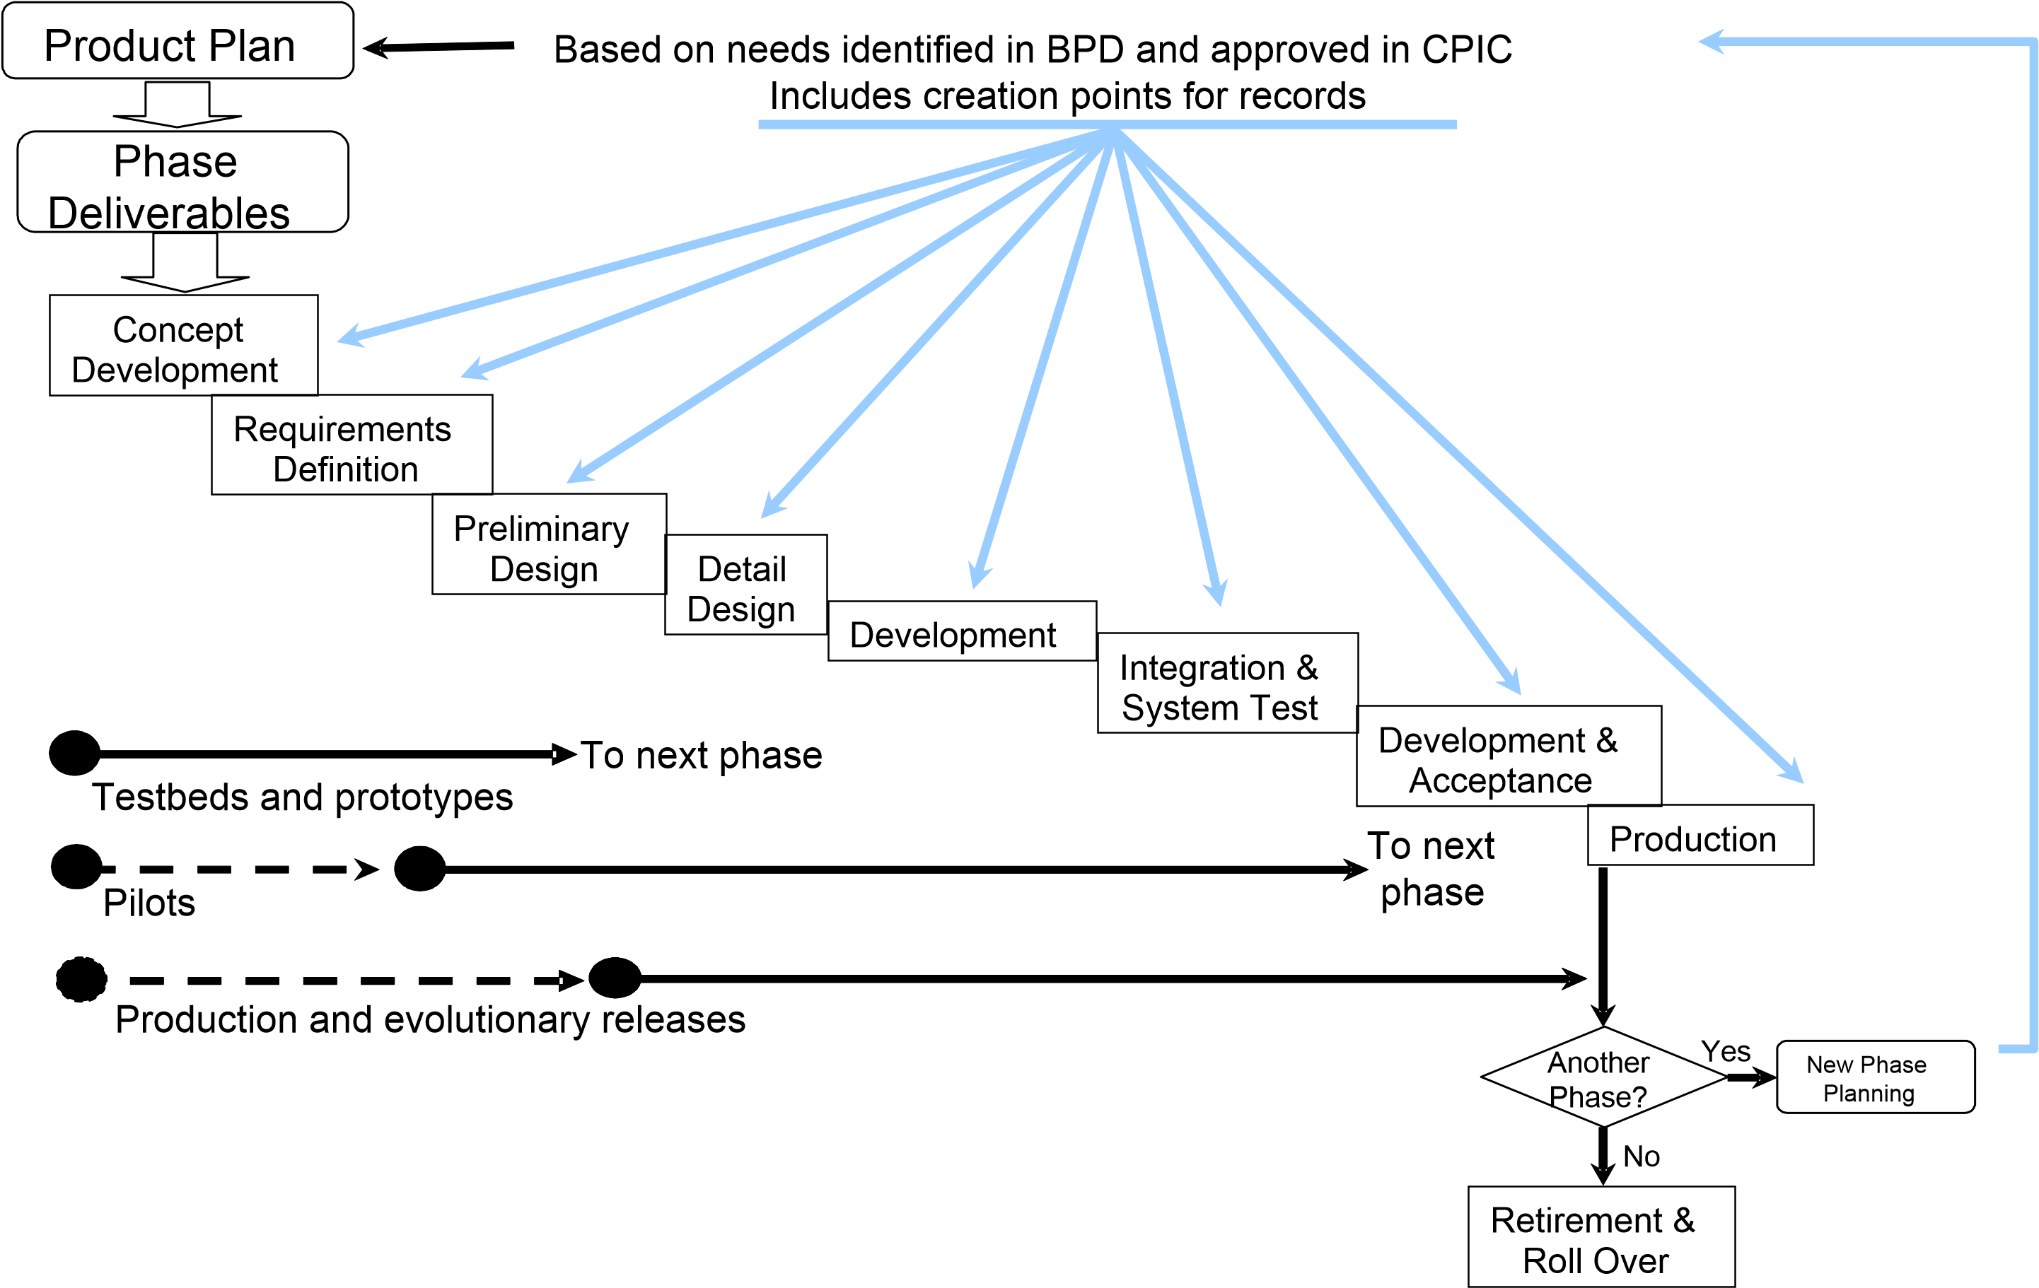

1. Refer to Federal Enterprise Records Management Profile, Sections 4.1.1 through 4.1.6; http://www.archives.gov/records-mgmt/policy/rm-profile.html.

  