[Company] [Company Address] | Tel: Fax: |  | [Company Phone] [Company Fax] [Company E-mail]
May 16, 2015 |  | [Ref. number] Marc Arnecke, PMP



[Sub-Project, phase, etc.]
Work Breakdown Structure (WBS)
The WBS is a hierarchical decomposition of the total scope of work to be carried out by the project team to accomplish the project objectives and create the required deliverables.

[Project Name]

TABLE OF CONTENTS
Introduction .......................................................................................................................................... 1
WBS ...................................................................................................................................................... 2
Outline View ..................................................................................................................................... 2
Hierarchical Structure ...................................................................................................................... 3
Tabular View ..................................................................................................................................... 3
Tree Structure View.......................................................................................................................... 4
WBS Dictionary ..................................................................................................................................... 5

INTRODUCTION
The WBS is a hierarchical deliverable oriented decomposition of the work to be executed by the project team to accomplish the project objectives and create the required deliverables. It organizes and defines the total scope of the project.

WBS
Below are different views. It depends to the project which type to use…
Outline View
The outline view is similar to a MS Word numbered list...
1. Project Name
1.1. Deliverable A
1.1.1. Control Account A1
1.1.1.1. Work Package
1.1.1.2. Work Package
1.1.1.3. …
1.1.2. Control Account A2
1.1.2.1. Work Package
1.1.2.2. Work Package
1.1.2.3. …
1.2. Deliverable B
1.2.1. Control Account B1
1.2.1.1. Work Package
1.2.1.2. …
1.2.2. Control Account B2
1.2.2.1. …

Hierarchical Structure
The hierarchal structure is much similar to the above list, however may be useful in some cases.
Level | WBS Code | Description
1 | 1. | Project Name
2 | 1.1 | Deliverable A
3 | 1.1.1 | Control Account A1
4 | 1.1.1.1 | Work Package
4 | 1.1.1.2 | Work Package
4 | 1.1.1.3 | …
3 | 1.1.2 | Control Account A2
4 | 1.1.2.1 | Work Package
4 | 1.1.2.2 | …
2 | 1.2 | Deliverable B
3 | 1.2.1 | Control Account B1
4 | 1.2.1.1 | Work Package
4 | 1.2.1.2 | Work Package
4 | 1.2.1.3 | …
3 | 1.2.2 | Control Account B2

Tabular View
Level 1 | Level 2 | Level 3 | Level 4
Project Name | Deliverable A | Control Account A1 | Work Package Work Package …
 |  | Control Account A2 | Work Package …
 | Deliverable B | Control Account B1 | Work Package Work Package …
 |  | Control Account B2 | Work Package

Tree Structure View

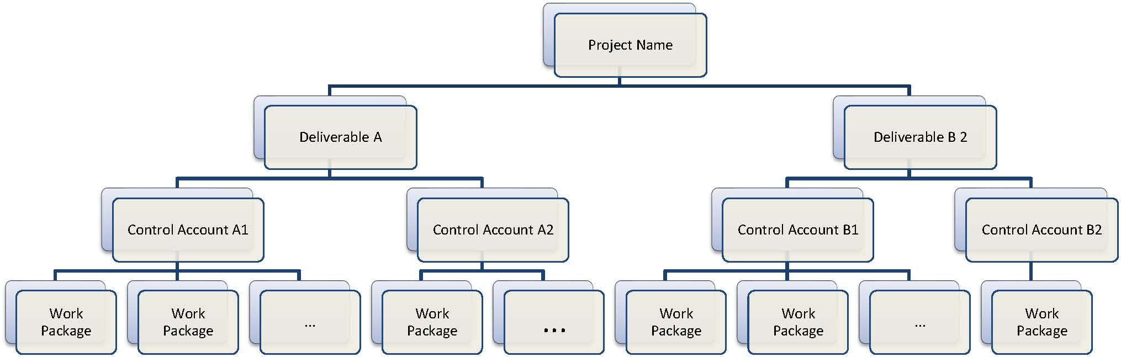
WBS DICTIONARY
The WBS Dictionary describes each WBS component including
• A brief definition of the scope or statement of work,
• Defined deliverable(s),
• Associated activities and a list of milestones,
• The responsible manager,
• Start- & end date,
• Required resources,
• Estimated cost,
• Charge number,
• Quality requirements,
• Contractual information and technical references.

WP Name |  |  |  |  |  |  |  | WBS ID
Description |  |  |  |  |  |  |  | Assumptions & Constraints
Milestones
SN. |  |  | Name |  |  | Due Date
Activity
SN. |  | Name |  |  | Human Resource |  |  | Non-human Resource |  |  | Material |  |  | Line Total
 |  | Hours |  | Rate | Total |  | Hours | Rate | Total |  | QTY | Rate |  | Total
Quality Requirements |  |  |  |  |  |  |  | Acceptance Criteria
Technical Reference |  |  |  |  |  |  |  | Contractual Info

