 **Dutch Brothers Plus** Tel: 530-315-4839

|  |  |  |  |
| --- | --- | --- | --- |
|  |  |  |  |
| Oct 03, 2018 |  |  | 400 |

Jeffery Morse, PM

Dutch Brothers Plus

*Dutch Brothers Plus Building Plan*

Project Cost Management Plan

The project cost management plan is a component of the project management plan that describes how costs will be planned, structured, and controlled.

### REVISIONS AND DISTRIBUTION

|  |  |  |  |  |  |  |  |  |  |  |  |  |  |
| --- | --- | --- | --- | --- | --- | --- | --- | --- | --- | --- | --- | --- | --- |
| **Revision** | **Release date** | **Distributed to\*** | | | | | | | | | | | |
| Client | Consultant | Main office(s) | Project Manager | Procurement Manager | Quality Manager | Costs Manager | Building and Planning | Contractor | Sub-contractors | Suppliers |  |
| Rev. 0 (draft) | 29/10/2013 |  |  |  |  |  |  |  |  |  |  |  |  |
|  |  |  |  |  |  |  |  |  |  |  |  |  |  |
|  |  |  |  |  |  |  |  |  |  |  |  |  |  |
|  |  |  |  |  |  |  |  |  |  |  |  |  |  |
|  |  |  |  |  |  |  |  |  |  |  |  |  |  |
|  |  |  |  |  |  |  |  |  |  |  |  |  |  |
|  |  |  |  |  |  |  |  |  |  |  |  |  |  |
|  |  |  |  |  |  |  |  |  |  |  |  |  |  |
|  |  |  |  |  |  |  |  |  |  |  |  |  |  |
|  |  |  |  |  |  |  |  |  |  |  |  |  |  |

*) Detailed distribution lists shall be prepared for each distribution event. Further details as per the project communication plan

#### Amendments

The Project Cost Management Plan may require updates. Any amendment to this plan shall be performed only after the Control Board has received authority for changes and then changes are made by the CB only. The initial page numbering system will be a normal continuous numbering displayed in the lower right corner of each page. If pages have to be added, characters shall be added to sequence. In case entire pages are deleted, the corresponding page shall be replaced by a blank page stating, “page removed”.

Each added/changed page shall have the revision number and date of approval displayed on the bottom of the page.

### PROJECT SPONSOR APPROVAL

|  |  |  |
| --- | --- | --- |
| **Prepared by:** | **Reviewed by:** | **Approved by Proj. Sponsor:** |
| HQ, 03/10/2018 | Place, dd/mm/yyyy | Place, dd/mm/yyyy |
|  |  |  |
| Jeffery Morse, PM  Designation | Name  Designation | Name  Designation |

**TABLE OF CONTENTS**

Revisions and Distribution..................................................................................................................II

Amendments ..............................................................................................................................II

Project Sponsor Approval .................................................................................................................III

Cost Management Approach 1

Estimate Cost 1

Cost Baseline 1

Cost Control 1

Cost Reporting 2

Change Control 2

Attachments: 3

# COST MANAGEMENT APPROACH

The process for cost management is simple – nothing will be changed without it being in the plans. The communications process insists on consensus on every level before a change can occur. As a result, only those changes that are absolutely necessary will occur. Cost management is first the task of the Cost Manager CM, and secondly the task of the Procurement Manager. No cost saving efforts will be used unless they meet both the quality and time constraints of the project. Any costs beyond the scheduled cost structure will have to approved by the Head Office, all managers, the contractors and the clients. Documentation will follow the assign document tracking system assigned in the Communications Plan.

# ESTIMATE COST

Estimate Costs are an analogous approximation of the monetary resources needed to complete the project. Estimation of costs are forwarded from qualified personnel of whom possess the knowledge of costs from recent similar construction projects.

# COST BASELINE

Aggregated the estimate costs of individual activities will be monitored for future reference. Contingency and management reserve are taken into consideration on two separate occasions. 1. Unforeseen large expense due to construction costs. 2. In the case that there is no existing building for remodel and benefit and cost analysis has shown to be positive for building both the store and kiosk at a location. Funding for each of these must be preapproved my financial managers, main project managers and investors and financiers. Current estimates for building and remodel are at 250k.

# COST CONTROL

The Cost Manager will measure costs throughout the project life cycle. Cost of three types will be tracked, procurement, labor, and contractor costs. The excel payment schedule file is a full list of the authorized payment schedule, however, the graph here is an overview. In responding to cost variances outside the expected schedule meeting must be held to discuss benefits out way costs by the Project Control Board for the DBP main project before any funds will be released.

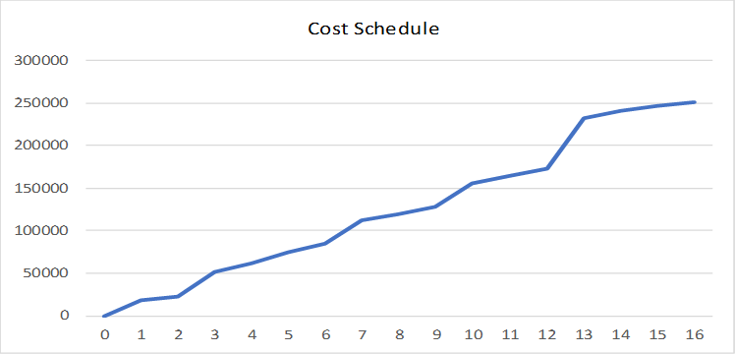

## **Cost Reporting**

Daily reports of Cost along with a graph with the expected costs and the actual costs will be published and sent to each manager of the project team. The PM of this sub project may be required to supply costs information to the PM of the main project upon request.

# CHANGE CONTROL

All changes to the baseline must first be approved by the DBP project manager and the control board.

# ATTACHMENTS:

|  |  |
| --- | --- |
| Attachment 1 |  |
| Attachment 2 |  |