Project Management Summative Assessment

Jeffery Morse

Brandman University

Project Management Summative Assessment

Coffee is a favorite beverage in America. However, there is a move towards healthier beverages. It has been noticed that the greater Linda California area can benefit from the installation of a Co-franchise Dutch Brothers /Jamba Juice store. This a description of on the part of that upstart project – the building. Dutch Brothers Plus Building Plan sub sheet can be viewed in appendix (A). Deliverables of this sub-plan are simple, a remodel of the existing building into a storefront to house Dutch Brothers Plus, and the building of a drive-through kiosk to provide service for those customers on the go. The final deliverable is to provide proper parking and landscaping for the store. This store will deliver the benefits of completion of a milestone in the overall plan, provide a product that is quality while performing in a safe green manner that is in congruence with company standards, and lastly, benefit the community in promoting growth.

**Project Management Approach**

This project will be choosing the “Phase” approach to project management. In general, the team authorities and members include the Project Manager (PM), Procurement Manager (PrM), Quality Manager(QM), and Costs Manager(CM). The Project Manager will oversee all other departments, create and set the scope and project life cycle and schedule. Also, the PM will ensure all work and processes align with Dutch Brothers Plus culture and standards. The PrM will be responsible for purchasing properties, building materials, as well as ensuring that all paperwork for city applications and building permits and on time and correctly filled out. The QM will work on three fronts. 1. City and County inspections and OSHA. 2. According to Dutch Brothers Plus Quality Guidelines. 3. On-site personal inspections of materials, and construction quality between phases. Lastly, the CM will oversee the Cost Schedule keeping track that costs are occurring to the predetermined patterns, actively seek cost reduction but not at the sacrifice of quality or time and oversee payments for any supplies needed not paid for through the procurement process. Lastly, the Control Board will consist of one C level representative from DBP the Main DBP PM and all managers from the sub-project DBP-Store.

**Milestone List**

The list of milestones set for this project goes into effect of the step one is achieved. The expected timeline of each following step is 30 days with a project end date six months from the start of step 2. Current projections are to purchase the building currently on the corner of Hammonton Smartsville Rd and N. Beale Rd, in Linda California. If for a reason currently unknown the procurement of this property needs to be extended no longer than three months will be allotted at which point a backup plan will be pursued. For further changes in delivery dates for required milestones meeting will be held by all manager to examine the benefits of further involvement.

Summary of milestones.

1. Signature of Project Charter and financing.
   1. Architectural plans are finished.
2. Procurement of property.
   1. In tandem, plans are receiving signatures from city planners.
3. Construction Begins Phase 1 (deconstruction & foundation work)
   1. Inspections
4. Construction Begins Phase 2 (framing, and electric).
   1. Inspections
5. Construction Begins Phase 3 (Stucco, drywall, concrete for landscaping)
   1. Inspections
6. Construction Begins Phase 4 (Finish Carpentry, Painting, Blacktop)
   1. Inspections

7. Walk Through, Signoff, and after meeting for learning.

**Baselines**

Schedule 16 Week Time Table

Phase 1

Milestone 1 Signature of project Charter and financing. Day 1

1. Architectural plans are finished.
2. Schedule Engineering, Sidewalks, Drainage, and Landscaping to City Approval
3. Landscape modification according to DBP Design

Milestone 2. Procurement of property. Week 3

1. In tandem, plans are receiving signatures from city planners.
2. All building permits acquired.
3. Groundwork, Landscaping.
4. Construction Supplies ordered with delivery setup
5. Foundations, plumbing, and electric inspections scheduled

Phase 2

Milestone 3. Construction Begins Phase 1 (deconstruction & foundation work) Week 5.

1. Inspections for the foundation, plumbing, and electric performed.
2. Changes made if needed.
3. Deconstruction of any existing for remodel, install flooring
4. Order supplies and set delivery date for next phase.
5. Set inspection times and dates

Phase 3

Milestone 4. Construction Begins Phase 2 (framing, and electric) Week 7.

1. Inspections black top, landscaping, and any changes
2. Framing, and electrical installs, lighting boxes countertops.
3. Order supplies and schedule delivery for the next phase.
4. Schedule framing inspector, electrical inspector, and DBP inspector.

Milestone 5. Construction Begins Phase 3 (Stucco, drywall, concrete for landscaping) Week 10.

1. Inspections, framing and electrical
2. Make changes if needed.
3. Install outside hardy backer, stucco, t111 if needed. Internally install drywall, tape and texture, sinks, toilets, tilework lighting assemblies, external lighting.
4. Order supplies for the next phase scheduled delivery date.
5. Schedule inspections for next phase.

Phase 4

Milestone 6. Construction Begins Phase 4 (Finish Carpentry, Painting, Roofing, Blacktop, and signage) Week 13

1. Inspections performed for stucco, insulation, lighting, roof, and plumbing.
2. Make changes if needed.
3. Finish Carpentry, Painting, Roofing, Tables Chairs, Point of Sales system, Music Systems, Signage, Alarm Systems, and Blacktop Painting.
4. Schedule final roof inspections, fire code inspections, and all other final city inspections. Schedule DBP deliverables signoff.

Phase 5

Milestone 7. Walk Through, Signoff, and after meeting for learning. Week 15

1. Inspections--all final.
2. Make changes if needed and reschedule if needed.
3. After all city and county inspections pass then perform DBP inspections
4. Make changes if needed and reschedule with DBP.
5. After all, is accepted get deliverables signoff.
6. Project team managers meet to discuss what worked and what did not, were can we improve the make changes to the process for next time.

**Cost**

This is the cost baseline for the project upon which cost management will be based. The total cost of the project is $250,000 with costs spanned over a 16-week period. The project will use weekly cost metrics to track and manage costs.

**Scope & Quality**

The scope of this project begins with acquiring the location to the signoff of deliverables received by DBP. The purchase of the intended location of the DBP store is not part of the scope, nor is the installation of any appliances or machinery needed to perform daily business. The only exceptions are the appliances that are part of the structure such as walk-in refrigeration and walk-in freezer. The quality baseline is meet by meeting California/Yuba County building requirements. Inspections are held every week by county and state inspectors. Finally, to ensure quality and vision, DBP inspectors will be added in the final weeks of construction.

**Project Scope and Work Breakdown Structure (WBS)**

Though the WBS is available and listed in Appendix (2) the scope of this project concerns itself with only the construction and remodel of the Store. This is listed as a subproject in the WBS in the appendix (2).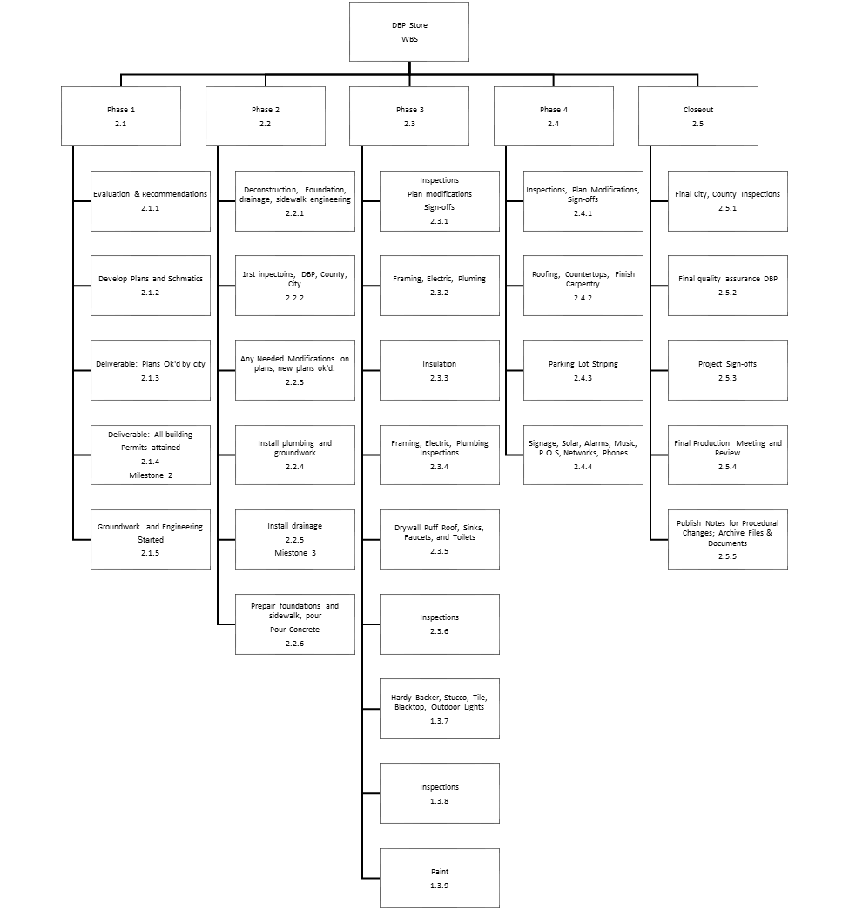

**Change Management Plan**

The Change Management Plan describes how this project manages change is through document tracking. First, a document is given a 3-digit number, for instance, the management plan is 100. This document goes up one unit with each revision. Secondly, change can only occur when they are included in the plans and signed off. The cover of each document has a form such as the one below. 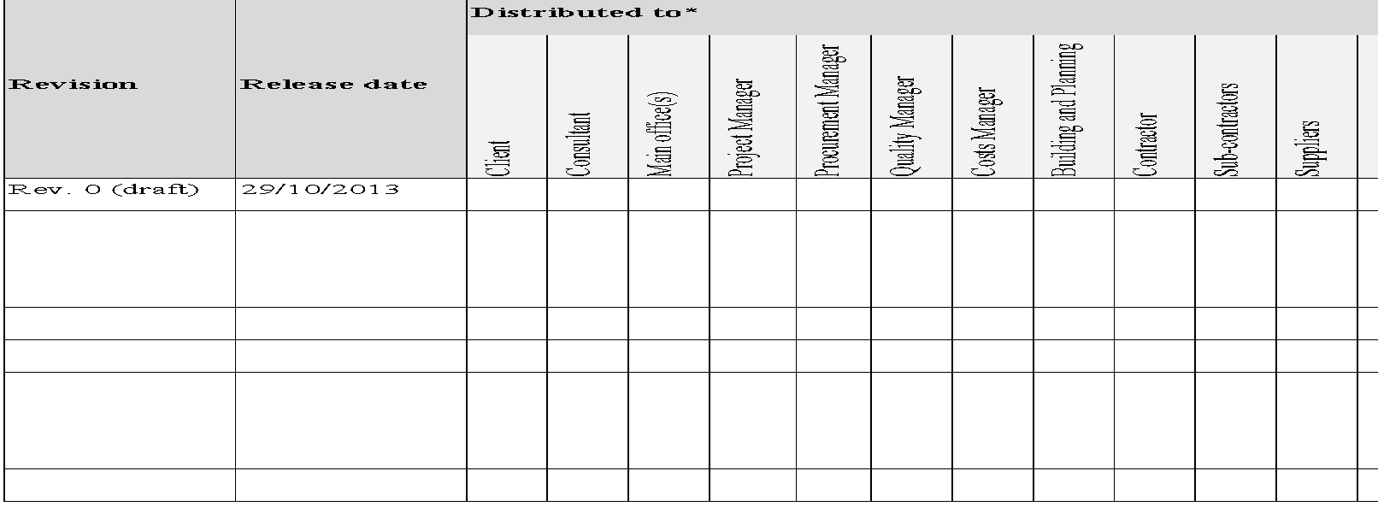

This tracks the revision and requires each change to be logged, agreed upon, and signed off by the client, consultants, head office, all managers, city and county planning, contractor and sub-contractors. Normally not all would be affected in a change, but any stakeholders listed will need to sign off before new plans are drawn up if needed. In construction, it is almost inevitable that changes will occur this process will ensure that only those changes that are necessary will be included.

**Communications Management Plan**

The Communications Management Plan defines the communication requirements for the project and how information will be distributed. To ensure the efficiency of communication, all formal communication shall be through document control. The document controller registers all incoming and outgoing documents and distributes them as needed. The Communications Management Plan (CM) documents 300 and can be found in Appendix (3). CMP covers such things as:

* Communication requirements based on type. (Formal, Informal).
* How information will be communicated and logged.
* How and when information is distributed and tracked.

**Cost Management Plan**

The Cost Management Plan outlines how Costs will be tracked. The Cost Manager will measure costs throughout the project lifecycle. Cost of three types will be tracked, procurement, labor, and contractor costs. The excel payment schedule file is a full list of the authorized payment schedule. However, the graph (cs 300-1) on page 6 is an overview. In responding to cost variances outside the expected schedule, the meeting must be held to discuss the benefits out way costs by the Project Control Board for the DBP main project before any funds will be released. The entire Costs Management Plan is presented in Appendix (4).

**Procurement Management Plan**

The Procurement Management Plan outlines how procurement will be handled. Project procurement will be conducted according to the WSB. Each phase of the project has inspection times scheduled. The inspection includes the processing and ordering of supplies for the upcoming phase. Many times, building supplies are covered by contractors and sub-contractors. When this is the case for all purchased materials contracted, and partnered suppliers are preferred. Most building supplies are contracted through Home Depot or Lowes. If substantial savings of costs can be found in uncontracted sources, these are only to be used if 1. There is no decrease in quality. 2. There is no increase in delivery time. Concrete will be contracted through Livingston's Concrete. A.C. will be contracted through the sub-contractor.

After supplies needed list is generated for the next phase, the Procurement Manager (PM) will subdivide the list in order of vender. As orders arrive, the PM must physically inspect the order and check each item off as present and of expected quality. Supplemental orders will be processed as needed and will be added to the total for the next phase.

**Project Scope Management Plan**

The Project Scope Management Plan is the first line of defense against scope creep. The Scope is defined starting from the closing of the purchase of the location to the sign—off on deliverables from DBP. It includes groundwork, sidewalk engineering, building remodel, kiosk construction, landscaping, and the parking lot. No changes to the plan will occur without documentation, changes to documentation and plans may only occur to meet 1. Quality Assurance. 2. DBP changes to allow DBP quality assurance. If changes are made the document must be signed by the modifier, and then forwarded to each manager for a signature as well as the foreman on site. Lastly, the PM will sign off the change before actual changes occur in construction. This section provides a summary of the Scope Management Plan in which it addresses the following:

* + - The scope of the project is under the authority of the Control Board, with the PM being the main contact.
    - The scope of this project starts after the purchase of the location and end after the store is built.
    - The scope of this project will be said to be complete after the DBP signs off as receiving.
    - The scope change process may be changed for reasons of quality increase or county code adherence. The control board will be the authorized body for Scope Change.
    - Final project deliverable and approving acceptance of project scope will be the DBP Startup General PM, Quality Manager, and Client if separate from DBP Offices.

Please refer to the appendix (7) for the full Project Scope Management Plan.

**Schedule Management Plan**

The Schedule Management Plan set the timetable for the project. The methodology of how the project schedule is implemented is first on a weekly basis. On a 16-week timetable not including the purchase of the property. Secondly, the schedule is separated into phases. These phases relate to the different modes of construction, groundwork, concrete, rough framing, and finish. Finally, this sub-project is governed by milestones and deliverables. With each short goal as a motivator as well as a trackable item for benchmarking progress. For the complete Schedule Management Plan, please see appendix (8).

**Quality Management Plan**

|  |  |  |  |  |  |  |  |  |
| --- | --- | --- | --- | --- | --- | --- | --- | --- |
| **Task Name** | **Duration** | **Start** | **Finish** | **Predecessors** | **Assigned To** | **% Complete** | **Status** | **Comments** |
| Phase 1 |  |  |  |  |  |  |  |  |
| Signature of Project Charter and financing. | 1d | 10/29/18 | 10/29/18 |  |  |  |  | Milestone 1 |
| a. Architectural plans are finished | 4d | 10/30/18 | 11/02/18 | 2 | PM |  |  |  |
| b. Schedule Engineering, Sidewalks, Drainage | 5d | 11/05/18 | 11/09/18 | 3 | PrM |  |  |  |
| c. Landscape modification according to DBP Design | 5d | 11/12/18 | 11/16/18 | 4 | Sub-Contr |  |  |  |
| Procurement of property. | 5d | 11/12/18 | 11/16/18 |  | Control |  |  | Milestone 2. |
| a. Plan Approval by City Building | 5d | 11/19/18 | 11/23/18 | 6 | PM |  |  |  |
| b. All building permits acquired | 5d | 11/26/18 | 11/30/18 | 7 | PrM |  |  |  |
| c. Groundwork, Landscaping | 5d | 12/03/18 | 12/07/18 | 8 | Contractor |  |  |  |
| d. Construction Supplies ordered with delivery setup | 5d | 12/03/18 | 12/07/18 |  | PrM |  |  |  |
| e. Foundations, plumbing, and electric inspections scheduled | 5d | 12/03/18 | 12/07/18 |  | PrM |  |  |  |
| Phase 2 |  |  |  |  |  |  |  |  |
| Deconstruction & foundation work |  |  |  |  |  |  |  | Milestone 3. Construction Begins Phase 1 |
| a. Inspections for the foundation, plumbing, and electric performed. | 5d | 12/10/18 | 12/14/18 |  | QC & QA |  |  |  |
| b. Changes made if needed. | 4d | 12/17/18 | 12/20/18 | 14 | PM, Contractor |  |  |  |
| c. Deconstruction of any existing for remodel, install flooring | 4d | 12/18/18 | 12/21/18 |  | Contractor |  |  |  |
| d. Order supplies and set delivery date for next phase. | 5d | 12/17/18 | 12/21/18 |  | PrM |  |  |  |
| e. Set inspection times and dates | 5d | 12/17/18 | 12/21/18 |  | PrM |  |  |  |
| Phase 3 |  |  |  |  |  |  |  |  |
| Framing, and electric |  |  |  |  |  |  |  | Milestone 4. Construction Begins Phase 2 |
| a. Inspections black top, landscaping, and any changes | 3d | 01/02/19 | 01/04/19 |  | QC & QA |  |  |  |
| b. Framing, and electrical installs, lighting boxes countertops. | 8d | 01/02/19 | 01/11/19 |  | Sub Contractor |  |  |  |
| c. Order supplies and schedule delivery for the next phase. | 5d | 01/07/19 | 01/11/19 |  | PrM |  |  |  |
| d. Schedule framing inspector, electrical inspector, and DBP inspector. | 5d | 01/07/19 | 01/11/19 |  | PrM |  |  |  |
| Stucco, drywall, concrete for landscaping |  |  |  |  |  |  |  | Milestone 5. Construction Begins Phase 3 |
| a. Inspections, framing and electrical | 5d | 01/14/19 | 01/18/19 |  | QC & QA |  |  |  |
| b. Make changes if needed. | 6d | 01/16/19 | 01/23/19 |  | Contractor |  |  |  |
| c. Install outside hardy backer, stucco | 5d | 01/21/19 | 01/25/19 |  | Contractor |  |  |  |
| d. Drywall, tape, and texture | 5d | 01/21/19 | 01/25/19 |  | Sub Contractor |  |  |  |
| e. Sinks, toilets, tile work lighting assemblies, external lighting. | 5d | 01/28/19 | 02/01/19 | 29 | Contractor |  |  |  |
| f. Order supplies for the next phase scheduled a delivery date | 5d | 01/28/19 | 02/01/19 |  | PrM |  |  |  |
| g. Schedule inspections for next phase | 5d | 01/28/19 | 02/01/19 |  | PrM |  |  |  |
| Phase 4 |  |  |  |  |  |  |  |  |
| Finish Carpentry, Painting, Roofing, Blacktop and signage |  |  |  |  |  |  |  | Milestone 6. Construction Begins Phase 4 |
| a. Inspections performed for stucco, insulation, lighting, roof, and plumbing. | 5d | 02/04/19 | 02/08/19 |  | QC & QA |  |  |  |
| b. Make changes if needed. | 6d | 02/06/19 | 02/13/19 |  | PM / Contractor |  |  |  |
| c. Finish Carpentry, Painting, Roofing | 7d | 02/14/19 | 02/22/19 | 36 | Contractor |  |  |  |
| D. Tables Chairs, Point of Sales system, Music Systems, Signage, Alarm Systems, and Blacktop Painting | 5d | 02/18/19 | 02/22/19 |  | Sub Contractor |  |  |  |
| d. Schedule final roof inspections, fire code inspections, and all other final city inspections | 5d | 02/25/19 | 03/01/19 | 38 | PrM |  |  |  |
| e. Schedule DBP deliverable sign-off. | 5d | 02/25/19 | 03/01/19 |  | PrM |  |  |  |
| Phase 5 |  |  |  |  |  |  |  |  |
| Walk Through, Sign-off, |  |  |  |  |  |  |  | Milestone 7. |
| a. Inspections--all final. | 10d | 02/25/19 | 03/08/19 | 38 | QC & QA & DBP |  |  |  |
| b. Make changes if needed and reschedule if needed. | 5d | 03/11/19 | 03/15/19 | 43 | PM / Contractor |  |  |  |
| c. DBP & Client inspections | 5d | 03/18/19 | 03/22/19 | 44 | QC & QA & PM |  |  |  |
| e. Deliverable sign-off. | 5d | 03/25/19 | 03/29/19 | 45 | PM |  |  |  |
| Improvement Meeting | 5d | 04/01/19 | 04/05/19 | 46 | All Managers |  |  |  |
|  |  |  |  |  |  |  |  |  |
|  |  |  |  |  |  |  |  |  |
|  |  |  |  |  |  |  |  |  |
|  |  |  |  |  |  |  |  |  |

The project schedule management plan is a component of the project management plan that establishes the activities for developing, monitoring, and controlling the project or program. The methodology of how the project schedule is implemented is first on a weekly basis. On a 16-week timetable not including the purchase of the property. Secondly, the schedule is separated into phases. These phases relate to the different modes of construction, groundwork, concrete, rough framing, and finish. Finally, this sub-project is governed by milestones and deliverables. With each short goal as a motivator as well as a trackable item for benchmarking progress. The Gantt Chart above list the weeks by Phase and highlight the critical pathway in red. For the complete Schedule Management Plan, please see appendix (8).

**Quality Management Plan**

The Quality Management Plan lists the process of tracking quality. Quality management under this document is defined as a system of planned activities that ensures that the deliverables of the DBP-Store sub-project that meet or exceed the client requirements, specifications and potentials. The system includes inspections, verifications, and evaluations of materials and artistry required to essay the quality of the deliverables. This quality management plan in conjunction with the other project plans identifies the necessary personnel involved in the quality team and their responsibilities.

Objective

The objective of this project quality management plan is to ensure that the DBP-Store sub-project is delivered by the contractual specifications, to satisfy stakeholder requirements, to reduce the cost of quality (namely cost of re-works, code violation, unnecessary maintenance and repair costs) and to complete the project within the contractual baselines.

Quality management shall focus on both product quality and project quality. Product quality is the quality of deliverables and focuses on product specifications, code requirements, and aesthetic requirements. Project quality more is concerned with the product is delivered. It focuses more on the production processes, planning, etc. The quality system, in general, shall follow the Plan – Do – Check – Act approach, while Total Quality Management will remain the responsibility of every employee quality will be further checked by Quality Control (QC) which are employed by the city, county and state building departments, DBP-QC which are employed by DBP-Store subproject team, and QA which are employed by DBP main project team. The complete 900 form is available in the appendix (9).

**Risk Management Plan**

Risk management will be conducted throughout the subproject. First, through TQM the quality of work performed will be closely monitored. Secondly, the risk will be addressed by initial inspections and on-going inspections of documents, work, and deliverables. There will be three levels of inspection 1. Quality Control (QC) are building inspectors employed by the city, county, and state to ensure compliance with city, county, and state building codes. These inspectors will have initial, follow-up, and final inspections. 2. Dutch Brothers Plus Quality Control (DBP-QC). These are inspectors employed by DBP-Store sub-project that inspect all procurements, deliverables, work standards, DBP quality requirements, and machinery to make sure orders and complete and of good quality, work standards meet quality assurance and safety standards, and machinery is in good safe operating condition. Finally, the PQM will function as the QA representative for the Control Board. QA will be watching to make sure quality is not lowered, costs are maintained, and deliverables are presented as scheduled. Lastly, the worksite is inspected by OSHA on a random basis. -­‐ Stakeholder Management Plan. Please refer to the complete Risk Management Plan with is available in the appendix (10).

**Staffing/Human Resource Management Plan**

The Human Resources Management Plan describes who will be hired for what where. People with the right skills and experiences are needed for the successful completion of the sub-project. The intention of the HR Management Plan is to identify and define the necessary positions for the success of the project. Missing or incorrect personnel will result in significant risk for the project's success. Please refer to the Project Risk Management Plan. For the complete Resource Management Plan, please see appendix (11).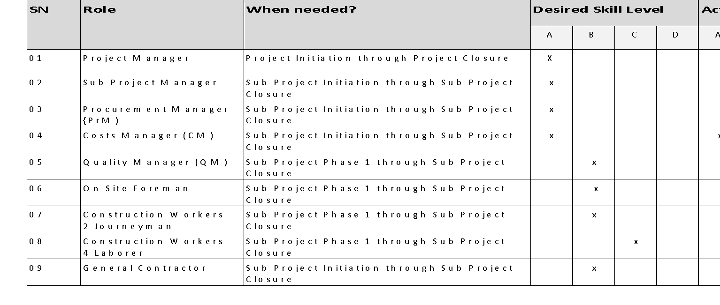

**Stakeholder Management Plan**

The project stakeholder management plan is a component of the project management plan and identifies the management strategies required to effectively engage stakeholders. The level of details can vary based on the needs of the project.

Stakeholder Management Approach

The processes required to identify people, groups or organizations that may be impacted by the project are anyone that is either directly or indirectly impacted by the project construction phase. To develop management strategies for effectively engaging stakeholders one must first identify these stakeholders. Please note that this Stakeholder Management Plan is only concerned with the DBP-Store subproject. For the Stakeholder management plan for the entire project, please inquire with the Control Board or the Main Project PM. 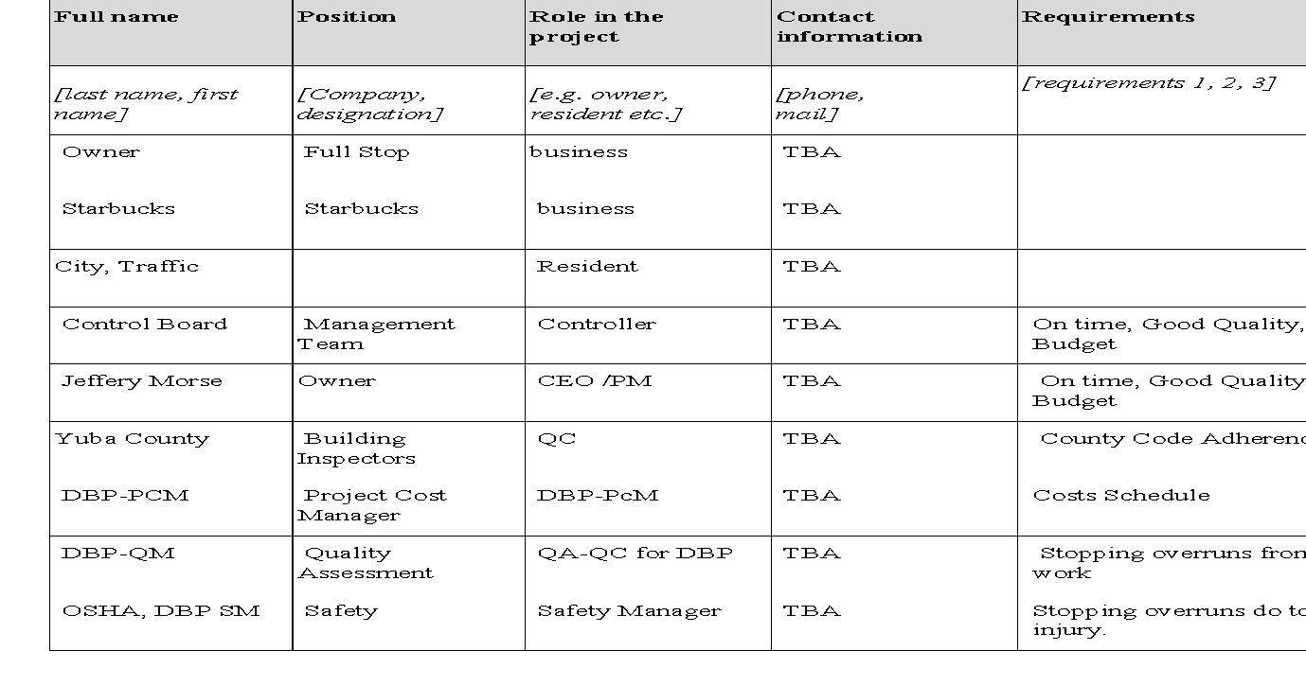

Stakeholder Identification

Any person or business that is directly or indirectly effected by the construction of the DBP-Store. It is taken for granted that all employees, contractors, and sub-contractors are affected and there for most are not included in the list below. Also, all financial providers whether an institution or personal loan is not included. Instead, the list centers on those who may be affected concerning only the sub-project and construction phase and not the main project. This concludes the review of the Project Management Plan for the sub-project DBP-Store.

Appendix 1: Project Management Plan  
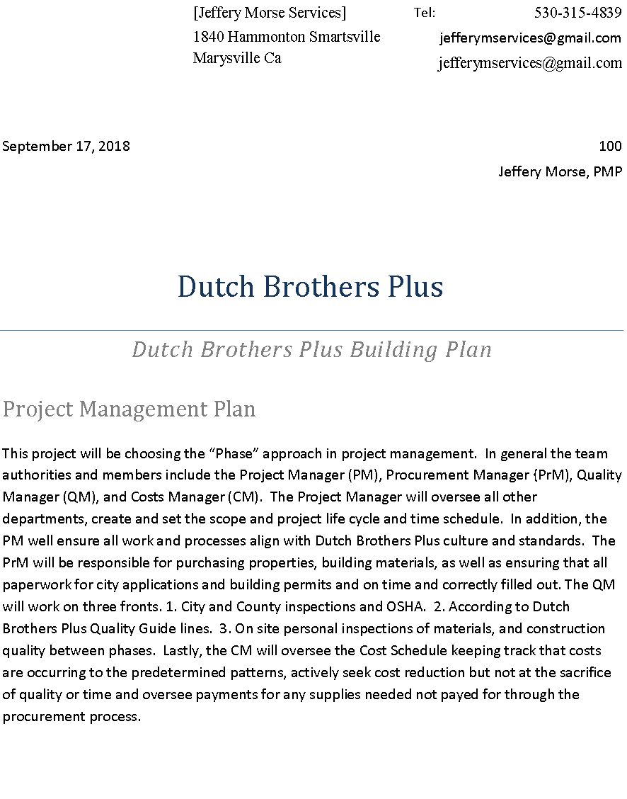

**Revisions and Distribution**

|  |  |  |  |  |  |  |  |  |  |  |  |  |  |
| --- | --- | --- | --- | --- | --- | --- | --- | --- | --- | --- | --- | --- | --- |
| **Revision** | **Release date** | **Distributed to\*** | | | | | | | | | | | |
| Client | Consultant | Main office(s) | Project Manager | Procurement Manager | Quality Manager | Costs Manager | Building and Planning | Contractor | Sub-contractors | Suppliers |  |
| Rev. 0 (draft) | 29/10/2013 |  |  |  |  |  |  |  |  |  |  |  |  |
|  |  |  |  |  |  |  |  |  |  |  |  |  |  |
|  |  |  |  |  |  |  |  |  |  |  |  |  |  |
|  |  |  |  |  |  |  |  |  |  |  |  |  |  |
|  |  |  |  |  |  |  |  |  |  |  |  |  |  |
|  |  |  |  |  |  |  |  |  |  |  |  |  |  |
|  |  |  |  |  |  |  |  |  |  |  |  |  |  |
|  |  |  |  |  |  |  |  |  |  |  |  |  |  |
|  |  |  |  |  |  |  |  |  |  |  |  |  |  |
|  |  |  |  |  |  |  |  |  |  |  |  |  |  |

*) Detailed distribution lists shall be prepared for each distribution event. Further details as per the project communication plan

Amendments

The form from time to time may require updates. Any amendment to this plan shall be informed to the change control board by use of the change request form and approved by the project change control board (the change and control board is all lead managers in the project unless otherwise stated) before distribution. Only revised parts of the plan will be distributed along with the approval and shall be accompanied by instructions on how to implement the changes.

The initial page numbering system (to be added upon initial approval) will be a normal continuous numbering displayed in the lower right corner of each page. If pages must be added, characters shall be added to the number. In case entire pages are deleted, the corresponding page shall be replaced by a blank page stating, “page removed.”

Each added/changed page shall have the revision number and date of approval displayed on the bottom of the page.

**Project Sponsor Approval**

|  |  |  |
| --- | --- | --- |
| **Prepared by: Jeffery Morse** | **Reviewed by:** | **Approved by Proj. Sponsor:** |
| HQ, 17/09/2018 | Place, dd/mm/yyyy | Place, dd/mm/yyyy |
|  |  |  |
| Jeffery Morse PM  Owner | Name  Designation | Name  Designation |

**Table of Contents**

Revisions and Distribution………………………………………………………………….. I

Amendments…………………………………………………………………………… … II

Project Sponsor Approval………………………………………………………….……… III

Project Life Cycle……………………………………………………………………………1

Project Management Approach………………………………………………………………2

Objective……………………………………………………………………………………..2

Project organization………………………………………………………………………….2

Project tools and techniques………………………………………………………………….2

Baselines & Change Control…………………………………………………………………3

Schedule Baseline……………………………………………………………………………3

Cost Baseline…………………………………………………………………………………3

Scope Baseline……………………………………………………………………………….3

Subsidiary Plans……………………………………………………………………………...4

Attachments.………………………………………………………………………………….5

Attachments.………………………………………………………………………………….5

**Project Life Cycle**

The list of milestones set for this project goes into effect of the step one is achieved. The expected timeline of each following step is 30 days with a project end date six months from the start of step 2. Current projections are to purchase the building currently on the corner of Hammonton Smartsville Rd and N. Beale Rd, in Linda California. If for a reason currently unknown the procurement of this property needs to be extended no longer than three months will be allotted at which point a backup plan will be pursued. For further changes in delivery dates for required milestones meeting will be held by all manager to examine the benefits of further involvement.

Summary of milestones.

1. Signature of Project Charter and financing.
   1. Architectural plans are finished.
2. Procurement of property.
   1. In tandem, plans are receiving signatures from city planners.
3. Construction Begins Phase 1 (deconstruction & foundation work)
   1. Inspections
4. Construction Begins Phase 2 (framing, and electric).
   1. Inspections
5. Construction Begins Phase 3 (Stucco, drywall, concrete for landscaping)
   1. Inspections
6. Construction Begins Phase 4 (Finish Carpentry, Painting, Blacktop)
   1. Inspections
7. Walk Through, Signoff, and after meeting for learning.

**Project Management Approach**

The project is undertaken to produce the deliverables of 1. The Dutch Brothers Plus (DBP) storefront building, the DBP kiosk drive-thru, and the customer parking areas. This project will be organized in phases while keeping track of costs. Finally, the Project Manager is the top tier with the PrM, QM, and CM forming the rest of the control board. Each phase activity will be overseen by the perspective manager; an exception will be handled by the control board.

Objective

Dutch Brothers Plus needs their buildings to build and customize.

Project organization

Dutch Brothers Plus. Jeffery Morse Services

Project tools and techniques

Monday.com will be used to formulate project scheduling and some communications; most other forms are cell phone based on texting, calls and video conferencing. All paperwork will be available to every manager through google drive. Other tools used will be gnat charts and flowcharts, WBS charts, along with the chart view of Monday.com.

**Baselines & Change Control**

Explain for each of the following the threshold and what to do in case of variance.

Schedule Baseline

Six months, Twelve months with exceptions.

Cost Baseline

Costs do not include the purchase price of the properties. $180,000

Scope Baseline

The scope of this project begins with the charter acceptance, though the cost of the purchase of the property is not part of the project. So for most intents, the scope begins with the purchase of the property and runs to the sign off on the project receivables. The scope includes the remodel of the existing building, the construction of the drive-thru kiosk, and the parking lot blacktop and landscaping. Also included are the items needed to successfully finish the deliverables at the customer requested quality within budget.

**Subsidiary Plans**

The subsidiary plans listed below set out the planning details for the respective management areas and shall be prepared by the responsible manager(s).

1. Project Scope Management Plan and Work Structure Breakdown (WBS),
2. Project Change Management Plan,
3. Project Communication Management Plan,
4. Project Cost Management Plan,
5. Project Procurement Management Plan,
6. Project Schedule Management Plan,
7. Project Quality Management Plan,
8. Project Risk Management Plan,
9. Project Stakeholder Management Plan,
10. Project Human Resource Management Plan,
11. Project Health and Safety Management Plan,
12. Project Environmental Management Plan,
13. Process Improvement Plan.

**Attachments:**

Attachments:

|  |  |
| --- | --- |
| Attachment 1 | No Current Attachments |
| Attachment 2 |  |

Appendix 2: WBS



**Dutch Brothers Plus** Tel: 530-315-4839

|  |  |  |  |
| --- | --- | --- | --- |
|  |  |  |  |
| Oct 02, 2018 |  |  | 200 |

Jeffery Morse, PM

Dutch Brothers Plus



*Dutch Brothers Plus Building Plan*

Project Communications Management Plan

This project communications management plan is a component of the project management plan that describes how project communication will be planned, structured, monitored, and controlled.

WORK BREAKDOWN STRUCTURE:

CONTENTS

Outline View ................................................................................................................................................................. 2

Hierarchical Structure DBP Startup ............................................................................................................................ 3

Tabular View DBP Startup ........................................................................................................................................... 4

Tree Structure View DBP Startup ................................................................................................................................ 5

WBS Dictionary Main Project ...................................................................................................................................... 6

Outline View Sub Project ............................................................................................................................................. 7

Hierarchical Structure DBP Store Project ................................................................................................................... 8

Tabular View DBP Store Project .................................................................................................................................. 9

Tree Structure View DBP Store Project..................................................................................................................... 10

WBS Dictionary Sub Project ...................................................................................................................................... 11

Glossary of Terms ...................................................................................................................................................... 12

OUTLINE VIEW

1. Management System
   1. Initiation
      1. Evaluation & Recommendations
      2. Develop Project Charter
      3. *Deliverable:* Submit Project Charter
      4. Project Sponsor Reviews Project Charter
      5. Project Charter Signed/Approved
   2. Planning
      1. Create Preliminary Scope Statement
      2. Determine Project Team
      3. Project Team Kickoff Meeting
      4. Develop Project Plan
      5. Submit Project Plan
      6. *Milestone:* Project Plan Approval
   3. Execution
      1. Project Kickoff Meeting
      2. Verify & Validate User Requirements
      3. Supply Contracts
      4. Procure Properties
      5. Build Store
      6. Install Appliances
      7. Human Resources
      8. Supply Stock
      9. Open First Day of Business
   4. Control
      1. Project Management
      2. Project Status Meetings
      3. Risk Management
      4. Update Project Management Plan
   5. Closeout
      1. Audit Procurement
      2. Document Lessons Learned
      3. Update Files/Records
      4. Gain Formal Acceptance
      5. Archive Files/Documents

HIERARCHICAL STRUCTURE

Please Note: The following excerpt was taken from the DBP Business Startup Plan and is only for Reference purposes.

|  |  |  |
| --- | --- | --- |
| Level | WBS Code | Element Name |
| 1 | 1 | Management System |
| 2 | 1.1 | Initiation |
| 3 | 1.1.1 | Evaluation & Recommendations |
| 4 | 1.1.2 | Develop Project Charter |
| 5 | 1.1.3 | Deliverable: Submit Project Charter |
| 6 | 1.1.4 | Project Sponsor Reviews Project Charter |
| 7 | 1.1.5 | Project Charter Signed/Approved |
| 2 | 1.2 | Planning |
| 3 | 1.2.1 | Create Preliminary Scope Statement |
| 4 | 1.2.2 | Determine Project Team |
| 5 | 1.2.3 | Project Team Kickoff Meeting |
| 6 | 1.2.4 | Develop Project Plan |
| 7 | 1.2.5 | Submit Project Plan |
| 8 | 1.2.6 | Milestone: Project Plan Approval |
| 2 | 1.3 | Execution |
| 3 | 1.3.1 | Project Kickoff Meeting |
| 4 | 1.3.2 | Verify & Validate User Requirements |
| 5 | 1.3.3 | Supply Contracts |
| 6 | 1.3.4 | Procure Properties |
| 7 | 1.3.5 | Build Store |
| 8 | 1.3.6 | Install Appliances |
| 9 | 1.3.7 | Human Resources |
| 10 | 1.3.8 | Supply Stock |
| 11 | 1.3.9 | Open First Day of Business |
| 2 | 1.4 | Control |
| 3 | 1.4.1 | Project Management |
| 4 | 1.4.2 | Project Status Meetings |
| 5 | 1.4.3 | Risk Management |
| 6 | 1.4.4 | Update Project Management Plan |
| 2 | 1.5 | Closeout |
| 3 | 1.5.1 | Audit Procurement |
| 4 | 1.5.2 | Document Lessons Learned |
| 5 | 1.5.3 | Update Files/Records |
| 6 | 1.5.4 | Gain Formal Acceptance |
| 7 | 1.5.5 | Archive Files/Documents |

TABULAR VIEW

|  |  |  |
| --- | --- | --- |
| Level 1 | Level 2 | Level 3 |
| 1 Management System | 1.1 Initiation | 1.1.1 Evaluation & Recommendations  1.1.2 Develop Project Charter  1.1.3 Deliverable: Submit Project Charter  1.1.4 Project Sponsor Reviews Project Charter  1.1.5 Project Charter Signed/Approved |
| 1.2 Planning | 1.2.1 Create Preliminary Scope Statement  1.2.2 Determine Project Team  1.2.3 Project Team Kickoff Meeting  1.2.4 Develop Project Plan  1.2.5 Submit Project Plan  1.2.6 Milestone: Project Plan Approval |
| 1.3 Execution | 1.3.1 Project Kickoff Meeting  1.3.2 Verify & Validate User Requirements  1.3.3 Supply Contracts  1.3.4 Procure Properties  1.3.6 Install Appliances  1.3.7 Human Resources  1.3.8 Supply Stock  1.3.9 Open First Day of Business |
| 1.4 Control | 1.4.1 Project Management  1.4.2 Project Status Meetings  1.4.3 Risk Management  1.4.4 Update Project Management Plan |
| 1.5 Closeout | 1.5.1 Audit Procurement  1.5.2 Document Lessons Learned  1.5.3 Update Files/Records  1.5.4 Gain Formal Acceptance  1.5.5 Archive Files/Documents |

TREE STRUCTURE VIEW

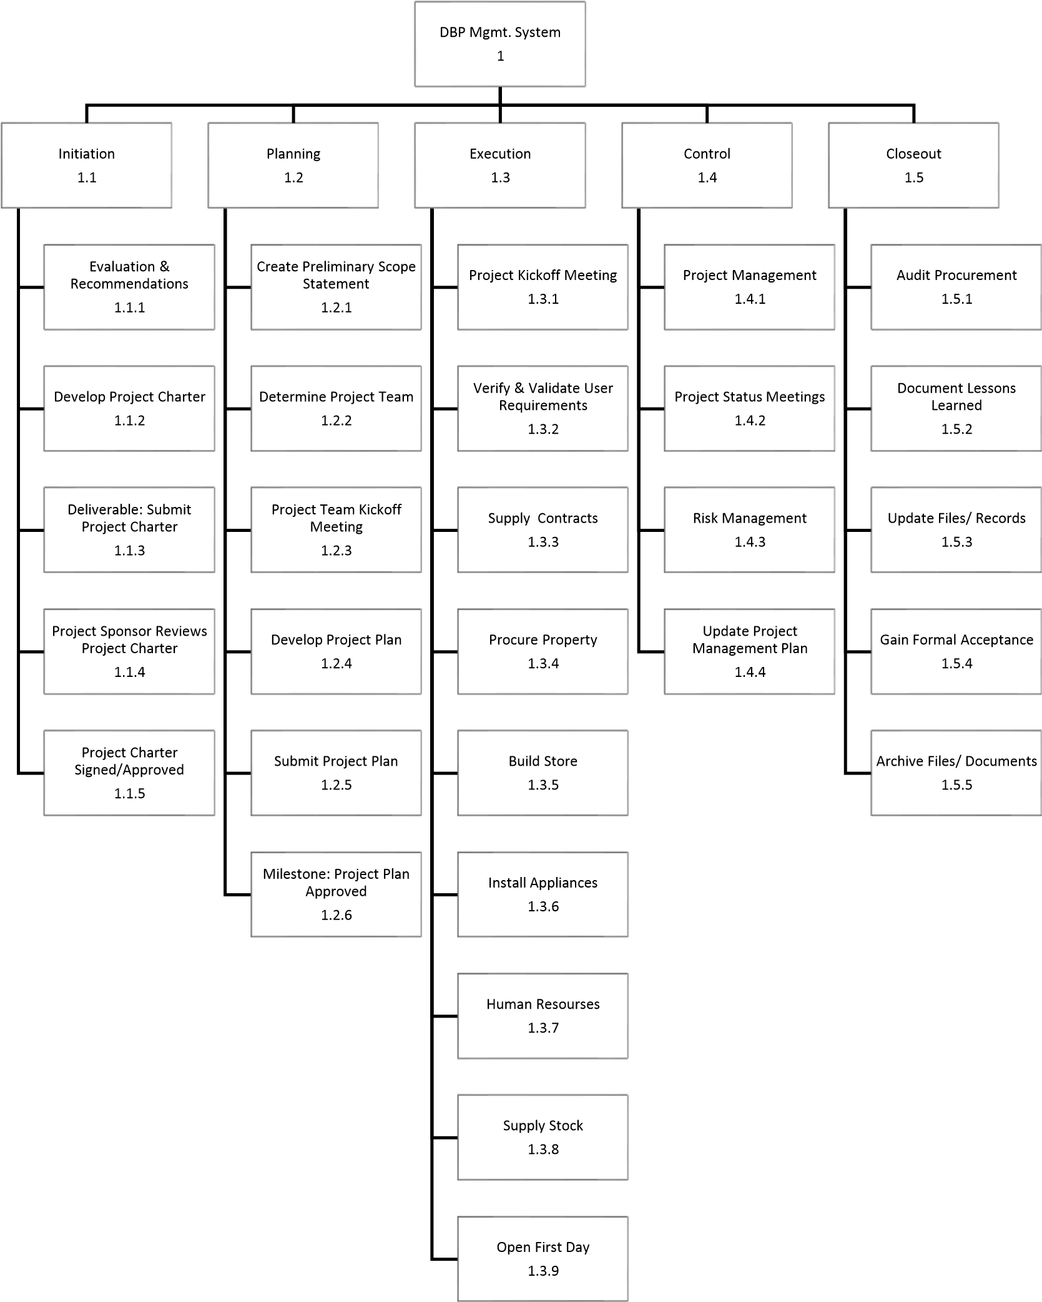

WBS DICTIONARY

|  |  |  |  |
| --- | --- | --- | --- |
| Level | WBS Code | Element Name | Definition |
| 1 | 1 | Management System | All work to implement a new DBP Franchise Business. |
| 2 | 1.1 | Initiation | The work to initiate the project. |
| 3 | 1.1.2 | Develop Project Charter | Project Manager to develop the Project Charter. |
| 4 | 1.1.4 | Project Sponsor Reviews Project Charter | Project sponsor reviews the Project Charter. |
| 5 | 1.1.5 | Project Charter Signed/Approved | The Project Sponsor signs the Project Charter which authorizes the Project Manager to move to the Planning Process. |
| 2 | 1.2 | Planning | The work for the planning process for the project. |
| 3 | 1.2.1 | Create Preliminary Scope Statement | Project Manager creates a Preliminary Scope Statement. |
| 4 | 1.2.2 | Determine Project Team | The Project Manager determines the project team and requests the resources. |
| 5 | 1.2.3 | Project Team Kickoff Meeting | The planning process is officially started with a project kickoff meeting which includes the Project Manager, Project Team and Project Sponsor (optional). |
| 6 | 1.2.4 | Develop Project Plan | Under the direction of the Project Manager, the team develops the project plan. |
| 7 | 1.2.5 | Submit Project Plan | Project Manager submits the project plan for approval. |
| 8 | 1.2.6 | Milestone: Project Plan Approval | The project plan is approved, and the Project Manager has permission to proceed to execute the project according to the project plan. |
| 2 | 1.3 | Execution | Work involved to execute the project. |
| 3 | 1.3.1 | Project Kickoff Meeting | Project Manager conducts a formal kick-off meeting with the project team, project stakeholders and project sponsor. |
| 4 | 1.3.2 | Verify & Validate User Requirements | The original user requirements is reviewed by the project manager and team, then validated with the users/stakeholders. This is where additional clarification may be needed. |
| 5 | 1.3.3 | Supply Contracts | Procure contracts with vital suppliers, fresh local Produce Especially |
| 6 | 1.3.4 | Procure of Properties | The procurement of all Properties and facilities needed for the project. |
| 7 | 1.3.5 | Build Store | Begin Sub Project, DBP Store Construction |
| 8 | 1.3.6 | Install Appliances | Install blenders, refrigerators, ovens, juicers, etc. |
| 9 | 1.3.7 | Human Resources | All users are provided with a four-hour training class. Additionally, managers are provided with an additional two hours class to cover advanced reporting. |
| 10 | 1.3.8 | Supply Stock | Contracted suppliers and vendors begin stocking the store. |
| 11 | 1.3.9 | Open First Day of Business | The store opens for all Customers. |
| 2 | 1.4 | Control | The work involved in the control process of the project. |
| 3 | 1.4.1 | Project Management | Overall project management for the project. |
| 4 | 1.4.2 | Project Status Meetings | Weekly team status meetings. |
| 5 | 1.4.3 | Risk Management | Risk management efforts as defined in the Risk Management Plan. |
| 2 | 1.5 | Closeout | The work to close-out the project. |
| 3 | 1.5.1 | Audit Procurement | An audit of all hardware and software procured for the project ensures that all procured products are accounted for and in the asset management system. |
| 4 | 1.5.2 | Document Lessons Learned | Project Manager along with the project team performs lessons learned meeting and documents the lessons learned for the project. |
| 5 | 1.5.3 | Update Files/Records | All files and records are updated to reflect the widget management system. |
| 6 | 1.5.4 | Gain Formal Acceptance | The Project Sponsor formally accepts the project by signing the acceptance document included in the project plan. |

Sub Project DBP Store Construction

OUTLINE VIEW DBP STORE PROJECT

1. DBP Store WSB
   1. Phase 1
      1. Evaluation & Recommendations
      2. Develop Plans and Schematics
      3. *Deliverable:* Plans Ok'd by Planning Dept*.*
      4. *Deliverable*: All Building Permits Attained
      5. Groundwork and Engineering Started
   2. Phase 2
      1. Deconstruction, Foundation, Drainage, Sidewalk Engineering 2.2.2. 1rst Inspections, DBP, County, City Planning and Building
      2. Any Needed Modifications on Plans, New Plans ok'd.
      3. Install Plumbing and Groundwork
      4. Install Drainage
      5. Prepare Foundations and Sidewalk; Pour Concrete
   3. Phase 3
      1. Inspections Plan Modifications and Plan Sign-offs
      2. Framing, Electric, Plumbing
      3. Insulation
      4. Framing, Electric, Plumbing Inspections
      5. Drywall Ruff Roof, Sinks, Faucets, and Toilets
      6. Inspections
      7. Hardy Backer, Stucco, Tile, Blacktop, Outdoor Lights
      8. Inspections
      9. Paint
   4. Phase 4
      1. Inspections, Plan Modifications, Sign-offs
      2. Roofing, Countertops, Finish Carpentry
      3. Parking Lot Striping
      4. Signage, Solar, Alarms, Music, P.O.S, Networks, Phones
   5. Closeout
      1. Final City, County Inspections
      2. Final Quality Assurance DBP
      3. Project Sign-offs
      4. Final Production Meeting and Review
      5. Publish Notes for Procedural Changes; Archive Files & Documents

HIERARCHICAL STRUCTURE DBP STORE

|  |  |  |
| --- | --- | --- |
| Level | WBS Code | Element Name |
| 1 | 2 | DBP Store WSB |
| 2 | 2.1 | Phase 1 |
| 3 | 2.1.1 | Evaluation & Recommendations |
| 4 | 2.1.2 | Develop Plans and Schematics |
| 5 | 2.1.3 | Deliverable: Plans Ok'd by Planning Dept. |
| 6 | 2.1.4 | Deliverable: All Building Permits Attained |
| 7 | 2.1.5 | Groundwork and Engineering Started |
| 2 | 2.2 | Phase 2 |
| 3 | 2.2.1 | Deconstruction, Foundation, Drainage, Sidewalk Engineering |
| 4 | 2.2.2 | 1rst Inspections, DBP, County, City Planning and  Building |
| 5 | 2.2.3 | Any Needed Modifications on Plans, New Plans ok'd. |
| 6 | 2.2.4 | Install Plumbing and Groundwork |
| 7 | 2.2.5 | Install Drainage |
| 8 | 2.2.6 | Prepare Foundations and Sidewalk; Pour Concrete |
| 2 | 2.3 | Phase 3 |
| 3 | 2.3.1 | Inspections Plan Modifications and Plan Sign-offs |
| 4 | 2.3.2 | Framing, Electric, Pluming |
| 5 | 2.3.3 | Insulation |
| 6 | 2.3.4 | Framing, Electric, Plumbing Inspections |
| 7 | 2.3.5 | Drywall Ruff Roof, Sinks, Faucets, and Toilets |
| 8 | 2.3.6 | Inspections |
| 9 | 2.3.7 | Hardy Backer, Stucco, Tile, Blacktop, Outdoor Lights |
| 10 | 2.3.8 | Inspections |
| 11 | 2.3.9 | Paint |
| 2 | 2.4 | Phase 4 |
| 3 | 2.4.1 | Inspections, Plan Modifications, Sign-offs |
| 4 | 2.4.2 | Roofing, Countertops, Finish Carpentry |
| 5 | 2.4.3 | Parking Lot Striping |
| 6 | 2.4.4 | Signage, Solar, Alarms, Music, P.O.S, Networks, Phones |
| 2 | 2.5 | Closeout |
| 3 | 2.5.1 | Final City, County Inspections |
| 4 | 2.5.2 | Final Quality Assurance DBP |
| 5 | 2.5.3 | Project Sign-offs |
| 6 | 2.5.4 | Final Production Meeting and Review |
| 7 | 2.5.5 | Publish Notes for Procedural Changes; Archive Files & Documents |

TABULAR VIEW

|  |  |  |
| --- | --- | --- |
| Level 1 | Level 2 | Level 3 |
| 2 Management System | 2.1 Phase 1 | 2.1.1 Evaluation & Recommendations  2.1.2 Develop Plans and Schematics  2.1.3 Deliverable: Plans Ok'd by Planning Dept  2.1.4 Deliverable: All Building Permits Attained  2.1.5 Groundwork and Engineering Started |
| 2.2 Phase 2 | 2.2.1 Deconstruction, Foundation, Drainage, Sidewalk Engineering  2.2.2 1rst Inspections, DBP, County, City Planning and Building  2.2.3 Any Needed Modifications on Plans, New Plans ok'd.  2.2.4 Install Plumbing and Groundwork  2.2.5 Install Drainage  2.2.6 Prepare Foundations and Sidewalk; Pour Concrete |
| 2.3 Phase 3 | 2.3.1 Inspections Plan Modifications and Plan Sign-offs  2.3.2 Framing, Electric, Plumbing  2.3.3 Insulation  2.3.4 Framing, Electric, Plumbing Inspections  2.3.5 Drywall Ruff Roof, Sinks, Faucets, and Toilets  2.3.6 Inspections  2.3.7 Hardy Backer, Stucco, Tile, Blacktop, Outdoor Lights  2.3.8 Inspections  2.3.9 Paint |
| 2.4 Phase 4 | 2.4.1 Inspections, Plan Modifications, Sign-offs  2.4.2 Roofing, Countertops, Finish Carpentry  2.4.3 Parking Lot Striping  2.4.4 Signage, Solar, Alarms, Music, P.O.S, Networks, Phones |
| 2.5 Closeout | 2.5.1 Final City, County Inspections  2.5.2 Final Quality Assurance DBP  2.5.3 Project Sign-offs  2.5.4 Final Production Meeting and Review  2.5.5 Publish Notes for Procedural Changes; Archive Files & Documents |

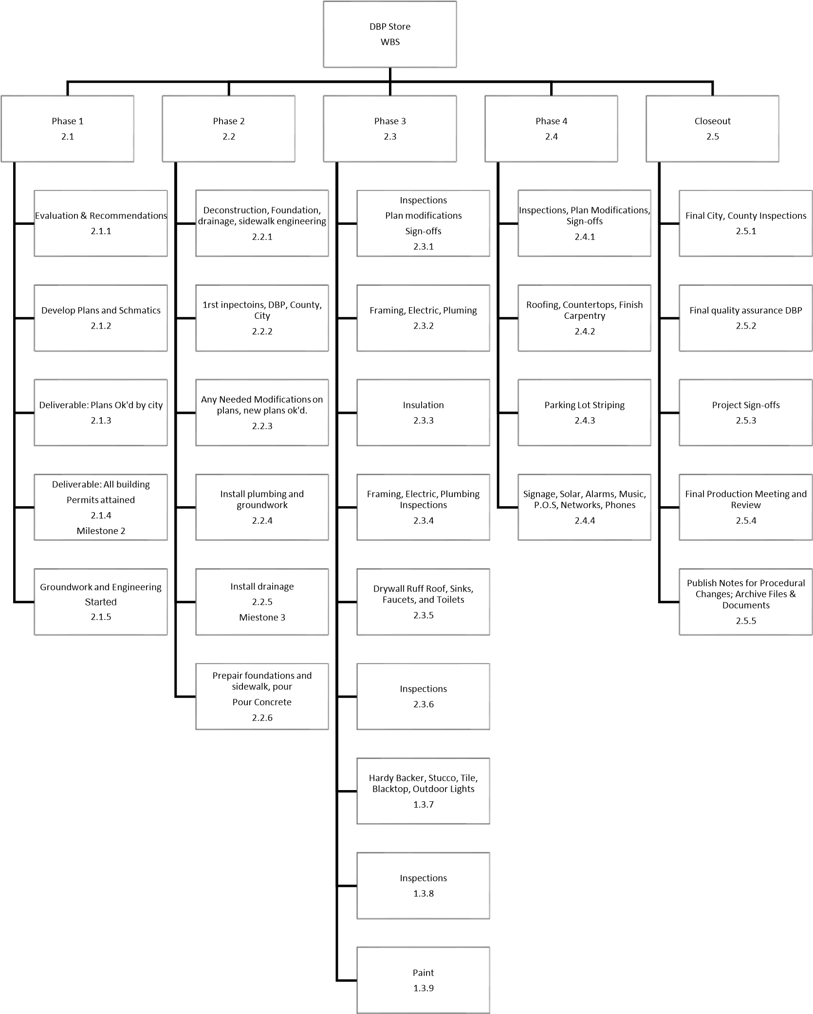

WBS DICTIONARY

|  |  |  |  |
| --- | --- | --- | --- |
| Level | WBS Code | Element Name | Definition |
| 1 | 2 | DBP Store | All work to implement the construction of a DBP Store at a new Franchise Location. |
| 2 | 2.1 | Phase 1 | The work to initiate the sub-project. |
| 3 | 2.1.1 | Evaluation & Recommendations | Evaluation Procured Properties, to develop building plan |
| 4 | 2.1.2 | Develop Plans and Schematics | Plans for Remodeling of existing facilities, Plans for Kiosk |
| 5 | 2.1.3 | Deliverable: Plans Ok'd by Planning Dept | All plans pass City, and County Building Planning & DBP Quality Assurance |
| 6 | 2.1.4 | Deliverable: All Building Permits Attained | All Building Permits attained from City, County, and State. |
| 7 | 2.1.5 | Groundwork Engineering Started | Compaction, Drainage, Electric Conduit, Water Supply, Sewer, and Leveling For Slab Engineering Only |
| 2 | 2.2 | Phase 2 | Building Begins Groundwork |
| 3 | 2.2.1 | Deconstruction, Demolition, Foundations | Deconstruction, Demolition, Foundations, Footings Dug, Curb and Sidewalks Engineered |
| 4 | 2.2.2 | 1rst Inspections, DBP, County, City  Planning and Building | Ground Compaction Inspection, City Inspector, County Inspector, DBP Inspector. |
| 5 | 2.2.3 | Any Needed Modifications on Plans, New Plans ok'd. | After inspection any modification needed are made to the plans, plans are sent and reviewed and signed by the Planning Dept, Managers, and Forman’s |
| 6 | 2.2.4 | Install Plumbing and Groundwork | GroundWork Begins for Conduit and Plumbing |
| 7 | 2.2.5 | Install Drainage | Ground Work, Drainage, Sewer |
| 8 | 2.2.6 | Prepare Foundations and Sidewalk; Pour Concrete | Foundation Forms, Sidewalk Forms, Iron Work, Form Inspections by Inspectors. Once Cleared Pour Concrete. |
| 2 | 2.3 | Phase 3 | Framing and Ruff Cut |
| 3 | 2.3.1 | Inspections Plan Modifications and Plan Sign-offs | Inspections for Cost Tracking, City Planning, Quality Assurance, Future Needs scheduled. |
| 4 | 2.3.2 | Framing, Electric, Plumbing | Framing for Remodel & New construction Kiosk. Electric Service setup, Romex, Outlets, Lighting Boxes, Indoor Plumbing Installed. |
| 5 | 2.3.3 | Insulation | Ridged Insulation is installed before inspection, all others after inspections |
| 6 | 2.3.4 | Framing, Electric, Plumbing Inspections | All Framing Inspections performed by City, County, and DBP, Insulation Installed afterward Hardy Backer is installed or another outdoor siding |
| 7 | 2.3.5 | Drywall Ruff Roof, Sinks, Faucets, and Toilets | All Drywall installed and Taped and Textured, Then Sinks and Toilets and plumbing appliances. The roof is framed and covered |
| 8 | 2.3.6 | Inspections | Electric Inspections, Roof Inspections, City Planning, and DBP |
| 9 | 2.3.7 | Hardy Backer, Stucco, Tile, Blacktop, Outdoor Lights | Hardy Baker is prepped, Stucco work is done, Tile work is done, Blacktop installed, Outdoor Lights Installed. |
| 10 | 2.3.8 | Inspections | All Inspections Performed. |
| 11 | 2.3.9 | Paint | All Interior and Exterior Painting |
| 2 | 2.4 | Phase 4 | Finish Carpentry |
| 3 | 2.4.1 | Inspections, Plan Modifications, Sign-offs | Overall project Tracking, Inspection from City, County, and DBP. Modifications if needed. |
| 4 | 2.4.2 | Roofing, Countertops, Finish Carpentry | Roofing Done, Countertops, Display Cases, Wilkins, Finish Carpentry, Bathroom Stalls put in. |
| 5 | 2.4.3 | Parking Lot Striping | All Parking Lot Striping and Land Scaping Completed. Handicap access. |
| 6 | 2.4.4 | Signage, Solar, Alarms, Music, P.O.S, Networks, Phones | All Sign and Menus installed, Solar Power, Alarms, Music Systems, Point of Sale Systems and Order Tracking, Networks, and Telephone systems |
| 2 | 2.5 | Closeout | The work to close-out the project. |
| 3 | 2.5.1 | Final City, County Inspections | All final City and County Inspections Performed |
| 4 | 2.5.2 | Final Quality Assurance DBP | All Dutch Brothers Quality Assurance Inspections Completed |
| 5 | 2.5.3 | Project Sign-offs | Deliverables Sign off by DBP |
| 6 | 2.5.4 | Final Production Meeting and Review | Review of what worked and what did not Procedure change recommendations. |
| 7 | 2.5.5 | Publish Notes for Procedural Changes; Archive Files & Documents | Document changes and archive all project files and documents for the future. |

GLOSSARY OF TERMS

DBP Dutch Brothers Plus

Level of Effort: Level of Effort (LOE) is how much work is required to complete a task.

WBS Code: A unique identifier assigned to each element in a Work Breakdown Structure to designate the elements hierarchical location within the WBS.

Work Package: A Work Package is a deliverable or work component at the lowest level of its WBS branch.

WBS Component: A component of a WBS which is located at any level. It can be a Work Package or a WBS Element as there's no restriction on what a WBS Component is.

WBS Element: A WBS Element is a single WBS component and its associated attributes located anywhere within a WBS. A WBS Element can contain work, or it can contain other WBS Elements or Work Packages.

Appendix 3: Communication Management Plan



**Dutch Brothers Plus** Tel: 530-315-4839

|  |  |  |  |
| --- | --- | --- | --- |
|  |  |  |  |
| Oct 02, 2018 |  |  | 300 |

Jeffery Morse, PM

Dutch Brothers Plus



*Dutch Brothers Plus Building Plan*

Project Communications Management Plan

This project communications management plan is a component of the project management plan that describes how project communication will be planned, structured, monitored, and controlled.

**REVISIONS AND DISTRIBUTION**

|  |  |  |  |  |  |  |  |  |  |  |  |  |  |
| --- | --- | --- | --- | --- | --- | --- | --- | --- | --- | --- | --- | --- | --- |
| **Revision** | **Release date** | **Distributed to\*** | | | | | | | | | | | |
| Client | Consultant | Main office(s) | Project Manager | Procurement Manager | Quality Manager | Costs Manager | Building and Planning | Contractor | Sub-contractors | Suppliers |  |
| Rev. 0 (draft) | 29/10/2013 |  |  |  |  |  |  |  |  |  |  |  |  |
|  |  |  |  |  |  |  |  |  |  |  |  |  |  |
|  |  |  |  |  |  |  |  |  |  |  |  |  |  |
|  |  |  |  |  |  |  |  |  |  |  |  |  |  |
|  |  |  |  |  |  |  |  |  |  |  |  |  |  |
|  |  |  |  |  |  |  |  |  |  |  |  |  |  |
|  |  |  |  |  |  |  |  |  |  |  |  |  |  |
|  |  |  |  |  |  |  |  |  |  |  |  |  |  |
|  |  |  |  |  |  |  |  |  |  |  |  |  |  |
|  |  |  |  |  |  |  |  |  |  |  |  |  |  |

*) Detailed distribution lists shall be prepared for each distribution event. Further details as per the project communication plan



Amendments

The Communications Plan from time to time may require updates. Any amendment to this plan shall be informed to the change control board by use of the change request form and approved by the project change control board before distribution. Only revised parts of the plan will be distributed along with the approval and shall be accompanied by instructions on how to implement the changes.

The initial page numbering system will be a normal continuous numbering displayed in the lower right corner of each page. If pages must be added, characters shall be added to the number. In case entire pages are deleted, the corresponding page shall be replaced by a blank page stating, “page removed.”

Each added/changed page shall have the revision number and date of approval displayed on the bottom of the page.

**PROJECT SPONSOR APPROVAL**

|  |  |  |
| --- | --- | --- |
| **Prepared by:** | **Reviewed by:** | **Approved by Proj. Sponsor:** |
| Place, 02/10/2018 | Place, dd/mm/yyyy | Place, dd/mm/yyyy |
|  |  |  |
| Jeffery Morse PM  Designation | Name  Designation | Name  Designation |

**COMMUNICATIONS MANAGEMENT APPROACH**

Communications for the use of this document and project shall be defined as the meaningful exchange of information horizontal or vertical between two or more parties formal or informal through the exchange of ideas, concepts, expectations, instructions, and the like. It is the responsibility of the sender of information to ensure that the information is received by the recipient and that the information is encoded properly in a way that allows the recipient to decode it without misunderstanding.

All senders and recipients at any time shall take a pro-active approach to ensure efficient and smooth communication.



Other Project Plans

This project communication management plan forms part of the overall project management plan. Further project plans to be read in conjunction with this project quality management plan are a) Project Management Plan,

1. Project Scope Management Plan,
2. Work Structure Breakdown Management Plan,
3. Change Management Plan,
4. Project Cost Management Plan,
5. Project Quality Management Plan,
6. Project Human Resource Management Plan,
7. Schedule Management Plan,
8. *(this Project Communications Management Plan),*
9. Project Risk Management Plan,
10. Project Procurement Management Plan,
11. Project Stakeholder Management Plan,

**COMMUNICATIONS MODES & STANDARDS**

To ensure the efficiency of communication, all formal communication shall be through document control. The document controller registers all incoming and outgoing documents, plans or whatsoever and distributes them as determined.

All documents plan or whatsoever must have a unique reference number. In the case of multi-page documents, the number on every single page shall be repeated in the header or footer.

Drawings will use a defined title block containing certain standard information. The title block will be determined by the respective department head.

All documents shall be signed and stamped by the authorized person. No document can be changed by anyone other than the Control Board (CB). The CB includes members from the main DBP project team as well as members of DBP-Store sub-project team.

The flow of Formal Communication

Dissemination of formal information, with implications on the scope, time, cost, and quality shall be through predefined and fixed lines of communication.

**Internal**

Within the company information shall be circulated from department heads to department heads and registered by document controller if appropriate.

Each department head for his area of responsibility controls and ensures that current, valid information, plans, etc. - whether at the site or in the office - are at the disposal of executing staffs and workers and that only valid versions of a document are in use. He provides his team with controlled copies and carries concern that old, or superseded versions are collected and stamped accordingly or be taken otherwise out of circulation.

**External (client)**

Outgoing documents addressed to the client will be transmitted or submitted (whatever applicable) as a hard copy to his office address.

All documents are to be registered by the document controller, and reception of the transmittal/submittal will be acknowledged by the recipient.

**External (sub-contractor/supplier)**

Outgoing documents addressed to any sub-contractor/supplier will be transmitted or submitted (whatever applicable) as a hard copy. The document will be deposited for receiver collection with document controller. Other methods may be agreed upon in individual cases should the described system be impractical. It is the sender's responsibility to ensure that the recipient is informed, where appropriate that a document is available for collection.

All documents are to be registered by the document controller, and reception of the transmittal/submittal will be acknowledged by the recipient.

Formal Communication

**Submittals**

Submittals for the use of this document and project shall be a non-verbal exchange of information including everything which the contract requires the contractor to present for review and illustrating some aspects of works or to demonstrate adherence to requirements and specifications and includes:

* All drawings,
* Product data,
* Designs,
* Diagrams,
* Illustrations,
* Schedules,
* Samples,
* Catalog cuts,
* Testing certificates,
* Approvals,
* Hand-over documents and 
* Other information prepared to illustrate some portion of the work.

**Transmittals**

Transmittals for the use of this document and project shall be a non-verbal exchange of information that provides information to another attached formal document. The transmittal serves as a record of delivery and provides the recipient with information for identifying the context in which to view the document.

Typical transmittals include:

* Letters,
* Meeting minutes,
* Requests,
* Quotations,
* Invoices, claims and the like,
* Reports,
* Change orders,
* Response(s) to any of the above, and - Other formal correspondence.

Informal Communication

**Meetings**

Meetings are gatherings of two or more people being convened to achieve a common goal through verbal sharing of information or reaching an agreement.

Meetings usually occur face to face, in special cases telephone or Skype conference calls may be agreed upon.

Meetings shall be time well spent and therefore usually shall be held periodically in not too short intervals and following specific rules, which in detail must be determined by the respective chairperson. Common general rules are the distribution of the meeting agenda not less than one working day in advance of the meeting and meeting minutes within two working days after the meeting. Further general rules are the usage of sign-in sheets, the adherence to speaking times, etc. 

Meeting agendas shall define the date and venue of the meeting, the required participants, the topics for discussion and the presenter. The first topic generally shall be a review of action items from the previous meeting.

Meeting minutes are a summary/record of the meeting and at least comprise of the date and duration of the meeting, the venue, a list of participants, the topics (item by item) along with actions to be taken, the owner of that action item and the schedule. Meeting minutes shall be distributed to the meeting participants within 48 working hours after the meeting was finished. Any clarifications or comments must be transmitted to the chairperson, within 48 hours after circulation of the meeting minutes.

**Meeting Schedule**

|  |  |  |  |  |
| --- | --- | --- | --- | --- |
|  | **Type of meeting** | **Chaired by**  (name & role or designation) | **Frequency** | **Attendance** |
| 01 | Tender Transfer  Meeting | xxx, COO | Once, upon award of a contract | * Project sponsor, * Project mngr., * Project team as far as available and appropriate, * Tendering dept. Staffs, * PMO (if any) |
| 02 | Project Team Meeting | Project manager | weekly | - Project team |
| 03 | Design Meeting | Technical lead | As needed | - Project team/parts thereof |
| 04 | Project Status Meeting | Project manager | Monthly | * Project sponsor, * Key stakeholders, * Project team/part thereof, * PMO (if any) |
|  | **Type of meeting** | **Chaired by**  (name & role or designation) | **Frequency** | **Attendance** |
| 05 | Quality Meeting | Quality manager | Weekly | * Project team/part thereof, * Stakeholders as appropriate,   - |
| 06 | HSE Meeting | QA manager | Weekly | * Project team/part thereof, * Stakeholders as appropriate,   - |



Other Informal Communications Modes

**Email & Fax**

Cases where the above-described communication channels for obvious reasons are unsuited or would delay unnecessarily the exchange of information, the use of common communication methods such as email, fax or others may be agreed upon and be accepted in exceptional cases.

This communication however usually shall be intended to be “for information or advance information only” and must not replace the formal exchange of information. This means consequently that all information with impact on scope, cost, schedule or quality must be submitted/transmitted formally subsequently.

**Verbal Instructions**

Verbal instructions with impact on scope, cost, schedule or quality are unacceptable in general. If in a case a verbal statement for reason of time is unavoidable, it must be submitted/transmitted formally within one hour.

It is up to the respective head of the department or his superior manager observing their level of authority to follow the received verbal instruction or not.

**REPORTS**

Reports are formal communication and shall be prepared, registered and transmitted to the various stakeholders. The frequency of transmission, level of details, and the nature of the information contained therein depend on the stakeholder type, his level of influence, and the stakeholder requirements. Such requirements shall be collected, and a reporting format shall be developed accordingly.

Although reports constitute formal communication, certain low-level reports depending on their content (e.g., daily workforce), the frequency and in coordination with the recipient can be sent electronically.

|  |  |  |  |  |  |
| --- | --- | --- | --- | --- | --- |
| **SN** | **Type of report** | **Responsible communicator** | **Communic. method** | **Frequency** | **Addressees** |
| 01 |  |  |  |  |  |
|  |  |  |  |  |  |
|  |  |  |  |  |  |
|  |  |  |  |  |  |
|  |  |  |  |  |  |
|  |  |  |  |  |  |
|  |  |  |  |  |  |
|  |  |  |  |  |  |
|  |  |  |  |  |  |
|  |  |  |  |  |  |
|  |  |  |  |  |  |
|  |  |  |  |  |  |

**FILING AND ARCHIVING**

Hard copies and softcopies shall be maintained simultaneously. Each data folder on the shared hard disk drive or server shall also be represented by a corresponding box file and vice versa. The names of both box file and data folder shall be the same; their contents consequently shall be same.



Filing Scheme

The filing scheme will follow the numbering system giving in document 100 the Management Plan in the overview section.

It is undisputed that further folders will be required over time to sort files in a logical and manageable order. However new folder will be labeled with the proper title and numerical number with the label of current, reconciling of documents will be done on a daily basis.

File and Folder Name(s)

**Folders**

Aside from the predefined folder names, new folders only shall be created after approval by the responsible manager. Preferably folder names shall be built of a number and a short descriptive name to have a consistent sorting and that the folder can be found in the same place at any time.



Data Integrity

Access (read, write, execute) to electronic data shall be restricted to the competent person respective group of persons.

Data Backup

A back-up of the electronic files shall be generated automatically on a daily basis. The minimum requirement is to copy all new and changed files to a different media automatically every night. Thus, accidentally deleted files and folders older than 24 hrs. Can be restored. A log file shall be generated automatically and checked at least once a week. 

For the automatic backup to run smoothly, compliance with the above filename restrictions is inevitable.

The backup media ideally shall be far from the original media at a different location. Otherwise, if that is not possible for some reason, two similar backup media shall be used reciprocal weekly. Thus in case of theft, fire or any other unlikely event only data of the last seven days can be lost.

**ARCHIVE**

Generally, all records shall be filed in standard filing folders. Each box file shall be labeled by the applicable standards of the organization.

Upon completion of the project or phase, all box files shall be packed into cardboard boxes. Boxes shall be suitable to withstand heat and humidity until the end of the lifetime of the project file. Boxes shall be stackable and shall withstand at least 3-5 relocations. The project lifetime shall be by project requirements and legal requirements. A corresponding dedicated procedure shall be developed and implemented at a later stage.

**LIST OF APPENDIXES**

|  |  |
| --- | --- |
| **Doc. No.** | **Name** |
|  |  |
|  |  |
|  |  |
|  |  |
|  |  |
|  |  |

Appendix 4: Cost Management Plan

 **Dutch Brothers Plus** Tel: 530-315-4839

|  |  |  |  |
| --- | --- | --- | --- |
|  |  |  |  |
| Oct 03, 2018 |  |  | 400 |

Jeffery Morse, PM

Dutch Brothers Plus



*Dutch Brothers Plus Building Plan*

Project Cost Management Plan

The project cost management plan is a component of the project management plan that describes how costs will be planned, structured and controlled.

**REVISIONS AND DISTRIBUTION**

|  |  |  |  |  |  |  |  |  |  |  |  |  |  |
| --- | --- | --- | --- | --- | --- | --- | --- | --- | --- | --- | --- | --- | --- |
| **Revision** | **Release date** | **Distributed to\*** | | | | | | | | | | | |
| Client | Consultant | Main office(s) | Project Manager | Procurement Manager | Quality Manager | Costs Manager | Building and Planning | Contractor | Sub-contractors | Suppliers |  |
| Rev. 0 (draft) | 29/10/2013 |  |  |  |  |  |  |  |  |  |  |  |  |
|  |  |  |  |  |  |  |  |  |  |  |  |  |  |
|  |  |  |  |  |  |  |  |  |  |  |  |  |  |
|  |  |  |  |  |  |  |  |  |  |  |  |  |  |
|  |  |  |  |  |  |  |  |  |  |  |  |  |  |
|  |  |  |  |  |  |  |  |  |  |  |  |  |  |
|  |  |  |  |  |  |  |  |  |  |  |  |  |  |
|  |  |  |  |  |  |  |  |  |  |  |  |  |  |
|  |  |  |  |  |  |  |  |  |  |  |  |  |  |
|  |  |  |  |  |  |  |  |  |  |  |  |  |  |

*) Detailed distribution lists shall be prepared for each distribution event. Further details as per the project communication plan



Amendments

The Project Cost Management Plan may require updates. Any amendment to this plan shall be performed only after the Control Board has received authority for changes and then changes are made by the CB only. The initial page numbering system will be a normal continuous numbering displayed in the lower right corner of each page. If pages must be added, characters shall be added to the sequence. In case entire pages are deleted, the corresponding page shall be replaced by a blank page stating, “page removed.”

Each added/changed page shall have the revision number and date of approval displayed on the bottom of the page.

**PROJECT SPONSOR APPROVAL**

|  |  |  |
| --- | --- | --- |
| **Prepared by:** | **Reviewed by:** | **Approved by Proj. Sponsor:** |
| HQ, 03/10/2018 | Place, dd/mm/yyyy | Place, dd/mm/yyyy |
|  |  |  |
| Jeffery Morse, PM  Designation | Name  Designation | Name  Designation |

**TABLE OF CONTENTS**

Revisions and Distribution..................................................................................................................II

Amendments .......................................................................................................................................II

Project Sponsor Approval .................................................................................................................III

Cost Management Approach 1

Estimate Cost 1

Cost Baseline 1

Cost Control 1

Cost Reporting 2

Change Control 2

Attachments: 3

**COST MANAGEMENT APPROACH**

The process for cost management is simple – nothing will be changed without it being in the plans. The communications process insists on consensus on every level before a change can occur. As a result, only those changes that are necessary will occur. Cost management is first the task of the Cost Manager CM, and secondly the task of the Procurement Manager. No cost saving efforts will be used unless they meet both the quality and time constraints of the project. Any costs beyond the scheduled cost structure will have to approve by the Head Office, all managers, the contractors, and the clients. Documentation will follow the assigned document tracking system assigned in the Communications Plan.

**ESTIMATE COST**

Estimate Costs are an analogous approximation of the monetary resources needed to complete the project. Estimation of costs is forwarded from qualified personnel of whom possess the knowledge of costs from recent similar construction projects.

**COST BASELINE**

Aggregated the estimated costs of individual activities will be monitored for future reference. Contingency and management reserve are taken into consideration on two separate occasions. 1. Unforeseen large expense due to construction costs. 2. In the case that there is no existing building for remodel and benefit and cost analysis has shown to be positive for building both the store and kiosk at a location. Funding for each of these must be preapproved my financial managers, main project managers and investors, and financiers. Current estimates for building and remodel are at 250k.

**COST CONTROL**

The Cost Manager will measure costs throughout the project lifecycle. Cost of three types will be tracked, procurement, labor, and contractor costs. The excel payment schedule file is a full list of the authorized payment schedule. However, the graph here is an overview. In responding to cost variances outside the expected schedule, the meeting must be held to discuss the benefits out way costs by the Project Control Board for the DBP main project before any funds will be released.

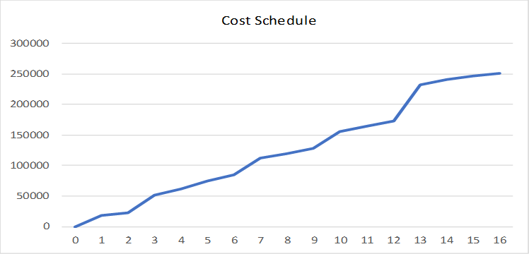

**Cost Reporting**

Daily reports of Cost along with a graph with the expected costs and the actual costs will be published and sent to each manager of the project team. The PM of this subproject may be required to supply costs information to the PM of the main project upon request.

**CHANGE CONTROL**

All changes to the baseline must first be approved by the DBP project manager and the control board. **ATTACHMENTS:**

|  |  |
| --- | --- |
| Attachment 1 |  |
| Attachment 2 |  |

Appendix 5: Procurement Management Plan



**Dutch Brothers Plus** Tel: 530-315-4839]

|  |  |  |  |
| --- | --- | --- | --- |
|  |  |  |  |
| Oct 03, 2018 |  |  | 500 |

Jeffery Morse, PM

Dutch Brothers Plus



*Dutch Brothers Plus Building Plan*

## Project Procurement Management Plan

### REVISIONS AND DISTRIBUTION

|  |  |  |  |  |  |  |  |  |  |  |  |  |  |
| --- | --- | --- | --- | --- | --- | --- | --- | --- | --- | --- | --- | --- | --- |
| **Revision** | **Release date** | **Distributed to\*** | | | | | | | | | | | |
| Client | Consultant | Main office(s) | Project Manager | Procurement Manager | Quality Manager | Costs Manager | Building and Planning | Contractor | Sub-contractors | Suppliers |  |
| Rev. 0 (draft) | 29/10/2013 |  |  |  |  |  |  |  |  |  |  |  |  |
|  |  |  |  |  |  |  |  |  |  |  |  |  |  |
|  |  |  |  |  |  |  |  |  |  |  |  |  |  |
|  |  |  |  |  |  |  |  |  |  |  |  |  |  |
|  |  |  |  |  |  |  |  |  |  |  |  |  |  |
|  |  |  |  |  |  |  |  |  |  |  |  |  |  |
|  |  |  |  |  |  |  |  |  |  |  |  |  |  |
|  |  |  |  |  |  |  |  |  |  |  |  |  |  |
|  |  |  |  |  |  |  |  |  |  |  |  |  |  |
|  |  |  |  |  |  |  |  |  |  |  |  |  |  |

*) Detailed distribution lists shall be prepared for each distribution event. Further details as per the project communication plan

#### Amendments

The Project Procurement Management Plan may require updates. Any amendment to this plan shall be informed to the change control board by use of the change request form and approved by the project change control board before distribution. Only revised parts of the plan will be distributed along with the approval and shall be accompanied by instructions on how to implement the changes.

The initial page numbering system will be a normal continuous numbering displayed in the lower right corner of each page. If pages must be added, characters shall be added to the number. In case entire pages are deleted, the corresponding page shall be replaced by a blank page stating, “page removed.”

Each added/changed page shall have the revision number and date of approval displayed on the bottom of the page.

### PROJECT SPONSOR APPROVAL

|  |  |  |
| --- | --- | --- |
| **Prepared by:** | **Reviewed by:** | **Approved by Proj. Sponsor:** |
| HQ, 03/10/2018 | Place, dd/mm/yyyy | Place, dd/mm/yyyy |
|  |  |  |
| Jeffery Morse, PM  Designation | Name  Designation | Name  Designation |

**TABLE OF CONTENTS**

Revisions and Distribution................................................................................................................. II

Amendments …...................................................................................................................................II

Project Sponsor Approval ..................................................................................................................III

Procurement Management Approach ................................................................................................. 1

Contract Types..................................................................................................................................... 1

Procurement Constraints ..................................................................................................................... 1

Scope ................................................................................................................................................... 1 

Responsibilities and Authorities .......................................................................................................... 1

Decision Criteria .................................................................................................................................. 2

Procurement Documentation ............................................................................................................... 2

Procurement Risk ................................................................................................................................ 2

Reporting Formats ............................................................................................................................... 2

Supplier Performance Measurement ................................................................................................... 2

Attachments: ....................................................................................................................................... 3

### PROCUREMENT MANAGEMENT APPROACH

Project procurement will be conducted according to the WSB. Each phase of the project has inspection times scheduled. Inspection includes the processing and ordering of supplies for the upcoming phase. Many times, building supplies are covered by contractors and sub-contractors. When this is the case for all purchased materials contracted, and partnered suppliers are preferred. Most building supplies are contracted through Home Depot or Lowes. If substantial savings of costs can be found in uncontracted sources, these are only to be used if 1. There is no decrease in quality. 2. There is no increase in delivery time. Concrete will be contracted through Livingston's Concrete. A.C. will be contracted through the sub-contractor.

After supplies needed list is generated for the next phase, the Procurement Manager (PM) will subdivide the list in order of vender. As orders arrive, the PM must physically inspect the order and check each item off as present and of expected quality. Supplemental orders will be processed as needed and will be added to the total for the next phase.

### CONTRACT TYPES

Define the types of contracts and the terms and conditions to be used for the project.

1. Fixed price contracts
   1. Main Contractor
   2. Sub-Contractor
   3. Livingstons Concrete
2. Cost-reimbursable Contracts
   1. Home Depot
   2. Lowes
3. T&M DBP Company Construction Personnel



PROCUREMENT CONSTRAINTS

The build time is a 16-week window. If preferred suppliers cannot deliver on time, auxiliary suppliers may be used if there is no change in quality, time or costs. County and city building inspectors must be scheduled in advance for each phase inspection, not doing so will raise project costs to unacceptable heights.

### RESPONSIBILITIES AND AUTHORITIES

DBP Main Project Manager, Control Panel, City and County Planning, DBP Quality Manager

**DECISION CRITERIA** 

Construction Contracts will be awarded to a Construction Firm of High Reputation, is known for quality craftsmanship and on-time deliverables at a fair price. Current DBP vendor partnership will have a preference

PROCUREMENT DOCUMENTATION

The procurement forms shall be backed up to the computer, every night. Data will also have daily scheduled backups to a backup drive and server. A sample is attached to the bottom of this document.

E.g.

1. Site requisition order forms with
   1. Full material specification and requirements. 
   2. Expectations (delivery time, place of delivery, etc.).
   3. Control account.
2. Request for quotation
   1. Standard forms acceptable,
   2. Quotations returned on forms provided by quoting firm.
3. Purchase order/contract (see above)
4. Procurement evaluation form

### PROCUREMENT RISK

Procurement risks include late delivery, cost increase, and inferior quality. For these reasons, this project includes a Procurement Manager to ensure the delivery, cost, and quality of all items procured.

### REPORTING FORMATS

Only obvious gross infringements will be logged. For quality failures due to shipping items will be returned and replaced. Miss orders will be returned. All returns will be logged on the procurement form. Gross infringements will be logged and forewarded ending in the loss of the contract.

### SUPPLIER PERFORMANCE MEASUREMENT

Suppliers will be classified as “Above Satisfactory,” “Satisfactory,” and “Unsatisfactory.” As this is construction supplier performance such as rooftop delivery of roofing is necessary to meet the 16-week timetable.

**ATTACHMENTS:** 

|  |  |
| --- | --- |
| Attachment 1 | Sample Procurement Form |
| Attachment 2 |  |

|  |  |  |  |  |  |
| --- | --- | --- | --- | --- | --- |
| **SN** | **Name**  (item or service) | **Description**  (short description and justification) | **Constraints**  (time) | **Constraints**  (requirements) | **Contract type** |
| 01 |  |  |  |  |  |
|  |  |  |  |  |  |
|  |  |  |  |  |  |
|  |  |  |  |  |  |

**SCOPE**

Define what goods and services will be procured and under what conditions.

Appendix 6: Project Scope Management Plan

|  |  |  |  |
| --- | --- | --- | --- |
|  | **Dutch Brothers Plus** | Tel: | 530-315-4839 |
| September 26, 2018 |  |  | 600 |

Jeffery Morse, PM

Dutch Brothers Plus



*Dutch Brothers Plus Building Plan*

Project Scope Management Plan

The project scope management plan is a component of the project management plan that describes how the scope will be defined, developed, monitored, controlled, and verified.

### REVISIONS AND DISTRIBUTION

|  |  |  |  |  |  |  |  |  |  |  |  |  |  |
| --- | --- | --- | --- | --- | --- | --- | --- | --- | --- | --- | --- | --- | --- |
| **Revision** | **Release date** | **Distributed to\*** | | | | | | | | | | | |
| Client | Consultant | Main office(s) | Project Manager | Procurement Manager | Quality Manager | Costs Manager | Building and Planning | Contractor | Sub-contractors | Suppliers |  |
| Rev. 0 (draft) | 29/10/2013 |  |  |  |  |  |  |  |  |  |  |  |  |
|  |  |  |  |  |  |  |  |  |  |  |  |  |  |
|  |  |  |  |  |  |  |  |  |  |  |  |  |  |
|  |  |  |  |  |  |  |  |  |  |  |  |  |  |
|  |  |  |  |  |  |  |  |  |  |  |  |  |  |
|  |  |  |  |  |  |  |  |  |  |  |  |  |  |
|  |  |  |  |  |  |  |  |  |  |  |  |  |  |
|  |  |  |  |  |  |  |  |  |  |  |  |  |  |
|  |  |  |  |  |  |  |  |  |  |  |  |  |  |
|  |  |  |  |  |  |  |  |  |  |  |  |  |  |

*) Detailed distribution lists shall be prepared for each distribution event. Further details as per the project communication plan



#### Amendments

The Project Scope Management Plan may require updates. Any amendment to this plan shall be informed to the change control board by use of the change request form and approved by the project change control board before distribution. Only revised parts of the plan will be distributed along with the approval and shall be accompanied by instructions on how to implement the changes.

The initial page numbering system will be a normal continuous numbering displayed in the lower right corner of each page. If pages have to be added, characters shall be added to the number. In case entire pages are deleted, the corresponding page shall be replaced by a blank page stating, “page removed.”

Each added/changed page shall have the revision number and date of approval displayed on the bottom of the page.

### PROJECT SPONSOR APPROVAL

|  |  |  |
| --- | --- | --- |
| **Prepared by: Jeffery Morse PM** | **Reviewed by:** | **Approved by Proj. Sponsor:** |
| HQ, 26/09/2018 | Place, dd/mm/yyy | Place, dd/mm/yyy |
|  |  |  |
| Jeffery Morse, PM  Designation | Name  Designation | Name  Designation |

**TABLE OF CONTENTS**

Revisions and Distribution................................................................................................................................ II

Amendments ............................................................................................................................................... II

Project Sponsor Approval ................................................................................................................................III

Introduction 1

Other Project Plans 1

Scope Management Approach 2

Scope Statement Development 2

WBS Structure Development 3

Scope Control 3

Acceptance of Deliverables 3

Project Scope Statement 4

Product Scope Description 4

Deliverables 4

Scope Acceptance Criteria 4

Scope Exclusions 4

Constraints 5

Assumptions 5

Work Breakdown Structure (WBS) and Dictionary 5

Attachments: 6

# INTRODUCTION

The Scope is defined starting from the closing of the purchase of the location to the sign—off on deliverables from DBP. It includes groundwork, sidewalk engineering, building remodel, kiosk construction, landscaping, and the parking lot. No changes to the plan will occur without documentation, changes to documentation and plans may only occur to meet 1. Quality Assurance. 2. DBP changes to allow DBP quality assurance. If changes are made the document must be signed by the modifier, and then forwarded to each manager for a signature as well as the foreman on site. Lastly, the PM will sign off the change before actual changes occur in construction.



## Other Project Plans

This Project Scope Management Plan forms part of the overall project management plan. Further project plans to be read in conjunction with this project quality management plan are:

1. Project Management Plan,
2. *(this Project Scope Management Plan),*
3. Project Change Management Plan,
4. Project Schedule Management Plan,
5. Project Cost Management Plan,
6. Project Quality Management Plan,
7. Project Human Resource Management Plan,
8. Project Communication Management Plan,
9. Project Risk Management Plan,
10. Project Procurement Management Plan,
11. Project Stakeholder Management Plan,
12. Project Financial Management Plan,

# SCOPE MANAGEMENT APPROACH



## Scope Statement Development

The scope statement will be developed using this list

1. This project is a sub-project of the DBP startup and is referred to as DBP-Store.
2. Deliverables.  DBP storefront and kiosk.
3. The justification for the project.  This project is initiated to build the store for the DBP Startup.
4. Constraints.  Planning Dept building Codes, Overbudget possibilities, 16 weeks.
5. Assumptions.  Weather, Availability, etc.
6. Inclusions/Exclusions.



## WBS Structure Development

WBS will be developed using the sticky note technique and set in phases. WBS dictionary will be created from terms used.



## Scope Control

Scope baseline will be managed by the rule “no changes without written authorization.” Only items included in approved blueprints and schematics will be constructed. The Goal of having a Storefront and Kiosk that looks the same at each new location is a selling point no variation can occur without full authorization. The scope will be maintained through the authorization process. Only the Control Board can change forms. When any form is changed that form is forwarded to each manager, and the Forman, and finally the county building dept for authorization, after this the PM must sign off and give the final authorization.



## Acceptance of Deliverables

After the final inspection from the county, city and state inspectors the DBP inspector will come and sign off for quality assurance. After all, inspectors have signed off; the DBP Franchise owner will come and do a walk through and sign off receiving the deliverables.

# PROJECT SCOPE STATEMENT



## Product Scope Description

xxx



## Deliverables

One set of approved plans and schematics, one remodeled storefront, with seating and music systems, signage and countertops. One kiosk drive-thru with signage, countertops, electric, and drainage. One parking area with landscape and signage. Note; in cases where there is no existing building the remodel will be a new build instead.



## Scope Acceptance Criteria

All deliverables must pass quality inspections by city, county and state building departments.

All deliverables must pass DBP quality management inspections.

All deliverables must include all authorized items, on time and within budget, unless authorization for extensions is authorized and signed off by DBP, and all Project Managers.



## Scope Exclusions

The scope does not include the purchase of the location of the store.

The scope does not include machinery or equipment needed for day to day business unless the item in part of the building itself –such as a walk-in refrigerator or freezer.



Scope Inclusions

The scope can be extended for a reason concerning quality assurance. i.e., to meet city, county, or state building codes; To meet store requirements for machinery or appliances. 

## Constraints

City, County, and State building codes; 16-week timetable; Electric service must include Solar, and alternative service providing.



## Assumptions

Major assumptions are that local building material will be available; Subcontractors for concrete work, framing, electric, blacktop, and alternative power services will be available within the time-frame.

# WORK BREAKDOWN STRUCTURE (WBS) AND DICTIONARY

The WBS is a hierarchical decomposition of the total scope of work to be carried out by the sub-project team to accomplish the project objectives and create the required deliverables.

Taking into consideration the importance and the possible size of the WBS, Please refer to Document 100.

The WBS can be prepared in different ways including commonly used project management software such as MS Project, Primavera or others.

# ATTACHMENTS:

|  |  |
| --- | --- |
| Attachment 1 |  |
| Attachment 2 |  |

Appendix 7: Project Schedule Management Plan



**Dutch Brothers Plus** Tel: 530-315-4839

|  |  |  |  |
| --- | --- | --- | --- |
|  |  |  |  |
| Oct 03, 2018 |  |  | 700 |

Jeffery Morse, PM 

Dutch Brothers Plus



*Dutch Brothers Plus Building Plan*

Project Schedule Management Plan

The project schedule management plan is a component of the project management plan that establishes the activities for developing, monitoring, and controlling the project or program.

**REVISIONS AND DISTRIBUTION** 

|  |  |  |  |  |  |  |  |  |  |  |  |  |  |
| --- | --- | --- | --- | --- | --- | --- | --- | --- | --- | --- | --- | --- | --- |
| **Revision** | **Release date** | **Distributed to\*** | | | | | | | | | | | |
| Client | Consultant | Main office(s) | Project Manager | Procurement Manager | Quality Manager | Costs Manager | Building and Planning | Contractor | Sub-contractors | Suppliers |  |
| Rev. 0 (draft) | 29/10/2013 |  |  |  |  |  |  |  |  |  |  |  |  |
|  |  |  |  |  |  |  |  |  |  |  |  |  |  |
|  |  |  |  |  |  |  |  |  |  |  |  |  |  |
|  |  |  |  |  |  |  |  |  |  |  |  |  |  |
|  |  |  |  |  |  |  |  |  |  |  |  |  |  |
|  |  |  |  |  |  |  |  |  |  |  |  |  |  |
|  |  |  |  |  |  |  |  |  |  |  |  |  |  |
|  |  |  |  |  |  |  |  |  |  |  |  |  |  |
|  |  |  |  |  |  |  |  |  |  |  |  |  |  |
|  |  |  |  |  |  |  |  |  |  |  |  |  |  |

*) Detailed distribution lists shall be prepared for each distribution event. Further details as per the project communication plan



Amendments

The Project Schedule Management Plan may require updates. Any amendment to this plan shall be informed to the change control board by use of the change request form and approved by the project change control board before distribution. Only revised parts of the plan will be distributed along with the approval and shall be accompanied by instructions on how to implement the changes.

The initial page numbering system will be a normal continuous numbering displayed in the lower right corner of each page. If pages must be added, characters shall be added to the number. In case entire pages are deleted, the corresponding page shall be replaced by a blank page stating “page removed.” Each added/changed page shall have the revision number and date of approval displayed on the bottom of the page.

**PROJECT SPONSOR APPROVAL** 

|  |  |  |
| --- | --- | --- |
| **Prepared by:** | **Reviewed by:** | **Approved by Proj. Sponsor:** |
| HQ, 03/10/2018 | Place, dd/mm/yyyy | Place, dd/mm/yyyy |
|  |  |  |
| Jeffery Morse, PM  Designation | Name  Designation | Name  Designation |

**TABLE OF CONTENTS**

Revisions and Distribution.................................................................................................................. I

Amendments ................................................................................................................................. II

Project Sponsor Approval ..................................................................................................................III

Schedule Management Approach ..................................................................................................... 1

Scheduling Process ........................................................................................................................ 1

Activity Identification ................................................................................................................... 1

Sequencing ................................................................................................................................... 1

Resource Estimating ..................................................................................................................... 1 

Duration Estimating...................................................................................................................... 1

Milestone List .................................................................................................................................... 2

Activity List ........................................................................................................................................ 3

Monitoring and Controlling ............................................................................................................... 4

Schedule Updates .......................................................................................................................... 4

Schedule Changes .......................................................................................................................... 4

Reporting ....................................................................................................................................... 4

Delay .............................................................................................................................................. 4

Attachments: ..................................................................................................................................... 5

**SCHEDULE MANAGEMENT APPROACH**

The methodology of how the project schedule is implemented is first on a weekly basis. On a 16-week timetable not including the purchase of the property. Secondly, the schedule is separated into phases. These phases relate to the different modes of construction, groundwork, concrete, rough framing, and finish. Finally, this sub-project is governed by milestones and deliverables. With each short goal as a motivator as well as a trackable item for benchmarking progress.



Scheduling Process

**Activity Identification**

Activities are identified as they produce either milestones or deliverables inside each phase.

**Sequencing**

Sequencing for construction projects is mostly straightforward. Many items cannot begin until the item before it is completed. For instance, foundations cannot be poured until the groundwork is completed. However, there are some items that can be performed conjointly. For instance, parking lot painting and finish carpentry can occur at the same time.

**Resource Estimating**

Resources are estimated from the plans. There will be a 10% increase for waste allowance. Simply at the time of the inspection, the plans are reviewed for the next phase, supplies are then ordered for the following week. In the event of any needed modifications due to building codes or quality goals the supplies needed for this will be added to the order.

**Duration Estimating**

Duration is estimated analogously. From past project, it is understood that the time need for each phase is listed. 

|  |  |  |  |  |  |  |  |  |  |  |  |  |  |  |  |  |  |  |  |  |  |  |  |  |  |  |  |  |  |  |  |  |  |  |  |  |  |  |  |  |  |  |  |  |  |  |  |  |  |  |  |  |  |  |  |  |  |  |  |  |  |  |  |  |  |  |  |  |  |  |  |  |  |  |  |  |  |  |  |  |  |  |  |  |  |  |  |  |  |  |  |
| --- | --- | --- | --- | --- | --- | --- | --- | --- | --- | --- | --- | --- | --- | --- | --- | --- | --- | --- | --- | --- | --- | --- | --- | --- | --- | --- | --- | --- | --- | --- | --- | --- | --- | --- | --- | --- | --- | --- | --- | --- | --- | --- | --- | --- | --- | --- | --- | --- | --- | --- | --- | --- | --- | --- | --- | --- | --- | --- | --- | --- | --- | --- | --- | --- | --- | --- | --- | --- | --- | --- | --- | --- | --- | --- | --- | --- | --- | --- | --- | --- | --- | --- | --- | --- | --- | --- | --- | --- | --- | --- | --- |
| **MILESTONE LIST**   |  |  |  |  |  |  |  | | --- | --- | --- | --- | --- | --- | --- | | **SN** | **Name** | **Description** | **Date** | **Type** |  |  | |  | Signature of Project Charter and financing | 1. Architectural plans are finished. | Week 1 | Internal | Interim | * Mandatory * Optional | |  | Procurement of property | 1. Plans are receiving signatures from city planners. 2. All building permits acquired. | Week 3 | External | Interim | * Mandatory * Optional | |  | Construction Begins Phase 1 | 1. Inspections for the foundation, plumbing, and electric performed. 2. Order supplies and set delivery date for next phase. 3. Set inspection times and dates | Week 5 | External | Interim | * Mandatory * Optional | |  | Construction Begins Phase 2 | a. Inspections  b. Framing, and electrical installs, lighting boxes countertops.  c. Order supplies and schedule delivery for the next phase. | Week 7 | External | Interim | * Mandatory * Optional | |  | Construction Begins Phase 3 | a. Inspections, framing, and electrical  c. Install outside hardy backer, stucco, t111 drywall, sinks, toilets, tilework lighting assemblies, external lighting.  d. Order supplies for the next phase scheduled delivery date.  e. Schedule inspections for next phase. | Week 10 | External | Interim | * Mandatory * Optional | |  | Construction Begins Phase 4 | a. Inspections performed, insulation, lighting, roof, and plumbing.  c. Finish Carpentry, Painting, Roofing, Tables Chairs, Point of Sales system, Music Systems, Signage, Alarm Systems, and Blacktop Painting.  d. Schedule final roof inspections, fire code inspections, and all other final city inspections. Schedule DBP deliverables signoff. | Week 13 | External | Interim | * Mandatory * Optional | |  | Walk Through, Signoff, and after meeting for learning | a. Inspections--all final.  c. After all city and county inspections pass perform DBP inspections | Week 15 | External | Final | * Mandatory * Optional | |  | Meeting | a. After all, is accepted get deliverables signoff.  b. Project team managers meet to discuss what worked and what did not, were can we improve the make changes to the process for next time. | Week 16 | Internal | Final | * Mandatory * Optional | |  |  |  |  | * Internal * External | ◻ Final ◻ Interim | * Mandatory * Optional | |  |  |  |  | * Internal * External | ◻ Final ◻ Interim | * Mandatory * Optional | |  |  |  |  | * Internal * External | ◻ Final ◻ Interim | * Mandatory * Optional | |  |  |  |  | * Internal * External | ◻ Final ◻ Interim | * Mandatory * Optional |   Jeffery Morse, PM 700 P a g e | **2** |
| **ACTIVITY LIST**   |  |  |  |  |  |  |  |  | | --- | --- | --- | --- | --- | --- | --- | --- | | **ID** | **Name** | **Description** |  | **Predecessor** |  | **Successor** | **Constraints** | | **ID** | **Relationship** | **ID** | **Relationship** |  | |  |  |  |  |  |  |  |  | |  |  |  |  |  |  |  |  | |  |  |  |  |  |  |  |  | |  |  |  |  |  |  |  |  | |  |  |  |  |  |  |  |  | |  |  |  |  |  |  |  |  | |  |  |  |  |  |  |  |  | |  |  |  |  |  |  |  |  | |  |  |  |  |  |  |  |  | |  |  |  |  |  |  |  |  | |  |  |  |  |  |  |  |  | |  |  |  |  |  |  |  |  | |  |  |  |  |  |  |  |  | |  |  |  |  |  |  |  |  | |  |  |  |  |  |  |  |  | |  |  |  |  |  |  |  |  | |  |  |  |  |  |  |  |  | |  |  |  |  |  |  |  |  | |  |  |  |  |  |  |  |  | |  |  |  |  |  |  |  |  | |  |  |  |  |  |  |  |  |     Jeffery Morse, PM 700 P a g e | **3** |

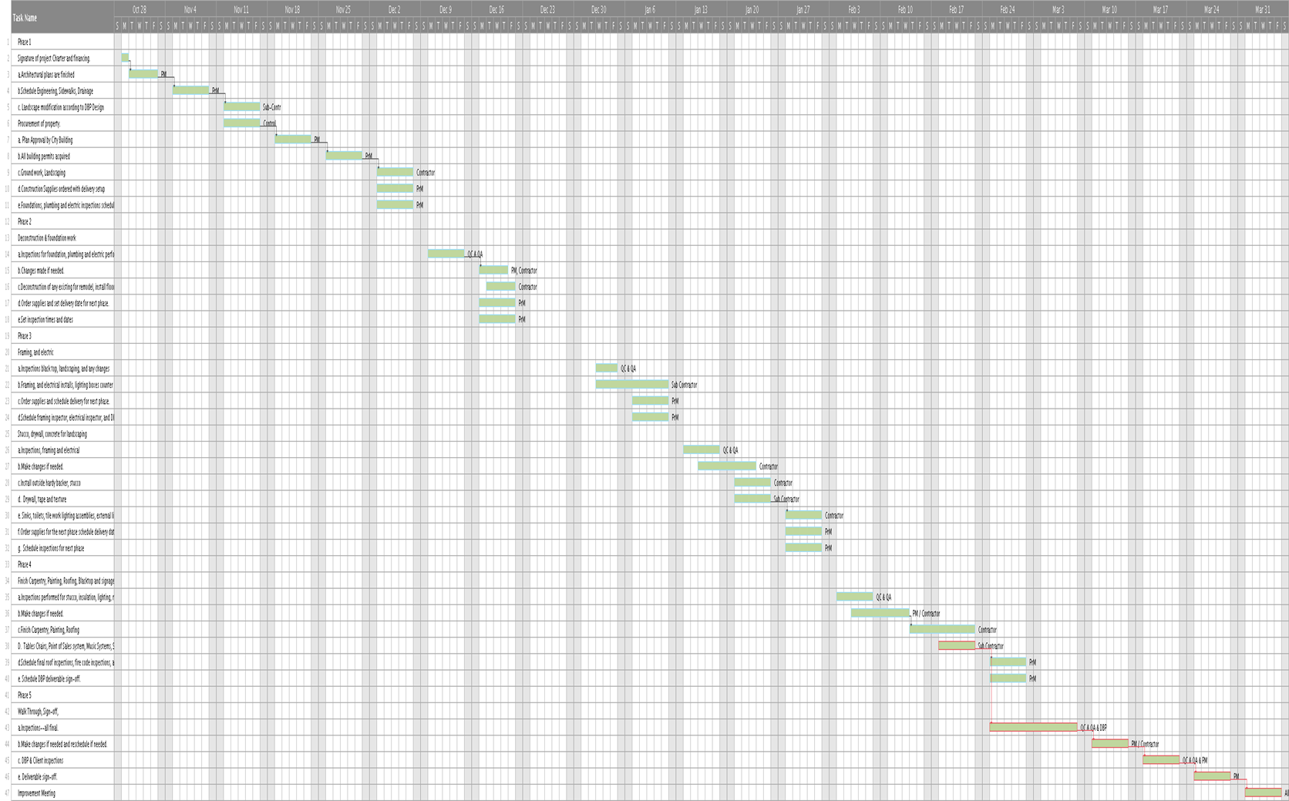



Appendix 8: Project Quality Management Plan (PQMP)



**Dutch Brothers Plus** Tel: 530-315-4839

|  |  |  |  |
| --- | --- | --- | --- |
|  |  |  |  |
| Oct 05, 2018 |  |  | 800 |

Jeffery Morse, PM

Dutch Brothers Plus



*Dutch Brothers Plus Building Plan*

Project Quality Management Plan (PQMP) 

The project quality management plan is a component of the project management plan that describes how the organization's quality policies will be implemented.

It describes how the project management team plans to meet the quality requirements set for the project.

### REVISIONS AND DISTRIBUTION

|  |  |  |  |  |  |  |  |  |  |  |  |  |  |
| --- | --- | --- | --- | --- | --- | --- | --- | --- | --- | --- | --- | --- | --- |
| **Revision** | **Release date** | **Distributed to\*** | | | | | | | | | | | |
| Client | Consultant | Main office(s) | Project Manager | Procurement Manager | Quality Manager | Costs Manager | Building and Planning | Contractor | Sub-contractors | Suppliers |  |
| Rev. 0 (draft) | 29/10/2013 |  |  |  |  |  |  |  |  |  |  |  |  |
|  |  |  |  |  |  |  |  |  |  |  |  |  |  |
|  |  |  |  |  |  |  |  |  |  |  |  |  |  |
|  |  |  |  |  |  |  |  |  |  |  |  |  |  |
|  |  |  |  |  |  |  |  |  |  |  |  |  |  |
|  |  |  |  |  |  |  |  |  |  |  |  |  |  |
|  |  |  |  |  |  |  |  |  |  |  |  |  |  |
|  |  |  |  |  |  |  |  |  |  |  |  |  |  |
|  |  |  |  |  |  |  |  |  |  |  |  |  |  |
|  |  |  |  |  |  |  |  |  |  |  |  |  |  |

*) Detailed distribution lists shall be prepared for each distribution event. Further details as per the project communication plan



#### Amendments

The Project Quality Management Plan (PQMP) may require updates. Any amendment to this plan shall be informed to the change control board by use of the change request form and approved by the project change control board before distribution. Only revised parts of the plan will be distributed along with the approval and shall be accompanied by instructions on how to implement the changes.

The initial page numbering system will be a normal continuous numbering displayed in the lower right corner of each page. If pages must be added, characters shall be added to the number. In case entire pages are deleted, the corresponding page shall be replaced by a blank page stating, “page removed.”

Each added/changed page shall have the revision number and date of approval displayed on the bottom of the page.

### PROJECT SPONSOR APPROVAL

|  |  |  |
| --- | --- | --- |
| **Prepared by:** | **Reviewed by:** | **Approved by Proj. Sponsor:** |
| HQ, 05/10/2018 | Place, dd/mm/yyyy | Place, dd/mm/yyyy |
|  |  |  |
| Jeffery Morse, PM  Designation | Name  Designation | Name  Designation |

**TABLE OF CONTENTS**

Revisions and Distribution................................................................................................................. II

Amendments ................................................................................................................................. II

Project Sponsor Approval ................................................................................................................. III

Quality Management Approach ........................................................................................................ 1

Objective ....................................................................................................................................... 1

Basic Processes of Quality Management ....................................................................................... 1

Tools and Techniques to be applied .............................................................................................. 1

General Approach .......................................................................................................................... 1

Laws, Regulations, and Guidelines ................................................................................................. 2

Other Project Plans ........................................................................................................................ 2

Project Scope of Works (Brief Description) ....................................................................................... 3

Organization and Staffing .................................................................................................................. 4

Organization Chart ........................................................................................................................ 4

Quality Metrics .................................................................................................................................. 5 

Quality Assurance ..............................................................................................................................8

General Inspection Sequence............................................................................................................ 9

Quality Control .................................................................................................................................11

Preparatory QC Meeting ............................................................................................................. 11

Initial QC Inspection .................................................................................................................... 11

Follow-Up QC Inspection ............................................................................................................. 11

Final Inspection ........................................................................................................................... 12

Client Absence during Inspections .............................................................................................. 12

Record Keeping ........................................................................................................................... 12

Document Submission ................................................................................................................. 12

Inspection Procedures ..................................................................................................................... 13

Material Receiving Inspection ..................................................................................................... 13

Material Storage Inspection ........................................................................................................ 13

Off-Site Inspection ....................................................................................................................... 13

Workmanship Inspection ............................................................................................................ 13 Equipment and Plant Inspections ............................................................................................... 14

Management and Services Review ............................................................................................. 14

Submittal Procedure ....................................................................................................................... 14

Submittal Types ........................................................................................................................... 14

“Approval” Submittals ................................................................................................................. 14

“Review” Submittals .................................................................................................................... 14

“Information” Submittals ............................................................................................................ 14

Typical Material and Vendor Submittal Document ................................................................ 14

Submittal Registration ................................................................................................................. 15

Submittal Review ......................................................................................................................... 15

Submittal Approval ...................................................................................................................... 15

Approval Stamp ........................................................................................................................... 17

Request for Information .............................................................................................................. 18

Deficiency Procedure ...................................................................................................................... 20

Preventive Measures ................................................................................................................... 20

Continuous Improvement ........................................................................................................... 20 

Non-Conformance Report (NCR) ................................................................................................. 20

Site Observation Report (SOR) .................................................................................................... 21

Corrective Action System ............................................................................................................ 21

Project Records and Project Documentation .................................................................................. 22

Filing System ................................................................................................................................ 22

Filing Scheme ............................................................................................................................... 22

Data Backup................................................................................................................................. 23

Testing ............................................................................................................................................. 24

General Testing Procedure .......................................................................................................... 23

3rd Party Testing ......................................................................................................................... 23

Test Results ................................................................................................................................. 23

Test and other Equipment Calibration and Maintenance .......................................................... 23

QA & QC Meetings .......................................................................................................................... 23

Mutual Understanding Meeting .................................................................................................. 23

Preparatory QC Meeting ............................................................................................................. 23 Weekly Meeting .......................................................................................................................... 23

Approval of Deliverables ................................................................................................................. 23

Definitions ....................................................................................................................................... 24

Acronyms and Abbreviations .......................................................................................................... 25

Appendices ...................................................................................................................................... 26

Attachments: ............................................................................................................................... 26 

Checklists: .................................................................................................................................... 26

Forms: .......................................................................................................................................... 26

Registers: ..................................................................................................................................... 26

Records: ....................................................................................................................................... 26

# QUALITY MANAGEMENT APPROACH

Quality management under this document is defined as a system of planned activities that ensures that the deliverables of the DBP-Store sub-project that meet or exceed the client requirements, specifications and potentials. The system includes inspections, verifications, and evaluations of materials and artistry required to essay the quality of the deliverables.

This quality management plan in conjunction with the other project plans identifies the necessary personnel involved in the quality team and their responsibilities.



## Objective

The objective of this project quality management plan is to ensure that the DBP-Store sub-project is delivered by the contractual specifications, to satisfy stakeholder requirements, to reduce the cost of quality (namely cost of re-works, code violation, unnecessary maintenance and repair costs) and to complete the project within the contractual baselines.



## Basic Processes of Quality Management

* Plan quality management,
* Control quality, 
* Perform quality assurance.



## Tools and Techniques to be applied

* Field monitoring,
* Inspecting,
* Testing,
* Reporting,
* Reviewing technical data,
* Detect defects while documenting necessary repairs,



## General Approach

Quality management shall focus on both **product quality** and **project quality**

**Product** quality is the quality of deliverables and focuses on product specifications, code requirements, and aesthetic requirements.

**Project** quality more is concerned with the product is delivered. It focuses more on the production processes, planning, etc.

The quality system, in general, shall follow the **Plan – Do – Check – Act** approach.



## Laws, Regulations, and Guidelines

Strict adherence to this plan in no way absolves any party from any obligations or responsibilities under applicable laws and regulations.

The laws and regulations applicable to this project and relevant to quality management are defined in the contract and include:

* Contracting law,
* California Construction Standard,
* Regulations by County and City Building and Planning, OSHA, and DBP Quality Management.



## Other Project Plans

This project quality management plan forms part of the overall project management plan. Further project plans to be read in conjunction with this project quality management plan are:

a) Project Management Plan,

1. Project Scope Management Plan,
2. Work Structure Breakdown Management Plan,
3. Change Management Plan,
4. Project Cost Management Plan,
5. *(This Project Quality Management Plan)*,
6. Project Human Resource Management Plan,
7. Schedule Management Plan,
8. Project Communications Management Plan*,*
9. Project Risk Management Plan,
10. Project Procurement Management Plan,
11. Project Stakeholder Management Plan,

# PROJECT SCOPE OF WORKS (BRIEF DESCRIPTION)

The overall project scope of works is defined in the scope of works documentation (SOW) and consists of:

* One set of approved plans and schematics, and all permits required.
* One remodeled storefront with the kiosk, parking, and signage.



The project and its site facilities are located at:

To be determined

# ORGANIZATION AND STAFFING



## Organization Chart

The organization chart is a supplemental chart for the overall project organization chart as depicted in the project human resource management plan.

The quality department shall be organized in sub-divisions, and their main roles shall be distributed as abstracted below: 

|  |  |  |
| --- | --- | --- |
| **Quality Assurance & Quality Control Management** | | |
| QA & QC Manager   * Plans the project quality management * Directs and manages the activities of the department * Coordinates activities with other disciplines * Reviews the outputs of the departments * Proposes and implements process improvements where advisable | | |
| **Quality Control: Everyone, PQM** | **Quality Assurance Everyone, PQM** | **Document Control: Control Board** |
| QC staff   * Inspects Phase for Code adherence * Verifies compliance with methodologies and appropriate working conditions | QA staff   * Reviews material submittals and method statements * Verifies compliance with quality   criteria   * Evaluates inspection records * Identifies training needs including supplier and sub-contr. personnel * Evaluates project records * Audits project procedures | DC staff   * Updates project records and   registers   * Compiles the quality file * Receives and registers relevant documents from other departments etc. * Distributes documents to other departments |

For more detailed descriptions of the roles and responsibilities refer to the corresponding section in the human resource management plan.

|  |  |  |  |  |  |  |  |  |  |  |  |  |  |  |  |  |  |  |  |  |  |  |  |  |  |  |  |  |  |  |  |  |  |  |  |  |  |  |  |  |  |  |  |  |  |  |  |  |  |  |  |  |  |  |  |  |  |  |  |  |  |  |  |  |  |  |  |  |  |  |  |  |  |  |  |  |  |  |  |  |  |  |  |  |  |  |  |  |  |  |  |  |  |  |  |  |  |  |  |  |  |  |  |  |  |  |  |
| --- | --- | --- | --- | --- | --- | --- | --- | --- | --- | --- | --- | --- | --- | --- | --- | --- | --- | --- | --- | --- | --- | --- | --- | --- | --- | --- | --- | --- | --- | --- | --- | --- | --- | --- | --- | --- | --- | --- | --- | --- | --- | --- | --- | --- | --- | --- | --- | --- | --- | --- | --- | --- | --- | --- | --- | --- | --- | --- | --- | --- | --- | --- | --- | --- | --- | --- | --- | --- | --- | --- | --- | --- | --- | --- | --- | --- | --- | --- | --- | --- | --- | --- | --- | --- | --- | --- | --- | --- | --- | --- | --- | --- | --- | --- | --- | --- | --- | --- | --- | --- | --- | --- | --- | --- | --- | --- | --- |
| **QUALITY METRICS**  The applicable quality metrics are defined in the contract, relevant laws and regulations and through requirements management.   |  |  |  |  |  |  |  | | --- | --- | --- | --- | --- | --- | --- | | **ID** | **Item** | **Standard Value** | **UOM** | **Measurement method** | **Acceptable Tolerance** | | | upper | lower | | 0001 | Plans | Approved by city planning and building |  | approval |  |  | | 0002 | Const. | Building Inspector, DBP Inspector, Codes |  | approval |  |  | | 0003 | Deliver | DBP, Project Management Team |  | approval |  |  | |  |  |  |  |  |  |  | |  |  |  |  |  |  |  | |  |  |  |  |  |  |  | |  |  |  |  |  |  |  | |  |  |  |  |  |  |  | |  |  |  |  |  |  |  | |  |  |  |  |  |  |  | |  |  |  |  |  |  |  | |  |  |  |  |  |  |  | |  |  |  |  |  |  |  | |  |  |  |  |  |  |  |   Jeffery Morse, PM 900 P a g e | 5 |

# QUALITY ASSURANCE

Quality assurance (QA) is the actions that ensure quality both in the processes which develop products as well as the products themselves. The focus of QA is the lower production costs through limiting mistakes.

By tracking compliance cost efficiency is maintained.

The key aim of QA is to avoid repetition of earlier issues while innovation of processes.

The targets are: 

1. Increase awareness of processes that could improve organizational proficiencies.
2. Identify what needs improvement.
3. Facilitate communications to allow stakeholders in sharing experiences and innovations from inside and outside their functional boundaries.
4. Continuous improvement objectives.

It is the aim of this plan to determine process errors, whether potential or existing and take corrective action. For further details, please read the “Process Improvement Plan.”



# QUALITY CONTROL

Quality control (QC) are the actions that ensure the quality of the products themselves. The focus of QC is to adhere to the Quality assigned by the Building Codes for the city of Marysville, in Yuba County, in the state of California. QC inspectors are not employees of DBP but our a city, county, and state employees. However, the PQM for DBP is also considered a QC.

.

QC Inspections shall be conducted as a three-phase control process such as

|  |  |
| --- | --- |
| Prior | **Plans Approved by Building** |
| stage | **1. Initial inspection** |
| Production stage | **2. Follow-up inspections** |
| **3. Final inspections** |

Inspections shall be carried out for each item whether produced by the DBP a contractor or a sub-contractor. Each single control phase is vital for achieving the mandatory grade of quality. Preparatory meetings and initial inspections are of great importance for making provision against re-works, failures, costs, and delays.



## Initial QC Inspection

Initial QC Inspection(s) shall be carried out by the QC staffs before any work item has been produced. The QC staff will validate compliance with specifications, procedures and workmanship.

If the case that building and planning inspectors are not available, and where their approval is not needed for advancement the DBP PQM will perform the duties of the QC inspector.

Any differences of opinion in the interpretation of requirements are settled with priority to the county, city, and state personnel where such items interfere with approval. For those items that do not brake Building Code standards, DBP QC will have priority.

Inspections are scheduled in advance. If a product or intermediate product is not ready “Inspection Reschedule Request” (form 1) shall be passed to the Control Board through the PM or his representative, and a copy of the schedule checklist shall be attached to it.



## Follow-Up QC Inspection

Follow-up QC inspection is an inspection to ensure compliance with a modification deemed necessary by the QC and will be performed as soon as possible after modifications are made. Follow - up inspections are also those inspections performed at the end of each phase.

Follow-up QC Inspection(s) are performed by the QC staff. These are done regularly during a production phase.



## Final Inspection

Upon completion of the whole of works, a pre-final inspection shall be carried out by the DBP QC staffs and the client or his representative.

The purpose of this inspection shall be to confirm the quality of the final deliverables.

Outstanding and non-conforming items will be identified and recorded on a punch-list. As each item is closed out, it will be documented. When all items recorded during the pre-final inspection have been corrected the final inspection should be scheduled.



## Client Absence during Inspections

If the client or his representative does not attend inspection(s), the inspection result(s) recorded by QC staffs shall be deemed binding and shall be passed on to the client or his representative “for information.” 



## Record Keeping

All documents and forms shall be passed to the Control Board (CB).

The CB registers the documents and distributes them to the respective departments and people.

The DBP-QC staff furthermore shall maintain “Daily Activity Records.” Those records shall summarize all QC operations including activities, tests performed, inspections, and modifications carried out for every single day during the project life cycle. All records shall be passed to QA staffs for review.



## Document Submission

All documents that are intended for the client or his representative shall be delivered to their respective office address by hand or postal service in addition to any electronic mail sent. The client or his representative may deliver documents to the Project Team in a similar way.

All documents addressed to subcontractors, or any other parties who have an office on site or nearby will be deposited for daily collection from the CB Document Control area.

For further details refer to the Communication Management Plan. 

# INSPECTION PROCEDURES

## Material Receiving Inspection

DBP QC staff as early as possible but latest one workday after delivery shall inspect all construction materials before use.

To plan and arrange timely material inspections, the Procurement Manager will update the delivery schedule continuously.

Inspection criteria include particularly

* Material identification and documentation, Delivery notes, Test results, Vendor certifications, Certificates of Origin.
* Signs of damage, Reparable, Non-reparable,
* Completeness,
* Compliance with specifications.

Results of the material receiving inspections shall be documented in the “Material Receiving Register” (register 4).

Any identified discrepancy must be resolved before re-inspection; otherwise, if rectification is not possible, the supplier shall remove the un-approved material immediately.

The Storekeeper will tag newly delivered material highly visible as “Uninspected - Don’t Use.” Only after the inspection is passed an inspection result is verified, the tag shall be removed, and material can be used.



## Material Storage Inspection

QC staff shall continuously watch over and inspect on a weekly basis the storage and handling of all construction materials. Inspection criteria particularly include storage and handling of the material by manufacturer's recommendations as guidelines.



## Off-Site Inspection

If required material sources and fabrication facilities shall be inspected by QC staff to control that specifications are followed, and requirements are implemented. Thus, the delivery of unacceptable materials or intermediate products at the site shall be avoided.



## Workmanship Inspection

QC staff will periodically inspect and verify artistry to ensure that installation, fabrication or whatsoever is executed in line with the specifications and requirements. This inspection is particularly important on work items which cannot be rectified later or reworks would become very difficult and cost intensive. 

Workmanship Inspection includes both on-site and off-site.



## Equipment and Plant Inspections

All devices, equipment, machines, and plants requiring periodical calibration shall be inspected by QC staffs and OSHA.

1. When made available at the site it shall be inventoried in the “Inventory Register” (register 5).
2. Calibration and maintenance shall be monitored and controlled and logged regularly.
3. All unsuitable items shall be Red Tagged and repaired, maintained, calibrated or whatsoever and re-inspected before use.



## Management and Services Review

The QA manager will periodically review compliance with established processes and procedures. This inspection shall include both the contractor and sub-contractor(s).

(Please refer to the Process Improvement Plan)

# SUBMITTAL PROCEDURE

Submittals shall be prepared for any type of material or intermediate product intended for permanent use, installation or whatsoever and thereby becoming part of the ready product, regardless whether the item is produced on-site or off-site and regardless whether it is produced by the contractor, sub-contractor, any supplier or fabricator, etc.



## Submittal Types

## “Approval” Submittals

“Approval” submittals are the type of submittal for conventional consideration. Examples of “approval” submittals include (but are not limited to) manufacturer’s product data, catalog cuts, shop drawings, samples, etc.. In accepting an approval submittal, it is confirmed that the details of the ready product, finishes, and materials are consistent with the design concept, specifications and requirements



## “Review” Submittals

“Review” submittals are the type of submittal for presenting procedures, methods, techniques or sequences before implementation. Examples include (but are not limited to) working drawings (i.e., scaffolding, shoring...), proposed equipment, production methods, safety precautions, etc.. In accepting such a submittal, it is acknowledged that the proposed method, etc. is sufficient to allow quality control and verification. Acceptance of this type of submittal does not relieve the contractor from the responsibility for ensuring that the work is performed by the terms of the contract. 



## “Information” Submittals

“Informational” submittals demonstrate that the contractor has complied with some requirements and specifications. Examples include concrete batch records, daily reports, calibration certificates, test reports, etc.. Action is not required for the contractor to proceed with the works. Although these submittals typically are not approved or rejected, they still need to be reviewed. If the provided information is determined not to comply with contractual documents, a non-conformance report may be issued.



## Typical Material and Vendor Submittal Document

Complete material or vendor submittals generally may include (but are not limited to):

* “Submittal Cover Sheet” (form 2) with o General information (reference number, date, submitter, contact details, etc.) o Date when the material will be needed at the site,

o Short material description, o Area of application, o Material source,

* Table of content,
* Corresponding plans, specifications and requirements,
* Catalogs (or catalog cuts),
* Datasheets,
* Shop drawings,
* Certifications,
* Work plans,
* QC plans and templates,
* Testing proposals,
* Diagrams, charts, and curves,
* Reference letters,
* Operating manuals, 
* Material samples,
* Company profile, Organization charts.

Submittals shall be prepared by the supplier, manufacturer, distributor or whoever supplies the material or intermediate product to the project.

Relevant information shall be highlighted.



## Submittal Registration

All submittals shall be submitted to the Document Controller for registration and further distribution to the concerned staffs or departments.



## Submittal Review

Submittals shall be reviewed by the designated QA staff. The Reviewer shall:

1. Upon receipt of a submittal prepare “Submittal Review Sheet” (form 3),
2. Record the submittal in the “Material Submission Register” (register 6),
3. Either
   1. If the submittal is insufficient for review through DC return it to the submitter for revision or
   2. Provide the submittal with minor comments and recommendations (if any) to the QA Manager.

Upon re-submission, the designated staff will

1. Update the “Submittal Review Sheet,”
2. Provide the submittal with minor comments and recommendations (if any) to the QA Manager,

The QA Manager will then propose the material to the client or his representative (engineer) and recommend comment solution (if any). For this purpose, he passes the submittal to the document controller for register update and submission.

Upon receipt of the client’s or engineer’s approval, comments, or rejection (whatever applicable)

1. The “Material Submission Register” shall be updated by the Document Controller accordingly,
2. A copy of the “Material Review Sheet” shall be returned to the submitter for his further action. 

Ideally, a submittal shall be prepared and submitted as early as possible granting at least

* Ten workdays processing time to the contractor,
* Ten workdays processing time to the client or his representative.

In cases where specifications, plans and requirements (whatever applicable) were made available late

* The processing time by the contractor shall be three workdays,
* The processing time by the client or his representative shall be three workdays.



## Submittal Approval

A submittal approval generally does not extend to the means, methods, sequences, techniques, or construction procedures. Following the review, the conventional response is to approve, approve conditionally, or reject the submittal, but only insofar as the end-result conforms to the design concept and complies with the contract documents.

Possible submittal responses are:

* Approved,
* Approved as noted,
* Revise and Resubmit, - Not Approved.



## Approval Stamp

|  |  |
| --- | --- |
| ***[Project Name]*** | |
| **ACCEPTED/APPROVED** ◻  **ACCEPTED/APPROVED AS NOTED** ◻  **REVISE AND RESUBMIT** ◻  **NOT APPROVED** ◻ | |
| Acceptance or approval of this document acknowledges only that the information being provided by the contractor conforms to the applicable requirements or specifications and the design concept of the completed project as outlined in the contract documents. Contractor solely is responsible for all matters related to fabrication, shipping, handling, storage, assembly, installation, construction (including all safety and environmental aspects of performing the works) and for coordinating the work and the means, methods, techniques, sequences, and procedures of construction to the extent that these items are not specifically addressed by the project specifications or requirements. | |
| By: _______________________ | Date: _____________________ |



## Request for Information

Any clarification of specifications and plans and requirements etc. is to be presented using the “Request for Information” (form 4). Requests must be clear and precise. The referenced plan, specification or whatsoever shall be attached and highlighted.

Requests for information shall be prepared by the enquirer as early as possible. The targeted timeframe for RFI submission is five workdays after certain information requiring clarification was made available for the first time.

RFIs shall be passed to the document controller. The DC registers the document in the “RFI Register” (register 7) and distributes it to the concerned staff respective department.

A copy of every RFI shall be passed to the QA department for the sake of process review and improvement.

RFIs must be answered as early as possible and the targeted response time generally shall not exceed five workdays. In cases where due to the severity a problem solution within this timeframe is not possible, the enquirer shall be notified through DC that the RFI is under review and further response will be given as early as possible.

RFI response shall be submitted back to the enquirer through DC. The DC updates the RFI register accordingly. 

# DEFICIENCY PROCEDURE

The primary goal of the quality program defined in this document is the prevention of nonconformances, reduction of reworks and continuous improvement of processes.

In the unfortunate event that non-conformance couldn’t be prevented any identified deficiencies shall be resolved with the approved plan and method in a timely and cost-effective manner and re-occurrence shall be avoided to its maximum extent.



## Preventive Measures

This Quality Management Plan is intended to be proactive, to reduce risks and avoid issues and deficiencies. The primer tools and techniques identified for this project to meet this target include (but are not limited to)

* Training and qualification,
* Inspections and verifications,
* Submittal management,
* Calibration and maintenance,
* … 

Overall quality shall be built in the product rather than to be inspected and rectified in the product.



## Continuous Improvement

The QC and QA manager(s) together with the project manager will review any instances where materials, components, assemblies, features of work, or completed products fail to meet the specified requirements and will take appropriate action to prevent future occurrences.

All project team and workers are encouraged to suggest improvements.

For further details refer to the “Process Improvement Plan.”



## Non-Conformance Report (NCR)

Identified executed insufficient artistry or used materials not conforming to the specifications and requirements or other non-conformities shall be documented by QC staff in a “Non-Conformance Report” (form 5) and signed by the QC manager.

The Non-Conformance Report will be passed to the document controller for registration in the

“NCR Register” (register 8) and for submission to the QA manager and to the responsible/involved/executing department(s), sub-contractor(s), supplier(s) or whatever applicable.

As a deficiency is corrected, a Corrective Action Report (CAR, form 6) shall be filled out by the executor of the subject works and shall be passed to the document controller for registration and further distribution to the QC manager or his designee.

The NCR remains open until the non-conformance satisfactory is resolved, inspected and approved by the QC manager or his designee and client or his representative (if applicable).

For the avoidance of repetition, each NCR also shall be included in the “Lessons Learned” (register 9) and shall be evaluated with regards to process improvement by the QA manager or his designee.



## Site Observation Report (SOR)

Significant deviations of any kind that can be corrected on the spot, but do not justify NCR at the discretion of the inspector are documented and communicated by Site Observation Report (form

7). 

Such deviations are promptly resolved on the spot so that the SOR is only for documentation regarding lessons learned and avoidance of future repetition.

In case of recurrence, the SOR may be a precursor to the NCR.

On the other hand, above average positive findings may also be documented in the form of a SOR to be recorded as good practice in the lessons learned.



## Corrective Action System

Identified negative quality trends such as repeated NCRs, observations, defects or whatsoever shall be documented by QA staff in a “Corrective Action Report” (form 6) and registered in the “CAR Register” (register 10).

For further details refer to the “Process Improvement Plan.”

# PROJECT RECORDS AND PROJECT DOCUMENTATION

The QA&QC manager with the assistance of all QC and QA staffs establishes and maintains through document controller the quality file which is a part of the project documentation. The purpose of this file is to maintain a complete set of all relevant documents and records. The quality file is a compilation of

* Plans,
* Reports,
* Registers and logs,
* Work orders,
* Change orders,
* Correspondences,
* As-built records,
* Certifications and
* Any other relevant records that provide information on the project.

Under no circumstances, documents of whatsoever shall be removed from the quality file, even if superseded. In such case, revisions shall be prepared and kept. 



## Filing System

The QA &QC department will file its documents (here softcopies) within the projects filing scheme.

Hard copies and electronic data shall be maintained simultaneously. Each data folder shall be represented by a corresponding box file and vice versa. The names of both box file and data folder shall be the same; their contents consequently shall be same.



## Filing Scheme

|  |  |  |  |
| --- | --- | --- | --- |
| **Level 1**  ~~Document.docx~~ | **Level 2**  ~~Document.docx~~ | **Level 3**  ~~Document.docx~~ | **Level 4** |
| **05_Quality** | **051_Initiation** | [empty] |  |
| **052_Planning** | 0521_Quality Mgmt |  |
| **053_Execution** | 0531_Quality Assurance |  |
| **054_Monitor&Control** | 0541_Quality Control |  |
| **055_Closure** | [empty] |  |

It is undisputed that further folders may be required over time to sort files in logic and manageable order.

However

1. No new folders shall be created on folder level 1 and 2, nor shall any existing folder be renamed and no data files such as, e.g. word files, excel spreadsheets, drawings, PDF-files, images or whatsoever shall be saved at this level.
2. Folders on folder level 3 shall not be renamed and no data files such as, e.g. word files, excel spreadsheets, drawings, PDF-files, images or whatsoever shall be saved at this level. On level 3 limited additional folders can be created upon approval by the responsible manager. 
3. Preferably additional folders only shall be created on level 4. The responsible manager must be consulted, and the filing scheme must be updated and communicated accordingly.



## Data Backup

All electronic data shall be backed up regularly.

Further details with regards to correspondences, data storage, and data integrity, etc. as well as the complete project filing scheme can be found in the Project Communication Management Plan.

# TESTING

Testing shall be performed, recorded and reported and test results shall be verified under the responsibility of QC staffs to ensure that specifications and requirements are met.

Before the first execution of a new work item testing methods and frequency of testing shall be reviewed, communicated to concerned staffs and shall be in line with applicable standards, contractual requirements, plans, approved method statements or whatever agreed upon.



## General Testing Procedure

1. Not less than 24 hrs. Prior to any testing client or his representative using “Inspection and Test Request” (form 1) shall be notified of the testing and may then at their discretion decide to attend the testing or not.
2. Before any test, the QC staff shall verify that
   1. Required equipment is available and calibrated,
   2. Testing criteria and procedure are known,
   3. Personnel is capable to perform the test and operate equipment.
3. Upon verification of requirements, the test may proceed and shall be witnessed and documented by QC staffs using a test specific form. Standard forms provided by a 3rd party testing organization (if applicable) shall be acceptable. 
4. All test results shall be
   1. Registered in the “Test Register” (register 11) and compiled in the quality file, b) Verified by QA staffs,

c) Submitted to the client or his representative (if required).

1. Any failing test result shall be recorded in the “Deficiency Register” (register 12), and the test shall be repeated as early as possible (unless otherwise agreed). Failed tests shall be subject to review with regards to process improvement.



## 3rd Party Testing

If testing by a third-party laboratory is required, whether on-site or off-site, QA staffs shall be responsible to verify 3rd party’s compliance to applicable standards and therefore shall review laboratory’s historical data such as QA & QC procedures, calibration records, logs for similar testings etc.3rd party testing organizations not being able to provide such records shall be avoided if possible. In the case of regular testing, the review may be carried out periodically.

A 3rd party testing organization shall be capable of performing a required test within two workdays (if applicable) from receipt of samples.

The QC Manager at his discretion together with a client or his representative may decide in general or case-by-case if witnessing the test by QC staff is required. Client or his representative may decide at their discretion to attend and witness the testing.

In any case, 3rd party test results shall be verified by their senior laboratory personnel.



## Test Results

Ideally, the original test record shall be submitted to the QC department within 48 hrs from the test. Advance copies of successful tests sent by fax and email shall be deemed acceptable to proceed with the works.

Once test results are received, they shall be registered and distributed by document controller and shall be verified by QC staffs as to: 

* Completeness of documents,
* Observance of the specified testing procedures, • Acceptability of results.



## Test and other Equipment Calibration and Maintenance

Test and measurement equipment shall be regularly maintained and calibrated according to the manufacturer’s specifications and recommendations. The service provider shall provide calibration and maintenance records. (To be read in conjunction with equipment and plant operating inspection procedure.)

# DEFINITIONS

For this plan and any further document developed through its use the following terms are used:

|  |  |
| --- | --- |
| **Quality Control**  **(QC)**  **Dutch Brothers Plus Quality Control**  **(DBP-QC)** | These are a city, county, and state employees that inspect for building code compliance.  The primary objective of DBP- QC is to anticipate potential risks and issues with regards to the grade of quality. The QC measures are to be adequate to cover all operations both on-site and off-site. |
| **Quality Assurance**  **(QA)** | The primary objective of QA includes verification, audits, and evaluations of the implementation of the quality control system by the contractor, its sub-contractors and suppliers. |
| **May** | means an optional action |
| **Shall** | means a mandatory action |
|  |  |
|  |  |
|  |  |

# ACRONYMS AND ABBREVIATIONS

CAR .............................. Corrective Action Report

COO ............................. Certificate of Origin

DC ................................ Document Control(ler)

Insp. ............................. Inspection

IR .................................. Inspection Register 

ITR ................................ Inspection and Test Request

NCR .............................. Non-Conformance Report

PQMP ........................... Project Quality Management Plan

QA ................................ Quality Assurance

QC ................................ County Building Inspectors

DBP-QC .........................Dutch Brothers Plus Quality Control

QMP ............................. Quality Management Plan

RFI ................................ Request For Information

|  |  |
| --- | --- |
| **APPENDICES** |  |
| Attachments:  Attachment 1 | Project Site Layout Plan |
| Attachment 2 | Organizational Chart QA & QC dept. |
| Checklists:  Checklist 1 | Preparatory Meeting Checklist |
| Checklist 2 | Initial Inspection Checklist |
| Checklist 3 | Follow-up Inspection Checklist |
| Forms:  Form 1 | Inspection and Test Request |
| Form 2 | Submittal Cover Sheet |
| Form 3 | Submittal Review Sheet |
| Form 4 | Request For Information |
| Form 5 | Non-Conformance Report |
| Form 6 | Corrective Action Report |
| Form 7 | Site Observation Report |
| Registers:  Register 1 | Inspection Register |
| Register 2 | Completion Inspection Register |
| Register 3 | Material Receiving Register |
| Register 4 | Inventory Register |
| Register 5 | Material Submission Register |
| Register 6 | RFI Register |
| Register 7 | NCR Register |
| Register 8 | Lessons Learned Register |
| Register 9 | CAR Register |
| Register 10 | Test Register |
| Register 11 Deficiency Register | |

## Records:

Record 1 Daily Activity Records 

Appendix 9: Project Risk Management Plan



**Dutch Brothers Plus** Tel: 530-315-4839

|  |  |  |  |
| --- | --- | --- | --- |
|  |  |  |  |
| Oct 06, 2018 |  |  | 900 |

Jeffery Morse, PM

Dutch Brothers Plus



*Dutch Brothers Plus Building Plan*

Project Risk Management Plan

The project risk management plan is the part of the project management plan that defines how risk management activities will be structured and completed.

### REVISIONS AND DISTRIBUTION

|  |  |  |  |  |  |  |  |  |  |  |  |  |  |
| --- | --- | --- | --- | --- | --- | --- | --- | --- | --- | --- | --- | --- | --- |
| **Revision** | **Release date** | **Distributed to\*** | | | | | | | | | | | |
| Client | Consultant | Main office(s) | Project Manager | Procurement Manager | Quality Manager | Costs Manager | Building and Planning | Contractor | Sub-contractors | Suppliers |  |
| Rev. 0 (draft) | 29/10/2013 |  |  |  |  |  |  |  |  |  |  |  |  |
|  |  |  |  |  |  |  |  |  |  |  |  |  |  |
|  |  |  |  |  |  |  |  |  |  |  |  |  |  |
|  |  |  |  |  |  |  |  |  |  |  |  |  |  |
|  |  |  |  |  |  |  |  |  |  |  |  |  |  |
|  |  |  |  |  |  |  |  |  |  |  |  |  |  |
|  |  |  |  |  |  |  |  |  |  |  |  |  |  |
|  |  |  |  |  |  |  |  |  |  |  |  |  |  |
|  |  |  |  |  |  |  |  |  |  |  |  |  |  |
|  |  |  |  |  |  |  |  |  |  |  |  |  |  |

*) Detailed distribution lists shall be prepared for each distribution event. Further details as per the project communication plan



#### Amendments

The Project Risk Management Plan may require updates. Any amendment to this plan shall be informed to the change control board by use of the change request form and approved by the project change control board before distribution. Only revised parts of the plan will be distributed along with the approval and shall be accompanied by instructions on how to implement the changes.

The initial page numbering system (to be added upon initial approval) will be a normal continuous numbering displayed in the lower right corner of each page. If pages must be added, characters shall be added to the number. In case entire pages are deleted, the corresponding page shall be replaced by a blank page stating, “page removed.”

Each added/changed page shall have the revision number and date of approval displayed on the bottom of the page.

### PROJECT SPONSOR APPROVAL

|  |  |  |
| --- | --- | --- |
| **Prepared by:** | **Reviewed by:** | **Approved by Proj. Sponsor:** |
| HQ, 06/10/2018 | Place, dd/mm/yyyy | Place, dd/mm/yyyy |
|  |  |  |
| Jeffery Morse, PM  Designation | Name  Designation | Name  Designation |

**TABLE OF CONTENTS**

Revisions and Distribution....................................................................................................................... II

Amendments .................................................................................................................................. II

Project Sponsor Approval ...................................................................................................................... III

Risk Management Approach 1

Methodology 1

Roles and Responsibilities 1

Budgeting 1

Timing 1

Risk Categories 2

Risk Probability and Impact 2

Definition 2

Stakeholder Tolerances 2

Reporting Formats 2

Tracking 2

Attachments: 2

Probability and Impact Matrix 3

# RISK MANAGEMENT APPROACH

Risk management will be conducted throughout the subproject. First, through TQM the quality of work performed will be closely monitored. Secondly, the risk will be addressed by initial inspections and on-going inspections of documents, work, and deliverables. There will be three levels of inspection 1. Quality Control (QC) are building inspectors employed by the city, county, and state to ensure compliance with city, county, and state building codes. These inspectors will have initial, follow-up, and final inspections. 2. Dutch Brothers Plus Quality Control (DBP-QC). These are inspectors employed by DBP-Store sub-project that inspect all procurements, deliverables, work standards, DBP quality requirements, and machinery to make sure orders and complete and of good quality, work standards meet quality assurance and safety standards, and machinery is in good safe operating condition. Finally, the PQM will function as the QA representative for the Control Board. QA will be watching to make sure quality is not lowered, costs are maintained, and deliverables are presented as scheduled. Lastly, the worksite is inspected by OSHA on a random basis.

# METHODOLOGY

Please refer to the Quality Management Plan for all paperwork about quality and submissions of non-compliant items. Please refer to the Scheduling Management Plan for scheduling of all inspections.

# ROLES AND RESPONSIBILITIES

Project Manager (PM), Procurement Manager (PrM), Quality Manager(QM), and Costs Manager(CM) for this sub-project all play a role in risk management. Costs Manager is responsible for overseeing possible threats to Cost and Scope Creep. The Quality Manager is the DBP-QC and is required to ensure the quality of all items. The PrM is responsible for on-time deliveries of supplies, as well as scheduling all inspections. The sub-project PM report to the PM of the main project and the Control Board on Scheduling, Costs, Quality, and Modifications of any type that may be considered a risk to either scope, quality, time, or costs.

**BUDGETING**

The estimated Budget for this subproject is $250,000. For further information concerning the budget, please refer to the Costs Management Plan.

# TIMING

Contingency protocols for the application of schedule contingency reserves and establish risk. 1. If there is no storefront to remodel at the suggested site for DBP and cost/benefit analysis must be performed to report the likely hood of construction cost overrun for new construction of both the storefront and the kiosk. The lost of the kiosk is acceptable but not desired for the project to remain in budget.

# RISK CATEGORIES

Risks to Costs

Injury, re-work, inferior parts.

Risks to Quality

Inferior parts, non-compliance to codes and quality standards to save time, contractor or sub-contractor non-compliance to codes and quality standards to save time and money, lack of vision.

Risks to Scheduling Completion

Re-working due to code compliance failure, failure of timely supply deliveries, failure to schedule inspection correctly, staff sickness and injury, improper equipment upkeep.

# RISK PROBABILITY AND IMPACT



## Definition

The quality and credibility of the risk analysis require that different levels of risk probability and impact be defined that are specific to the project context.

# STAKEHOLDER TOLERANCES

No tolerances on quality.

Costs 10% tolerance on total estimated costs.

Time there is a five-day tolerance on the deadline.

# REPORTING FORMATS

Reporting of the risk management process will be documented, analyzed, and communicated. If these communique’s are digital hard copies must be filled with Document Control. All verbal communique’s must be backed up in writing and filled with Document Control.

# TRACKING

Tracking documents how risk activities will be recorded for the benefit of the current project and how risk management processes will be audited by the DBP-QC, QA, and the Control Board or CB representative.

## Probability and Impact Matrix

|  |  |  |  |  |  |  |
| --- | --- | --- | --- | --- | --- | --- |
|  |  |  |  |  |  |  |
|  |  |  |  |  |  |
|  |  |  |  |  |  |
|  |  |  |  |  |  |
|  |  |  |  |  |  |
|  | **Very low** | **Low** | **Medium** | **High** | **Very high** |
|  |  |  |  | **Impact** |  |  |

# 

# ATTACHMENTS:

|  |  |
| --- | --- |
| Attachment 1 |  |
| Attachment 2 |  |

Appendix 10: Project Human-Resource Management Plan



**Dutch Brothers Plus** Tel: 530-315-4839

|  |  |  |  |
| --- | --- | --- | --- |
|  |  |  |  |
| Oct 06, 2018 |  |  | 1100 |

Jeffery Morse, PM

Dutch Brothers Plus



*Dutch Brothers Plus Building Plan*

Project Human-Resource Management Plan 

The Project Human-Resource Management Plan is a component of the Project Management Plan that describes how the roles and responsibilities, reporting relationships, and staff management will be addressed and structured.

### REVISIONS AND DISTRIBUTION

|  |  |  |  |  |  |  |  |  |  |  |  |  |  |
| --- | --- | --- | --- | --- | --- | --- | --- | --- | --- | --- | --- | --- | --- |
| **Revision** | **Release date** | **Distributed to\*** | | | | | | | | | | | |
| Client | Consultant | Main office(s) | Project Manager | Procurement Manager | Quality Manager | Costs Manager | Building and Planning | Contractor | Sub-contractors | Suppliers |  |
| Rev. 0 (draft) | 29/10/2013 |  |  |  |  |  |  |  |  |  |  |  |  |
|  |  |  |  |  |  |  |  |  |  |  |  |  |  |
|  |  |  |  |  |  |  |  |  |  |  |  |  |  |
|  |  |  |  |  |  |  |  |  |  |  |  |  |  |
|  |  |  |  |  |  |  |  |  |  |  |  |  |  |
|  |  |  |  |  |  |  |  |  |  |  |  |  |  |
|  |  |  |  |  |  |  |  |  |  |  |  |  |  |
|  |  |  |  |  |  |  |  |  |  |  |  |  |  |
|  |  |  |  |  |  |  |  |  |  |  |  |  |  |
|  |  |  |  |  |  |  |  |  |  |  |  |  |  |

*) Detailed distribution lists shall be prepared for each distribution event. Further details as per the project communication plan



#### Amendments

The Project Human-Resource Management Plan may require updates. Any amendment to this plan shall be informed to the change control board by use of the change request form and approved by the project change control board before distribution. Only revised parts of the plan will be distributed along with the approval and shall be accompanied by instructions on how to implement the changes.

The initial page numbering system will be a normal continuous numbering displayed in the lower right corner of each page. If pages must be added, characters shall be added to the number. In case entire pages are deleted, the corresponding page shall be replaced by a blank page stating, “page removed.”

Each added/changed page shall have the revision number and date of approval displayed on the bottom of the page. 

### PROJECT SPONSOR APPROVAL

|  |  |  |
| --- | --- | --- |
| **Prepared by:** | **Reviewed by:** | **Approved byProj. Sponsor:** |
| HQ, 03/10/2018 | Place, dd/mm/yyyy | Place, dd/mm/yyyy |
|  |  |  |
| Jeffery Morse, PM  Designation | Name  Designation | Name  Designation |

**TABLE OF CONTENTS**

Revisions and Distribution ............................................................................................................................. II

Amendments ................................................................................................................................................. II

Project Sponsor Approval .............................................................................................................................. III 

Objective ............................................................................................................................................ 1

HR Requirements in Overview ........................................................................................................................ 2

Blank ................................................................................................................................................................ 3

Blank ................................................................................................................................................................ 4

Description of Roles & Responsibilities…………………………………………………………………….. 5

Project Manager………..………………………………………………………………………`……………. 5

QA & QC Manager…………………………………………….……………………………… ……………. 6

QC Inspector (on-site)..………………………………………………………………………………………. 7

QC Inspector (off-site)…………………….…………………………………………………………………. 7

QA Eng…………………………………………..…………………………………………………………… 8

QA Eng. (submittal review)……………………………………………..……………………………………. 8

Document Controller………………………………………………………………………………………….. 8

Responsibility Assign Matrix (RAM)…………………………………………………………………………… 9

Staffing management…………………………………………………………………………………………… 10

Staff Acquisition………………………………………………………………….………………………….. 10

Resource Calendar……………………………………………………………………………………………. 10

Training……………………………………………………………………………………………………….. 10

Performance Review…………………………………………………………………………….……………. 10

Recognition and Rewards………………………………………………………………………………………10

# OBJECTIVE

People with the right skills and experiences are needed for the successful completion of the sub-project. The intention of the HR Management Plan is to identify and define the necessary positions for the success of the project. Missing or incorrect personnel will result in significant risk for the project's success. Please refer to the Project Risk Management Plan.



#### Other Project Plans

This project communication management plan forms part of the overall project management plan. Further project plans to be read in conjunction with this project quality management plan are:

1. Project Management Plan,
2. this Project Scope Management Plan,
3. Project Change Management Plan,
4. Project Schedule Management Plan,
5. Project Cost Management Plan,
6. Project Quality Management Plan,
7. (*This Project Human Resource Management Plan*),
8. Project Communication Management Plan,
9. Project Risk Management Plan,
10. Project Procurement Management Plan,
11. Project Stakeholder Management Plan,
12. Project Financial Management Plan,

|  |  |  |  |  |  |  |  |  |  |  |  |  |  |  |  |  |  |  |  |  |  |  |  |  |  |  |  |  |  |  |  |  |  |  |  |  |  |  |  |  |  |  |  |  |  |  |  |  |  |  |  |  |  |  |  |  |  |  |  |  |  |  |  |  |  |  |  |  |  |  |  |  |  |  |  |  |  |  |  |  |  |  |  |  |  |  |  |  |  |  |  |  |  |  |  |  |  |  |  |  |  |  |  |  |  |  |  |  |  |  |  |  |  |  |  |  |  |  |  |  |  |  |  |  |  |  |  |  |
| --- | --- | --- | --- | --- | --- | --- | --- | --- | --- | --- | --- | --- | --- | --- | --- | --- | --- | --- | --- | --- | --- | --- | --- | --- | --- | --- | --- | --- | --- | --- | --- | --- | --- | --- | --- | --- | --- | --- | --- | --- | --- | --- | --- | --- | --- | --- | --- | --- | --- | --- | --- | --- | --- | --- | --- | --- | --- | --- | --- | --- | --- | --- | --- | --- | --- | --- | --- | --- | --- | --- | --- | --- | --- | --- | --- | --- | --- | --- | --- | --- | --- | --- | --- | --- | --- | --- | --- | --- | --- | --- | --- | --- | --- | --- | --- | --- | --- | --- | --- | --- | --- | --- | --- | --- | --- | --- | --- | --- | --- | --- | --- | --- | --- | --- | --- | --- | --- | --- | --- | --- | --- | --- | --- | --- | --- | --- | --- | --- |
| **HR REQUIREMENTS IN OVERVIEW** A = proficient, B = well experienced, C = experienced, D = basic   |  |  |  |  |  |  |  |  |  |  |  |  | | --- | --- | --- | --- | --- | --- | --- | --- | --- | --- | --- | --- | | **SN** | **Role** | **When needed?** | **Desired Skill Level** | | | | **Actual Skill Level** | | | | **Skill Development Strategy** | | A | B | C | D | A | B | C | D | | 01 | Project Manager | Project Initiation through Project Closure | X |  |  |  |  | X |  |  | Send for PM training | | 02 | Sub Project Manager | Sub Project Initiation through Sub Project Closure | x |  |  |  |  | x |  |  |  | | 03 | Procurement Manager {PrM) | Sub Project Initiation through Sub Project Closure | x |  |  |  |  | x |  |  |  | | 04 | Costs Manager (CM) | Sub Project Initiation through Sub Project Closure | x |  |  |  | x |  |  |  |  | | 05 | Quality Manager (QM) | Sub Project Phase 1 through Sub Project Closure |  | x |  |  |  | x |  |  | Send Total Quality Management Training | | 06 | On-Site Foreman | Sub Project Phase 1 through Sub Project Closure |  | x |  |  |  | x |  |  |  | | 07 | Construction Workers 2 Journeyman | Sub Project Phase 1 through Sub Project Closure |  | x |  |  |  | x |  |  |  | | 08 | Construction Workers 4 Laborer | Sub Project Phase 1 through Sub Project Closure |  |  | x |  |  |  | x |  |  | | 09 | General Contractor | Sub Project Initiation through Sub Project Closure |  | x |  |  |  | x |  |  | G. Contractor will bring in Sub-Contractors | |
| Blank Page |

Blank Page

# DESCRIPTION OF ROLES & RESPONSIBILITIES



## Project Manager

The Project Manager (All things concerning the Main Project)

* Prepares the project management plan and revision(s) to it.
* Participates in and manages project planning activities.
* Manages, reviews, and prioritizes the project work plans with the objective to stay on time and budget.
* Provides status and progress reviews to Sponsor and receives directions.
* Manages and supervises project team.
* Brings issues to the Sponsor as needed and makes recommendations.
* Identifies required project team members and forms a project team.
* Motivates and coaches project team members.
* Monitors contract compliance.
* Manages change orders. 
* Conducts risk management analysis.
* Meets facility and resource requirements.
* Reviews deliverables.
* Communicates with the Control Board (is Representative of).
* Oversees DBP-Store Sub-Project PM



## DBP-Store Sub-Project Manager

The Sub-Project Manager (all things concerning the Sub Project Only)

* Prepares the project management plan and revision(s) to it.
* Participates in and manages project planning activities.
* Manages, reviews, and prioritizes the project work plans with the objective to stay on time and budget.
* Provides status and progress reviews to Sponsor and receives directions.
* Manages and supervises project team.
* Brings issues to the Sponsor as needed and makes recommendations.
* Identifies required project team members and forms a project team.
* Motivates and coaches project team members.
* Monitors contract compliance.
* Manages change orders. 
* Conducts risk management analysis.
* Meets facility and resource requirements.
* Reviews deliverables.
* Communicates with the Control Board (is Representative of).
* Oversees DBP-Store Sub-Project PM

## QA & QC Manager

The QA & QC Manager

* Develops the project quality management system and prepares the project quality management plan and the process improvement plan and revision(s) to it.
* Distributes the project quality management plan and relevant documentation to subcontractors and suppliers.
* Monitors the effectiveness of the project quality management system and recommends and implements improvements when required.
* Performs project audits.
* Ensures that all quality requirements are collected and informed to the concerned persons and parties.
* Directs and manages all quality related processes on the project including all inspections, testing, audits, verifications, approvals, etc..
* Verifies that production activities and deliverables or part(s) thereof are by applicable standards.
* Attends client quality management meetings.
* Chairs the regular QA & QC meetings with sub-contractors and suppliers.
* Coordinates manages and controls the compilation of the project quality file.
* Reviews project staff qualifications and determines training requirements.
* Monitors and controls the remedial action of all issued non-conformance reports and closes all client complaints related to project quality.
* Coordinates project requirements with the procurement manager.
* Coordinates all quality related correspondence with the client and the client representative.
* Archives the project documentation upon completion of the project.
* Supervises the activities of the subsidiary staffs. 



## QC Inspector (on-site is DBP-Store QC manager)

The QC Inspector at site

* Verifies the quality of material and intermediate products.
* Monitors the production of all products and intermediate products.
* Inspects during all stages of the production process.
* Verifies the quality of products and intermediate product.
* Documents inspections and tests conducted on materials, products and intermediate products.
* Maintains checklists.
* Identifies risks and issues with quality.



## QC Inspector (City, County, State Planning Dept.)

The QC Inspector off the project premises

* Verifies the quality of material and intermediate products adhere to Building Codes.
* Monitors the production of all products and intermediate products.
* Inspects during all stages of the production process.
* Verifies the quality of products and intermediate product.
* Documents inspections and tests conducted on materials, products and intermediate products.
* Maintains checklists.
* Identifies risks and issues with quality.



## QA Eng.

The QA Engineer

* Contributes to process improvement planning.
* Establishes best practices.
* Develops and implements quality assurance procedures.
* Ensures compliance to established processes and procedures.
* Participates in project auditing.
* Reviews project documents. 
* Analyzes non-compliances and recommends accordingly.
* Contributes to change control.



## QA Eng. (submittal review)

The Submittal Review Engineer

* Receives and reviews submittals from sub-contractors and suppliers and checks completeness of the document.
* Verifies that proposed materials and intermediate products are by the project requirements and specifications.
* Marks deviations and either corrects them or comments or asks for re-submission if necessary (depends on the severity of deviation).
* Updates and communicates approved material list.



## 

## Document Controller

...

# RESPONSIBILITY ASSIGN MATRIX (RAM)

|  |  |  |  |  |  |  |  |
| --- | --- | --- | --- | --- | --- | --- | --- |
| **SN** | **Task** |  | **Roles as described above** | | | | |
| **Project Mngr.** | **QA & QC Mngr.** | **...** |  |  |  |
|  | To Be Assigned |  |  |  |  |  |  |
|  |  |  |  |  |  |  |  |
|  |  |  |  |  |  |  |  |
|  |  |  |  |  |  |  |  |
|  |  |  |  |  |  |  |  |
|  |  |  |  |  |  |  |  |
|  |  |  |  |  |  |  |  |
|  |  |  |  |  |  |  |  |
|  |  |  |  |  |  |  |  |
|  |  |  |  |  |  |  |  |
|  |  |  |  |  |  |  |  |
|  |  |  |  |  |  |  |  |
|  |  |  |  |  |  |  |  |
|  |  |  |  |  |  |  |  |
|  |  |  |  |  |  |  |  |
|  |  |  |  |  |  |  |  |

**Key**: R = Responsible for completing the task

A = Accountable for ensuring task completion,

C = Consulted before any decision taken

I = Informed of taken decisions

# STAFFING MANAGEMENT



## Staff Acquisition

Resources of the Management will be selected by DBP Human Recourses.

Construction Personnel (Foreman, Journeyman, Laborers) will be selected by DBP-Store PM.

Contractors will be hired by DBP Control Board.



## Resource Calendar

All must be hired by the beginning of phase 1 construction. 



## Training

PM’s will receive PM training QM’s will receive training in Total Quality Management



## Performance Review

Performance reviews are held weekly by the DBP-Store PM.



## Recognition and Rewards

None

Appendix 11: Project Stakeholder Management Plan 

**Dutch Brothers Plus** Tel: 530-315-4839

|  |  |  |  |
| --- | --- | --- | --- |
|  |  |  |  |
| Oct 07, 2018 |  |  | 1200 |

Jeffery Morse, PM

Dutch Brothers Plus

*Dutch Brothers Plus Building Plan*

## Project Stakeholder Management Plan

The project stakeholder management plan is a component of the project management plan and identifies the management strategies required to effectively engage stakeholders. The level of details can vary based on the needs of the project.

### REVISIONS AND DISTRIBUTION

|  |  |  |  |  |  |  |  |  |  |  |  |  |  |
| --- | --- | --- | --- | --- | --- | --- | --- | --- | --- | --- | --- | --- | --- |
| **Revision** | **Release date** | **Distributed to\*** | | | | | | | | | | | |
| Client | Consultant | Main office(s) | Project Manager | Procurement Manager | Quality Manager | Costs Manager | Building and Planning | Contractor | Sub-contractors | Suppliers |  |
| Rev. 0 (draft) | 29/10/2013 |  |  |  |  |  |  |  |  |  |  |  |  |
|  |  |  |  |  |  |  |  |  |  |  |  |  |  |
|  |  |  |  |  |  |  |  |  |  |  |  |  |  |
|  |  |  |  |  |  |  |  |  |  |  |  |  |  |
|  |  |  |  |  |  |  |  |  |  |  |  |  |  |
|  |  |  |  |  |  |  |  |  |  |  |  |  |  |
|  |  |  |  |  |  |  |  |  |  |  |  |  |  |
|  |  |  |  |  |  |  |  |  |  |  |  |  |  |
|  |  |  |  |  |  |  |  |  |  |  |  |  |  |
|  |  |  |  |  |  |  |  |  |  |  |  |  |  |

*) Detailed distribution lists shall be prepared for each distribution event. Further details as per the project communication plan



#### Amendments

The Project Stakeholder Management Plan may require updates. Any amendment to this plan shall be informed to the change control board by use of the change request form and approved by the project change control board before distribution. Only revised parts of the plan will be distributed along with the approval and shall be accompanied by instructions on how to implement the changes.

The initial page numbering system will be a normal continuous numbering displayed in the lower right corner of each page. If pages must be added, characters shall be added to the number. In case entire pages are deleted, the corresponding page shall be replaced by a blank page stating, “page removed.”

Each added/changed page shall have the revision number and date of approval displayed on the bottom of the page.

### PROJECT SPONSOR APPROVAL

|  |  |  |
| --- | --- | --- |
| **Prepared by:** | **Reviewed by:** | **Approved by Proj. Sponsor:** |
| HQ, 07/10/2018 | Place, dd/mm/yyyy | Place, dd/mm/yyyy |
|  |  |  |
| Jeffery Morse, PM  Designation | Name  Designation | Name  Designation |

**TABLE OF CONTENTS**

Revisions and Distribution......................................................................................................................... II

Amendments .......................................................................................................................................... II

Project Sponsor Approval ......................................................................................................................... III

Stakeholder Management Approach .......................................................................................................... 1

Stakeholder Identification .......................................................................................................................... 1

Stakeholder Register .............................................................................................................................. 2

Blank Page ………………………………………………………..………………………………….. 3

Power/Interest Grid ................................................................................................................................ 4 

Stakeholder Management Strategies .......................................................................................................... 5

Manage closely ....................................................................................................................................... 5

Keep satisfied ......................................................................................................................................... 5

Keep informed ........................................................................................................................................ 5

Monitor ................................................................................................................................................... 5

Control Stakeholder Engagement ............................................................................................................... 6

Attachments: ............................................................................................................................................... 6

### STAKEHOLDER MANAGEMENT APPROACH

### The processes required to identify people, groups or organizations that may be impacted by the project are anyone that is either directly or indirectly impacted by the project construction phase. To develop management strategies for effectively engaging stakeholders one must first identify these stakeholders. Please note that this Stakeholder Management Plan is only concerned with the DBP-Store subproject. For the Stakeholder management plan for the entire project, please inquire with the Control Board or the Main Project PM.

### STAKEHOLDER IDENTIFICATION

Any person or business that is directly or indirectly affected by the construction of the DBP-Store. It is taken for granted that all employees, contractors, and sub-contractors are affected and there for most are not included in the list below. Also, all financial providers whether an institution or personal loan is not included. Instead, the list centers on those who may be affected concerning only the sub-project and construction phase and not the main project.

|  |  |  |  |  |  |  |  |  |  |  |  |  |  |  |  |  |  |  |  |  |  |  |  |  |  |  |  |  |  |  |  |  |  |  |  |  |  |  |  |  |  |  |  |  |  |  |  |  |  |  |  |  |  |  |  |  |  |  |  |  |  |  |  |  |  |  |  |  |  |  |  |  |  |  |  |  |  |  |  |  |  |  |  |  |  |  |  |  |
| --- | --- | --- | --- | --- | --- | --- | --- | --- | --- | --- | --- | --- | --- | --- | --- | --- | --- | --- | --- | --- | --- | --- | --- | --- | --- | --- | --- | --- | --- | --- | --- | --- | --- | --- | --- | --- | --- | --- | --- | --- | --- | --- | --- | --- | --- | --- | --- | --- | --- | --- | --- | --- | --- | --- | --- | --- | --- | --- | --- | --- | --- | --- | --- | --- | --- | --- | --- | --- | --- | --- | --- | --- | --- | --- | --- | --- | --- | --- | --- | --- | --- | --- | --- | --- | --- | --- | --- | --- |
| Stakeholder Register   |  |  |  |  |  |  |  |  | | --- | --- | --- | --- | --- | --- | --- | --- | | **Full name** | **Position** | **Role in the project** | **Contact information** | **Requirements** | **Expectations** | **Influence level** | **Power**  **level** | | *[last name, first name]* | *[Company, designation]* | *[e.g. owner, resident etc.]* | *[phone, mail]* | *[requirements 1, 2, 3]* | *[expectation 1, 2 ,3]* | *[high]* | *[supporter]* | | Owner | Full Stop | business | TBA |  | The Stores opposite the site will be affected | High |  | | Starbucks | Starbucks | business | TBA |  | The Starbucks in the College will lose customers | High |  | | City, Traffic |  | Resident | TBA |  | Traffic may be interrupted during construction |  |  | | Control Board | Management Team | Controller | TBA | On time, Good Quality, In Budget | Requires Weekly Reports | High | Supporter | | Jeffery Morse | Owner | CEO /PM | TBA | On time, Good Quality, In Budget | Daily | High | Supporter | | Yuba County | Building Inspectors | QC | TBA | County Code Adherence. | Weekly | High |  | | DBP-PCM | Project Cost Manager | DBP-PcM | TBA | Costs Schedule | Daily Reports | High | Supporter | | DBP-QM | Quality Assessment | QA-QC for DBP | TBA | Stopping overruns from re-work | Daily Reports | High | Supporter | | OSHA, DBP SM | Safety | Safety Manager | TBA | Stopping overruns due to injury. | Daily Reports | High | Supporter |   Jeffery Morse, PM 1200 P a g e | **3** |

Blank Page



#### Power/Interest Grid

|  |  |  |  |
| --- | --- | --- | --- |
|  |  | Keep satisfied | Manage closely |
|  | Monitor | Keep informed |
|  | **Low** | **high** |
| **Influence** | | | |

### STAKEHOLDER MANAGEMENT STRATEGIES

In effectively engaging the stakeholders throughout the project life cycle, the following list categorizes them based on their needs, interests, and potential impact on project success.



#### Manage closely

Safety, Quality, and all those concerned with these areas



#### Keep satisfied

County and City Planning and Building, OSHA, any Financial Institution.



#### Keep informed

Client, Control Board, all Managers, County and City Planning,



Monitor

Local business, Traffic Interruptions

### CONTROL STAKEHOLDER ENGAGEMENT

Stakeholder involvement will be monitored according to the project plan. If it is found that reporting or involvement needs adjusting due to a need for more current information or information too often adjustments will be made to satisfy any need the stakeholders genuinely need.

**ATTACHMENTS:** 

|  |  |
| --- | --- |
| Attachment 1 |  |
| Attachment 2 |  |