quantItative fluency

Jeffery Morse

Brandman University

Author Note

For correspondence concerning this paper, Jeffery Morse can be reached at

jmorse@mail.brandman.edu

I have selected study number one from the Appendix of the instructions. It is as follows:



Table 1

Case Studies for Summative Assessment Case Study #1 Flight Delays. The problem is as follows:

|  |  |  |
| --- | --- | --- |
| X | F  Table 2 | X(f) |
| 190 | 1 | 190 |
| 240 | 2 | 480 |
| 290 | 3 | 870 |
| 320 | 2 | 640 |
| 400 | 3 | 1200 |
| 540 | 4 | 2160 |
| 555 | 7 | 3885 |
| 720 | 5 | 3600 |
| 800 | 6 | 4800 |
| 820 | 7 | 5740 |
| 850 | 10 | 8500 |
| 900 | 6 | 5400 |
| 920 | 11 | 10120 |
| 950 | 8 | 7600 |
| 950 | 9 | 8550 |
| 960 | 11 | 10560 |
| 1,005 | 9 | 9045 |
| 1,090 | 16 | 17440 |
| 1,150 | 12 | 13800 |
| 1,400 | 23 | 32200 |
| 15050 | 155 | 146780 |
| 752.5 | 7.75 | 946.97 |

“As an advisor to the small regional airport, you have been asked to look into the relationship between the delay times for flights and the length of the flight overall (measured in miles). The local division of the Federal Aviation Administration (FAA) has supplied you with a simple random sample of 20 recent flight delays for your analysis. The division would also like to know if the average flight delay times for this year are higher or lower than last year’s average flight delay time of 42 minutes. “

This is an observational study, as these flights have already occurred, and further, we will be looking at data from a random sample (a parameter that is given) from the population of flights. The population is all flights, of course, this is nearly impossible to get unless we put a time period parameter on it. For instance all the flights in one year; this is not given so we do have P(Population). What is given is the sample number (n) which equals 20. These flights are measured quantitatively and discrete, as we will not be looking at any flights that are not complete. We will not be looking at any half flights or quarter flights etc. Also, each flight is Independent and mutually exclusive. Each flight is one flight, and each flight only can have one plane. The sample size is less than the needed amount for a normal distribution, the rule is the sample must be greater than 30 or be stated as a normal distribution. This has neither, as it is not stated that it is a normal distribution as we go we will have to assume it is in order to any hypothesis testing further on. By assuming this it will allow us to use the standard normal distribution bell curve. If we did not assume this now we could go no further in this study at that point. The independent variable(x) is the Length of Flights as this is the variable that is manipulated or controlled, and the dependent variable (f-frequency) is the Flight Delay, as this is the measurement we are measuring. The level of measurement is a ratio, as zero means zero, and the difference between two measurements has significance. To clarify, if a flight has 0 miles in flight, then the flight = 0 and does not exist. Also if the dependent variable (flight delay) has a value of 0 then time for delay = 0 and there is no delay. We are missing σ (standard deviation for µ), and S (standard deviation for x̄). We will have to derive “S”. We further will be using t-score test statistic as a result of the σ (standard deviation for µ) being unknown, and sample size being less than 30. The parameter of interest is the length of flight in correlation with delay times. As a result we will be looking at both.

Examination of Descriptive Statistics:

The next step is to examine the data that are provided in the case study. First off we need to make sure that there are no outliers. To do this we will make a box and whisker chart. The low-class limit is 190, and the upper-class limit is 1400. Those two areas are easily read from the data. Next, we need to find the Median or Midpoint. We must first set the data in order from smallest to greatest as seen in table 2. Since there are 20 classes the median will be the average of classes 10 and 11 which have values 820 and 850. We can use the equation for mean as that is just the average. = 835. We then find the median of Q1 and Q2 the same way. = 470 = 955. So LL = 190, Q1 =470, Q2 or Median= 835, Q3= 955, and UL=1400. We need to next find the IQR (inner quartile range) by subtracting this from our LL, and adding it to our UL we will see if any values of X are considered outliers. Q3-Q!=IQR = 955-470 = 480. Subtracting IQR from Q1 = 470-480 = -10. Adding IQR to our Q3 = IQR+Q3 = 955+480 = 1435. Our outlier range boundaries are -10 thru 1435, as we see all our values for X are well within this, so there are no outliers. Although this range is very wide, the fact that outliers are not present means our data may be more accurate. Let us also look at frequency. We may find outliers on the other side. The low-class limit is 1, and the upper-class limit is 23. Next we need the median. This means we need to align the data in ascending order according to frequency as in table 3. We can use the equation for mean as that is just the average. = 7. Next, we will plot our Box and Whiskers Chart. Q1 = = 3.5. Q3 = = 10.5. Please also note the these are multi-modal with duplicates at 2, 3,6, 7,9, and 11. The standard mean using  is listed at the bottle of table 2 column 2 and is 7.75. Using the same process as about our IQR is 14.5. Q1 – 14.5 = -11 and Q3 + 14.5 = 25. So our outlier range is -11 thru 25. There are no outliers.



Table 3

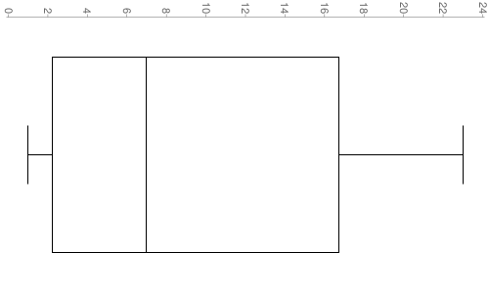

3.5

14.5

7

Sample Mean:

The mean of a sample or x-bar is what we use here as µ is mean for a Population. It is given by the equation: . Please refer to column 3 of Table 2. ∑(x(f))= 146780 ∑f=155 146780/155 = 946.97. Notice that the x-bar value is almost at Q3 and is over 100 points above the median.

Also, note that the population mean =  would be 752.5 according to our calculations. This is about center of our box, but do to the fact that we are dealing with a



752.5

946.97

sample, and further, since we do not have “P” the mean value is moved far to the right. Since the mean is greater than the median we now know this data distribution is not normal but skewed. The mode is 950 as it is the only value that is entered twice. This makes our sample unimodal. This means the distribution will be skewed. This is resulting in a low sample size and the presence of the mode at 950. Expectedly the distribution will be something other than a bell curve, with a flat point at 950.

Standard Deviation and Variance:

We found x̄ = 946.97, and the variance for a sample is or as *Df= n-1* . Further, the standard deviation is given by . = = 928590.4167. If we take the square root of that we have 963.6339641 this is our Standard Deviation or “S”. It seems very high but we are working with large numbers.

Though a few things seem out of order, for one Σ(x-x̄) should be close to zero, even though, according to the table in Appendix One, Σ(x-x̄) = -3889.4 our outcome can be proven. Just to show the piont I ran this equation just too double check the calculations. . With this equation variance is 583872.9 and the square root of that is our standard deviation of “s” which is 764.1158. Our entire range is 1400-190= 1210 for x which is not a big jump to our deviation. This confirms our calculations. The reason for the great variance from a number closer to zero is due to the non-symmetrical form of our distribution.

Description of Sample Data:

Referring to Appendix A. We used the X vs. f column to create the following histogram. We can see that the curve is heavily skewed by examining both the histogram as well as the average line plot. Instead of a bell shaped curve or normal distribution we see increasing values as we move down the x axis. By this, we could almost conclude that the relationship is linear. I took the average of 2 at a time we might be able to see this relationship a little better. In fact, we can actually find the slope of the line 

 = 22/12.10 = 1.8182m. The problem is the small sample size. We might assume that we are looking at a tail. This is possible given the large number of flights compared to our sample size. If we can draw a line then we can say that this measurement is proportional. The proportion is giving by the slope of the line. The approximant slope is 18/10. This ratio show proportion is further evidence of a skewed distribution. For such skews we might consider using χ 2 (chi squared) distribution. These are used for skewed data distributions. However, in order to even look at most of this data we have assumed that this is a normal distribution. As a result we will not be looking at χ. Further, since there seem to be no outliers in either sets of data we will have to go with these statistic calculations.

Examination of Inferential Statistics:

Here is where we begin to assume parameters. First, the text does say that the sample was random. Next, we assume that this random sampling was not biased in any way. Now we will begin our first area which is finding our C.I. (Confidence Interval). There are two different equations for finding the C.I. I the first equation C.I. = x̄ ± zα/2 , we have to know σ or the standard deviation for a Population. We do not have that so we will have to go with the second which is not as accurate as it assumes “s”. However, in appendix 5 we have worked out the σ using χ, σ = or 4.474331995 < σ < 8.60604017 an average of 6.540186082. Using this we could work this using a Z-score. However, since our sample is less then 30 we will have to use a T-Score anyway. Although our statistics have shown this to not be normal distribution, one may wish to do a Z-score P-value test. For this reason appendix 5 is provided. Here is the equation that we will use. C.I. = = x̄ ± tα/2. µ=752.5, x̄ = 946.97, S = 963.63. n = 20

We have to first find our T- value. Here is the equation,  = 0.90252.

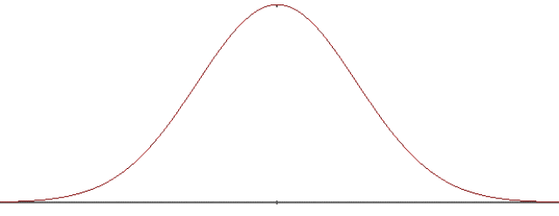

752.5

0

946.97

0.90252

α = 1.729

Mean

T-value

We now need to find our α. We can find this by setting our Significance Level. The three most common are 95%, 97%, and 99.7%. We will choose 95% or .95. We now can take this number and read our T-score from the chart in Appendix C. We look up .05, for one tail with a Df of 19 this gives 1.729. A second method is using the calculator which gives the answer 1.729132792. Next, comes our error level which is found by E = Tα/2 = 1.729132792 (963.6339641/√20) = 372.5850698 or rounded 372.59. So now we can find error range of significance. x̄ - E < µ < x̄ + E. 946.97 – 372.59 < µ < 946.97 + 372.59 574.38 < µ < 1319.56 .

**I do not know what the population mean is for all flights but I can be 95% sure that the mean will be inside the range 574.38 < µ < 1319.56.**

The µ we have been using from using  is 752.5 which is inside that range. Although our µ has an error of 194.7 this is still with our E parameter of 372.59. We are now able to use an alternative method for finding x̄ and E to check the math. x̄ = (upper value + lower value) / 2 and E = (upper value – lower value) / 2. x̄ = (574.38 + 1319.56) / 2 = 946.97 E = (1319.56 – 574.38)/ 2 = 372.59. All the numbers check.

Hypotheses Testing:

“The division would also like to know if the average flight delay times for this year are higher or lower than last year’s average flight delay time of 42 minutes. “ That’s a pretty high number. We will have to work out some info on our delay times. We cannot really use our sample mean for a frequency here as it is out of the range. As a result, we will start with just a standard sample mean  = 7.75 according to table 2. This is far below the 42 minutes in question. Currently, it is looking as if µ < 42.

A requirement for hypotheses testing is that the sample must be random and it is. Next, we need to know if σ or S is known. Here “S” is. Finally, we need “n > 30” or the population distribution to be normal. Neither are true in this case, however, for this test, we will assume the population distribution to be normal. Again we will be using a T-Score =  and . Let us work out S first. According to Appendix 1 S of the Delay time is 5.892401.

Step one the claim.

For a two tailed test we use = or ≠. And since we are given the number 42 in our question we will set µ = 42 as our Ho and µ ≠ 42 as our Ha. In appendix 3 the t-score for a two tailed test with 99% probability is -1.729.  = -25.99. We can see that the results of this test show that Ho is rejected, thus Ha is not rejected.



**There is enough evidence to support the claim that average delay time given with a 99% degree of confidence is either higher or lower than the 42 minute average of last year.**

claim is that µ < 42, this makes the opposite claim µ ≥ 42. So to restate the claim to identify H0 and Ha. So the H0 is µ ≥ 42 as this statement has the equality and is the null hypothesis. This makes Ha = µ < 42 the alternative hypothesis. Next, let us restate these again to help identify the µ equality and whether it is one tail or a two tail test.

To find out if it is higher or lower than the average let us perform a one tailed test.

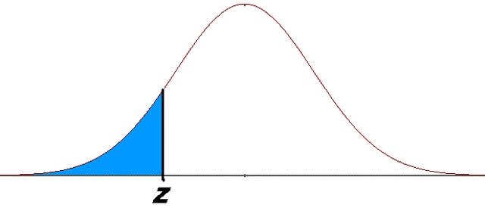

F.T.R

C.V. =-2.54

T =-25.99

H0 : µ = 42; Ha: µ < 42. Since µ is less than 42 this will be a left tail test. α = .01 for a 99% probability level. Now on to  , x̄ = 7.75, S = 5.892401, and *n* = 20. Also µ is found in the restatement of H0: µ = 42.  = -25.99, and Degrees of freedom is 19. Looking at the table in Appendix 3. We see our Critical Value is -2.54.

T falls into the reject region of the distribution using the Traditional Method.

Let double check to make sure using the P – Value test.

Our C.I. is .01 > 0 so we reject again. Therefore, H0 : µ ≥ 42; Ha: µ < 42. So we reject H0 µ ≥ 42. This means that the alternative is true.

**There is enough evidence to support the claim that average delay time given in this sample is less than 42 minutes with a 99% degree of confidence.**



F.T.R

T =-25.99

α = 0

These stats show possible correlations that there is a positive linear relationship between flight time and delay time. It seems that as flights time increases so does delay time. Further, the national average given seems unrealistic according to our data and the average wait time is much less than 42 minutes. The concern, however, is all the assuming that had to be made in order to perform hypothesis testing. Not only was the sample size too low but also the distribution was not normal. Normally we would attempt a χ test. This required σ to be known, as a result, this text was not performed. However, χ is the normal test for skewed distributions.

Comparison and Conclusions:

The last order of business is to see whether the data and decisions we have come to can be supported by another study. Professor Peter Belobaba of M.I.T. published such a study called FLIGHT TIME COMPONENTS AND THEIR DELAYS ON US DOMESTIC ROUTES” (P. Belobaba, 2010). Belobaba found there was a linear relationship between flight time and delay time – though not as pronounced to what we found.



Belobaba found that of the studied route 74% have block delays, 20% have average block delays between zero and five minutes and only 6% had delays that were longer than 5 minutes. 92% of all flights arrived on time. So he found x̄ ≤ 5 (P. Belobaba, 2010). E = Tα/2 = E = -25.99  = 34.24 from our data. Needless to say that we are in range easily of the 5 minute average listed by **Belobaba.**

Recommendations:

Recommendations for further study are warranted. Though Belobaba covers many of the reasons for delay times among flights little or no solutions are offered. The correlation between flight time and delay suggests that there may be possible places for improvement.

**List of Works Cited.**

Belobaba, P. (2010) FLIGHT TIME COMPONENTS AND THEIR DELAYS ON US DOMESTIC ROUTES Dr. Prof. Amy Cohn MIT GLOBAL AIRLINE INDUSTRY PROGRAM, *http://web.mit.edu/airlines/industry_outreach/board_meeting_presentation_files/meeting-nov-2010/Skaltsas%20Schedules%20and%20Delays.pdf*

**Appendix 1** Spreadsheet 1

S=



**Appendix 2:** Spreadsheet 2





**Appendix 3:** T - Tables

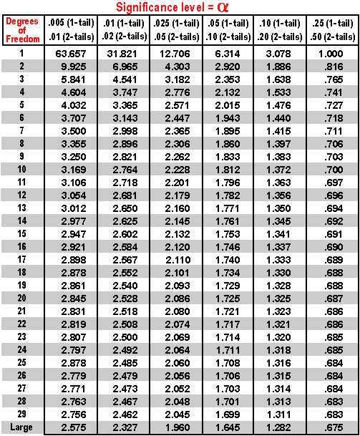

**Appendix 4:** List of Equations.

Outlier Equation. Median. The Median of the upper is Q1 and Lower is Q2. The IQR is Q2-Q1

Population Mean 

Sample Mean 

Sample Mean of a frequency 

Range = R = Xmax – Xmin

Sample Variance 

Sample Standard Deviation. 

Mean and Standard Deviation of the Sample Mean: Mean µ̄̄̄x̄ = µ , Deviation σx̄

Mean and Standard Deviation of the Population Proportion: Mean µ̄̄̄p̂= µ, Deviation σp̂, *q* = 1-*p*

Population Variance 

Population Standard Deviation 

Independent Theorem. *P (A∩ B)= P(A) * P(B)*

Variance of a Discrete Random Variable X σ2 = Σ(*x-µ)P(x)*

Standard Deviation of a Discrete Random Variable 

Bothe Z-Scores and T-Scores can be found on tables as well as graphing calculators.

Z- Scores: Population  Sample 

Use T-Score if σ is not known and sample is less than 30 T-Score 

**T-score is sample is more than 30** 

Confidence Intervals. For Z If σ is known: C.I. = x̄ ± zα/2 , If σ is not known: C.I. = = x̄ ± zα/2

Confidence Intervals. for T If σ is known: C.I. = x̄ ± zα/2 , If σ is not known: C.I. = = x̄ ± tα/2

Degrees of Freedom: *Df=n-1*

Measure of error for T. E = Tα/2 

Chi values. Χ 2 = 

**Appendix 5:** Chi statistics

Chi statistics is for skewed data distribution. . Χ 2 =  . n = sample number, s2 is sample variance, and σ 2 is population variance. Further things to note are: 1. Distribution is no symmetrical. 2. Values are never negative. 3. As df (n-1) goes up the distribution gets more symmetrical. 4. The χ chart reads values to the right. So n = 20 and the confidence level is 95%. With a two sided test we have α = .05/2 that giva a χr score of right 32.852 and χL left 8.907 according to appendix 6. S = 5.892401 from calculations previously make in the paper.

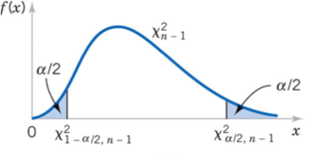

32.952

8.907

Finding the confidence interval and σ 2 using Χ 2 = . < σ 2 < 

< σ 2 <  = 20.01969468 < σ 2 < 74.06392741

or 4.474331995 < σ < 8.60604017 average of 6.540186082

We do not know the exact standard deviation, but we can be 95% sure that the standard deviation will be in this range 4.474 < σ < 8.606.

**Appendix 6:** Chi table

