HUM/MUS16: World Music

Assignment 2
Due: Jan. 31 for Qs, Feb. 5 to turn in NAME: Jeffery Morse

You will be analyzing the song you chose for Assignment 1 by applying the terms of musical elements you learned in Chapters 2. Add answer lines as necessary after each question.

Title of your song: My Prayer

Artist: Jeffery Morse
http://www.reverbnation.com/jefferymorse/song/2010333-my-prayer

- List the number of singers involved and their gender. One Male

- List the instruments used in the song and their classification, such as aerophone, chordophone, etc.
Concert Grand Piano; chordophone/idiophone
Violins: chordophone
Bass sting ensemble: chordophone
Orchestral percussion set: idiophone
Drums: membranaphone/idiophone
Trumpets: aerophone
French horn: aerophone
Fm Synth electrophone
Vocals Layered multiple tracks single voice. aerophone

- Discuss the overall timbre(s) of the song. Does it change? How?
The intro has higher violins but concludes with a very low set of strings, the main instrument is the piano over a Bass that is irregular sometime playing and sometimes not, playing cord harmony basso continuo. The timbre changes in the instrumental section(the brass sound really fake, I’ll have to fix that one day) in the end the timbre changes and include a type of instrument that allows micro tones, it’s used as a supporting instrument.

- Does the main melody involve wide or narrow range? Though the main melody modulates several times the range stays relatively close.

- Discuss the intervals used to construct the main melody. Are they mainly large intervals, mainly small intervals, or about equal amounts? Discuss the effects the sizes of intervals have on this piece. All the interval are close, this is gives a feeling of peace and fulfillment, also makes one listen to the text more as dictation is very clear.

- What is/are the prevailing melodic contour(s)? the main melody of the chorus stays the same, descending almost chromatically twice then ascending. The verse is almost recitative.

Refrain Chorus

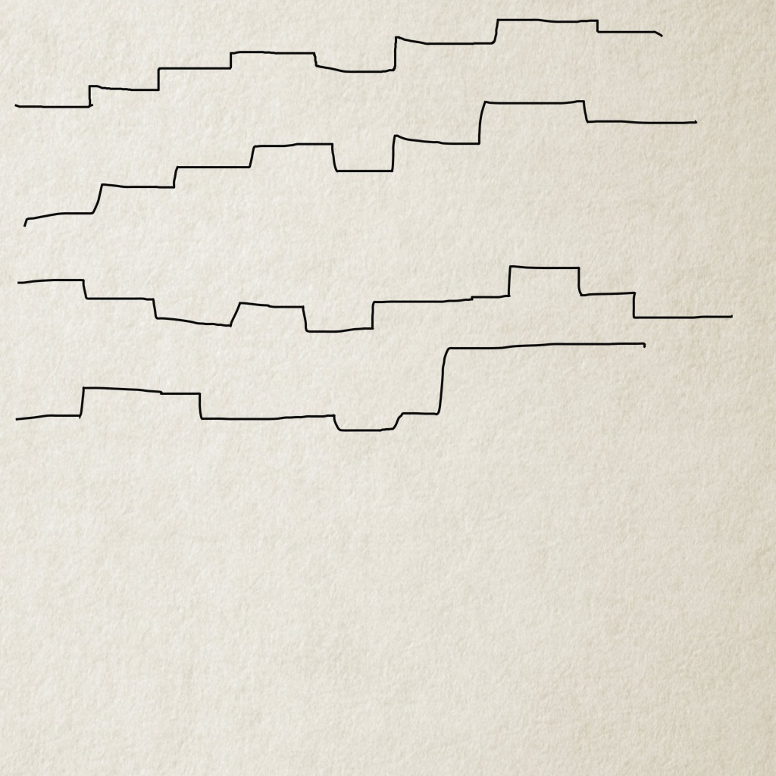

- Is the melody constructed simply or does it contain a lot of ornamentation?

It is very simple, not much ornamentation at all.

- Does the song have steady beats (pulsatile), or does it contain free rhythm section (quasi- or non-pulsatile)? How would you describe its rhythmic density?
Song has a very slow steady pulse that is set by the idiomatic violins in the beginning and later held by the continuo harmonies falling on the first strong beat of the measures.

- Is the meter duple or triple? 4/4 time duple

- Is the tempo slow, medium or fast? Does it stay steady, or does it change?
4/4 time at 115 bpm but is felt very slow, the tempo remains steady throughout the song.

- What phonic structure does the song employ?
Mostly Homophony.

- Does the song have much dynamic variations or contrasts?
Very small dynamic variations. The tag, or bridge gets to mp, or almost piano, and then the end works up toward a crescendo.

- Is the song strophic? If so, how many verses does the song contain? If not, can you figure out its form, or formal structures?
Prelude, refrain1, verse1, modulation up, refrain2, modulation up refrian3, v2, refrain3, modulation up, instrumental, bridge, modulation up, refrain.
aBABBCBDB ?? I do notice the the piano has a reoccurring sequence that appears in every key, also note the scales going up toward the end as to say that the prayer is headed toward the heavens.
- How does the title relate to the work?
The title is exactly what the song is, the prayer of a man to be inside God’s will and presence and to become more Christ like.

- How is the meaning of the text conveyed in the music?
The range is small without ornamentation, (it’s just a simple prayer) the mood is soft and sincere. ( no games) the bible says “If I go up to the heavens, you are there; if I make my bed in the depths, you are there.(ps139:8) the range of the instruments has real big bass areas, and real high violins. As prayer draws you closer to the Lord, this song modulates up and up, and at the end as the song concludes in its highest modulation there is the addition of the piano scales going upward, as we become closer to God we ascend into His kingdom.

- If it is a purely instrumental work, is it totally abstract, or does it convey any type of meaning? Was it composed with any function in mind, such as dance, ritual, religious, making shoppers happy, etc.? The song one might say is religious, but to me I wrote it to the Lord, for the Lord, and wanted the contents to be the cry of my heart, so it is very personal to me, and not religious at all. Many don’t realize that God is close, they think He is in space somewhere or somewhere far away, but the Word says, “Don’t your know? Haven’t you heard? The Kingdom of God is in you!” as to day God lives in us. Now some think He is just air or some mysterious force that you isn’t really a person, but Jesus is a person. When He lives in you, he is a Person Living In You, with His own voice, will, etc. A friend that stick closer than a brother, it’s very real and very intimate. Everything you think and do He sees, and lives with you. So that is the context of the song.

- As you analyzed the piece which represents you, did you discover anything further about yourself from perhaps a different perspective, about your experiences with music, or about your general musical preference? Please elaborate.

My musical preference is fickle, I love worship or spirit filled music the most, not religious music, I mean music that caused me to feel the Spirit of God, or music He inhabits. But I have listened to Alt rock and other music. I find my tastes change. As for the revelations, well I wrote, performed, and sang the song, from conception to completion its all me and God.

