Jeffery Morse

Virtual Trip of Peru

World Music Dr. Aya Ueda.

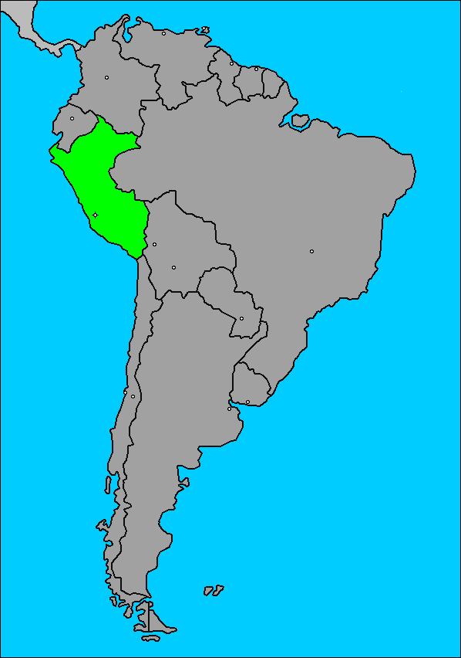

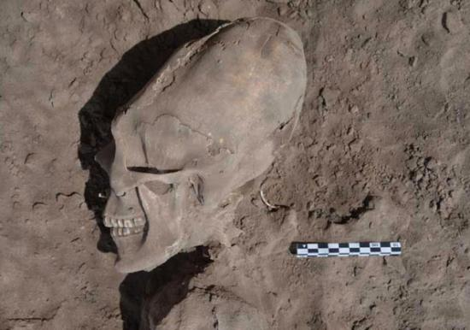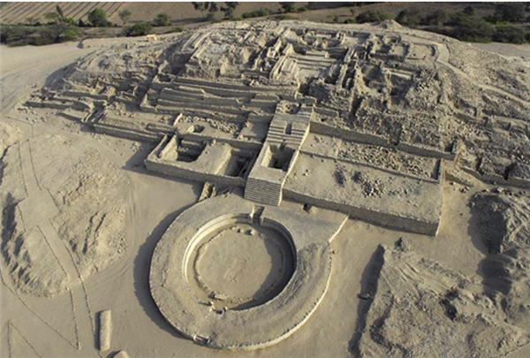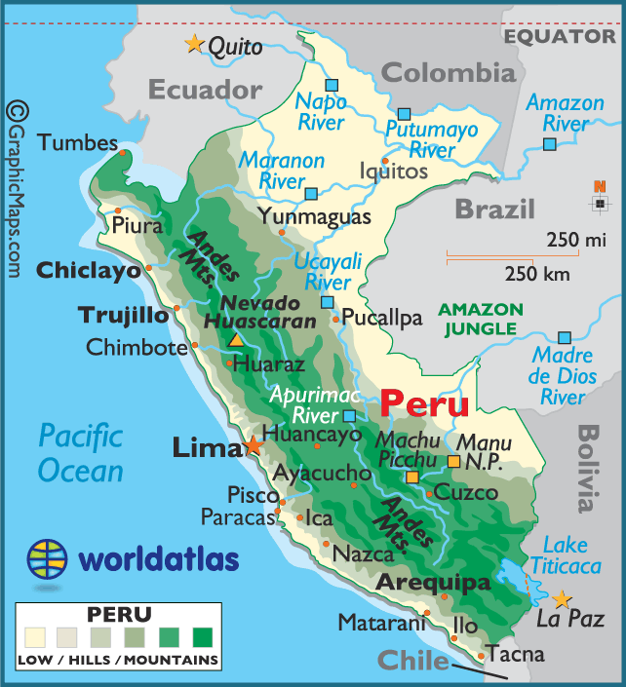Peru’s landscape varies greatly, with urban areas on the western coast and tropical rain forest and the Amazon to the eastern interior. In the middle is the Andes mountain range where the ancient Incas lived. You can find there descendants still there living in adobe huts surrounded by llamas and alpacas. Peru’s native and mestizo people are the majority. The common languages are Spanish and Quechua, a language from the lost Incan empire, Aymara, and numerous Amazonian languages are also spoken. Migrants are thought to have reached Peru around 6000 BC, probably entering the [Amazon River](http://en.wikipedia.org/wiki/Amazon_River) basin from the northwest. [8] The Incan empire dates from about the 13th century; however, they were not the first civilization of Peru. Important places of culture are the city of Cusco near lake Titicaca, and Machu Picchu a lost city, in the Andes at an elevation of about nine thousand feet.[1](number refers to list of works cited).Peru’s geographic location is South America, and it touts itself as the third-largest nation in South America. To its north east is Columbia taking up approximately one third of it upper eastern border. Brazil is Peru’s eastern most neighbor taking up another third of Peru’s boarder. The remaining third is split by Ecuador to Its north, Bolivia to its southeast, and Chili to its south. For [brief tour of Peru](http://www.youtube.com/watch?v=v-BktfTJzxI) please click on this You tube link.[5] Peru’s oldest evidence of civilization was a a group we don't know much about, but that thrived 5,000 years ago and created the city of Caral, the oldest known city in the Americas. It is located a few hours north of Lima. There is great evidence of civilization. Unfortunately we have not found other forensic evidence.[6] Another culture was the Paracas. They lived from 700 BC to 400 AD . This culture is most famous weavings and textile work which they used to wrapped around the bodies of their dead. One item that was used in the epic movie of Indiana Jones was the fact that the craniums of the Paraca have been deformed. According to experts this is the result from the attachment of boards to change the shape of the head. It’s said that the famous “Crystal Skulls” have their origin with these people. A people that were able to form crystal without leaving not one file mark. It is also believed by some that these people had understood frequency, and wave length as they were said to be able to harness the power of the crystal. Next up are 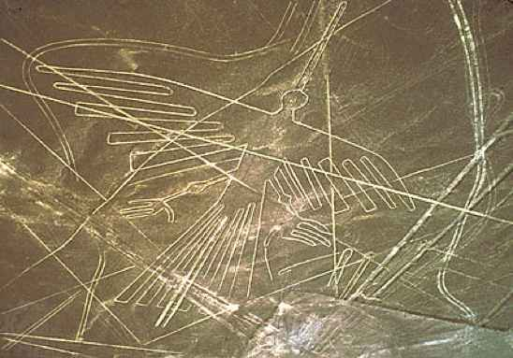the Nazca culture which thrived from 200 BC until 600 AD. Most people know the Nazca for the Nazca Lines, a massive formation that still baffles everyone today. These designs are carved into 500 square kilometers of arid desert landscape. There are over 800 straight lines and 300 geoglpyhs. The amazing thing is that these works of art are almost impossible to notice at ground level, which is what gives rise the the “Ancient Alien Theory. [6] More recently. archaeologists, [anthropologist](http://en.wikipedia.org/wiki/Anthropology), and [forensic anthropologist](http://en.wikipedia.org/wiki/Forensic_anthropology) have found evidence of a coastal civilization dating back two thousand years called the Moche. Here is a link to the [entire movie](http://www.youtube.com/watch?v=IjJQ6ivm0bY) [5]Its pre-colonial history includes ancient cultures well before the Incan Empire, and many of Perú's instruments can be traced to that time.[4] It seems that the Moche’s life was filled with ritual, dance and human sacrifice. The sacrifices evidence is our best tell. At first archeologists didn’t quite understand why all the skeletal remain were incased in mud. However, later they have come to the conclusion after 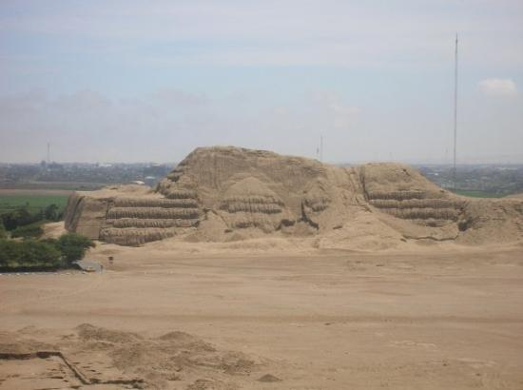careful forensic examination that these were sacrifices at times of el nino floods. The other evidence are the many pyramid style structures that look to the naked eye like just mounds of dirt. It’s only at inspection that the bricks that build up the walls are revealed. [7] The Inca are by far the best know Cultural group from Peru. Incas are referred to as Andean. Most of the document music of the countries revolves around probably the most ancient pre-encounter musical tradition of the Andeans and is referred to as Andean music: With panpipes, flutes, drums and percussion instruments. Much of the rhythms and dances of the Andes remain today a testimony to their perseverance. On the coast, people (and music) are referred to as *Criollo* (Creole), where we find a myriad of rhythms and dances—some directly descendant from Europe, such as the northern Spanish *jota* to the Viennese waltz.[4] these are also commonly referred to as Afro-Peruvian. This was the result of the Slave Trade. The Europeans brought a significant slave population to the coast, along with European religious beliefs and music. As a result much of Peru is Roman Catholic. The other people groups of Peru, which there seem to be many as the nation was tribal for a period, is beyond the scope of this paper. Suffice to say that in the rich tribal heritage several religious and mythic belief systems ran amuck. From the Blood letters of the Moche to the great drawings of false gods in the dirt that only can be seen from the air, there are probably animalists as well in the amazon tribes. However, as I stated I will commit the rest of this paper mostly on the Incas. I did try an find some references to the Amazon tribes of Peru but had little luck. I did see an episode of “Man –vs- Wild with some reference to them, they reminded me of aborigine a little. All the places and sites listed in this paper are worth going to if visiting Peru, however, I would be amiss if I 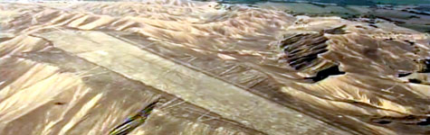didn’t pay special attention to the city [Machu Picchu](http://www.youtube.com/watch?feature=player_embedded&v=YI6M9LC4Pn0#!) and its sister city Puma Punku. These almost mythical cities stump all experts. The blocks that build them way in excess of 50 tons each and are really big. The landing strip at near one of the cities is also a place of extreme debate. Even to call it a landing strip is somewhat daring. It is obvious though after looking at the pictures. Furthermore, the stone that built these cities also stumps people as they seem to be machined with laser like accuracy. There are [no chisel marcs](http://www.youtube.com/watch?v=p5ucwGAYmUg), no grind marks, and the granite is big and unmovable. How did such a primitive people do manufacture and erect such feats of engineering. To put this in perspective today we don’t even have the ability to do it with all our expertise, the granite blocks are too big too heavy to transport. Furthermore, to engineer them to fit so precisely would be a feat that today would take years, and even then there would be evidence of tooling. But enough lets get on with the paper

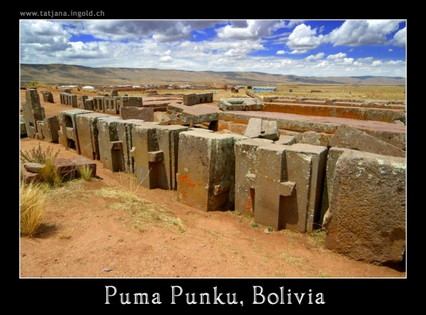 The Andean people would remind you of a cross between native American and Mexican. They have a rich tribel customs that include different types of dances. [Dance one](http://www.youtube.com/watch?v=qwFVjvWPX70). [Dance two](http://www.youtube.com/watch?v=8qsu7cYLA8Q). The two links listed are clips on youtube that show some of the cultural dances.

Now lets look at the instruments of the Andean people first up is the chordophones. The **'charango'** is a tiny 10-stringed guitar made of an armadillo shell. It is [sweet sounding with its happy](https://www.youtube.com/watch?v=28IdRyWd22o) high-pitched sound and is perhaps the instrument which best symbolizes the blending of the two very different cultures - the 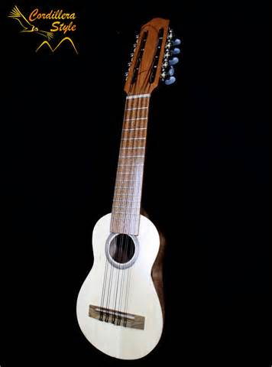Spanish and the Inca. Introduced to the Americas by the Spanish The guitar makes use of armadillo shells for the body It is believed that the soul of the animal is kept alive by 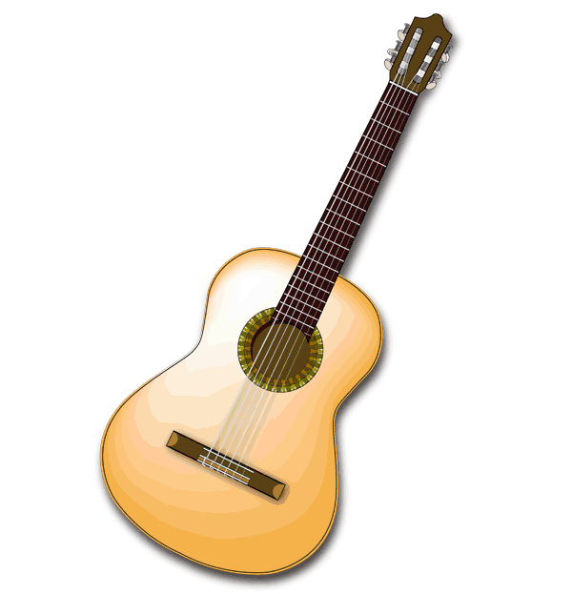playing music

Next up is the Spanish guitar, a typical [classical sound](https://www.youtube.com/watch?v=KC3hJFvQv3A) and style that is seen in many places today. Also used in place is the harp with its [heavenly sound](http://www.youtube.com/watch?v=7Q-8A7HQWSc).

|  |  |
| --- | --- |
| chac-chas.gifquena.gifZampoña.jpgNext the aero phones. zampona.gif The **'zampoña'** (called siku in the book) and is known as 'pan pipe' in other parts of the world. It is a series of bamboo reeds, each tuned to a specific note, and tied together. The smallest sikus are known as **'chillis'** or **'icas'** and the largest are **'toyos'**. It takes strong lungs to play the zampoña. A musician blows across and down the hollow reeds in the same way one would play a whisky jug. The picture to the left is a fine example of one. The siku has the sound of a flute in and many times may even be mistaken for one. [Its music](https://www.youtube.com/watch?v=9fYo3V_x_kA) is sweet to the ear and can lull one to sleep peacefully. Speaking of a flute the **'quena'** is the Andean version of the flute. It has a wide range of sounds which [can evoke many different emotions](https://www.youtube.com/watch?v=Rz5_EJnB8yQ). Originally constructed of animal bones or bamboo shoots, but today is made of wood. The quena also varies in size and pitch. The smallest is the **'quenilla'** and the largest is the **'quenacho'**.The **'tarka'** is an ancient wooden flute used for religious ceremonies and dances. It makes an [eerie sound](https://www.youtube.com/watch?v=KcxrlLNbk2c) and existed long before the Spanish invasion.tarka.gif[3] Next up are the Idiophones and the membrane phones. There are several types of these used in various ways. The **'chác-chás'** or **'chullus'** (chew-use) are [rattles made](https://www.youtube.com/watch?v=uktKgm9NvFc) of goat or lama hooves tied to a strip of cloth that may be worn around the wrists or held in the hand. It makes a rattling noise and you’l l hear the sound in the selection at the end along with the rest of these instruments. The **'bombo legüero'** is a [drum](https://www.youtube.com/watch?v=zawdQPMf4PI) traditionally made of a hollowed tree trunk and covered with bombo.gifanimal skins. The **'chaucha'** is a giant wild pod up to two feet long that is dried and filled with seeds or beans. It is used as a rattle in traditional Andean melodies. [3] The **'palo de lluvia'** (you-via), or "[rain stick](https://www.youtube.com/watch?v=rEpktV6Qlc0)" is a giant palo_de_lluvia.gifbamboo reed measuring up to six feet in. Inside the instrument are dozens of sticks chauca.gifplaced diagonally and small dried beans fall across them when the stick is tilted from one end to the next. The **'cajita'** is another [percussion cajita.gifinstrument](https://www.youtube.com/watch?v=pqC16EG21lo) developed in Peru. It is made out of wood. One plays the cajita by opening and cajon-flamenco-la-peru-profesional-cp4019.jpgclosing the top lid to the rythm of the music, while striking it with a stick. The next instrument we are going to cover is the **'cajon'.** It is a percussion instrument, a wooden box with a sound hole in back. QUIJADA DE BURRO.jpgThe player sits on top of it [and strikes the front](http://www.youtube.com/watch?v=vxUFqxSdKCc) with his hands. [3] The final Instrument to me is the most interesting it is the “Quijada” or donkey jaw instrument. When a donkey dies the jaw is dried and tempered so the bones will make a high pitch when stuck and the teeth will rattle. Very interesting instrument. It has a distinct sound when played. Here are two links. [Link1](http://www.youtube.com/watch?feature=player_embedded&v=54kqG393LYM#!) [link2](http://www.youtube.com/watch?v=mHASUzLgwUY). The ensembles range into different type from pearly [percussion](https://www.youtube.com/watch?v=DW5pFFMmW4g), [aero](http://www.youtube.com/watch?v=PYIy1WBMrlg&list=UUnHipE6emXdPUbOsbdQ4viA&index=1) [phones](http://www.youtube.com/watch?v=tsTlrg5VvsM), [chordophones and aerophones](http://www.youtube.com/watch?v=mvUBJTy_StI), only to entire ensembles referred to as sukirus ([link](https://www.youtube.com/watch?v=odUZjGzpThI)). The people there eat off the land, with several native fruit, however, things are different in the big cities where you might want to try out some of the [local cuisine](https://www.youtube.com/watch?v=ZSH8BQltf7A&list=PL47FA215F03C99348). If your planning on going on a visit soon I would suggest to make sure it is not el nino season, and make sure that none of the [many](http://en.wikipedia.org/wiki/List_of_volcanoes_in_Peru) local volcanoes are not [erupting](https://www.youtube.com/watch?v=lcTc4rX_xP4). |  |

|  |  |
| --- | --- |
|  |  |

|  |  |
| --- | --- |
|  |  |

Lists of works Cited.

1. World Music a Global Journey. 3rd edition T.E. Miller. Published by Routledge.
2. Peru's Ancient Coastal Cultures *By* [*Henry Arnault*](http://ezinearticles.com/?expert=Henry_Arnault) 
   1. <http://ezinearticles.com/?Perus-Ancient-Coastal-Cultures&id=6444443>
3. 2003 Wheat Media
   1. <http://www.wheatmedia.com/inca/instruments.html>
4. National Geographic --- *Rebeca Mauleon*
   1. http://worldmusic.nationalgeographic.com/view/page.basic/country/content.country/peru\_16/en\_US
5. www.youtube com for reference videos.
6. Peru's Ancient Coastal Cultures ---*Henery Arnault* --Peru Travel.
   1. <http://ezinearticles.com/article/print/6444443>
7. “The Lost Civilisation of Peru” Movie. BBC . produced by *Horizon.*
   1. <http://www.bbc.co.uk/sn/tvradio/programmes/horizon/peru_prog_summary.shtml>
8. Wikipedia
   1. <http://en.wikipedia.org/wiki/Indigenous_peoples_in_Peru>