1 The Middle East

Turkey, Iran, Egypt, Sufism, Judaism

2 Middle East Map

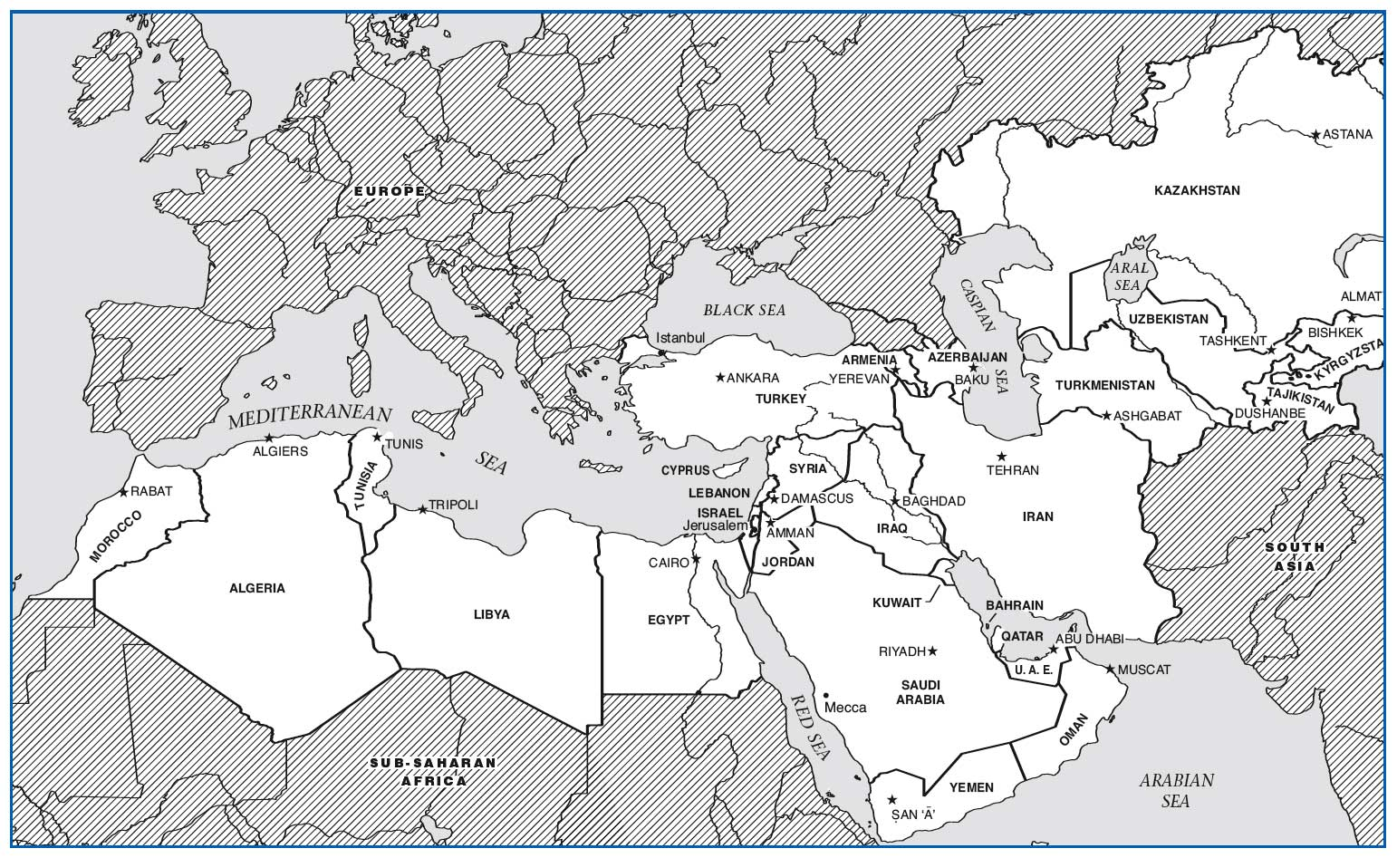

3 Background Preparation

a. West Asia & North Africa

b. Islam, Christianity, Judaism

c. Ancient civilizations

e. Influence on Europe

d. Arabic, Turkish & Persian

4 Turkey

Site 1: Islamic “Call to Prayer”

Site 2: Arabic Modal Improvisation

5 Arrival: Turkey

a. Crossroads of Europe and Asia

b. “Istanbul, not Constantinople”

* Ottoman Empire

c. European Effect

6 Site 1: Islamic “Call to Prayer”

a. First Impressions

--Heightened speech

1. Aural Analysis

--Melismatic male voice

--“Allah” - God is Great

7 Cultural Considerations

a. Muhammad

*--Koran*

b. Muslim

1. Mosque

*--Mihrab*

*--*Mecca

*-*-- The *Ka’ba*

*---* Minaret

1. *Muezzin*

8 The “Blue Mosque”

9 Non-mus ic (vs. Music)

a. *Koranic* Chant

1. *Adhan* - Call to Prayer
2. Pilgrimage Chants *(Hajj)*
3. Eulogy Chants & Chanted Poetry

10 (Non-Music) vs. Music

* Family and Celebratory Music
* Occupational music  
  (Caravan, shepherd, work songs)

Military Music

11 Site 2: Arabic Modal Improvisation

12 Cultural Considerations

13 Iran

14 Arrival: Iran

15 Site 3: Dastgah -Santur & Voice

16 Cultural Considerations

17 Egypt

18 Arrival Egypt

19 Site 4: Arabic Takht Ensemble

20 Takht Instruments

21 Cultural Considerations

22 Sufism

23 Arrival: Sufism

24 Site 5: Sufi Dhikr Ceremony

25 Cultural Considerations

• Dhikr -“Remembrance”

• Music as a

“spiritual ladder”

• Spiritual ecstasy -Oneness with Allah

• “Whirling” dervish

26 Judaism

• Site 6: Liturgical Cantillation

27 Arrival: Judaism

28 Site 6: Jewish Cantillation

• First Impressions

– Sung recitation

• Aural Analysis –Cantor

– “Speech” rhythm

– Melodic formulas

29 Cultural Considerations

• Torah

• Synagogue

• Shofar