1. Sub-Saharan Africa
   1. Ghana, D.R. Congo  
      Zimbabwe, Uganda  
      Senegal-Gambia  
      Republic of South Africa

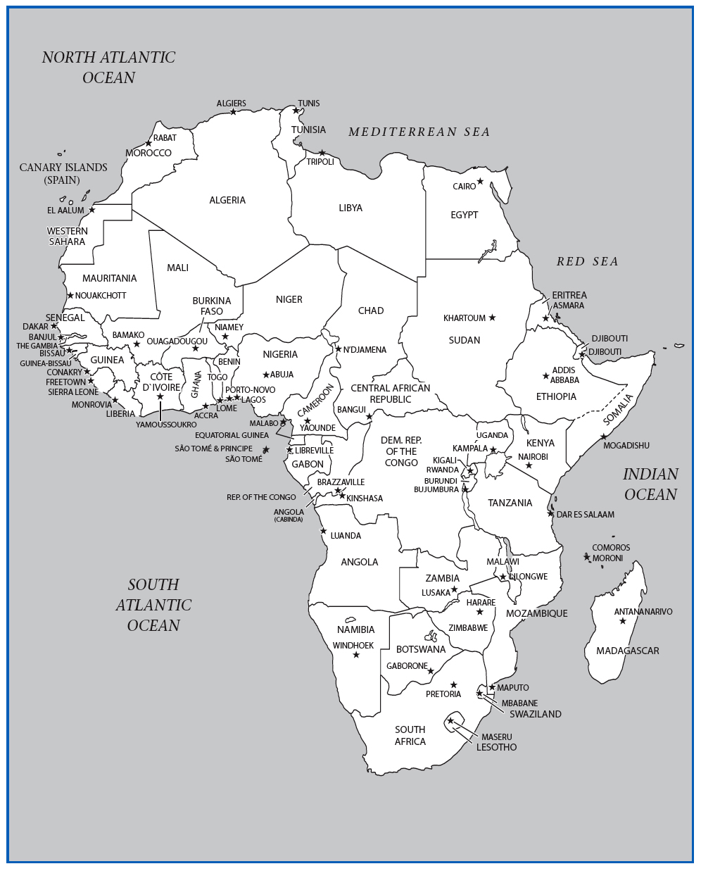

1. Africa Map
2. Background Preparation
   1. Farming is a primary occupation
   2. Cultural Zones:
      1. Pan-Arabic/Sahel/Sub-Saharan Africa
   3. Nearly 3,000 separate ethnic groups
      1. Roughly 1,800 spoken languages
         1. European languages common
   4. Modern politics
3. African Beliefs
   1. Community is social focus
   2. “I am, because we are.”
   3. Community includes living and ancestors
   4. Animism prevalent
   5. Music is a part of life
4. African Music Principles
   1. Oral tradition is not written down.
   2. Focus on group over individual
   3. Polyrhythm
   4. Call and Response
   5. Dance
5. Ghana
   1. Site 1: Polyrhythmic Ensemble
   2. Site 2: “Talking” Drums
   3. Site 3: Palm Wine “Highlife” Song
6. Arrival: Ghana
   1. West Africa most familiar to outsiders
   2. *Kente* cloth
   3. *Akan* and other indigenous languages
7. Site 1: Polyrhythmic Ensemble
   1. First Impressions
      1. Rhythmic kaleidoscope
   2. Aural Analysis
      1. Drums, rattles, bells
      2. Polyrhythm
      3. Call & response
8. Polyrhythm
   1. Overall sound is rhythmically dense
   2. Time-line patterns
      1. “Simple” individual patterns
      2. Complex combined whole
      3. Density referent-- relationships, not meter
9. Cultural Considerations
   1. Recreational bands
   2. Formal and Informal contexts
   3. Master drummers
10. Site 2: “Talking” Drums
    1. First Impressions
       1. Mimicking drum
    2. Aural Analysis
       1. Surrogate Speech:
          1. Tonal contour of language
          2. Speech rhythm
       2. Hi/Lo drums or one drum with multiple tones
11. Cultural Considerations
    1. Drums give words more power
    2. Praise drumming
    3. “Proverb” performance
12. Site 3: Palm Wine “Highlife” Song
    1. First Impressions
       1. Easygoing guitar
    2. Aural Analysis
       1. Polyrhythmic melody and percussion
          1. Interlocking guitar motives
       2. Call and “harmony” response
13. Cultural Considerations
    1. “Highlife” styles
    2. Palm Wine
    3. Social commentary
14. Central Africa
    1. Site 4: Pygmy Music.. one of the only known people might step up to take a leadership role but they don’t actually have chiefs. Or a leadership structure.
15. Arrival: Democratic Republic of the Congo
    1. Rainforests of Central Africa
    2. Unknown Pygmy population
    3. Nomadic egalitarian societies
16. Site 4: Pygmy Music
    1. First Impressions
       1. Interweaving  
          “Hoots and hollers”
    2. Aural Analysis
       1. Vocal polyrhythm
       2. Minimal percussion
       3. Call & response
17. Cultural Considerations
    1. Portable instruments
    2. Communal performance
    3. Animistic beliefs
18. Zimbabwe
    1. Site 5: *Mbira dza vadzimu a round small semi circle with metal tines that you pluck, used to call the spirits. ??*
19. Arrival: Zimbabwe
    1. Victoria Falls
    2. Former British colony
    3. *Shona* ethnic group
20. Site 5: Mbira dza vadzimu
    1. First Impressions
       1. Polyrhythmic music box
    2. Aural Analysis
       1. *Mbira (dza vadzimu)*
          1. *Kushaura - Kutsinhira*
       2. *Hosho* and Voice
21. Cultural Considerations
    1. “Called” to play *mbira*
    2. Music is “protected” property
    3. *Bira* - Spirit possession ceremony
22. Uganda
    1. Site 6: *Akadinda* Xylophone
23. Arrival: Uganda
    1. Lake Victoria
    2. Kingdom of Buganda
    3. Idi Amin (r.1971-1979)
24. Site 6: Akadinda
    1. First Impressions
       1. Super-dense  
          “rush hour” rhythm
    2. Aural Analysis
       1. *Akadinda*
       2. Triple interlocking patterns
25. Cultural Considerations
    1. Royal instrument
    2. Other xylophones
26. Senegal-Gambia
    1. Site 7: *Jali* with *Kora*
27. Arrival: Senegal-Gambia
    1. Former French & British colonies
    2. *Mandinka* ethnic group
    3. *Jali* as oral historia
28. Site 7: Jali with Kora
    1. First Impressions
       1. Churning  
          underlying harp
       2. Declamatory singing
    2. Aural Analysis
       1. *Kora*
          1. *Kumbengo*
          2. *Birimintingo*
       2. Syllabic singing
          1. Descending contour
29. Cultural Considerations
    1. Praise-singing
    2. “Spraying”
    3. *Griot* - modern *jali*
30. Republic of South Africa
    1. Site 8: *Mbube* Vocal Choir
31. Arrival: South Africa
    1. *Afrikaners*
    2. Shaka Zulu (1787-1828) very nice choir songs that we heard in class.
    3. Apartheid
    4. Nelson Mandela  
       and the ANC
32. Site 8: Mbube Vocal Choir
    1. First Impressions
       1. Deep and lush choir harmony
    2. Aural Analysis
       1. “Controller” and “Chord”
       2. Emphasis on lower range
       3. Frequent tempo changes
33. Cultural Considerations
    1. Townships
    2. *Mbube* competitions
    3. *Iscathamiya*