1 The Middle East

Turkey, Iran, Egypt, Sufism, Judaism

2 Middle East Map

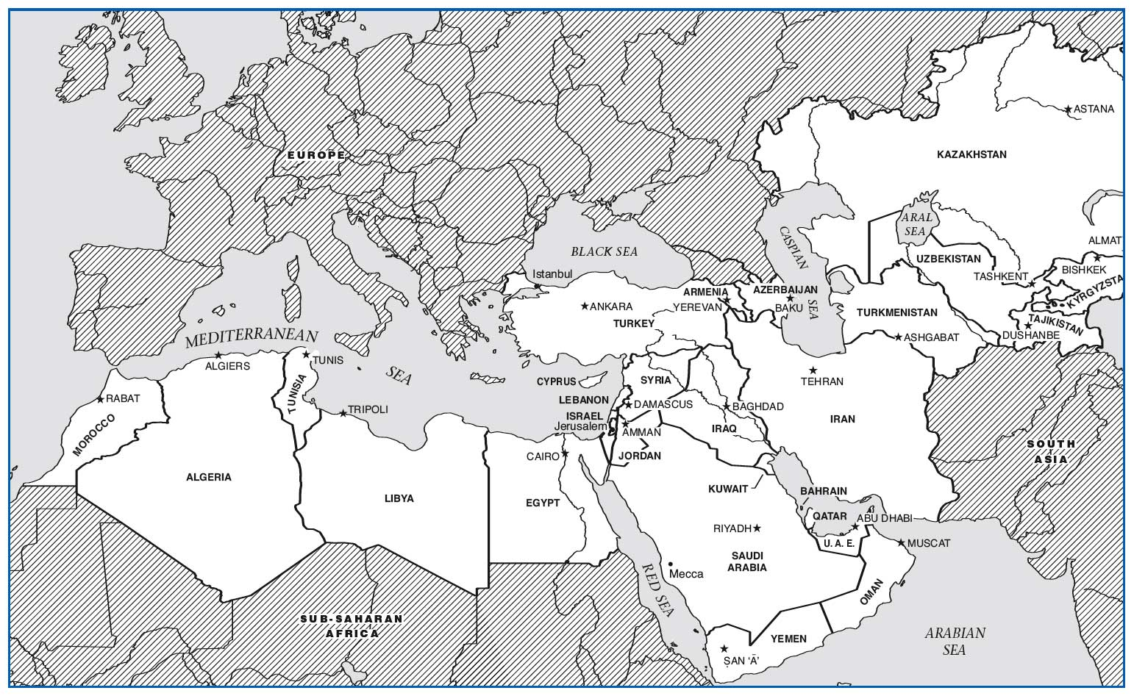

3 Background Preparation

a. West Asia & North Africa

b. Islam, Christianity, Judaism

c. Ancient civilizations

e. Influence on Europe

d. Arabic, Turkish & Persian

4 Turkey

Site 1: Islamic “Call to Prayer”

Site 2: Arabic Modal Improvisation

5 Arrival: Turkey

a. Crossroads of Europe and Asia

b. “Istanbul, not Constantinople”

--Ottoman Empire

c. European Effect

6 Site 1: Islamic “Call to Prayer”

a. First Impressions

--Heightened speech

1. Aural Analysis

--Melismatic male voice

--“Allah” - God is Great

7 Cultural Considerations

a. Muhammad

*--Koran*

b. Muslim

1. Mosque

*--Mihrab*

*--*Mecca

*-*-- The *Ka’ba*

*---* Minaret

1. *Muezzin*

8 The “Blue Mosque”

9 Non-mus ic (vs. Music)

a. *Koranic* Chant

1. *Adhan* - Call to Prayer
2. Pilgrimage Chants *(Hajj)*
3. Eulogy Chants & Chanted Poetry
4. Non-Music) vs. Music
   1. Family and Celebratory Music
   2. Occupational music  
      (Caravan, shepherd, work songs)
   3. Military Music
5. Site 2: Arabic Modal Improvisation
   1. First Impressions
      1. “Dreamy” Improvisation
   2. Aural Analysis
      1. *Ud* and *Buzuq*
      2. *Makam* - “Composition Kit”
         1. *Taqasim*
      3. Free Rhythm
      4. 24 pitches to the octave
6. Cultural Considerations
   1. Islamic attitudes towards music
      1. Legitimate
         1. Music for worship or function
   2. Controversial
      1. “Art” or “Entertainment”
      2. Non-Islamic sacred music
   3. Illegitimate
      1. Sensual Music
      2. *Haram*
7. Iran Site 3 Dastgah for Santur and Voice

WMGJ: pp.208-210, CD 1.27

Ornamentation is typical of Persian classical music, especially with regards to the voice. Much Persian classical music sounds “sad” to Western ears, which indeed supports the text that often reflects, directly or indirectly, the hardships of living in the harsh environment of Iran.

The santur is a hammered zither, described also as a dulcimer. Many organologists consider this instrument the source for similar hammered zithers found throughout Asia, e.g., yang qin from China, khim from Thailand, as well as the Western world, e.g., cimbalom from Hungary, American hammered dulcimer from the United States. Some even regard it as the inspiration for the creation of the piano, derived from earlier instruments, i.e., harpsichord and clavichord, but adding the concept of hammered strings.

Dastgah denotes mode in the Persian classical tradition. A key distinction between the pedagogy of Arabic music and that of Persian is the former is primarily an oral tradition, whereas the Persian tradition has a vast body of “composed” melodies. These short melodic compositions are known as Gusheh.

Each Dastgah has a collection of gusheh associated with it. A performer memorizes these short melodic compositions and then strings them together to create longer compositions. This allows for an element of improvisation while still remaining within the modal framework. A Radif is a collection of these gusheh used in association with a particular “school” of dastgah performance.

1. Arrival: Iran
   1. Largely mountainous
   2. Persian, not Arabic
   3. Predominantly Shi’a Muslim
   4. Theocracy since 1979
      1. Ayatollah Ruhollah Khomeinii  
         (1900 - 1989
2. Site 3: Dastgah -Santur & Voice
   1. First Impressions
      1. Melancholy Melisma
   2. Aural Analysis
      1. *Santur*
      2. *Dastgah*
         1. *Gusheh*
         2. *Radif*
3. Cultural Considerations
   1. Schools of *Dastgah*
   2. Non-meter over meter
   3. Classical underground
4. Egypt
   1. Site 4: Arabic *Takht* Ensemble
5. Arrival Egypt
   1. Pyramids & Pharaohs
   2. Suez Canal - 1869
   3. Modern Era
6. Site 4: Arabic Takht Ensemble

Takht ensembles generally play metered music and may or may not include a vocalist.

Ud: Fretless plucked lute.

Kemanja: Fretless bowed lute.

Kanun (qanun): Plucked zither

Ney: vertical flute

Riqq: tambourine

Duff: single-headed frame drum, often with a snare

Tabla (Also, Darabukka): goblet drum. Various terms for this type of drum. Remind students that it is NOT similar to the Indian tabla drum pair.

Melodic forms are common in takht ensemble performance. *Bashraf* is a form with a recurring melody, as in the audio example.

The use of rhythmic modes (*Iqa-at*) is also common. Several modes may be used in a single performance, changing meter as well as tempo.

* 1. First Impressions
     1. Graceful “belly” dance music
  2. Aural Analysis
     1. *Takht*
        1. Melody: *ud, kemanja, kanun, ney*
        2. Rhythm: *riqq, duff, tabla (darabukka)*
  3. *Bashraf* & *Iqa-at*

1. Takht Instruments
   1. *Ud, Kanun, Darabukka* (band)
   2. *Riqq & Duff* (drums)
   3. *Ney* (flute)
2. Cultural Considerations
   1. “Belly” Dance
   2. Music evokes emotion
3. Sufism
   1. Site 5: *Dhikr* Ceremony
4. Arrival: Sufism
   1. “Mystical” branch of Islam
   2. Noted for their woolen (*suf*) robes
   3. Most common in Turkey
   4. Monasteries and *dervish*
      1. Followers of the Sunni and Shiah branches of Islam are often critical of the Sufi branch, which employs many unique rituals borrowed from other religious traditions. Strictly speaking, Sufis do not consider themselves to be Muslims as they are open to any religion or ritual that assists them in their spiritual quest. Yoga activities, for example, play a key role in many Sufi rituals. Music is considered to have healing and spiritual powers and is therefore often used in the context of worship, whereas the mainstream branches of Islam forbid musical performance in worship.
      2. Sufis generally wear two sets of robes. The outer robe is black, symbolic of the “dark” realm of the secular world, whereas the inner robe is white, symbolic of the purity of heaven/God, etc. Black robes are worn in non-spiritual activities, while the white robe is revealed during rituals.
      3. Whereas some Muslims view Sufis as heretics, they have been well-respected in Turkey where many monasteries can be found.
      4. Most Sufis live in monasteries to aid the follower in separating himself from the secular world in order to achieve a higher state of spirituality. Others seclude themselves as individuals, living like hermits, but depending on the general public for their means of subsistence. Thus, some sufis accept alms, which has earned them a nickname as a “dervish,” which generally translates as beggar. Still other Sufis live within the secular world, working as average folk do, but also attending Sufi rituals.

24 Site 5: Sufi Dhikr Ceremony

25 Cultural Considerations

• Dhikr -“Remembrance”

• Music as a

“spiritual ladder”

• Spiritual ecstasy -Oneness with Allah

• “Whirling” dervish

26 Judaism

• Site 6: Liturgical Cantillation

27 Arrival: Judaism

28 Site 6: Jewish Cantillation

• First Impressions

– Sung recitation

• Aural Analysis –Cantor

– “Speech” rhythm

– Melodic formulas

29 Cultural Considerations

• Torah

• Synagogue

• Shofar