- Southeast Asia
  - Vietnam, Thailand, Indonesia.
  - 150 different ethnic group. They were ruled, and colonized, like vietam was colonized by france so there is a lot of influence.
- Southeast Asia Map
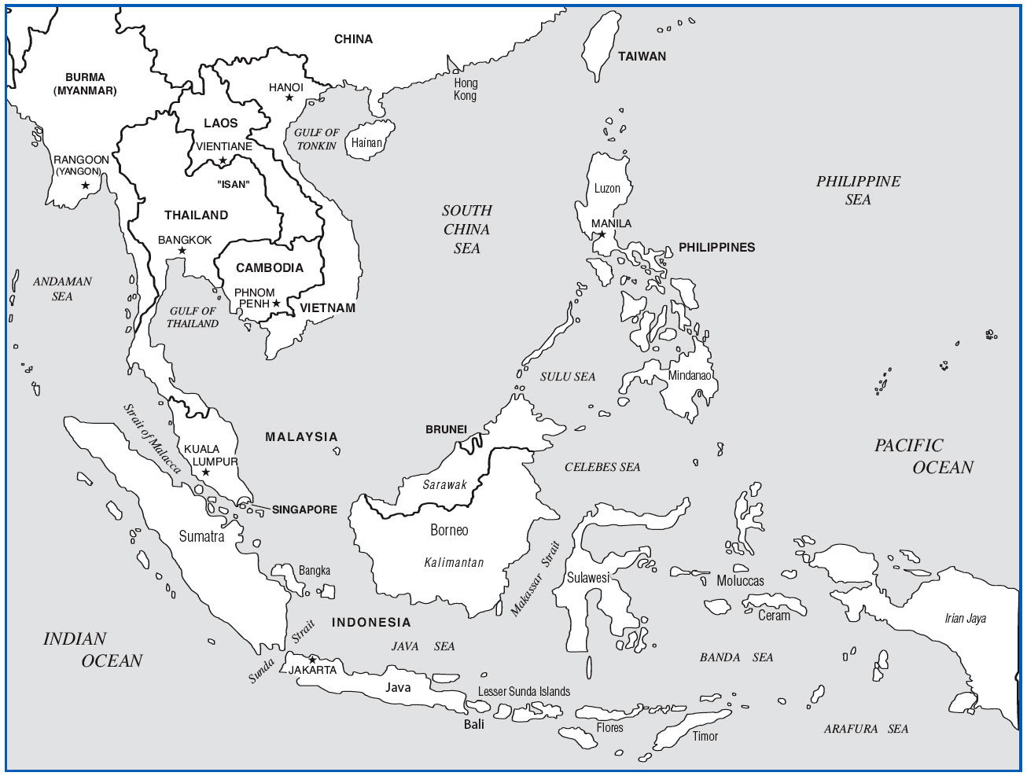
- Background Preparation
  - Mainland and Island
  - Buddhism - Islam
  - Tropical climate varies greatly from north to south.
  - Rice is the main staple of this region. Because its hard to access rice fields are grown on hillsides and are planed and harvested by hand.
  - Bamboo & bronze, very important recourses of the region. Important in music because a lot of instruments out of. Bronze has been around along time 2000 b.c.e. made out of copper tin.
- Vietnam
  - Site 1: Upland Bronze Gongs
  - Site 2: Tài Tử Chamber Music
- Arrival: Vietnam
  - Upland - Lowland Culture
  - Chinese influence
  - Vietnam War, was very devastating war for Vietnam – communism was in power from 1950-1990.
- Site 1: Upland Bronze Gongs -- bronze plate like instruments, has a handle and you hit it like a gong. Played like a hand bell choir each member only plays when their pitch is required.
  - First Impressions
    - Repetitive ringing
  - Aural Analysis
    - Interlocking construction
  - Strong tonal center
  - Simple duple meter
- Cultural Considerations
  - large cooperative ensembles
  - Particular to upland ethnic groups
  - Often accompanies dance
  - Common at festivals and funerals.
  - There is no music theory so pitches and scales have no name.
- Site 2: Tài Tử Amateur Chamber Music –these instruments look a lot like Chinese instruments.
  - First Impressions
    - “Flexible” feeling-- because of frequent tone bending.
  - Aural Analysis
    - Small string ensemble
    - Frequent tone bending
    - Heterophony – same melody but with some differences.
      - The Vietnamese guitar has scooped frets and the string are loose so that you can bend the pitches more. Not represented in the music supplied.
      - The (Dan co) fiddle has a bow.
      - (Dan tranh) is like a zither.
      - (Dan kim) Lute like instrument.
IV. improvised in the beginning then played to a composed piece taught be rote.
- Cultural Considerations p141
  - Talented, amateur music
    - Entertainment settings.
    - Like the Chinese shiatsu. And are all ameture.
  - Entertainment music
  - Often includes vocalist
  - “Talented” amateur music
- Thailand
  - Site 3: Classical Piphat
  - Site 4: Lam Klawn
  - Site 5: Phleng Luk Thung
- Arrival: Thailand
  - Formerly Siam
  - Cultural regions
  - Central (Bangkok)
  - North (Lanna)
  - Northeast (Isan)
  - South
  - Predominantly Buddhist
  - Thai is a tonal language
- Site 3: Classical Piphat
  - First Impressions
  - Organized chaos
  - “Duck call” and “ching”
  - Aural Analysis
  - Melodic & rhythmic percussion
  - Pi (quadruple reed aerophone)
  - Seven equidistant tones per octave
- Thai Classical Instruments
  - Khong wong yai (gong circle)
  - Ranat ek (leading xylophone)
  - Thon ramana (goblet & frame drums)
  - Chap lek (large cymbals)
  - Krap sepha (wood clappers)
  - Ching (small cymbals)
  - Left 2: Pi (reed aerophones)
  - Right 3: Khlui (flutes)
- Temple Analogy
  - Layered Roof
  - Melodic percussion & pi
  - Pillars
  - Ching - aural conductor
  - Foundation
  - Drums, small percussion
- Cultural Considerations
  - Wai Khru - Teacher Honoring Ceremony

- Arrival: Northeast Thailand
- Site 4: Northeast Thai Lam Klawn
- Cultural Considerations
- Site 5: Phleng Luk Thung
- Cultural Considerations
- Indonesia
- Arrival: Indonesia
- Site 6: Javanese Court Gamelan
- Colotomic Structure
- Cultural Considerations
- Site 7: Balinese Gamelan Gong Kebyar
- Cultural Considerations

