**Oceania**

--Australia,

--Papua New Guinea,

--Hawaii, Kiribati

**Oceania Map**

**Background Preparation**

• Nearly 25,000 islands

• Australia, Melanesia, Micronesia, Polynesia

• 1,200 different languages

– English & French common

• Animism/Totemism, Christianity

• Primarily vocal music

**(class notes)**

* Divided into three groups all of which are in the pacific ocean. Also the total land mass of Australia is 7.6 square km. and all the other Islands combind are 8 hundred thousand square km.
  + Melanesia – means “Dark Island”
  + Micronesia—Means “small Island”
  + Polynesia – means “many Islands”
* A common denominator with all groups is a close tie to nature. Complex **animistic and totemistic** spiritual systems have evolved throughout Oceania, in which practitioners call on animals and natural elements for guidance, protection, and subsistence.
* Thought influence of Christian missionaries and colonies from mostly Britain have influenced the culture, making the common language English, and French there still remains aprox 1200 different dialects throughout Oceania.
* The Music is primarily vocal.

**Planning the Itinerary**

* Didjeridu and instrument found among the Aborigines of northern
* Australia. Classified as a trumpet, uses circular breathing.
* Mouth harp, a piece of wood with a string.
* Hawaiian slack guitar
* Choral traditions.

**Australia**

Site 1:

Aborigine Song with didjeridu

**Arrival: Australia**

• The “Outback” or “Bush”

– Arnhem Land, Northern Territory

• Aborigines

– 40,000 year old culture

– Nomadic lifestyle

• Dreamtime

– Concept of Creation

**(Class notes)**

* Most cities are on the coast.
* The interior is referred to as the Bush or the OutBack.
* Most of the native Aborigines now life on a reservation calls Arnham Land where some thirty thousand live.
* Those that don’t live on the Res still conform to the nomadic traditions.
* **Animism** the belief that all living things as well as natural phenomena, such as wind or fire, have a spirit.
* **Dreamtime** – Aboriginal cosmology and is the focus of much artistic activity within the Aboriginal communities of Australia.

**Site 1: Aboriginal Music**

• First Impressions

– Low rumble & “bang”

• Aural Analysis

–Didjeridu

•Circular Breathing

– Clapsticks

– Vocal “Storyteller”

**(class notes)**

* first impressions.
  + didgeridoo is playing as drone, the boomerang is used as clapsticks. And the storyteller shouts out even to his ancestors.
* Aural Analysis.
  + Didgeridoo is made from wood, eucalyptus or blood wood branch that was hallowed by termites, has beeswax on the mouthpiece end and requires circular breathing to be used.
* Cultural considerations.
  + Dream time dreaming, supposedly put them in contact with the spirits of theyre ancestors, they believe that the go back to a time when the earth was just a swirl, and are able to talk to them, these spirit give them “History songs” which they believe have been unchanged, this music is part of they’re believe structure.
  + Women are not allowed to play the didgeridoo. Because it being from the spirits would cause the woman to become to fertile and produce more children then the tribe can support.
  + These instruments are most commonly used for funeral and boy circumcision.

**Cultural Considerations**

• History songs

• Wondjina (spirits)

• Corroboree

• Aboriginal women

--do not play didjeridu

**Papua New Guinea**

Site 2: Susap

**(class notes)**

* Site 2: Susap (LAMELLOPONE) from Papua New Guinea

--Explore More: Singsing of Papua New Guinea

Things to remember from chapter 3.

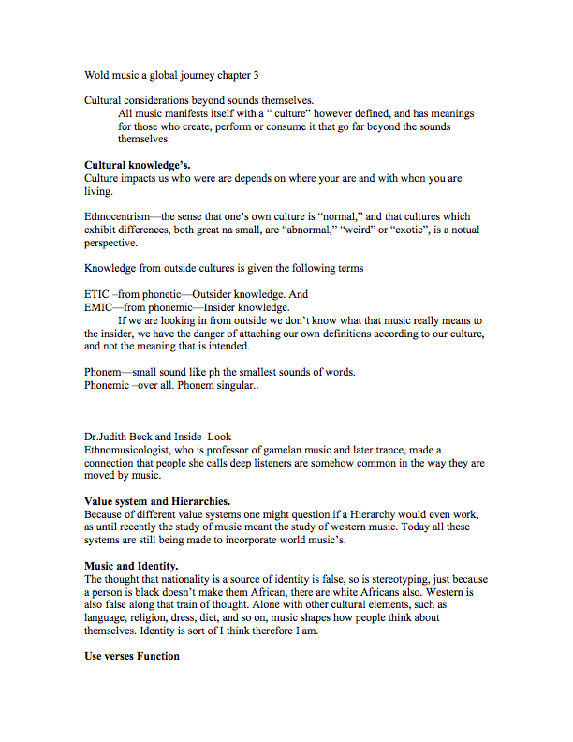

**Arrival: Papua New Guinea**

• Largest island of Melanesia

• Fewer than 5 million inhabitants

• More than 700 indigenous languages

– English is “official” language

**Site 2: Susap (mouth harp)**

• First Impressions

– “Electronic” timbre

• Aural Analysis

–Susap

– Mouth is resonator

– Manipulation of overtones

**Cultural Considerations**

• Susap acts as a “speech surrogate”

– “Disguises” speech

• Common to courting rituals

– Possesses love-controlling magic

**Hawaii**

Site 3: Drum-Dance Chant

**Arrival: Hawaii**

• Northernmost islands of Polynesia

• Captain James Cook (1778)

• King Kamehameha I & II

• Pearl Harbor (December 7, 1941)

• 50th U.S. state (1959)

**Site 3: Drum-Dance Chant**

• First Impressions

– “Wavy” chant

– “Earthy” drums

• Aural Analysis

–Kilu and pahu

– Vocal vibrato

– Open-ended words

**Cultural Considerations**

• Mele (poetry)

• Hula (dance)

• Pahu drum considered sacred

–Mana (spiritual power)

**Kiribati**

Site 4: Group Song

**Arrival: Kiribati**

• Group of islands, including:

– Line Islands (east)

– Phoenix Islands (central)

– Gilbert Islands (west)

• British protectorates during 1800s

• Christian missionaries influential

**Site 4: Kiribati Group Song**

• First Impressions

– “Youthful”a capella choir

• Aural Analysis

– Call & Response

– Unison rhythm

– Handclaps

**Cultural Considerations**

• Music skills are valuable clan property

• Maneaba - communal meeting houses

• Music and dance once used for “battle”

• European Colonialism affected music function and form

Class notes

An Inside Look: Amy Ku’uleialoha stillman

Explore More: Hawaiian Steel Guitar and Ukulele

Site 3: Hawaiin Drum-Dance Chant.

Arrival Kirbati

site 4: group song for bino ( sitting dance) from Kiribati.

Questions to Consider.

On Your own time.