**10 Steps to Effective and Efficient Changes to**

**Increase your Metabolism and Lose Weight**

Step 1: Exercise aerobically 5-7 days a week in the morning.

Reasons: 1. Physiologically – keeps your metabolism elevated throughout the day, so you burn extra calories even when you are not exercising.

2. Psychologically

75% of morning exercisers continue

25% of evening exercisers continue

Exercise is a more effective stress reducer if youdo it in the morning.

Step 2: Exercise in the correct intensity zone.

*It is possible for you to be doing all of the other nine steps correctly and not lose weight if your intensity is not high enough.

*Low intensity doesn’t do much for your metabolism; moderately high intensity exercise does.

60-70% of HR Max – almost wasting your time zone

70-80% of HR Max – the “results zone”, you get results here

80-90% of HR Max – for trained individuals; hard to maintain

Step 3: Exercise for 20-60 minutes each exercise session.

*You need to work hard enough and long enough to break a sweat.

*As you get in better shape, you sweat more and sooner in your workout.

Step 4: Eat a low-fat, balanced diet each day.

*20-50 grams of unsaturated fat a day.

*Eat foods high in Omega-3 fatty acids. (Examples of foods high in Omega-3 fatty acids are walnuts, fish, olive oil and avocados.)

*Eat when you are hungry.

*At the end of your meal, you should still want to eat just a little. ( You want to feel your hunger.)

ChooseMyPlate.gov

MyPlate encourages consumers to eat for health through three general areas of recommendation:

1. Balance calories:
   1. Enjoy your food, but eat less.
   2. Avoid oversized portions.
2. Foods to increase:
   1. Make half your plate fruits and vegetables.
   2. Make at least half your grains whole.
   3. Switch to fat-free or 1% milk products.
3. Foods to reduce:
   1. Compare sodium in foods like soup, bread, and frozen meals – and choose the foods with lower numbers.
   2. Drink WATER instead of sugary drinks.

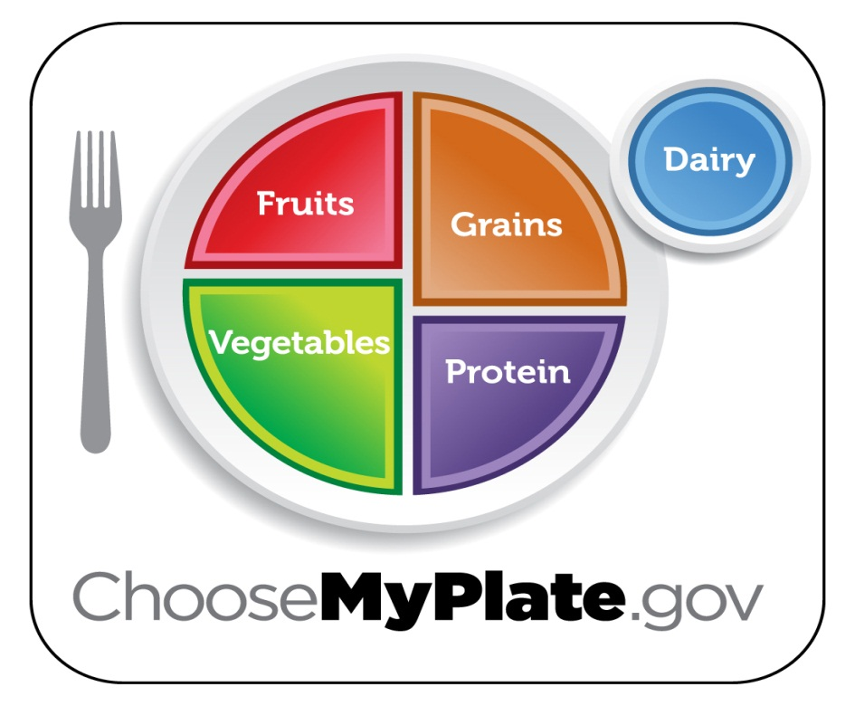

Metabolic Rates:

Step #5: Eat three meals and two snacks each day.

*Your metabolism needs food to keep it elevated.

Step #6: Limit or eliminate alcohol.

*Alcohol is high in calories. (7 calories per gram)

*Alcohol slows your metabolism. (It is a depressant.)

Step #7: Stop eating two to three hours before bedtime.

*Eat breakfast and eat early.

*Move more of your calories earlier in the day.

*Stop eating around 8:00pm at night.

Step #8: Drink six to eight glasses of water each day. (3-4 typical water bottles)

Reasons: 1. Digestion and metabolism will work to their full capacity.

2. Water fills you up.

3. Workouts are more effective.

4. Muscles require water:

Muscle is 70% water.

Fat is 25% water.

Step #9: Have at least two servings of fruit and three servings of vegetables each day.

*Fruits and vegetables have lots of vitamins.

*Fruits and vegetables have few calories.

*Fruits and vegetables fill you up and have good fiber content.

*Eating at least 5 fruits and vegetables can reduce the risk of several forms of cancer.

Step 10: Sleep contributes to a healthy metabolism.

Sleep deficiencies can play a key role in increasing risk for type 2 diabetes, hypertension and sleep apnea.

Studies are showing that people who sleep less than 8 hours per night had higher BMI’s. (Leptin, the hormone that tells you that you are full, is lower with less sleep. Ghrelin, the hormone that tells you are hunger, is higher with less sleep.)

References:

Make the Connection by Ron Greene

Health the Basics by Donatelle