- Southeast Asia
  - Vietnam, Thailand, Indonesia.
  - 150 different ethnic group. They were ruled, and colonized, like vietam was colonized by france so there is a lot of influence.
- Southeast Asia Map
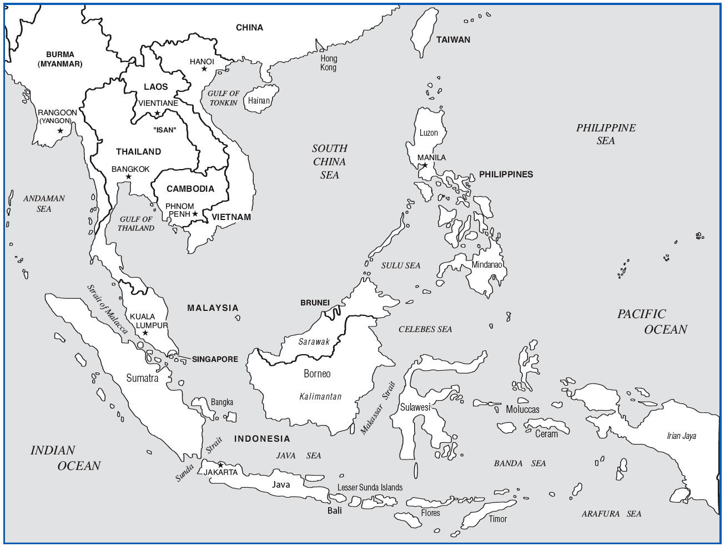
- Background Preparation
  - Mainland and Island
  - Buddhism - Islam
  - Tropical climate varies greatly from north to south.
  - Rice is the main staple of this region. Because its hard to access rice fields are grown on hillsides and are planed and harvested by hand.
  - Bamboo & bronze, very important recourses of the region. Important in music because a lot of instruments out of. Bronze has been around along time 2000 b.c.e. made out of copper tin.
- Vietnam
  - Site 1: Upland Bronze Gongs
  - Site 2: Tài Tử Chamber Music
- Arrival: Vietnam
  - Upland - Lowland Culture
  - Chinese influence
  - Vietnam War, was very devastating war for Vietnam – communism was in power from 1950-1990.
- Site 1: Upland Bronze Gongs -- bronze plate like instruments, has a handle and you hit it like a gong. Played like a hand bell choir each member only plays when their pitch is required.
  - First Impressions
    - Repetitive ringing
  - Aural Analysis
    - Interlocking construction
  - Strong tonal center
  - Simple duple meter
- Cultural Considerations
  - large cooperative ensembles
  - Particular to upland ethnic groups
  - Often accompanies dance
  - Common at festivals and funerals.
  - There is no music theory so pitches and scales have no name.
- Site 2: Tài Tử Amateur Chamber Music –these instruments look a lot like Chinese instruments.
  - First Impressions
    - “Flexible” feeling-- because of frequent tone bending.
  - Aural Analysis
    - Small string ensemble
    - Frequent tone bending
    - Heterophony – same melody but with some differences.
      - The Vietnamese guitar has scooped frets and the string are loose so that you can bend the pitches more. Not represented in the music supplied.
      - The (Dan co) fiddle has a bow.
      - (Dan tranh) is like a zither.
      - (Dan kim) Lute like instrument.
IV. improvised in the beginning then played to a composed piece taught be rote.
- Cultural Considerations p141
  - Talented, amateur music
    - Entertainment settings.
    - Like the Chinese shiatsu. And are all ameture.
  - Entertainment music
  - Often includes vocalist
  - “Talented” amateur music
- Thailand used to be called siam, and is a constitutional monarchy. (constutional, means the government still is democratic but still have royalty)
  - Site 3: Classical Piphat
  - Site 4: Lam Klawn
  - Site 5: Phleng Luk Thung
- Arrival: Thailand
  - Formerly Siam (until 1932)
  - Cultural regions 19 Million people. Tonal language, (different tones have different meanings.)
    - Central (Bangkok)
    - North (Lanna)
    - Northeast (Isan)
    - South
  - Predominantly Buddhist
  - Thai is a tonal language
- Site 3: Classical Piphat
  - First Impressions
    - Organized chaos
    - “Duck call” and “ching”
  - Aural Analysis
    - Melodic & rhythmic percussion (has melodic and rhythmic components to it.)
    - Pi nai (Pee NI) (quadruple reed aerophone)
    - Seven equidistant tones per octave(western is 12 pitches)
- Thai Classical Instruments
  - Khong wong yai (gong circle) idiophone
  - Ranat ek (leading xylophone)idiophone
  - Thon ramana (goblet & frame drums)menbaniphone, and idiophone
  - Chap lek (large cymbals)idiophone
  - Krap sepha (wood clappers)idionphone
  - Ching (small cymbals)idiophone
  - Left 2: Pi (reed aerophones)
  - Right 3: Khlui (flutes)
- Temple Analogy
  - Polyphonic stratification
    - Consists of layers of different melodies.
  - Layered Roof
    - Melodic percussion & pi
  - Pillars
    - Ching - aural conductor
  - Foundation
    - Drums, small percussion
- Cultural Considerations
  - Wai Khru - Teacher Honoring Ceremony like (guru)
- Arrival: Northeast Thailand
  - Culturally Lao
  - Rice economy
  - Isan influence (Isan a term reffering to a northeast culture and it’s music) Primerily flat land weather variation that are good for the rice harvest.
- Site 4: Northeast Thai Lam Klawn
  - First Impressions
    - Peppy poets
    - Happy “harmonica”
  - Aural Analysis
    - Khaen - mouth organ. Sounds very blue grassy like a harmonica, the song in class was a courtship song in which the man sing then the woman.
    - Lam - poetic song
    - Repartee
  - A reed instrument seen throughout asia,
  - 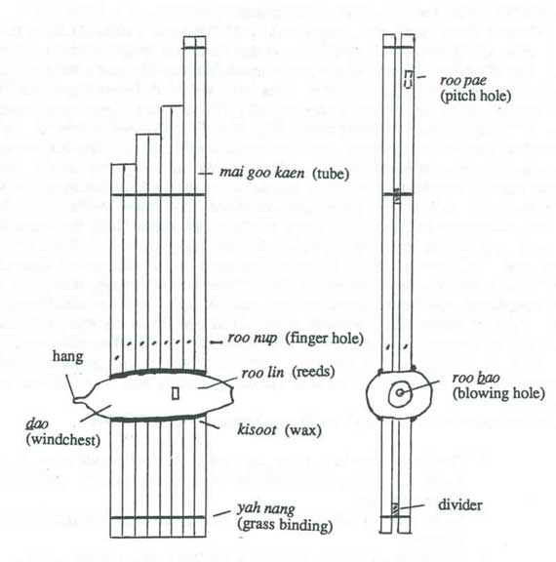
- Cultural Considerations
  - Maw lam
    - Professional poets
  - Festival and ritual entertainment
- Site 5: Phleng Luk Thung
  - First Impressions
    - Old-fashioned “country” pop
  - Aural Analysis
    - Mix of modern and traditional instruments
  - Derived from lam
    - saw bip (fiddle)
phin (lute)
khaen (mouth organ
- Cultural Considerations
  - Traditional “crossover” music.. ty pop sounds very western with 4/4 time and 12 pitch structure. Little bit of modeality.
  - Bangkok boom
  - Stage shows
- Indonesia
  - Site 6: Javanese Court Gamelan
  - Site 7: Balinese Gamelan Gong Kebyar
- Arrival: Indonesia
  - More than 13,000 islands
  - Most populous Islamic nation, more than the middle eastern countries because of the populations.
  - More than 300 languages
D. Focus for many ethnomusicologists & composers
- Site 6: Javanese Court Gamelan
  - First Impressions
    - Metallic music with “misty” interlude
  - Aural Analysis
    - Mostly metallophones
    - “Soft & Strong” styles
    - Colotomic structure
- Colotomic Structure
  - Principal Melody
    - Rack gongs and large metallophones
  - Periodic Punctuation
    - Marked by Hanging Gongs
  - Embellishment
    - Small metallophones
    - Mist” of the music
    - 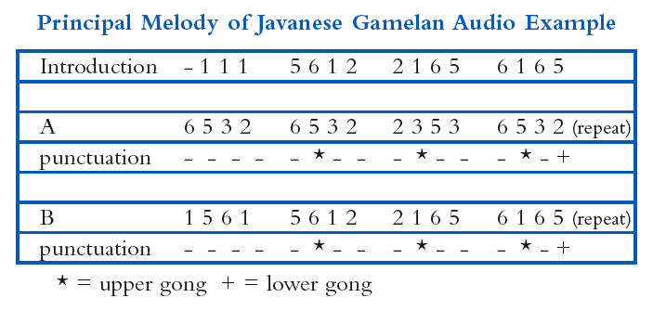
- Cultural Considerations
  - Islam
  - Court Music
  - Tranquility you might expect a concoffeny of sound but actually sonds quite serine and the dance accompanies it.
  - Dance.. on the student site there is a video.
- Site 7: Balinese Gamelan Gong Kebyar
  - First Impressions
  - Dynamic
shifts of mood
- Aural Analysis
  - Starts and stops
  - Sectional solos
  - “Superhuman speed”
  - “Shimmer effect”
- Cultural Considerations
  - Hindu
  - Offering
to deities
  - Dynamic dance
  - Shadow puppets

