1 East Asia

China, Mongolia, Korea, Japan, Tibet

2 East Asia Map

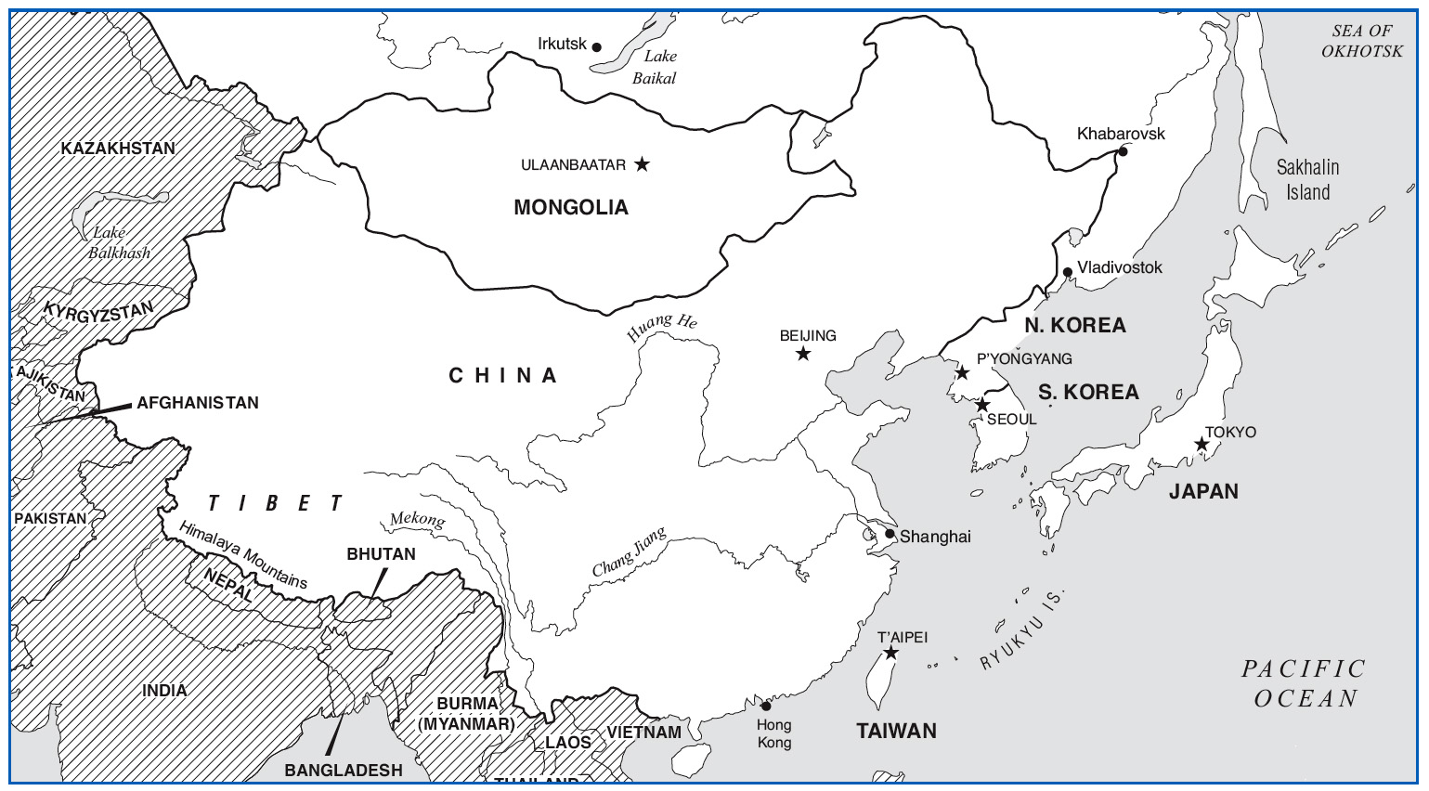

China is roughly the same size as the United States. Tibet is often referred to as the “Rooftop of the World” as its elevation is the highest plateau on the globe. The Great Wall of China runs East-West in an area just north of Beijing.

3 Background Preparation

1.47 billion people

Chinese influence

Dynastic histories

Tradition meets Today

4 China

Site 1: *Gu qin* “Ancient Zither”

Site 2: *Sizhu* “Silk and Bamboo”

Site 3: Beijing Opera

Site 4: Revolutionary Opera

1. Arrival: China
   1. World’s most populous country (1.2 billion+)
   2. Ideographic writing system
   3. Chinese Philosophy
      1. Confucianism, Taoism, Buddhism
   4. Communism
      1. Mao Zedong (1893-1976)
2. Site 1: Gu qin “Ancient Zither”
   1. First Impressions
      1. Quiet and intimate
   2. Aural Analysis
      1. Seven-string fretless zither
      2. Harmonics and tone “sliding” like guitar harmonics you press the strings down and make sound at different pitches. Uses tablature.
      3. Free rhythm:
3. Cultural Considerations
   1. Scholar’s instrument
   2. Sonic meditation
      1. Highly philosophical
      2. Musician interprets notation
   3. Programmatic themes –titles that make you think of things like “spring”{ makes you thinkg of a meadow”
4. Site 2: Sizhu “Silk & Bamboo” its like the veitemise counter part. Started with people getting together and jamming.
   1. First Impressions
      1. Clear melodic line with “flowing” feel
   2. Aural Analysis
      1. *Bayin* organ logical system : Bay men=eans 8 and in is instrument or thing so 8 things liested here:
         1. Stone, metal, gourd, skin, wood, clay, silk, bamboo
      2. Heterophony Structure
      3. Clear beat rhythmic structure that is regulated.

9 Sizhu Instruments

a. Pipa. Type of lute. chordophone

b. Dizi type of flute aero phone

c. *Yang qin like a dulcimer a choriphone that is struck, .. like an idiophone. I really enjoyed the music from this.*

*d. Erhu like a home made tub bass but with out the tub and uses a bow.*  I Really enjoyed the Solo music from this

10 Cultural Considerations

* 1. Regional styles
  2. Amateur Music
  3. Social clubs
     1. A *Jiangnan sizhu* ensemble  
        at a teahouse in Shanghai’s historical district

1. Site 3: Jingju “Beijing Opera”
   1. First Impressions
      1. Shrill voices and nasal fiddle
      2. “Rising and falling” gongs
   2. Aural Analysis
      1. *Jinghu* and melodic ensemble
      2. Melody follows tonal contour of the language
      3. Movement” percussion
         1. *Jinghu*
2. Cultural Considerations
   1. Symbolic scenery
   2. Stylized speech
   3. Major role types
      1. *Sheng* (male)
      2. *Dan* (female)
      3. *Jing* (painted-face)
      4. *Chou* (comedians

13. Jingju Scenes   
-*Jing* actor  
-Warrior battle scene  
-*Dan* prepares makeup  
-*Jingju* orchestra  
-*Dan* & *Chou* actors

1. Site 4: Revolutionary Beijing Opera
   1. First Impressions
      1. “Orchestral” sound
      2. Modern theatre display
   2. Aural Analysis Chinese cultural revolution
      1. Traditional-Modern Orchestra
      2. Western harmony—added western sounding music.
2. Cultural Considerations
   1. Cultural Revolution (1966-1976) , an attempt to eradicate all social classes. So topics of operas and stuff were highly regulated. Because the traditional bejing opera was for the elite class and not for the people the Revolutionary Opera got replaced it, this opera was good vs evil with good winning. Was popular from 66-79 fading though, However, in the 1980s a return of the revolutionary opera, but with a massacre in 1989 it disappeared again, today mostly traditional opera is performed. Revolutionary Bejing opera is what we here in old westerns and old movies.
   2. “Eight Model Works” read book to know about this.
   3. Democracy Movement.. there is an increasing gap between those that have and those that have not.
      1. Korea now has North Korea is threatening to launch missiles at neighboring countries. Side note not for test.
3. Mongolia

Site 5: Throat Singing

1. Arrival: Mongolia
   1. Nomadic herders
   2. Genghis and Kublai Khan
   3. Soviet influence
2. Site 5: Throat Singing
   1. First Impressions
      1. “Whistling” with low grumble
   2. Aural Analysis
      1. Overtone singing
      2. Fundamental drone
3. Cultural Considerations
   1. Spiritual connection
   2. Republic of Tuva
   3. Western attraction

21. Korea

a. Site 6: P’ansori

22. Arrival: Korea

a. China-Japan influence between Japan and China…. So a lot of Korean people can read and write Japanese and Chinese both.

b. Korean War

c. North/South Korea

there are a lot of stars that are from Japan popular in North Korea, and a lot of North Korean stars that are popular in North korea

1. Site 6: P’ansori : was considered a dieing art in the early 20th century but in 1964 it enjoyed a revival, today its studies in universities.
   1. First Impressions
      1. “Wailing” voice: almost like a commentary, close to speech,
      2. Minimal use of drum. Acts almost like a punctuation mark in a sentence.
   2. Aural Analysis
      1. Wide Vibrato: singing can be without vibrato. But in this it has a lot.
      2. Song to Speech
      3. *Puk.* Is the drum p219 played with hand and stick. The more spaced out is happening with long breaks in between hit. Also the drummer is shouting and vocalizing.
2. Cultural Considerations
   1. “Preserved” *p’ansori:*
   2. Former festival storytellers
   3. Korean musical identity
3. Japan .
   1. Site 7: Gagaku
   2. Site 8: Kabuki Theater: is still a traditional style of theater. Stories about virtues of a morally strong person.
4. Arrival: Japan
   1. Island nation with dense population: is about the size of California, but with 4 times the population. But because young people are having less children, the society is currently in decline.
   2. Shogun and Samurai: Samurai started in 9th century, they first provided protection but then took over, until the shogun came into power, between 16th and 19th century. But because the family in control was so powerful they enjoyed peace.
   3. Zen Buddhism : came from Japan in the 6th century. During the trade era Christianity was brought and at time accepted. During the Shogun era it was rejected. Japan is an island culture, Japan has limited resources, no oil. So sharing, respecting the rules and not sticking out was an important part of the culture.
      1. “Less is Best”
   4. Consistency and control
5. Site 7: Sankyoku
   1. First Impressions
      1. Serene, but deleberate
   2. Aural Analysis
      1. Koto is a
      2. Shamisen type of lute
      3. Shakuhachi, type of flute very hard to play and make music with it. Takes a lot of air, and the idea is that you become one with the wind.
      4. Heterophony
6. Cultural Considerations
   1. Contrast to Chinese’s music. Japanese music has more a sense of space, made by lots of spaces in between.
   2. Programmatic
   3. Zen influence: less is more.. this is zen and has influence Japan. Zen Buddism is bassed on meditation, you meditate to become nothing. The nothingness is better then the fullness. No you meditate to become empty and complete with nature.
      1. Site 8: Kabuki Theatre : stories about disputes, or a father doing something to force his child to grow up, or about love, or ghost stories. Like a maid who broke one of the precious plates and was punished by death, and she comes back haunting the master counting the plates everynight. Kabuki is the peoples theater, and is made for the taste of the masses. Kabuki actors are all males, even though they look like females.
         1. First Impressions
            1. “Twangy” lute
            2. “Yo” and “Ho” calls
         2. Aural Analysis
            1. *Chobo*

Narrator – *Shamisen*

* + - * 1. Drums and *Noka*
    1. Cultural Considerations
       1. Classic Popular theater
       2. All male actors
       3. Puppet performance. Is not the kabuki, is called boonraku, all the acting is done by the puppet. Three people work together to make one puppet come to life, one on the head one on the feet, the last on the body.
       4. Point to point dance.

31 Tibet

Site 9: Tibetan Buddhist Ritual

32 Arrival: Tibet

• “Rooftop of the World”

• Tartaric Buddhism

• Dalai Lama

• Tibetan diasporas

1. Site 9: Tibetan Buddhist Ritual
   1. First Impressions
      1. “Fog-horn” trumpets
      2. Guttural chants
   2. Aural Analysis
      1. Overlapping trumpets
      2. Punctuating percussion
      3. Tibetan monks play the *bub chen* (cymbals)
2. Tibetan Trumpets
   1. Left: *Dung chen*  
      Right Top: *Kang dung*  
      Right Below: *Dung kar*
3. Cultural Considerations
   1. “Death without dying”
   2. Trumpet symbolism
   3. The “sound of silence”
   4. The Bodhnath Stupa near Kathmandu, Nepal